* **All data are inserted and Printed Successfully as they are valid with all the requirement.**

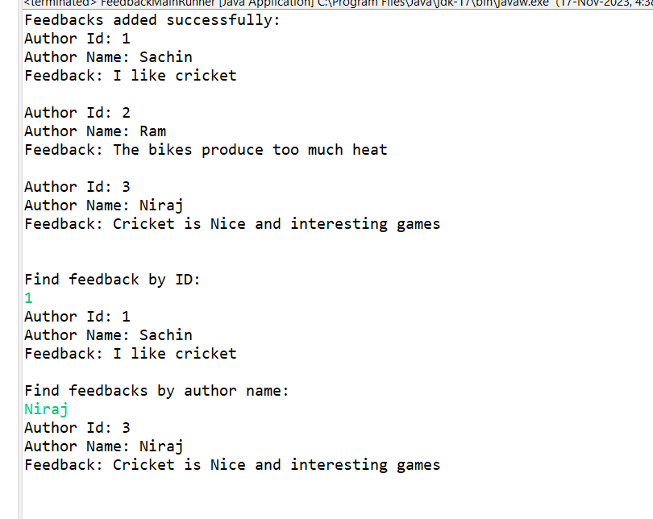

* **As Author name was not valid as it was smaller than 2 digit so it shows exception.**

* **As Feedback was not valid as it was smaller than 5 character so it shows exception.**

* **As Author Id and Author Name was not found in the list so it gives massage of not found while Searching.**

