**SPEECH THERAPY ASSESSMENT FOR CHILDREN**

**Abstract:**

This report outlines the development of a mobile application aimed at addressing the speech therapy needs of children diagnosed with Autism Spectrum Disorder (ASD). ASD is a complex developmental condition characterized by communication challenges. Children with ASD often struggle with speech and language development, making early intervention crucial. The mobile application serves as a vital tool to assist these children in improving their communication skills.

The motivation behind this project stems from the pressing need to provide effective and accessible solutions for children with ASD. Traditional speech therapy methods often require extensive in-person sessions, which can be both logistically challenging and costly for families. Moreover, the variability in ASD symptoms demands personalized interventions. By leveraging technology and creating a user-friendly mobile app, the project aims to bridge these gaps, offering a cost-effective and customizable solution that empowers parents and caregivers to actively participate in the child's therapy journey.

The mobile application employs modern technologies, with a focus on Android development and utilization of articulatory phonetics in the Marathi language. The app features two core modules: an administrative section for customization and a user-friendly interface for children and their parents. The admin module allows for the addition, modification, or deletion of speech therapy content, including words, audio files, and assessment questions in Marathi. The user module offers children the opportunity to engage with speech therapy exercises in a gamified manner, listen to audio pronunciations, and undergo assessments to monitor progress. By combining technology, linguistic expertise, and a user-centered design, the project aims to provide an innovative and effective tool for addressing the unique speech therapy needs of children with ASD.

***Keywords****: ASD, autism, app development, react-native, speech therapy*

Contents

1. INTRODUCTION: 3

1.1 Motivation 3

1.2 Need of Proposed System 3

1.3 Brief Introduction to Application 3

1.4 Reason Behind Making the Application 4

1.5 How Proposed System Will Help Users 4

2. LITERATURE SURVEY 5

2.1 Literature Review 5

2.2 Review of Existing System 5

3. DESIGN 7

3.1 UML Diagram 7

3.2 INTERFACE DETAILS AND SCREENSHOTS 13

4. MODULES SPLIT-UP 15

4.1 DATABASE: 15

5. PROPOSED SYSTEM 16

5.1 Admin Module: 16

5.2 User Module: 16

6. SOFTWARE TOOLS / TECHNOLOGIES TO BE USED 18

7. PROPOSED OUTCOMES 19

8. PROJECT PLAN 2.0 20

# INTRODUCTION:

## 1.1 Motivation

The primary motivation driving this project is the pressing need to address the speech and language development challenges faced by children diagnosed with Autism Spectrum Disorder (ASD). ASD is a complex developmental condition that often manifests in communication difficulties, making early intervention essential. Traditional methods of speech therapy are often constrained by geographic limitations and cost, hindering access to critical therapy services for many families. To bridge this gap, the project embarked on the development of a mobile application tailored to the unique needs of children with ASD, offering a convenient, cost-effective, and accessible solution.

## 1.2 Need of Proposed System

The need for the proposed system can be outlined as follows:

1. Lack of concrete treatment on Autism: Autism is not defined by any clear symptoms; hence it lacks any concrete treatment. The treatment is thus varied depending upon the symptoms.
2. Use of technology: Despite the thriving technology sector, its integration into the medical industry for Autism treatment has been limited. However, the incorporation of React-Native, SQL, Cloudinary, and Power BI into the project leverages cutting-edge technology to address this gap and provide innovative solutions for Autism treatment.
3. Elimination of unnecessary follow ups: With the treatment available at one click on the mobile application.

## 1.3 Brief Introduction to Application

The developed application functions as a dual-purpose system, comprising an administrative module and a user module. It provides essential support to children with ASD and enables healthcare professionals to effectively monitor their progress. In terms of functionality, the application is designed to establish communication with a database for the secure storage of user data. The administrative module grants authorized users the ability to manage therapy content, which includes tasks such as adding, modifying, or deleting speech therapy materials and assessment questions specifically tailored to the Marathi language. Conversely, the user module offers children and their parents a user-friendly interface for participating in speech therapy exercises, listening to audio pronunciations, and undergoing assessments to track their progress.

## 1.4 Reason Behind Making the Application

1. Aid Children with ASD: Develop the app to assist children with Autism Spectrum Disorder (ASD), specifically targeting speech and language challenges.
2. Empower Parents/Caregivers: Enable parents and caregivers to actively participate in therapy, reducing the need for frequent medical visits.
3. Utilize Modern Technology: Leverage Android and technology advancements to make therapy accessible and effective.
4. Streamline Administration: Simplify administrative tasks for healthcare professionals, allowing them to focus on patient care.
5. Customize Therapy: Tailor therapy materials to each child's specific needs, recognizing the variability in ASD symptoms.
6. Address Contemporary Needs: Respond to the growing demand for innovative medical solutions, especially in the context of ASD therapy.

## 1.5 How Proposed System Will Help Users

The proposed system will offer several significant benefits to its users, including:

* Enhanced Communication Skills: Children with ASD will have access to a structured and engaging platform for speech therapy.
* Convenience and Accessibility: Parents and caregivers will find the system convenient, as they can actively engage in therapy sessions with their children without the need for frequent visits to healthcare facilities.
* Personalized Therapy: The system's ability to customize therapy materials and assessments ensures that each child's unique needs are addressed.
* Cost-Effective Solution: By reducing the reliance on in-person therapy sessions, the proposed system offers a cost-effective alternative for families.
* Empowerment: Parents and caregivers will be empowered with tools and insights to actively contribute to their child's therapy journey.
* Language-Specific Support: For users in Marathi-speaking communities, the system provides language-specific support, making therapy content more relevant and effective.
* Data-Driven Progress Tracking: The system's data capture and analysis capabilities enable users and healthcare professionals to track progress effectively. Assessment results and session data offer valuable insights for informed decision-making.

# LITERATURE SURVEY

## 2.1 Literature Review

**Card Talk** does not require login, while **Jellow Basic AAC Communicator** necessitates user login. In contrast, the **Proposed Application** requires login for admin but not for users. **Card Talk** has the permission to record audio, whereas **Jellow Basic AAC Communicator** lacks this option. The **Proposed Application** takes permission while recording audio. Both **Card Talk** and **Jellow Basic AAC Communicator** have their entire applications in the English language. However, the **Proposed Application** is specifically designed to use Marathi alphabets. While **Card Talk** categorizes content into Tools, People, Vehicles, Place, Time, etc., **Jellow Basic AAC Communicator** categorizes content into learning, people, places, etc. In contrast, the **Proposed Application** includes categories based on Marathi alphabets, tailoring its content to the linguistic needs of its users.

#### Table No 2.1: Comparison table of various applications and proposed application

|  |  |  |
| --- | --- | --- |
| Card Talk | Jellow Basic Aac Communicator | Proposed Application |
| No login required. | Login required for user. | Login required for admin but not for user. |
| Permission to record audio. | No option to record audio. | Take permission while recording audio. |
| The entire application is in English language. | The entire application is in English language. | The application is intended to use Marathi alphabets. |
| Categories include Tools, People, Vehicles, Place, Time, etc. | Categories include learning, people, places, etc. | Categories include Marathi alphabets. |

## 2.2 Review of Existing System

Other referred applications:

**Card Talk**: Here no signup is required and takes permission to record audio.

Reference

link🡪 <https://play.google.com/store/apps/details?id=jp.co.litalico.cardtalk&hl=en&gl=US>

**Jellow Basic AAC Communicator**: Login is required and there is no option to record audio.

Reference

Link🡪<https://play.google.com/store/apps/details?id=com.dsource.idc.jellowintl&hl=en_GB>

These applications provide various features which will be beneficial to users. But even with these features there are certain required aspects which make these applications limited. One of them is language.

Here is a UI of Jellow basic aac and Card Talk Applications

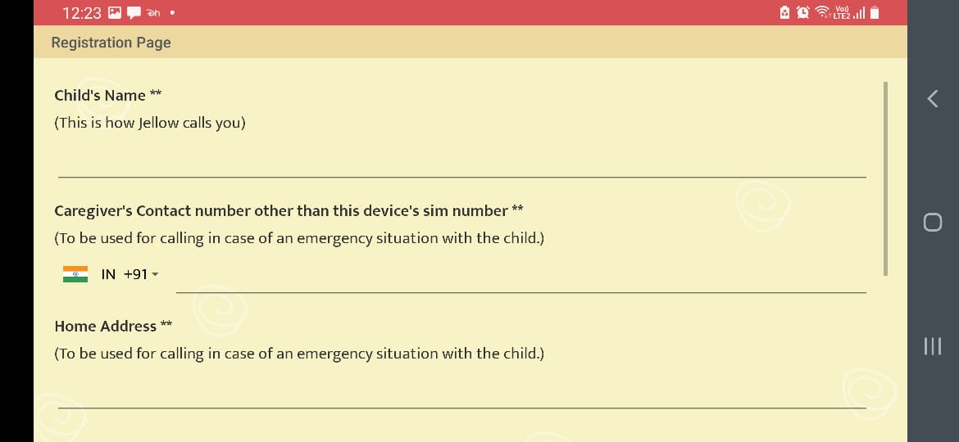

Fig 2.2.1 Jellow basic aac App Registration page

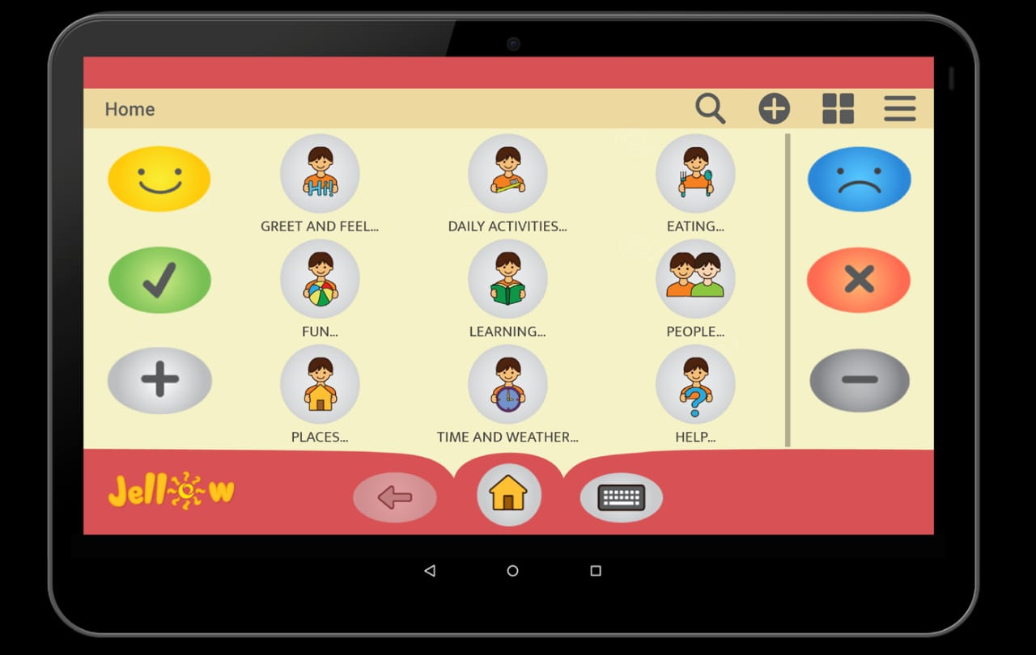

Fig 2.2.2 Jellow basic aac App Home UI

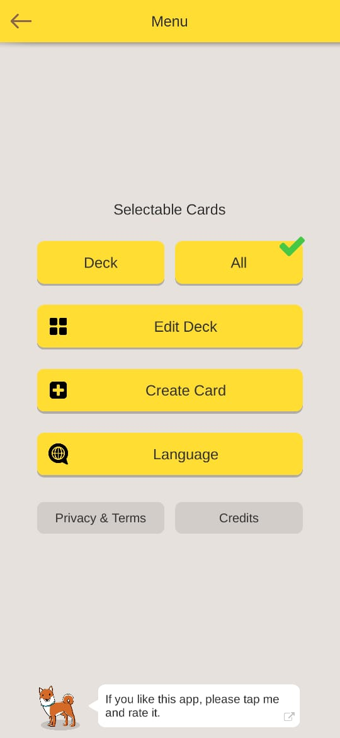 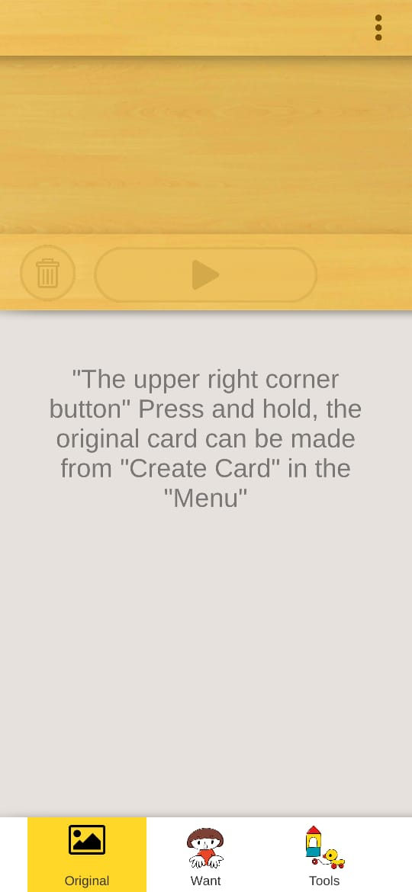

Fig 2.2.3 Card talk Home page UI Fig 2.2.4 Card talk app Main page UI

There are many applications in English but very less or negligible applications intended to teach Marathi alphabets.

# DESIGN

## 3.1 UML Diagram

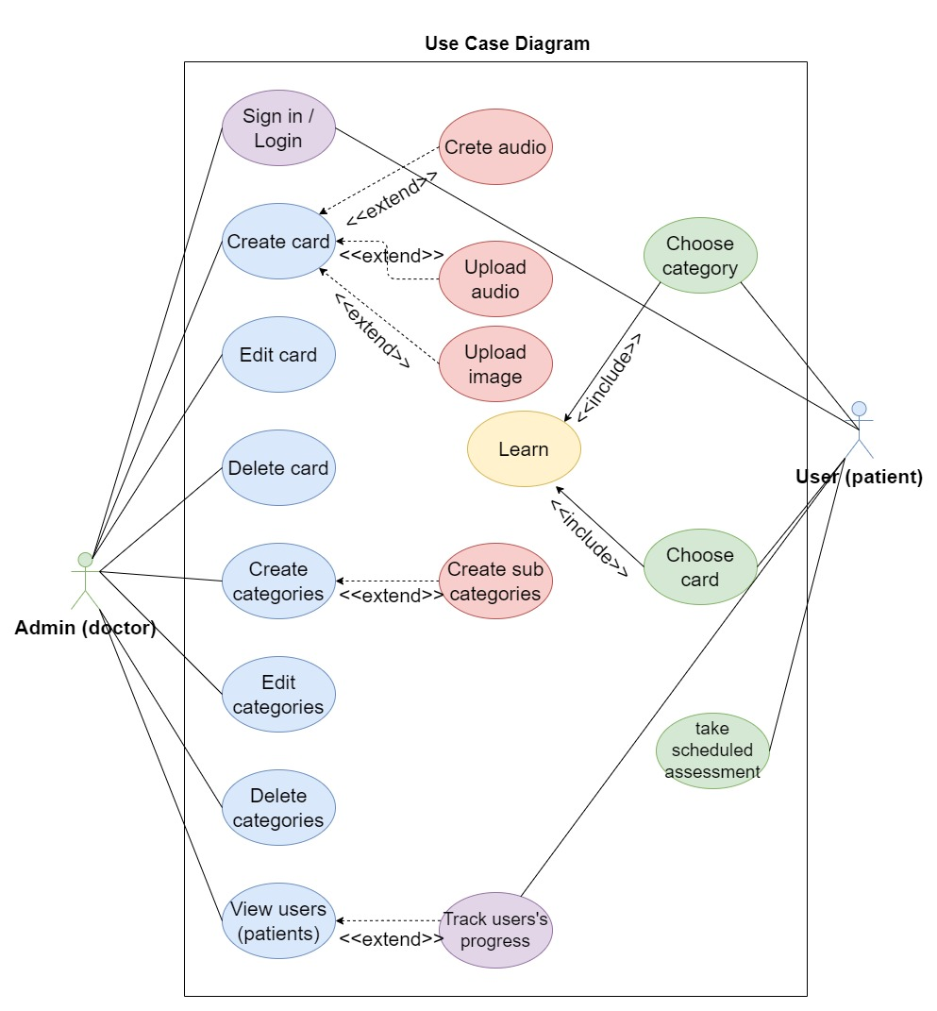

*Fig. 4.1.1 Use case Diagram*

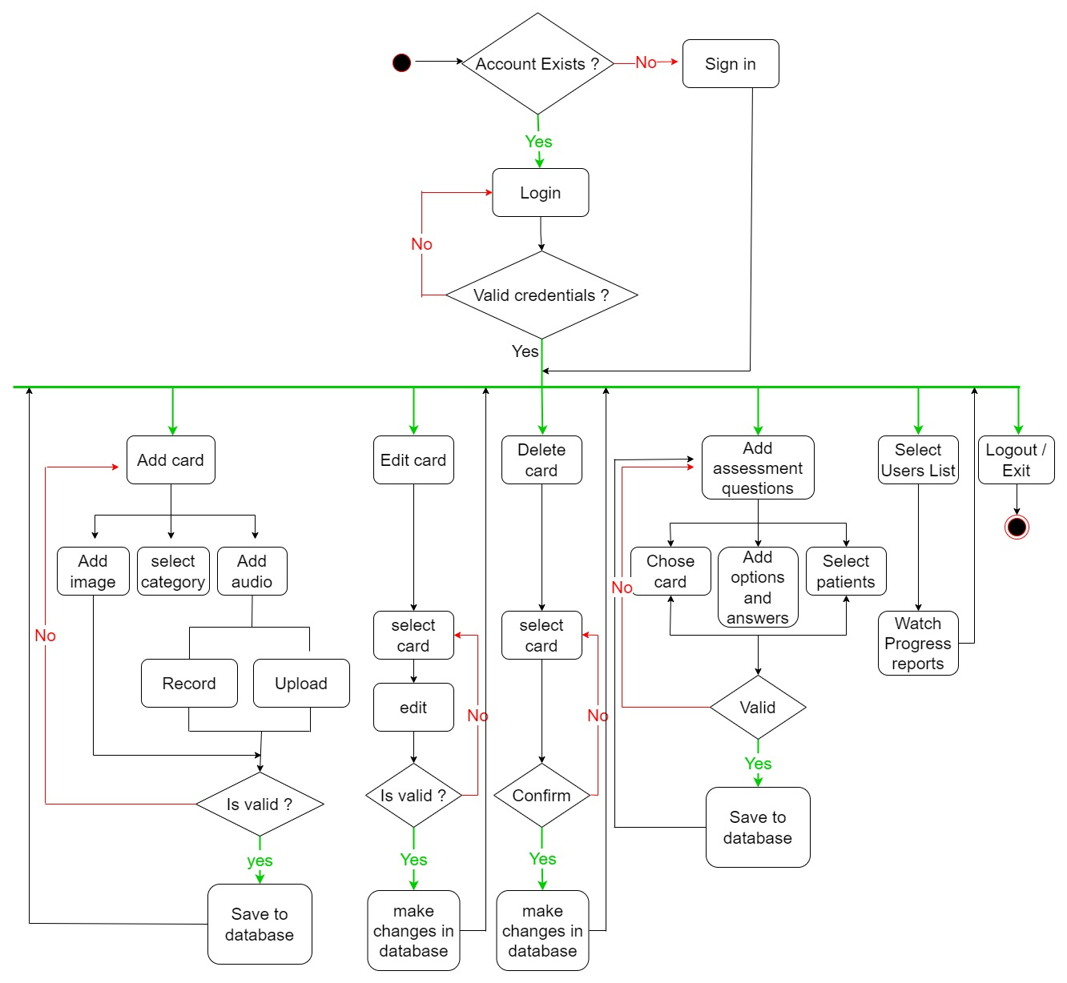

*Fig. 4.1.2 Admin Flow Diagram*

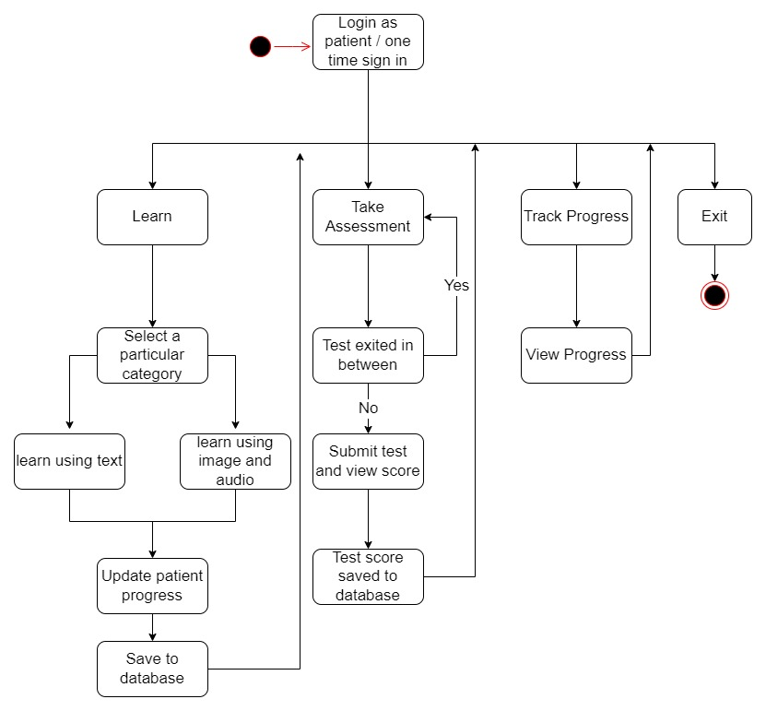

*Fig. 4.1.3 User Flow Diagram*

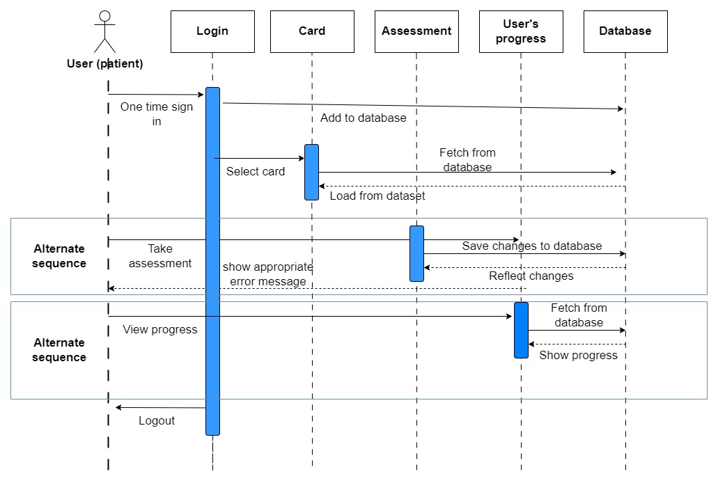

*Fig. 4.1.5 User Sequence Diagram*

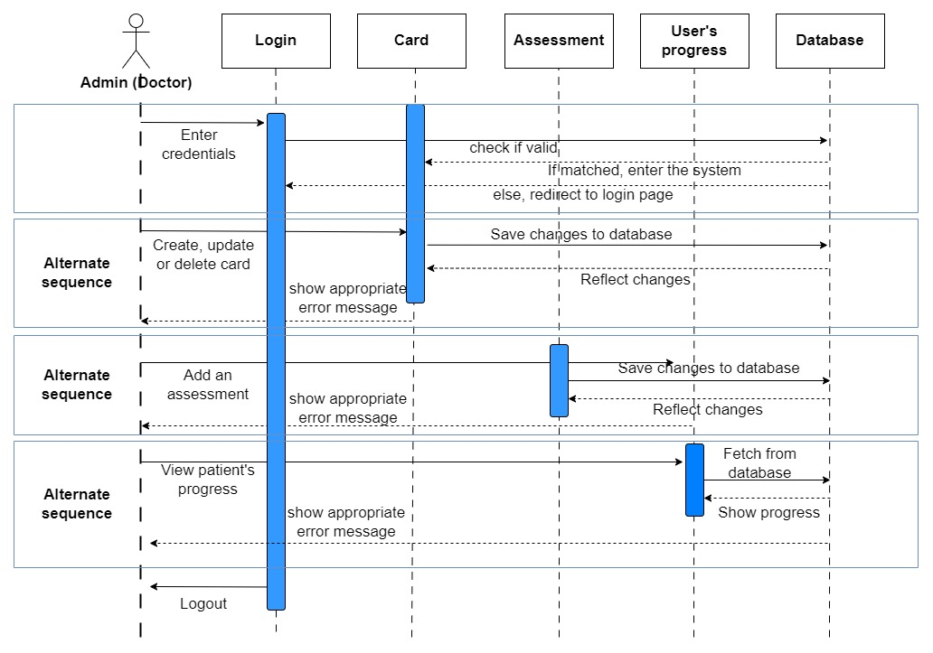

*Fig. 4.1.6 Admin Sequence Diagram*

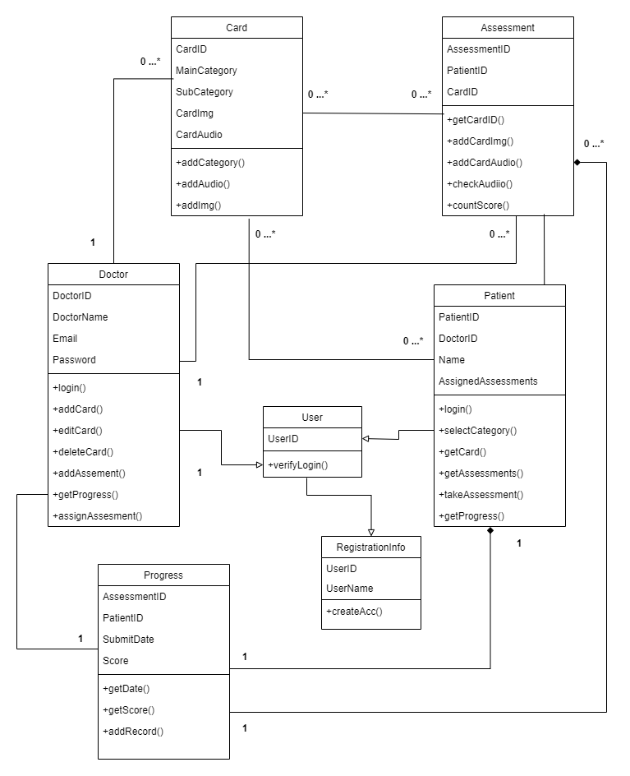

*Fig. 4.1.4 Class Diagram*

5.3 TEAM ORGANIZATION

5.3.1 Team Structure

Our team: - Our team consists of developers, internal guide, external guide, and few mentors.

Developers:

* Chirag Chawade
* Harsh Chawla
* Niraj Amrutkar
* Suniket Khairnar

Internal Guide:

* Dr. Aparna Junnarkar

## 3.2 INTERFACE DETAILS AND SCREENSHOTS

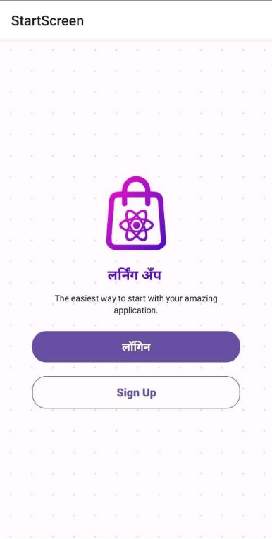

#### Fig 5.4.1 Start Screen

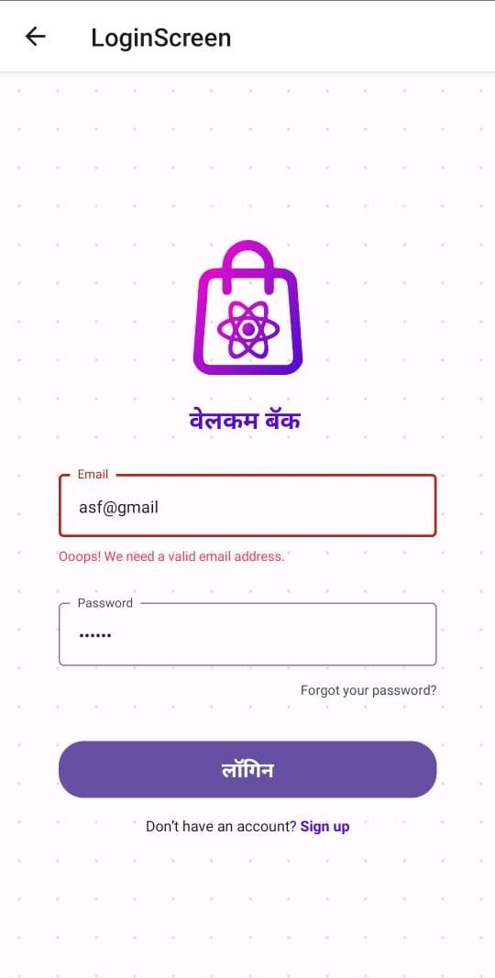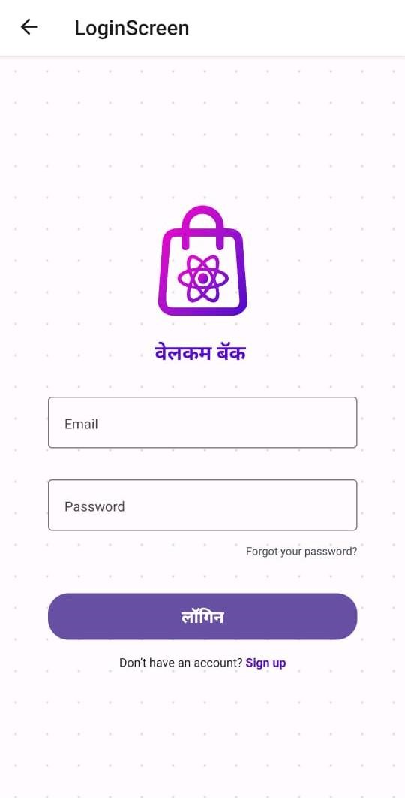

#### Fig 5.4.2 Login Screen Fig 5.4.3 Login Screen Email Validation

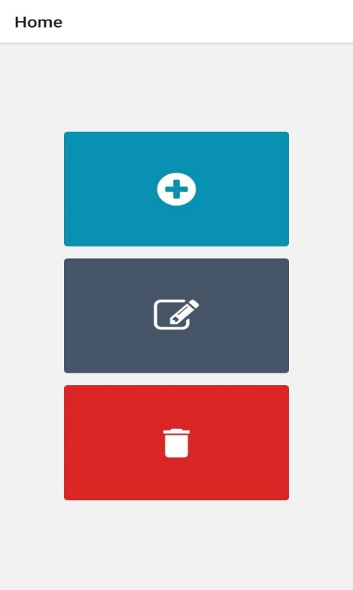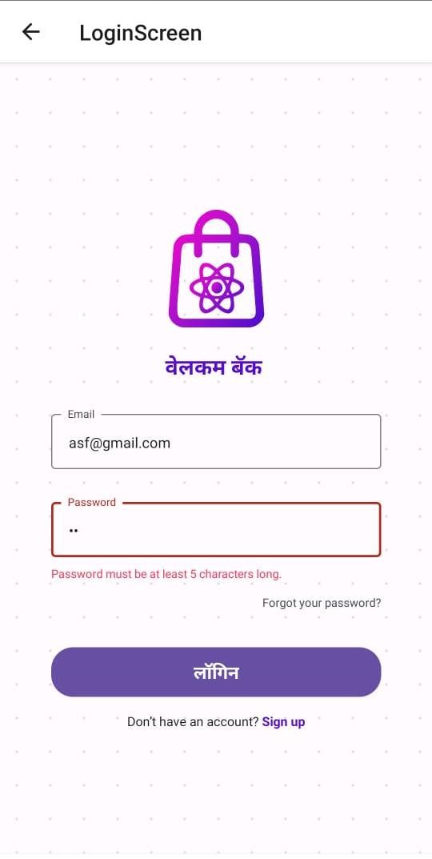

#### Fig 5.4.4 Login Validation Fig 5.4.5 Menu after login

# MODULES SPLIT-UP

## 4.1 DATABASE:

**Entities and Tables:**

Doctor Table:

|  |  |  |  |
| --- | --- | --- | --- |
| DoctorID | DoctorName | Email | Password |

DoctorID (Primary Key) - INT

DoctorName - VARCHAR

Email - VARCHAR

Password - VARCHAR

Patient Table:

|  |  |  |  |  |  |
| --- | --- | --- | --- | --- | --- |
| PatientID | DoctorID | Name | Password | UserType | Email |

PatientID (Primary Key) – INT

DoctorID (Foreign Key) - INT

Name - VARCHAR

Card Table:

|  |  |  |  |  |
| --- | --- | --- | --- | --- |
| CardID | MainCategory | SubCategory | CardImg | CardAudio |

CardID (Primary Key) - INT

CategoryMain - VARCHAR

SubCategory - VARCHAR

CardImg - VARCHAR

CardAudio - VARCHAR

Assessments Table:

|  |  |  |
| --- | --- | --- |
| AssessmentID | PatientID | CardID |

AssessmentID (Primary Key) – INT

PatientID (Foreign Key) - INT

CardID (Foreign Key) - INT

Score Table:

|  |  |  |  |
| --- | --- | --- | --- |
| PatientID | AssessmentID | SubmitDate | Score |

PatientID (Foreign Key) - INT

AssessmentID (Foreign Key) - INT

SubmitDate - DATE

Score - INT

# PROPOSED SYSTEM

The proposed speech therapy application is designed to offer a comprehensive solution for children diagnosed with Autism Spectrum Disorder (ASD) and their caregivers. It leverages modern technology to address the unique speech and language development challenges faced by these children. Here is a detailed breakdown of the proposed system:

**User Authentication and Roles:**

* **User Types**: The system supports two main user types: administrators (admins) and regular users. Admins have additional privileges for managing the system, while regular users, typically parents or caregivers, can access the therapy content and track their child's progress.

## 5.1 Admin Module:

* **Content Management**: Admins have the capability to manage therapy content, including:
  + **Categories**: Admins can create and edit categories of therapy materials. For example, they can create categories like "Marathi Alphabets," "Sentences," or "Words."
  + **Cards**: Admins can add, edit, or delete individual therapy cards within categories. Each card typically includes:
    - An image representing the therapy concept (e.g., a picture of a letter "A" for alphabets).
    - Audio pronunciation of the concept (e.g., the correct pronunciation of the letter "A" in Marathi).
* **Assessment Management**: Admins can set up assessments for users, defining the specific cards or categories to be included in each assessment. These assessments help track a child's progress over time.

## 5.2 User Module:

* **User Dashboard**: Upon logging in, regular users are presented with a user-friendly dashboard where they can access various features of the application.
* **Category Selection**: Users can select specific therapy categories (e.g., "Marathi Alphabets," "Sentences," or "Words") to work on during their therapy sessions.
* **Audio Pronunciation**: Users can listen to audio pronunciations associated with each therapy concept, helping them understand correct pronunciation.
* **Assessments**: Users can take assessments to evaluate their progress. These assessments are based on the content selected by the admin and provide valuable feedback on the child's development.

**Benefits of the Proposed System:**

1. **Accessibility**: The application offers convenient access to speech therapy materials, reducing the need for in-person sessions and making therapy accessible from the comfort of a child's home.
2. **Customization**: Admins can tailor therapy materials to each child's specific needs, recognizing the variability in ASD symptoms. This personalized approach enhances the effectiveness of therapy.
3. **Empowering Caregivers**: The system empowers parents and caregivers to actively participate in their child's therapy journey, reducing the dependency on healthcare professionals for regular therapy sessions.
4. **Technology-Driven**: Leveraging Android development, React Native, SQL, Cloudinary, and Power BI, the application incorporates cutting-edge technology to provide innovative solutions for Autism treatment.
5. **Language Specific**: The application focuses on the Marathi language, recognizing the importance of addressing speech therapy needs in local languages.
6. **Progress Monitoring**: The system allows for the continuous monitoring of a child's progress, helping caregivers and therapists make data-driven decisions about therapy plans.
7. **Cost-Effective**: By reducing the need for frequent medical visits and providing therapy materials through a mobile app, the system offers a cost-effective solution for families.
8. **Future Scope**: The project is designed with future enhancements in mind, allowing for the addition of new therapy content, features, and improvements to benefit children with ASD.

# SOFTWARE TOOLS / TECHNOLOGIES TO BE USED

1. **Android Development**: The mobile application will primarily be developed for the Android platform. Android offers a wide user base and a robust development environment, making it an ideal choice for reaching a broad audience.
2. **React Native**: React Native will be utilized to facilitate cross-platform development. This framework allows for the creation of a single codebase that can be deployed on both Android and iOS devices, reducing development time and costs while maintaining a consistent user experience.
3. **SQL**: A traditional SQL database management system (e.g., MySQL, PostgreSQL, Microsoft SQL Server) will serve as the backend database for storing user information, therapy content, assessments, and user progress data. SQL databases provide strong data consistency and are well-suited for structured data storage.
4. **Cloudinary**: Cloudinary, a cloud-based media management platform, will be integrated to handle the storage and retrieval of multimedia content, such as images and audio files associated with therapy cards. It offers features like content optimization, CDN delivery, and secure storage, ensuring efficient media management within the application.
5. **Node.js**: Node.js will be used on the server side to create an API for communication between the mobile application and the SQL database. Node.js's non-blocking, event-driven architecture allows for efficient handling of asynchronous operations and real-time interactions.
6. **Power BI**: Power BI, a powerful data visualization and business intelligence tool by Microsoft, will be employed for data analysis and reporting. It will help in generating insightful reports and dashboards for tracking user progress and assessing the effectiveness of therapy interventions.
7. **IDEs (Integrated Development Environments)**:
   * **Android Studio**: Android Studio will be the primary IDE for Android app development. It offers a rich set of tools, including an emulator for testing and debugging Android applications.
   * **Visual Studio Code**: Visual Studio Code is a versatile code editor that can be used for developing React Native applications. It supports a wide range of extensions and provides an efficient development environment.
8. **Version Control**: Git and platforms like GitHub or GitLab will be used for version control and collaborative development. This ensures code integrity, collaboration among team members, and the ability to roll back to previous versions if needed.

# PROPOSED OUTCOMES

1. Improved Speech and Language Skills: The primary goal of the application is to facilitate significant improvements in the speech and language skills of children with ASD. Through engaging therapy exercises, audio pronunciations, and assessments, children will have the opportunity to enhance their communication abilities, which is crucial for their overall development and quality of life.
2. Increased Accessibility: By providing therapy content through a mobile application, the system significantly increases accessibility to speech therapy services. Families and caregivers can access therapy materials at any time, eliminating the need for frequent in-person sessions and overcoming geographical barriers.
3. Empowered Caregivers: The application empowers parents and caregivers to actively participate in their child's therapy journey. They can guide therapy sessions, track progress, and provide consistent support, reducing the child's dependency on healthcare professionals for therapy sessions.
4. Customization and Personalization: The system allows for the customization of therapy materials and assessments. This means that therapy can be tailored to meet each child's specific needs and challenges, recognizing the variability in ASD symptoms.
5. Cost-Effective Solution: The application offers a cost-effective alternative to traditional in-person speech therapy sessions. It reduces the financial burden on families by eliminating the need for frequent clinic visits and providing an affordable and accessible therapy solution.
6. Data-Driven Insights: The system captures and stores data on user progress, including assessment scores and session times. This data can be used to generate insightful reports and dashboards using tools like Power BI, helping caregivers and therapists make informed decisions about therapy plans.
7. Language-Specific Support: Focusing on the Marathi language (or any specific language), the application caters to the linguistic needs of children in local communities. This ensures that therapy content is relevant and effective for the target audience.
8. Future Scalability: The project is designed with future enhancements in mind. This includes the ability to add new therapy content, features, and improvements. As the application evolves, it can continue to address the evolving needs of children with ASD and their caregivers.
9. Positive Impact on Quality of Life: Ultimately, the application's success will be measured by its positive impact on the quality of life of children with ASD. Improved communication skills can lead to better social interactions, increased independence, and enhanced overall well-being.
10. Research and Insights: The data collected through the application can contribute to research on speech therapy outcomes for children with ASD. This data may be valuable for healthcare professionals, researchers, and organizations working in the field of autism research.
11. Community Building: The application can foster a sense of community among users, caregivers, and therapists. Forums, support groups, and interactive features can encourage knowledge sharing and emotional support among users facing similar challenges.

# PROJECT PLAN 2.0

In Project Plan 2.0, we are taking our commitment to addressing the needs of individuals with autism disorder to the next level. Recognizing the severe lack of accessible therapy services in rural and underserved regions, we are determined to bridge this gap by introducing a free tier service. Our mission is to extend the benefits of speech therapy to those who often face geographical and financial barriers to care. By offering this free service in rural parts where autism treatment options are virtually non-existent, we aim to make a positive impact on the lives of individuals and families affected by autism. This initiative reflects our dedication to inclusivity and our vision of a world where every individual, regardless of their location or socioeconomic status, can receive the support they need to thrive.