**SPEECH THERAPY ASSESSMENT FOR CHILDREN**

**Abstract:**

This report outlines the development of a mobile application aimed at addressing the speech therapy needs of children diagnosed with Autism Spectrum Disorder (ASD). ASD is a complex developmental condition characterized by communication challenges. Children with ASD often struggle with speech and language development, making early intervention crucial. The mobile application serves as a vital tool to assist these children in improving their communication skills.

The motivation behind this project stems from the pressing need to provide effective and accessible solutions for children with ASD. Traditional speech therapy methods often require extensive in-person sessions, which can be both logistically challenging and costly for families. Moreover, the variability in ASD symptoms demands personalized interventions. By leveraging technology and creating a user-friendly mobile app, the project aims to bridge these gaps, offering a cost-effective and customizable solution that empowers parents and caregivers to actively participate in the child's therapy journey.

The mobile application employs modern technologies, with a focus on Android development and utilization of articulatory phonetics in the Marathi language. The app features two core modules: an administrative section for customization and a user-friendly interface for children and their parents. The admin module allows for the addition, modification, or deletion of speech therapy content, including words, audio files, and assessment questions in Marathi. The user module offers children the opportunity to engage with speech therapy exercises in a gamified manner, listen to audio pronunciations, and undergo assessments to monitor progress. By combining technology, linguistic expertise, and a user-centered design, the project aims to provide an innovative and effective tool for addressing the unique speech therapy needs of children with ASD.

***Keywords****: ASD, autism, app development, react-native, speech therapy*

**Problem Statement**: The integration of technology and specialized therapeutic methodologies into a cohesive, user-friendly mobile application, ensuring equitable access to high-quality autism intervention regardless of geographical or socioeconomic barriers.

Contents

1. INTRODUCTION: 3

1.1 Motivation 3

1.2 Need of Proposed System 3

1.3 Brief Introduction to Application 3

1.4 Reason Behind Making the Application 4

1.5 How Proposed System Will Help Users 4

2. LITERATURE SURVEY 5

2.1 Literature Review 8

2.2 Review of Existing System 9

3. MODULES SPLIT-UP 11

4.1 DATABASE: 11

4. PROPOSED SYSTEM 12

5.1 Admin Module: 12

5.2 User Module: 13

5. SOFTWARE TOOLS / TECHNOLOGIES TO BE USED 14

6. PROPOSED OUTCOMES 15

7. PROJECT PLAN 2.0 17

# INTRODUCTION:

## 1.1 Motivation

The primary motivation driving this project is the pressing need to address the speech and language development challenges faced by children diagnosed with Autism Spectrum Disorder (ASD). ASD is a complex developmental condition that often manifests in communication difficulties, making early intervention essential. Traditional methods of speech therapy are often constrained by geographic limitations and cost, hindering access to critical therapy services for many families. To bridge this gap, the project embarked on the development of a mobile application tailored to the unique needs of children with ASD, offering a convenient, cost-effective, and accessible solution.

## 1.2 Need of Proposed System

The need for the proposed system can be outlined as follows:

1. Lack of concrete treatment on Autism: Autism is not defined by any clear symptoms; hence it lacks any concrete treatment. The treatment is thus varied depending upon the symptoms.
2. Use of technology: Despite the thriving technology sector, its integration into the medical industry for Autism treatment has been limited. However, the incorporation of React-Native, SQL, Cloudinary, and Power BI into the project leverages cutting-edge technology to address this gap and provide innovative solutions for Autism treatment.
3. Elimination of unnecessary follow ups: With the treatment available at one click on the mobile application.

## 1.3 Brief Introduction to Application

The developed application functions as a dual-purpose system, comprising an administrative module and a user module. It provides essential support to children with ASD and enables healthcare professionals to effectively monitor their progress. In terms of functionality, the application is designed to establish communication with a database for the secure storage of user data. The administrative module grants authorized users the ability to manage therapy content, which includes tasks such as adding, modifying, or deleting speech therapy materials and assessment questions specifically tailored to the Marathi language. Conversely, the user module offers children and their parents a user-friendly interface for participating in speech therapy exercises, listening to audio pronunciations, and undergoing assessments to track their progress.

## 1.4 Reason Behind Making the Application

1. Aid Children with ASD: Develop the app to assist children with Autism Spectrum Disorder (ASD), specifically targeting speech and language challenges.
2. Empower Parents/Caregivers: Enable parents and caregivers to actively participate in therapy, reducing the need for frequent medical visits.
3. Utilize Modern Technology: Leverage Android and technology advancements to make therapy accessible and effective.
4. Streamline Administration: Simplify administrative tasks for healthcare professionals, allowing them to focus on patient care.
5. Customize Therapy: Tailor therapy materials to each child's specific needs, recognizing the variability in ASD symptoms.
6. Address Contemporary Needs: Respond to the growing demand for innovative medical solutions, especially in the context of ASD therapy.

## 1.5 How Proposed System Will Help Users

The proposed system will offer several significant benefits to its users, including:

* Enhanced Communication Skills: Children with ASD will have access to a structured and engaging platform for speech therapy.
* Convenience and Accessibility: Parents and caregivers will find the system convenient, as they can actively engage in therapy sessions with their children without the need for frequent visits to healthcare facilities.
* Personalized Therapy: The system's ability to customize therapy materials and assessments ensures that each child's unique needs are addressed.
* Cost-Effective Solution: By reducing the reliance on in-person therapy sessions, the proposed system offers a cost-effective alternative for families.
* Empowerment: Parents and caregivers will be empowered with tools and insights to actively contribute to their child's therapy journey.
* Language-Specific Support: For users in Marathi-speaking communities, the system provides language-specific support, making therapy content more relevant and effective.
* Data-Driven Progress Tracking: The system's data capture and analysis capabilities enable users and healthcare professionals to track progress effectively. Assessment results and session data offer valuable insights for informed decision-making.

# LITERATURE SURVEY

A comprehensive examination of recent literature on Autism Spectrum Disorder (ASD) illuminates critical facets of this complex condition. Genetic studies have underscored the high heritability of ASD and highlighted the variability within normal development, emphasizing the importance of understanding specific genes contributing to susceptibility [1]. Concurrently, research has focused on mobile applications tailored for ASD, acknowledging their significance in clinical settings. Evaluations of existing mobile apps for ASD have proven pivotal, guiding clinicians and families toward evidence-based interventions [2]. Notably, interventions like the Puzzle Walk app and tablet apps from Open Autism Software have demonstrated the potential of technology in enhancing physical activity and social interactions among individuals with ASD [3][4]. Furthermore, participatory design approaches have yielded educational mobile apps that are instrumental in improving numeracy skills, emphasizing the necessity for tailored tools in addressing diverse ASD needs [5].

Studies delve into innovative methods for ASD interventions, including Applied Behavior Analysis (ABA) techniques like Discrete Trial Instruction (DTI), mand training, and Natural Environment Teaching (NET). These approaches have provided valuable insights into effective teaching methodologies for individuals with ASD, particularly within inclusive school settings [6]. Moreover, environmental factors have come under scrutiny, revealing possible links between pollutants, advanced parental age, older siblings with ASD, and increased risk for autism [7]. This knowledge underscores the multifaceted nature of ASD, necessitating holistic interventions that consider both genetic predispositions and environmental influences.

The integration of Information and Communication Technology (ICT) in ASD interventions has marked a significant stride. Recent reviews have highlighted the importance of early development interventions, focusing on imitation and joint attention, facilitated by robotics and interactive applications [8]. Categorized into diagnostic tools, intervention tools, and mobile apps, these technological advancements represent a beacon of hope. Notably, Augmentative and Alternative Communication (AAC) tools like Picture Exchange Communication System (PECS) have showcased positive outcomes, improving communication skills and aiding in adapting to normal life [9]. As technology continues to evolve, these findings underscore the transformative potential of innovative interventions, offering promise for individuals with ASD and their families in navigating the challenges associated with the disorder.

|  |  |  |
| --- | --- | --- |
| Sr No | Paper No | Name |
| 1 | 1 | Autism Spectrum Disorders By Catherine Lord ‡ Edwin H. Cook, Bennett L. Leventhal, and David G. Amaral |
| 2 | 2 | Smartphone Apps for Autism Spectrum Disorder—Understanding  the Evidence  Jung Won Kim1 & Thuc-Quyen Nguyen2 & Shih Yee-Marie Tan Gipson3 & Ah Lahm Shin1 & John Torous4 |
| 3 | 3 | Puzzle Walk: A Gamified Mobile App to Increase Physical Activity in Adults with Autism Spectrum Disorder |
| 4 | 4 | Evaluation of Tablet Apps to Encourage Social Interaction  in Children with Autism Spectrum Disorders  Juan Pablo Hourcade, Stacy R. Williams, Ellen A. Miller, Kelsey E. Huebner, Lucas J. Liang |
| 5 | 5 | Development of a Mobile App to Improve Numeracy Skills of Children With Autism Spectrum Disorder: Participatory Design and Usability Study Theoneste Ntalindwa 1 , MSc; Mathias Nduwingoma1 , PhD; Evariste Karangwa 2 , PhD; Tanjir Rashid Soron3 , MD, MPH, MSc; Alphonse Uworwabayeho1 , PhD; Annette Uwineza4 , MD, PhD |
| 6 | 6 | Applied Behavior Analysis: Its Application in the Treatment of Autism and Related Disorders in Young ChildrenSandra L. Harris, PhD Professor of Clinical Psychology Graduate School of Applied and Professional Psychology Lara Delmolino, PhD Research Assistant Professor Douglass Developmental Disabilities Center Rutgers, The State University of New Jersey New Brunswick, New Jersey |
| 7 | 7 | Children with Autism Spectrum Disorder and Patterns of  Participation in Daily Physical and Play Activities  Amir Hossein Memari,1 Nekoo Panahi,1 Elaheh Ranjbar,1 Pouria Moshayedi,2  Masih Shafiei,1 Ramin Kordi,1 and Vahid Ziaee3 |
| 8 | 8 | MISE AU POINT/ IN-DEPTH REVIEW AUTISM IN REVIEWSimone KHALIFEH1,2,3, Walid YASSIN2,3, Silva KOURTIAN2,3,4, Rose-Mary BOUSTANY1,2,3, |
| 9 | 9 | Features of Mobile Apps for People with Autism in a Post COVID-19 Scenario: Current Status and Recommendations for Apps Using AI Ikram Ur Rehman 1 , Drishty Sobnath 2 , Moustafa M. Nasralla 3 , Maria Winnett 1 , Aamir Anwar 1 , Waqar Asif 1 and Hafiz Husnain Raza Sherazi 1, |
| 10 | 10 | Assisting Children with Autism Spectrum Disorder with Educational Mobile Apps to Acquire Language and Communication Skills: A Review Azham Hussain (*) Universiti Utara Malaysia, Sintok, Malaysia hussazham@yandex.com Emmanuel O.C. Mkpojiogu Universiti Utara Malaysia, Sintok, Malaysia Veritas University, Abuja, Nigeria Pauline Chiamaka Okoroafor Veritas University, Abuja, Nigeria |
| 11 | 11 | INCREASING COMMUNICATIVE INTERACTIONS OF YOUNG CHILDREN WITH AUTISM USING A VOICE OUTPUT COMMUNICATION AID AND NATURALISTIC TEACHING MAUREEN M. SCHEPIS FAMILY, INFANT, AND PRESCHOOL PROGRAM AND WESTERN CAROLINA CENTER DENNIS H. REID CAROLINA BEHAVIOR ANALYSIS AND SUPPORT CENTER AND LOUISIANA STATE UNIVERSITY MEDICAL CENTER MICHAEL M. BEHRMANN GEORGE MASON UNIVERSITY AND KELLY A. SUTTON WESTERN CAROLINA CENTER FOUNDATION |
| 12 | 12 | Interventions for Children With Autism Spectrum Disorders in Inclusive School Settings Lynn Koegel, Rosy Matos-Fredeen, Russell Lang, and Robert Koegel, University of California, Santa Barbar |
| 13 | 13 | Interactive Technologies for Autistic Children: A Review Sofiane Boucenna, Antonio Narzisi, Elodie Tilmont, Filippo Muratori, Giovanni Pioggia, David Cohen & Mohamed Chetouani |
| 14 | 14 | Autism Children’s App based intervention |
| 15 | 15 | Applications for Children with Autism in Preschool and Primary Education Maria Xanthopoulou (*), Georgia Kokkalia, Athanasios Drigas National Center for Scientific Research-Demokritos, Attica, Greece maxanthopoulou@yahoo.com |
| 16 | 16 | Autism Children’s App using PECS Nareena Soomro1, * and Safeeullah Soomro |

|  |  |
| --- | --- |
| Paper  No | Survey |
| 1 | Genetics of autism and identification of specific genes - High heritability and variability within normal development |
| 2 | Study examines mobile apps for Autism Spectrum Disorder (ASD) - Assessing evidence for ASD apps is critical for clinicians and families. Examined available mobile device-based applications for ASD - Reviewed evidence for commercially available mobile device apps for ASD |
| 3 | Puzzle Walk app developed to increase physical activity in adults with ASD - Incorporates behaviour change techniques and gamification elements |
| 4 | Study on tablet apps for social interaction in children with ASDs - Apps from Open Autism Software increased positive social interactions |
| 5 | Participatory design approach used to develop mobile app - App improves numeracy skills of children with ASD. Literature review explored existing mobile apps - Literature review compared previous studies for app design |
| 6 | Autism is a disorder characterized by deficits in social communication and repetitive behaviours. - The genetics of autism is an area of significant research, with evidence of high heritability and potential genetic variations contributing to susceptibility. |
| 7 | ABA methods used to educate children with autism - DTI is an effective teaching approach for autism. DTI is an effective teaching approach for individuals with autism. - Mand training and NET are contrasted with DTI. |
| 8 | Low rate of physical activity in children with ASD - Gender, income, and household structure associated with activity scores. Age and gender differences in physical activity levels - Autism Treatment Evaluation Checklist (ATEC) used to monitor severity of symptoms |
| 9 | Research suggests a possible link between environmental pollutants and autism. - Advanced parental age and having an older sibling with ASD are risk factors for autism |
| 10 | Study analyses existing mobile apps for people with ASD - Identifies common features and recommends enhancements using AI. 52 articles and technical reports were selected. - Common issues considered: social interactions, repetitive behaviour, verbal/non-verbal interactions |
| 11 | Review of literature on autism and educational mobile apps - educational apps effective in helping autistic children acquire language and communication skills. The literature review explores theories related to autism spectrum disorder. - It discusses the use of educational mobile apps for children with ASD. |
| 12 | VOCA and naturalistic teaching increased communicative interactions in children with autism - No negative effects of VOCA use on other communicative behaviours. Summary of research-based interventions for students with ASD - Focus on interventions in inclusive school settings |
| 13 | Summary of research-based interventions for students with ASD - Focus on interventions in inclusive school settings |
| 14 | Review of recent ICT applications for autism treatment - Focus on early development of imitation and joint attention in children with autism and roboticsOverview of recent ICT applications for ASD treatment - Focus on early development of imitation and joint attention in children with ASD and robotics |
| 15 | Focus on applications for children with Autism Spectrum Disorder (ASD) - Categorized into Diagnostic Tools, Intervention Tools, and Mobile Apps |
| 16 | Autism app using PECS improves communication in children - Positive impact on adapting to normal life. |

## 2.1 Literature Review

**Card Talk** does not require login, while **Jellow Basic AAC Communicator** necessitates user login. In contrast, the **Proposed Application** requires login for admin but not for users. **Card Talk** has the permission to record audio, whereas **Jellow Basic AAC Communicator** lacks this option. The **Proposed Application** takes permission while recording audio. Both **Card Talk** and **Jellow Basic AAC Communicator** have their entire applications in the English language. However, the **Proposed Application** is specifically designed to use Marathi alphabets. While **Card Talk** categorizes content into Tools, People, Vehicles, Place, Time, etc., **Jellow Basic AAC Communicator** categorizes content into learning, people, places, etc. In contrast, the **Proposed Application** includes categories based on Marathi alphabets, tailoring its content to the linguistic needs of its users.

#### Table No 2.1: Comparison table of various applications and proposed application

|  |  |  |
| --- | --- | --- |
| Card Talk | Jellow Basic Aac Communicator | Proposed Application |
| No login required. | Login required for user. | Login required for admin but not for user. |
| Permission to record audio. | No option to record audio. | Take permission while recording audio. |
| The entire application is in English language. | The entire application is in English language. | The application is intended to use Marathi alphabets. |
| Categories include Tools, People, Vehicles, Place, Time, etc. | Categories include learning, people, places, etc. | Categories include Marathi alphabets. |

## 2.2 Review of Existing System

Other referred applications:

**Card Talk**: Here no signup is required and takes permission to record audio.

Reference

link🡪 <https://play.google.com/store/apps/details?id=jp.co.litalico.cardtalk&hl=en&gl=US>

**Jellow Basic AAC Communicator**: Login is required and there is no option to record audio.

Reference

Link🡪<https://play.google.com/store/apps/details?id=com.dsource.idc.jellowintl&hl=en_GB>

These applications provide various features which will be beneficial to users. But even with these features there are certain required aspects which make these applications limited. One of them is language.

Here is a UI of Jellow basic aac and Card Talk Applications

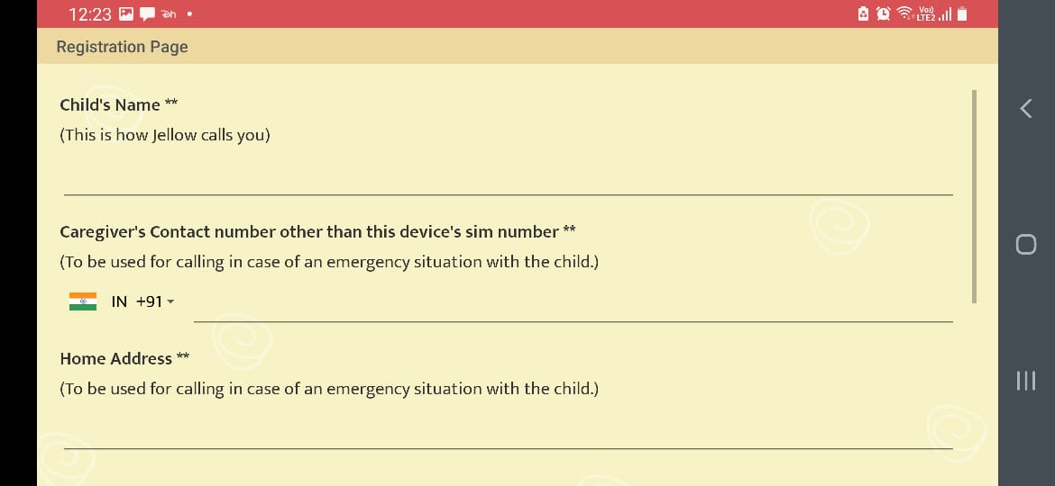

Fig 2.2.1 Jellow basic aac App Registration page

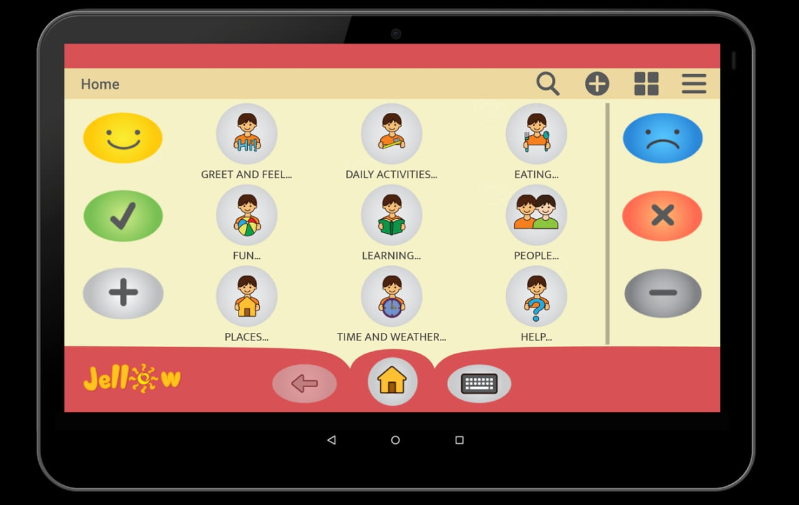

Fig 2.2.2 Jellow basic aac App Home UI

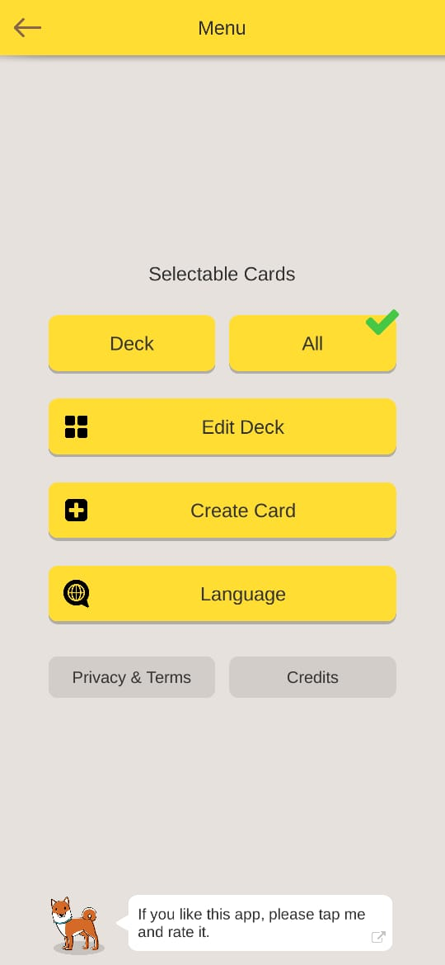 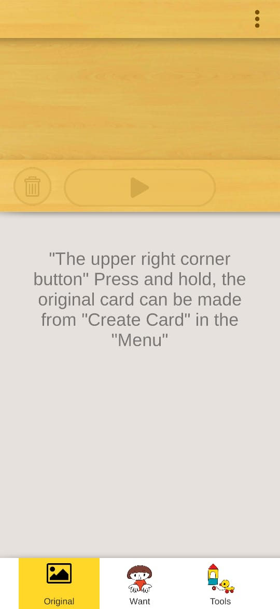

Fig 2.2.3 Card talk Home page UI Fig 2.2.4 Card talk app Main page UI

There are many applications in English but very less or negligible applications intended to teach Marathi alphabets.

# MODULES SPLIT-UP

## 3.1 DATABASE:

**Entities and Tables:**

Doctor Table:

|  |  |  |  |
| --- | --- | --- | --- |
| DoctorID | DoctorName | Email | Password |

DoctorID (Primary Key) - INT

DoctorName - VARCHAR

Email - VARCHAR

Password - VARCHAR

Patient Table:

|  |  |  |  |  |  |  |  |
| --- | --- | --- | --- | --- | --- | --- | --- |
| PatientID | DoctorID | Name | Email | Password | DateOf  Birth | Assigned  Category | Assigned Subcategory |

PatientID (Primary Key) – INT

DoctorID (Foreign Key) - INT

Name – VARCHAR

Email – VARCHAR

DATEOFBIRTH – DATE

Assigned Category – VARCHAR

Assigned Subcategory – VARCHAR

Card Table:

|  |  |  |  |  |
| --- | --- | --- | --- | --- |
| CardID | MainCategory | SubCategory | CardImg | CardAudio |

CardID (Primary Key) - INT

CategoryMain - VARCHAR

SubCategory - VARCHAR

CardImg - VARCHAR

CardAudio - VARCHAR

Assessments Table:

|  |  |  |
| --- | --- | --- |
| AssessmentID | PatientID | DoctorID |

AssessmentID (Primary Key) – INT

PatientID (Foreign Key) - INT

DoctorID (Foreign Key) - INT

Progress Table:

|  |  |  |  |
| --- | --- | --- | --- |
| PatientID | AssessmentID | SubmitDate | Score |

PatientID (Foreign Key) - INT

AssessmentID (Foreign Key) - INT

SubmitDate - DATE

Score - INT

# PROPOSED SYSTEM

The proposed speech therapy application is designed to offer a comprehensive solution for children diagnosed with Autism Spectrum Disorder (ASD) and their caregivers. It leverages modern technology to address the unique speech and language development challenges faced by these children. Here is a detailed breakdown of the proposed system:

**User Authentication and Roles:**

* **User Types**: The system supports two main user types: administrators (admins) and regular users. Admins have additional privileges for managing the system, while regular users, typically parents or caregivers, can access the therapy content and track their child's progress.

## 5.1 Admin Module:

* **Content Management**: Admins have the capability to manage therapy content, including:
  + **Categories**: Admins can create and edit categories of therapy materials. For example, they can create categories like "Marathi Alphabets," "Sentences," or "Words."
  + **Cards**: Admins can add, edit, or delete individual therapy cards within categories. Each card typically includes:
    - An image representing the therapy concept (e.g., a picture of a letter "A" for alphabets).
    - Audio pronunciation of the concept (e.g., the correct pronunciation of the letter "A" in Marathi).
* **Assessment Management**: Admins can set up assessments for users, defining the specific cards or categories to be included in each assessment. These assessments help track a child's progress over time.

## 5.2 User Module:

* **User Dashboard**: Upon logging in, regular users are presented with a user-friendly dashboard where they can access various features of the application.
* **Category Selection**: Users can select specific therapy categories (e.g., "Marathi Alphabets," "Sentences," or "Words") to work on during their therapy sessions.
* **Audio Pronunciation**: Users can listen to audio pronunciations associated with each therapy concept, helping them understand correct pronunciation.
* **Assessments**: Users can take assessments to evaluate their progress. These assessments are based on the content selected by the admin and provide valuable feedback on the child's development.

**Benefits of the Proposed System:**

1. **Accessibility**: The application offers convenient access to speech therapy materials, reducing the need for in-person sessions and making therapy accessible from the comfort of a child's home.
2. **Customization**: Admins can tailor therapy materials to each child's specific needs, recognizing the variability in ASD symptoms. This personalized approach enhances the effectiveness of therapy.
3. **Empowering Caregivers**: The system empowers parents and caregivers to actively participate in their child's therapy journey, reducing the dependency on healthcare professionals for regular therapy sessions.
4. **Technology-Driven**: Leveraging Android development, React Native, SQL, Cloudinary, and Power BI, the application incorporates cutting-edge technology to provide innovative solutions for Autism treatment.
5. **Language Specific**: The application focuses on the Marathi language, recognizing the importance of addressing speech therapy needs in local languages.
6. **Progress Monitoring**: The system allows for the continuous monitoring of a child's progress, helping caregivers and therapists make data-driven decisions about therapy plans.
7. **Cost-Effective**: By reducing the need for frequent medical visits and providing therapy materials through a mobile app, the system offers a cost-effective solution for families.
8. **Future Scope**: The project is designed with future enhancements in mind, allowing for the addition of new therapy content, features, and improvements to benefit children with ASD.

# SOFTWARE TOOLS / TECHNOLOGIES TO BE USED

1. **Android Development**: The mobile application will primarily be developed for the Android platform. Android offers a wide user base and a robust development environment, making it an ideal choice for reaching a broad audience.
2. **React Native**: React Native will be utilized to facilitate cross-platform development. This framework allows for the creation of a single codebase that can be deployed on both Android and iOS devices, reducing development time and costs while maintaining a consistent user experience.
3. **SQL**: A traditional SQL database management system (e.g., MySQL, PostgreSQL, Microsoft SQL Server) will serve as the backend database for storing user information, therapy content, assessments, and user progress data. SQL databases provide strong data consistency and are well-suited for structured data storage.
4. **Cloudinary**: Cloudinary, a cloud-based media management platform, will be integrated to handle the storage and retrieval of multimedia content, such as images and audio files associated with therapy cards. It offers features like content optimization, CDN delivery, and secure storage, ensuring efficient media management within the application.
5. **Node.js**: Node.js will be used on the server side to create an API for communication between the mobile application and the SQL database. Node.js's non-blocking, event-driven architecture allows for efficient handling of asynchronous operations and real-time interactions.
6. **Power BI**: Power BI, a powerful data visualization and business intelligence tool by Microsoft, will be employed for data analysis and reporting. It will help in generating insightful reports and dashboards for tracking user progress and assessing the effectiveness of therapy interventions.
7. **IDEs (Integrated Development Environments)**:
   * **Android Studio**: Android Studio will be the primary IDE for Android app development. It offers a rich set of tools, including an emulator for testing and debugging Android applications.
   * **Visual Studio Code**: Visual Studio Code is a versatile code editor that can be used for developing React Native applications. It supports a wide range of extensions and provides an efficient development environment.
8. **Version Control**: Git and platforms like GitHub or GitLab will be used for version control and collaborative development. This ensures code integrity, collaboration among team members, and the ability to roll back to previous versions if needed.

# PROPOSED OUTCOMES

1. Improved Speech and Language Skills: The primary goal of the application is to facilitate significant improvements in the speech and language skills of children with ASD. Through engaging therapy exercises, audio pronunciations, and assessments, children will have the opportunity to enhance their communication abilities, which is crucial for their overall development and quality of life.
2. Increased Accessibility: By providing therapy content through a mobile application, the system significantly increases accessibility to speech therapy services. Families and caregivers can access therapy materials at any time, eliminating the need for frequent in-person sessions and overcoming geographical barriers.
3. Empowered Caregivers: The application empowers parents and caregivers to actively participate in their child's therapy journey. They can guide therapy sessions, track progress, and provide consistent support, reducing the child's dependency on healthcare professionals for therapy sessions.
4. Customization and Personalization: The system allows for the customization of therapy materials and assessments. This means that therapy can be tailored to meet each child's specific needs and challenges, recognizing the variability in ASD symptoms.
5. Cost-Effective Solution: The application offers a cost-effective alternative to traditional in-person speech therapy sessions. It reduces the financial burden on families by eliminating the need for frequent clinic visits and providing an affordable and accessible therapy solution.
6. Data-Driven Insights: The system captures and stores data on user progress, including assessment scores and session times. This data can be used to generate insightful reports and dashboards using tools like Power BI, helping caregivers and therapists make informed decisions about therapy plans.
7. Language-Specific Support: Focusing on the Marathi language (or any specific language), the application caters to the linguistic needs of children in local communities. This ensures that therapy content is relevant and effective for the target audience.
8. Future Scalability: The project is designed with future enhancements in mind. This includes the ability to add new therapy content, features, and improvements. As the application evolves, it can continue to address the evolving needs of children with ASD and their caregivers.
9. Positive Impact on Quality of Life: Ultimately, the application's success will be measured by its positive impact on the quality of life of children with ASD. Improved communication skills can lead to better social interactions, increased independence, and enhanced overall well-being.
10. Research and Insights: The data collected through the application can contribute to research on speech therapy outcomes for children with ASD. This data may be valuable for healthcare professionals, researchers, and organizations working in the field of autism research.
11. Community Building: The application can foster a sense of community among users, caregivers, and therapists. Forums, support groups, and interactive features can encourage knowledge sharing and emotional support among users facing similar challenges.

# PROJECT PLAN 2.0

In Project Plan 2.0, we are taking our commitment to addressing the needs of individuals with autism disorder to the next level. Recognizing the severe lack of accessible therapy services in rural and underserved regions, we are determined to bridge this gap by introducing a free tier service. Our mission is to extend the benefits of speech therapy to those who often face geographical and financial barriers to care. By offering this free service in rural parts where autism treatment options are virtually non-existent, we aim to make a positive impact on the lives of individuals and families affected by autism. This initiative reflects our dedication to inclusivity and our vision of a world where every individual, regardless of their location or socioeconomic status, can receive the support they need to thrive