# ACKNOWLEDGEMENT

We take this opportunity to thank Head of the Department Prof. P.Futane and our project guide Prof. S.G.Dedgaonkar for their valuable guidance and providing all the necessary facilities, which were indispensable in the completion of this project report. We are also thankful to all the staff members of the Department of Information Technology, VIIT, Pune for their valuable time, support, comments, suggestions and persuasion. We would also like to thank Mrs.Suruchi Dedgaonkar and the institute for providing the required infrastructure, internet and library facility.

Chirag Chawade

Harsh Chawla

Niraj Amrutkar

Suniket Khairnar

# ABSTRACT

Autism is a frequent comorbidity in children in which they may avoid eye contact, repeat action like turning around themselves and use the parent’s hand instead of pointing to indicate an object they want. There is no as such proper solution to this as its symptoms are different in different children. Research shows that early diagnosis and interventions, such as during preschool or before, are more likely to have major positive effects on symptoms and later skills. People who have ASD have the best chance of using all of their abilities and skills if they receive appropriate therapies and interventions. We are presenting one such recommended solution in the form of a mobile application which includes development of teaching and learning aid using articulatory phonetics in regional language (Marathi).

The project includes an application to assist children suffering from autism. The main aim of this application is to help the society using the recent technologies like Android which will also be a huge help to the medical industry.

To achieve the objective we will be making a mobile phone application which will be user-friendly and will be effective in achieving the desired outcome. The application will have a good user-interface which will make it easy for the parent and the child to use it. It will consist of an admin part where the admin can add the category to the existing category of letters in Marathi language. Likewise, the admin can delete or modify the same. Similarly, the admin can add, delete, update the words and audio associated with a specific category of letters. The user will be able to choose a category of words and then clicking on the words will produce the audio pertaining to that word.

The application will be a cost-effective solution and the parents themselves can monitor their child’s progress without having to go to the doctor . Its ease of use and accessibility impacts and benefits both the child and the doctor. The mobile application is the need of the hour.

**CONTENTS**

|  |  |  |
| --- | --- | --- |
| **Sr.No** | **Chapter** | **Page No** |
|  | Acknowledgement |  |
|  | Abstract |  |
| **1.** | **INTRODUCTION** |  |
|  | 1.1 Motivation |  |
|  | 1.2 Need of Proposed System |  |
|  | 1.3 Brief Introduction to our Application |  |
|  | 1.4 Reason behind making the application |  |
|  | 1.5 Applications |  |
| **2** | **LITERATURE SURVEY** |  |
|  | 2.1 Literature review |  |
|  | 2.2 Review of Existing System |  |
|  | 2.2.1 System Functions |  |
| **3.** | **PROJECT STATEMENT** |  |
|  | 3.1 Purpose behind the project |  |
|  | 3.2 Decision of scope |  |
|  | 3.3 Methodology Practice |  |
| **4.** | **SYSTEM REQUIREMENT AND**  **SPECIFICATION** |  |
|  | 4.1.1 Introduction |  |
|  | 4.1.2 User classes and characteristics |  |
|  | 4.1.3 Operating Environment |  |
|  | 4.1.4 External Interface Requirements |  |
|  | 4.1.5 Product Perspective |  |
|  | 4.1.6 Product Function |  |
| **5.** | **PROJECT ANALYSIS AND DESIGN** |  |
|  | 5.1 Use Case Diagram |  |
|  | 5.2 Sequence Diagram |  |
|  | 5.3 Team organization |  |
|  | 5.3.1 Team structure |  |
|  | 5.3.2 Methodology Practice |  |
|  | 5.3.3 Interface Details and Screenshots |  |
| **6** | **IMPLEMENTATION OF SOFTWARE TESTING** |  |
|  | 6.1 Database |  |
|  | 6.2 Introduction |  |
|  | 6.3 Purpose |  |
|  | 6.4 Test objective |  |
|  | 6.5 Process overview |  |
|  | 6.6 Test Case and Results |  |
| **7.** | **CONCLUSION AND FUTURE WORK** |  |
|  | 7.1 Conclusion |  |
|  | 7.2 Future Scope |  |
| **8.** | **SCHEDULE OF THE PROJECT** |  |

## LIST OF FIGURES

|  |  |  |
| --- | --- | --- |
| **Sr.No** | **Figure Name** | **Page No** |
| Fig 3.3.3 | Flowchart of admin system |  |
| Fig 3.3.4 | Flowchart of user system |  |
| Fig 5.1 | Use Case Diagram |  |
| Fig 5.2 | Sequence Diagram |  |
| Fig 5.4.1 | Start Screen |  |
| Fig 5.4.2 | Login Screen |  |
| Fig 5.4.3 | Login Screen Email Validation |  |
| Fig 5.4.4 | Login Validation |  |
| Fig 5.4.5 | Menu after login |  |
| Fig 5.4.6 | Create screen |  |
| Fig 5.4.7 | Choose Image Option |  |
| Fig 5.4.8 | After Choosing Image |  |
| Fig 5.4.9 | Audio recording screen |  |
| Fig 5.4.10 | Audio recording screen |  |
| Fig 5.4.11 | Category screen |  |
| Fig 5.4.12 | Add Category Screen |  |
| Fig 5.4.13 | Add Sub Category page |  |
| Fig 5.4.14 | Update category page |  |
| Fig 5.4.15 | Sub Category Update Page |  |
| Fig 5.4.16 | Update Page |  |
| Fig 5.4.17 | Delete Page |  |
| Fig 5.4.18 | Delete Category Page |  |
| Fig 5.4.19 | Categories visible to the user |  |
| Fig 5.4.20 | Sub-categories visible to the user |  |
| Fig 5.4.21 | On-clicking a particular sub-category |  |
| Fig 5.4.22 | On-clicking on play button on a particular subcategory |  |
| Fig 6.1.1 | Database structure |  |
| Fig 6.1.2 | Database structure |  |
| Fig 6.1.3 | Records under different categories and subcategories |  |
| Fig 6.1.4 | Records under different categories |  |
| Fig 6.1.5 | Records under different sub-categories |  |

**LIST OF TABLES**

|  |  |  |
| --- | --- | --- |
| Sr. No | Table Name | Page No |
| Table 2.1 | Comparison table of various applications and our application |  |
| Table 6.6.1 | Test Cases |  |
| Table 8.1 | Schedule of the project |  |

# CHAPTER 1

## INTRODUCTION

### 1.1 MOTIVATION

Health is an asset to which though many people are becoming aware about but still the medical industry lacks solution to modern problems. In our article, we are going to cover the main functions of the application, explain what technologies are used for its development.

### 1.2 NEED OF THE PROPOSED SYSTEM

We would like to point out the need for proposed system-

1. Lack of concrete treatment on Autism: Autism is not defined by any clear symptoms , hence it lacks any concrete treatment. The treatment is thus varied depending upon the symptoms.

1. Use of technology : Though, the technology sector is booming , but it is not used to that extent in the medical industry for treatment on Autism.

1. No need for repeated follow ups: With the treatment available at one click on the mobile application.

### 1.3 BRIEF INTRODUCTION TO OUR APPLICATION

1. The application is a single functional unit consisting of admin module and user module
2. This application assist children suffering from autism and the parents themselves can monitor their child’s progress without having to go to the doctor.
3. The system communicates with the database for the storage of data.

### 1.4 REASON BEHIND MAKING THE APPLICATION

1. Assist the kids suffering from autism.
2. Easy for parents to check their child’s progress.
3. Making the best possible use of the available technology.
4. No doctor’s intervention required.
5. The doctor can add the necessary cards and categories at a single click.

### 1.5 APPLICATIONS

Above system can also be applied to general language learning applications as well as involve other local languages.

# CHAPTER 2

## LITERATURE SURVEY

### 2.1 LITERATURE REVIEW

#### Table No 2.1: Comparison table of various applications and our application

|  |  |  |
| --- | --- | --- |
| CARD TALK | JELLOW BASIC AAC  COMMUNICATOR | OUR APPLICATION |
| No login required. | Login required for user. | Login required for admin but not for user. |
| Permission to record audio. | No option to record audio. | Take permission while recording audio. |
| The entire application is in English language. | The entire application is in English language. | The application is intended to use Marathi alphabets. |
| Categories include Tools,  People, Vehicles, Place, Time, etc. | Categories include learning, people, places, etc. | Categories include Marathi alphabets. |

### 2.2 REVIEW OF EXISTING SYSTEM

The applications we referred for making our application are:

Card Talk: Here no signup is required and takes permission to record audio.

Jellow Basic AAC Communicator: Login is required and there is no option to record audio.

These applications provide various features which will be beneficial to users. But even with these features there are certain required aspects which make these applications limited. One of them is language. **There are many applications in English** **but very less or negligible applications intended to teach Marathi alphabets**.

#### 2.2.1 System Functions

There are two modules within our application. They are:

1. Admin Module
2. User Module

#### Admin Module

Login: Admin can use his name id and password to use the system.

The functionalities at the admin’s side are:

* Adding different cards: The admin can add different cards to a particular category .
* Editing existing cards: The admin can edit existing cards.
* Deleting cards: The admin can delete cards from a particular category .
* Creating a new category: The admin can create a new category of cards .
* Editing an existing category: The admin can edit existing cards.
* Deleting an existing category: The admin can delete a particular category.
* Changing the password: The admin can change his login password.
* Logout: The admin can logout of the application.
* Analysis: Admin can analyze the progress of patient.

#### User Module

User Authentication : User have to login.

The functionalities at the user’s side are:

* Viewing different cards: The user can view different cards belonging to a particular category.
* Listen to the audio: The user can listen to the audio of the pronunciation of a particular card .
* Assessment:
* Assessment Result:
* Session time recording:

**CHAPTER 3**

## PROJECT STATEMENT

### 3.1 PURPOSE BEHIND THE PROJECT

The project includes an application to assist children suffering from autism. The main aim of this project is to help the society using the recent technologies like Android which will also be a huge help to the medical industry.

The application will be a cost-effective solution and the parents themselves can monitor their child’s progress without having to go to the doctor . Its ease of use and accessibility impacts and benefits both the child and the doctor. The mobile application is the need of the hour.

### 3.2 DECISION OF SCOPE

To achieve the objective we will be making a mobile phone application which will be user-friendly and will be effective in achieving the desired outcome. The application will have a good user-interface which will make it easy for the parent and the child to use it. It will consist of an admin part where the admin can add the category to the existing category of letters in Marathi language. Likewise, the admin can delete or modify the same. Similarly, the admin can add, delete, update the words and audio associated with a specific category of letters. The user will be able to choose a category of words and then clicking on the words will produce the audio pertaining to that word.

### 3.3 METHODOLOGY FOR SOLVING THIS PROPOSED SOLUTION

#### Process Flow

1. Register – User can get registered themselves as Guest and admin can sign in as an admin.

1. Login - Once registered, admin can login using his credentials and user can sign in as a guest.

1. View Card/Category: The user can view card/category depending on what the person wants.

1. Edit/Delete Card/Category: The admin can edit/delete card belonging to a particular category or an entire category.

#### Flowchart of Admin System

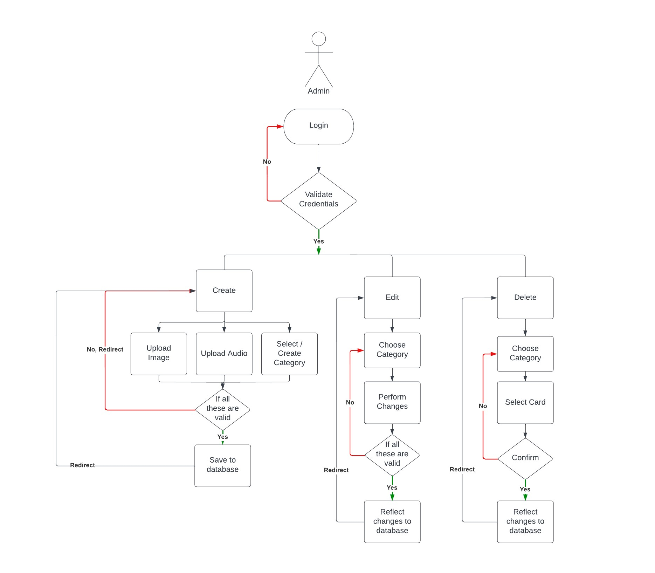

#### Fig 3.3.3 : Flowchart of admin system

The admin can login using his credentials and if the credentials are correct, then the admin will get the access to the system. Once, the credentials are correct the admin can create, edit, delete the cards belonging to a particular category or an entire category.

After performing all the operations, the admin can logout of the system.

#### Flowchart of User System

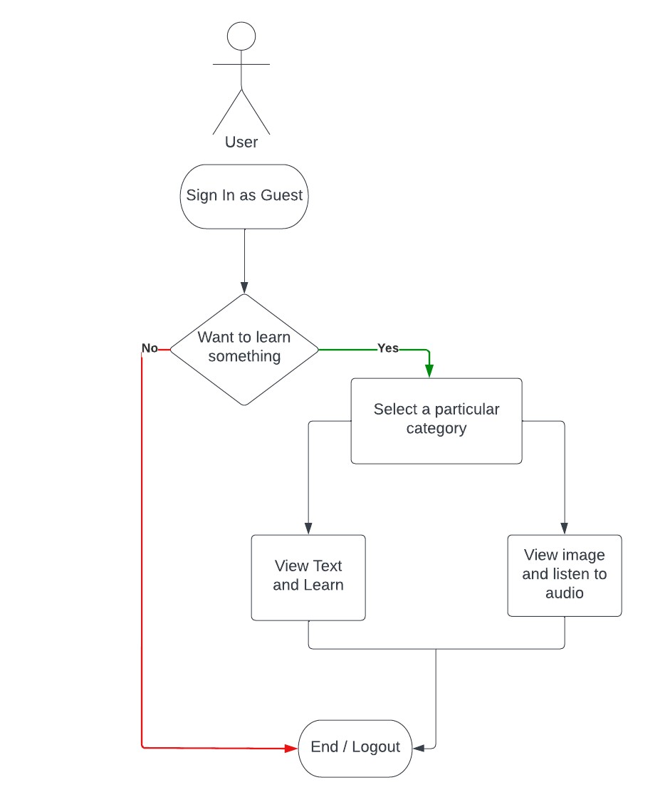

#### Fig 3.3.4 : Flowchart of user system

The user can login as a guest , then the user will get the access to the system. Once, the credentials are correct the user can view, edit, delete the cards belonging to a particular category or an entire category. After performing all the operations, the user can logout of the system.

**CHAPTER 4**

## SYSTEM REQUIREMENTS AND SPECIFICATIONS

**4.1 SOFTWARE REQUIREMENTS SPECIFICATIONS:**

### 4.1.1 Introduction

Intended Audience and Reading Suggestions: Users of the system are children, parents to assist their children and the administrator of the system .The members are assumed to have basic understanding and knowledge of computer and internal browsing while the administrator should have more knowledge so that he/she can resolve small problems and perform information.

The intended audience includes all stakeholders as mentioned below

1. Developers
2. Users/Designers
3. Testers
4. Documentation Writers

**4.1.2 User Classes and Characteristics**

There are two users in the system:

### User

* Go to the required app
* Sign in as a guest.
* Select particular category and study cards.

### Admin

* Adding different cards
* Editing existing cards
* Deleting cards
* Creating a new category
* Editing an existing category
* Deleting an existing category
* Changing the password
* Logout

#### 4.1.3 Operating Environment

The only requirement would be the internet connection, mobile phone and self presence.

* Hardware Requirements :
* Display screen: For the user-system interaction.
* Output devices -display screen

### • Database-MongoDB

* FrontEnd – React Native
* BackEnd – Node.js
* Cloud Technology- Cloudinary
* Analysis: Power Bi

**4.1.4 External Interface Requirements**

#### User Interfaces

There are two kind of users:

1. Admin - Admin will have the first interface to login. He/She will be provided an UI to enter Id and Password and the login button which will take admin to perform actions like to add/delete/modify the cards. In add section the admin can upload images and audio for a card as well as admin can add new category. In delete option the particular card will be deleted from app. And in modify option admin can modify the image or audio or spelling of a card. This page will also have a logout button which will logout the admin from this app.

1. User - User will have an option to login as guest when he opens the app for the first time. Now the user will have to choose from one of the category like barakhadi , sentences, words and many more. The cards will be displayed with images when the user clicks on a particular card the app will correctly pronounce the card.

#### Hardware Interfaces

This app is supported in all android as well as ios devices. The requirements are speaker and display to the device. This app has various functions as mentioned below:

1. Add – To perform this function one needs camera & microphone enabled device. When the admin clicks on add button the admin is given options to add new card to any category or create new category, then admin can click/upload the picture and add voice for that card.

1. Delete – When logged in as admin, he/she will have the ellipsis over each card. When clicked on it, it gives admin two options i.e. delete & modify. When clicked on delete button the particular card is deleted. Similarly any category can be deleted.

1. Modify - When logged in as admin, he/she will have the ellipsis over each card. When clicked on it, it gives admin two options i.e. delete & modify. When clicked on modify button you are given options to modify image/audio or category. After performing the task when user clicks on save the modification is accomplished.

1. Listen – To listen to audio user/admin can click on any card and he/she will be able to learn the correct pronunciation for a given card*.*

#### Software Interfaces

The software database used in this project is MySQL.

Communication interfaces

The machine needs to work properly and communicate with the database for proper functioning.

### Other Non-functional Requirements

#### Performance Requirements

The performance requirements for this app are that the user should be familiar with the basic functionalities of mobile phone and should be able to use them. The admin should place all the images and audio for a card very precisely because this may lead to learn the wrong pronounciation. For user he/she should wait for some milliseconds to listen the pronounciation. Admin should remember the password to login and make changes into the data of app. User can select continue as guest and proceed further for learning.

#### Safety Requirements

There should be database backup so that if any problem occurs the data is not affected rather not lost.

#### Security Requirements

Admin should maintain a strong password so that no other person can make changes to the app data. The child user should be supervised by the parent user. The database is secured with the default SQLite security feature.

#### Software Quality Attributes

The primary objective is to create a good software which is judged using the following guidelines:

1. Consistency – All system code should be consistent.
2. Test cases – All functionalities are tested properly.
3. Reliability -The protocol communication should be reliable.

4.Availability- The product should be available on internet as well as on app stores.

5.Maintainability- The system should be maintained and updated regularly. The addition of new features should be easy and convenient.

#### Business Rules

The business rules for the software are as follows:

1. The admin has the right to fix the spellings and images and to set or update the pronunciation as and when required.
2. The user should download the application in his/her device.
3. Admin should keep adding new words/sentences as well as categories.
4. Admin should maintain a high security password.
5. User should click on a particular card to hear the correct pronunciation.

##### 4.1.5 Product Perspective

1. The application is a single functional unit consisting of admin module and user module.
2. This application assist children suffering from autism and the parents themselves can monitor their child’s progress without having to go to the doctor.
3. The system communicates with the database for the storage of data.

**4.1.6 Product Function**

Some major product functionalities of the system are as follows:

#### User

* Go to the required app
* Sign in as a guest.
* Select particular category and study cards.

#### Admin

* Adding different cards
* Editing existing cards
* Deleting cards
* Creating a new category
* Editing an existing category
* Deleting an existing category
* Changing the password • Logout
* View Patient List
* Monitor Patient’s progress

## CHAPTER 5

**PROJECT ANALYSIS AND DESIGN**

### 5.1 USE CASE DIAGRAM

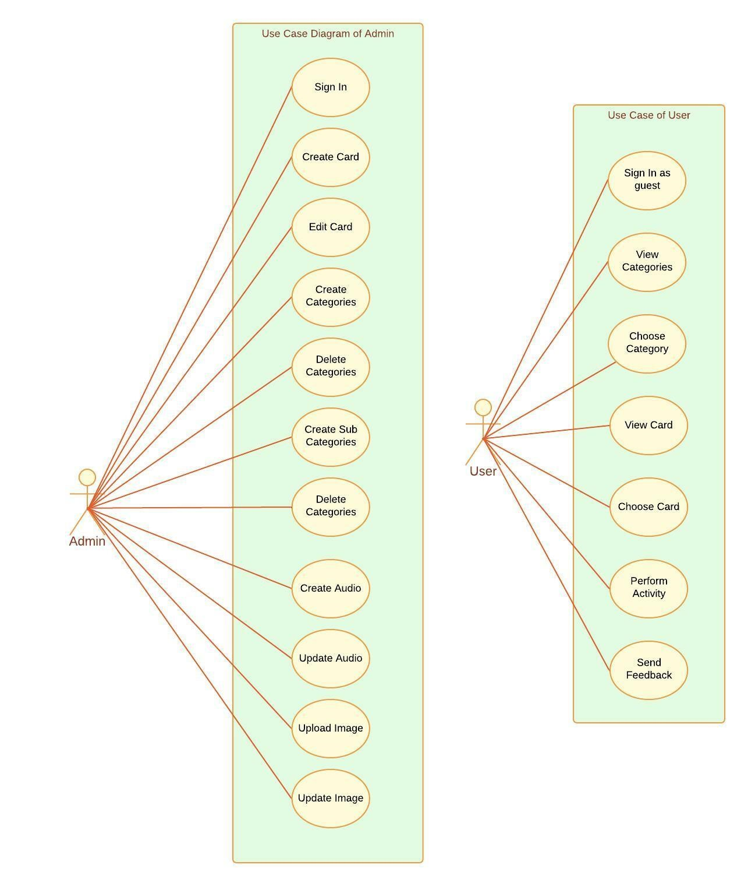

#### Fig 5.1 Use Case Diagram

Admin:

The admin can sign in, change password, create card, edit card, delete card, create categories, update categories, delete categories, create audio, delete audio, update audio, get total count of users, etc.

User:

The user can sign in, view card/category ,perform activity if any and submit feedback about the system and finally logout of the system.

### 5.2 SEQUENCE DIAGRAM

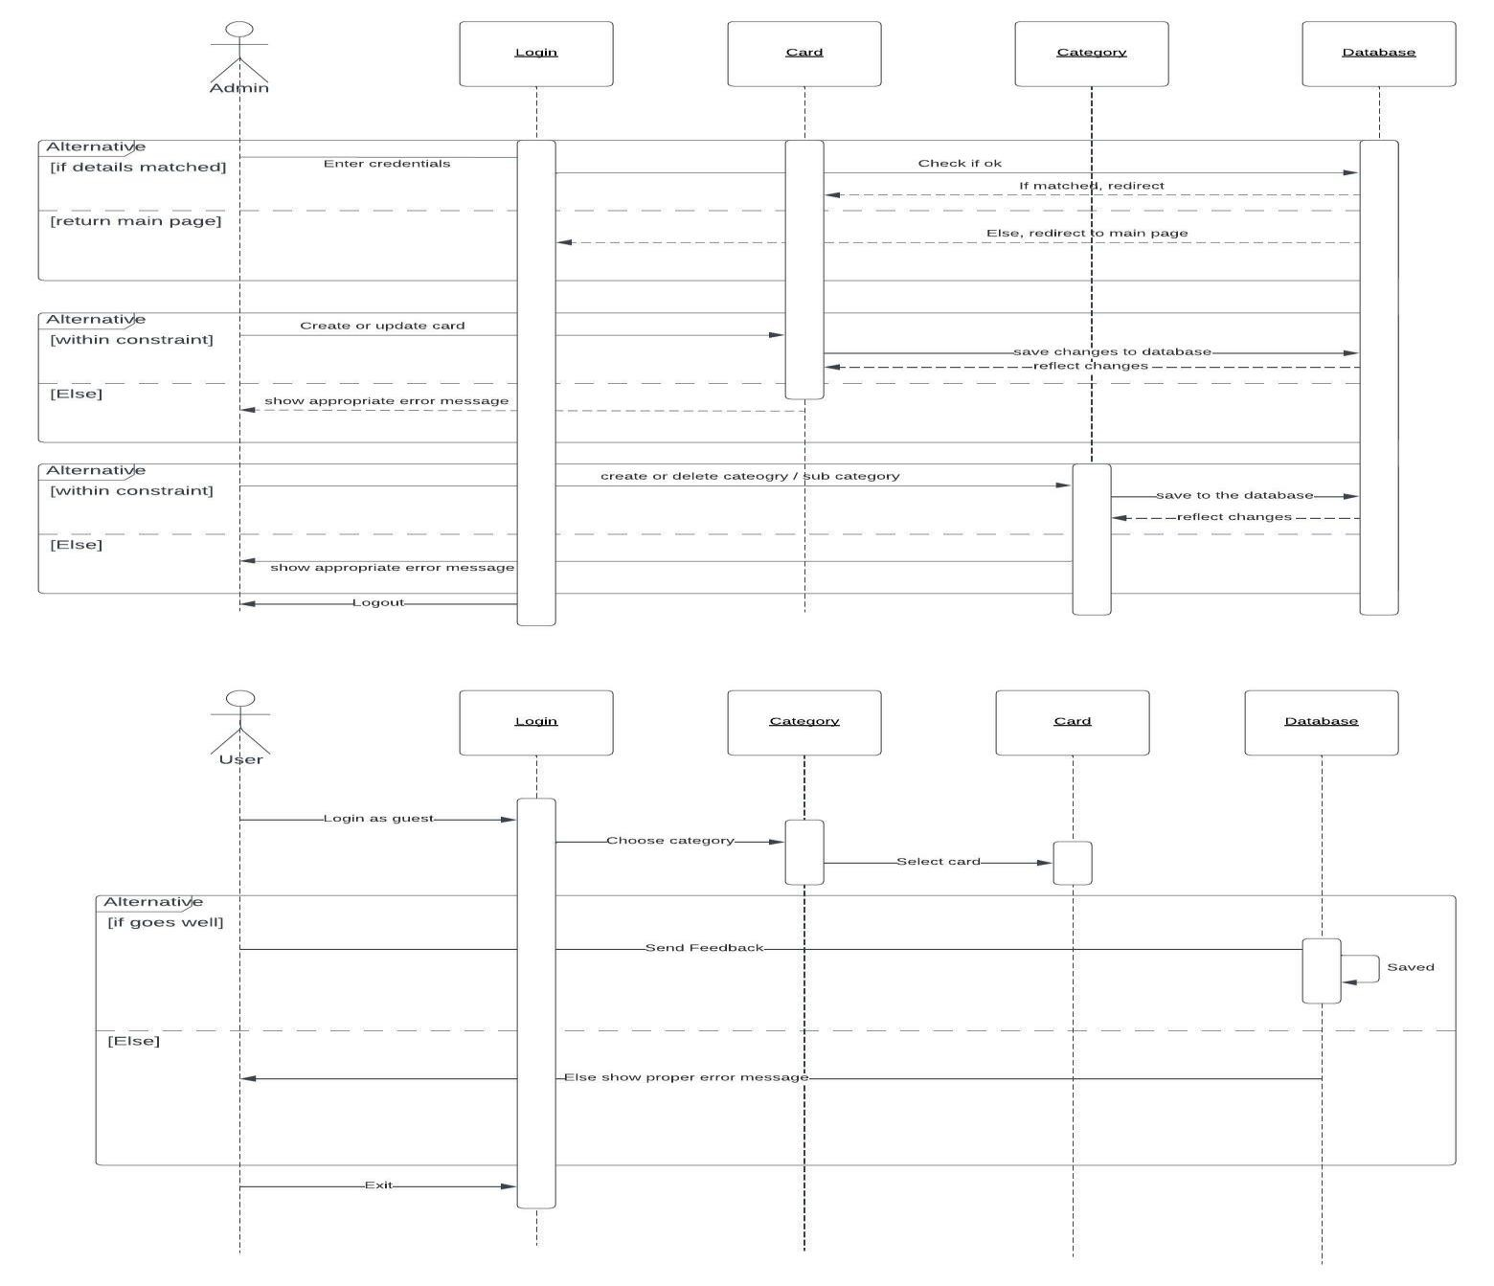

#### Fig 5.2 Sequence Diagram

Sequence Diagram description: The admin first communicates with the system through interface enters necessary data. System checks the data, verifies and sends it to the db. The system contains format ,necessary data and unique credentials of each category/card which classifies the categories/cards then according to its functions and expected outcomes the data is processed, updated, therefore giving the necessary confirmation and assurance regarding the saving of data.

### 5.3 TEAM ORGANIZATION

#### 5.3.1 Team Structure

Our team: - Our team consists of developers, internal guide, external guide and few mentors.

Developers:

* Viraj Sancheti
* Adesh Lalwani
* Bhavesh Mehta
* Jainam Kothari

Internal Guide:

* Mrs.Suruchi Dedgaonkar

#### 5.3.2 Methodology Practice

In our project, we followed agile methodology.

5.3.2.1 Daily scrum calls: In our daily scrum calls (Duration 15-30 minutes) in the presence of VIIT faculty Mrs. Suruchi Dedgaonkar and all four project group members we discussed about the daily updates of work, roadblocks and progress regarding the same. Also, we planned the task heading up.

5.3.2.2 Weekly Review Meeting: In our weekly review meeting we discussed the progress of work done in that particular week, the work that should be done in the week showing up next. Also, we discussed all possible progress and roadblock factors and solutions towards the same.

### 5.4 INTERFACE DETAILS AND SCREENSHOTS

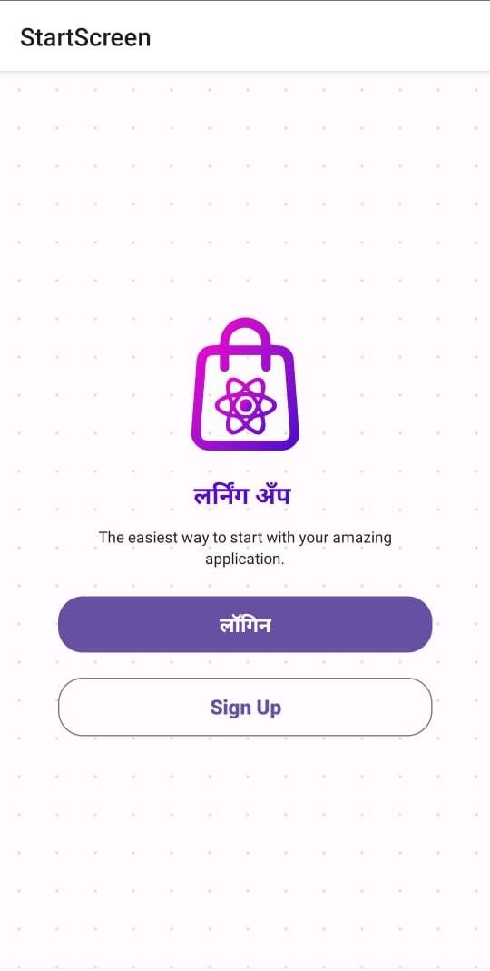

#### Fig 5.4.1 Start Screen

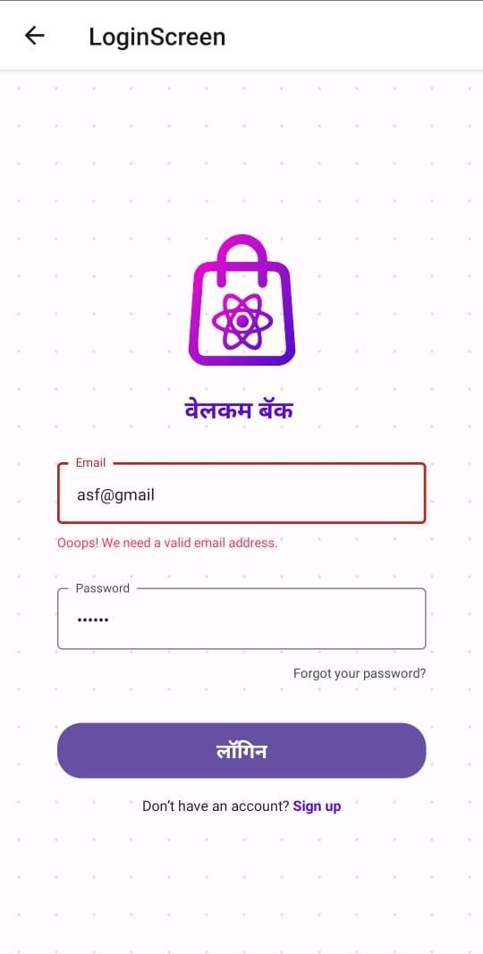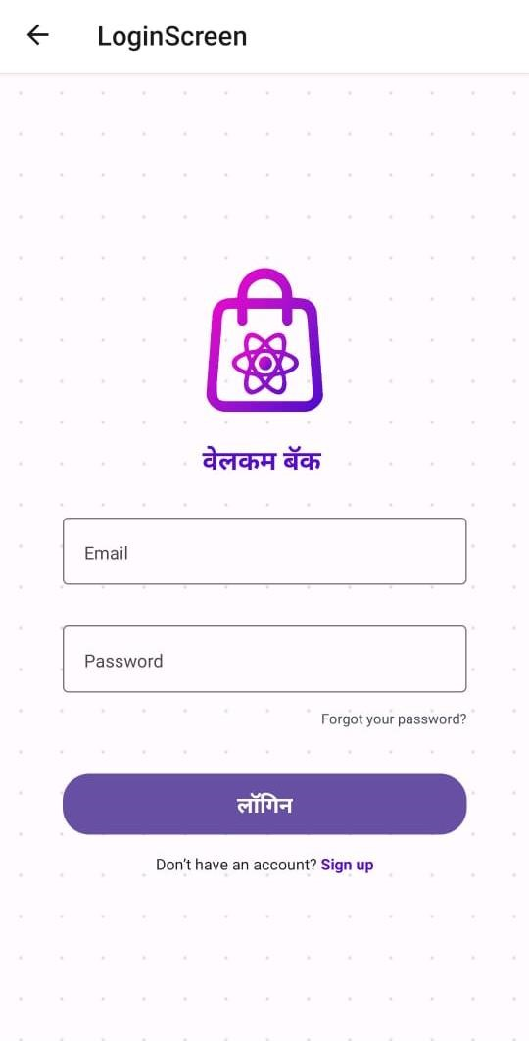

#### Fig 5.4.2 Login Screen Fig 5.4.3 Login Screen Email Validation

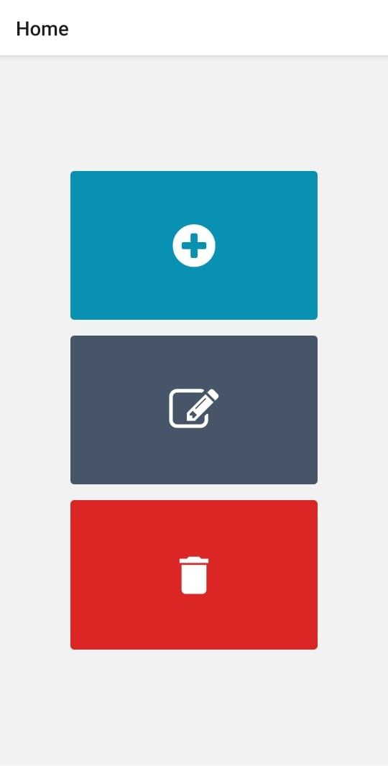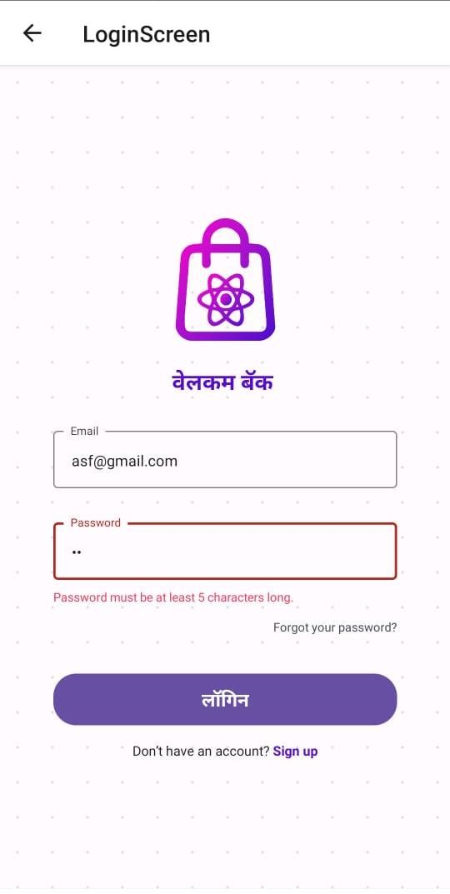

#### Fig 5.4.4 Login Validation Fig 5.4.5 Menu after login

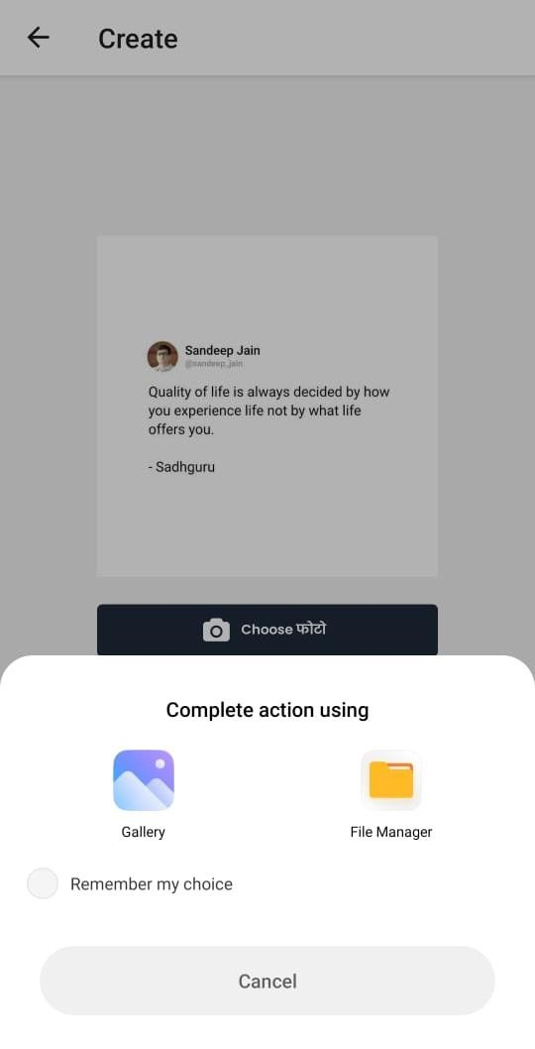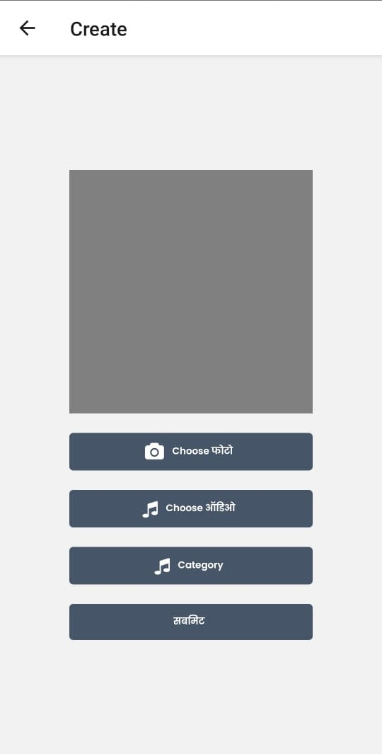

#### Fig 5.4.6 Create screen Fig 5.4.7 Choose Image Option

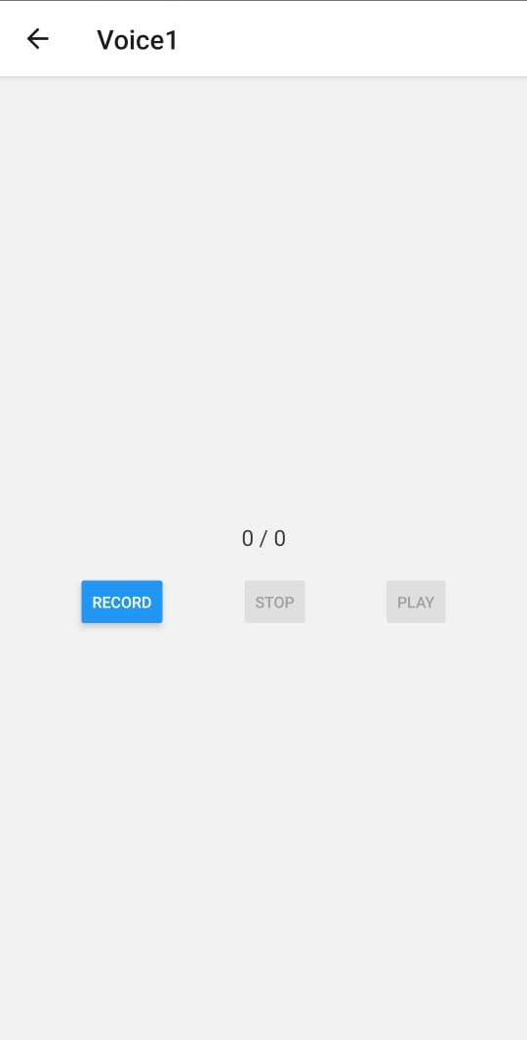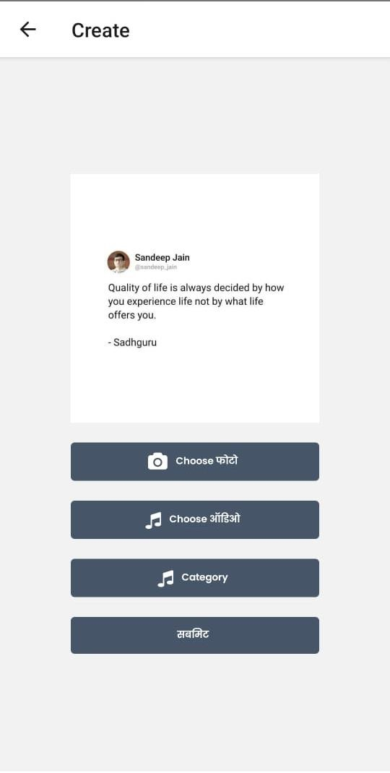

#### Fig 5.4.8 After Choosing Image Fig 5.4.9 Audio recording screen

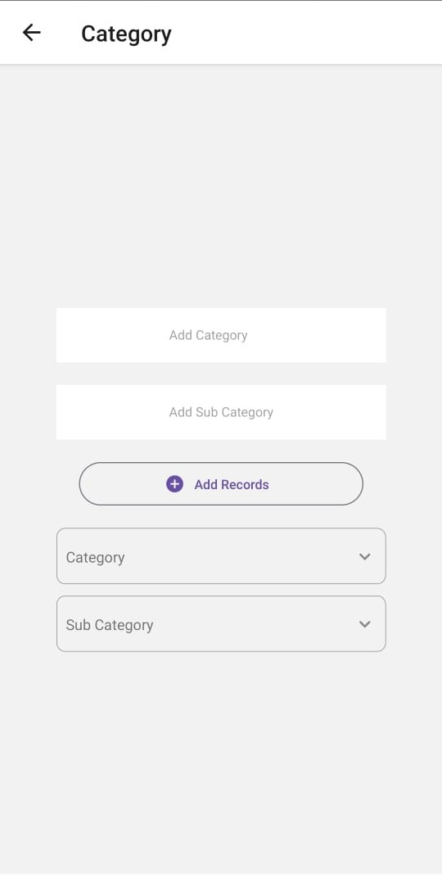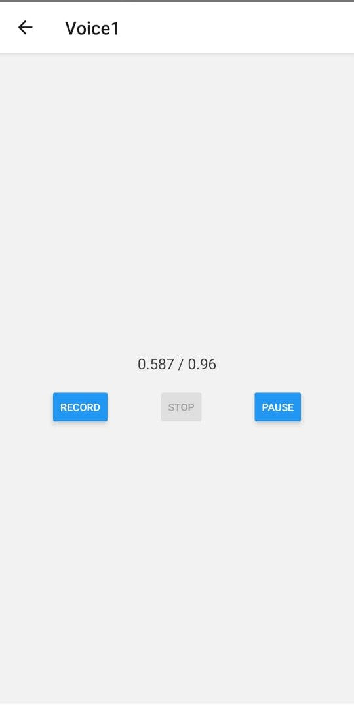

#### Fig 5.4.10 Audio recording screen Fig 5.4.11 Category screen

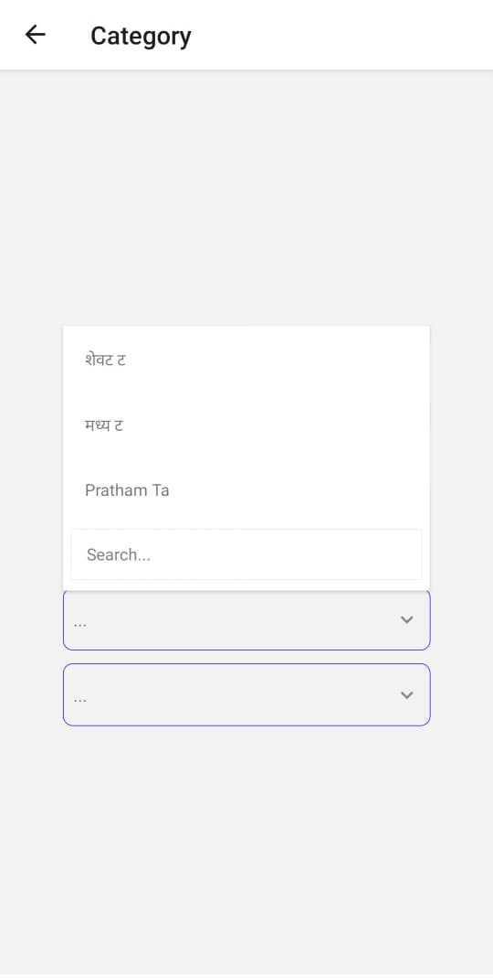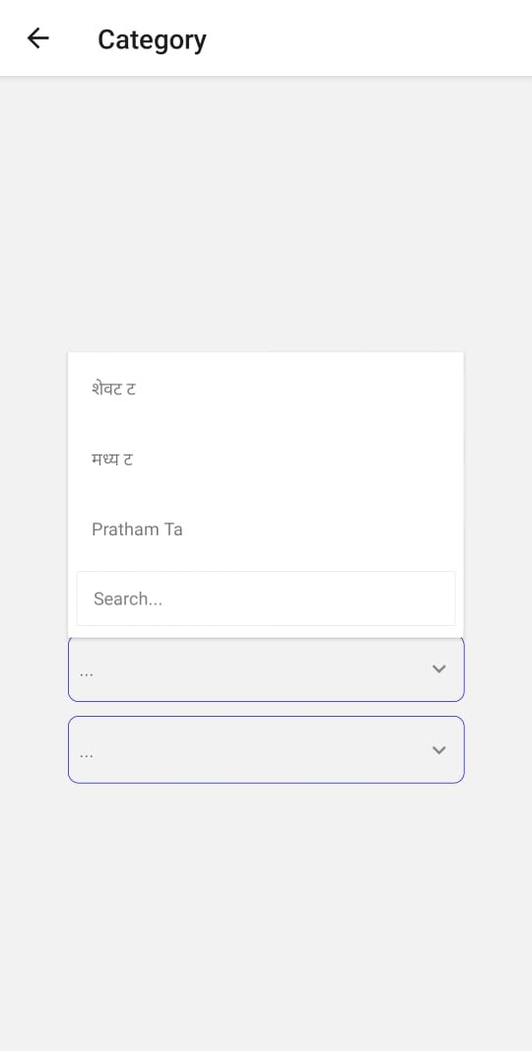

#### Fig 5.4.12 Add Category Screen Fig 5.4.13 Add Sub Category Screen

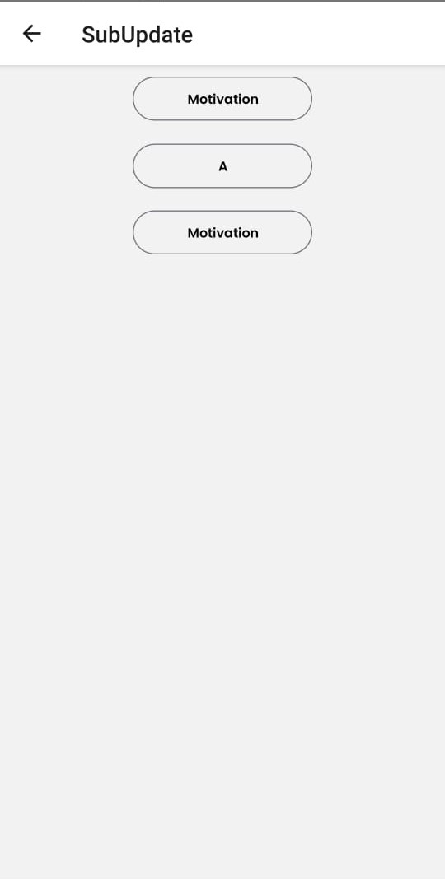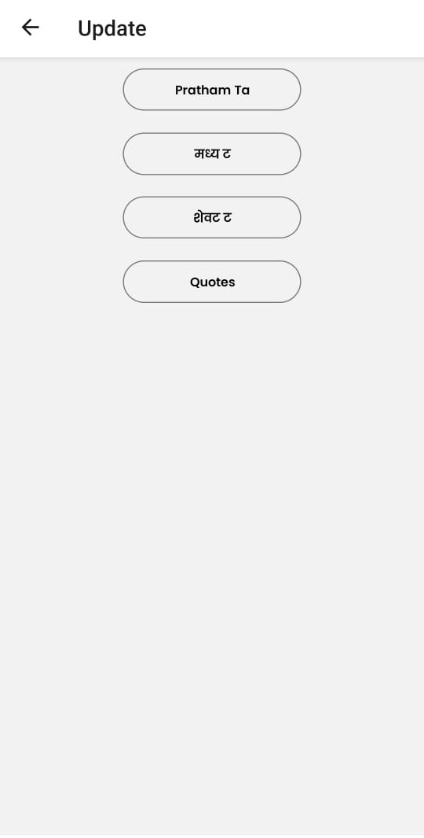

**Fig 5.4.14 Update category page Fig 5.4.15 Sub-Category Update Page**

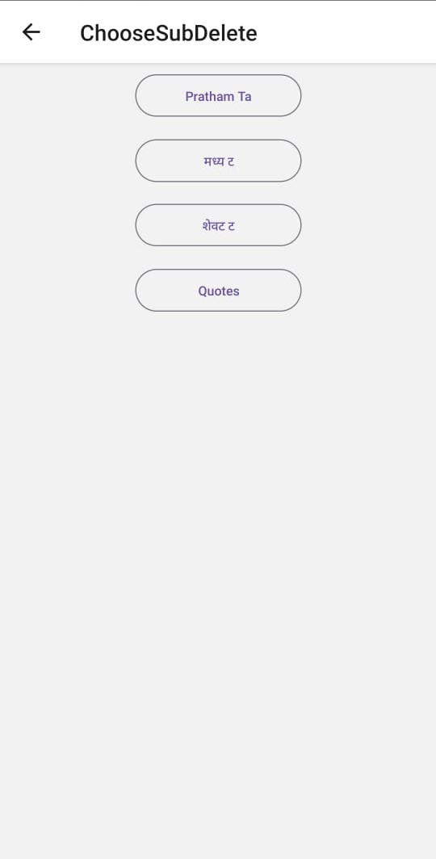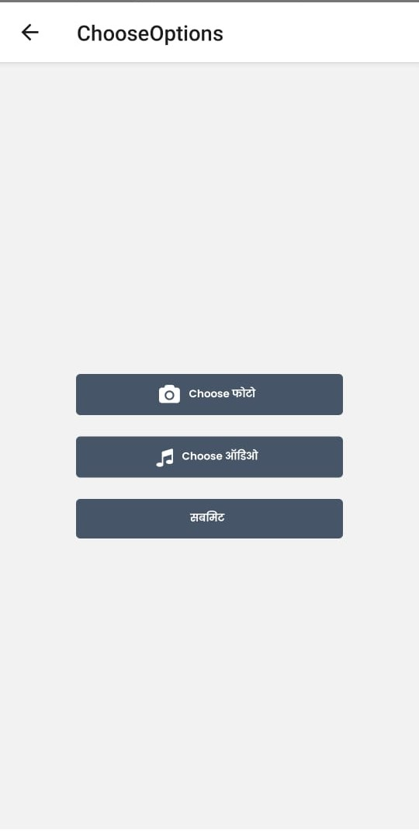

#### Fig 5.4.16 Update page Fig 5.4.17 Delete page

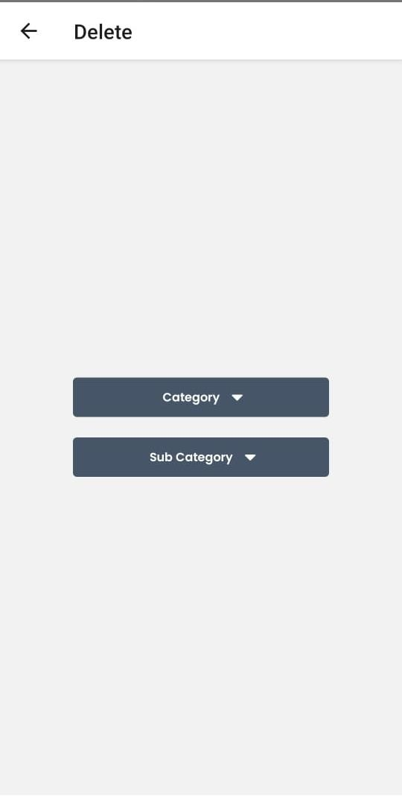

**Fig 5.4.18 Delete Category page**

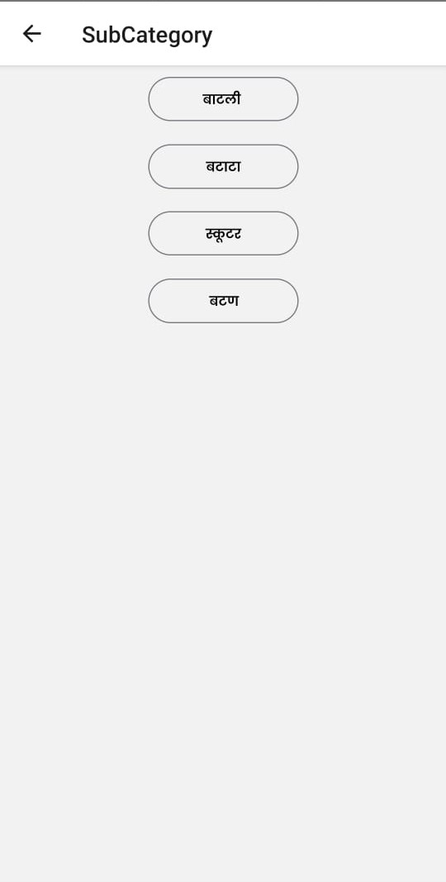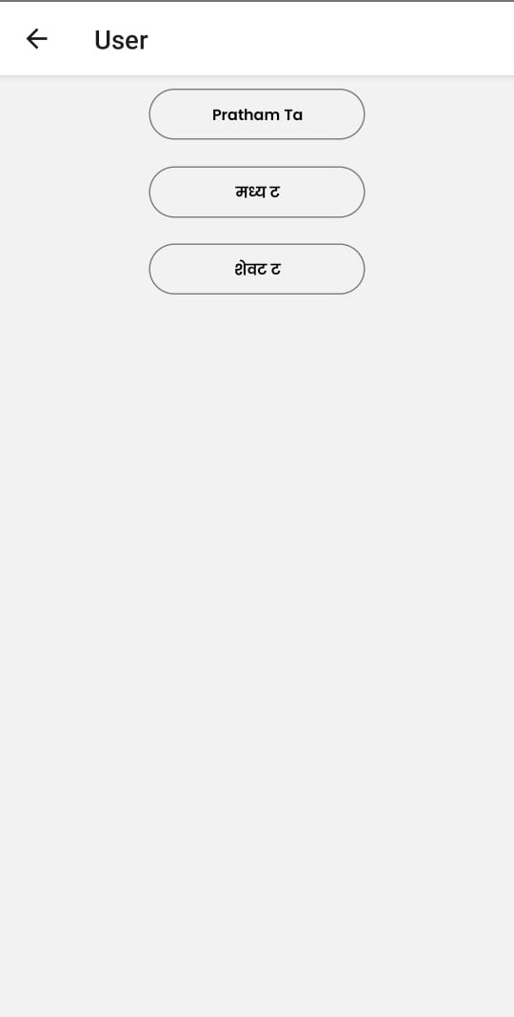

#### Fig 5.4.19 Categories visible to user Fig 5.4.20 Sub-Categories visible to user

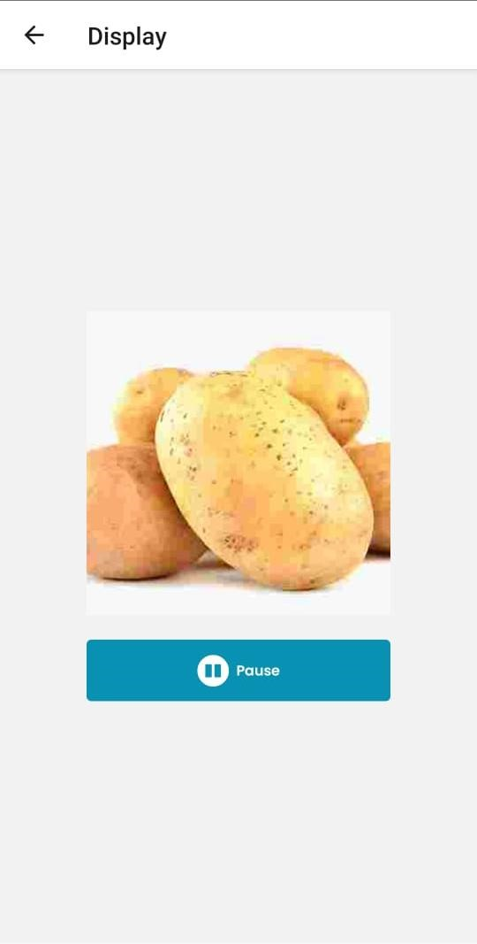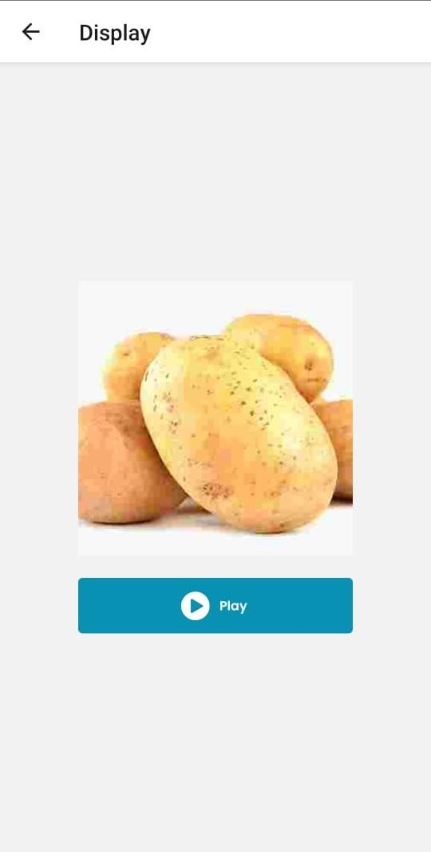

**Fig 5.4.21 Particular subcategory Fig 5.4.22 Play button to hear the audio**

## CHAPTER 6 IMPLEMENTATION OF SOFTWARE TESTING

### 6.1 DATABASE

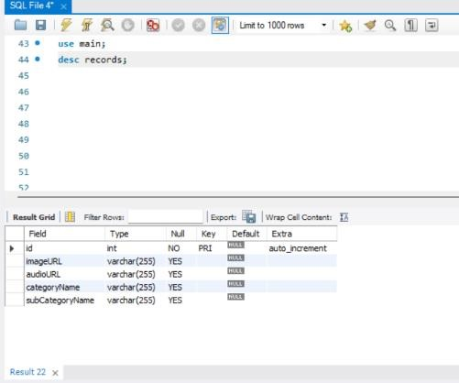

#### Fig 6.1.1 Database Structure

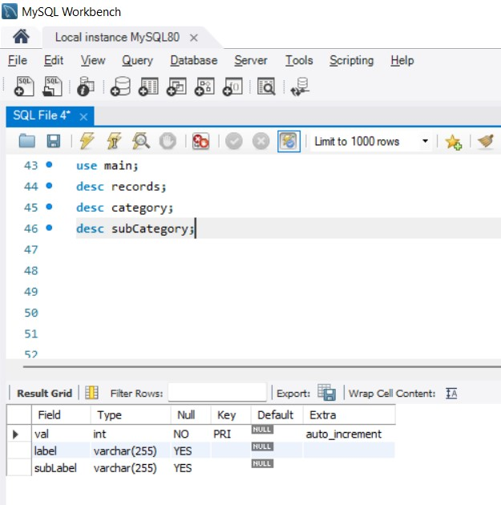

#### Fig 6.1.2 Database Structure

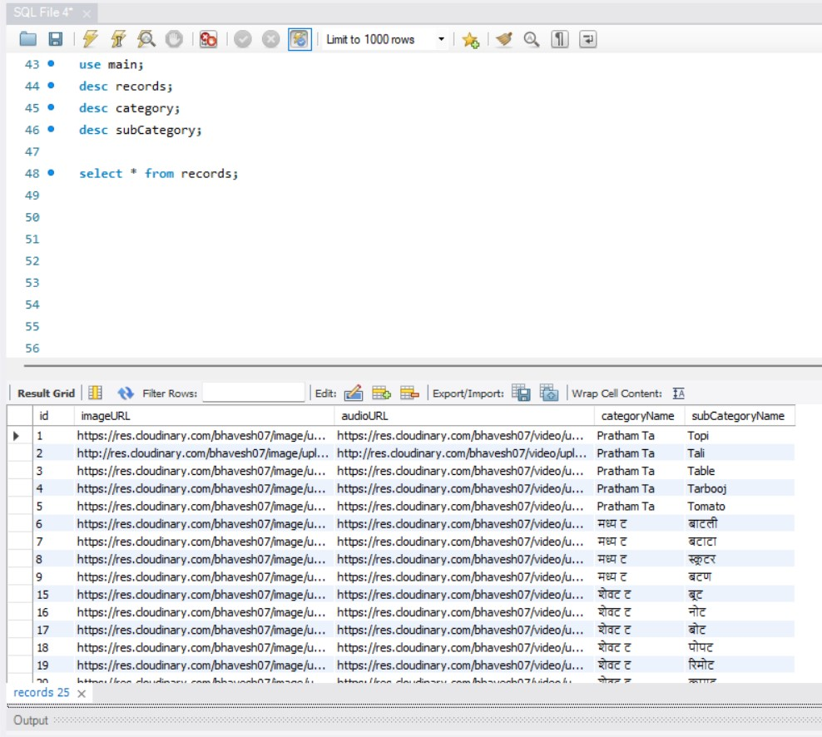

#### Fig 6.1.3 Records under different categories and sub-categories with images and audio-URL

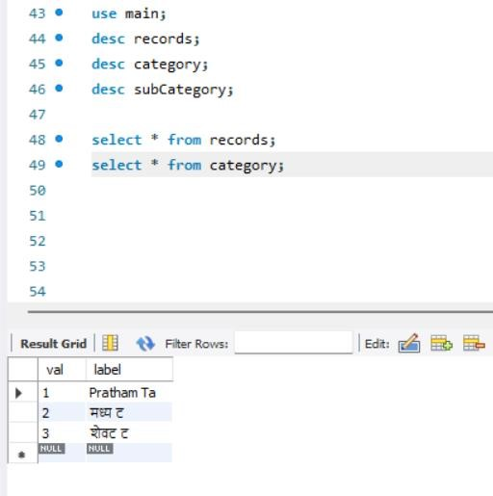

**Fig 6.1.4 Records under different categories**

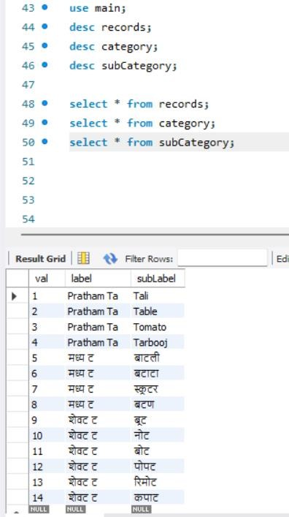

**Fig 6.1.5 Records under different sub-categories**

### 6.2 INTRODUCTION

This document is a complete overview for our strategy to test for the website application. It’s a objective is to book events and accommodation for the respective event. It displays an image of the project as well as of the last planning phase.

### 6.3 PURPOSE

The project aims at providing a user-friendly application. In the project, we render services as per the requirement from the doctor’s side and give access/services to the admin to handle the database related to the complex.

### 6.4 TEST OBJECTIVE

The objective of testing the application is to look for as many errors and bugs as possible.

Although, we haven’t performed any exhaustive testing using any application for testing, we have performed manual testing. The major test cases for the application were tested thoroughly using manual testing. The application will help the doctor and parents to assist the children suffering from any fluency disorder.

### 6.5 PROCESS OVERVIEW

The steps given below represent the flow of the testing process:

1. Identify and observe the test cases against which the application is to be tested.
2. Look upon and review the test case to ensure that the application has been thoroughly tested.
3. Identify the ideal result which is expected on test case check.
4. Perform the test.
5. Document all of the test case data.
6. If the test case does not run successfully, then again look for the errors or refactor the code in order to identify the bug and perform successful validation.

### 6.6 TEST CASES AND RESULTS

#### Table No 6.6.1 Test Cases

|  |  |  |  |  |  |  |
| --- | --- | --- | --- | --- | --- | --- |
| Testcase | Test Case  Name | Prerequisites | Action | Excepted  Result | Actual Result | Status |
| 1 | Login | Username and  password  should be entered.  . | Click on login button | Successful login for  correct  username and password | Successful login | Pass |
| 2 | Login | Username and  password  should be entered  . | Click on login button | Unsuccessful login  for wrong  username and password | Unsuccessful ul login | Pass |
| 3 | Signup | All details must be entered | Click on signup button | Successful ul sign-  up for correct details | Successful  Sign- up | Pass |
| 4 | Signup | All details | Click on | Successful | Unsuccessful | Pass |

|  |  |  |  |  |  |  |
| --- | --- | --- | --- | --- | --- | --- |
|  |  | must be  entered | signup  button | sign-  up for correct details | l  Sign- up for wrong detail  s |  |

## CHAPTER 7 CONCLUSION AND FUTURE WORK

### 7.1 CONCLUSION

In this project we successfully implemented the tasks given to us. For the frontend, the team built Wireframes for the complete application using Figma. This helped at finalizing the scope, developing business logic and gave an idea to the Product Owners. We were able to develop Screens for the wireframes. We were also able to show Integration of Frontend and Backend.

### 7.2 FUTURE SCOPE

In our project, further modules can be designed as per the updates in scope, integration of the other modules in scope. Not only view/edit/delete options for admin but the user can himself add audio and a particular card to a category. Also, some practice exercises can be developed to check the progress of the child.

As per the further development, we can take the user’s voice and will match with the already present voice in the database and provide the feedback accordingly.

## CHAPTER 8

**TIME SCHEDULE OF THE PROJECT**

### TABLE 8.1. TIME SCHEDULE OF THE PROJECT

|  |  |  |  |
| --- | --- | --- | --- |
| **Week**  **No.** | **Date of Meeting** | **Activity Completed Status** | **Plan for the next week** |
| 1. | 21/07/2022 | Formation of problem statement ,scope,  objective, business  objective of the project and learning Phase. | Brainstorming about different technologies which could be applied. |
| 2. | 28/07/2022 | Brainstorming and thinking of simple low-fidelity system for the same and finalized the technologies. | Learning about Wireframes and  Tools for developing wireframes. |
| 3. | 05/08/2022 | Developed Wireframes. | Learning and studying about the technologies |

|  |  |  |  |
| --- | --- | --- | --- |
|  |  |  | which will be used in the project. |
| 4. | 12/08/2022 | Learning of the different technologies to be used. | Starting implementation for the admin side. |
| 5. | 26/08/2022 | Started implementation for the admin side(completed the login and authentication part) and  providing choices to the admin to edit, delete and add cards to a category. | Preparation for FTR0. |
| 6. | 11/09/2022 | Completed the FTR0 including presentation, report, finalized abstract, etc. | Implementing the images part going into the database. |
| 7. | 25/09/2022 | Implementation of images portion of a particular category and of categories in general. | Preparation for FTR1(SRS and other deliverables). |
| 8. | 03/10/2022 | Preparation for FTR1(SRS and other deliverables). | Learning about audio mechanism and how to insert audio in the database. |
| 9. | 15/11/2022 | Implemented the audio portion of the project. | Preparation for FTR2. |
| 10. | 29/11/2022 | Prepared report and other deliverables expected during FTR2. | Meeting the doctor and inserting an entire category of cards in the  database as per the requirements  and developing the user interface  for the user’s side. |
| 11. | 11/12/2022 | Completed with one category of cards in the database with images and audio. | Preparation for the final review. |
| 12. | 27/12/2022 | Completed the final review of the project. | __ |

**REFERENCES**

The references for the above software are as follows:-

i.*IEEE SA - IEEE Recommended Practice for Software Requirements Specifications* (no

date) *IEEE Standards Association*. Available at: https://standards.ieee.org/standard/830-

1993.html

ii.*(PDF)autism in Review - Researchgate*. Available at: https://www.researchgate.net/publication/306213069_Autism_in_Review.

iii.Author links open overlay panelJean-G.GehrickeaPersonEnvelopeLea

AnnLowerybEnvelopeSharina

DyanAlejoaEnvelopeMeghanDawsonaEnvelopeJamesChancEnvelopeRobert

A.ParkercEnvelopeAbigailArchibaldaEnvelopeAngelinaLoaEnvelopeHazelBenavidezaE nvelopeTanyaSainiaEnvel *et al.* (2022) Elsevier. Available at:

<https://www.sciencedirect.com/science/article/pii/S1750946722000927>

iv.Memari, A.H. *et al.* (2015) *Children with autism spectrum disorder and patterns of participation in daily physical and play activities*, *Neurology Research International*. Hindawi. Available at: https://www.hindawi.com/journals/nri/2015/531906/