**INTRODUCTION:**

### 1.1 MOTIVATION

### The primary motivation driving this project is the pressing need to address the speech and language development challenges faced by children diagnosed with Autism Spectrum Disorder (ASD). Traditional methods of speech therapy are often constrained by geographic limitations and cost, hindering access to critical therapy services for many families. To bridge this gap, the project embarked on the development of a mobile application tailored to the unique needs of children with ASD, offering a convenient, cost-effective, and accessible solution.

### 1.2 NEED OF THE PROPOSED SYSTEM

The need for the proposed system can be outlined as follows:

1.Lack of concrete treatment on Autism

2.Use of technology

3.Elimination of unnecessary follow ups

## **1.3 Brief Introduction to Application**

The developed application functions as a dual-purpose system, comprising an administrative module and a user module. It provides essential support to children with ASD and enables healthcare professionals to effectively monitor their progress. In terms of functionality, the application is designed to establish communication with a database for the secure storage of user data. The administrative module grants authorized users the ability to manage therapy content, which includes tasks such as adding, modifying, or deleting speech therapy materials and assessment questions specifically tailored to the Marathi language. Conversely, the user module offers children and their parents a user-friendly interface for participating in speech therapy exercises, listening to audio pronunciations, and undergoing assessments to track their progress.

**Overall Description:**

**2.1 Product Perspective:**

1. The application is a bi functional unit consisting of admin module and user module.
2. This application assist children suffering from autism.
3. The system communicates with the database for the storage of data.

**2.2 Product Functions:**

Some major product functionalities of the system are as follows:

#### **User**

* Go to the required app
* Sign in as a guest.
* Select category and study cards.

#### **Admin**

* Adding different cards
* Editing existing cards
* Deleting cards
* Creating a new category
* Editing an existing category
* Deleting an existing category
* Changing the password
* View Patient List
* Monitor Patient’s progress

## **2.3 User Classes and Characteristics**

There are two users in the system:

User

* Go to the required app
* Sign in.
* Select category and study cards.
* Can able to give assessment.

Admin

* Adding different cards
* Editing existing cards
* Deleting cards
* Creating a new category
* Editing an existing category
* Deleting an existing category
* Add Assessment questions
* Track progress
* Changing the password
* Logout

## **2.4 Operating Environment**

The only requirement would be the internet connection, mobile phone and self-presence.

* Hardware Requirements:
* Display screen: For the user-system interaction.
* Output devices -display screen
* Database-SQL
* Frontends – React Native
* Backend – Node.js
* Cloud Technology- Cloudinary
* Analysis: Power Bi

**3.External Interface Requirements:**

#### **User Interfaces**

There are two kinds of users:

1. **Admin** - Admin will have the first interface to login. He/she will be provided an UI to enter Id and Password and the login button which will take admin to perform actions like to add/delete/modify the cards. In add section the admin can upload images and audio for a card as well as admin can add new category. In delete option the card will be deleted from app. And in modify option admin can modify the image or audio or spelling of a card. This page will also have a logout button which will logout the admin from this app. Admin can able to add the assessment to users and can track also.

UI images:

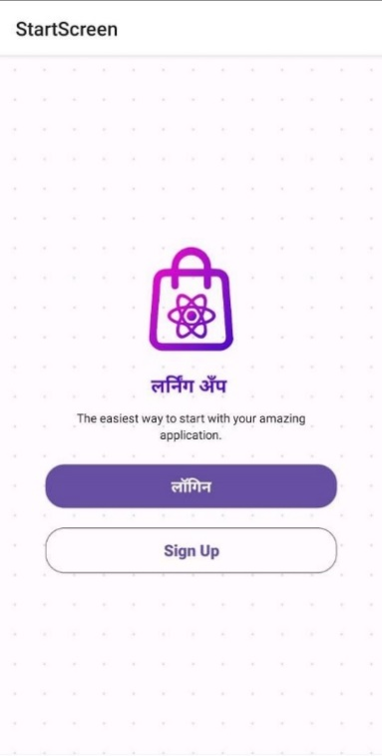

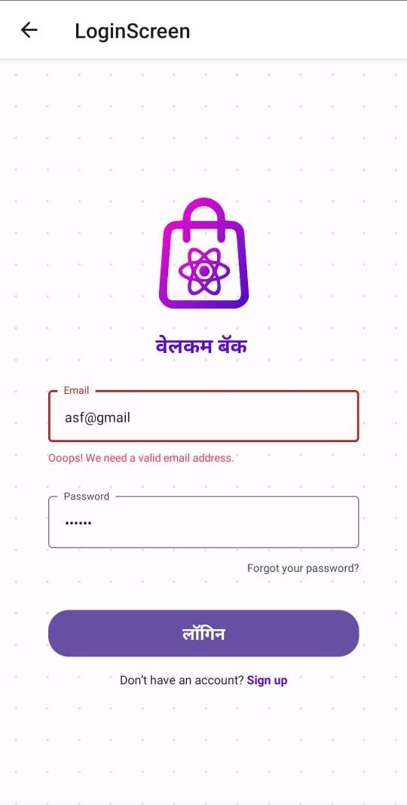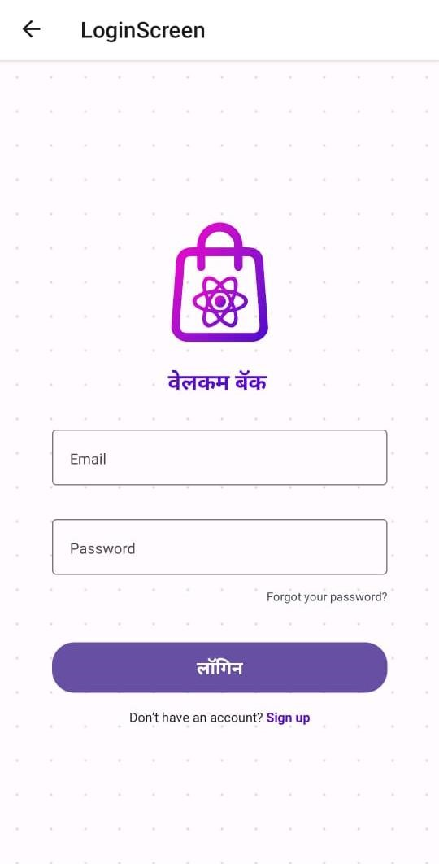

1. **User** - User will have an option to login as guest when he opens the app for the first time. Now the user will have to choose from one of the categories like barakhadi, sentences, words and many more. The cards will be displayed with images when the user clicks on a particular card the app will correctly pronounce the card.

#### **Hardware Interfaces**

This app is supported in all android as well as ios devices. The requirements are speaker and display to the device. This app has various functions as mentioned below:

1. Add – To perform this function one needs camera & microphone enabled device.
2. Delete – When logged in as admin, he/she will have the ellipsis over each card. When clicked on it, it gives admin two options i.e., delete & modify.
3. Modify - When logged in as admin, he/she will have the ellipsis over each card. When clicked on it, it gives admin two options i.e., delete & modify. When clicked on modify button you are given options to modify image/audio or category.
4. Listen – To listen to audio user/admin can click on any card and he/she will be able to learn the correct pronunciation for a given card*.*

**Software Interfaces:**

The mobile in which this software is installed needs to have android or ios operating system. will require some permission regarding mike and audio permission.

**Communication interfaces:**

The machine needs to work properly and communicate with the database for proper functioning.

**4. System Features**

**4.1 System Features 1-Admin**

Login: Admin can use his name id and password to use the system.

The functionalities at the admin’s side are:

* Adding different cards: The admin can add different cards to a particular category .
* Editing existing cards: The admin can edit existing cards.
* Deleting cards: The admin can delete cards from a particular category .
* Creating a new category: The admin can create a new category of cards .
* Editing an existing category: The admin can edit existing cards.
* Deleting an existing category: The admin can delete a particular category.
* Changing the password: The admin can change his login password.
* Logout: The admin can logout of the application.
* Analysis: Admin can analyze the progress of patient.

**4.2 System Features 2-User**

User Authentication : User have to login(one time).

The functionalities at the user’s side are:

* Viewing different cards: The user can view different cards belonging to a particular category.
* Listen to the audio: The user can listen to the audio of the pronunciation of a particular card
* Assessment:
* Assessment Result:
* Session time recording:

### 5. Other Non-functional Requirements:

#### **5.1 Performance Requirements**

The performance requirements for this app are that the user should be familiar with the basic functionalities of mobile phone and should be able to use them. The admin should place all the images and audio for a card very precisely because this may lead to learn the wrong pronunciation. For user he/she should wait for some milliseconds to listen the pronunciation. Admin should remember the password to login and make changes into the data of app. User can select continue as guest and proceed further for learning.

#### **5.2 Safety Requirements**

There should be database backup so that if any problem occurs the data is not affected rather not lost.

#### **5.3 Security Requirements**

Admin should maintain a strong password so that no other person can make changes to the app data. The child user should be supervised by the parent user. The database is secured with the default SQLite security feature.

#### **5.4 Software Quality Attributes**

The primary objective is to create a good software which is judged using the following guidelines:

1. Consistency – All system code should be consistent.
2. Test cases – All functionalities are tested properly.
3. Reliability -The protocol communication should be reliable.

4.Availability- The product should be available on internet as well as on app stores.

5.Maintainability- The system should be maintained and updated regularly. The addition of new features should be easy and convenient.

#### 5.5 Business Rules

The business rules for the software are as follows:

1. The admin has the right to fix the spellings and images and to set or update the pronunciation as and when required.
2. The user should download the application in his/her device.
3. Admin should keep adding new words/sentences as well as categories.
4. Admin should maintain a high security password.
5. User should click on a particular card to hear the correct pronunciation.