Software Requirements Specification
for
Speech Therapy Assessment Application
Prepared by <author>
Vishwakarma Institute of Information Technology, Pune
Contents
1. Introduction 1
1.1 Purpose 1
1.2 Document Conventions 1
1.3 Intended Audience and Reading Suggestions 1
1.4 Product Scope 2
1.5 References 3
2. Overall Description 3
2.1 Product Perspective 3
2.2 Product Functions 3
2.3 User Classes and Characteristics 4
2.4 Operating Environment 4
2.5 User Documentation 5
3. External Interface Requirements 5
3.1 User Interfaces 8
3.2 Hardware Interfaces 9
3.3 Software Interfaces 10
4. System Features 11
5. Other Nonfunctional Requirements 12
5.1 Performance Requirements 12
5.2 Security Requirements 12
5.3 Software Quality Attributes 12
5.4 Business Rules 13
6. Annexure I: 14
6.1 UML diagrams: 14
7. Annexure 2: 21
7.1 User Stories: 21

Introduction
Autism Spectrum Disorder (ASD) is a complex developmental condition that often manifests in communication difficulties, making early intervention essential. Traditional methods of speech therapy are often constrained by geographic limitations and cost, hindering access to critical therapy services for many families. To bridge this gap, the project embarked on the development of a mobile application tailored to the unique needs of children with ASD, offering a convenient, cost-effective, and accessible solution. The primary motivation driving this project is the pressing need to address the speech and language development challenges faced by children diagnosed with autism spectrum disorder (ASD).

Purpose
Speech Therapy Assessment is a mobile application especially developed for children suffering from autism. The main aim of this project is to help society using the recent technologies like Android which will also be a huge help to the medical industry. The application will be a cost-effective solution and the parents themselves can monitor their child’s progress without having to go to the doctor. Its ease of use and accessibility impacts and benefits both the child and the doctor. The mobile application is the need of the hour.

Document Conventions
The document is prepared using Microsoft Word 365 and uses the font type 'Calibri (Body)'. The fixed font size that has been used to type this document is 11pt with 1.5 line spacing. It has used the bold property to set the headings of the document. UML diagrams have been created according to UML 2.0 standards. Standard IEEE template is the template used to organize the appearance of the document and its flow.

Intended Audience and Reading Suggestions
Users of the system are children, parents to assist their children and the administrator of the system. The members are assumed to have basic understanding and knowledge of computer and internal browsing while the administrator should have more knowledge so that he/she can resolve small problems and perform information.
The intended audience for the Speech Therapy Assessment Application, as mentioned in the provided document, includes the following stakeholders:
Developers: These individuals or teams will be responsible for creating, maintaining, and updating the mobile application.
Users/Designers: This category likely includes the children with autism who will use the application for speech therapy, as well as their parents or caregivers who may assist them in using the app.
Testers: Individuals responsible for testing the application to ensure it functions correctly and meets its requirements.
Documentation Writers: Those responsible for creating user manuals, on-line help, tutorials, and other forms of documentation related to the application.
It is important to note that the document mentions that users of the system are children and parents, assuming they have basic computer knowledge. Additionally, it implies that the administrator should have more advanced knowledge to address potential issues and perform administrative tasks within the application.

Product Scope
The software being specified is a groundbreaking mobile application designed to address the speech therapy needs of children diagnosed with Autism Spectrum Disorder (ASD). The primary purpose of this software is to provide a versatile and user-friendly tool that facilitates speech and language development in children with ASD, offering tailored therapy experiences.
Accessibility for Marathi Speakers: Marathi-speaking families and children with ASD often face challenges in accessing therapy materials in their language. The software bridges this gap, ensuring that therapy content is accessible to Marathi speakers.
Assessment: Patient can give assessment which is assigned by the doctor.
Progress Tracking: User and Doctor can view all assessment scores and doctor can track and analyses the progress by various statistical models.

References
<List any other documents or Web addresses to which this SRS refers. These may include user interface style guides, contracts, standards, system requirements specifications, use case documents, or a vision and scope document. Provide enough information so that the reader could access a copy of each reference, including title, author, version number, date, and source or location.>

Overall Description

Product Perspective
The Speech Therapy Assessment is a mobile-based new software product which will be produced by a project team to assist children suffering from autism. The application is a bi functional unit consisting of an admin module and user module. This application assist children suffering from autism and the parents themselves can monitor their child’s progress without having to go to the doctor. The system communicates with the database for the storage of data.

Product Functions
Some major product functionalities of the system are as follows:
User
- Go to the required app.
- Sign in (one time).
- Select category and study cards.
Admin
- Adding different cards
- Editing existing cards
- Deleting cards
- Creating a new category
- Editing an existing category
- Deleting an existing category
- Changing the password
- View Patient List
- Monitor Patient’s progress.

User Classes and Characteristics
There are two users in the system.
User: Users will be able to see the assigned cards, and they also will be able to fetch the assessment uploaded by the admin. Users will be able to see their marks after every assessment.
Admin: Admin will be able to create cards, update cards, delete cards, edit cards, create categories and sub-category, and add assessment. Admin has the privilege of monitoring patients’ progress through the system.

Operating Environment
Supported Platforms:
The mobile application is compatible with both iOS and Android platforms.
Hardware Requirements:
- For optimal performance, users are recommended to have a smartphone or tablet.
- The application is optimized for devices with screen sizes ranging from 4.7 inches to 10 inches.
- The application needs permission to access microphone for audio recording purpose.
- For optimal performance, users are recommended to have android version 4.1 and ios version 8.0.
Software Requirements:
- Frontend- React Native
- Backend – Node.js, Express.js
- Cloud Technology- Cloudinary Platform
- Analysis: Power Bi
- Database-MySQL
- Platform-Visual Studio Code

User Documentation
- User Manual: A comprehensive user manual will be provided, offering step-by-step instructions on how to use the application. It will include detailed information on account creation, navigation, content selection, pronunciation practice, assessments, and session monitoring.
- Tutorials: The user documentation will include tutorials or video guides that walk users through common tasks and exercises. These tutorials will be accessible from within the application or through online platforms.
- FAQ Section: A Frequently Asked Questions (FAQ) section will be available, addressing common queries and concerns that users may have. It will provide quick answers to commonly encountered issues.
- System Requirements: Clear information about the hardware and software requirements necessary to run the application will be included. This will help users ensure their devices are compatible.
- Updates and Release Notes: Information about software updates, new features, and bug fixes will be made available in release notes. Users will be informed about improvements to the application.

External Interface Requirements
Wireframes:
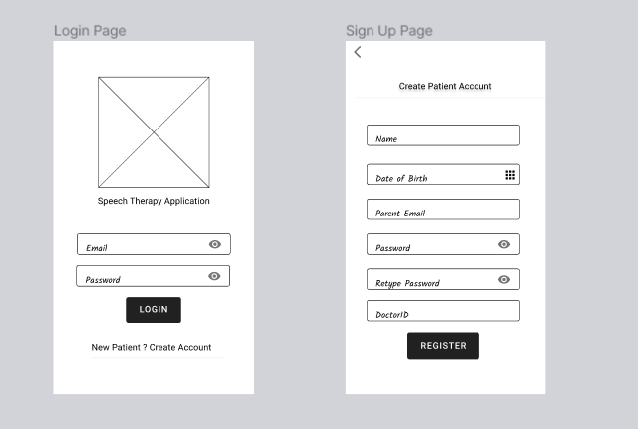
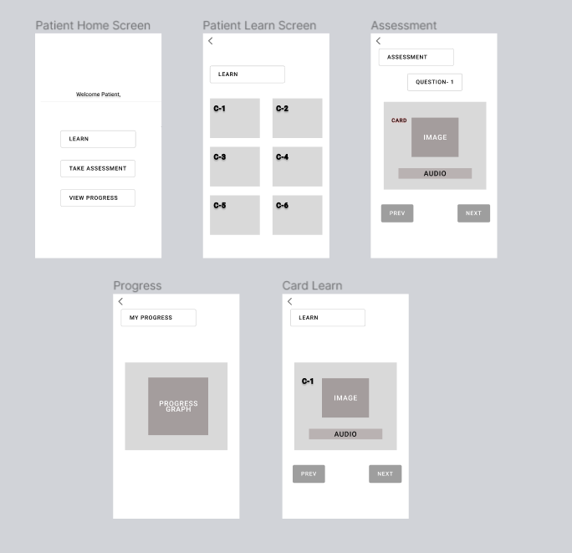
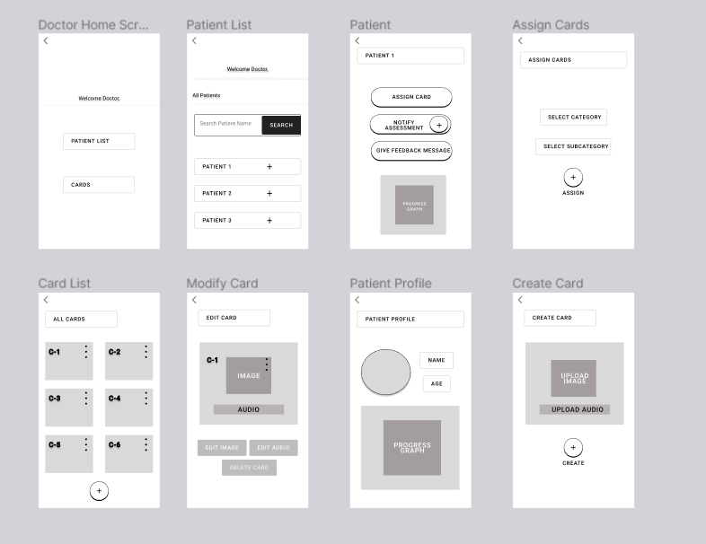

User Interfaces

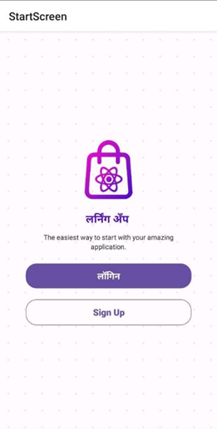
Fig 3.1.1 Start Screen
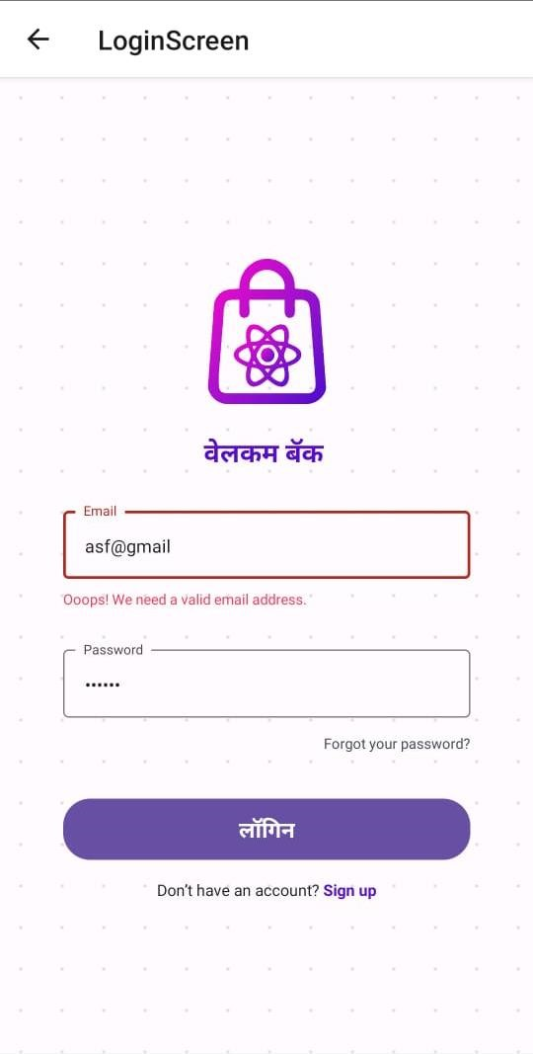
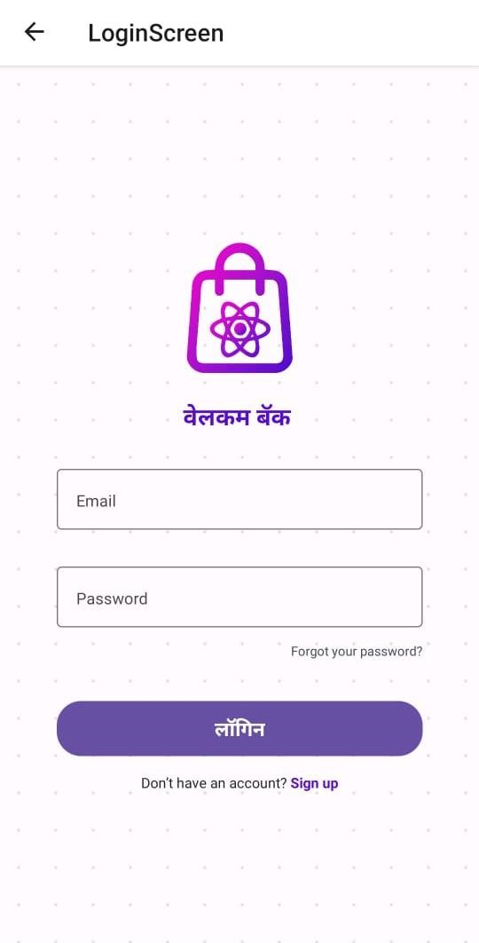
Fig 3.1.2 Login Screen Fig 3.1.3 Login Screen Email Validation

Hardware Interfaces
This app is supported on all android as well as ios devices. The requirements are speaker and display to the device. This app has various functions as mentioned below:
- Supported Devices: The application is designed to run on both Android and iOS platforms, indicating compatibility with a range of smartphones and tablets.
- Device Specifications: For optimal performance, users are recommended to have a smartphone or tablet. The application is optimized for devices with screen sizes ranging from 4.7 inches to 10 inches.
- Microphone: The application requires permission to access the device's microphone for audio recording purposes. This is likely used for speech therapy exercises and assessments.
- Android and iOS Versions: For optimal performance, users are recommended to have Android version 4.1 or higher and iOS version 8.0 or higher installed on their devices.
These hardware interfaces and requirements ensure that the application functions properly on a variety of devices and that it can access the necessary hardware components like the microphone for its features, particularly those related to speech therapy exercises and assessments.

Software Interfaces
Operating System Compatibility: The application is compatible with both Android and iOS platforms, indicating that it interacts with the operating systems of these mobile platforms.
Database Management System (DBMS): The software interfaces with a MySQL database. This means it communicates with and utilizes a MySQL DBMS for data storage and retrieval.
Frontend Technology: The frontend of the application is built using React Native, which is a popular cross-platform mobile app development framework. React Native is used for creating the user interface and user interactions.
Backend Technology: The backend of the application is built using Node.js and Express.js. These technologies likely handle server-side logic, authentication, and interactions with the database.
Cloud Technology: The application integrates with the Cloudinary platform for efficient management of media files, including images and audio pronunciations associated with therapy cards.
Analysis Tool: Power BI is integrated into the application for data analysis and reporting purposes. Power BI is used to generate visual reports on user progress and therapy effectiveness.
Development Platform: Visual Studio Code is mentioned as the development platform for building the application, indicating that it's used by developers to write and test the application code.
These software interfaces define how the Speech Therapy Assessment Application interacts with various software components, databases, development frameworks, and analysis tools to deliver its functionalities.

System Features
User Registration: Users can create accounts or sign in as guests, while administrators can log in using their credentials. User authentication ensures data privacy and security.
Content Management: Administrators can add, modify, or delete speech therapy materials and assessment questions in Marathi. They can create new categories for therapy content and customize the learning experience.
User Management: Administrators can manage user accounts, including creating and managing therapist accounts.
Password Management: Admins can change their login passwords for security purposes.
Category Selection: Users (children with ASD and their parents/caregivers) can select specific categories of therapy content, such as Marathi alphabets, words, or sentences.
Interactive Exercises: Users can engage in speech therapy exercises designed to improve pronunciation and communication skills. Exercises may include image-based associations and pronunciation practices.
Audio Pronunciations: The application provides audio pronunciations for therapy content, helping users learn correct pronunciation.
Assessments: Users can undergo assessments to evaluate their progress in speech and language development.
Session Time Recording: The application records the time spent on each session to monitor user engagement.
SQL Database: The system uses an SQL database to securely store user data, therapy content, assessment results, and session history.
Media Management: Cloudinary is integrated for efficient management of media files, including images and audio pronunciations associated with therapy cards.
Power BI Integration: The application integrates with Power BI for data analysis and reporting. It generates visual reports on user progress and therapy effectiveness.
Android and iOS Support: The application is compatible with both Android and iOS platforms, ensuring accessibility for a wide range of devices.
Marathi Language: The application primarily supports the Marathi language, including therapy content, audio pronunciations, and the user interface.

Other Nonfunctional Requirements

Performance Requirements
The performance requirements for this app are that the user should be familiar with the basic functionalities of mobile phone and should be able to use them. The admin should place all the images and audio for a card very precisely because this may lead to learning the wrong pronunciation. For user he/she should wait for some milliseconds to listen the pronunciation. Admin should remember the password to login and make changes into the data of app. User can select sign up or sign in (one time) and proceed further for learning.

Security Requirements
Admin should maintain a strong password so that no other person can make changes to the app data. The child user should be supervised by the parent user. The database is secured with the default SQLite security feature.

Software Quality Attributes
The primary objective is to create a good software which is judged using the following guidelines:
- Consistency – All system code should be consistent.
- Test cases – All functionalities are tested properly.
- Reliability -The protocol communication should be reliable.
- Availability- The product should be available on internet as well as on app stores.
- Maintainability- The system should be maintained and updated regularly. The addition of new features should be easy and convenient.

Business Rules
The business rules for the software are as follows:
The admin has the right to fix the spellings and images and to set or update the pronunciation as and when required.
The user should download the application in his/her device.
Admin should keep adding new words/sentences as well as categories.
Admin should maintain a high security password.
User should click on a particular card to hear the correct pronunciation.

Annexure I:

UML diagrams:
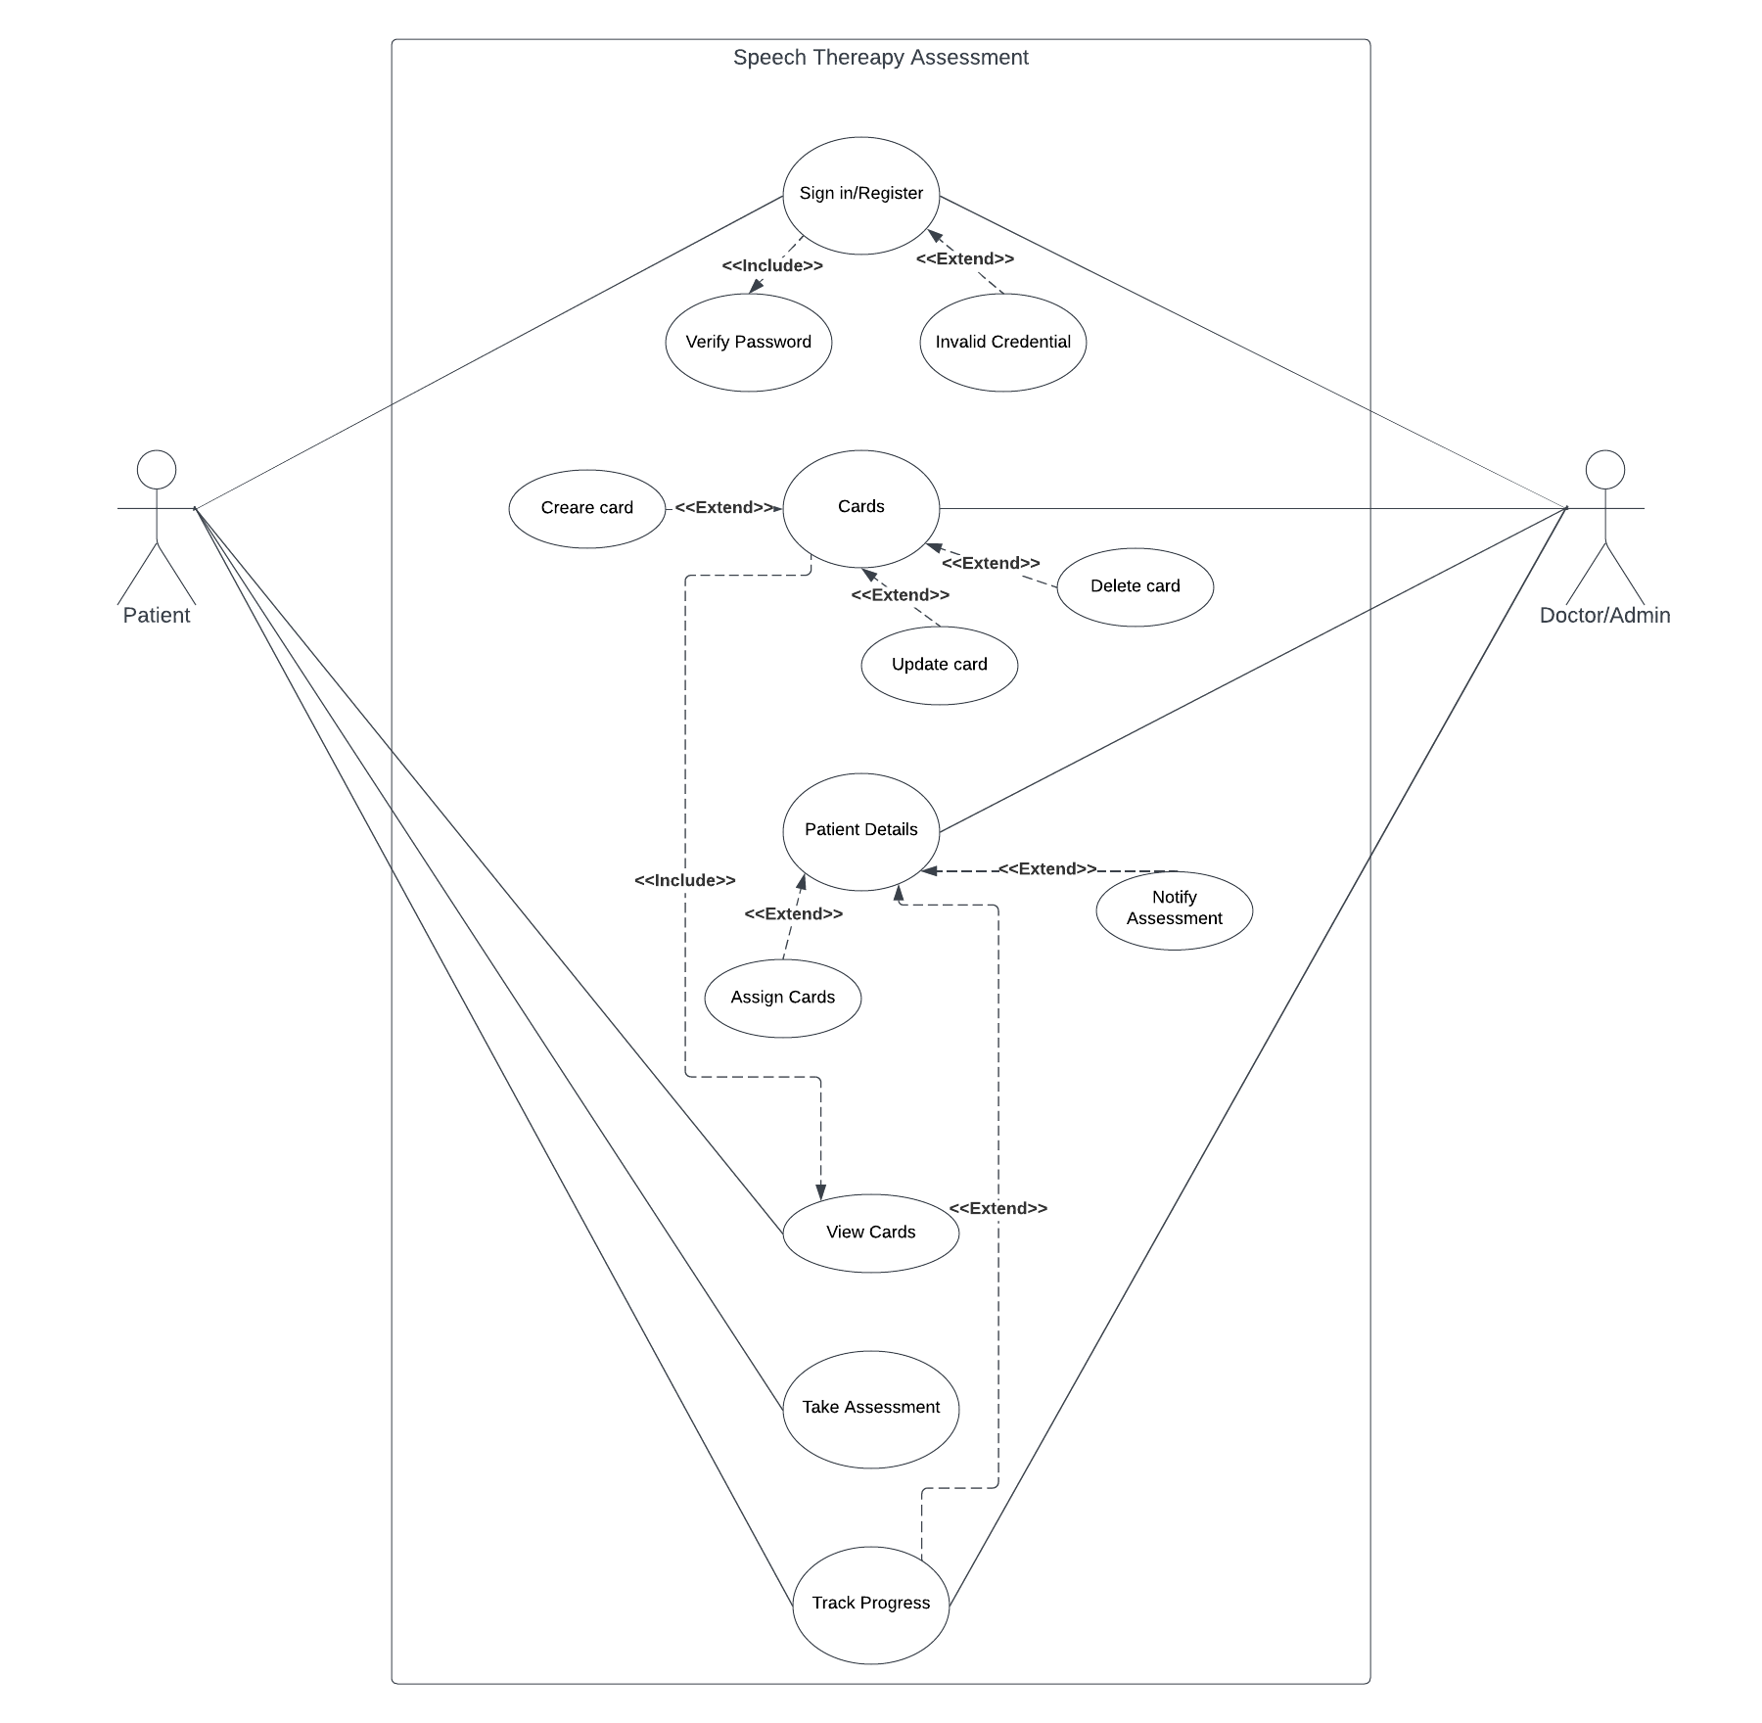
Fig. 6.1.1 Use case Diagram
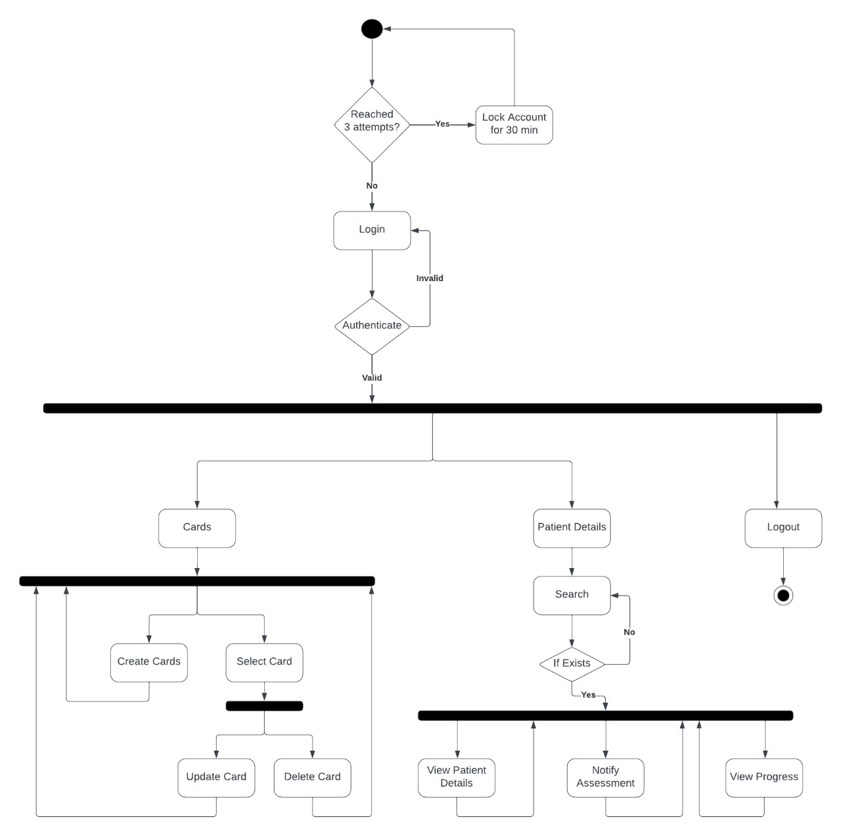

Fig. 6.1.2 Admin Flow Diagram
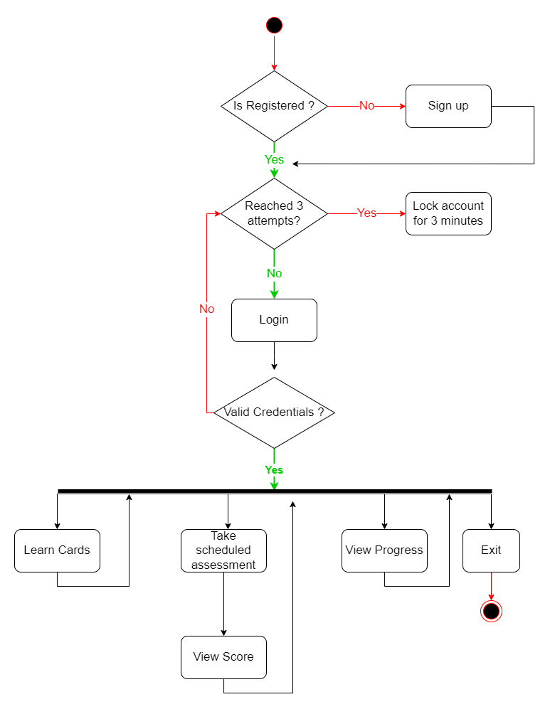
Fig. 6.1.3 User Flow Diagram
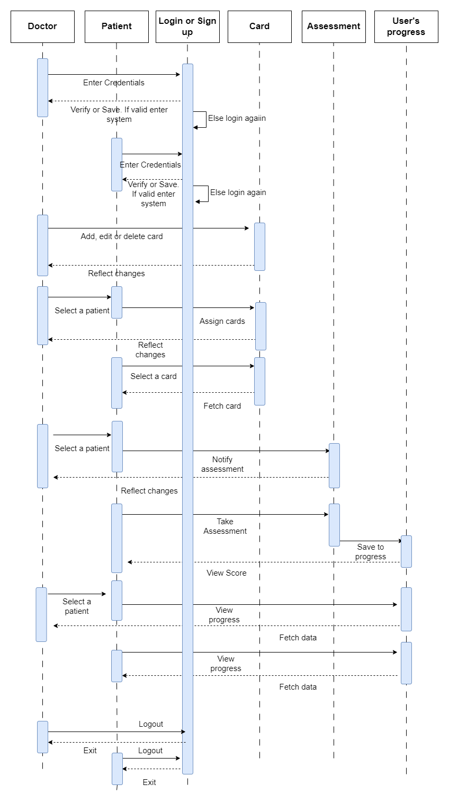
Fig. 6.1.4 Admin Sequence Diagram
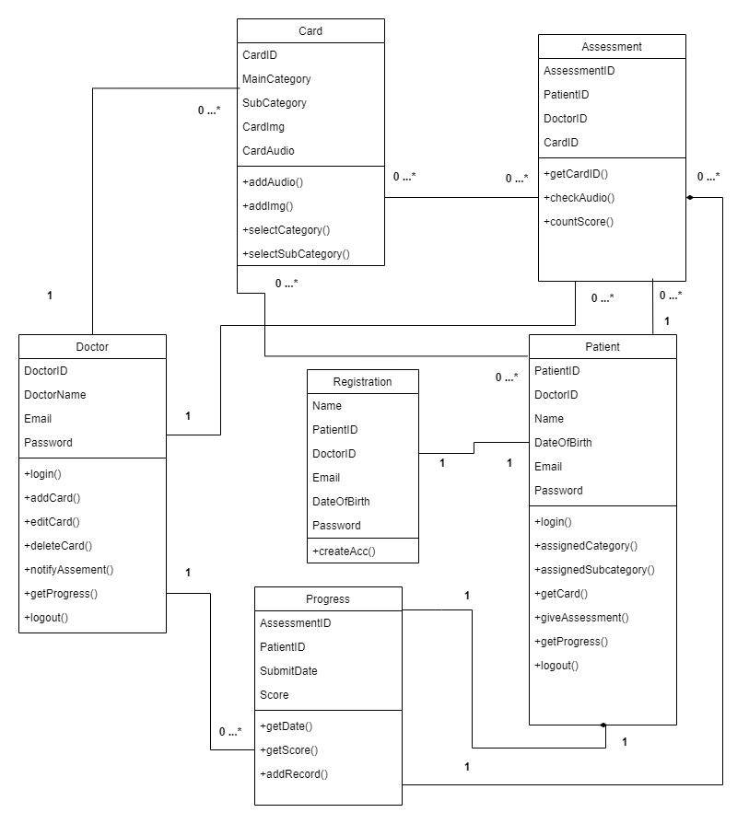
Fig. 6.1.4 Class Diagram

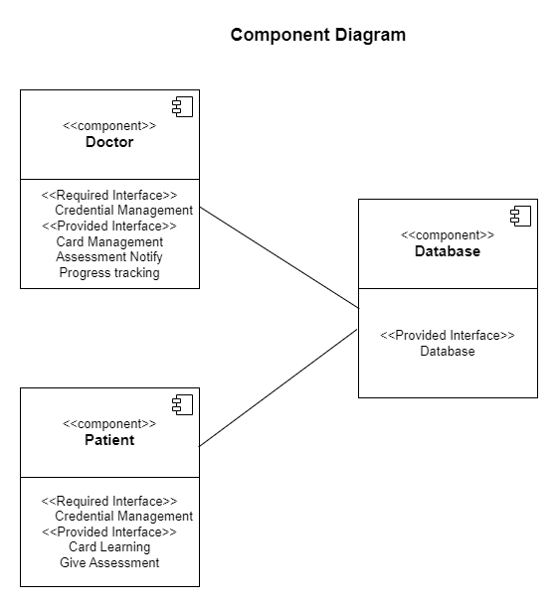

Deployment Diagram
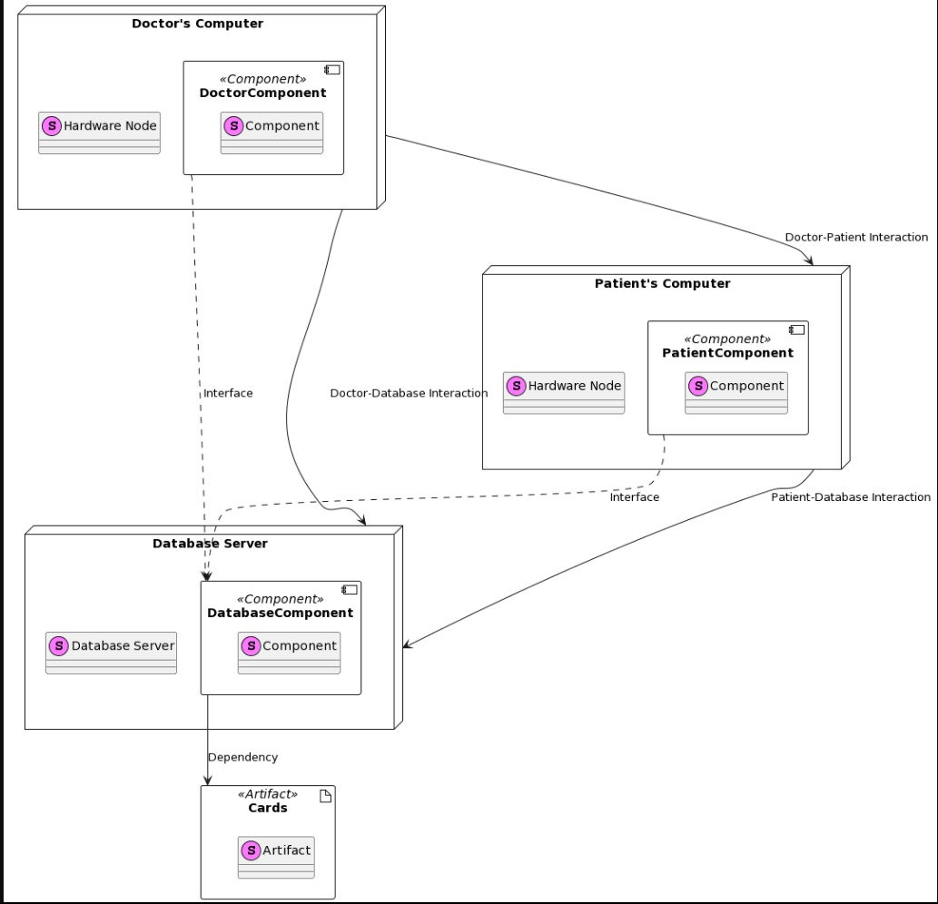

ER Diagram:
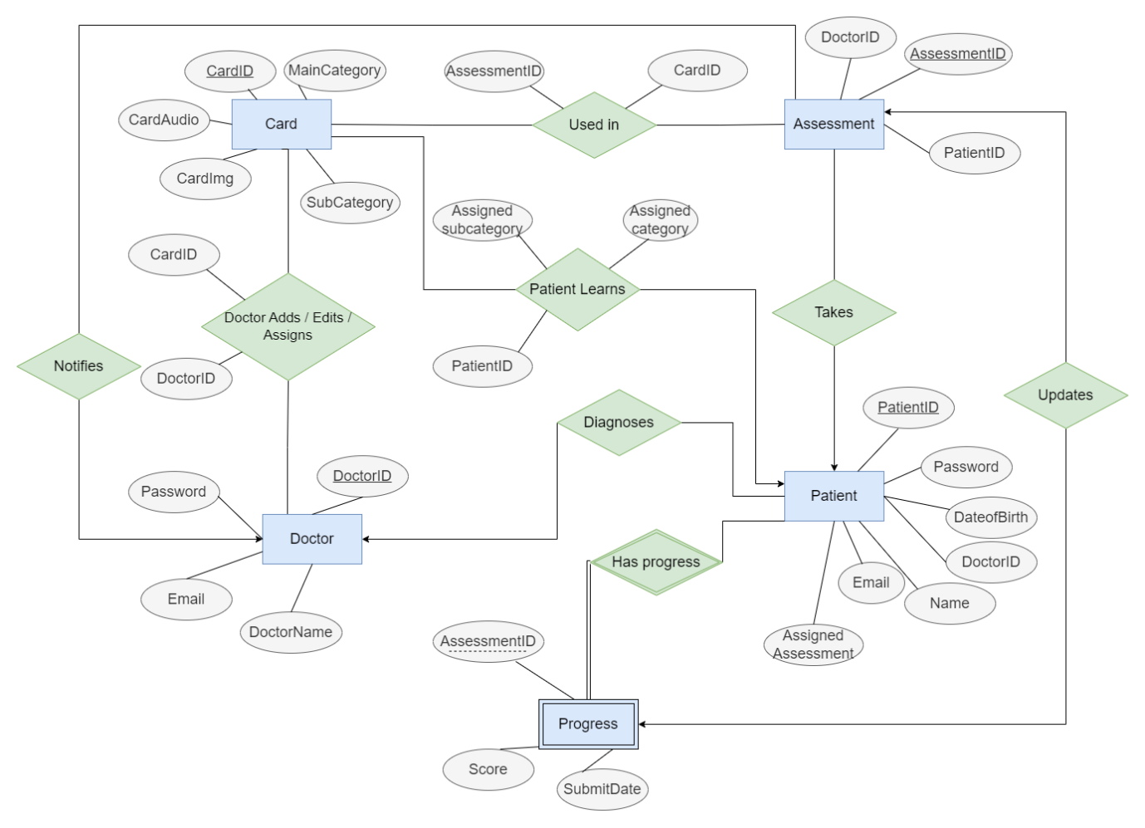

Annexure 2:

User Stories:
User Stories | Scenario
- As a User, I want to sign in (one time) to the app to access content and assessments. | - Given: The User knows how to use a mobile.  - When: User clicks on the app icon.  - And: The system provides a screen which provides learning cards and other app functions.  - Then: User practices on the set of cards.
- As a User, I want to view and interact with the cards, which includes listening to correct pronunciations when I tap on them. | - Given: The User knows how to use a mobile.  - When: User click on any card button.  - And: The system provides a audio message through system speakers.  - Then: The user able to listen to the audio generated by system speakers.
- As a User, I want to access cognitive assessment with cards. | - Given: The User knows how to use a mobile.  - When: User click on cognitive Assessment button.  - And: The system provides a screen which displays assessment in the form of questions which includes audio and image files.  - Then: The user answers the questions by selecting correct option.  And: The system records the response of the user and store it in database.
- As an Admin, I want to sign into app to access admin functionalities. | - Given: The Admin knows how to use a mobile.  - When: The Admin clicks on the sign in button.  - And: The system asks for the credentials from the admin  - Then: Admin must provide valid credentials to login into app.
- As an Admin, I want to have the ability to add new cards with images and audio, categories to the app, so I can continually update the content for children with autism. | - Given: The Admin must log in and know how to use an app.  - When: The Admin clicks on the create card icon.  - And: The system provides interface to create card by uploading image and audio.  - Then: Admin must provide permission to record audio and upload files on app.  And: Admin records the audio, upload images, select category on app and create card.  Then: The system collects and stores the data in database.
- As an Admin User, I want to create assessment by adding questions with images and audio and correct answer for children to practice their language skills. | - Given: The Admin knows how to use an app.  - When: The Admin clicks on create assessment icon  - And: The system provides interface to create assessment and asks for permission to access microphone and upload image.  - Then: Admin must provide permission to create assessment.  And: Admin create assessment by uploading images, audio, correct option.  Then: The system collects and stores the data in database.
- As an Admin User, I want to create assessment by adding questions only with audio and children has to give answer in audio format. | - Given: The Admin knows how to use an app.  - When: The Admin clicks on create assessment icon  - And: The system provides interface to create assessment and asks for permission to access microphone and upload audio file.  - Then: Admin must provide permission to create assessment.  And: Admin create assessment by uploading audio.  Then: The system collects and stores the data in database.
- As a User, I want to access speech assessment cards. | - Given: User knows how to use an app.  - When: User click on Speech-based Assessment button.  - And: The system provides a screen which displays assessment in the form of questions which includes audio.  - Then: The user clicks on the audio button  And: the system generates audio.  Then: User must click on the record audio button and record his/her audio.  And: The system records the voice of the user and stores the audio file in database.
- As an Admin User, I want to analyze and view the results of assessments, which helps me monitor the progress of children using the app. | - Given: The Admin knows how to use an app.  - When: The Admin clicks on analyze the assessment button.  - And: The system provides interface to which includes details of all users and their progress.  - Then: Admin can select one of the users to analyze their progress.  And: The system provides progress chart on that specific user  Then: Admin able to check the progress of the user and can make conclusion on progress report.

