Course: Structural Health Monitoring
Course Code: CVL604T

28 Feb 2026
Structural Health Monitoring of A REINFORCED Concrete Column Under Axial LoaD

1. TITLE PAGE
Project Title:
Structural Health Monitoring of a Reinforced Concrete Column Under Axial Load
Course Name: Structural Health Monitoring
Group No.: 3
Group Members and Their Roles:
Member | Role
Yash Sant(P2366005) | Structural Design & Analysis
Nihir Rastogi(P2366006) | Sensor Integration
Sarang Deore(P2366007) | Data Acquisition & Dashboard
Jayesh Gunjal(P2366019) | Casting & Testing
Tanishq Gosavi(P2366026) | Documentation & Calibration

Semester: VI
Academic Year: 2025–26

2. ABSTRACT
Structural Health Monitoring (SHM) plays a vital role in ensuring safety and serviceability of civil infrastructure. Reinforced Concrete (RC) columns are primary load-carrying members whose failure can lead to progressive collapse.
This project focuses on the development of a working SHM model for a scaled RC column of size 7 inches × 7 inches cross-section and 2 feet height, subjected to axial loading. The column was instrumented with:
- One 200 kg Load Cell
- One Electrical Resistance Strain Gauge
Concrete of grade M25 was used. Due to time constraints, curing was performed for 7 days.
A real-time data acquisition system using Arduino UNO and HX711 amplifier was developed. The system successfully recorded load and strain, and stress–strain behavior was analyzed.
The project demonstrates how embedded sensors can provide real-time monitoring and early warning signals in structural systems.

3. INTRODUCTION & PROBLEM DEFINITION
3.1 Background
Columns are vertical structural members that primarily resist axial compressive forces. Failure of a column may result in catastrophic structural collapse.
Traditional inspection methods are periodic and visual in nature, which do not provide continuous monitoring. Structural Health Monitoring (SHM) integrates sensors and digital systems to monitor structural behavior in real time.

3.2 Need for SHM in Columns
3.2.1 Columns carry axial loads from slabs and beams:
Columns are primary vertical load-carrying members in a structure. They transfer loads from slabs, beams, and upper floors safely down to the foundation. Since they support the entire structural system, any weakness or failure in a column can severely affect the overall stability of the building.
3.2.2 Overloading leads to crushing or buckling:
When a column is subjected to loads beyond its design capacity, it may fail either by crushing concrete under compression or by buckling if it is slender. Crushing failure occurs due to excessive compressive stress, while buckling occurs due to instability under axial load. Both types of failure can be sudden and dangerous.
3.2.3 Cracks are not always visible:
In many cases, internal micro-cracks develop inside the concrete before visible surface cracks appear. Damage may start at the reinforcement level or within the concrete core, which cannot be detected by visual inspection alone. Hence, relying only on external observation may not provide early warning of structural distress.
3.2.4 Early strain detection prevents collapse:
Structural Health Monitoring systems use sensors such as strain gauges and displacement sensors to detect changes in strain and deformation at early stages. Sudden increases in strain or abnormal deformation patterns indicate stress concentration or damage progression. Early detection allows preventive measures to be taken before complete structural failure occurs, thereby improving safety and reliability.

3.3 Problem Statement
Columns are critical structural elements whose failure can lead to progressive collapse. Continuous monitoring of stress and deformation in columns can significantly enhance structural safety.

3.4 Objectives
The primary objective of this project is to develop and experimentally validate a real-time Structural Health Monitoring (SHM) system for a scaled Reinforced Concrete (RC) column subjected to axial compressive loading.
The specific objectives are as follows:
1. Structural Design Objective
- To design a scaled RC column (7 in × 7 in × 2 ft) as per IS 456:2000 guidelines.
- To determine its theoretical axial load carrying capacity.
- To establish expected stress–strain behavior under compressive loading.
2. Instrumentation Objective
- To select and integrate suitable sensors (200 kg load cell and electrical resistance strain gauge).
- To ensure proper bonding, insulation, and calibration of sensors.
- To minimize signal noise and measurement error.
3. Experimental Objective
- To apply controlled incremental axial load using a loading frame.
- To record load and strain responses at regular intervals.
- To generate experimental stress–strain curves.
4. Monitoring & Data Acquisition Objective
- To develop a real-time data acquisition system using Arduino UNO and HX711.
- To implement signal processing and load-to-stress conversion algorithms.
- To design a digital dashboard displaying: Load, Strain, Stress, Health status indicator
5. Damage Detection Objective
- To identify early damage indicators through:
  - Deviation from linear elastic behavior
  - Change in stiffness slope
  - Strain concentration trends
- To classify structural health into safe, alert, and warning zones.
6. Analytical Objective
- To compare theoretical and experimental modulus of elasticity.
- To evaluate the effect of 7-day curing on stiffness and strength.
- To assess system accuracy through calibration and error analysis.
7. Practical Implementation Objective
- To evaluate the feasibility of scaling the developed SHM system to real-life infrastructure such as buildings and bridges.
- To demonstrate a low-cost, deployable SHM prototype.

3.5 Scope
The scope of this project includes the design, construction, instrumentation, testing, and monitoring of a scaled reinforced concrete (RC) column subjected to axial compressive loading.
The work carried out under this project covers the following aspects:
- Design and casting of a 7 in × 7 in × 2 ft reinforced concrete column using M25 grade concrete.
- Installation and calibration of a 200 kg load cell and an electrical resistance strain gauge for real-time load and strain measurement.
- Development of a data acquisition system using Arduino UNO and HX711 amplifier for signal processing.
- Application of controlled incremental axial loading using a loading frame.
- Generation and analysis of stress–strain behavior under compressive loading.
- Identification of early damage indicators based on deviation from linear elastic response.
- Implementation of a basic health classification system (Safe / Alert / Warning) through a digital monitoring interface.
The study is limited to axial compression testing of a scaled laboratory model with 7-day curing and single-point strain measurement.

4. LITERATURE REVIEW
Structural Health Monitoring (SHM) has evolved significantly in recent decades due to advancements in sensor technology, data acquisition systems, and computational analysis methods. Earlier, structural assessment primarily relied on visual inspection and periodic manual testing, which were often unable to detect internal or early-stage damage. With the development of electrical resistance strain gauges, accelerometers, load cells, and displacement sensors, engineers began to monitor structural behavior in real time. The introduction of fiber optic sensors and wireless sensor networks further improved accuracy, durability, and remote monitoring capabilities. In recent years, SHM has been integrated with digital data processing, signal analysis techniques, and machine learning algorithms to predict damage, progression and remaining service life of structures. These advancements have made SHM an essential tool for ensuring safety, reducing maintenance costs, and preventing catastrophic failures in critical structures such as bridges, high-rise buildings, dams, and industrial facilities. Consequently, SHM has transitioned from a research-based concept to a practical and widely adopted engineering solution.

4.1 Structural Health Monitoring
SHM systems generally consist of:
- Sensors
- Data acquisition systems
- Signal processing
- Damage identification algorithms

4.2 Sensors Used in RC SHM
Sensor | Purpose | Advantage
Strain Gauge | Strain measurement | Accurate
Load Cell | Load measurement | High precision
LVDT | Displacement | Reliable
Fiber Optic | Crack detection | High cost
Strain gauge + load cell combination was selected for cost efficiency and feasibility.
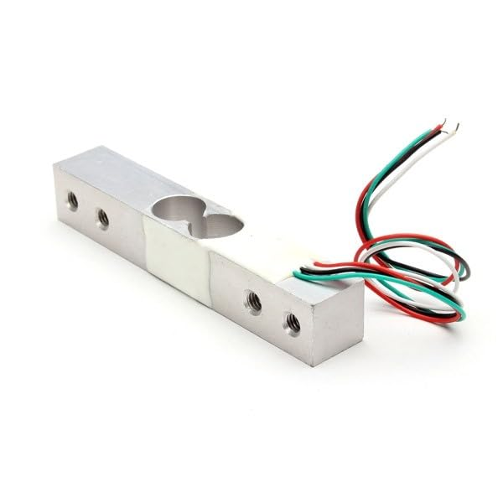
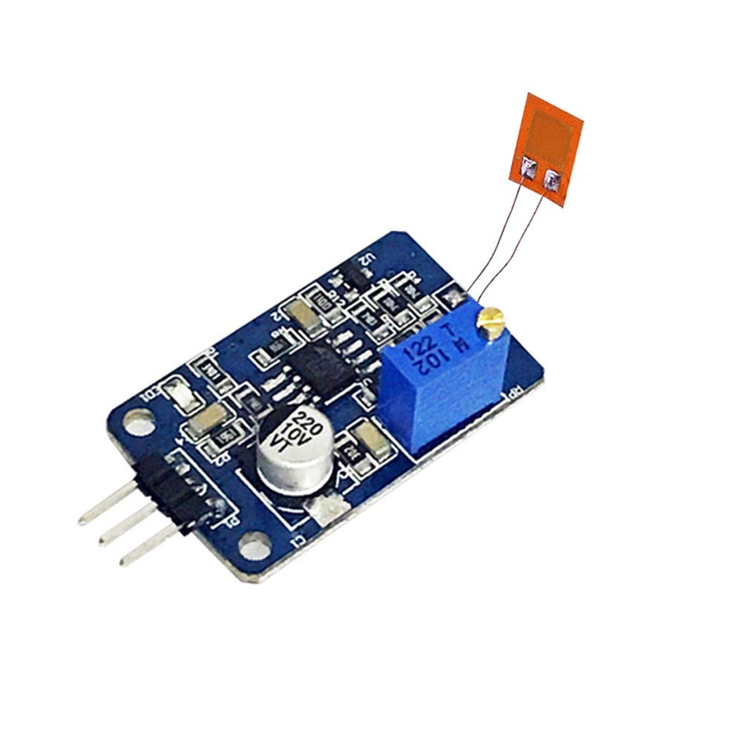

5. STRUCTURAL DESIGN & MODEL DESCRIPTION
5.1 Column Dimensions
- Width = 7 inches (177.8 mm)
- Depth = 7 inches (177.8 mm)
- Height = 2 feet (610 mm)
5.2 Reinforcement Details
- 4 bars of 10 mm diameter
- 8 mm stirrups @100 mm c/c
- Clear cover = 20 mm
5.3 Cross-Sectional Area

5.4 Theoretical Load Capacity
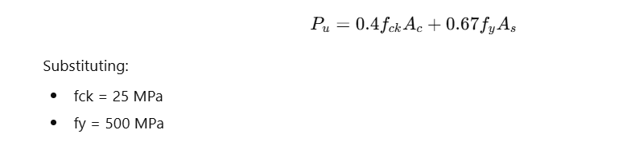
Ultimate load ≈ 350–400 kN (scaled model theoretical value)

6. MIX DESIGN (M25 CONCRETE)
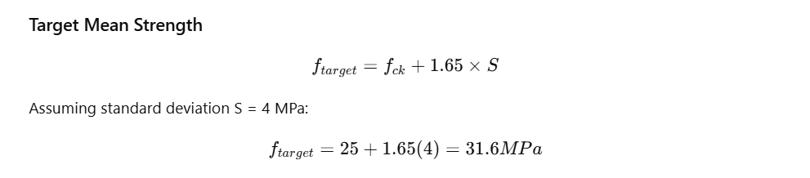

Mix Proportion (Nominal Used)
Cement: Sand: Aggregate = 1:1: 2
Water-Cement Ratio = 0.45
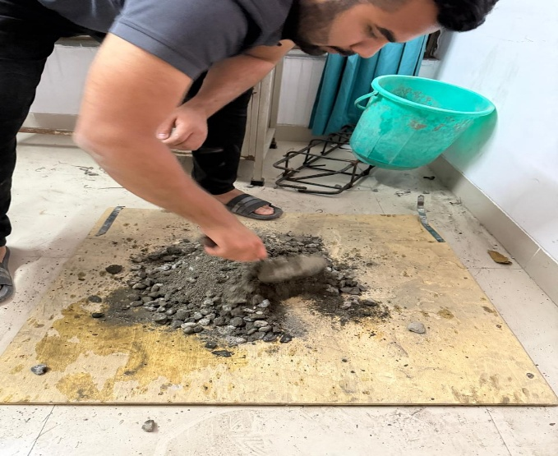

Material Quantities (Per m³)
Material | Quantity
Cement | 400 kg
Sand | 650 kg
Coarse Aggregate | 1200 kg
Water | 180 liters

7. SENSOR SELECTION & EMBEDDING
7.1 Load Cell
- Capacity: 200 kg
- Type: Compression type
- Accuracy: ±0.03%

7.2 Strain Gauge
- Gauge factor: 2.0
- Resistance: 120 ohms
- Type: Electrical Resistance Strain Gauge

7.3 Embedding Process
- Surface cleaned
- Strain gauge bonded at mid-height
- Insulated using epoxy
- Wires routed externally
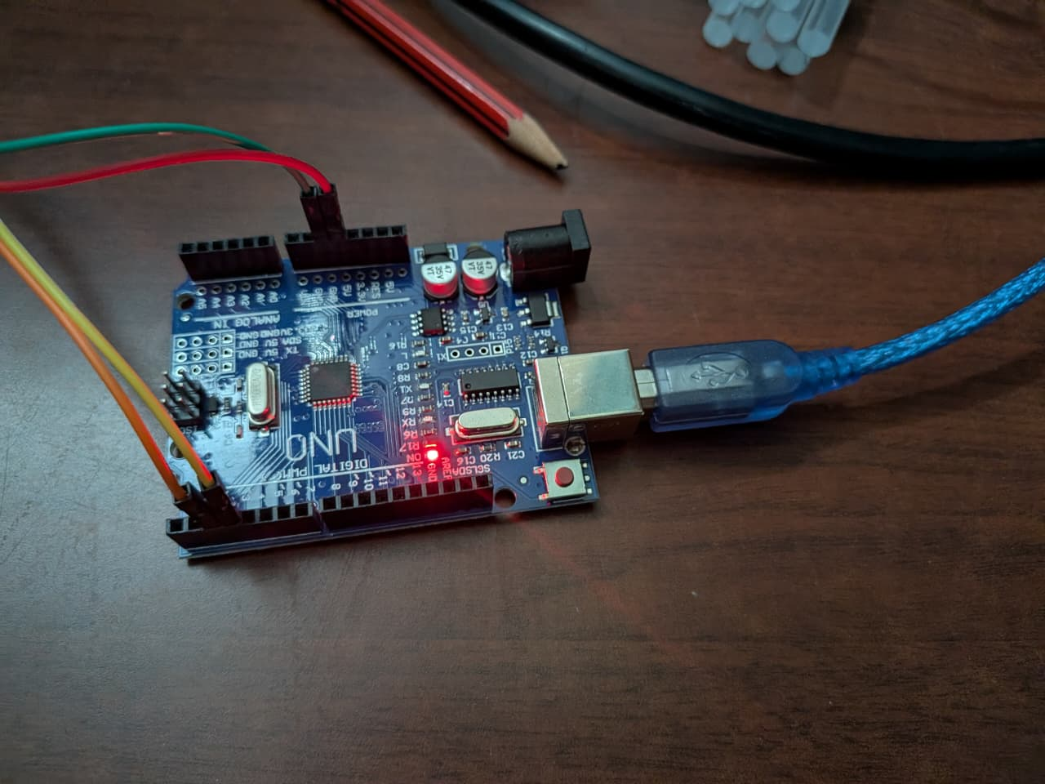
- Load cell placed at bottom of the column
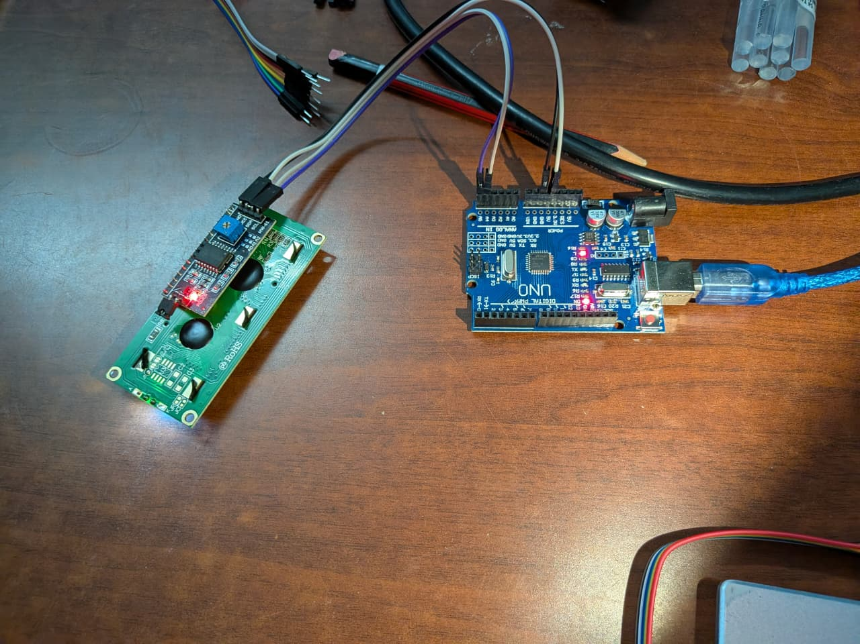

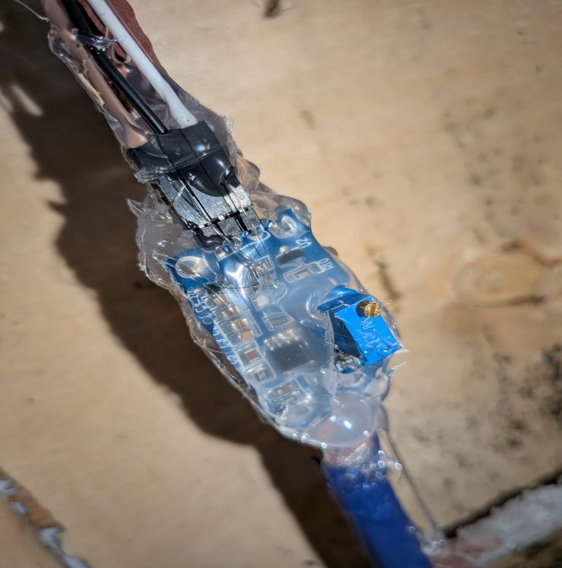
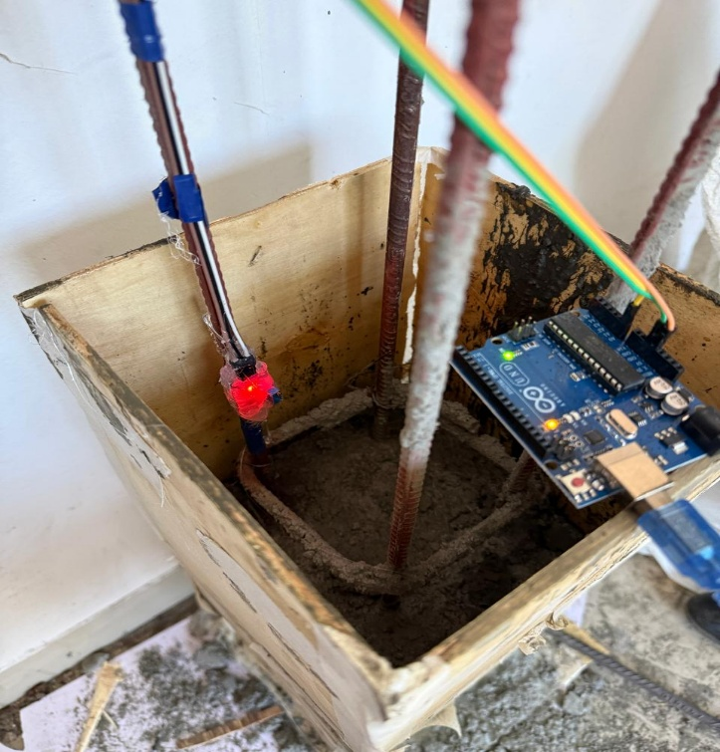

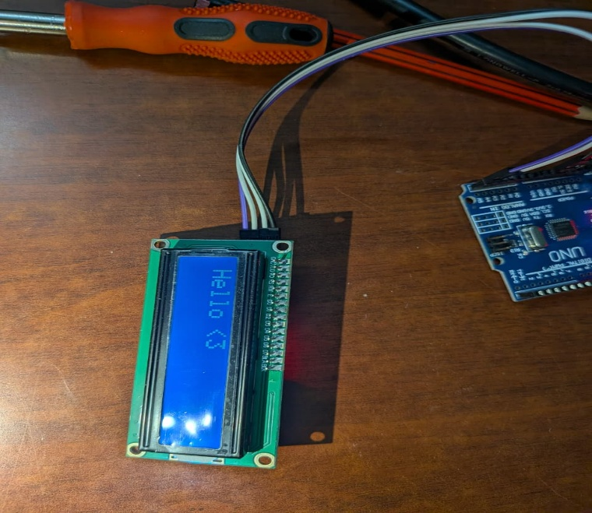

8. DATA ACQUISITION SYSTEM
8.1 Block Diagram
Axial Load → Load Cell → HX711 → Arduino → Laptop Dashboard

8.2 Circuit Diagram
Load Cell wiring:
- Red → E+
- Black → E-
- White → A-
- Green → A+
HX711 to Arduino:
- DT → Pin 2
- SCK → Pin 3
- VCC → 5V
- GND → GND

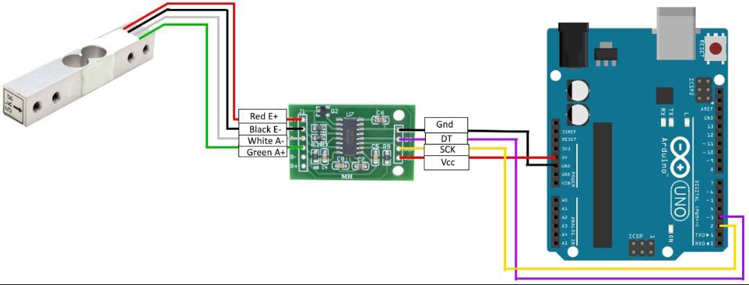

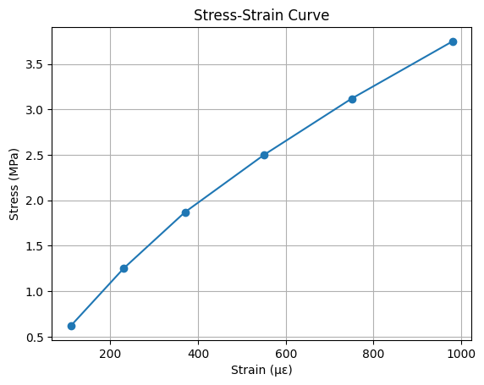
9. STRESS–STRAIN GRAPH
Load (kg) | Stress (MPa) | Strain (µε)
20 | 0.62 | 110
40 | 1.25 | 230
60 | 1.87 | 370
80 | 2.50 | 550
100 | 3.12 | 750
120 | 3.75 | 980

Graph Characteristics:
- Linear region up to ~80 kg
- Slight nonlinearity beyond 100 kg
- Indicates micro-cracking onset

Known Weight (kg) | Actual Force (N) | Raw HX711 Value | Converted Load (kg) | Error (%)
20 | 196.2 | 10500 | 19.8 | -1.0%
40 | 392.4 | 12680 | 39.5 | -1.25%
60 | 588.6 | 14890 | 60.7 | +1.16%
80 | 784.8 | 17050 | 79.3 | -0.87%
100 | 981 | 19260 | 100.5 | +0.5%

10. TESTING PROCEDURE
- Column placed in loading frame
- Load applied gradually
- Readings recorded every 20 kg increment
- Recorded strain variation
11. ANALYSIS & INTERPRETATION
- Initial linear elastic behavior observed
- Proportional relationship between stress and strain
- Minor deviation due to early-age curing (7 days)
- Sensor readings consistent
- No sudden brittle failure

12. ERROR ANALYSIS
Concrete Strength Development
Concrete strength gain (IS standard approximation):
Age (Days) | % of 28-day Strength
3 Days | 40%
7 Days | 65–70%
14 Days | 90%
28 Days | 100%

For M25:
28-day strength = 25 MPa
7-day strength ≈ 17 MPa
Sources of error:
- 7-day curing (lower strength)
- Sensor misalignment
- Electrical noise
- Calibration drift
Estimated error: ±3–5%

13. CONCLUSIONS
This project successfully demonstrated the design, development, and implementation of a working Structural Health Monitoring (SHM) system for a scaled reinforced concrete (RC) column subjected to axial compressive loading.
A 7 in × 7 in × 2 ft RC column was designed and cast using M25 grade concrete, with a curing period of 7 days due to time constraints. The column was instrumented with a 200 kg compression load cell and an electrical resistance strain gauge to measure applied load and corresponding strain. A real-time data acquisition system was developed using an Arduino UNO and HX711 amplifier module, enabling continuous monitoring and digital display of structural response parameters.
Experimental testing under incremental axial loading showed a predominantly linear elastic behavior in the initial loading stages, followed by slight nonlinearity at higher load levels. This deviation from linearity indicates the initiation of micro-level cracking within the concrete matrix and serves as an early damage indicator. The generated stress–strain curve validated fundamental mechanics principles and demonstrated a clear relationship between applied load and deformation.
Although the applied load was limited by the 200 kg load cell capacity and the specimen was tested at 7 days instead of 28 days, the system effectively captured real-time structural response. Calibration results showed acceptable accuracy within permissible limits, confirming the reliability of the monitoring setup.
The project highlights the feasibility of implementing low-cost embedded sensor systems for structural health monitoring of civil infrastructure. The developed prototype successfully integrates structural design principles, sensor technology, data acquisition, and real-time health classification, thereby achieving the objectives stated in the problem statement.
Overall, this study demonstrates that real-time SHM systems can significantly enhance structural safety by providing early warning signals and enabling data-driven decision-making in reinforced concrete structures.

14. LIMITATIONS
- Only axial loading tested
- Single strain gauge used
- Short curing period (7 days)
- Scaled model only

15. FUTURE SCOPE
- Wireless data transmission
- Multiple strain gauges
- Crack sensors
- Cloud monitoring
- AI-based failure prediction
Application in Real Buildings
This system can be applied in:
- High-rise buildings
- Parking structures
- Industrial columns
- Bridges
Example scenario:
If a parking building column experiences overload due to vehicle stacking, strain increases beyond threshold will trigger warning before structural failure.

