1. Fix the bug in the below snippet.

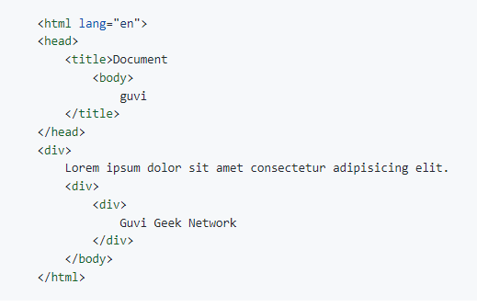­­

Ans: <html lang="en">

<head>

<title>Document guvi </title>

</head>

<body>

<div>

Lorem ipsum dolor sit amet consectetur adipisicing elit.

</div>

<div>

Guvi Geek Network

</div>

</body>

</html>

1. 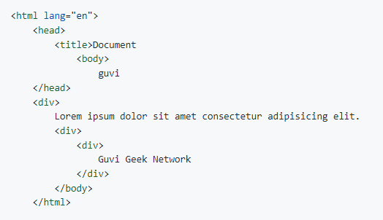Try the below one.

Ans: <html lang="en">

<head>

<title> Document guvi </title>

</head>

<body>

<div>Lorem ipsum dolor sit amet consectetur adipisicing elit. </div>

<div> Guvi Geek Network </div>

</body>

</html>

1. Design a contact us form with all fields are required.

<!DOCTYPE html>

<html lang="en">

<head>

    <meta charset="UTF-8">

    <meta http-equiv="X-UA-Compatible" content="IE=edge">

    <meta name="viewport" content="width=device-width, initial-scale=1.0">

    <title>Form</title>

    <style>

        .form {

            border: 2px solid black;

            border-radius: 5px;

            background-color: beige;

           margin-left: 30%;

           margin-right: 40%;

           padding: 20px;

        }

        #fname, #lname, #phone {

            margin-left: 40px;

        }

        #phone {

            margin-left: 15px;

        }

        #birthday {

            margin-left: 50px;

        }

        input:last-child, input:nth-last-child(2) {

            margin-left:70px ;

        }

        #message{ margin-left: 90px;}

    </style>

</head>

<body>

    <div class="form">

        <h1 style="text-align:center ;">Contact Me</h1>

        <form>

            <label for="fname">First name:</label>

            <input type="text" id="fname" name="fname" required><br><br>

            <label for="lname">Last name:</label>

            <input type="text" id="lname" name="lname" required><br><br>

            <label for="email">Enter your email:</label>

            <input type="email" id="email" name="email"><br><br>

            <label for="phone">Phone number:</label>

            <input type="tel" id="phone" name="phone" size="20" minlength="10" maxlength="13"><br><br>

            <label for="professional"> Are you working professional</label>

            <input type="checkbox" id="professional" name="professional" value="yes"><br><br>

            <label for="birthday">Birthday:</label>

            <input type="date" id="birthday" name="birthday"><br><br>

            <label for="gender">Gender:</label>

            <input type="radio" id="male" name="gender " value="Male">

            <label for="male">Male</label>

            <input type="radio" id="female" name="gender " value="female">

            <label for="female">Female</label><br><br>

            <label for="message">Message Me:</label><br>

            <textarea name="message" id="message" cols="30" rows="5"></textarea><br><br>

            <input type="submit" value="Submit">

            <input type="reset">

          </form>

    </div>

</body>

</html>

Output:

1. Use certain HTML elements to display the following in a HTML page.

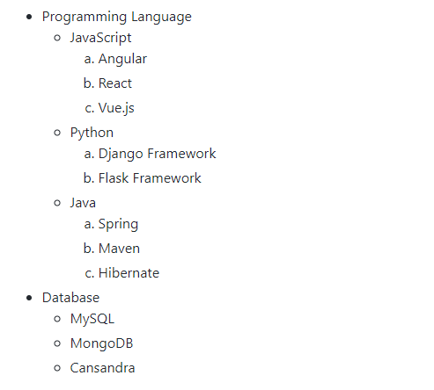

Ans:  <ul>

        <li>

            Programming Language

            <ul type="circle">

                <li>JavaScript

                    <ol type="a">

                        <li>Angular</li>

                        <li>React</li>

                        <li>Vue.js</li>

                    </ol>

                </li>

                <li>Python

                    <ol type="a">

                        <li>Django Framework</li>

                        <li>Flask Framework</li>

                    </ol>

                </li>

                <li>Java

                    <ol type="a">

                        <li>Spring</li>

                        <li>Maven</li>

                        <li>Hibernate</li>

                    </ol>

                </li>

            </ul>

        </li>

        <li>Database

            <ul type="circle">

                <li>MySQL</li>

                <li>MonoDB</li>

                <li>Cansandra</li>

            </ul>

        </li>

    </ul>

1. Create an element that helps you to open the [https://google.com](https://google.com/) in separate new tab.

Ans: <a href="http://www.google.com" target="_blank">click here</a>

1. In the form, add two radio buttons with grouping them for employee type (salaried & owned business).

<form>

   <label for="employeeType">Employee Type:</label>

   <input type="radio" id="salaried" name="employeeType" value="salaried">

   <label for="salaried">Salaried</label>

   <input type="radio" id="business" name="employeeType" value="business">

<label for="business">Own Business</label>

</form>

1. Use the table tag to design given image 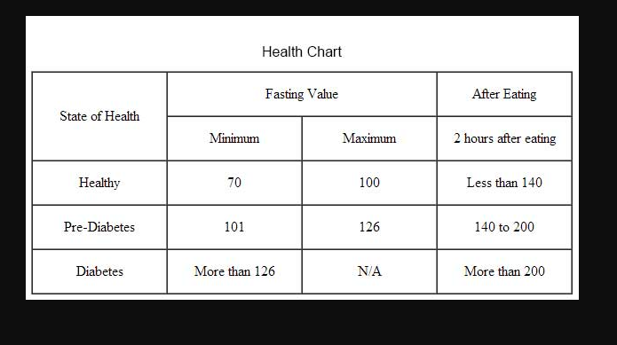

<!DOCTYPE html>

<html lang="en">

<head>

    <meta charset="UTF-8">

    <meta http-equiv="X-UA-Compatible" content="IE=edge">

    <meta name="viewport" content="width=device-width, initial-scale=1.0">

    <title>Table</title>

    <style>

        table, td{

            border-collapse: collapse;

            border-width: 1px;

            border-style: solid;

            padding: 7px;

            text-align: center;

        }

    </style>

</head>

<body>

    <h3 style="margin-left: 150px;">Health Chart</h3>

    <table>

        <tr>

            <td rowspan="2">State of Health</td>

            <td colspan="2">Fasting Value</td>

            <td>After Eating</td>

        </tr>

        <tr>

            <td>minimum</td>

            <td>maximum</td>

            <td>after 2 hours</td>

        </tr>

        <tr>

            <td>Healthy</td>

            <td>70</td>

            <td>100</td>

            <td>less than 140</td>

        </tr>

        <tr>

           <td>Pre-Diabetes</td>

           <td>101</td>

           <td>126</td>

           <td>140 to 200</td>

        </tr>

        <tr>

            <td>Diabetes</td>

            <td>More than 126</td>

            <td>N/A</td>

            <td>More than 200</td>

        </tr>

    </table>

</body>

</html>

Output:

1. In your, HTML page add the below line and highlight it without using any CSS.

"HTML & CSS is awesome"

Ans: <ul>

        <li>&ldquo;<mark>HTML & CSS is awesome</mark>&rdquo;</li>

    </ul>