**CONTENTS**

# **Introduction**

* 1. Objective of the project
  2. Features of project

1. **System Design**
   1. ER Diagram-high level data modeling
   2. Schema Diagram – conceptual data modeling
   3. State Diagram

**INTRODUCTION**

Blood bank management system is an online software application that helps in managing a blood bank in a better way. This project gives information about various blood deposits available along with associated details. These details include blood group, components and date of extraction and date of expiry. These details help in maintaining and monitoring the blood deposits. This project allows to check whether required blood deposits of a particular group are available in the blood bank . Moreover, the system also contains information about donors, cases for which blood is being used, hospitals requesting for blood and staff that manages the blood bank .It has added features such as donor id, name and contacts, blood booking request and even need for certain blood group is posted on the website to find available donors for a blood emergency .

**Objectives of the project:**

The goal and objective of the blood bank management system is to provide blood donation service to the community wherein registered donors can donate blood and patients via hospital can request and receive blood of the required type or its components.

**Problem Statement :**

In recent times, people require blood for various cases owing to rise in accidents. There has been a substantial increase in people falling prey to rare diseases like Leukaemia and Masto cytosis. Around 57 per cent of women and 25 percent of men (in the 15-49 group) suffer from anaemia.. The age old way of telephonic communication has proven to be costly .If the blood group isn’t available at the blood bank then the manual transmission might prove in vain. There is no information regarding the blood donation or managing programs available on any of the portal. This manually system raises the cost and time required to a considerable extent. Also, people don’t have any idea about blood donation how it works. This necessitates automation of blood bank database for efficient management of blood that needs to be delivered to different hospitals as per the request.

**Features of the project:**

* **Ensures hospitals have good supply or inventories of blood bags**:
* Hospitals request for blood of specific blood group for a specific purpose.
* They may require certain components of blood only like plasma, platelets, RBC’s etc.
* The blood bank supplies the required quantity in ‘first-come-first -serve’.
* Emergency cases are dealt differently.
* Even if the stock for required blood group is limited, the database is checked for registered eligible donors and they can be contacted immediately.
* In worst cases , universal donors are contacted or donors whose blood group is compatible with the required one is given.
* The system allows multiple cross-match to be done for a component and store cross-match details of all. At the same time, it does not allow a cross match to be done for an issued/rejected component unit.
* The system does not allow a unit to be issued to patients if cross-match fails for the component.
* **List the availability of blood bags at any given time:**
* Available stock of blood for different groups and their respective components are constantly kept up to date.
* Ensures a minimum quantity of blood is maintained and flow of incoming blood bags and outgoing quantity of blood is regulated.
* **Alerts for blood requirement from registered donors:**
* Registered eligible donors are contacted immediately if there is a shortage of whole blood or any component like platelets, plasma and RBC of the respective blood groups.
* Donor information such as contact , address , gender etc are extensively maintained.
* **Auto-check if the person donated blood in the last 3 months:**
* Whenever a donor approaches the blood bank to donate blood either directly or through blood donation camps, the database is used to check whether he/she is a registered donor. If he/she is a registered donor , the date of donation field in the database is used to check whether they are eligible to donate blood (they shouldn’t donate blood within 3 months of their previous blood donation). If not ,the new donor is registered with a new donor id and their blood is received.
* **Support fast searching to find match blood bags for the right person:**
* Database queries are properly written for optimized search for donors based on their blood group
* They have a unique id and all other necessary details are displayed.
* **Effectively manage blood camps:**
* Separate table is maintained for various blood camps organised by noble samaritans.
* Data pertaining to the staff that manage and extract the blood are also maintained.
* **Blood Camp Management and Reporting**
* Provides recording of details of camp beginning from allocation of staff, details of facilities available in the camp venue.
* Provides assigning of donor to a particular camp and generate camp organizer report.
* **Donor Management**
  + Intuitive and intelligent donor form for capturing details like Donor Questionnaire, Medical Examination and Blood Collection Details.
  + The system allows bulk update for serology for blood units. Serology result for many donors can be updated at once.
  + The system allows for either component creation before serology test or vice versa. Based on the serology test, the component created are updated automatically
  + Queries provide filtering over many factors like Blood Group, gender, area, blood Camp, date of donation, donor type etc.
* **Request Management:** The requests for different groups of blood or their components are received from various hospitals
* **Billing:**
  + The cost of the blood is computed based on number of units and type of component received by hospitals.
  + All blood charges are shown under the 039X revenue code series.

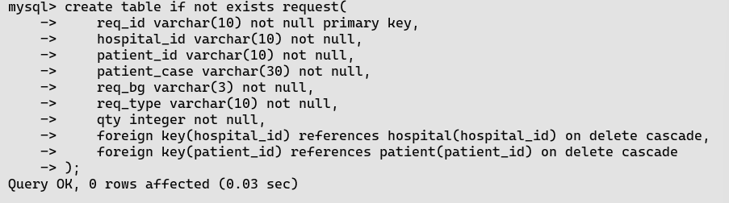

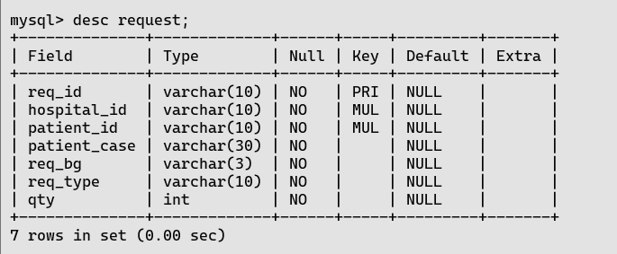

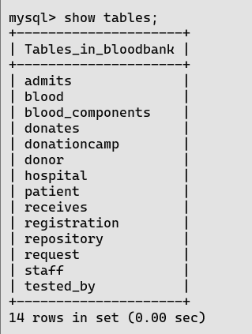

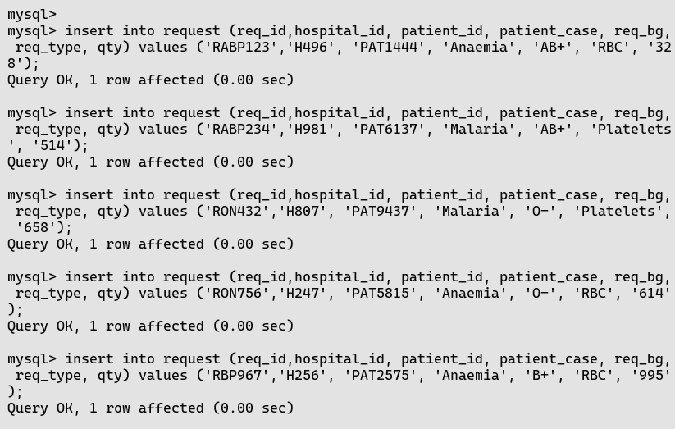

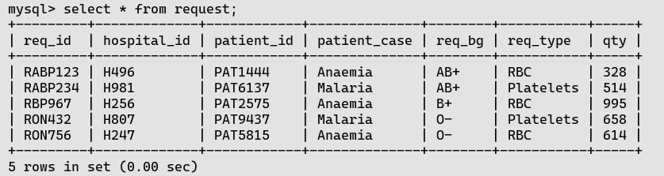

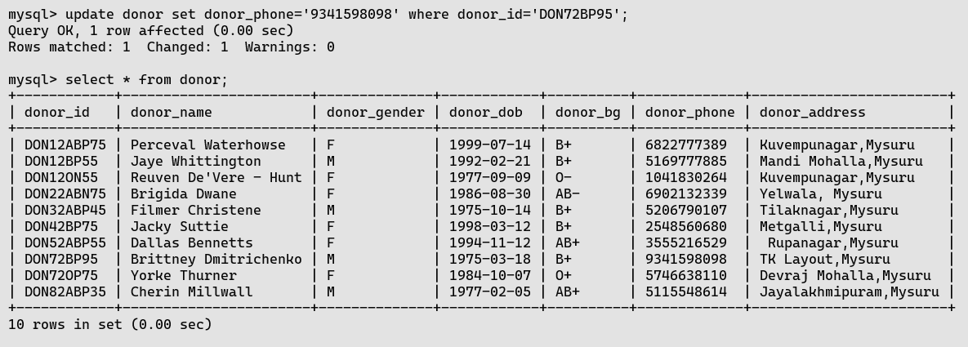

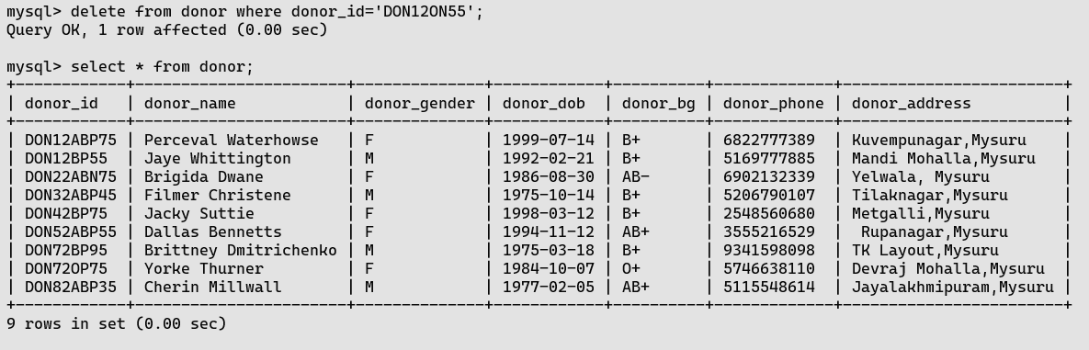

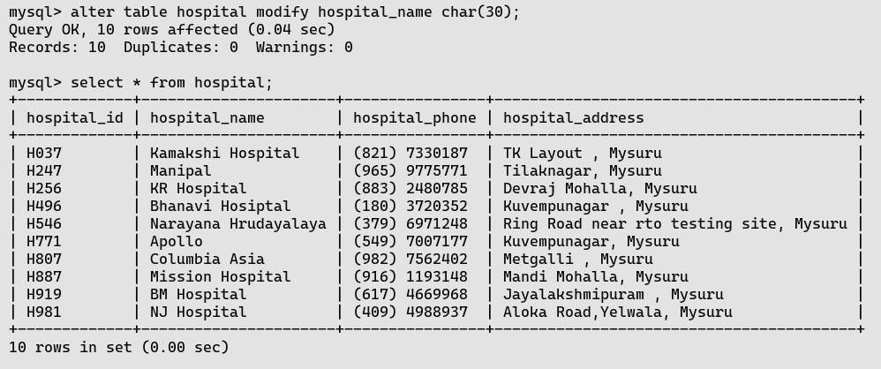

**NESTED QUERIES:**

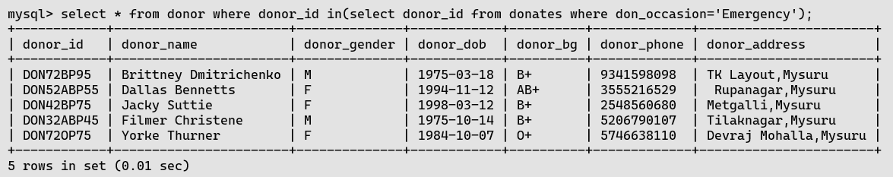

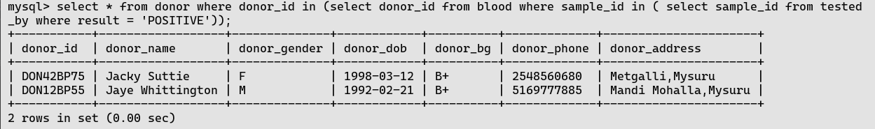

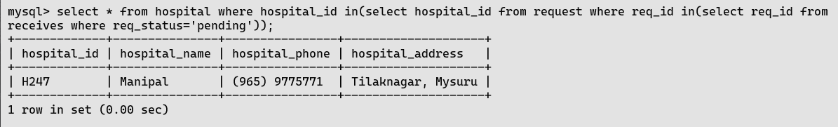

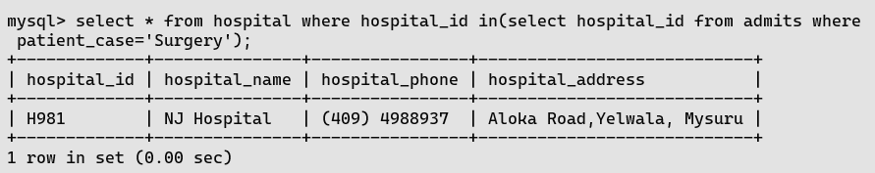

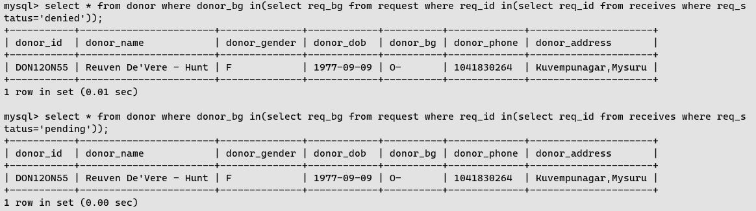

**Group by:**

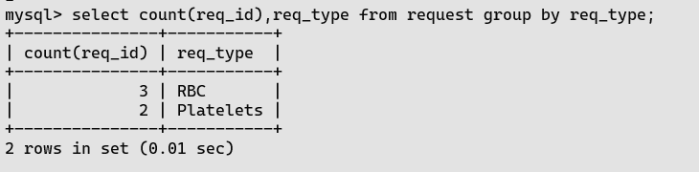

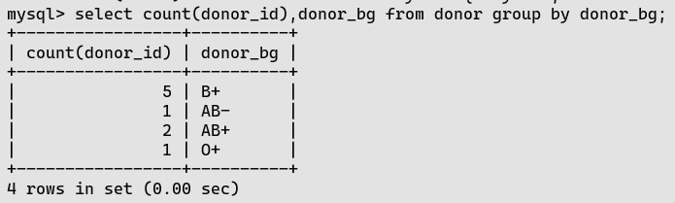

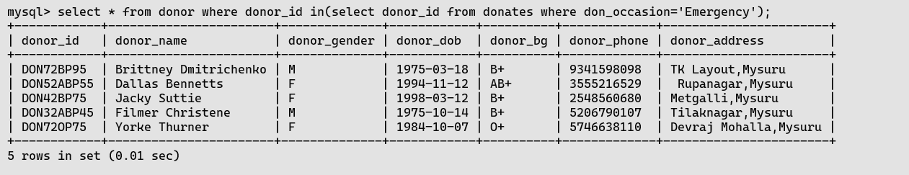

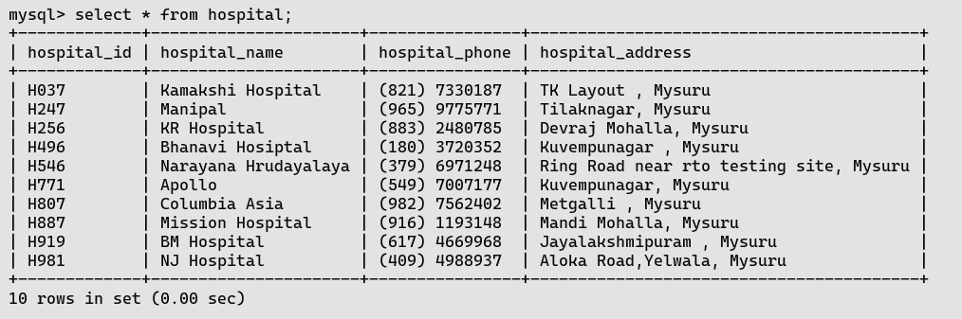

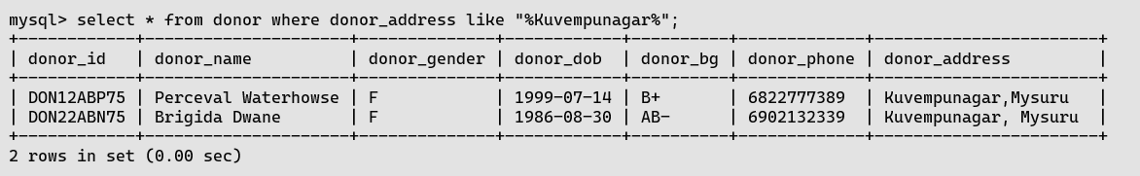

**Like:**

