**Monolithic architecture (1 EC2 instance: MYSQL & WORDPRESS): -**

**Step:1** update all the packages



**Step:2** install Apache web server to handle http request.

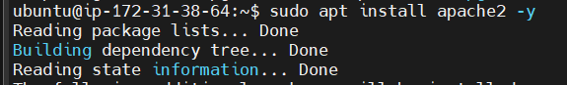

**Step:3** install php cause WordPress is built on php.

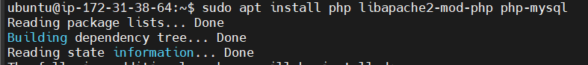

**Step:4** install MYSQL server as a database to WordPress.

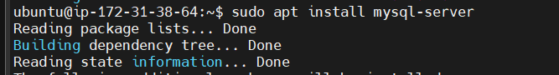

**Step:5** login as a root user to MySQL.

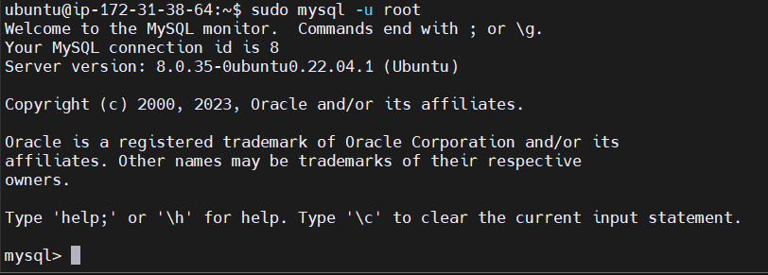

**Step:6** set a password for root user and WordPress user**.**

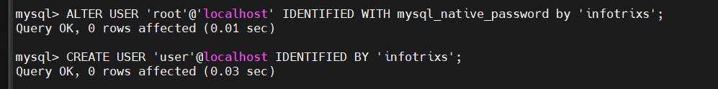

**Step:7** create database named wordpress.

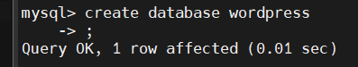

**Step:8** grant all privileges to the user.

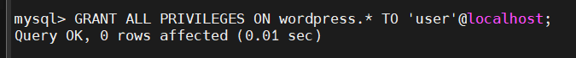

**Step:9** move to tmp and install WordPress tar file.

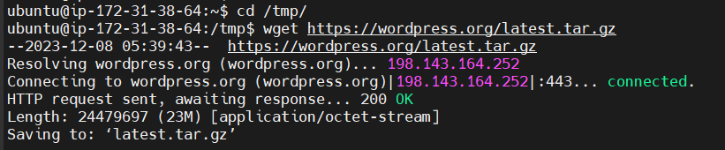

**Step:10** unzip tar file of WordPress.

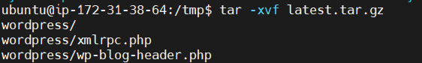

**Step:11** Move WordPress folder to Apache document root.



**Step:12** restart the Apache server.



**Step:12** Configuring WordPress wp-config file

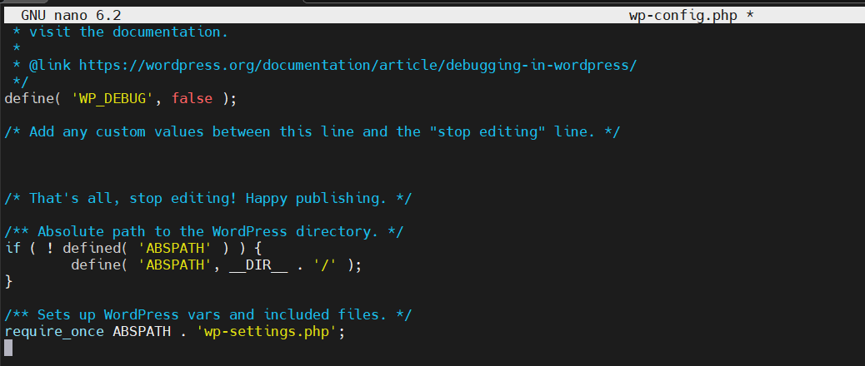

**Accessing WordPress from sever Ip address**

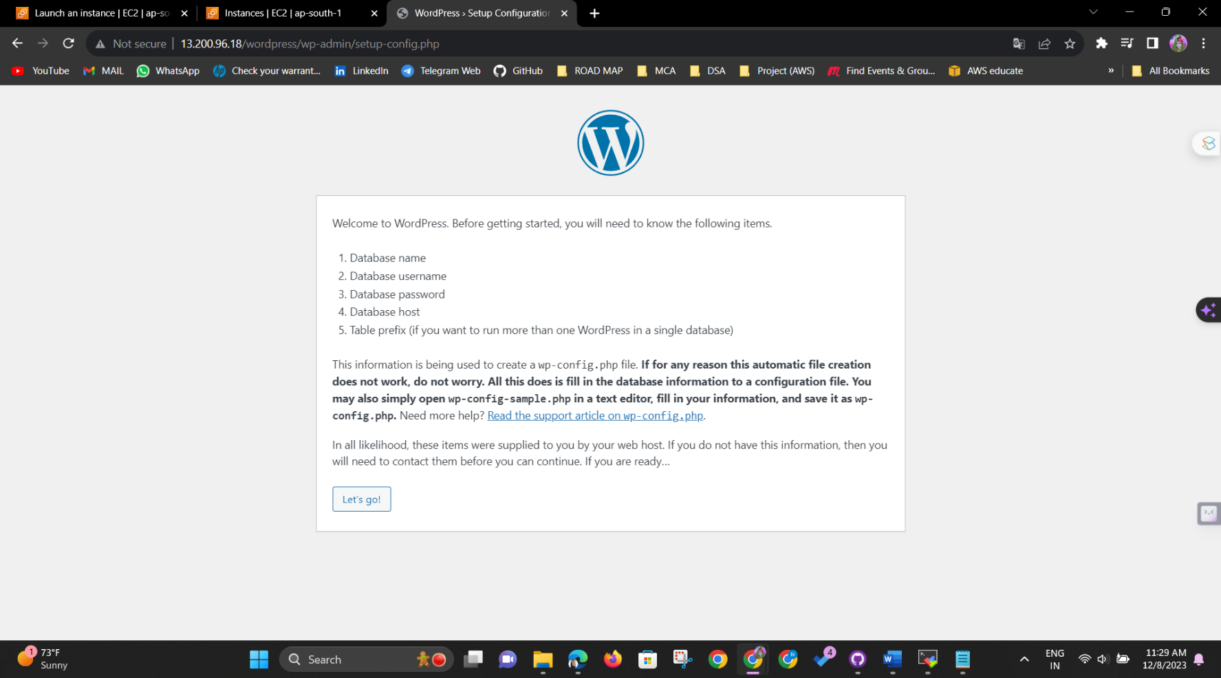

**Setting database configuration**

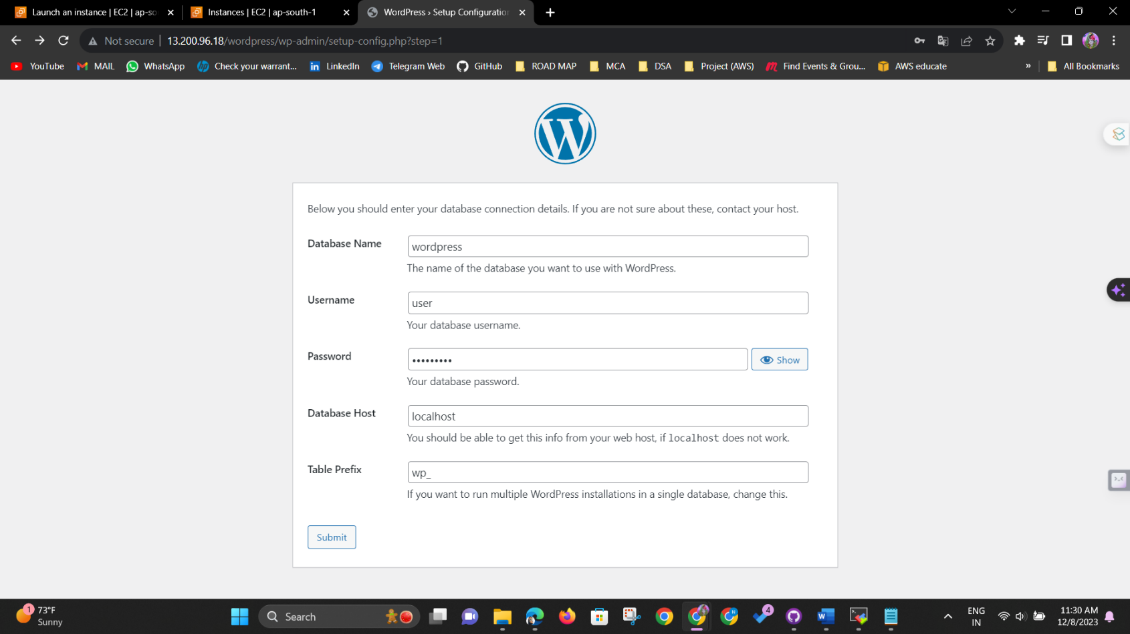

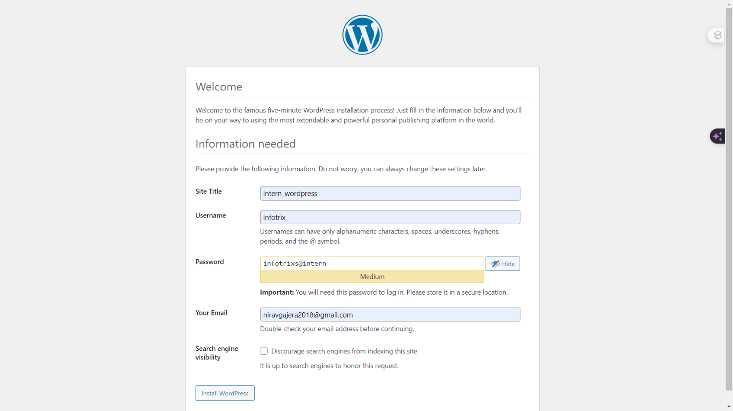

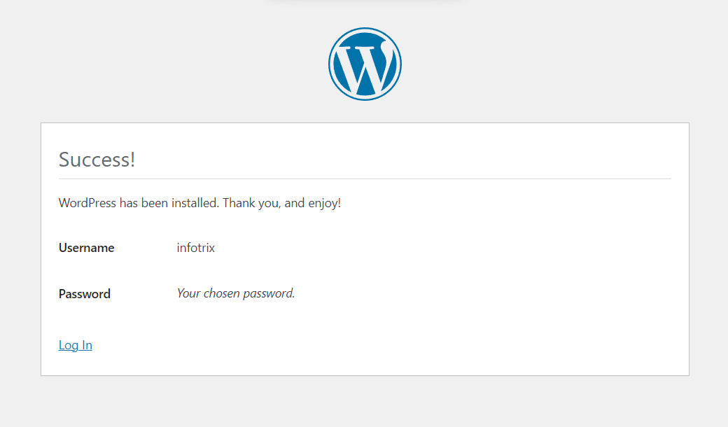

**Home Page**

