Monetization Report

Introduction:

This report outlines the methods and steps used to gather and analyze data on how websites that spread disinformation generate revenue. The focus is on identifying the revenue streams these websites rely on, such as direct donations, subscriptions, and other monetization strategies.

Step1: Converting Data Files:

Input: JSON files (file1&file2)

Output: CSV files(file1 & file2) (note that these 2 csv files were also taken by the Blanquerna team to take screenshots) included the following fields:

- Type: Nature of the content.
- URL: The website address.
- EU Relation: Relationship to EU topics.
- Country of Origin: Where the website is based.
- Claim Reviewed: The content or claim that was fact-checked.
- Source URL: The link to the original source of the disinformation.
- Date Published: The publication date of the content.

Process:
Using Python scripts, we converted the JSON files (file1 & file2) into CSV format. This involved filtering out non-essential fields and extracting only the relevant data about websites spreading disinformation.

Step2: Filtering and Refining Source URL Field
Input:
- Source URL field from the CSV files(file1 & file2).
Output:
- A refined Excel file containing:
  - Original URL: Filtered URLs of disinformation-spreading news websites.
  - Monetization URL: Links to pages where users can donate, subscribe, or buy products.
  - Type of Revenue: Methods used to earn income (e.g., subscriptions, donations, sales, or partner funding).
  - Partner Names: Names or links to partner websites supporting these disinformation platforms financially.
Process:
- Social media URLs (e.g., X, Threads, Instagram, Telegram) were programmatically removed using domain-based string matching (e.g., filtering out Twitter, Facebook).
- The cleaned dataset focused on news websites spreading disinformation.
- URLs were further enriched to include monetization details like donation pages or subscription links.

Step 3: Manual Collection of Monetization Data URLs
Input:
- Source URLs from excel file .
Output:
Updated Excel file with:
- Monetization URLs(added manually): Links to funding-related pages.
- Types of Revenue: Categorized as Direct Donations, Subscriptions/Memberships, Product Sales, or Advertising.
Process:
- Each monetization URL was manually reviewed by visiting the associated news websites.
- Links to donation or subscription pages were identified and recorded.
- Additional information about how the website generates income was documented, focusing on the revenue methods listed above.

Step4: Processing of Monetization URLs: Direct Donation and Subscription Monetization
Input:
- Subset of URLs focusing on Direct Donation and Subscription methods.
- Prompt for extracting detailed monetization-related data.
Output:
- Refined dataset containing detailed information, including:
  - Monetization Method: Revenue streams (e.g., donations, subscriptions, ads).
  - Donation Links: URLs directing to donation pages.
  - Donation Methods: Payment methods accepted (PayPal, credit cards, cryptocurrency, etc.).
  - Suggested Donation Amounts: Recommended amounts for donations.
  - Recurring Donations Option: Availability of one-time or recurring donation options.
  - Text Related to Donations: Calls to action or donation-related phrases (translated into English).
  - Buttons or Widgets: Details about donation buttons or widgets on the page.
  - Placement of Donation Section: Location of donation options (e.g., header, footer).
  - Third-Party Platforms: Integration with platforms like Patreon or GoFundMe.
  - Call to Action Messages: Prominent donation messages (translated into English).
  - Payment Platform Integration: Supported payment platforms (e.g., Stripe, PayPal).
  - Accepted Payment Methods: Payment types allowed (e.g., credit cards, bank transfers).
  - Pricing Models: Pricing structures for subscriptions or donations.
  - Currency Support: Supported currencies.
  - Subscription Plans: Details of membership tiers or subscription offers.

Process:
- Subset Creation: Filtered the URLs to focus on Direct Donation and Subscription monetization methods.
- Data Extraction:
  - scrape webpage text and links of the monetization urls.
  - Used the OpenAI GPT-4o-mini model with prompt to identify key monetization details (as outlined above).
- Refinement:
  - Links related to donations are re-examined by retrieving the webpage text from these collected donation URLs, specific to each disinformation-spreading website.
  - These URLs are again parsed and passed to the same AI model using the same prompt to extract the monetization details.

Example of Data Extraction of Direction donations/Subscription URL
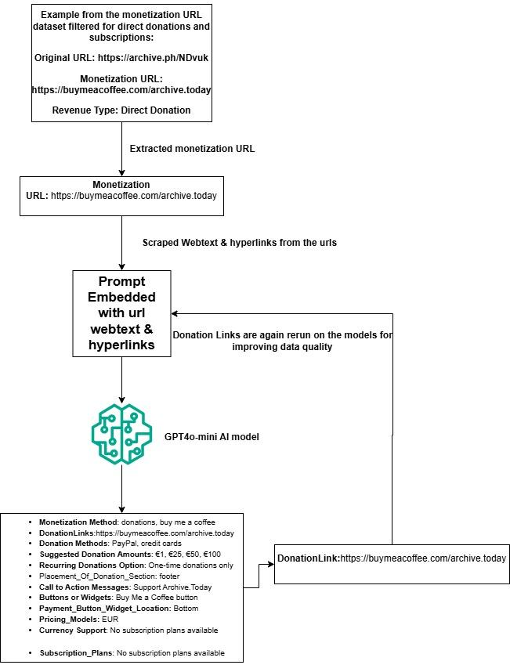

Step5: Processing of Monetization URLs: Product/Magazine Sales Monetization

Filtering for Product Sales Monetization Method

Input:
- Subset of URLs focusing on Product Sales and Magazine Sales methods.
- Prompt for extracting detailed product-related data.
Output:
- Refined dataset containing detailed information for each product or magazine, including:
  - Product Name: The name of the product or magazine.
  - Product Description: A brief description, if available.
  - Price: Listed price, if provided.
  - Discount or Offers: Information on promotional discounts or offers.
  - Product Category: The main category (e.g., books, apparel).
  - Subcategory: Specific subcategory, if applicable.
  - Product Page URL: Direct link to the product’s page.
  - Related Products or Links: Links to similar or related items.
  - Brand Name: The brand or publisher associated with the product.
  - Seller Information: Details about the seller, if mentioned.
  - Shipping Information: Options, delivery times, or other details about shipping.
  - Product Image URL(s): Links to product images.
  - Video URL(s): Links to any product-related videos.
  - Promotional Banners or Ads: Banners or ads promoting the product.
  - Special Campaigns or Discounts: Ongoing campaigns or discounts.
  - Product Tags or Keywords: Tags or keywords associated with the product.
  - Webpage Title: Title of the product’s webpage.
  - Meta Description: Meta description of the webpage, if available.
  - Last Updated Date: Date when product details were last updated.
  - Publisher or Website Owner: The website or company hosting the product.
Process:
- Subset Creation: Filtered URLs to focus on Product and Magazine Sales.
- Data Extraction:
  - Used the OpenAI GPT-4o-mini model to scrape and analyze webpage content.
  - Employed detailed prompts to capture the key information listed abov
- Output Generation:
  - Compiled the extracted details into a structured format for analysis.
This process ensures comprehensive data collection for all product and magazine sales methods utilized by the disinformation-spreading websites

Example of Data Extraction of Product/Magazine Sales URL
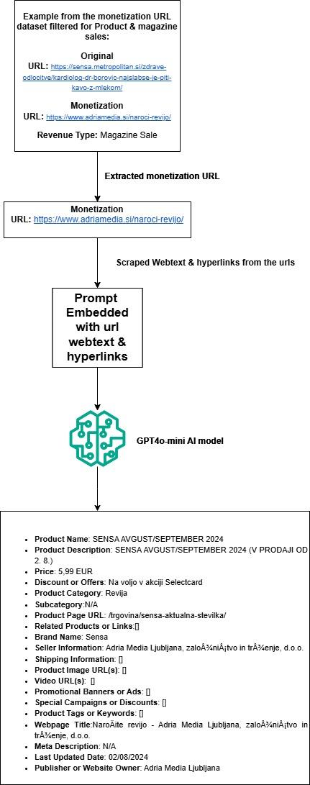

Step6: Processing of Monetization URLs: Advertising
Input:
- Subset of URLs focused on Advertising Monetization Methods.
Output:
- A refined dataset containing advertising-related details, including:
  - Email: Contact email for advertising inquiries.
  - Contact Number: Phone number for advertisers.
  - Advertising Rates: Pricing for advertisements.
  - Advertising Platforms: Media platforms used (e.g., radio, internet, print, television).
  - Advertising Dimensions: Ad sizes and formats.
  - Currency: Currency in which ad rates are quoted.
  - Payment Options: Available payment methods for advertisers.
  - Advertising Details Links: URLs to guides or pages with detailed advertising options or rates.
Process:
- Subset Creation:
  - Filtered URLs to focus specifically on advertising monetization methods.
- Manual Review and Data Extraction:
  - Manually screened the web pages associated with the URLs to extract advertising-related information.
  - Gathered contact details (email and phone) for advertising inquiries.
  - Identified advertising rates, ad dimensions, and available payment options.
- Advertising Details from PDF Guides:
  - Most advertising details for disinformation-spreading websites were obtained from informational guides or rate guides available in PDF format.
  - These guides were accessible through URLs provided under the "Advertising Details Links" field in the CSV file
  - The guides contained critical information about advertising, including pricing details based on the dimensions and locations of advertisements on the platform.

Prompt for Direct donation/Subscriptions Extraction:

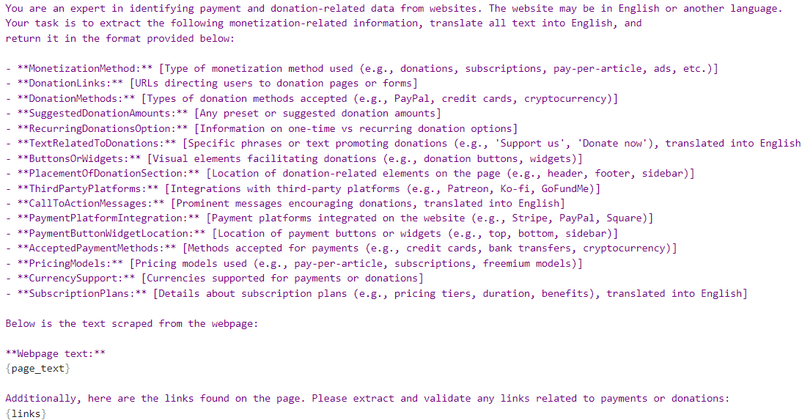

Prompt for Product/Magazine Sales Extraction:
