**LAB 19**

//opengl app for illustration of orthogonal projection

#include <GL/glut.h>

int win_width = 800;

int win_height = 600;

void drawCube() {

glBegin(GL_QUADS);

// Front face

glColor3f(1.0f, 0.0f, 0.0f); // Red

glVertex3f(-0.5f, -0.5f, 0.5f);

glVertex3f(0.5f, -0.5f, 0.5f);

glVertex3f(0.5f, 0.5f, 0.5f);

glVertex3f(-0.5f, 0.5f, 0.5f);

// Back face

glColor3f(0.0f, 1.0f, 0.0f); // Green

glVertex3f(-0.5f, -0.5f, -0.5f);

glVertex3f(0.5f, -0.5f, -0.5f);

glVertex3f(0.5f, 0.5f, -0.5f);

glVertex3f(-0.5f, 0.5f, -0.5f);

// Left face

glColor3f(0.0f, 0.0f, 1.0f); // Blue

glVertex3f(-0.5f, -0.5f, -0.5f);

glVertex3f(-0.5f, -0.5f, 0.5f);

glVertex3f(-0.5f, 0.5f, 0.5f);

glVertex3f(-0.5f, 0.5f, -0.5f);

// Right face

glColor3f(1.0f, 1.0f, 0.0f); // Yellow

glVertex3f(0.5f, -0.5f, -0.5f);

glVertex3f(0.5f, -0.5f, 0.5f);

glVertex3f(0.5f, 0.5f, 0.5f);

glVertex3f(0.5f, 0.5f, -0.5f);

// Top face

glColor3f(0.0f, 1.0f, 1.0f); // Cyan

glVertex3f(-0.5f, 0.5f, 0.5f);

glVertex3f(0.5f, 0.5f, 0.5f);

glVertex3f(0.5f, 0.5f, -0.5f);

glVertex3f(-0.5f, 0.5f, -0.5f);

// Bottom face

glColor3f(1.0f, 0.0f, 1.0f); // Magenta

glVertex3f(-0.5f, -0.5f, 0.5f);

glVertex3f(0.5f, -0.5f, 0.5f);

glVertex3f(0.5f, -0.5f, -0.5f);

glVertex3f(-0.5f, -0.5f, -0.5f);

glEnd();

}

void display() {

glClear(GL_COLOR_BUFFER_BIT | GL_DEPTH_BUFFER_BIT);

glMatrixMode(GL_MODELVIEW);

glLoadIdentity();

gluLookAt(1.5, 1.5, 1.5, 0, 0, 0, 0, 1, 0);

drawCube();

glutSwapBuffers();

}

void reshape(int w, int h) {

glViewport(0, 0, w, h);

glMatrixMode(GL_PROJECTION);

glLoadIdentity();

glOrtho(-1.5, 1.5, -1.5, 1.5, -10.0, 10.0);

glMatrixMode(GL_MODELVIEW);

glLoadIdentity();

}

int main(int argc, char *argv[]) {

glutInit(&argc, argv);

glutInitDisplayMode(GLUT_DOUBLE | GLUT_RGB | GLUT_DEPTH);

glutInitWindowSize(win_width, win_height);

glutInitWindowPosition(100, 100);

glutCreateWindow("LAB-19 Niraj Maharjan");

glClearColor(1.0f, 1.0f, 1.0f, 1.0f);

glEnable(GL_DEPTH_TEST);

glutDisplayFunc(display);

glutReshapeFunc(reshape);

glutMainLoop();

return 0;

}

**OUTPUT**

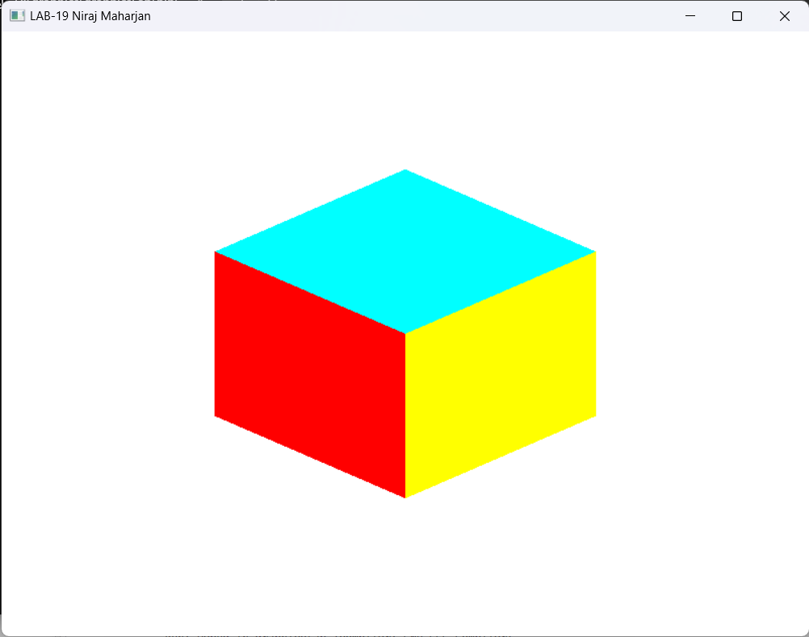

**LAB 20**

//opengl app tp show clipping using orthogonal project

#include <GL/glut.h>

int win_width = 800;

int win_height = 600;

void display() {

glClear(GL_COLOR_BUFFER_BIT);

// Set up the clipping region using glOrtho

glMatrixMode(GL_PROJECTION);

glLoadIdentity();

glOrtho(-0.4, 0.4, -0.4, 0.4, -1.0, 1.0);

// Draw the original non-filled triangle

glColor3f(0.0f, 0.0f, 1.0f);

glBegin(GL_LINE_LOOP);

glVertex2f(-0.5f, -0.4f);

glVertex2f(0.7f, -0.2f);

glVertex2f(0.2f, 0.7f);

glEnd();

glutSwapBuffers();

}

void reshape(int w, int h) {

glViewport(0, 0, w, h);

glMatrixMode(GL_PROJECTION);

glLoadIdentity();

gluOrtho2D(-1.0, 1.0, -1.0, 1.0);

glMatrixMode(GL_MODELVIEW);

glLoadIdentity();

}

int main(int argc, char *argv[]) {

glutInit(&argc, argv);

glutInitDisplayMode(GLUT_DOUBLE | GLUT_RGB);

glutInitWindowSize(win_width, win_height);

glutInitWindowPosition(100, 100);

glutCreateWindow("LAB-20 Niraj Maharjan");

glClearColor(1.0f, 1.0f, 1.0f, 1.0f);

glutDisplayFunc(display);

glutReshapeFunc(reshape);

glutMainLoop();

return 0;

}

**OUTPUT**

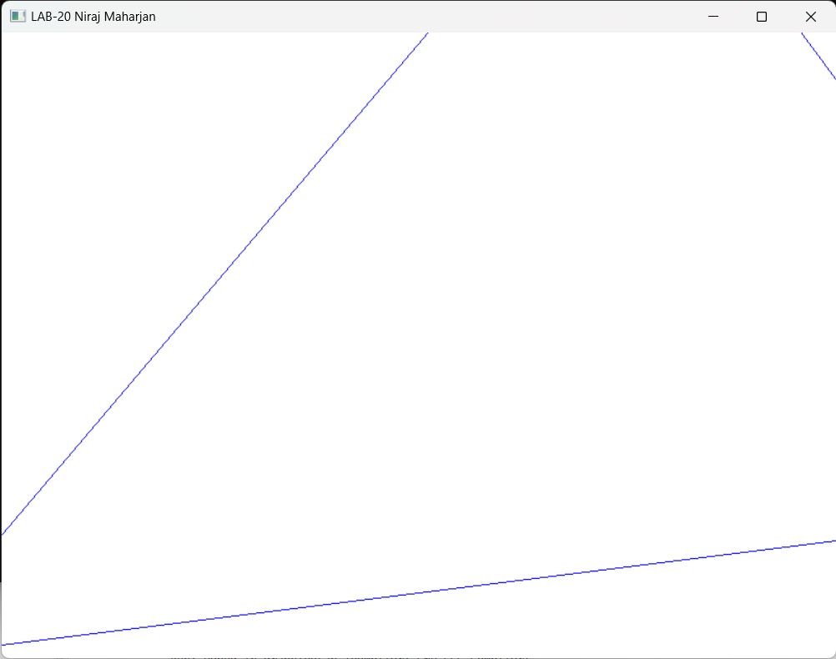

**LAB 21**

//OPENGL app to show rectangle in two different viewports

#include <GL/glut.h>

int win_width = 800;

int win_height = 600;

void display() {

glClear(GL_COLOR_BUFFER_BIT);

// Set up viewport for the left rectangle

glViewport(0, 0, win_width / 2, win_height);

glMatrixMode(GL_PROJECTION);

glLoadIdentity();

glOrtho(-1.0, 1.0, -1.0, 1.0, -1.0, 1.0);

glMatrixMode(GL_MODELVIEW);

glLoadIdentity();

// Draw the left rectangle

glColor3f(0.0f, 0.0f, 1.0f);

glBegin(GL_POLYGON);

glVertex2f(-0.8f, -0.8f);

glVertex2f(-0.2f, -0.8f);

glVertex2f(-0.2f, 0.8f);

glVertex2f(-0.8f, 0.8f);

glEnd();

// Set up viewport for the right rectangle

glViewport(win_width / 2, 0, win_width / 2, win_height);

glMatrixMode(GL_PROJECTION);

glLoadIdentity();

glOrtho(-1.0, 1.0, -1.0, 1.0, -1.0, 1.0);

glMatrixMode(GL_MODELVIEW);

glLoadIdentity();

// Draw the right rectangle

glColor3f(1.0f, 0.0f, 0.0f);

glBegin(GL_POLYGON);

glVertex2f(0.2f, -0.8f);

glVertex2f(0.8f, -0.8f);

glVertex2f(0.8f, 0.8f);

glVertex2f(0.2f, 0.8f);

glEnd();

glutSwapBuffers();

}

void reshape(int w, int h) {

glViewport(0, 0, w, h);

glMatrixMode(GL_PROJECTION);

glLoadIdentity();

gluOrtho2D(-1.0, 1.0, -1.0, 1.0);

glMatrixMode(GL_MODELVIEW);

glLoadIdentity();

}

int main(int argc, char *argv[]) {

glutInit(&argc, argv);

glutInitDisplayMode(GLUT_DOUBLE | GLUT_RGB);

glutInitWindowSize(win_width, win_height);

glutInitWindowPosition(100, 100);

glutCreateWindow("LAB-21 Niraj Maharjan");

glClearColor(1.0f, 1.0f, 1.0f, 1.0f);

glutDisplayFunc(display);

glutReshapeFunc(reshape);

glutMainLoop();

return 0;

}

**OUTPUT**

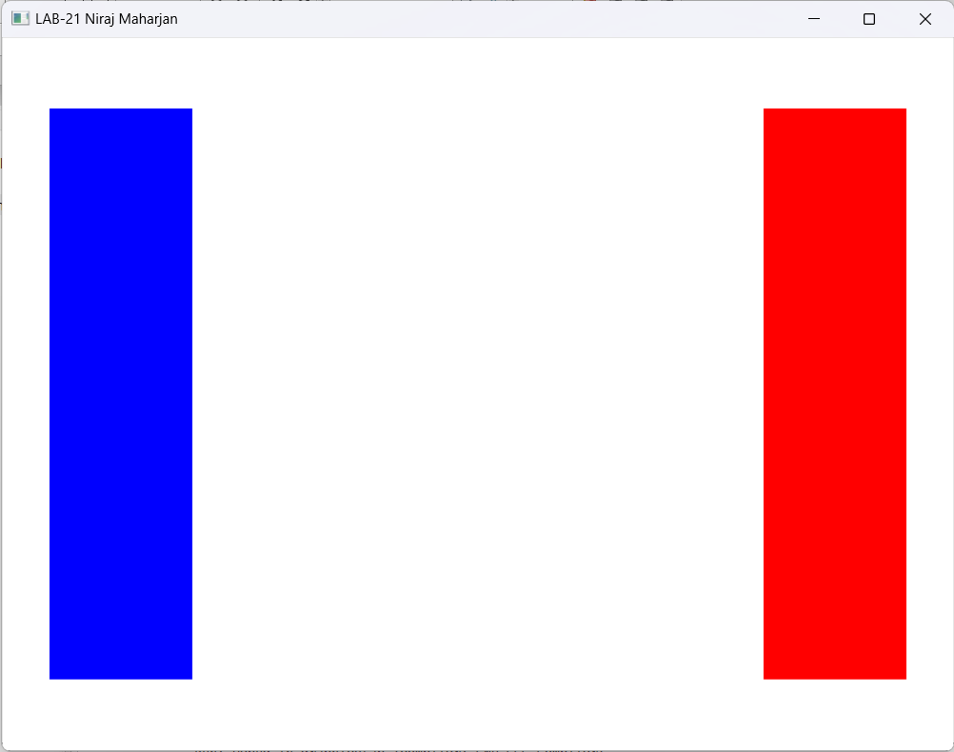

**LAB-22**

//OPEN_GL implementation of cohen shuterland algorithm

#include <GL/glut.h>

int wx_max = 100, wy_max = 100, wx_min = 50, wy_min = 50;

int x_1 = 40, x_2 = 100, y_1 = 50, y_2 = 150;

int getCode(int x, int y){

int code = 0000;

if (x < wx_min)

code |= 1;

else if (x > wx_max)

code |= 2;

if (y < wy_min)

code |= 4;

else if (y > wy_max)

code |= 8;

return code;

}

void drawline(int x_1, int y_1, int x_2, int y2){

glClear(GL_COLOR_BUFFER_BIT);

glColor3f(0.0f, 0.0f, 0.0f); // black

glLineWidth(2.0);

// Draw the window

glBegin(GL_LINE_LOOP);

glVertex2i(wx_min, wy_min);

glVertex2i(wx_max, wy_min);

glVertex2i(wx_max, wy_max);

glVertex2i(wx_min, wy_max);

glEnd();

// Draw the line

glColor3f(0.0f, 0.0f, 1.0f); // blue

glBegin(GL_LINES);

glVertex2i(x_1, y_1);

glVertex2i(x_2, y2);

glEnd();

glFlush();

}

void cohen_sutherland(){

int code1 = getCode(x_1, y_1);

int code2 = getCode(x_2, y_2);

bool accept = false;

do

{

// Check if the line is completely inside or outside the window

if ((code1 == 0) && (code2 == 0))

{

accept = true;

break;

}

else if (code1 & code2)

{

break;

}

else

{

glColor3f(1.0f, 0.0f, 0.0f);

// Clipping variables

int code;

float m = (float)(y_2 - y_1) / (float)(x_2 - x_1);

float c = y_1 - m * x_1;

float x, y;

// Find the intersection points

if (code1 != 0)

code = code1;

else

code = code2;

if (code & 1) // Left boundary

{

y = m * wx_min + c;

x = wx_min;

}

else if (code & 2) // Right boundary

{

y = m * wx_max + c;

x = wx_max;

}

else if (code & 4) // Bottom boundary

{

x = (wy_min - c) / m;

y = wy_min;

}

else if (code & 8) // Top boundary

{

x = (wy_max - c) / m;

y = wy_max;

}

if (code == code1)

{

x_1 = x;

y_1 = y;

code1 = getCode(x_1, y_1);

}

else

{

x_2 = x;

y_2 = y;

code2 = getCode(x_2, y_2);

}

}

} while (accept == false);

}

void display(){

drawline(x_1, y_1, x_2, y_2);

Sleep(1000);

cohen_sutherland();

drawline(x_1, y_1, x_2, y_2);

}

int main(int argc, char **argv){

glutInit(&argc, argv);

glutInitDisplayMode(GLUT_SINGLE | GLUT_RGB);

glutInitWindowSize(800, 600);

glutCreateWindow("LAB-22 Niraj Maharjan");

glClearColor(1.0f, 1.0f, 1.0f, 1.0f);

glMatrixMode(GL_PROJECTION);

glLoadIdentity();

gluOrtho2D(-20, 200, -20, 200);

glMatrixMode(GL_MODELVIEW);

glutDisplayFunc(display);

glutMainLoop();

return 0;

}

**OUTPUT:**

