#Assignment No. 3 : KNN Classification

#Import packages
Import numpy as np
Import pandas as pd
#reading dataset
dataset=pd.read_csv(“c://data.csv”)
x=dataset.iloc[:,:-1].values
y=dataset.iloc[:,2].values
#import KNeighborsClassifier and create object of it
from sklearn.neighbors import KNeighborsClassifier
classifier = KNeighborsClassifier (n_neighbors=3)
classifier .fit_(X,y)
#predict class for the points(6,6)
X_test=np.array([6,6])
y_pred=classifier.predict([X_test])
print ‘General KNN:’,y_pred
classifier = KNeighborsClassifier (n_neighbors=3,Weight=’distance’)
classifier .fit_(X,y)

#predict class for the points(6,6)
X_test=np.array([6,6])
y_pred=classifier.predict([X_test])
print ‘Distance Weighted KNN:’,y_pred
classifier = KNeighborsClassifier (n_neighbors=3,Weight=’distance’)
classifier .fit_(X,y)

data.csv
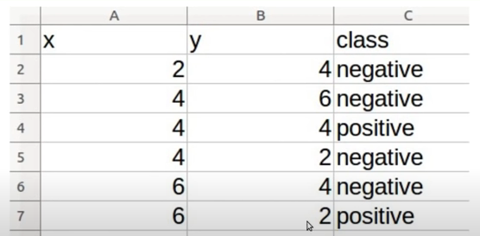

Output :
