**Cryptography & Network Security**

PRN - 2019BTECS00026

Name - Niraja Vasudev Kulkarni

Batch - B1

**Assignment - 1**

* **Title - Caeser Cipher**
* **Objective -**

Decrypting the cipher text encrypted using Caesar Cipher

* **Theory** -

The Caesar Cipher technique is one of the earliest and simplest methods of encryption technique. It’s simply a type of substitution cipher, i.e., each letter of a given text is replaced by a letter with a fixed number of positions down the alphabet. The method is apparently named after Julius Caesar, who apparently used it to communicate with his officials.

Procedure -

1. Take the plain text from user as an input
2. Apply the given shift & find the cipher text - For example with a shift of 3, A would be replaced by D, B would become E, and so on.

* **Code –**

#include <bits/stdc++.h>

using namespace std;

string encrypt(string plainText, int key)

{

    string ans = "";

    for (int i = 0; i < plainText.length(); i++)

    {

        ans += char(int(plainText[i] + key - 'A') % 26 + 'A');

    }

    return ans;

}

int main()

{

    int option;

    cout << "How do you want to give input?:\n1) Through terminal\n2) Through File\n";

    cin >> option;

    string plainText;

    int key;

    cout << "Enter Key (Shift): ";

    cin >> key;

    switch (option)

    {

    case 1:

        cout << "Enter the plain text: ";

        break;

    case 2:

        freopen("input.txt", "r", stdin);

        freopen("output.txt", "w", stdout);

        break;

    default:

        break;

    }

    cin >> plainText;

    cout << "Cipher Text: "

         << encrypt(plainText, key) << "\n";

    return 0;

}

* **Outputs –**

Sample output 1 –

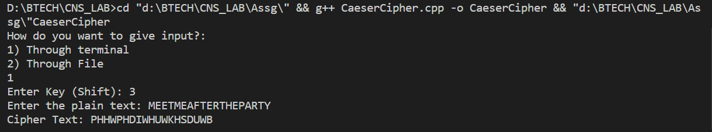

Sample output 2 -

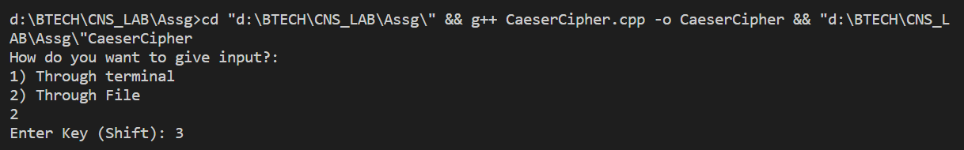

Input file -

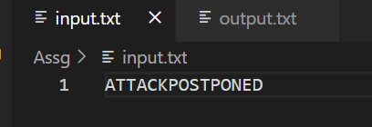

Output file -

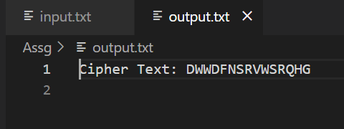

* **Conclusion –**

Caesar Cipher is simple substitution (mono alphabetic) technique. The key can be deciphered easily. So, it is a classical way of cryptography which is not secure in modern era.