**Cryptography & Network Security**

PRN - 2019BTECS00026

Name - Niraja Vasudev Kulkarni

Batch - B1

**Assignment - 4**

**Vigenere Cipher**

* **Objective -**

To implement Vigenere Cipher in C

* **Theory -**

Vigenere Cipher is a simple form of [polyalphabetic substitution](https://en.wikipedia.org/wiki/Polyalphabetic_cipher" \t "https://www.geeksforgeeks.org/vigenere-cipher/_blank). A polyalphabetic cipher is any cipher based on substitution, using multiple substitution alphabets. The encryption of the original text is done using the [Vigenere table](https://en.wikipedia.org/wiki/Vigen%C3%A8re_cipher" \l "/media/File:Vigen%C3%A8re_square_shading.svg" \t "https://www.geeksforgeeks.org/vigenere-cipher/_blank). The table consists of the alphabets written out 26 times in different rows, each alphabet shifted cyclically to the left compared to the previous alphabet, corresponding to the 26 possible[Caesar Ciphers](https://www.geeksforgeeks.org/caesar-cipher/). At different points in the encryption process, the cipher uses a different alphabet from one of the rows. The alphabet used at each point depends on a repeating keyword.

Procedure -

1. Take the input - plaintext & the key from user
2. Make the key size same as text size by repeating it as required
3. Add each character of key & text and find out the cipher text accordingly

* **Code Snapshots -**

#include <bits/stdc++.h>

using namespace std;

string generateKey(string plainText, string key)

{

    int i = 0;

    while (key.size() != plainText.size())

    {

        key.push\_back(key[i]);

        i++;

    }

    return key;

}

string encrypt(string plainText, string key)

{

    string ans;

    for (int i = 0; i < plainText.size(); i++)

    {

        char x = (plainText[i] + key[i]) % 26;

        x += 'A';

        ans.push\_back(x);

    }

    return ans;

}

string decrypt(string cipherText, string key)

{

    string plainText;

    for (int i = 0; i < cipherText.size(); i++)

    {

        char x = (cipherText[i] - key[i] + 26) % 26;

        x += 'A';

        plainText.push\_back(x);

    }

    return plainText;

}

int main()

{

    int option;

    string key, plainText, ans;

    cout << "How do you want to give input?:\n1) Through terminal\n2) Through File\n";

    cin >> option;

    cout << "Enter key: ";

    cin >> key;

    switch (option)

    {

    case 1:

        cout << "Enter plainText: ";

        break;

    case 2:

        freopen("input.txt", "r", stdin);

        freopen("output.txt", "w", stdout);

        break;

    }

    cin >> plainText;

    key = generateKey(plainText, key);

    ans = encrypt(plainText, key);

    cout << "Cipher plainText: " << ans << endl;

    cout << "Original plainText: " << decrypt(ans, key);

    return 0;

}

* **Outputs -**
* **Sample Output 1 -**

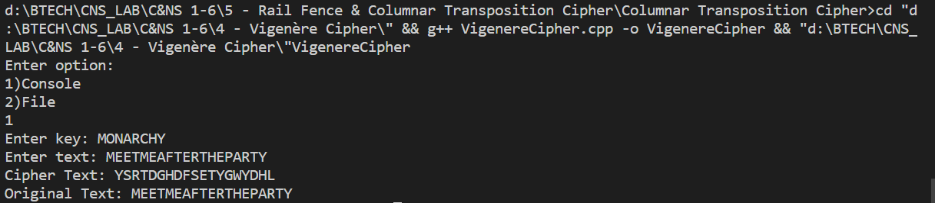

* **Sample Output 2-**

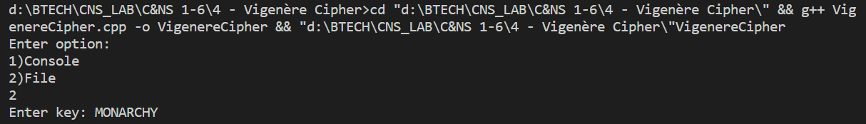

**Input file -**



**Output file -**

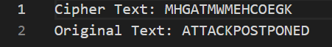

* **Conclusion -**

Vigenere Cipher is polyalphabetic substitution cipher , in which a single alphabet can be encrypted with different alphabets when its occurrence is repeated.