**Cryptography & Network Security**

PRN - 2019BTECS00026

Name - Niraja Vasudev Kulkarni

Batch - B1

**Assignment - 5**

**Transposition Ciphers - Railfence & Columnar**

* **Objective -**

To implement Railfence cipher & Columnar cipher in C

* **Theory -**

In a transposition cipher, the order of the alphabets is re-arranged to obtain the cipher-text. In the rail fence cipher, the plain-text is written downwards and diagonally on successive rails of an imaginary fence. When we reach the bottom rail, we traverse upwards moving diagonally, after reaching the top rail, the direction is changed again. Thus the alphabets of the message are written in a zig-zag manner. After each alphabet has been written, the individual rows are combined to obtain the cipher-text.

The Columnar Transposition Cipher is a form of transposition cipher just like Rail Fence Cipher. Columnar Transposition involves writing the plaintext out in rows, and then reading the ciphertext off in columns one by one.

* **Code Snapshots -**

**Railefence Cipher :**

#include <bits/stdc++.h>

using namespace std;

string encrypt(string plainText, int depth)

{

    char matrix[depth][(plainText.length())];

    for (int i=0; i < depth; i++)

        for (int j = 0; j < plainText.length(); j++)

            matrix[i][j] = '*';

    int d = -1;

    int r = 0, c = 0;

    for (int i=0; i < plainText.length(); i++)

    {

        if (r == 0 || r == depth-1)

            d = -1*d;

        matrix[r][c++] = plainText[i];

        if(d==1) r++; //d==1 means we should go down in the matrix

        else r--;

    }

    string cipherText;

    for (int i=0; i < depth; i++)

        for (int j=0; j < plainText.length(); j++)

            if (matrix[i][j]!='*')

                cipherText.push_back(matrix[i][j]);

    return cipherText;

}

int main()

{

    int option;

    cout << "How do you want to give input?:\n1) Through terminal\n2) Through File\n";

    cin >> option;

    string plainText;

    int depth;

    cout << "Enter Depth for RailFence cipher: ";

    cin >> depth;

    switch (option)

    {

    case 1:

        cout << "Enter Text: ";

        break;

    case 2:

        freopen("input.txt", "r", stdin);

        freopen("output.txt", "w", stdout);

        break;

    default:

        break;

    }

    cin >> plainText;

    cout << "Cipher Text: "

         << encrypt(plainText, depth) << "\n";

    return 0;

}

**Columnar Cipher -**

#include <bits/stdc++.h>

using namespace std;

string encrypt(string key, string plainText,bool printSteps) {

vector <int> pos;

    for(int i=1;i<=key.length();i++)

    {

        int j;

        for(j=0;j<key.length();j++)

        {

            if(key[j]==char(i+48))

            break;

        }

        pos.push_back(j);

    }

    string cipherText="";

    int k=0,j;

    int rows=(int)ceil(floor(plainText.length())/floor(key.length()));

    int cols=key.length();

    vector<vector<char>> mat( rows , vector<char> (cols, 0));

    for(int i=0;i<rows;i++)

    {

        for( j=0;j<cols;j++)

        {

            mat[i][j]='*';

        }

    }

    for(int i=0;i<rows;i++)

    {

        for( j=0;j<cols;j++)

        {

            if(plainText[k]=='\0')

              break;

            mat[i][j]=plainText[k++];

        }

        if(j!=key.length())

        break;

    }

    if(printSteps)

    {

        cout<<"\nMatrix for columnar encryption:\n";

     for(int i=0;i<rows;i++)

    {

        for(int j=0;j<key.length();j++)

        {

            cout<<mat[i][j]<<" ";

        }

        cout<<"\n";

    }

    }

    int cnt=0;

    for(int loop=0;loop<cols;loop++)

    {

        for(int j=0;j<rows;j++)

        {

                cipherText.push_back(mat[j][pos[loop]]);

        }

    }

  return cipherText;

}

string decrypt(string key, string cipherText,bool printSteps)

 {

vector <int> pos;

    for(int i=1;i<=key.length();i++)

    {

        int j;

        for(j=0;j<key.length();j++)

        {

            if(key[j]==char(i+48))

            break;

        }

        pos.push_back(j);

    }

    string plainText="";

    int j,cnt=0;

    int rows=(int)ceil(floor(cipherText.length())/floor(key.length()));

    int cols=key.length();

    vector<vector<char>> mat( rows , vector<char> (cols, 0));

    for(int i=0;i<cols;i++)

    {

        for( j=0;j<rows;j++)

        {

            mat[j][pos[i]]=cipherText[cnt++];

        }

    }

    if(printSteps){

cout<<"\nMatrix for columnar decryption:\n";

     for(int i=0;i<rows;i++)

    {

        for(int j=0;j<cols;j++)

        {

            cout<<mat[i][j]<<" ";

        }

        cout<<"\n";

    }

    }

    for(int i=0;i<rows;i++)

    {

        for(int j=0;j<cols;j++)

        {

          if(mat[i][j]!='*')

          plainText.push_back(mat[i][j]);

        }

    }

  return plainText;

}

string removeDummy(string cipherText)

{

    string ans;

    for(int i=0;i<cipherText.size();i++)

    {

        if(cipherText[i]!='*')

        ans.push_back(cipherText[i]);

    }

    return ans;

}

int main()

{

  int option;

    cout << "How do you want to give input?:\n1) Through terminal\n2) Through File\n";

    cin >> option;

    string plainText;

    string key;

    bool printSteps=false;

    cout << "Enter key: ";

    cin >> key;

    switch (option)

    {

    case 1:

        cout << "Enter Text: ";

        break;

    case 2:

        freopen("input.txt", "r", stdin);

        freopen("output.txt", "w", stdout);

        break;

    default:

        break;

    }

    if(option==1) printSteps=true;

    cin >> plainText;

    string cipherText=encrypt(key,plainText,printSteps);

    cout << "Cipher Text: "

         << removeDummy(cipherText) << "\n";

    string original=decrypt(key,cipherText,printSteps);

    cout << "Original Text: "

         << original << "\n";

    return 0;

}

* **Outputs -**

1. **Railfence Cipher :**

* **Sample Output 1 -**

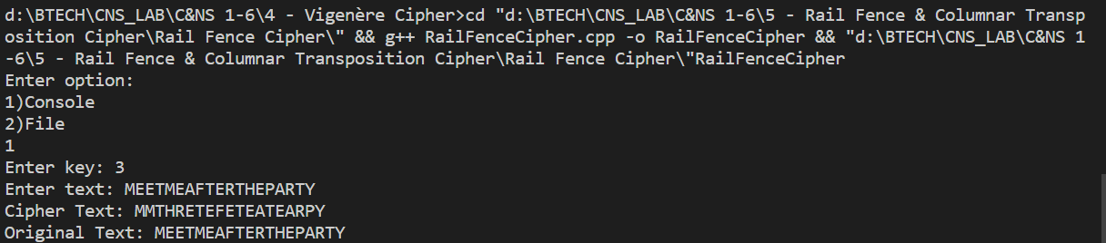

* **Sample Output 2 -**

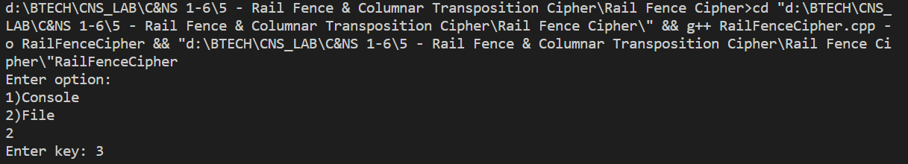

Input file -



Output file -

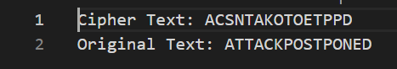

1. **Columar Cipher -**

* Sample Output 1 -

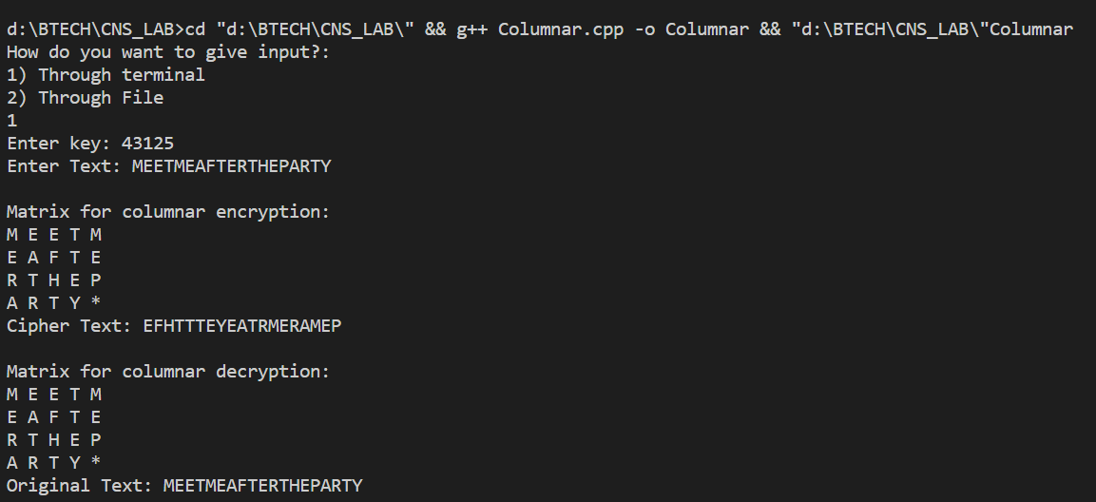

* **Sample Output 2 -**

Input file -



Output File -

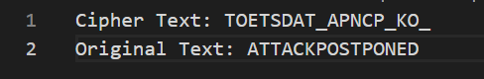

* **Conclusion -**

 The number of columns in rail fence cipher remains equal to the length of plain-text message. And the key corresponds to the number of rails. In case of columnar cipher , the message is written out in rows of a fixed length, and then read out again column by column, and the columns are chosen in some scrambled order. Both of them are simple transposition ciphers.