

**TRIBHUVAN UNIVERSITY**

**INSTITUTE OF ENGINEERING**

**THAPATHALI CAMPUS**

**Report**

**On**

**Online Bus Ticket Software**

**Submitted by:**

Pratik Sharma (THA081BEI031)

Pujan Thapa Magar (THA081BEI032)

Shivam Adhikari (THA081BEI041)

Shrizal Aryal (THA081BEI042)

**Submitted to:**

Department of Electronics and Computer Engineering

Thapathali Campus

Kathmandu, Nepal

February 2025

# 

# DECLARATION

We hereby declare that the report of the project entitled **“Bus Ticketing System”** which is being submitted to the **Department of Electronics and Computer Engineering, IOE, Thapathali Campus**, in the partial fulfillment of the requirements for the award of the Degree of Bachelor of Engineering in **Electronics, Communication and Information Engineering**, is a bonafide report of the work carried out by us. The materials contained in this report have not been submitted to any University or Institution for the award of any degree and we are the only author of this complete work and no sources other than the listed here have been used in this work.

Pratik Sharma (THA081BEI031) ________________________

Pujan Thapa Magar(THA081BEI032) ________________________

Shivam Adhikari (THA081BEI041) ________________________

Shrizal Aryal (THA081BEI042) ________________________

# CERTIFICATE OF APPROVAL

The undersigned certify that they have read and recommended to the **Department of Electronics and Computer Engineering, IOE, Thapathali Campus**, a project work entitled “**Bus Ticketing System**” submitted by **Pratik Sharma, Pujan Thapa Magar, Shivam Adhikari** and **Shrizal Aryal** in partial fulfillment for the award of Bachelor’s Degree in Electronics and Communication Engineering. The Project was carried out under special supervision and within the time frame prescribed by the syllabus.

We found the students to be hardworking, skilled and ready to undertake any related work to their field of study and hence we recommend the award of partial fulfillment of Bachelor’s degree of Electronics and Communication Engineering.

Project Supervisor

Prajwal Pakka

Department of Electronics and Computer Engineering, Thapathali Campus

Project Co-ordinator

Anup Shrestha

Department of Electronics and Computer Engineering, Thapathali Campus

Umesh Kamant Ghimire

Head of the Department,

Department of Electronics and Computer Engineering, Thapathali Campus

# COPYRIGHT

The author has agreed that the library, Department of Electronics and Computer Engineering, Thapathali Campus, may make this report freely available for inspection. Moreover, the author has agreed that the permission for extensive copying of this project work for scholarly purpose may be granted by the professor/lecturer, who supervised the project work recorded herein or, in their absence, by the head of the department. It is understood that the recognition will be given to the author of this report and to the Department of Electronics and Computer Engineering, IOE, Thapathali Campus in any use of the material of this report. Copying of publication or other use of this report for financial gain without approval of the Department of Electronics and Computer Engineering, IOE, Thapathali Campus and author’s written permission is prohibited.

Request for permission to copy or to make any use of the material in this project in whole or part should be addressed to department of Electronics and Computer Engineering, IOE, Thapathali Campus.

# 

# ACKNOWLEDGEMENT

We express our heartfelt gratitude to everyone who supported us throughout the development of the "**Online Bus Ticket Software**" project. This project would not have been possible without the encouragement, guidance, and support of several individuals and organizations.

We sincerely thank our mentor, **Anup Shrestha sir and Prajwal Pakka sir**, if applicable, for their invaluable suggestions and constant guidance, which helped us navigate challenges and achieve the project objectives. Their expertise and constructive feedback have been instrumental in shaping this work.

Our deepest appreciation extends to the **Department of Electronics and Computer Engineering, Thapathali Campus**, for providing us with the necessary resources and an environment conducive to learning and innovation.

Lastly, we extend our gratitude to our peers, family, and friends for their unwavering encouragement and support, which motivated us throughout the project's completion

# ABSTRACT

This is the project on developing Online Bus Ticketing Software using C programming. The development of system software will be done as a console-based application, wherein users will have two different roles: one client and one admin. The client can view the available buses, check the availability in any particular bus, book a ticket or cancel, and retrieve booking details. The admin will have privileges to add/remove buses, manage schedules, and access passenger records. The project targets the improvement of practical understanding in file handling, data structures, and input/output operations in feasibility analysis was made, considering technical, operational, economic, and legal aspects with special emphasis on the Nepalese context. Although the present system is a basic prototype, it acts as the foundation for possible future enhancements in terms of graphical interfaces, networking capabilities, and integration with online payment facilities. The project is helpful for the learning process of first-year engineering students to have practical experience in software development and problem-solving.

***Keywords:*** *C programming, file handling, bus ticketing system, data structures, console-based application*

**Table of Contents**

DECLARATION i

CERTIFICATE OF APPROVAL ii

COPYRIGHT iii

ACKNOWLEDGEMENT iv

ABSTRACT v

List of Tables vii

List of Diagrams vii

List of Abbreviations vii

1. INTRODUCTION 1

1.1 Background 1

1.2 Motivation 1

1.3 Objectives 1

2. LITERATURE REVIEW 3

2.1 RedBus 3

2.2 Bus Sewa 4

3. FEASIBILITY STUDY 5

3.1 Technical Feasibility 5

3.2 Operational Feasibility 5

3.3 Economic Feasibility 5

3.4 Legal Feasibility 6

4. SYSTEM ARCHITECTURE AND METHODOLOGY 7

4.1 Block Diagram/Architecture 7

4.2 Flowcharts/Algorithms (and other design methods) 8

5. IMPLEMENTATION DETAILS 10

5.1 Header Files 10

5.2 Functions and Conditional Statements 10

5.3 File Handling 11

6. RESULTS AND ANALYSIS 12

6.1 Project Outputs 12

6.2 Error Analysis 12

7. FUTURE ENHANCEMENT 13

8. TIME ESTIMATION 13

9. CONCLUSION 14

References 15

# List of Tables

Table 8.1: Time Gantt Chart……................................................................................... 7

# List of Diagrams

Table 4.2(a): flowchart diagram…................................................................................9

# List of Abbreviations

|  |  |
| --- | --- |
| BITS | Birla Institute of Technology and Science |
| EMTA | European Metropolitan Transport Authority |
| GDS | Gramin Dak Sevak |
| GMV | Gross Merchandise Value |
| GUI | Graphics User Interface |
| HTML | Hyper Text Markup Language |
| PHP | Hypertext Preprocessor |
|  |  |
|  |  |

# INTRODUCTION

## Background

The software will be created using C programming using its different libraries supporting string and other standard things and file handling. Our “Online Bus Ticketing Software” would contain two servers. One for client another for the admin. Clients can see available buses, check seat availability, book and cancel their reservations and check their details entered whereas the admin side would have option to add or remove buses to any routes and time and see all passenger details. This is console based software where all operations takes place in console of the computer. Overall, the project would help us get hands on experience in C program as well as strengthen our understanding of C programming basics, including file handling, libraries, and useful functions.

## Motivation

For the first project using C program in Bachelor level, we decided to prepare something simple yet beneficial for us to understand different libraries, file handling and other useful keywords and functions of C programming and make our basics strong. Our plan was to built something that would make us work comfortably and enhance our coding skills on the same time. So, we decided to prepare “Online Bus Ticket Software”. This software is not a new concept but as a first semester student it would help in enhancing our performance practically as well as theoretically helping in code redundancy and be familiar with different libraries and explore new syntax and libraries of C program. For our group, this project is officially a starting point of our coding journey and hope it goes in our way.

## Objectives

The main objective of this project is**:**

* To understand file handling, data structure and input/output operations
* To ensure proper storage and retrieval of ticketing data using files

**1.4 Scope and Applications**

The Online Bus Ticketing Software provides a simple easy to use platform for passengers to book them bus tickets. Some of its functionalities includes viewing available buses, checking availability of seats, booking bus tickets, canceling their reservation, and displaying passenger’s details. The system uses file handling to store and retrieve data on routes, bookings, and passenger information.  Designed in C program, the project ensures that the working of the project is efficient by menu-driven interface and input validation. While focused on core functionalities, the system has scalability and real-time update issues; it thus acts more as a stand-alone educational prototype.

This project will provide a practical implementation of C programming concepts for first-year students, such as input/output operations, data structures and file handling. It will also provide basic knowledge about the  real projects dealing with reservation systems, whether for buses, trains, or flights. The project can also be presented as an academic project or demonstration for showcasing problem-solving, data management, and workflow design skills. Moreover, it might be a stepping stone toward more complex systems with networking, GUI integrations, or online payments for future projects. Finally, it is practical experience and provides an introduction to the practical implementation of the concepts of programming.

# LITERATURE REVIEW

A consultant with European Metropolitan Transport Authority (EMTA), Mohamed Mezghani (2008) stated that EMTA has established a working group to work on the issue of electronic ticketing. This group is mandated to generate knowledge, exchange/compile information and learn from the experience of its members in the field of electronic ticketing. In his framework, EMTA has launched a study on electronic ticketing in public transport under the supervision of the working group and they designed certain concepts such as the public transport pricing, public transport ticketing and electronic ticketing in public transport. On the contrary, his research which discussed certain concepts in relation to electronic ticketing in public transport was a one-directional article which didn’t relate the idea about customer reserving seats and for their journey at a date chosen by them. Nevertheless, this project will be designed to encapsulate these areas mentioned as well as display certain screenshots of the customers’ reservations system.[1]

## RedBus

redBus is an online platform form where one can book bus through their portal or mobile app. Based in Bangalore, India, redBus operates over 3,500 buses across different countries like India, Malaysia, Indonesia, Singapore, Peru and Colombia. It has enabled more than 180 million trips and has a customer base of over 20 million. In 2018, the company reached a GMV of ₹50 billion, which is approximately ₹67 billion or $770 million in 2023, with a market share of 70% in the Indian online bus ticketing market.

Founded in the year 2006 by three engineers from BITS Pilani-Phanindra Sama, Sudhakar Pasupunuri, and Charan Padmaraju-with an initial investment of ₹500,000, the company was later acquired by Ibibo Group in 2013, which itself merged with MakeMyTrip in 2017. Other than this, redBus owns BOGDS, a cloud service for bus operators, and SeatSeller, a GDS for the distribution of the bus inventory.[2]

## Bus Sewa

Bus Sewa is an online platform that facilitates the purchase of bus tickets, providing a diverse selection for long and medium-distance travel to numerous destinations throughout Nepal. The platform offers real-time ticketing for luxury, tourist, and regular buses without any additional booking charges. With rigorous passenger services, Bus Sewa has successfully served over 1 million passengers over the years. It is the platform where numerous bus companies sell bus tickets to passengers from around the world. Bus Sewa now has become one of the leading online bus tickets buying platform of Nepal due to its user-friendly interface and conveniency. [3]

# FEASIBILITY STUDY

In the context of Nepal, a feasibility analysis for an online bus ticketing software would consider factors specific to the local environment, infrastructure, and regulatory requirements. Below is how the feasibility analysis applies to Nepal:

## Technical Feasibility

Internet access in Nepal is on the path to improvement; however, in rural areas, there's poor connectivity. In such cases, an online bus ticketing system should be able to support these customers through some offline functionalities. Though the software was created in C program, but interfaces and integrations of payments and navigations will need a combination of C with web technologies-HTML, JavaScript, PHP, or mobile development tools. The system should be integrated with local payment gateways like eSewa and Khalti and support multiple languages.

## Operational Feasibility

The software  should have a user-friendly interface that would allow the  people with minimal computer skills to utilize this software , and it should support mobile and desktop versions because of the high mobile usage in Nepal. It requires an intuitive interface and support for various languages to increase its usage. This will involve ongoing support and maintenance, ensuring there is a customer service channel that will handle bookings, payments, and inquiries efficiently. The system should be scalable to handle increasing users, have various bus routes, and bookings with increased internet access and the use of mobile phones.

## Economic Feasibility

The C-based online bus ticketing system may be cheaper in an initial stage, but integrating it with web technologies, payment gateways, and mobile apps will add the budget to it. It needs skilled developers, server infrastructure, and maintenance costs. It provides the revenue potential in the form of ticket sales, ads, or partnerships with the bus companies; however, in rural areas, the adoption may be slow due to low digital literacy and access to the internet. The project should align with Nepal's economic constraints, offering low transaction fees to attract users.

## Legal Feasibility

The system shall be at par with the local law and regulations on data privacy laws, such as the Personal Data Protection Act; it has to adhere to set regulations by the Department of Transport Management, Nepal. It assures security management in users' data and the validity of transactions. The system would need cooperation from bus operators and, where necessary, permits from transport authorities to access or manipulate data about bus timetables and bookings. The integration of payment gateways should also follow the set standards for the same.

# SYSTEM ARCHITECTURE AND METHODOLOGY

This section elaborates on the system architecture, block diagram, and methodologies employed in the development of the "Online Bus Ticketing Software.

## Block Diagram/Architecture

The **block diagram** provides a visual representation of how different components of the system interact.

1. INPUT BLOCK

* Accepts user input from the admin or client, such as bus details, booking information, or cancellation requests.
* Interfaces used: Console-based input.

1. Processing Block

* Implements logic for various functionalities including ticket booking, cancellation, and updating bus schedules.
* Components include:
* **Admin functionalities:** Add/remove buses, view passenger details.
* **Client functionalities:** Check availability, book tickets, cancel bookings.

1. File Management Block

* Handles storage and retrieval of data using files like bus.txt and passenger.txt
* Ensures persistent data management for all operations.

1. Output Block

* Displays the result of operations such as ticket availability, booking confirmations, or admin updates.
* Medium: Console Display

1. Control Block

* Acts as a mediator between input, processing, and output blocks.
* Ensures flow control based on user roles (admin or client) and operations selected.

## ****Flowcharts/Algorithms (and other design methods)****

This subsection outlines the step-by-step flow of the system through flowcharts and algorithms.

1. **Algorithms:**

* Ticket Booking Algorithm

1. Input bus number and passenger details.

2. Check seat availability in `buses.txt`.

3. If seat available:

a. Update seat count in `buses.txt`.

b. Add passenger details in `bus_[busnumber].txt`.

4. Else:

Display error message.

5. End.

* Admin Operations Algorithm

1. Display admin menu options (Add Bus, Remove Bus, View Passengers, Exit).

2. Take user input for choice.

3. Perform the corresponding action:

a. Add Bus → Write to `buses.txt`.

b. Remove Bus → Update `buses.txt`.

c. View Passengers → Read passenger files for selected bus.

4. Return to admin menu or Exit.

1. **Flowchart:**

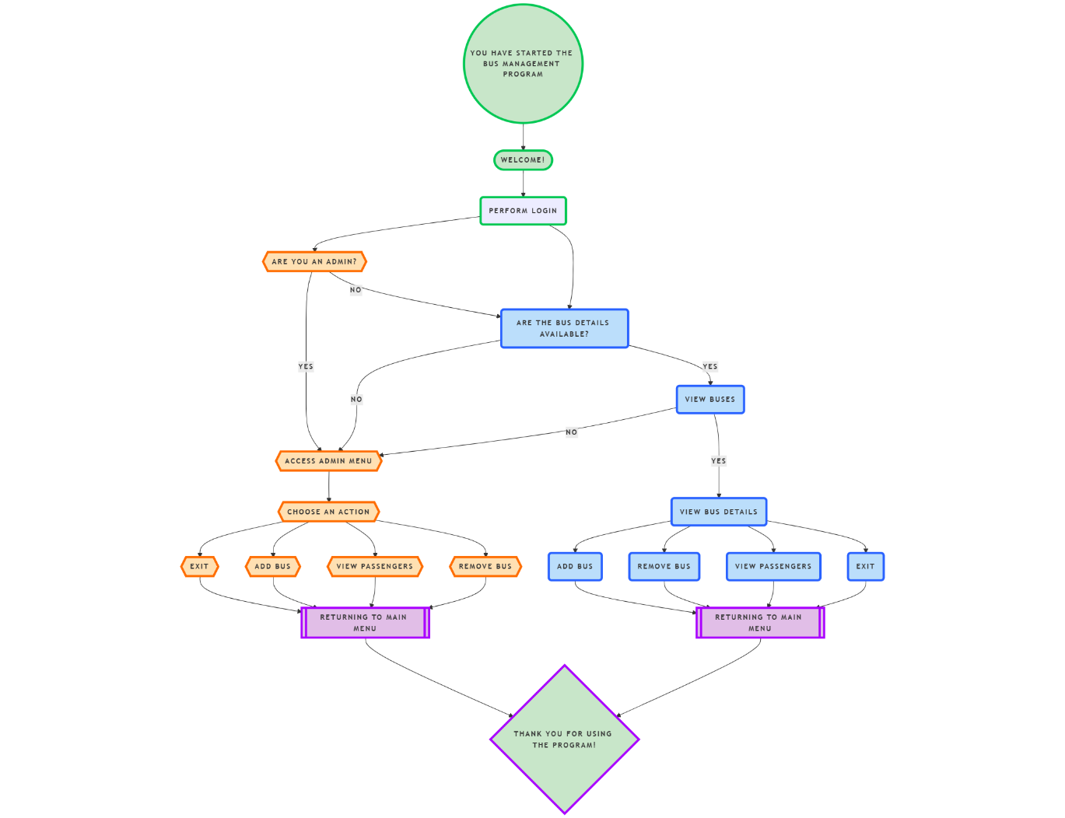

Fig 4.2(a): flowchart diagram of bus management system

# IMPLEMENTATION DETAILS

The various methodologies that were used in gathering data and analysis which are relevant to the research includes different header files, structures and file handling.

## Header Files

In C language, header files contain the set of predefined standard library functions. It contains C function declarations and macro definitions to be shared between several source files. In this project, we have used several header files as per convenience that are listed below:

* stdio.h
* stdlib.h
* string.h
* conio.h

## Functions and Conditional Statements

Functions are used in almost every step of development of this software. Any activity to be performed if handed out to the respective functions which makes the program readable as well as efficient. These userdefined functions are accessed from main functions.

Similarly, conditional statements are also used densely in the program. What is to be done when something specific happens is governed by the conditional statements in the programming world. They make programming easier by branching out a single statement with multiple outcomes. The customer can choose the type of bus he wants to do in desired location in desired time and have his desired seat and can cancel the tickets anytime before bus leaves.

## File Handling

File handling in C provides the facility for persistence, that is, storing and retrieving related data in an online bus ticketing system. A typical system involves a number of data, such as information about buses, passenger bookings, and transactions made. For such data management, files can be opened in modes like r, w, a with functions like fopen(), fscanf(), fprintf() and fclose().

The file can store all the information in “buses.txt” that may include details of bus number, routes, and sitting capacity. And, when this data is fetched to make available the viewable buses of a user using fscanf(), this would display to him. Using fprintf(), he could write upon every booking with details like Ticket Id, bus Id, Name, and Seat number in an existing file “tickets.txt” in case he wanted to book the seat, cancel, or edit the book.

A mode, while “a” mode ensures appending without overwriting the previous records. In the same manner, it reads the data within the file in order to have current occupancy, previous bookings, and transactions maintained within the system. The respective error handling mechanism needs to be maintained for every filling operation.  
Because the information remains there for different sessions, this makes file handling a strong and efficient and scalable system that handles bookings and bus management with transaction handling.

# RESULTS AND ANALYSIS

## Project Outputs

* **Numeric Outputs:** The program successfully reads and writes data for buses and passengers into text files. The following outputs were observed during testing:
* Total number of buses added/removed: X.
* Tickets successfully booked: Y.
* Tickets canceled: Z.
* **Graphical Results:** Though the system is console-based, graphs can be generated (outside the program) to represent metrics like:
* Bus utilization rates.
* Booking success rates over time.

## Error Analysis

* **Sources of Errors:**
* Incorrect or invalid file paths leading to failure in reading or writing data.
* Input errors such as seat numbers already booked or bus details entered incorrectly.
* Limited validation of edge cases (e.g., seats exceeding available capacity).
* **Impact of Errors:**
* Slight deviations in total available seats due to improper updates.
* System crashing if files were missing or improperly formatted.
* **Mitigation Measures:**
* Added error handling for file operations.
* Implemented validation checks to ensure input correctness and prevent invalid data processing.

# FUTURE ENHANCEMENT

* **Graphical User Interface (GUI)**

Transition from a console-based application to a more user-friendly graphical interface using libraries such as **GTK+** or **Qt** for desktop versions.

* **Networking Capabilities**

Enable online accessibility, allowing users to book tickets via the internet.

* **Integration with Payment Gateways**

Incorporate secure payment options like **eSewa**, **Khalti**, or international gateways such as **PayPal** for online transactions.

* **Database Integrations**

Replace file handling with a robust database system, such as **MySQL** or **SQLite**, to improve scalability and efficiency in data storage and retrieval.

# TIME ESTIMATION

Table 8.1: Time Estimation Gantt Chart

# CONCLUSION

The **"Online Bus Ticketing Software"** project provided a hands-on opportunity to apply fundamental concepts of C programming, including file handling, structured programming, and input/output operations. The implementation of a console-based application for both administrative and client users demonstrated a practical understanding of modular programming and systematic data management.

Key takeaways include:

1. **Learning Outcome:** Gaining foundational skills in programming logic, file operations, and user interaction design.
2. **Practical Application:** Building a prototype system that can evolve into a full-fledged ticketing application with added features like GUI and networking capabilities.
3. **Challenges Addressed:** Successfully navigating challenges in data validation, input accuracy, and ensuring a smooth workflow for users.

Although currently serving as a basic prototype, the project highlights the potential for future scalability. With further development, the integration of networking, advanced search, secure payment gateways, and multi-platform support can significantly enhance the system's usability and real-world applicability.

This project not only solidifies programming skills but also acts as a stepping stone for more complex software development ventures, marking an important milestone in the academic and professional journey.

# References

1. Mohamed Mezghani, “Study on electronic ticketing in public transport”, May 2008
2. Wikipedia, “redBus”, January 2025.
3. Tripadvisior, “Bus Sewa”, January 2025