**Name=Niraj Kumar**

**Mongodb Assignment**

Connect to a running mongo instance, use a database named mongo_practice. Document all your queries in a javascript file to use as a reference.

Insert the following documents into a movies collection.

title : Fight Club

writer : Chuck Palahniuko

year : 1999

actors : [ Brad Pitt Edward Norton ]

title : Pulp Fiction

writer : Quentin Tarantino

year : 1994

actors : [ John Travolta Uma Thurman ]

title : Inglorious Basterds

writer : Quentin Tarantino

year : 2009

actors : [ Brad Pitt Diane Kruger Eli Roth ]

title : The Hobbit: An Unexpected Journey

writer : J.R.R. Tolkein

year : 2012

franchise : The Hobbit

title : The Hobbit: The Desolation of Smaug

writer : J.R.R. Tolkein

year : 2013

franchise : The Hobbit

title : The Hobbit: The Battle of the Five Armies

writer : J.R.R. Tolkein

year : 2012

franchise : The Hobbit synopsis : Bilbo and Company are forced to engage in a war against an array of combatants and keep the Lonely Mountain from falling into the hands of a rising darkness.

title : Pee Wee Herman's Big Adventure

title : Avatar

**Explanation**: Created a database named as Mongo_practice and inside the database , movies collection has been created and then inserted the document on by one.

The screenshots consist the entire code for insertion of each document.

To insert the document in movies collection db.movies.insert command has been used.

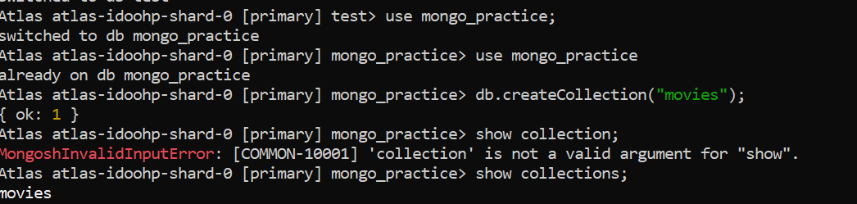

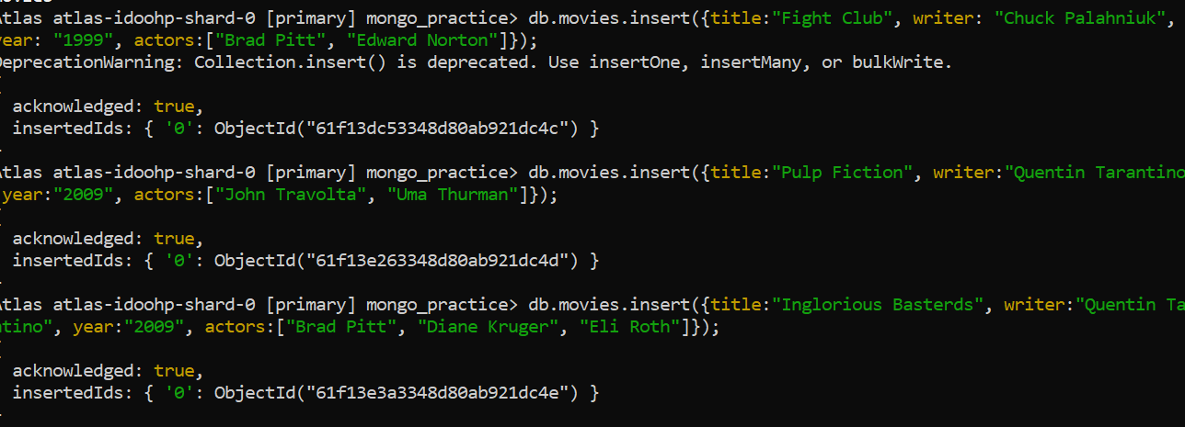

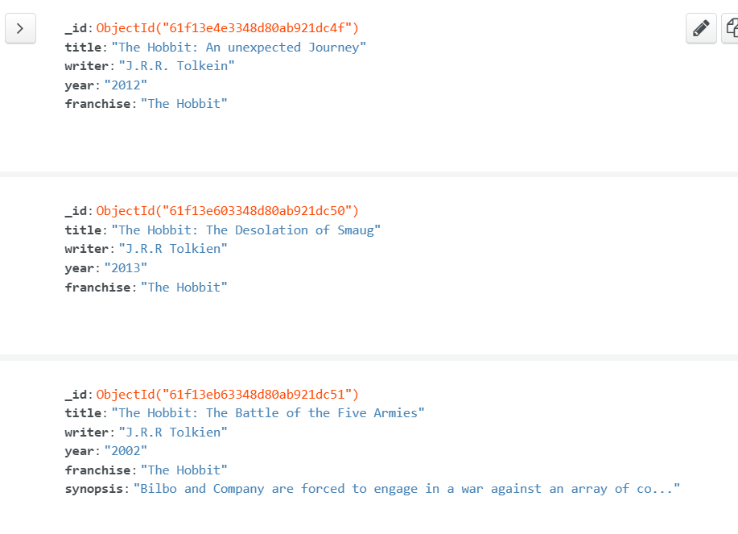

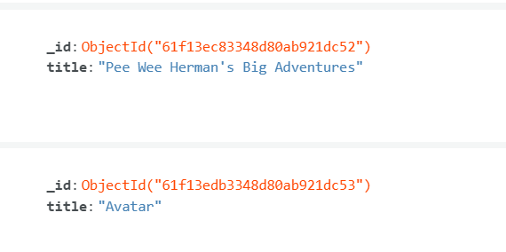

query the movies collection to

1. get all documents

db.movies.find();

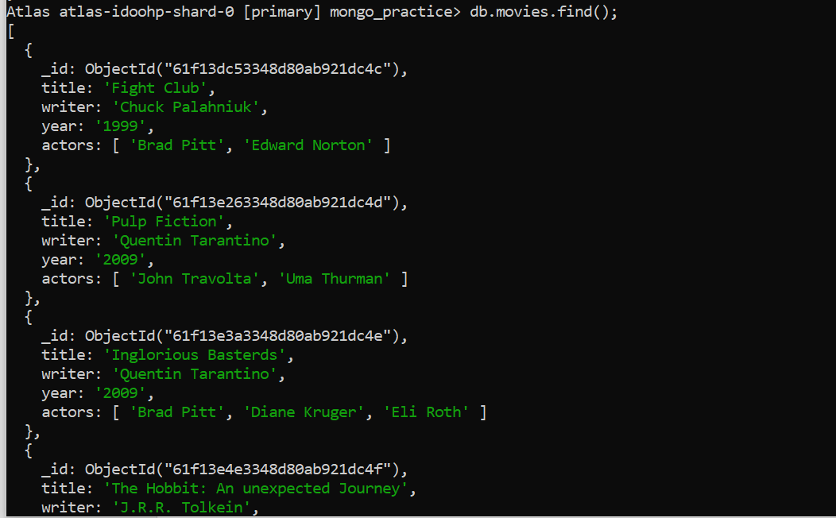

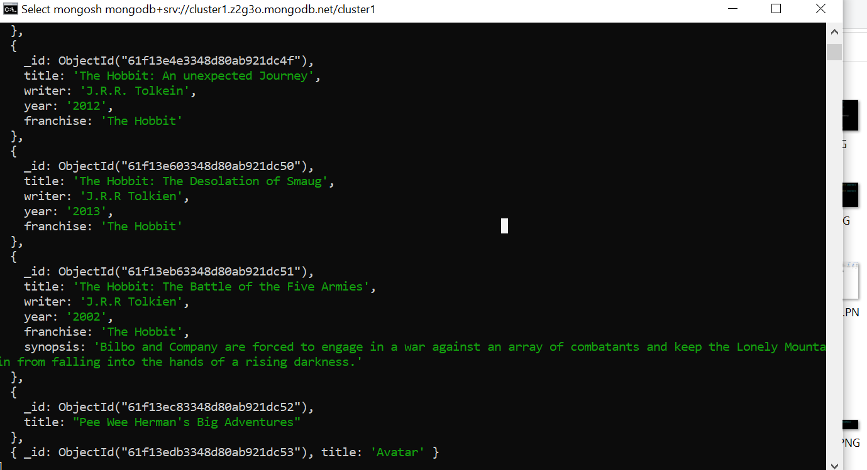

1. get all documents with writer set to "Quentin Tarantino"

Expalnation: db.movies.find({writer:”Quentin Tarantino”});

1. get all documents where actors include "Brad Pitt"

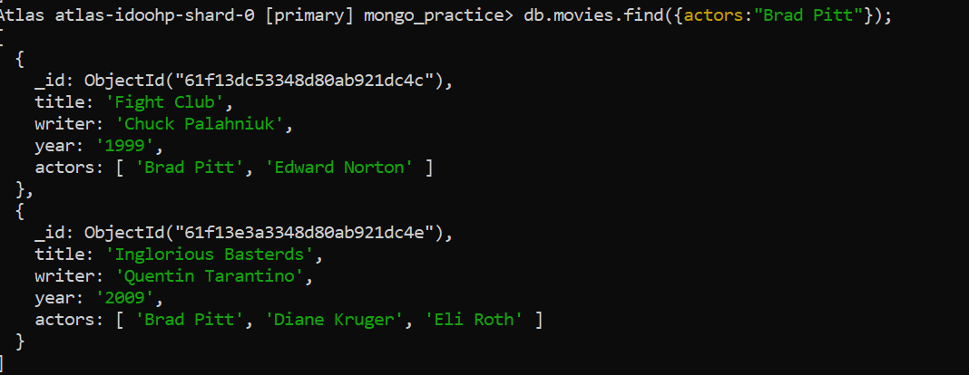

1. get all documents with franchise set to "The Hobbit"

1. get all movies released in the 90s

1. get all movies released before the year 2000 or after 2010

1. add a synopsis to "The Hobbit: An Unexpected Journey" : "A reluctant hobbit, Bilbo Baggins, sets out to the Lonely Mountain with a spirited group of dwarves to reclaim their mountain home - and the gold within it - from the dragon Smaug."

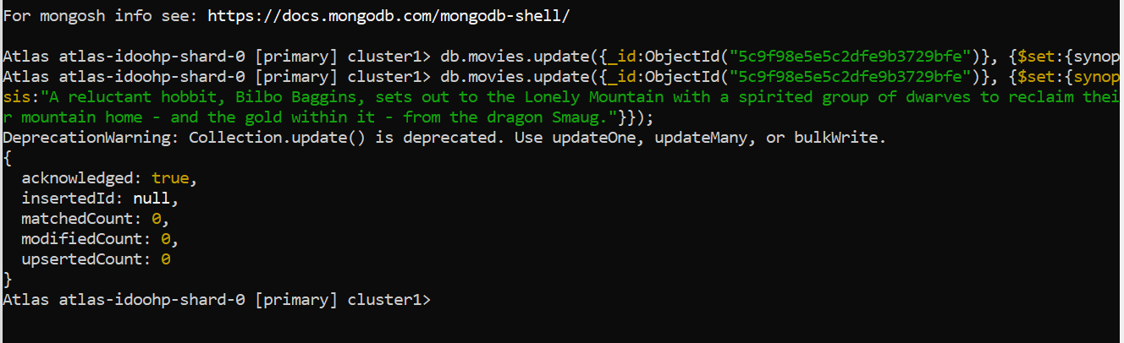

add a synopsis to "The Hobbit: The Desolation of Smaug" : "The dwarves, along with Bilbo Baggins and Gandalf the Grey, continue their quest to reclaim Erebor, their homeland, from Smaug. Bilbo Baggins is in possession of a mysterious and magical ring."

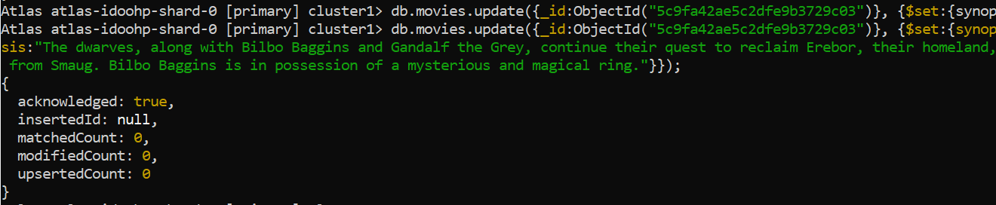

add an actor named "Samuel L. Jackson" to the movie "Pulp Fiction"

1. find all movies that have a synopsis that contains the word "Bilbo"

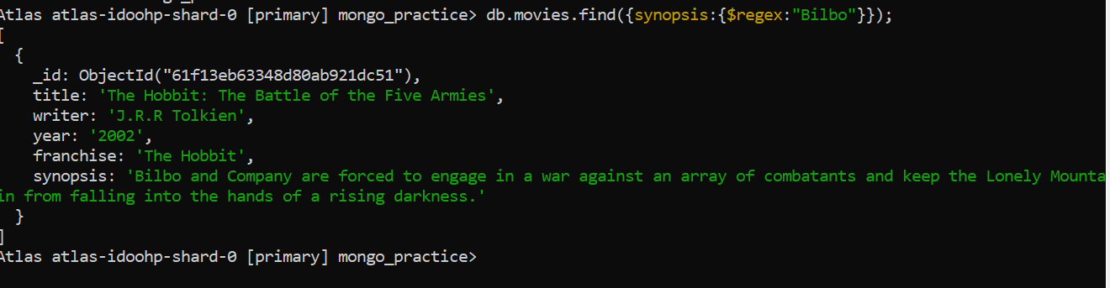

find all movies that have a synopsis that contains the word "Gandalf

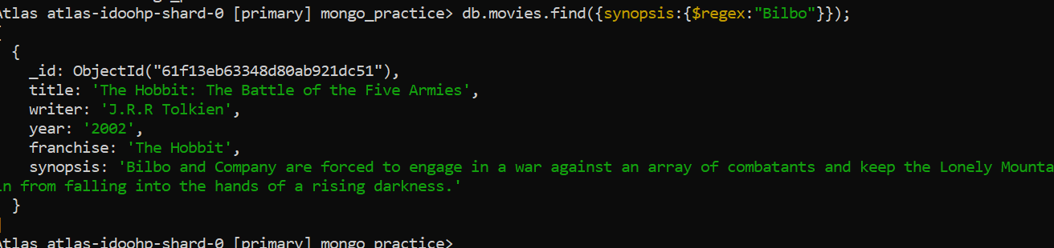

find all movies that have a synopsis that contains the word "Bilbo" and not the word "Gandalf"

