1. Generate the frequent itemsets and strong association rules for the below transaction data considering minimum support count=2 and minimum confidence threshold of 70%.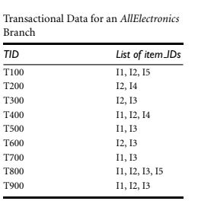
2. Generate the frequent itemsets and strong association rules for the below transaction data considering minimum support = 60% and minimum confidence threshold of 80%.

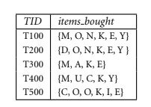

1. Generate the frequent itemsets and strong association rules for the below transaction data considering minimum support = 60% and minimum confidence threshold of 80%.

[SPECTF dataset](https://drive.google.com/drive/u/1/folders/1ri6B6AYyHT5hIWkvZzbbeXQq2seqZiD1)

**Note** : Consider the first 20 rows and 5 columns for generating frequent itemsets and association rules.