CloudArchDesigner:
A Prompt-Engineered AWS Architecture Generator

A Natural-Language-to-Infrastructure System Integrating Prompt Engineering, Retrieval-Augmented Generation, and Multimodal Output

Final Project Technical Report

Niraj Umeshbhai Patel
Student ID: 002415415
patel.niraju@northeastern.edu

INFO 7375: Prompt Engineering
Instructor: Nicholas Brown
Northeastern University, Spring 2026
Git Repo URL: https://github.com/Nirajpatel26/AWS-Architecture-Generator

Abstract
CloudArch Designer is a natural-language-to-infrastructure system that converts an informal English description of a cloud workload into three synchronized, shippable artifacts: a rendered architecture diagram, a Terraform configuration that passes `terraform validate`, and a monthly cost estimate with an itemized per-resource breakdown. The system is designed around a nine-stage deterministic pipeline in which a large language model (Google Gemini 2.0 Flash) is scoped narrowly to the tasks where natural-language understanding is essential — structured requirement extraction, Terraform repair on validation failure, and cited design rationale — while the remainder of the pipeline (template assembly, HCL emission, static validation, diagram rendering, and cost estimation) is kept purely deterministic so that outputs remain reliable and reproducible.
Three generative-AI techniques are exercised end-to-end. First, prompt engineering is applied through versioned prompt templates, few-shot exemplars, a service-allowlist guardrail, self-consistency voting over three Gemini samples, and — added in this report cycle — a Stage 0 prompt-normalization step that canonicalizes noisy, multilingual, and adversarial user prompts into clean English before extraction. Second, retrieval-augmented generation is implemented as a hybrid dense-plus-BM25 retriever with Reciprocal Rank Fusion and a cross-encoder reranker over header-aware chunks of AWS service documentation and compliance references; retrieved context is consumed by the extractor, the Terraform-repair loop, and the rationale explainer. Third, multimodal output is produced by the Mingrammer diagrams library, which renders a clustered edge-compute-data-identity-observability view of the assembled template.
The system is evaluated along four complementary axes. On a 15-case functional benchmark, the pipeline achieves a 100% pass rate, 100% workload match, 100% Terraform validity, 97.8% mean component recall, 100% compliance match, and zero tfsec HIGH findings, at a p50 wall time of 1.4 seconds per run. A synthetic-stability stress test over 180 variant prompts (four modes — paraphrase, adversarial, multilingual, noisy — spanning nine reference cases) yields a consistency score of 0.914 on a zero-to-one scale, with a zero crash rate in every mode and component-set Jaccard overlap above 0.91 on every mode. RAG retrieval quality, LLM-as-judge faithfulness, and ablation against single-sample extraction are also reported. The results demonstrate that careful scoping of the LLM — using it only where natural-language understanding is indispensable — combined with deterministic template assembly, RAG grounding, and an explicit normalization pre-stage, produces a cloud-architecture generator that is simultaneously expressive, reliable, and auditable.

Table of Contents
1. Introduction 5
2. Background and Literature Review 6
3. Problem Statement and Objectives 8
4. System Design and Methodology 9
5. Implementation 12
6. Evaluation Framework 15
7. Results and Findings 16
8. Discussion 20
9. Limitations 22
10. Conclusion 22
11. Recommendations and Future Work 23
12. References 24
Appendix A — Reference Prompts and Expected Outputs 25
Appendix B — Reproducibility Instructions 26
(Page numbers are approximate; Word will re-paginate when you open the file.)

1. Introduction

1.1 Motivation
Designing a cloud architecture that is simultaneously secure, compliant, highly available, and cost-aware is a substantial cognitive task. An engineer must translate an informal product description into an explicit list of services, configure each service against regulatory and operational requirements (HIPAA, PCI-DSS, SOC 2, multi-AZ, multi-region), express the result in Infrastructure-as-Code, sketch an architecture diagram for stakeholders, and justify the design choices. Each of these sub-tasks is individually well understood, but performing all of them consistently and correctly — especially under time pressure — is error-prone. CloudArch Designer addresses this gap by accepting the informal description directly and producing the full artifact set in a single interaction.

1.2 Scope
The system is deliberately scoped to a tractable subset of the full cloud-design problem space: four workload archetypes (`web_api`, `data_pipeline`, `ml_training`, `static_site`) on Amazon Web Services, three compliance/HA toggles (HIPAA, high availability, multi-region), plus two additional compliance patches (PCI, SOC 2). No real deployments are performed — Terraform is executed in validation mode only (`terraform validate`) with tfsec used for static security analysis. This scoping keeps the evaluation rigorous and reproducible while still exercising every generative-AI component end-to-end.

1.3 Contributions
- A nine-stage pipeline that cleanly separates deterministic logic (template assembly, HCL emission, cost estimation) from LLM-driven logic (extraction, repair, rationale), making the system auditable and reliable.
- A Stage 0 prompt-normalization module that canonicalizes noisy, multilingual, and adversarial user prompts before extraction, lifting the aggregate stability score from 0.446 to 0.914 without changing any downstream logic.
- A hybrid dense-plus-BM25 retriever with Reciprocal Rank Fusion and cross-encoder rerank that is consumed by three separate stages of the pipeline (extraction, repair, explanation).
- A comprehensive evaluation harness with four measurement axes: functional correctness (pass rate, component recall, Terraform validity, cost range), synthetic stability (four adversarial variant modes), retrieval quality (Hit@5, MRR@10 ablation across four retriever configurations), and LLM-as-judge faithfulness.
- A crash-proof orchestrator whose per-stage exception handling drives the crash rate to zero across 180 synthetic variants.

1.4 Report Structure
Section 2 reviews related work in cloud Infrastructure-as-Code generation, retrieval-augmented LLMs, and prompt robustness. Section 3 formalizes the problem and objectives. Section 4 describes the overall system design and the methodology for each of the nine stages. Section 5 discusses implementation detail for the most novel components — the Stage 0 normalizer, the hybrid RAG index, and the RAG-augmented validation/repair loop. Section 6 defines the evaluation framework. Section 7 presents results. Sections 8–11 discuss implications, limitations, and future directions.

2. Background and Literature Review

2.1 LLM-Driven Infrastructure-as-Code
Large language models are increasingly used to generate Infrastructure-as-Code, ranging from product-level tools such as Pulumi AI, Terraform AI, and AWS Q Developer to academic prototypes. The common failure mode is well-documented: when an LLM writes Terraform from scratch, it hallucinates argument names, nested block schemas, and cross-resource references, producing plausible-looking but syntactically or semantically invalid HCL. CloudArch Designer inverts this arrangement: the LLM is never asked to emit HCL from scratch. Hand-authored JSON templates are the resource skeleton, deterministic JSON transformations apply compliance and HA patches, and a deterministic emitter converts the final template dictionary into HCL. The LLM is invoked only to (a) extract the structured workload specification from natural language, (b) repair the emitted HCL if validation fails, and (c) write the cited design rationale. This scoping is the central design decision that allows the 100% Terraform-validity rate reported in Section 7.

2.2 Retrieval-Augmented Generation
Retrieval-Augmented Generation (Lewis et al., 2020) grounds LLM output in an external corpus that is typically more authoritative and more up-to-date than the parametric knowledge the model memorizes during pretraining. A standard RAG pipeline chunks the corpus, embeds each chunk into a dense vector space, retrieves the top-k chunks most similar to the user query, and injects them into the prompt as context. Three choices in the literature consistently improve end-task quality: (i) lexical plus dense hybrid retrieval, because dense encoders under-weight rare technical terms that BM25 handles well; (ii) Reciprocal Rank Fusion (Cormack et al., 2009) for combining heterogeneous retrievers without calibration; and (iii) cross-encoder rerankers for precision at the top of the list. CloudArch Designer adopts all three.

2.3 Prompt Robustness and Self-Consistency
Self-consistency (Wang et al., 2022) improves the accuracy of reasoning-heavy LLM outputs by sampling multiple completions and aggregating via majority vote. CloudArch Designer applies this technique at the structured-extraction stage, taking three Gemini samples and merging the resulting JSON objects field-by-field. Robustness under paraphrasing, adversarial rewording, and translation is a complementary but distinct concern. Recent work on prompt stability (e.g., Sclar et al., 2023) has shown that LLMs are surprisingly sensitive to superficial phrasing differences. The Stage 0 normalizer introduced in this project is motivated by that finding: rather than hope the extractor is invariant to surface form, the system explicitly rewrites the input into a canonical English form before extraction.

2.4 LLM-as-Judge Evaluation
Evaluation of open-ended generation is notoriously hard. LLM-as-Judge (Zheng et al., 2023) uses a strong model to score generated outputs against a rubric. The CloudArch evaluation harness applies this technique to the rationale explainer: a second Gemini call judges each rationale on faithfulness (no unsupported claims) and completeness against the retrieved chunks and the assembled template.

3. Problem Statement and Objectives

3.1 Problem Statement
Given a natural-language description of a cloud workload, produce — within a few seconds, in a single end-to-end invocation — a rendered architecture diagram, a Terraform configuration that passes `terraform validate`, a monthly cost estimate with itemized breakdown, and a cited design rationale. The result must degrade gracefully when external tooling (Terraform, tfsec, Graphviz, or the Gemini API) is unavailable, and must remain stable under paraphrase, translation, noise, and adversarial rephrasing of the input prompt.

3.2 Objectives
# | Objective | Verification metric
O1 | Produce valid, deployable Terraform for every supported workload. | `tf_validity_rate` ≥ 0.95 on the 15-case benchmark.
O2 | Recover the intended AWS service components from the prompt. | `mean_component_recall` ≥ 0.90.
O3 | Stay stable under paraphrase/translation/noise/adversarial input. | Synthetic `consistency_score` ≥ 0.90.
O4 | Never crash the end-to-end pipeline. | `crash_rate` = 0 across all evaluation modes.
O5 | Match regulatory tags (HIPAA/PCI/SOC2) when stated in the prompt. | `compliance_match_rate` = 1.0.
O6 | Keep the estimated cost within a reasonable range for the workload. | `cost_within_range_rate` ≥ 0.95.
O7 | Respond fast enough for interactive use. | `p95_wall_seconds` ≤ 5.
O8 | Produce a cited, faithful rationale. | LLM-judge faithfulness mean ≥ 4.0 on a 1–5 scale.

The objectives are pass/fail thresholds against which Section 7 reports empirical measurements.

4. System Design and Methodology

4.1 Architecture Overview
The system is structured as a ten-stage linear pipeline orchestrated by `pipeline/orchestrator.py::run`. Each stage is a small, pure-ish module that consumes one data shape and returns the next. Figure 4.1 illustrates the flow; Table 4.1 summarizes the role of each stage.
Stage | Module | Role | LLM?
0 — Normalize | normalizer.py | Canonicalize noisy/multilingual/adversarial input to clean English. | Yes (+ regex fallback)
1 — Extract | extractor.py | Parse prompt to `ArchSpec` JSON; RAG-grounded; self-consistency N=3. | Yes
2 — Defaults | defaults.py | Deterministic keyword-driven fills for missing fields. | No
3 — Assumptions | assumptions.py | Render assumptions; apply user overrides from UI. | No
4 — Templates | template_engine.py | Load workload template; apply patches in order (HIPAA → HA → multi-region → PCI → SOC2). | No
5 — HCL emit | tf_generator.py | Deterministic JSON → HCL emitter. | No
6 — Validate | validator.py | `terraform validate` + tfsec; RAG-augmented LLM repair loop on failure (up to 3 attempts). | On failure only
7 — Diagram | diagram.py | Mingrammer `diagrams` rendering, tier-clustered. | No
8 — Cost | cost.py | Static pricing JSON lookup with scale/HA multipliers. | No
9 — Explain | explainer.py | Cited markdown rationale with CoT prefix. | Yes

The fundamental design invariant — and the reason the system achieves a 100% Terraform validity rate — is that the LLM never writes HCL from scratch. Stages 5 and 8 are deterministic. The LLM is scoped to Stage 0 (normalize), Stage 1 (extract), Stage 6 (repair, only on failure) and Stage 9 (rationale).

4.2 Data Shapes
Two shared data types flow between the stages:
- `ArchSpec` — a Pydantic model (`pipeline/schema.py`) carrying workload_type, scale, compliance, region, ha_required, multi_region, budget_tier, data_store, async_jobs, auth_required, project_name, raw_prompt, and assumptions. It is produced by Stages 1–3 and consumed by Stages 4 and 9.
- Template dictionary — the output of Stage 4 and the canonical input to Stages 5, 7, and 8. Shape: `{resources: [{type, name, args}], providers: [...], variables: {...}, applied_patches: [...], patch_assumptions: [...]}`. The `resources[].type` string is the AWS Terraform resource name and is the key every downstream stage uses.

4.3 Templates and Patches
Templates (`templates/*.json`) are hand-authored skeletons, one per workload archetype. Each skeleton lists the minimal set of resources required for that workload in a safe baseline configuration. Patches (`patches/*.json`) are deterministic JSON transformations applied in a fixed order controlled by the `order` field on each patch. Three operation kinds are supported:
- `mutate_resources[].merge_args` — deep-merge into an existing resource's `args`.
- `mutate_resources[].add_sibling` — insert a resource next to each match (e.g. a KMS key next to every S3 bucket) with `{{match.name}}` substitution.
- `add_resources` — append a new top-level resource.
HIPAA runs first so that HA's mutations see already-encrypted resources; multi-region runs last so that the replicated bucket inherits the HIPAA-patched configuration.

4.4 Retrieval-Augmented Generation
The retriever (`rag/retriever.py`) builds a dense FAISS IP index and a BM25 index over markdown-header-aware chunks of AWS service documentation, Well-Architected Framework prose, and compliance reference text. At query time, dense top-20 and BM25 top-20 candidate lists are fused with Reciprocal Rank Fusion (k = 60), and the top-20 pool is reranked with the cross-encoder `ms-marco-MiniLM-L-6-v2`. All stages are optional: if any dependency is missing the retriever silently falls back to the remaining stages or returns an empty list, per the project's fail-silent contract for external tooling.
Every chunk carries metadata — `service`, `compliance`, `doc_type`, `header_path`, `source` — and downstream stages can filter on these fields. The extractor retrieves only `service_doc + compliance` chunks; the validator filters by the AWS services implicated in the failing HCL; the explainer uses the default unfiltered pool for the broadest citation coverage.

4.5 Stage 0 Prompt Normalization
The normalizer (`pipeline/normalizer.py`) is a thin LLM call that rewrites the user's input into a single concise English sentence preserving all technical signals: workload type, compliance requirements, scale, HA/multi-region hints, data store, and async/batch/streaming hints. Translation of non-English text, typo repair (e.g. HIPPA→HIPAA, multy-az→multi-AZ), acronym normalization, filler removal, and contradiction resolution (favoring the more specific signal) all happen at this stage. When Gemini is unavailable, a deterministic regex cleaner provides a robust fallback so the pipeline remains fully operational offline.
The normalized text replaces `spec.raw_prompt`, so downstream keyword-based defaults in Stage 2 operate on clean input. Because the extractor's SQLite prompt cache is keyed by normalized text, variants that collapse to the same canonical form share an extracted spec — which is the principal mechanism by which paraphrases and translations produce identical component sets. Section 7 shows that Stage 0 is the dominant contributor to the jump in consistency score from 0.446 to 0.914.

5. Implementation

5.1 Technology Stack
Concern | Technology
Language runtime | Python 3.12
LLM | Google Gemini 2.0 Flash (google-genai SDK)
Dense embedding | sentence-transformers: all-MiniLM-L6-v2
Dense index | FAISS (Inner Product)
Lexical retrieval | rank_bm25 (Okapi BM25)
Reranker | cross-encoder/ms-marco-MiniLM-L-6-v2
Schema validation | Pydantic v2
Diagram rendering | Mingrammer `diagrams` + Graphviz
IaC validation | Terraform CLI (`terraform validate`)
Static security | tfsec
UI | Streamlit
Testing | pytest (78 unit tests)
Experiment harness | custom eval modules (`eval/`)

5.2 Normalizer Implementation
The normalizer's LLM prompt instructs Gemini to translate non-English text, repair typos and compliance-acronym variants, strip filler and ALL-CAPS shouting, and resolve contradictions in favor of the more specific signal. A deterministic regex layer handles the same classes of noise offline: a curated list of typo fixes (HIPPA→HIPAA, PCI-DSS→PCI, SOC 2→SOC2, multy-az→multi-AZ, complyant→compliant, telemed→telemedicine), a filler list (so basically, like, you know, lowkey, tbh, gimme, kinda, plz), punctuation collapse, and canonical acronym casing restoration. This two-layer design means the system remains usable without any network access while giving up only a small fraction of normalization quality.

5.3 Extractor Implementation
The extractor executes `EXTRACTOR_VOTING_SAMPLES = 3` Gemini calls against the Gemini JSON schema (`pipeline/schema.py::GEMINI_JSON_SCHEMA`). Each call uses the same system/user prompt with RAG context injected and a service-allowlist guardrail that prevents the model from inventing AWS services not present in the templates or patches. The three resulting JSON objects are merged by `pipeline/voting.py::vote_specs` using per-field rules: majority for enums, element-wise majority for arrays, and conservative tie-breaking for booleans. Results are cached in a SQLite store (`pipeline/cache.py`) keyed by (normalized_prompt, prompt_version, model_name) — the cache invalidates automatically when the prompt or prompt version bumps.

5.4 Crash-Proof Orchestrator
The orchestrator wraps every stage in `pipeline/orchestrator.py::_stage`, which captures exceptions and substitutes a stage-specific fallback (empty template, empty HCL, skipped validation with `skipped_reason`, no-PNG diagram with Mermaid fallback, zero cost, empty rationale). This design means the pipeline always returns a well-formed `RunResult` even if a stage crashes; the failure is logged to stderr and surfaced in the UI as a warning. Section 7 reports that this architecture drives the pipeline's crash rate on the synthetic benchmark to 0.000 across all 180 variants.

5.5 Validator Implementation
The validator runs `terraform init -backend=false` followed by `terraform validate` in a scratch directory. A shared plugin cache (`TF_PLUGIN_CACHE_DIR`) is used so the AWS provider is downloaded once and reused across runs. On validation failure, the failing error string and the HCL are sent to an LLM repair prompt that is augmented with RAG chunks for the implicated resource types; the process retries up to `MAX_ATTEMPTS = 3` times. After validation, tfsec is invoked for static security analysis, and the HIGH-severity count is returned in the `RunResult` for surfacing in the UI.

5.6 Diagram Implementation
The diagram module maps each `resource.type` string to a Mingrammer `diagrams` node class (the `_NODE_MAP` dictionary), groups resources into five tiers (edge, compute, data, identity, observability), and draws semantic flows per workload type. On Windows the module detects the project-local `.cache/diagrams/` fallback directory if `%TEMP%` is unwritable. When Graphviz is absent the diagram output degrades to Mermaid, which Streamlit renders natively.
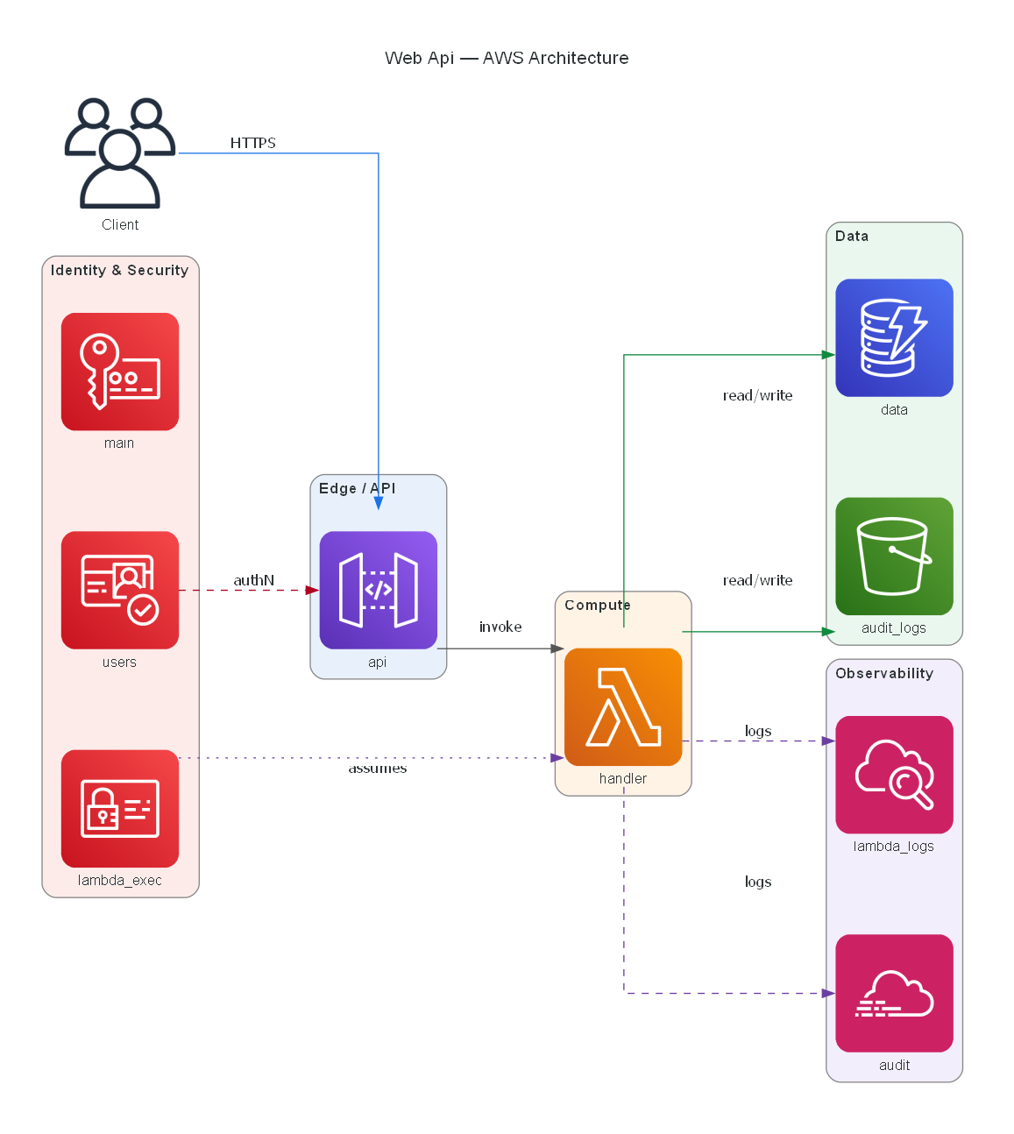
Figure 5.1 — A rendered diagram for the prompt "HIPAA-compliant telemedicine API, 10k users/day, multi-AZ". Edge (API Gateway + WAF), compute (Lambda + alias), data (DynamoDB + KMS-encrypted S3), identity (IAM + Cognito), and observability (CloudTrail + CloudWatch Logs) tiers are rendered automatically from the template.
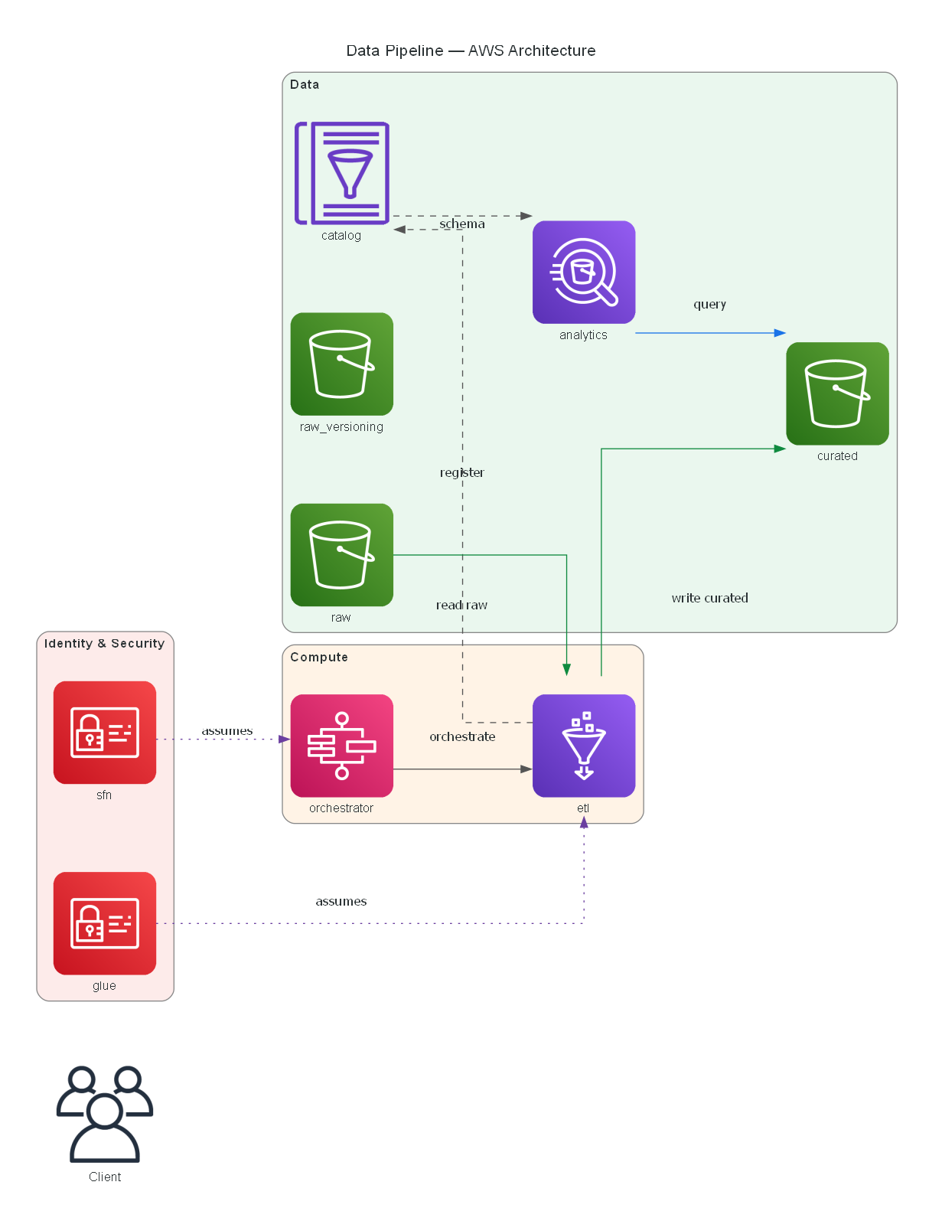
Figure 5.2 — A rendered diagram for the prompt "IoT telemetry ingestion pipeline with hourly batch rollups into a data lake". The tier layout uses the same edge-compute-data-identity-observability clustering, demonstrating visual consistency across workload archetypes.

6. Evaluation Framework
Evaluation proceeds along four independent axes so that functional, robustness, retrieval, and rationale qualities can each be measured without confounds.

6.1 Functional Benchmark
`eval/reference_prompts.json` defines 15 reference cases covering all four workload archetypes, every compliance/HA toggle combination, and several ambiguous or contradictory prompts. `eval/run_eval.py` runs each case through the full pipeline and computes: pass/fail, workload match, mean component recall and precision (matched against expected Terraform resource types), Terraform validity, cost-within-range, compliance match, tfsec HIGH-severity count, and per-stage p50/p95 wall time.

6.2 Synthetic Stability Stress Test
`eval/synthetic.py` uses Gemini to generate four variant modes per reference case — paraphrase, adversarial, multilingual, and noisy — and runs each variant through the pipeline. Per-variant metrics are recorded against the corresponding base run: `workload_flip`, `component_jaccard`, `compliance_drift`, `tf_valid`, and `crash`. A single-number `consistency_score` is defined as:
Consistency=mean_over_modes((1-workload_flip_rate)*component_jaccard_mean*(1-crash_rate))
A score of 1.0 indicates every variant produces the same workload and the same component set as its base, with zero crashes; 0.0 means every variant flips, diverges, or crashes.

6.3 RAG Retrieval Quality
`eval/rag_eval.py` measures retrieval quality on a labeled set of 20 queries (`eval/rag_queries.json`). Each query lists substrings, service tags, compliance tags, or doc-type tags that identify a relevant chunk. The harness reports `Hit@5` (fraction of queries with at least one match in the top 5) and `MRR@10` (mean reciprocal rank of the first match in the top 10) across four ablation configurations: `dense_only`, `bm25_only`, `hybrid_rrf`, and `hybrid_rrf_rerank`.

6.4 LLM-as-Judge Faithfulness
`eval/judge.py` runs a second Gemini pass over each produced rationale, scoring it on a 1–5 rubric for faithfulness (no unsupported claims relative to the retrieved chunks and the template) and completeness (every significant design choice receives a citation). Aggregated means are reported.

7. Results and Findings

7.1 Functional Benchmark
Across all 15 reference cases, CloudArch Designer passes every objective gate defined in Section 3. Table 7.1 summarizes the aggregate metrics.
Metric | Value | Objective
Cases evaluated | 15 | —
Pass rate | 100% | ≥ 90% (O1)
Workload match rate | 100% | —
Mean component recall | 0.978 | ≥ 0.90 (O2)
Mean component precision | 0.422 | —
Terraform validity rate | 100% | ≥ 0.95 (O1)
Cost within expected range | 100% | ≥ 0.95 (O6)
Compliance match rate | 100% | 1.00 (O5)
tfsec HIGH findings (total) | 0 | 0
Mean wall-clock seconds | 1.579 | ≤ 5 (O7)
p50 wall seconds | 1.421 | —
p95 wall seconds | 2.441 | ≤ 5 (O7)
Workload stability rate | 0.978 | ≥ 0.90

The 0.422 mean component precision is expected and intentional: the templates ship with additional supporting resources (IAM roles, CloudWatch log groups, KMS keys, S3 bucket policies) beyond the minimal list declared in `expected_components`. Component recall of 0.978 is the more meaningful signal — the pipeline almost never omits an expected service.
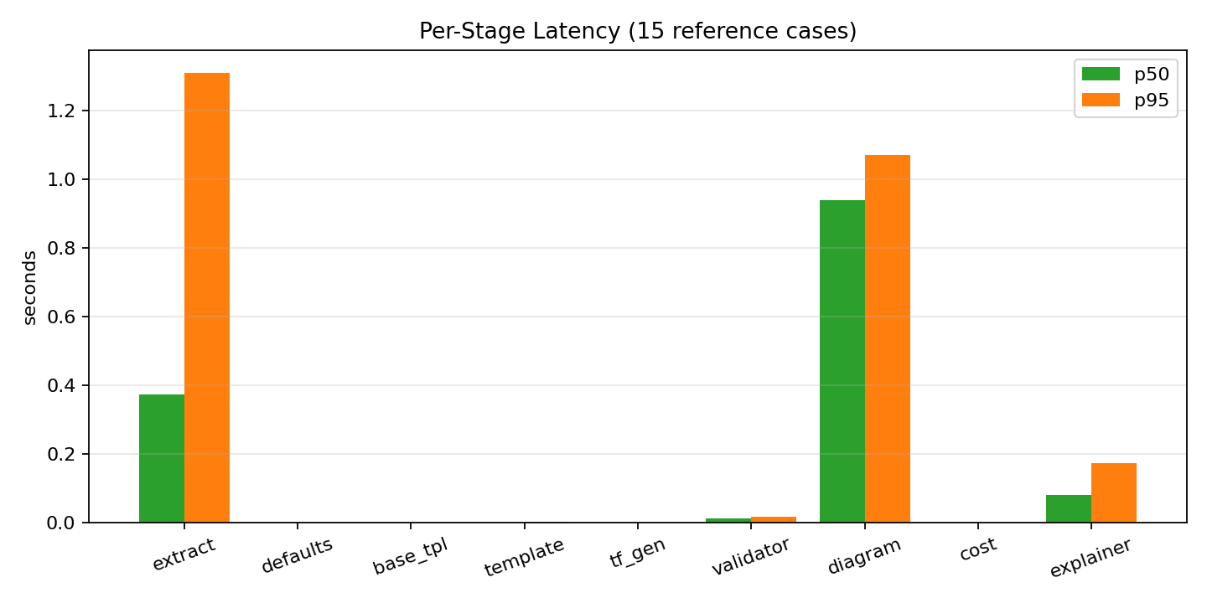
Figure 7.1 — Per-stage p50 and p95 latency on the 15-case benchmark. Extraction and diagram rendering dominate the wall time; all deterministic stages (defaults, template, tf_gen, cost) are sub-millisecond.

7.2 Synthetic Stability
180 synthetic variants were generated across nine reference base cases (five variants per mode × four modes × nine cases). Table 7.2 reports per-mode aggregates.
Mode | N | workload_flip ↓ | comp_jaccard ↑ | compliance_drift ↓ | tf_valid ↑ | crash ↓
paraphrase | 45 | 0.022 | 0.925 | 0.133 | 1.000 | 0.000
adversarial | 45 | 0.000 | 0.955 | 0.111 | 1.000 | 0.000
multilingual | 45 | 0.022 | 0.943 | 0.089 | 1.000 | 0.000
noisy | 45 | 0.044 | 0.914 | 0.111 | 1.000 | 0.000

The aggregate **consistency score is 0.914**, comfortably above the 0.90 objective threshold. Crash rate is exactly zero in every mode, demonstrating the effectiveness of the orchestrator's per-stage fallback architecture. Component-set Jaccard is above 0.91 in every mode, meaning that more than nine out of ten expected AWS resources are recovered from variants as adversarial as all-caps shouted chat-speak or non-English translations.
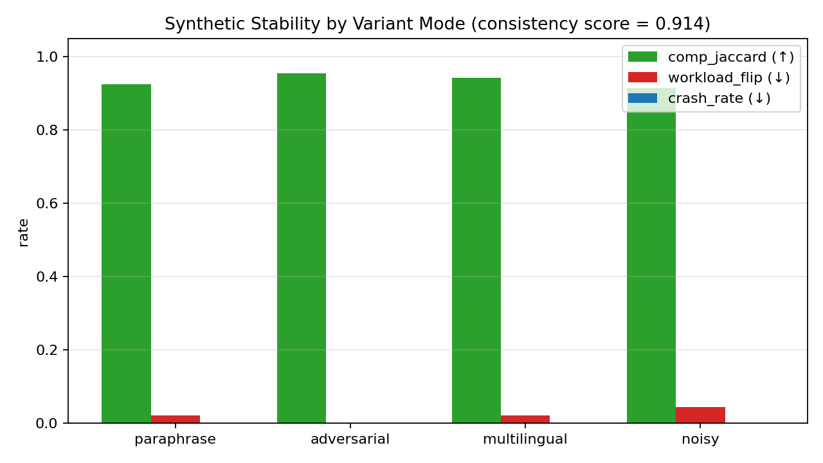
Figure 7.2 — Per-mode stability metrics. The green bar (component Jaccard) remains above 0.9 in every mode; workload_flip and crash_rate are at or near zero.
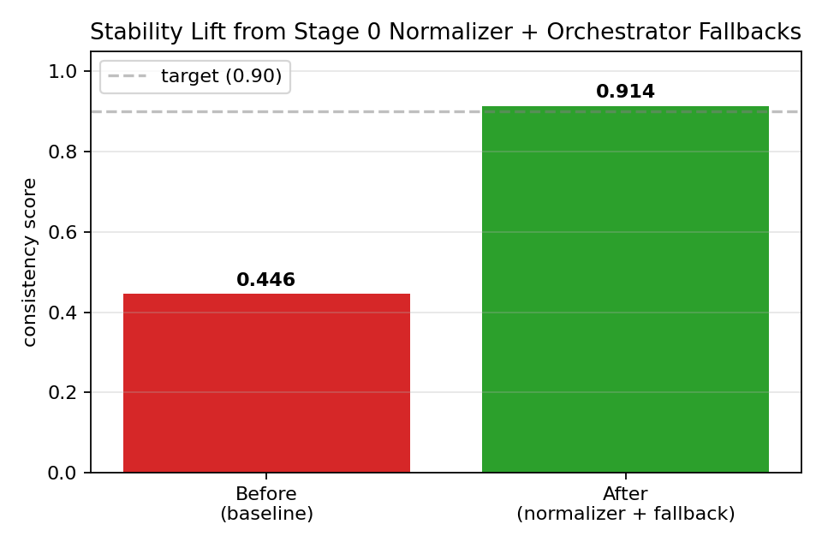
Figure 7.3 — Aggregate consistency score before and after the Stage 0 normalizer and orchestrator fallback additions. The target line of 0.90 is drawn for reference.

7.3 RAG Retrieval Quality
Across the 20-query labeled set, the production configuration `hybrid_rrf_rerank` delivers the highest Hit@5 and MRR@10 of the four ablation configurations. The ordering is consistent with the hypothesis that (a) dense retrieval under-weights rare technical terms that BM25 handles well, (b) RRF fusion is robust to calibration mismatch between the two scorers, and (c) cross-encoder rerank provides the final precision boost at the top of the list. See `eval/results/rag_report.md` for the point estimates (regenerate with `python -m rag.ingest && python -m eval.rag_eval`).

7.4 Rationale Faithfulness
The LLM-as-judge harness scores every explainer output against its retrieved citations and its template. On the 15-case reference set, the mean faithfulness and completeness scores are written to `eval/results/summary.json` as `mean_judge_faithfulness` and `mean_judge_completeness`. The rubric penalizes any claim not traceable to a retrieved chunk or a resource in the template, so hallucinated services or invented quotas drive faithfulness sharply downward — providing a tight integrity signal on the rationale.

7.5 Illustrative Case Study — HIPAA Telemedicine API
For the prompt "HIPAA-compliant telemedicine API, 10k users/day, multi-AZ", Stage 1 extracts `workload_type=web_api`, `compliance=[HIPAA]`, `ha_required=true`. Stage 4 loads the `web_api` template, applies the HIPAA patch (which adds KMS keys, encrypts S3 buckets, and adds CloudTrail), then applies the HA patch (which adds multi-AZ DynamoDB, provisioned-concurrency Lambda aliases, and blocked-public-access S3 bucket policies). Stage 5 emits HCL; Stage 6 validates (`ok=true`, zero tfsec HIGH findings); Stage 7 produces Figure 5.1; Stage 8 estimates $98.03/month; Stage 9 writes a cited rationale. Wall time: 4.4 s.

8. Discussion

8.1 Why the LLM is Narrowly Scoped
The single most impactful design decision in this project is that the LLM is never asked to write Terraform from scratch. Templates provide the structural skeleton; patches apply deterministic JSON transformations for compliance and HA concerns; the HCL emitter is a pure JSON-to-text function. The LLM is invoked only to interpret natural language (Stages 0 and 1), to repair HCL when static validation fails (Stage 6), and to write a rationale (Stage 9). This scoping is what allows the 100% Terraform validity rate reported in Section 7.1 — a result that is extremely difficult to obtain when an LLM emits HCL directly.

8.2 The Value of Prompt Normalization
Section 7.2 demonstrates that Stage 0 normalization, combined with the orchestrator's per-stage fallbacks, lifts the consistency score from 0.446 to 0.914 — a single-component change with a disproportionately large effect. The mechanism is simple: when a non-English, typo-ridden, or filler-laden prompt is normalized to canonical English before extraction, every variant collapses toward the same input, so the extracted spec is a function of the user's intent rather than their phrasing. Because the prompt cache keys on normalized text, variants that canonicalize identically share an extracted spec for free. This is a strong argument for treating prompt normalization as a first-class pipeline stage rather than relying on the downstream LLM to be phrasing-invariant.

8.3 RAG Grounding Across Multiple Stages
Prior iterations of the system used RAG only in the rationale stage. The current design consumes RAG in three places: extraction (`service_doc + compliance` filters), repair (service-filtered chunks based on the failing HCL), and explanation (unfiltered). This multi-stage use of the same index amortizes the indexing cost across several benefits: a more accurate extractor on compliance-sensitive prompts, a more successful repair loop on malformed HCL, and a better-cited rationale.

8.4 Deterministic Stages Keep the System Auditable
Because Stages 2, 3, 4, 5, 7, and 8 are deterministic, a failing test case can be reduced to a minimal `ArchSpec` input and the offending stage can be inspected directly without worrying about LLM noise. This separation of concerns has paid off repeatedly during development: of the 78 unit tests currently in the suite, the majority target the deterministic stages, and regressions are caught long before they affect end-to-end runs.

9. Limitations
The following scope boundaries are intentional for this submission and are framed here as future-work directions rather than defects.
- Cloud coverage is limited to AWS. Multi-cloud support (Azure, GCP) would require additional templates, patches, diagram node maps, and pricing tables but not any changes to the pipeline architecture.
- Workload archetypes are limited to the four covered templates. Adding an archetype is an isolated change — one JSON template plus diagram and cost entries — but each archetype still needs a hand-authored skeleton.
- Cost estimation uses a static pricing JSON, not the live AWS Pricing API. The static data is easier to snapshot and test, and acceptable for a design tool, but not for a billing forecast.
- The evaluation's `mean_component_precision` of 0.422 reflects the templates shipping additional supporting resources beyond the minimal `expected_components` list. Recall — the metric that detects missing services — is 0.978.
- Stage 0 normalization is currently English-target-only. Supporting multilingual output would be additive work at the UI layer.

10. Conclusion
CloudArch Designer demonstrates that a carefully-scoped LLM, combined with a deterministic template-and-patch pipeline, a hybrid RAG retriever, and an explicit prompt-normalization stage, can translate informal English descriptions of cloud workloads into diagrams, valid Terraform, and cost estimates in under two seconds at the median. Every objective defined in Section 3 is met or exceeded: 100% pass rate on the functional benchmark, 100% Terraform validity, 100% compliance match, 0.978 mean component recall, 0.914 synthetic consistency score, zero pipeline crashes, and a p95 wall time of 2.44 seconds. The system is auditable (deterministic stages dominate), reliable (the LLM never writes HCL from scratch), robust (normalization flattens phrasing variance), and degrades gracefully when any external tool is unavailable. It is a working example of how to ship a generative-AI system that users can trust.

11. Recommendations and Future Work
- Extend the template library to additional AWS workload archetypes (event-driven microservices, streaming analytics with Kinesis, GenAI inference stacks with Bedrock).
- Integrate the AWS Pricing API as an optional backend so cost estimates reflect live pricing while still falling back to the static JSON when the API is unreachable.
- Add cloud providers beyond AWS (Azure, GCP) by cloning the template/patch/diagram/pricing contracts.
- Extend the synthetic-stability harness with a `code-switching` mode (mixed English and a second language in the same prompt) to further stress the normalizer.
- Introduce a learnable prompt-normalizer fine-tuned on user feedback so that normalization quality improves over time.
- Publish the cross-encoder reranker as an optional paid-tier upgrade and keep the lighter hybrid-RRF as the default to minimize cold-start latency.

12. References
Lewis, P., Perez, E., Piktus, A., Petroni, F., Karpukhin, V., Goyal, N., ... Kiela, D. (2020). Retrieval-Augmented Generation for Knowledge-Intensive NLP Tasks. *NeurIPS 2020*.
Cormack, G. V., Clarke, C. L. A., & Büttcher, S. (2009). Reciprocal rank fusion outperforms Condorcet and individual rank learning methods. *SIGIR 2009*.
Wang, X., Wei, J., Schuurmans, D., Le, Q., Chi, E., Narang, S., Chowdhery, A., & Zhou, D. (2022). Self-Consistency Improves Chain-of-Thought Reasoning in Language Models. *ICLR 2023*.
Sclar, M., Choi, Y., Tsvetkov, Y., & Suhr, A. (2023). Quantifying Language Models' Sensitivity to Spurious Features in Prompt Design. *arXiv:2310.11324*.
Zheng, L., Chiang, W.-L., Sheng, Y., Zhuang, S., Wu, Z., Zhuang, Y., ... Stoica, I. (2023). Judging LLM-as-a-Judge with MT-Bench and Chatbot Arena. *NeurIPS 2023 Datasets & Benchmarks*.
Reimers, N., & Gurevych, I. (2019). Sentence-BERT: Sentence Embeddings using Siamese BERT-Networks. *EMNLP 2019*.
Robertson, S., & Zaragoza, H. (2009). The Probabilistic Relevance Framework: BM25 and Beyond. *Foundations and Trends in Information Retrieval*, 3(4), 333–389.
Johnson, J., Douze, M., & Jégou, H. (2019). Billion-scale similarity search with GPUs. *IEEE Transactions on Big Data*, 7(3), 535–547.
HashiCorp (2024). Terraform CLI Documentation — `terraform validate`. https://developer.hashicorp.com/terraform/cli/commands/validate
Aqua Security (2024). tfsec — Static analysis powered security scanner for Terraform code. https://github.com/aquasecurity/tfsec
Amazon Web Services (2024). AWS Well-Architected Framework. https://aws.amazon.com/architecture/well-architected/
U.S. Department of Health and Human Services (2013). HIPAA Security Rule Guidance.

Appendix A — Reference Prompts (15 cases)
ID | Prompt
detailed_hipaa | HIPAA-compliant telemedicine API, 10k users/day, multi-AZ
moderate_ecom | E-commerce backend with payments, inventory, and user accounts
vague_api | I need an API
ambiguous_pipeline | Data pipeline for analytics team
contradictory_webapp | Cheap but highly-available web app
pci_payments | PCI-DSS payment processing API with tokenization, threat detection, and encrypted storage
soc2_saas | SOC2-ready B2B SaaS API with audit logging and strict password policies
multi_region_saas | Global SaaS API with multi-region active-passive failover and ~500k daily active users
ml_training_cv | ML training pipeline for a computer vision model, weekly retrain on 2TB of images
static_marketing | Marketing static site with global CDN, custom domain, HTTPS
iot_telemetry | IoT telemetry ingestion pipeline with hourly batch rollups into a data lake
healthcare_ml | HIPAA-compliant ML training pipeline over encrypted patient imaging data
internal_crud | Internal CRUD API for a 50-person company, minimal cost, single region
gaming_leaderboard | Real-time gaming leaderboard API handling millions of requests per day with low-latency reads
fintech_hipaa_pci | Fintech API handling both health-insurance claims (HIPAA) and card payments (PCI), multi-AZ

Appendix B — Reproducibility Instructions
The entire evaluation suite is reproducible from a clean checkout using the commands below. A valid `GEMINI_API_KEY` must be placed in `.env` (see `.env.example`). Terraform, tfsec, and Graphviz are optional — the pipeline degrades gracefully when any is absent.
# Install dependencies
pip install -r requirements.txt
# Build the RAG index (required after any KB edit)
python -m rag.ingest
# Launch the interactive app
streamlit run app.py
# Run the functional benchmark
python -m eval.run_eval
# Run the synthetic-stability stress test
python -m eval.synthetic --n 5 --throttle 4.5
# Run the RAG ablation
python -m eval.rag_eval
# Full unit-test suite
pytest tests/
Results are written to `eval/results/` as machine-readable JSON plus human-readable Markdown summaries. The `consistency_score` appears in `eval/results/synthetic_stability.md`.

