Games Programming IMAT 3606 – Final Team Coursework Submission

Game Name: Cereal Killer
Game Genre: Survival, Thriller
Controller: Mouse & Keyboard

Team members | Roles
Nathan Sainsbury | Technical Director & Lead Programmer
Wade Garrett | Lead Game Design & Programmer
Augustine Obiogbolu | Programmer

Game Description
Cereal Killer is a survival horror set inside a cursed supermarket. One night the contents of the shelves come alive in the form of hideous food-monsters, the on duty janitor must use item he finds around the supermarket to defend himself from the onslaught of cereal monsters.

Controls
To start the game, run - .\GameEngine\GameEngine\build\Release\GameEngine.exe
Note: You must have a graphics card to run this program
Once the game has loaded, you will be on the menu screen, pressed the “enter” key to start the main game. Use the WASD keys to move the character around the level. You can also type “help” into the console window to get a list of useable commands.

Individual Piece Team Member Contributions

Nathan Sainsbury
What I’ve done | What is it | How to inspect
System framework* | Handles inter-module and inter-service communications, system updates and start-up/shut-down. | System/Framework
Events module | Global announcement of arbitrary events. | System/Modules/Events
Audio module | Sound effects and background music. Division of effects in to channels – each with their own volume that is modulated by master volume. Background music transitions. | System/Modules/Audio
Input management | Determines relevant user input and forwards it to relevant locations based on the active ControlSet. | System/Modules/Input
Window & rendering* | Shader-based rendering. Multiple shader support. Multiple scene support. Multiple light support. Textured objects and multi-texturing. Materials for defining surface properties. Multiple cameras. | System/Modules/Window&Rendering
Resource module | Tight memory packing of sharable resources using partially template storage. | System/Modules/Resources
Entity module | Entity management using “entity specifications”. Assignment of unique ids. Entity groups. | Scene/Modules/Entity
Acting module* | Creating a render-able component to attach to entities. Meshes. Cube-maps (skybox). Actors as an instance of a Mesh. | Scene/Modules/Acting
Scripting module | Text file based scripting language with support for basic mathematics, variables (all global), magic numbers and | Game/Modules/Scripting
Shaders | Wrote the phong lighting shader with multiple light support & the cubemap shader. | Run the game or see the data folder: data/shaders/
Models | Produced the 3D models: “begin_text”, “ceiling”, “floor”, “lamp”, “trolley” and “wall”. Textures are not my own. | Run the game or see the data folder: data/meshes

* Indicates a component that was produced as part of the first submission but has since received note-worthy updates.
Wade Garrett
What I’ve done | What is it | How to inspect
Visual assets | Created most of the 3D models and textures using Maya and Inkscape. | Run the game or see the data folder: data/meshes & data/textures
Physics Module | Created all Physics based code | Scene/Modules/Physics
GUI module | Created the GUI module | Scene/Modules/GUIModule
MD2 animation | Created animated .md2 models | See included video files
Sound assets | Located and converted appropriate audio assets | Run the game or see the data folder: data/audio/fx & data/audio/music
Misc. Maths | Contributed to the MathsUtils Object | MathsUtils.cpp

Augustine Obiogbolu
What I’ve done | What is it | How to inspect
AI module | Artificial intelligence | Scene/Modules/AI

Evidence of team working - GIT submission logs
Project Start – 26/01 – 18/02
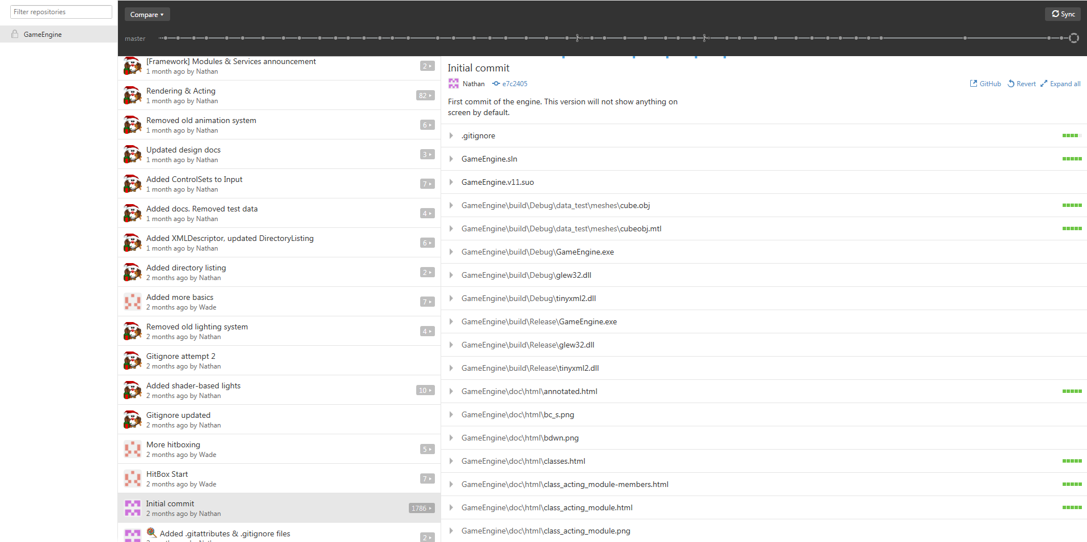
09/03 – 15/03
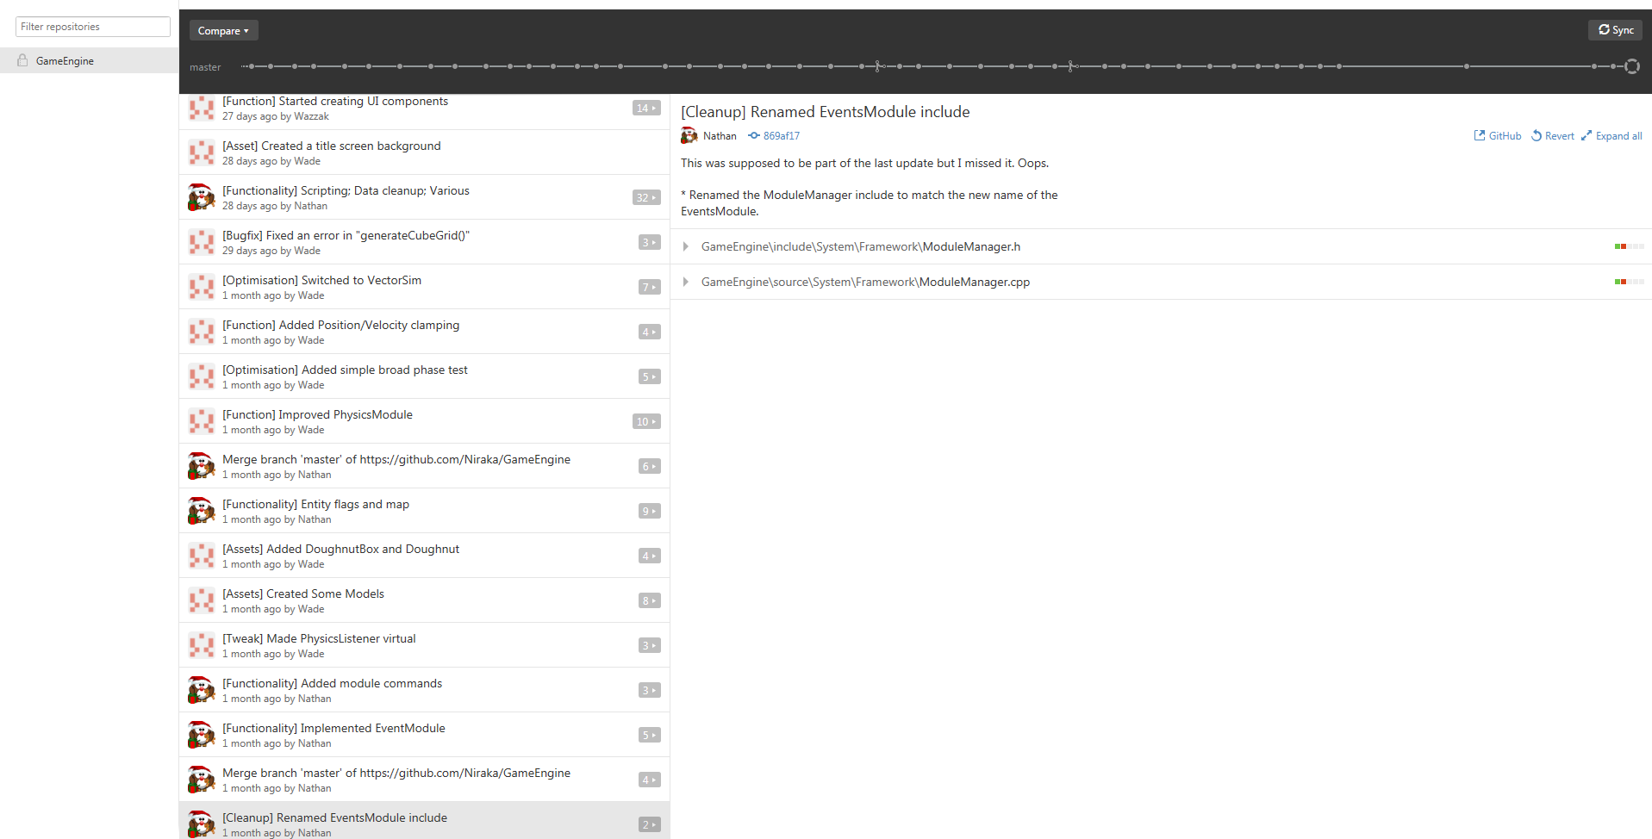

15/03 – 21/03
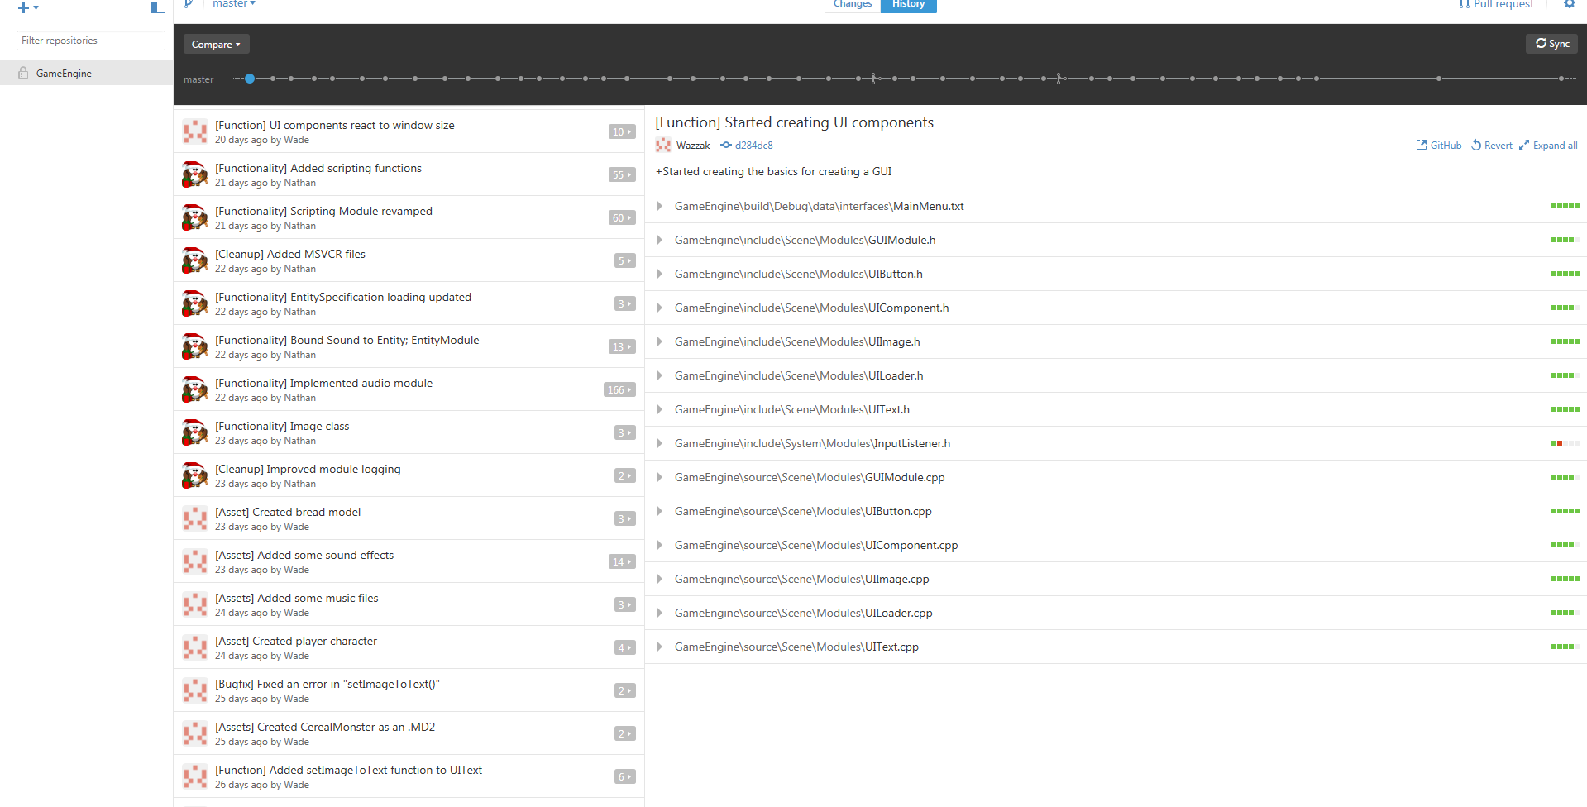

Project End – 24/03 – 11/04

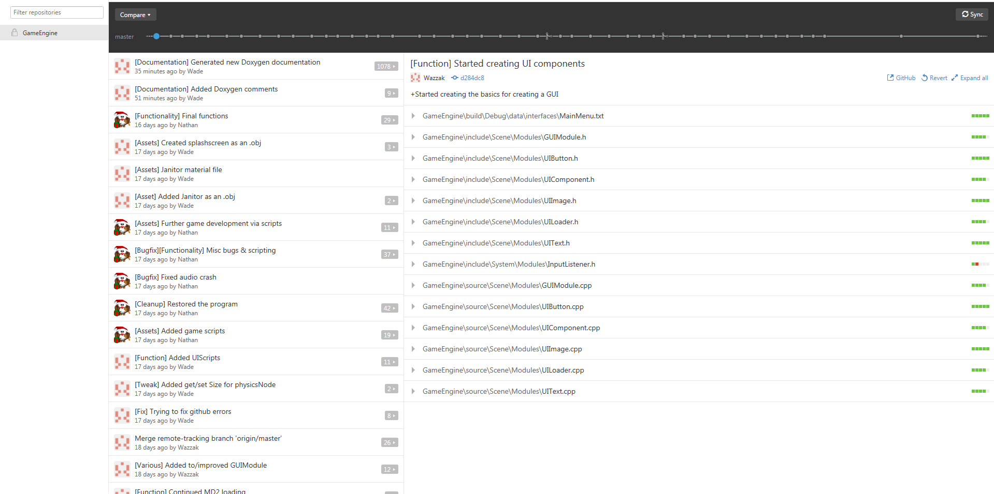
Please feel free to add any additional supporting evidence/documentation here e.g. Final Class diagrams, game design docs etc.
To view Doxygen documentation, open - .\GameEngine\GameEngine\doc\html\index.html

