Nirakar Shrestha

Artificial Intelligence

Professor Rosemina Vohra

November 2 2020

Assignment 8

A logical knowledge base represents the world using a set of sentences with no explicit structure. An analogical representation, on the other hand, has physical structure that corresponds directly to the structure of the thing represented. Consider a road map of any country as an analogical representation of facts about the country—it represents facts with a map language. The two-dimensional structure of the map corresponds to the two-dimensional surface of the area.

a. Give five examples of symbols in the map language.

Symbols in the map language differ on the size of the map and on an online map, zooming can bring the objects under differing portrayal.

i) Roadways (Streets, drives, roads, terrace, avenues, etc.) are the white block of lines and yellow block of lines for highways.

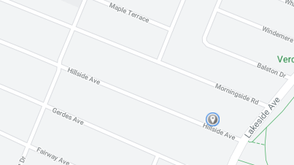

ii) Waterbodies (Lakes, Rivers, Seas, Oceans, etc.) are the blue-colored objects.

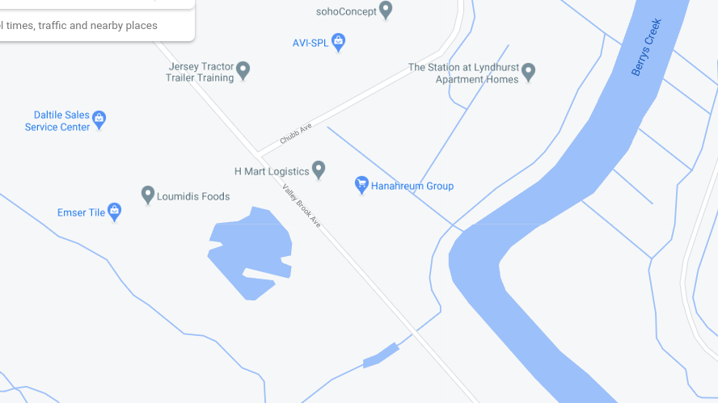

iii) Food Places (Restaurants, Diners, Fast food chains, etc.) are portrayed by an orange location sign (upside-down water droplet sign) with white fork and knife in the symbol.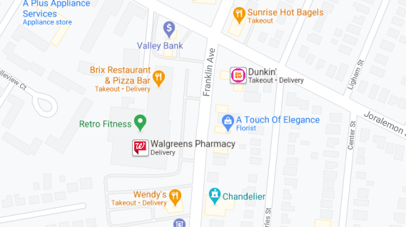

iv) Parks are demonstrated as a green patch of land.

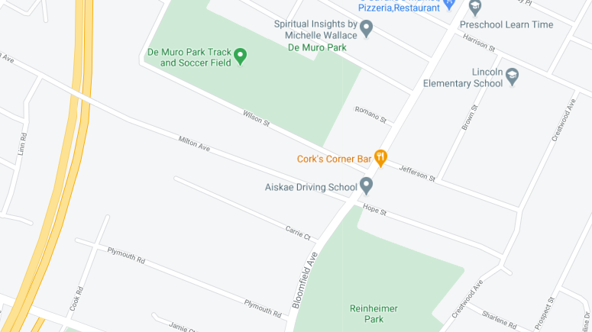

v) Shopping Stores (Groceries, Essentials, Pharmacies, etc. ) are displayed with a blue location symbol with a white bag or a white cart in it.

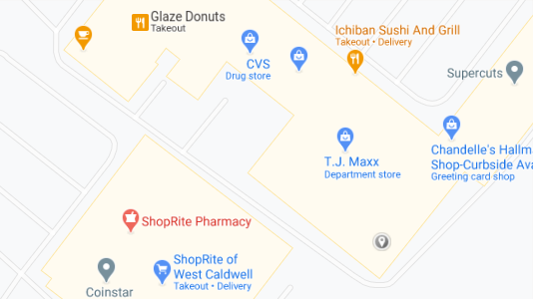

b. An explicit sentence is a sentence that the creator of the representation actually writes down. An implicit sentence is a sentence that results from explicit sentences because of properties of the analogical representation. Give three examples each of implicit and explicit sentences in the map language.

Explicit sentence is a sentence about something independent of any other object. It is a statement that identifies an object. Three examples are:

i) I-90 East runs throughout the eastern coast of the U.S.

ii) The Shoprite Pharmacy is located in West Caldwell and is represented by a red location symbol.

iii) Hudson river runs in between New York and New Jersey.

Implicit Sentence is derived from understanding various explicit sentences. They define the details and provide more information about an object. The examples are:

i) Bloomfield Avenue is longer than Westville Avenue.

ii) West Caldwell is located closer to Caldwell than to Montclair.

iii) County Road 506 is the highway connected to Bloomfield Avenue.

c. Give three examples of facts about the physical structure of this country that cannot be represented in the map language.

i) Depth of the water bodies.

ii) The infrastructure like water lines, telephone and electricity poles.

iii) Geographical height of land, mountains and hills.

d. Give two examples of facts that are much easier to express in the map language than in first-order logic.

i) The fastest or shortest route from one place to another.

ii) The closest park from a given location.

iii) Number of parks in a particular area.

e. Give two other examples of useful analogical representations. What are the advantages and disadvantages of each of these languages?

The two other examples of useful analogical representations are:

i) Analog Clock- clock with hour hand, minute hand and second hand (optional).

ii) Tape recorder - Analog tape recorder.

The advantages of analogical representations are it is easier to find the time in the analog clock and easier to record sound in the tape recorder. It is because they have simpler mechanisms and can be used without much problem. The disadvantage in the tape recorder is that it cannot distinguish between noise and required sound and store all the data though it is unwanted. It is also very difficult to remove the noise so we have to record again to get better recording. In case of the clock, we cannot find the time in the milliseconds as it does not give any information on the milliseconds.