LAB 5- String Format Vulnerability Nirakar Shrestha

The vulnerable.c file is as following: 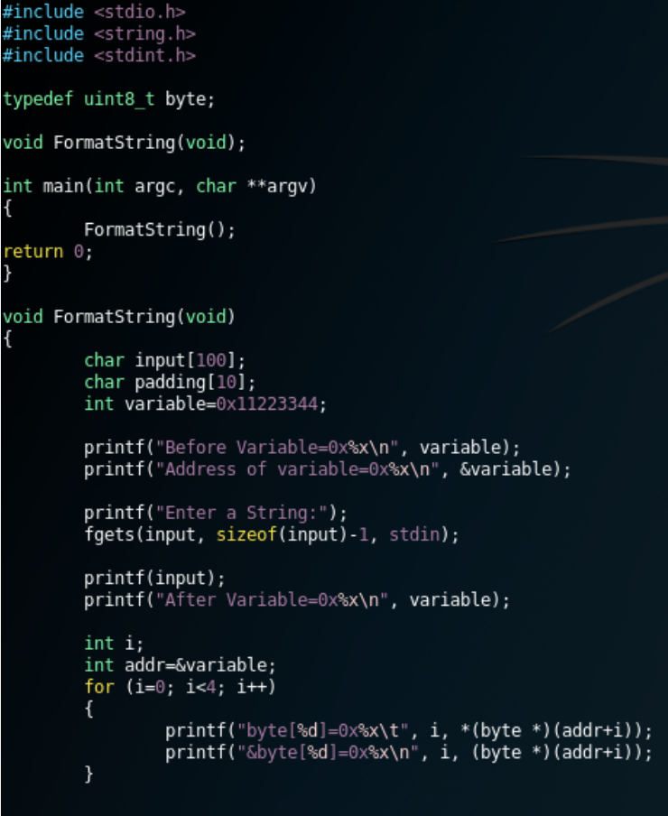The Makefile looks like following: 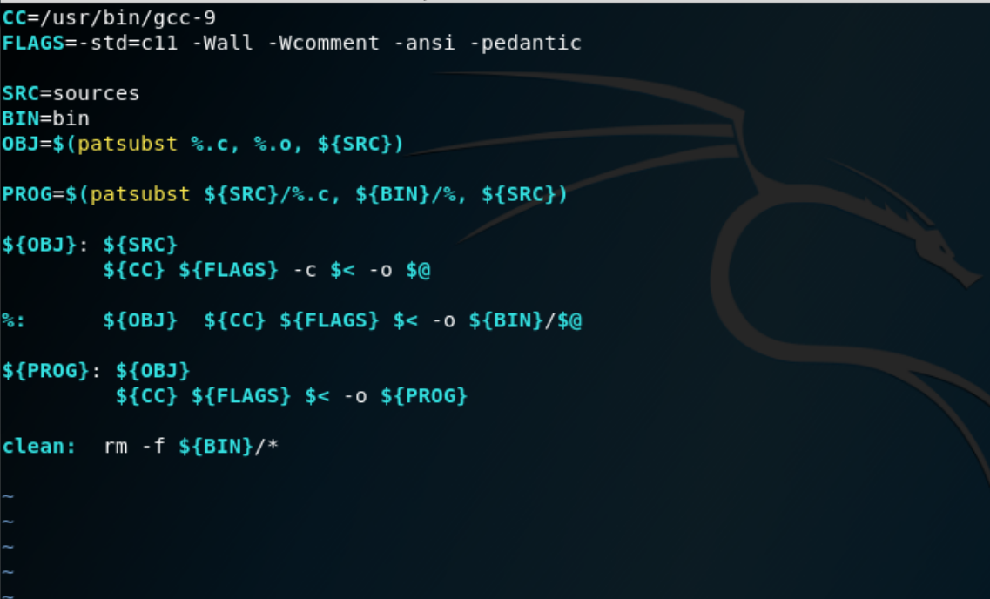

Using the Makefile to compile the vulnerable.c program: 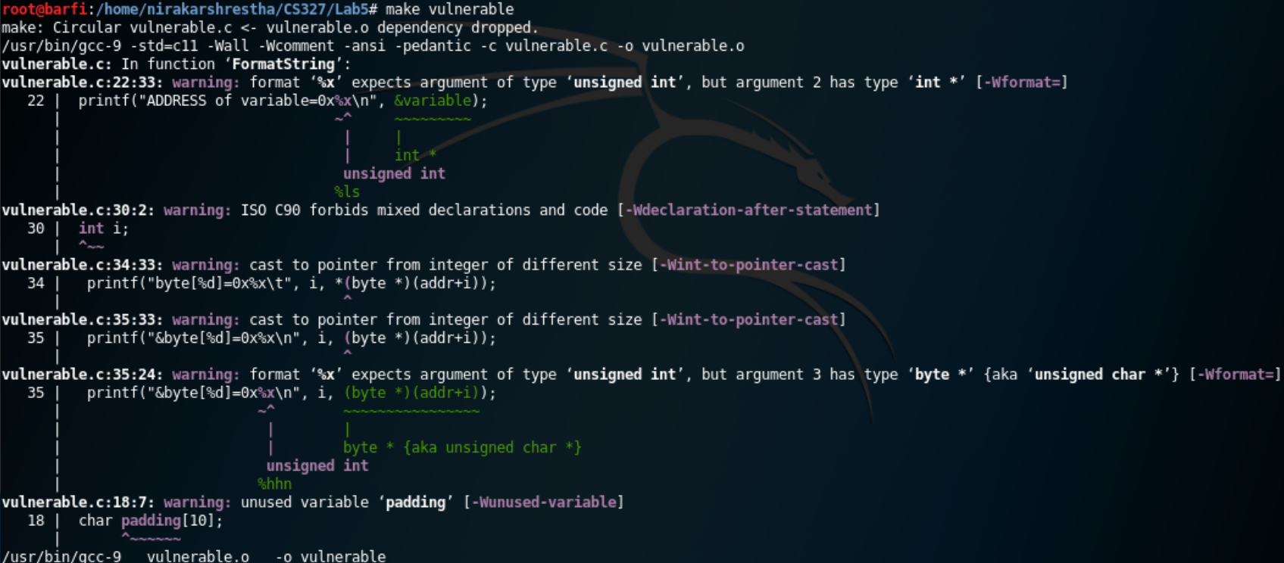

I compiled the vulnerable.c program and entered “%s%s%s%s%s” and the result was as following: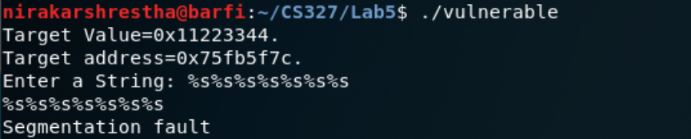

I followed the instructions given in the Lecture notes and captured the results as following: 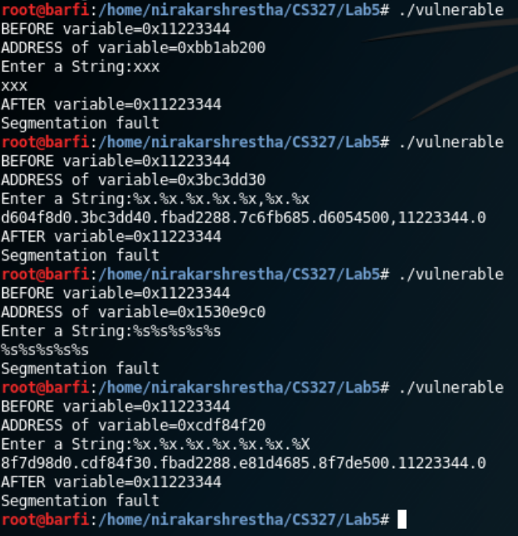

I tred changing several parts of the code and tried running the commands but the results came out as ‘Segmentation Fault’. Following is the proof of the result:

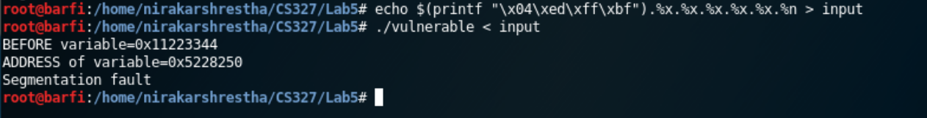

This time around I tried running the program in seedubuntu. Attached in the screenshot of output in the vm:

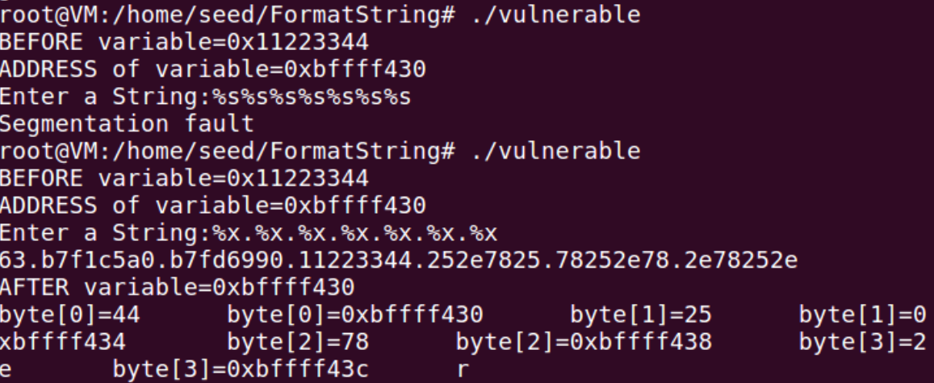

Then I followed through the instructions from the lecture. This time again the segmentation fault occurred: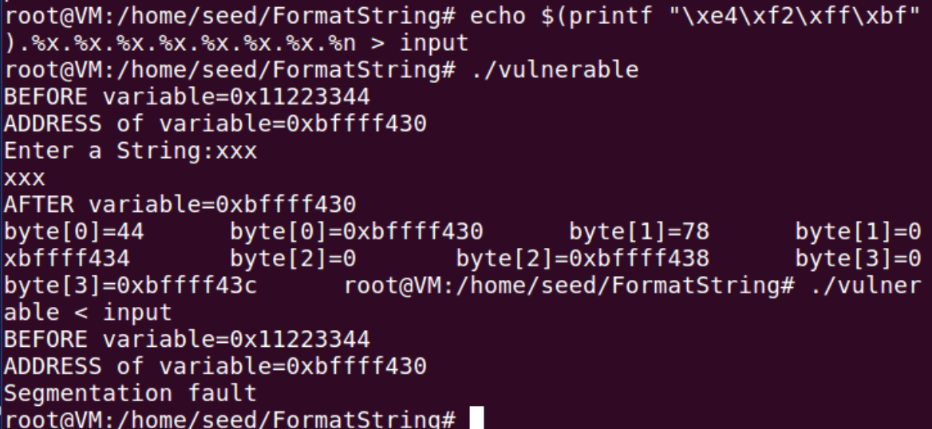

I tried with other instructions for echoing into input and this time the results were different. The after variable did not change though.

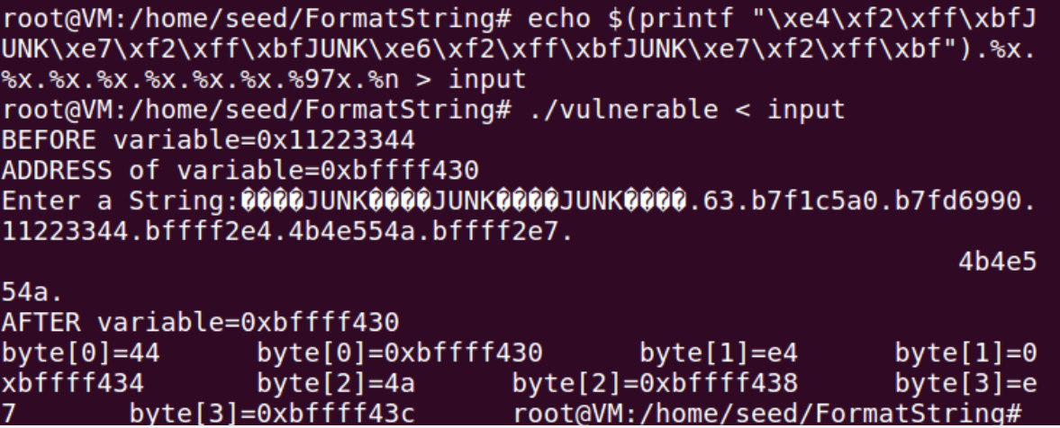

After several attempts of changing the input I still could not bring any change in the after variable.