I started the apache service using the diven command as following: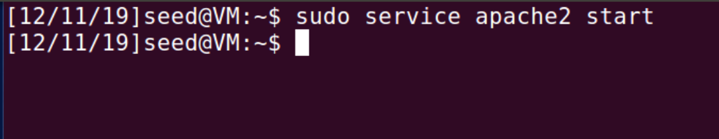

My /etc/hosts file showed following information.