Savyata Regmi

Professor Wise

Internet and Enterprise Security: Lab11

December 15, 2019

**This is phase 2 of the network configuration in a virtual environment. After configuring three virtual hosts for networking using static IP addresses, we want to configure two of these hosts as primary and secondary DNS servers, respectively. the steps are outlined below:**

1. Create 3 virtual machines (VMs) by cloning an existing one.

This was done in part 1 assignment. Below are the details for my 3 Virtual Machines:

**Host FQDN IPv4 Address**

**ns1 ns1.student.local 10.0.2.5**

**ns2 ns2.student.local 10.0.2.4**

**User Attacker.student.local 10.0.2.15**

1. **Configure networking for the primary DNS server (ns1.student.local, or User.student.local)—there are two configuration files:**

**B**elow is the edited file for **/etc/hosts** in **my primary DNS server named as Savyata-server in Virtual Machine :**

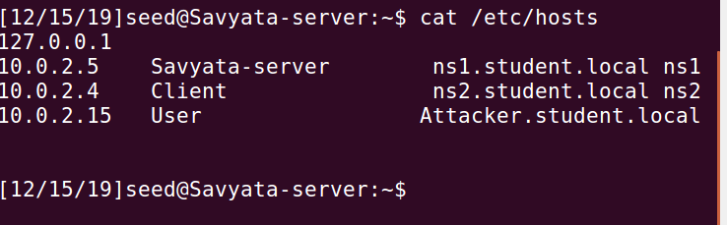

Below is the edited file for **/etc/network/interfaces**

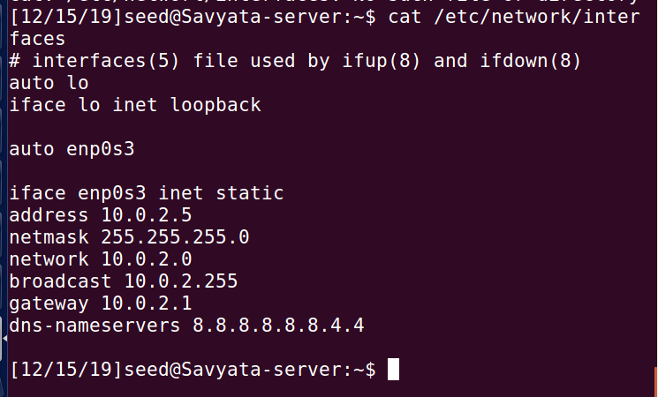

Then I restarted the networking services using the command ***$ sudo /etc/init.d/networking restart***  when is given below:

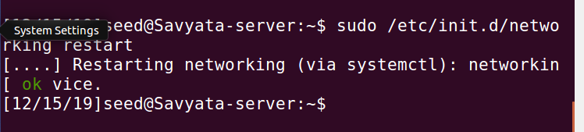

**3. Configure networking for the secondary DNS server (ns2.student.local or Server.student.local)—the same configuration files as before, /etc/hosts and /etc/network/interfaces, with the same exact settings as for the primary DNS server.**

I repeated the same process as above to configure the networking for secondary DNS server ns2.student.local with the same settings as above. **In my case, the VM with secondary DNS server is named as Client**. The screenshots of the configurations are mentioned below:

**edit file /etc/hosts**

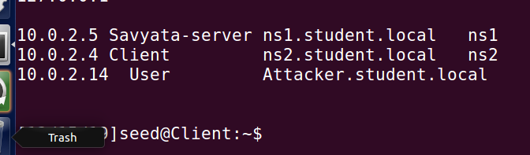

**edit file /etc/network/interfaces**

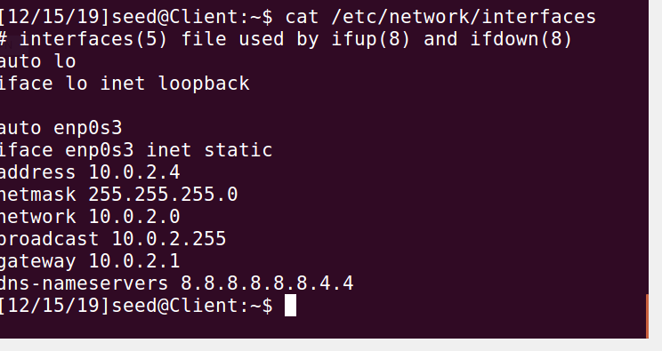

Then I restarted the networking services using the command ***$ sudo /etc/init.d/networking restart***  when is given below:

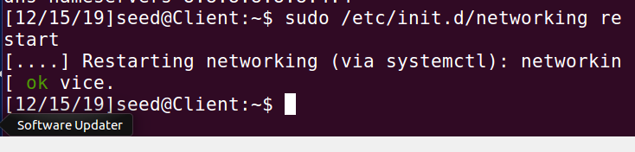

**4. Install BIND on the primary DNS server.**

Now I switched back to my Primary VM for Primary DNS configuration. I installed BIND on the primary DNS with **sudo apt-get -y update** for updating package lists, and **sudo apt-get -y install bind9 bind9utils bind9-doc** for downloading and installing BIND.

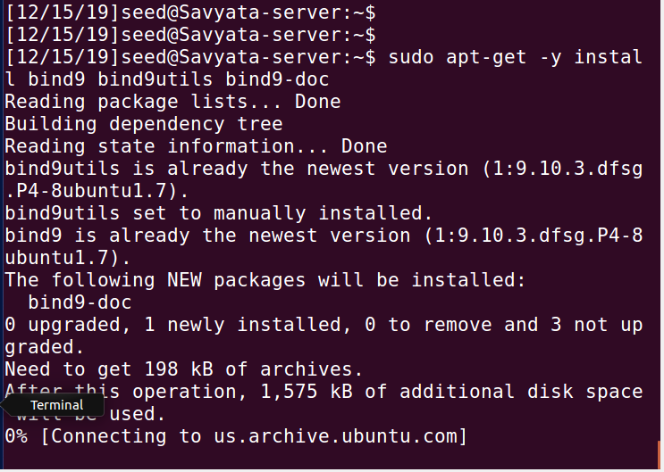

configure BIND for IPv4: Below is the screenshot of configuration of BIND for IPv4

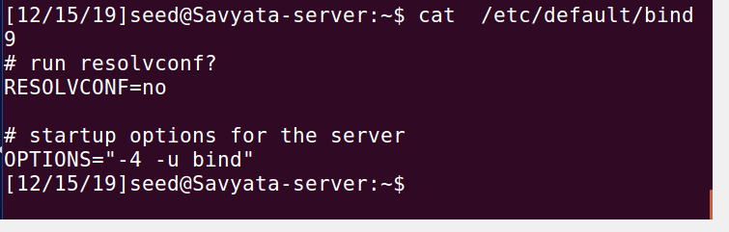

**5. Configure the primary DNS server—there are 4 configuration files for the DNS server, whose process name is named:**

**5.1.the primary configuration file /etc/bind/named.conf**

**5.2.options file /etc/bind/named.conf.options**

**5.3.local configuration file /etc/bind/named.conf.local**

**5.4.default zones file /etc/bind/named.conf.default-zones**

The screenshots for each step are attached below:

edit /etc/bind/named.conf.options

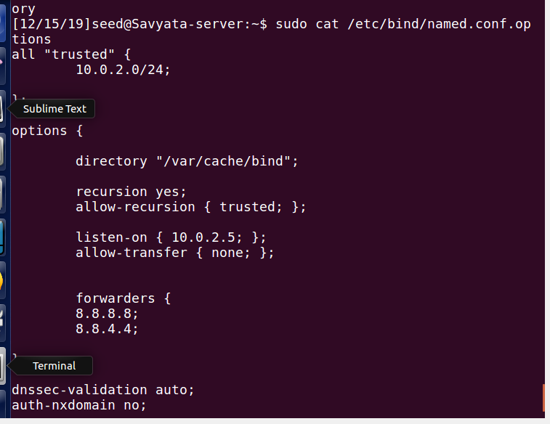

edit zones file /etc/bind/named.conf.local on ns1

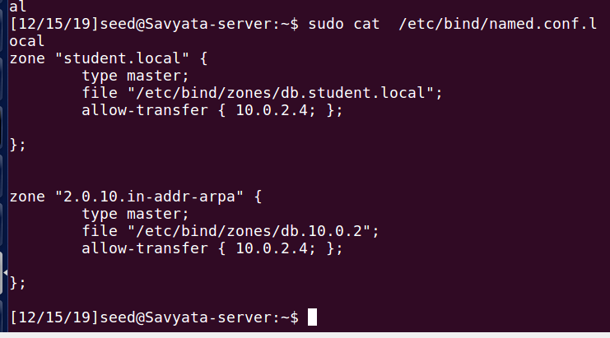

create forward zone file in new directory /etc/bind/zones

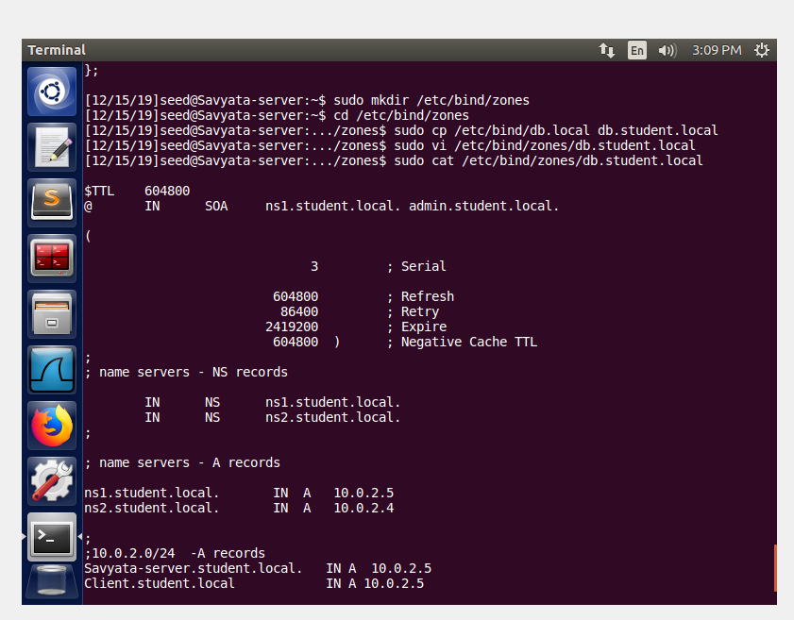

create reverse zone file in same directory /etc/bind/zones

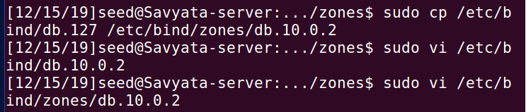

**check syntax of files: named.conf.local, zones/db.student.local, and zones/db.10.0.2 and restart BIND**

Now, I checked the syntax for my configurations that I did in the above steps. The result was returned as OK which means my codes are correct. Below is the screenshots attached.

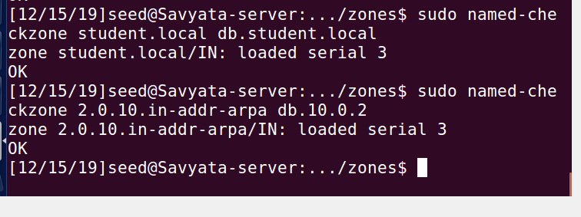

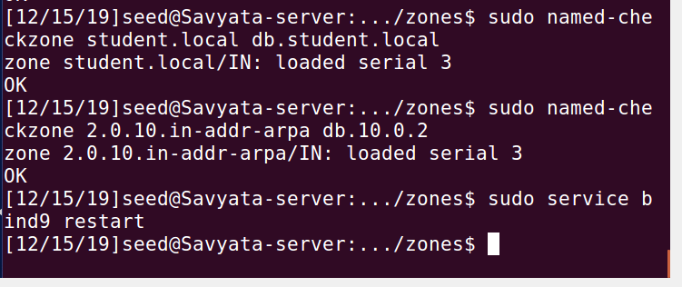

I successfully installed BIND in primary DNS virtual machine, now i am installing and configuring BIND in my secondary machine named as **Client.**

**6. Install BIND on the secondary DNS server.**

Attached are the screenshots for updating package and download and installation of BIND.

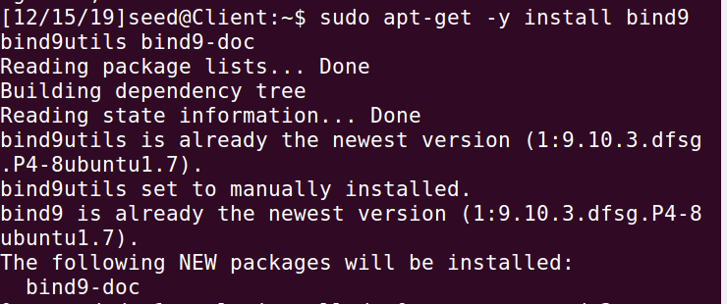

**configure BIND for IPv4**

**Then, I configured BIND for IPv$ which is attached below:**

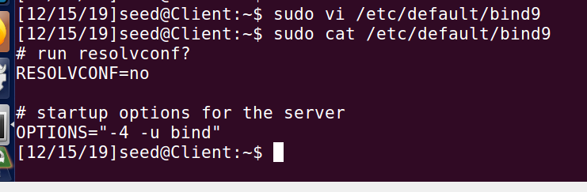

**7. Configure the secondary DNS server—there are 4 configuration files for the**

**DNS server, whose process name is named:**

**7.1.the primary configuration file /etc/bind/named.conf**

**7.2.options file /etc/bind/named.conf.options**

**7.3.local configuration file /etc/bind/named.conf.local**

**7.4.default zones file /etc/bind/named.conf.default-zones**

All the steps are attached below:

**edit /etc/bind/named.conf.options**

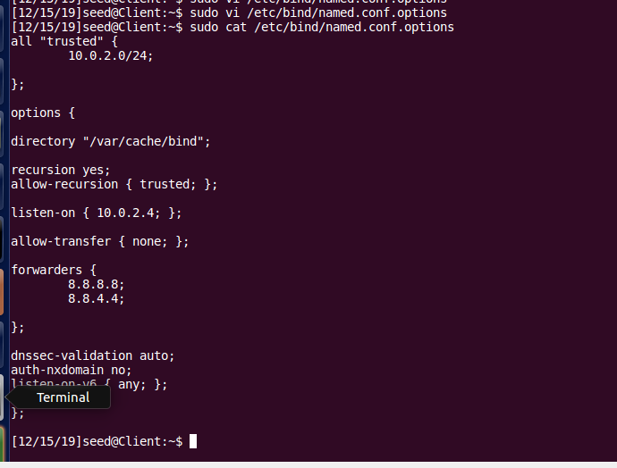

**edit zones file /etc/bind/named.conf.local on ns2**

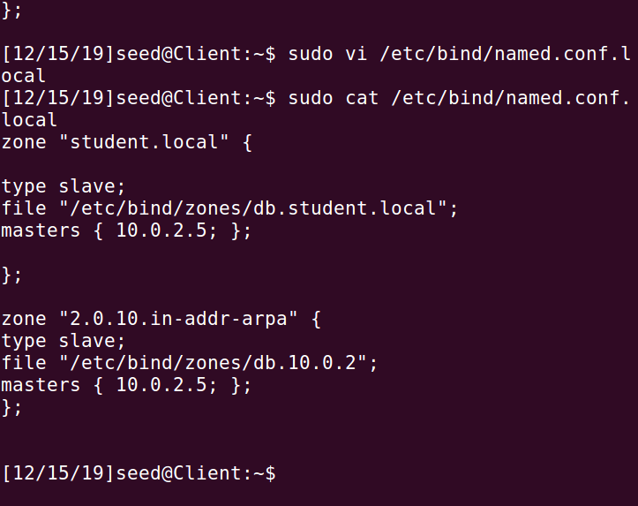

**8. Configure client networking (machine Attacker.student.local, IP 10.0.2.15).**

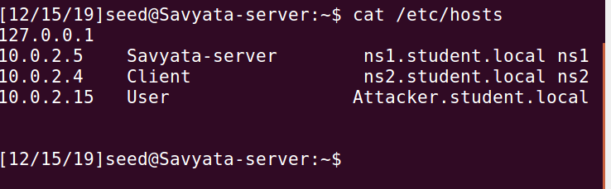

**edit file /etc/network/interfaces**

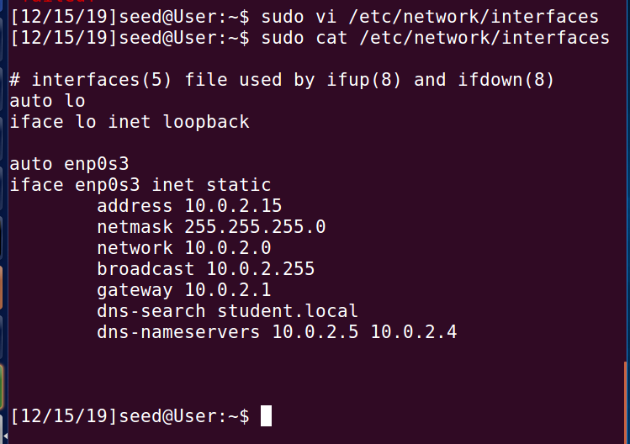

**test the reverse lookup**

I used the nslookup command to find the IP address that corresponds to a host or a server. Below the address for Server is shown as 10.0.2.5 which is the address we used for primary DNS server configuration. Similarly, it shows the address for the current VM which is configured to be 10.0.2.15 and with the FQDN name as Attacker.student.local which is also displayed below:

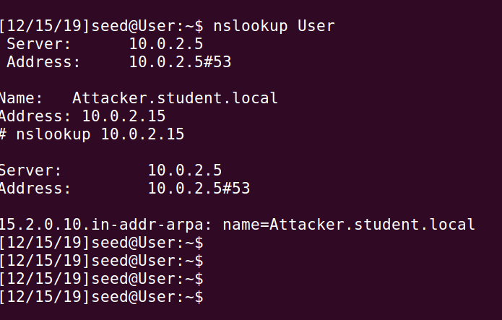

**Hence, the DNS configuration was successful.**