**Practical-6**

Step 1 : First get new file in Photoshop and give it radial gradient .

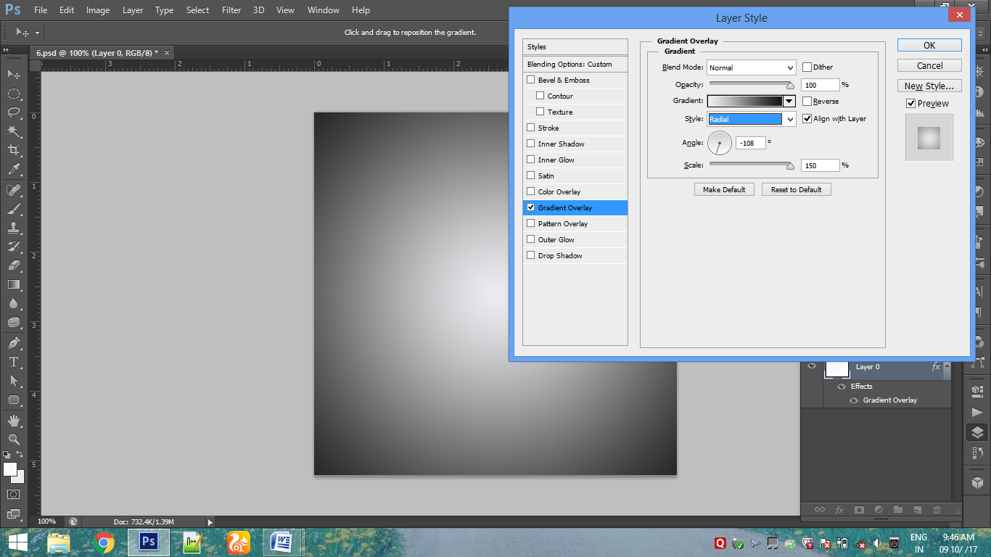

Step 2: Then choose the the color of gradient.

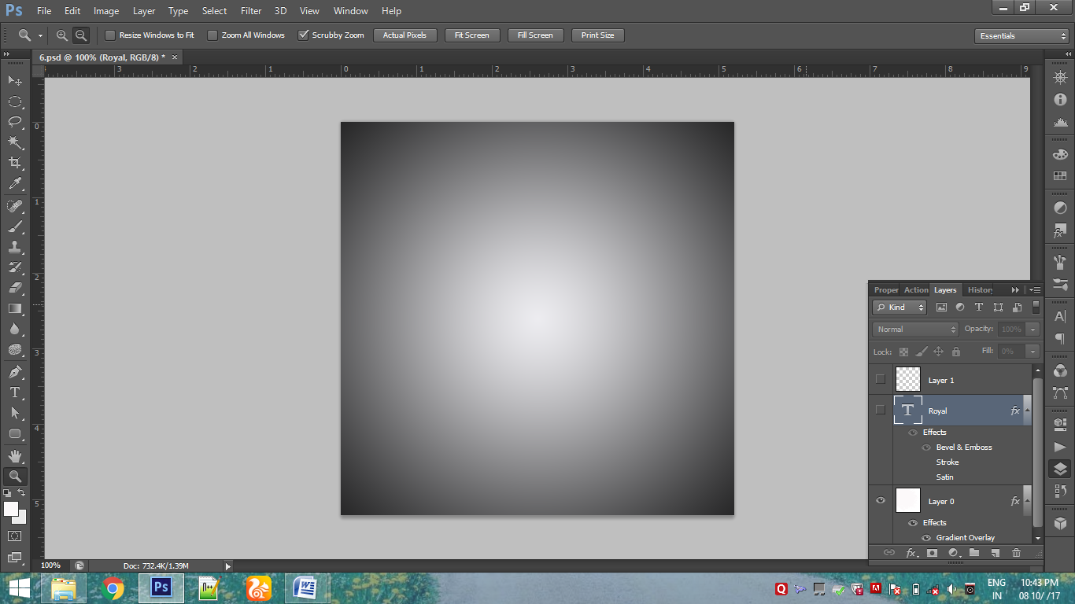

Step 3: Select the type tool and write text in center.

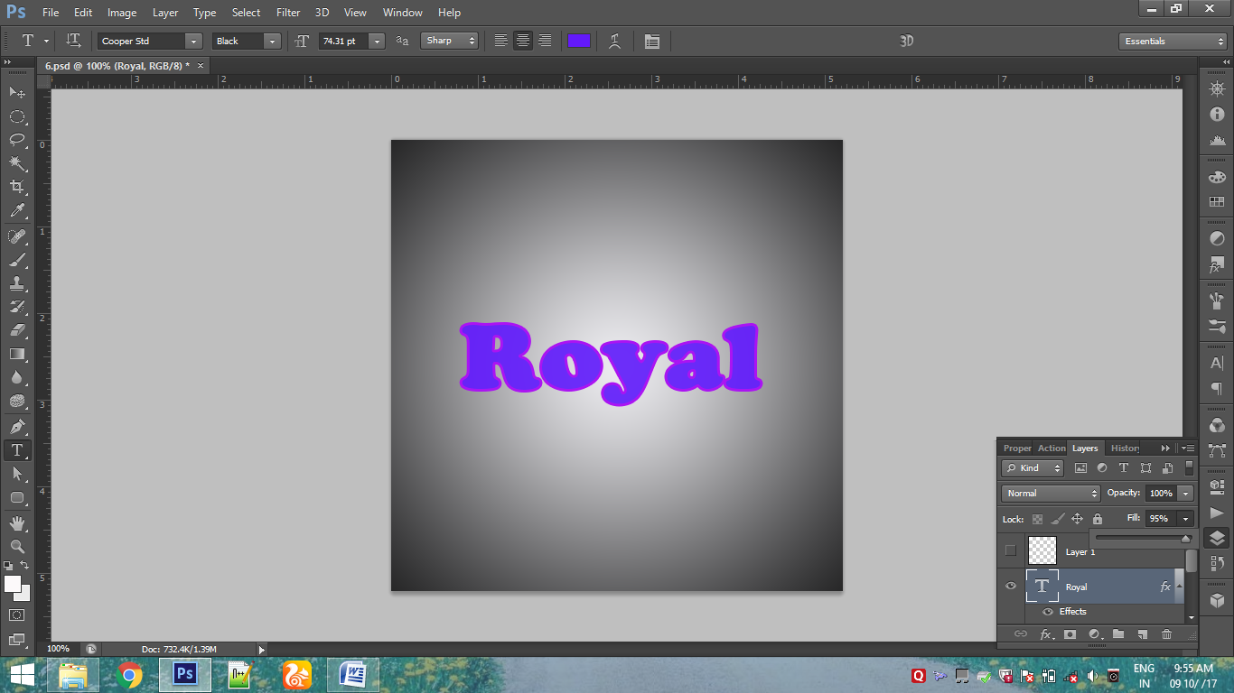

Step 4 : Put the fill of text to 0 and give it blending option Bevel and Emboss . Select the texture effect in it .

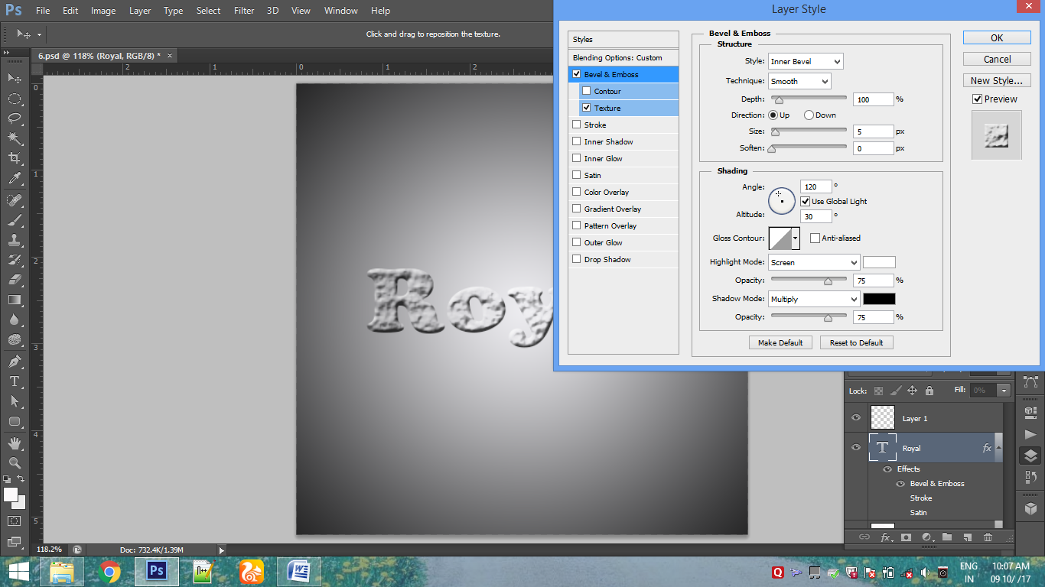

The result is:

