Practical-XIV

**Unit – V**

**Introduction to ActionScript**

1. **Write Action Script using loops, variables and arrays.**

## Open Adobe Flash CS5 and click on Create New Flash File (ActionScript 3.0).

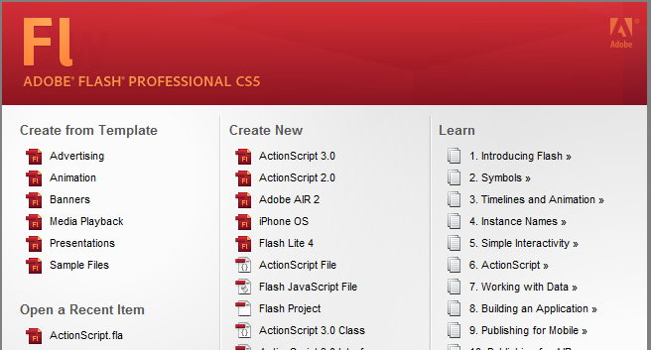

## Select Debug Workspace. This workspace is used when working with ActionScript.

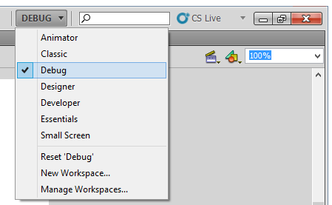

## This will Change workspace. You can see output window at bottom of workspace (you can also use F2 key to show output window, or Window > Output).

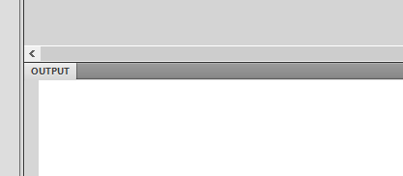

## Now press F9 key, this will show window to write an ActionScript. (You can also use menu Window > Actions).

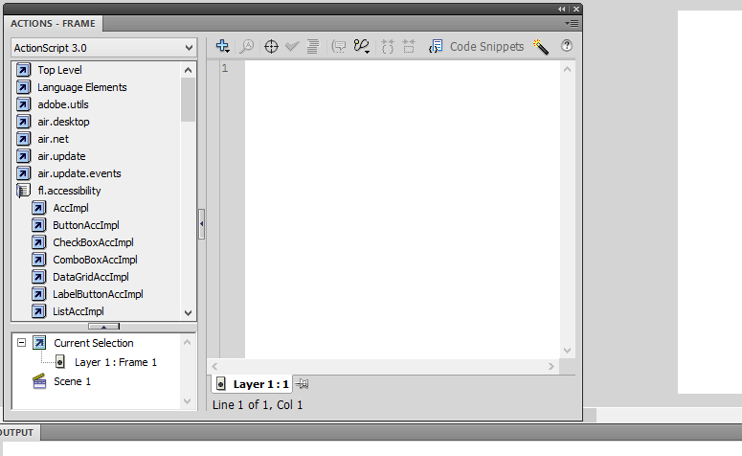

## Write the following code into content area.

var arrVar:Array = new Array("LOGO", "FLYER", "BROCHURE", "STATIONARY");

trace('Categories in Design Factory');

for(var i:int=0; i<arrVar.length; i++){

trace("Categories: "+arrVar[i]);

}

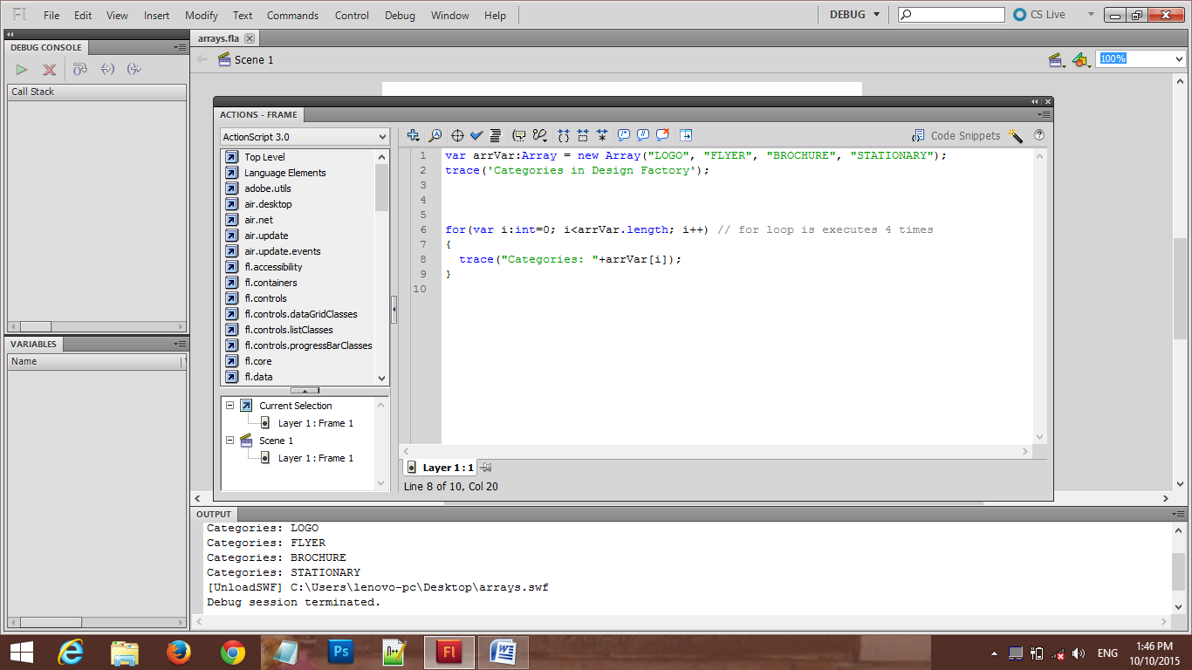

## Now, it is time to debug: go to Debug > Debug Movie > Debug.

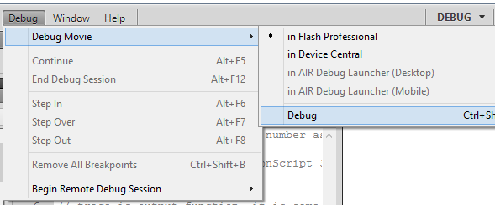

## A blank window is opened, but don’t worry, you can see ActionScript output at Output window.

## 