Practical-XI

**Unit – IV**

**Symbols, Animation and Organizing Projects**

1. **Write, test and debug small applications with Scenes and Frame Labels.**

## Create a new Flash document, and draw a rectangle on the left side of frame 1

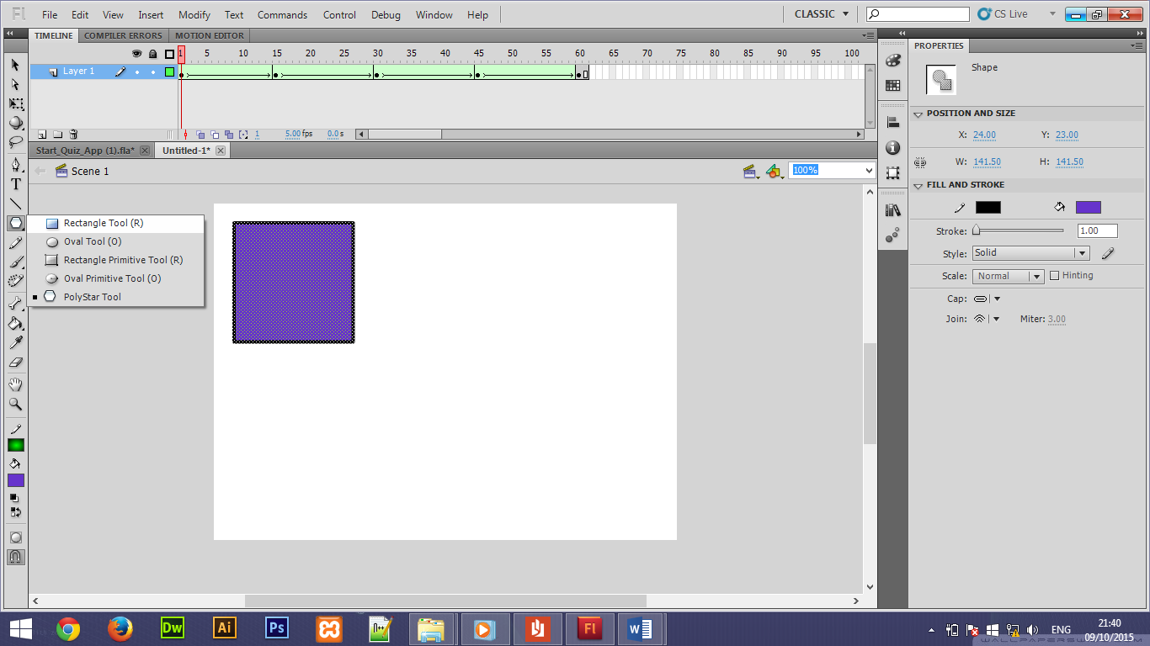

## Click frame 15, and right click to insert a blank keyframe. You now have 15 frames full of nothing but a circle.

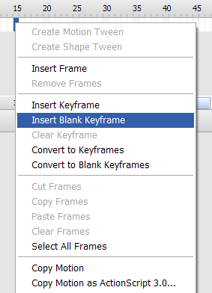

## Select the keyframe at frame 15, choose the circle tool (not the circle primitive tool), and draw a circle on the right side of the work area.

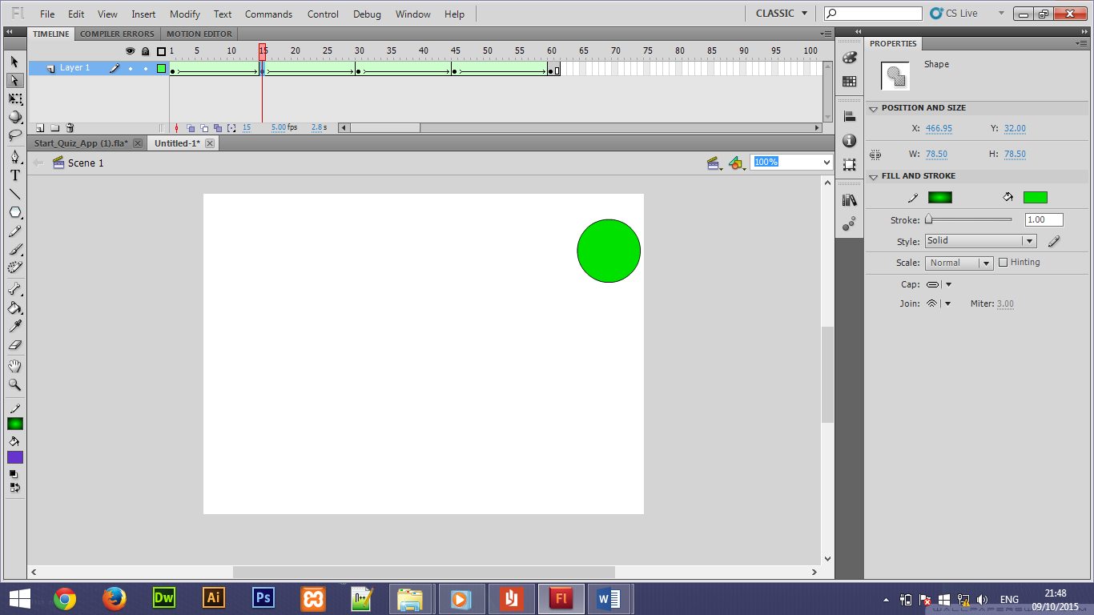

## Then select anywhere in the extended frame 15, and Insert a Shape Tween from the menu (or right-click on the frame and select Shape Tween).

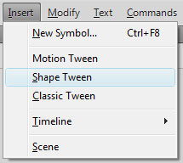

### Note: Plz apply a shape tween after inserting a each new shapes or when you apply a new blank keyframe.

## Then select a frame 30 and insert a blank keyframe over it.

## D:\Computer Engineer\5th Sem\MAT\Assi Data\sfu\Flash Animation_files\insert_blank.gif

## Select the keyframe at frame 30, choose the square tool, and draw a square on the right-bottom side of the work area.

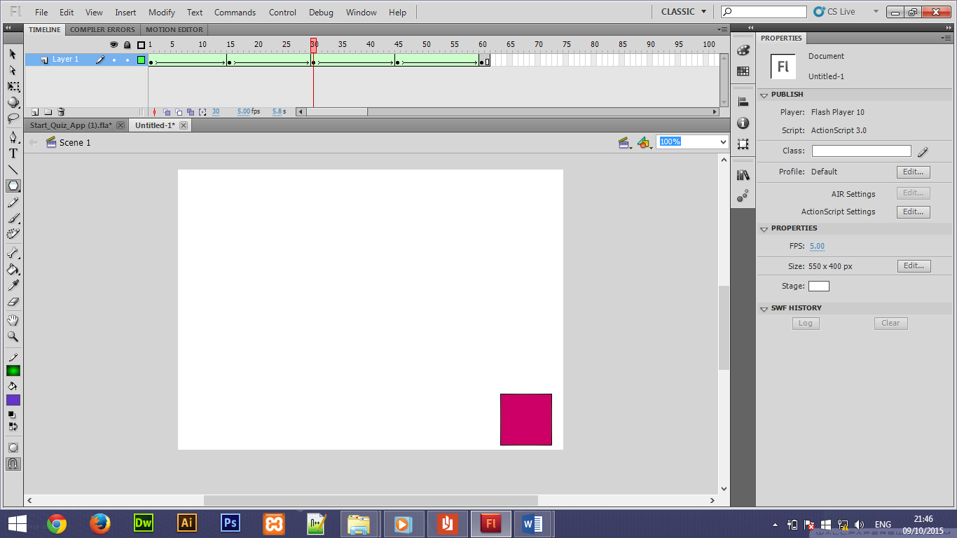

## (follow same procedure for this step as followed in step 4)

## Select the keyframe at frame 45, choose the PolyStar tool, and draw a polystar on the left-bottom side of the work area.

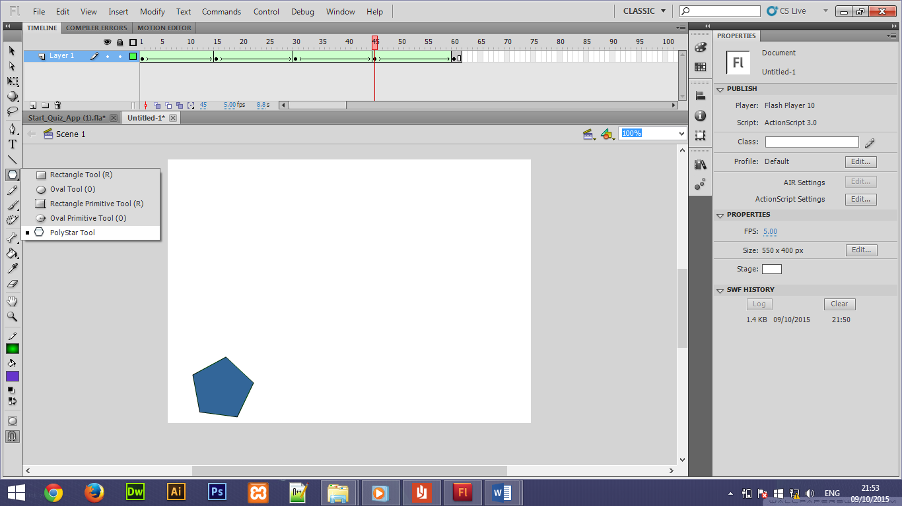

## Select the keyframe at frame 60, choose again rectangle tool at the same place where we had drawn a first rectangle shape to complete shape loop.

* **Output:**

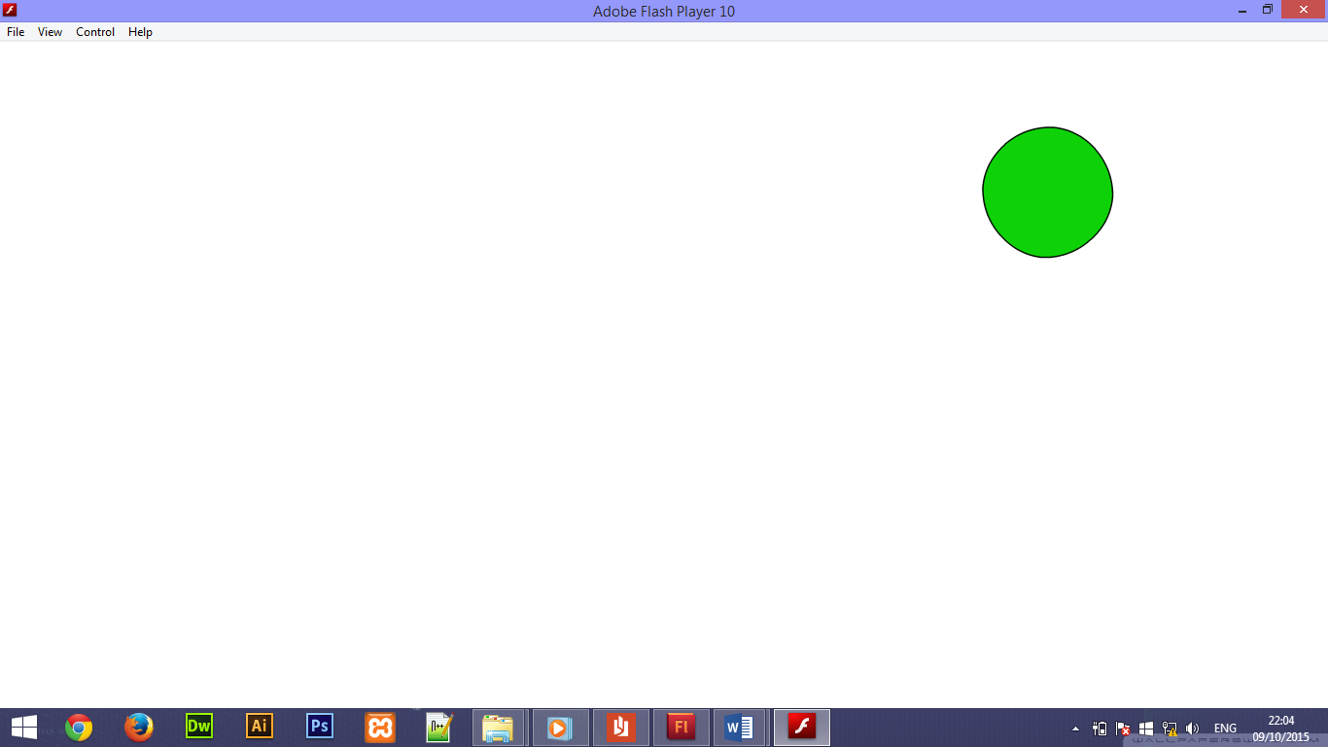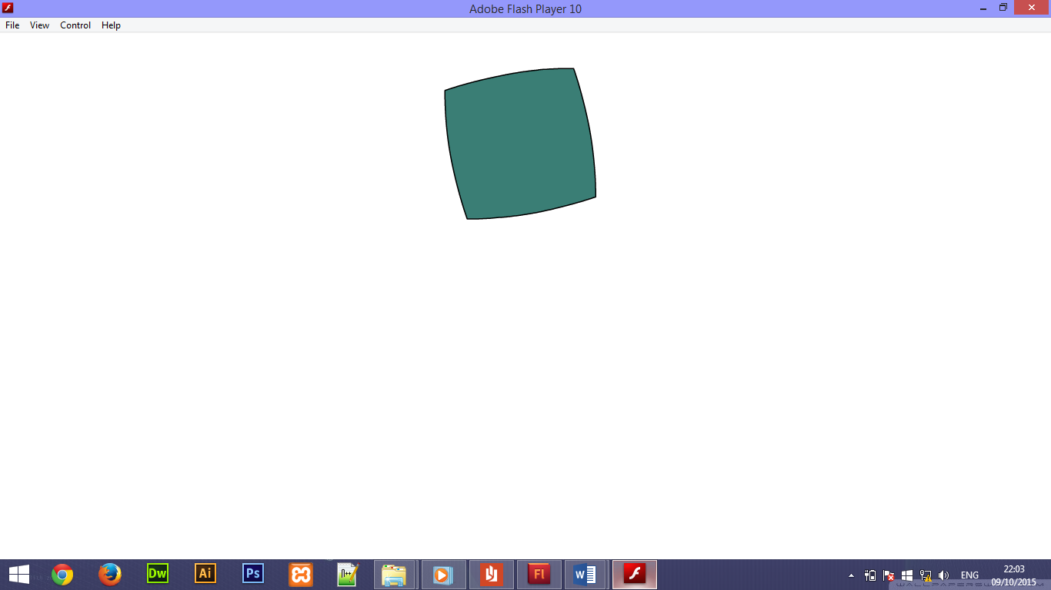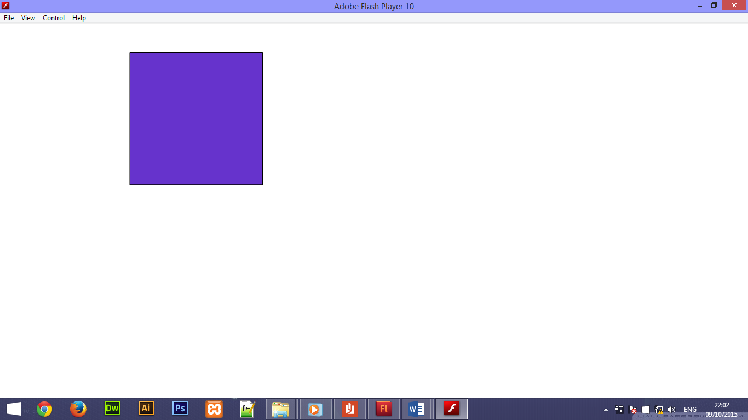

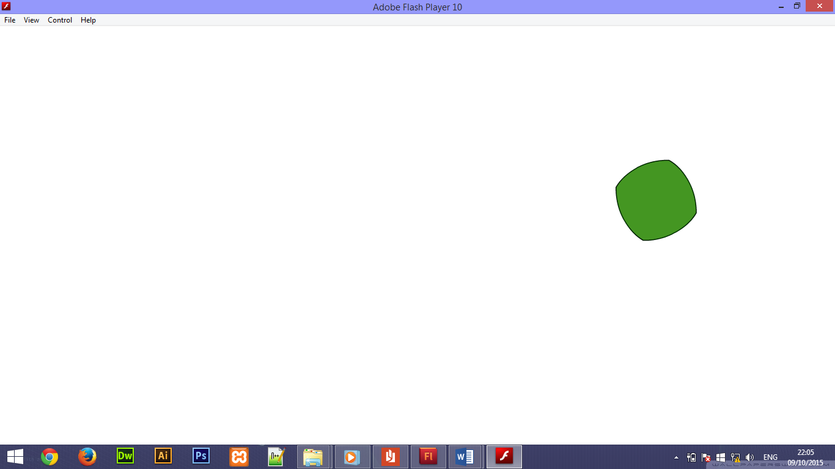

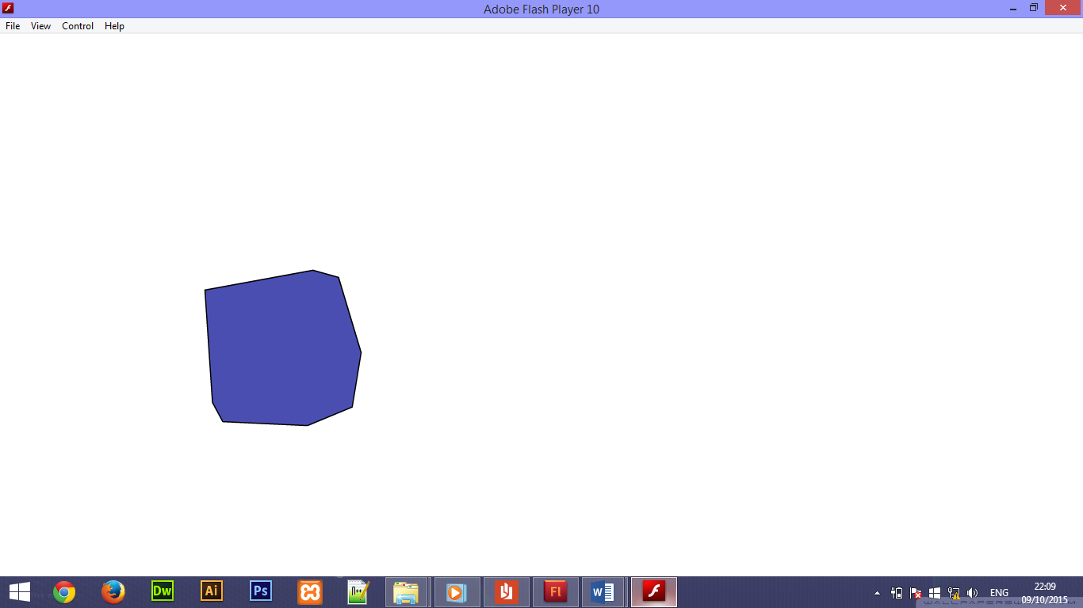

**Frames Labels**

