**IoT Mini Project**

**on**

**SMART DUSTBIN**

# INDEX

|  |  |  |
| --- | --- | --- |
| **Sr. No.** | **Content** | **Page No** |
| **1** | Introduction | 3 |
| **2** | List of Components | 4 |
| **3** | Circuit of system | 5 |
| **4** | Hardware Setup | 6 |
| **5** | Source Code | 8 |
| **6** | Outcome | 9 |

# Introduction

**Smart Dustbin** as its name represents it works smartly or we can say that it is an automatic dustbin. it works like when you will come in front of this dustbin it will open automatically with the help of a servo motor. so there is some sensor work to detect the object in front of the dustbin.

Smart Dustbin is a very good project from the Arduino board. It works likewise smart things. we can say that, It is a decent gadget to make your home clean and attractive. due to practically all offspring of home consistently make it grimy and spread trash to a great extent by paper, rappers and numerous different things.

kids have fun with this dustbin they play with the dustbin and in the play of them they clean your home as well because every time they use the smart Dustin and it attract the kids. they generally will be utilized to through all trash and waste into this smart dustbin. smart dustbin having the sensor when it detects any object in front of it, it opens and closes it’s top.

# List of Components

Components required to make **smart dustbin**: -

**Arduino Uno:** -

Arduino is an open-source electronics platform based on easy-to-use hardware and software. Arduino boards are able to read inputs - light on a sensor, a finger on a button, or a Twitter message - and turn it into an output - activating a motor, turning on an LED, publishing something online.

Price:- 449 ₹

**Ultrasonic Sensor: -**

Ultrasonic sensors are used primarily as proximity sensors. They can be found in automobile self-parking technology and anti-collision safety systems. Ultrasonic sensors are also used in robotic obstacle detection systems, as well as manufacturing technology.

Price:- 55₹

**Servo motor: -**

Servo motors or “servos”, as they are known, are electronic devices and rotary or linear actuators that rotate and push parts of a machine with precision. Servos are mainly used on angular or linear position and for specific velocity, and acceleration. Price:- 119₹

**Jumper** **wire:** **-**

A jumper wire is an electric wire that connects remote electric circuits used for printed circuit boards. By attaching a jumper wire on the circuit, it can be short-circuited and short-cut (jump) to the electric circuit.

Price:- 45₹

**9v battery: -**

A nine-volt battery, either disposable or rechargeable, is usually used in smoke alarms, smoke detectors, walkie-talkies, transistor radios, test and instrumentation devices, medical batteries, LCD displays, and other small portable appliances.

Price:- 20₹

# Circuit of System

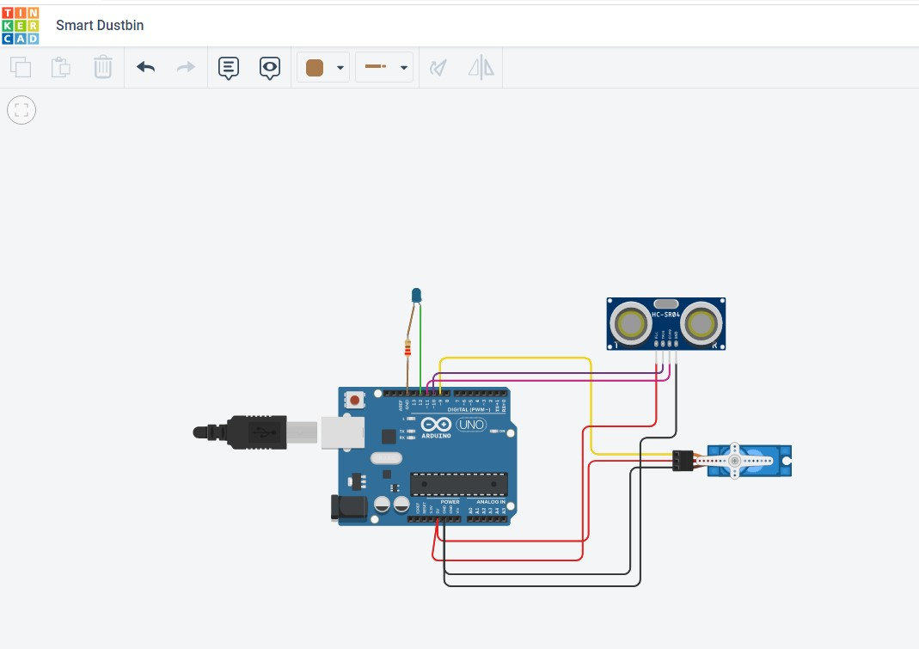

# Hardware Setup

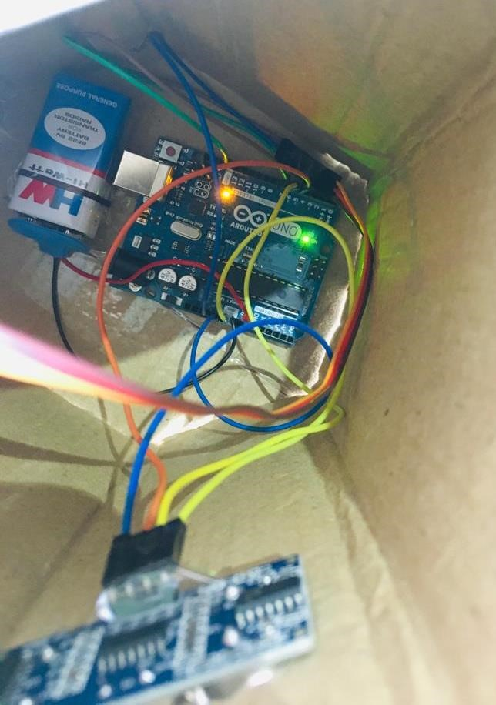

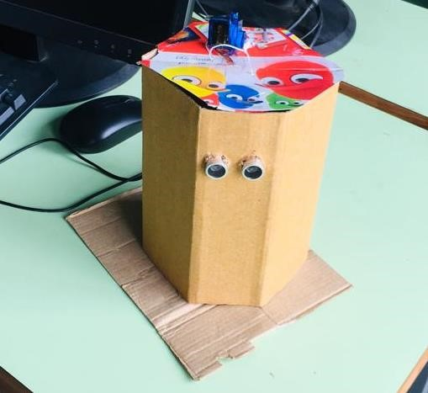

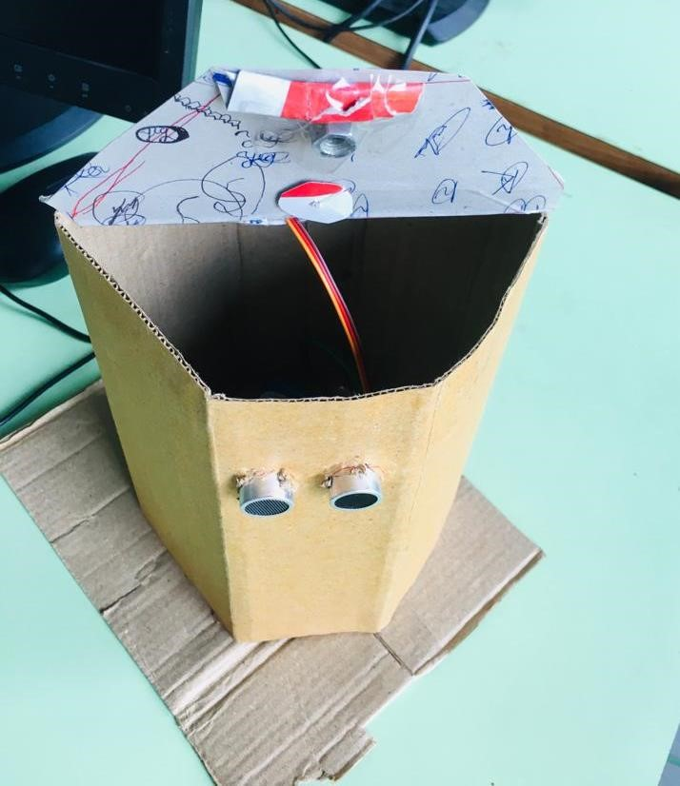

# Source Code(With LED)

#include <Servo.h> Servo myservo; int pos = 20; const int trigPin = 10; const int echoPin = 11; const int led = 12; long duration; float distance; void setup()

{

myservo.attach(9); pinMode(trigPin, OUTPUT); pinMode(echoPin, INPUT); pinMode(led, OUTPUT); myservo.write(pos);

}

void loop()

{

//Serial.begin(9600); digitalWrite(trigPin, LOW); delayMicroseconds(2); digitalWrite(trigPin, HIGH); delayMicroseconds(10); digitalWrite(trigPin, LOW); duration = pulseIn(echoPin, HIGH);

distance = 0.034*(duration/2);

//Serial.println(distance); if (distance <= 50)

{

digitalWrite(led,HIGH); myservo.write(pos+160);

delay(100);

} else

{

digitalWrite(led,LOW); myservo.write(pos);

}

delay(100);

}

# Outcome

In Range:

LED blinks

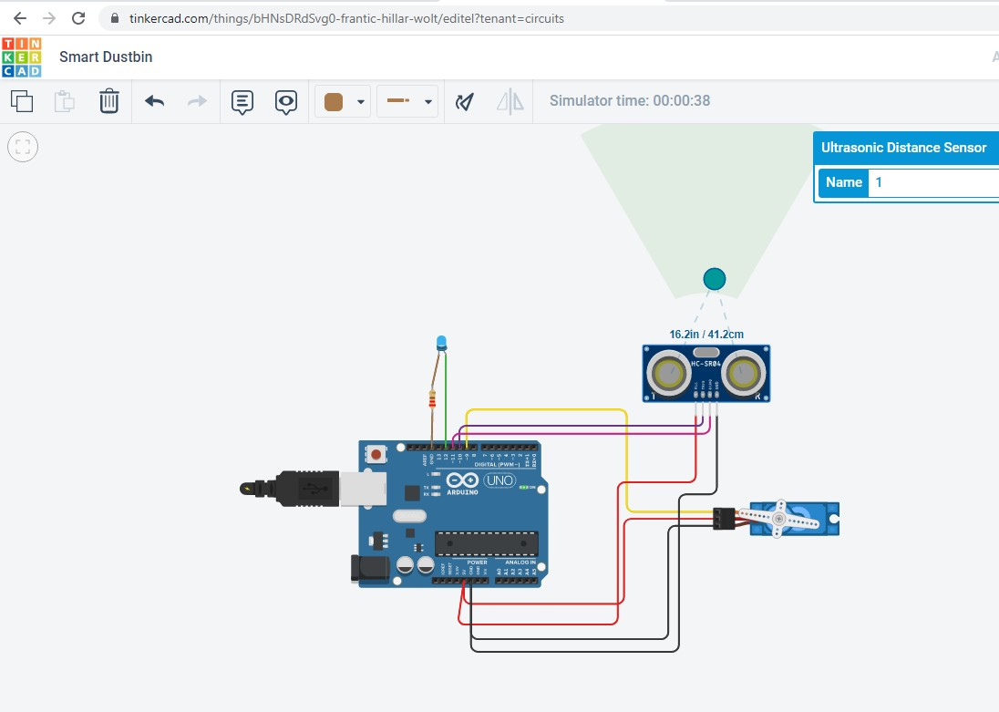

Not in Range: LED don’t blinks

