Health Intel Report 2021-10-14

# Individual Report

Numeric Data Analysis

## Fever Duration

* The average fever duration is: 8.22 days
* The median fever duration is: 8.00 days
* The interquartile range for fever duration: 5.75 days

## Fever Temperature

* The average fever temperature reported is: 100.88 ℃ F
* The median fever temperature is: 101.00℃ F
* The interquartile range for fever temperature: 4.00℃ F

## Age

* The average age of patient is : 40.10 years
* The median age of pateint is : 40.00 years
* The interquartile range for age is : 25.00 years

## BMI (Body Mass Undex)

* The average BMI of patient is : 23.75
* The median value is : 24.00
* The interquartile range for BMI is : 7.00

## Oxygen Saturation Level

* The average oxygen saturation level is : 95.22%
* The median level is : 96.00%
* The interquartile range is : 6.00% points

Nominal Data Analysis

* 47.62% Covid positive patients reported being Diabetic
* 46.67% Covid positive patients reported having Heart Problems
* 48.57% Covid positive patients reported being Asthmatic
* 68.10% Covid positive patients reported having Cough
* 74.29% Covid positive patients reported having Throat Ache

# City Report

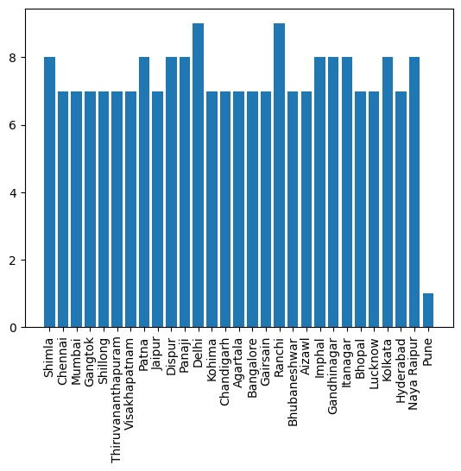

Outbreak Alert

* Ranchi is most vulnerable with 9 cases recently reported

# State Report

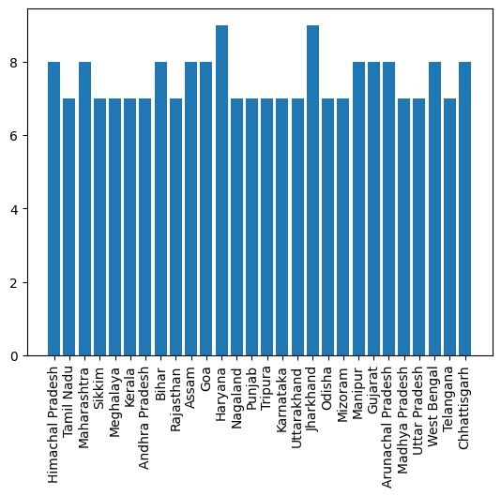

Pandemic Alert

* Jharkhand is most vulnerable with 9 cases recently reported

End of Report

_________________________________