Assignment 1a: Dashboard design using HTML,CSS,Bootstrap

Website image:

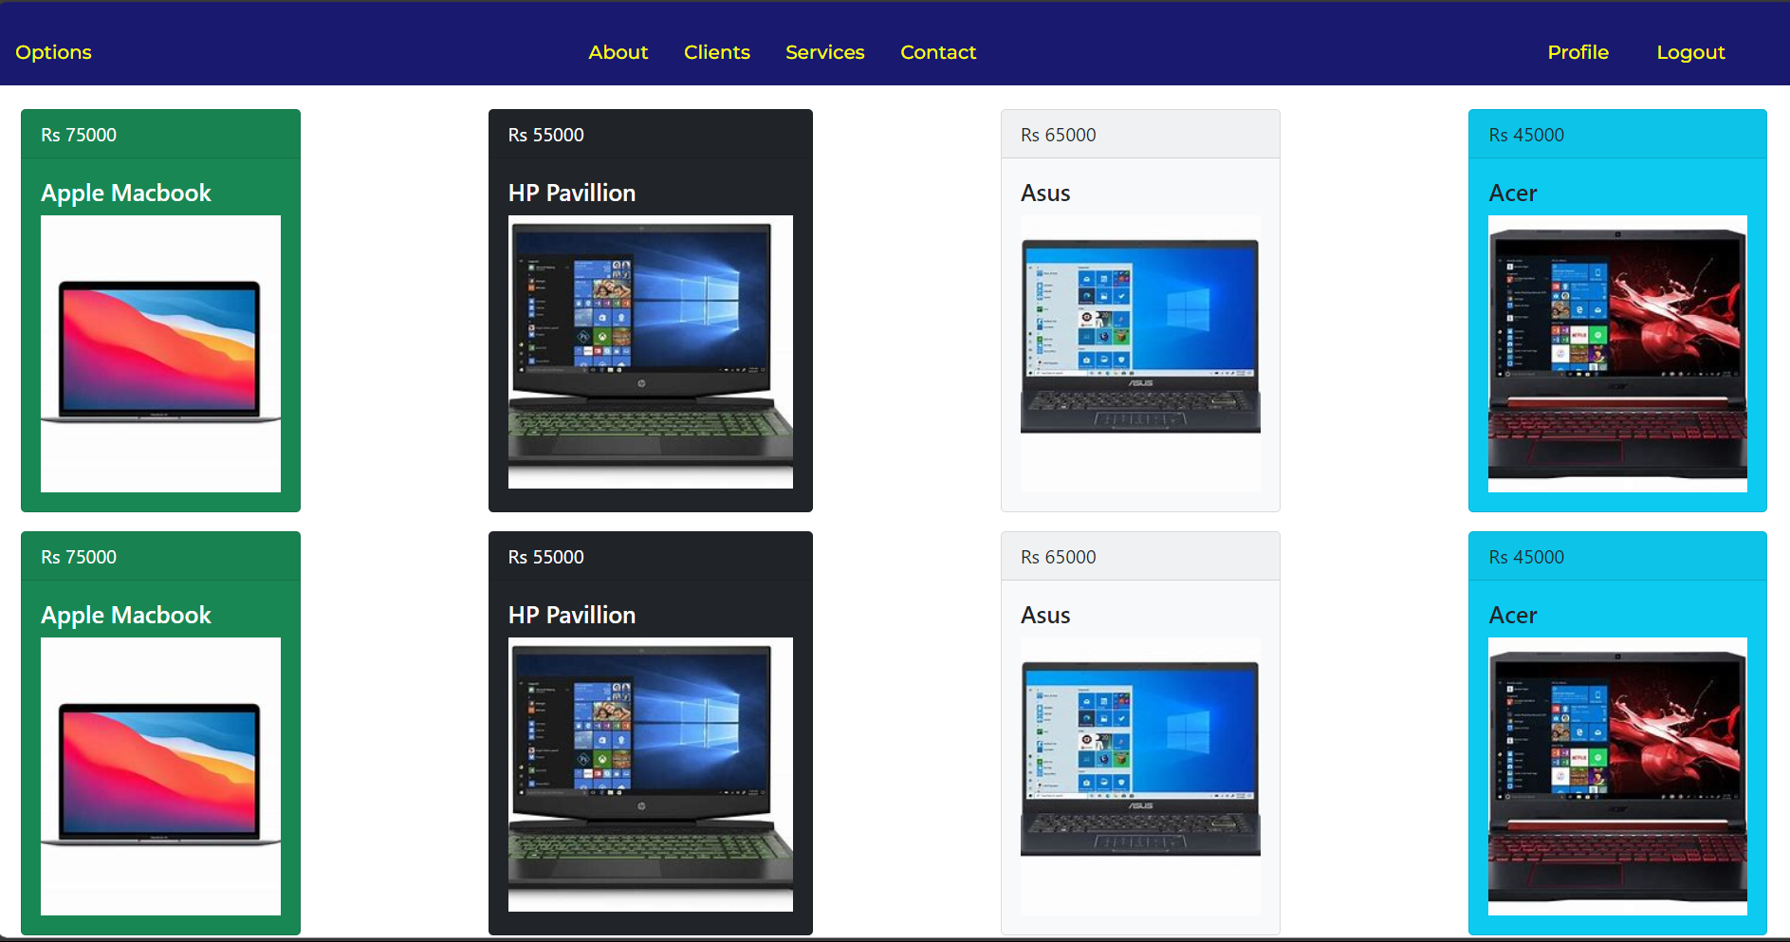

Togglable side bar:

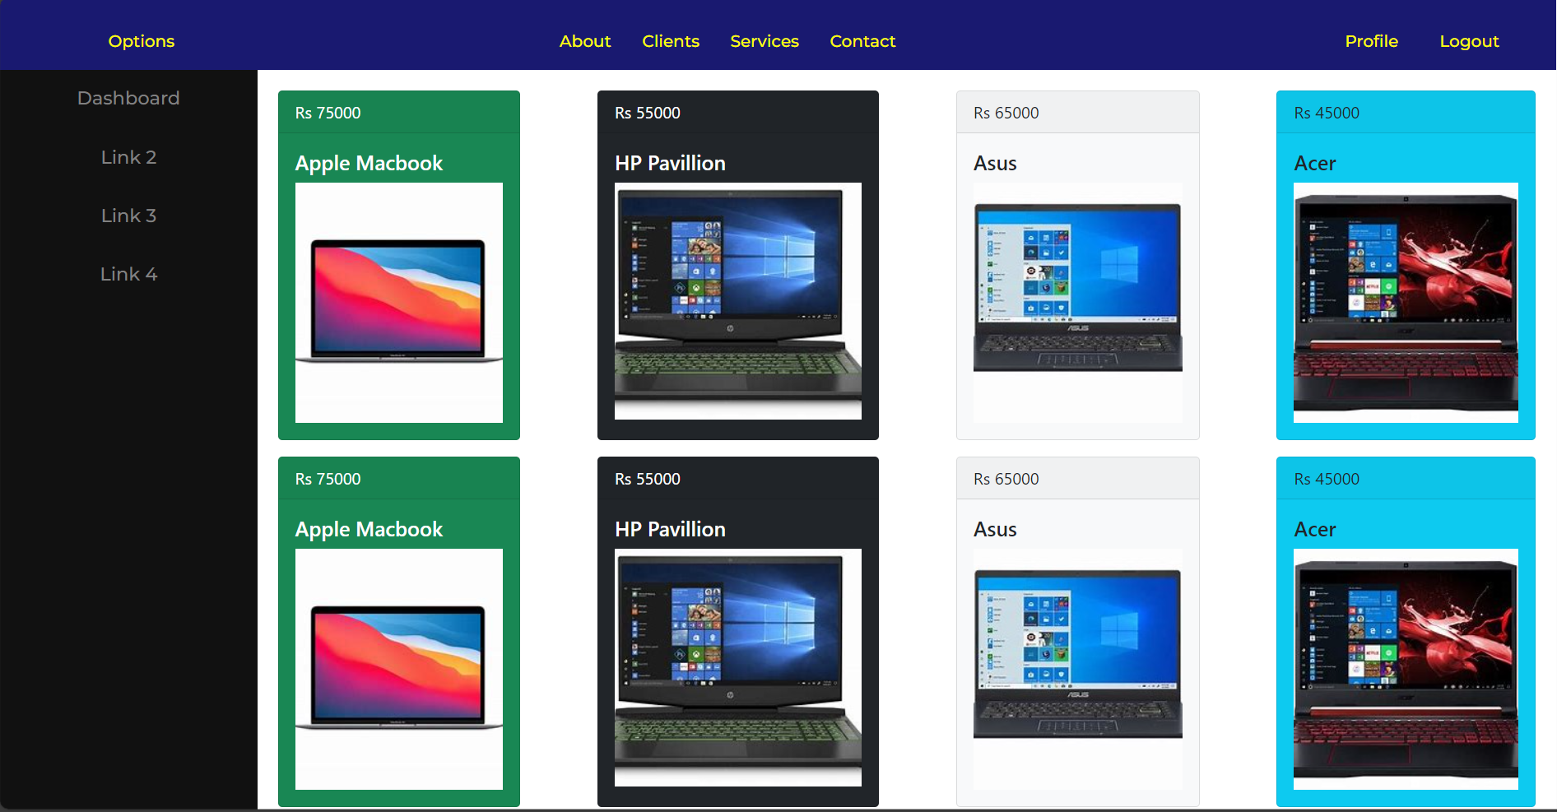

Responsive nature of website:

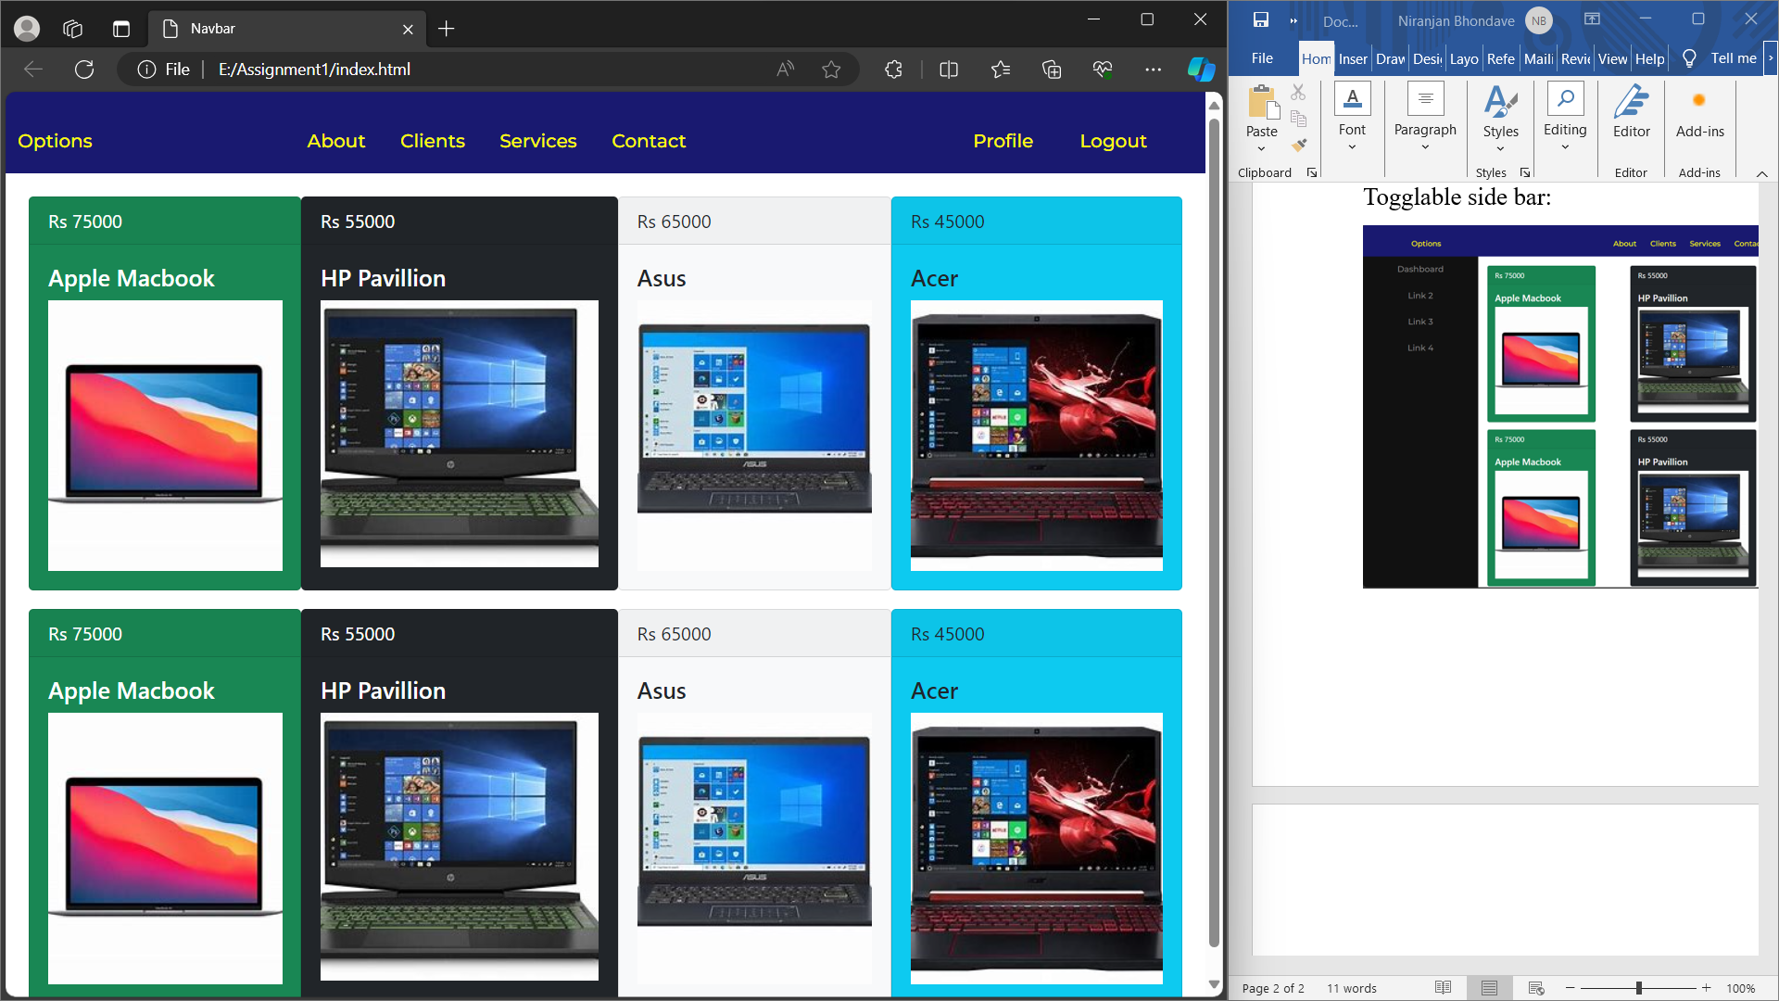

Assignment 1b: Write a JavaScript Program to get the user registration data and push to array/local storage with AJAX POST method and data list in new page.

Registration page:

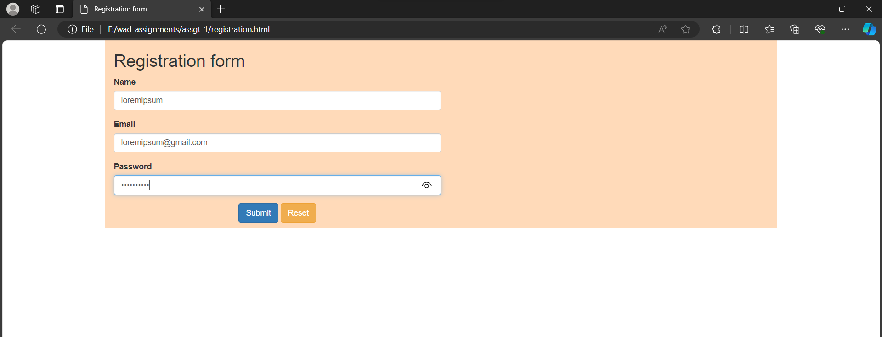

Validation: using existing email

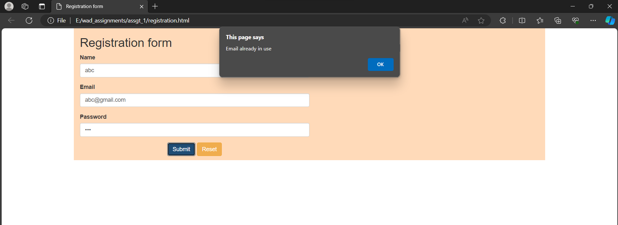

Successful login and simultaneous home page

