**OUTPUT OF ASSIGNMENT 1B**

**VALIDATIONS:**

1. **Registering with existing ID:**

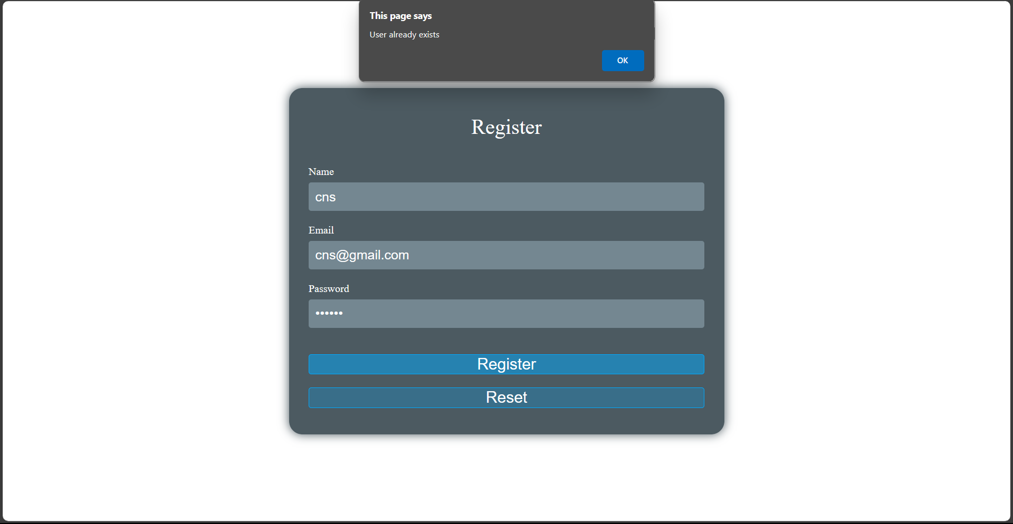

1. **Invalid credentials**

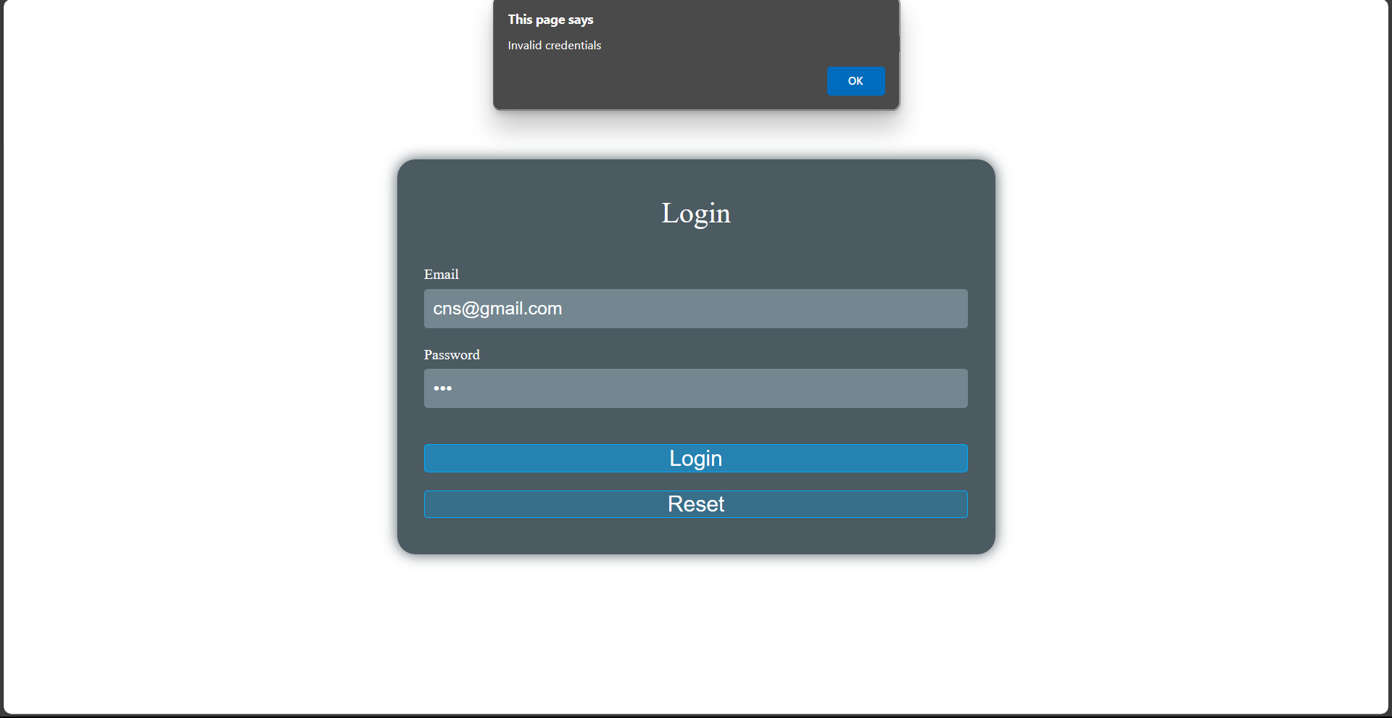

1. **Invalid email**

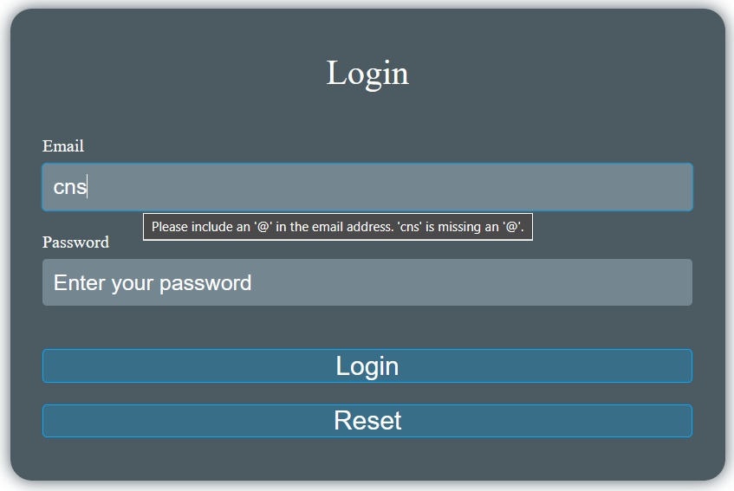

**NORMAL WORKING**

1. **Successful registration and registration to local storage**

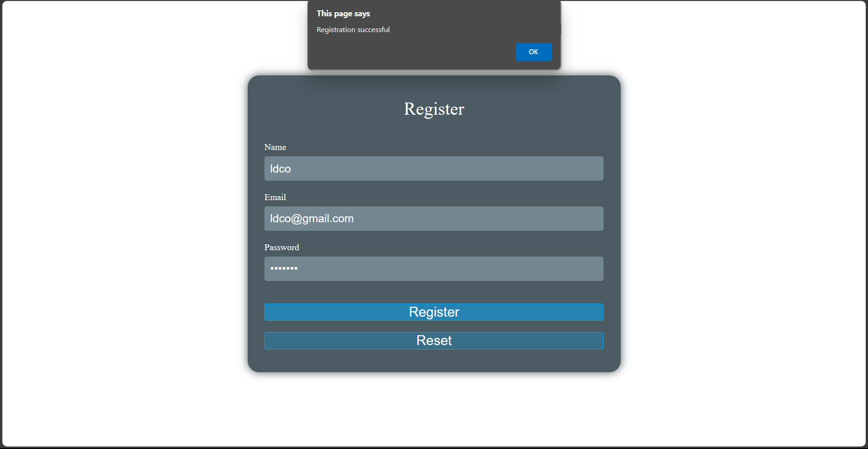

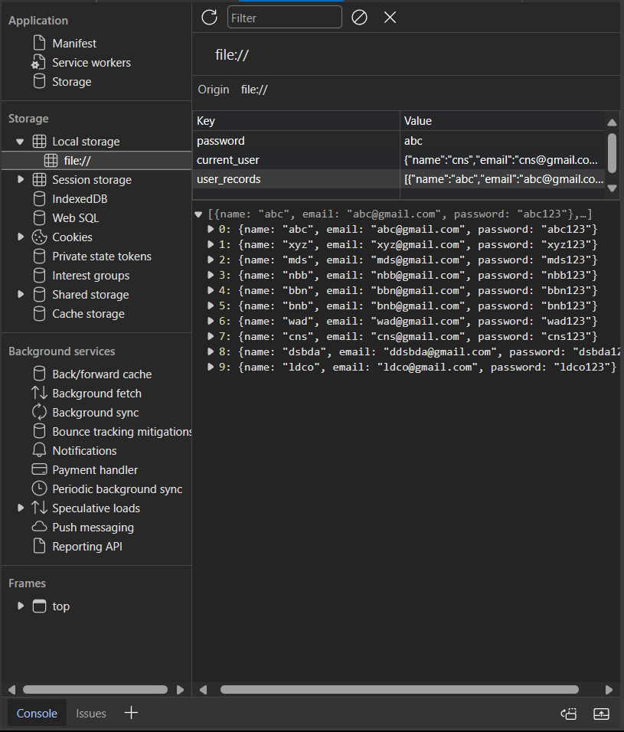

1. **Successful login**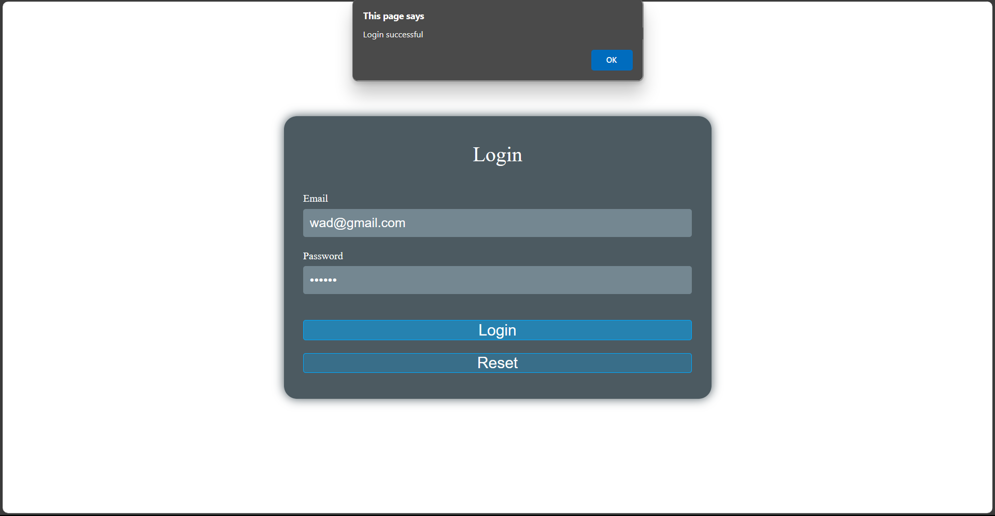
2. **Home page**

