**CODE OF THE ASSIGNMENT**

<!doctype html>

<html lang="en">

<head>

<meta charset="utf-8">

<meta name="viewport" content="width=device-width, initial-scale=1">

<title>tap demo</title>

<link rel="stylesheet" href="//code.jquery.com/mobile/1.5.0-alpha.1/jquery.mobile-1.5.0-alpha.1.min.css">

<script src="//code.jquery.com/jquery-3.2.1.min.js"></script>

<script src="//code.jquery.com/mobile/1.5.0-alpha.1/jquery.mobile-1.5.0-alpha.1.min.js"></script>

<style>

html, body {

padding: 0;

margin: 100;

}

html, .ui-mobile, .ui-mobile body {

height: 85px;

}

.ui-mobile, .ui-mobile .ui-page {

min-height: 85px;

}

#nav {

font-size: 200%;

width:17.1875em;

margin:17px auto 0 auto;

}

#nav a {

color: #777;

border: 2px solid #777;

background-color: #ccc;

padding: 0.2em 0.6em;

text-decoration: none;

float: left;

margin-right: 0.3em;

}

#nav a:hover {

color: #999;

border-color: #999;

background: #eee;

}

#nav a.selected,

#nav a.selected:hover {

color: #0a0;

border-color: #0a0;

background: #afa;

}

div.box {

width: 30em;

height: 3em;

background-color: #108040;

align-self: center;

margin-bottom: 25em;

}

div.box.tap {

background-color: #7ACEF4;

}

div.box.swipeleft {

background-color: #F4A460;

}

div.box.swiperight{

background-color: purple;

}

div.box.swipeup{

background-color: #F4A460;

}

</style>

</head>

<body>

<h3>Tap the square to change the color to blue:</h3>

<div class="box"></div>

<h3>Swipe the box left to change color to orange: </h3>

<div class="box"></div>

<script>

$(function(){

$( "div.box" ).bind( "tap", tapHandler );

function tapHandler( event ){

$( event.target ).addClass( "tap" );

}

});

$(function(){

// Bind the swiperightHandler callback function to the swipe event on div.box

$( "div.box" ).on( "swiperight", swiperightHandler );

// Callback function references the event target and adds the 'swiperight' class to it

function swiperightHandler( event ){

$( event.target ).addClass( "swiperight" );

}

});

$(function(){

// Bind the swipeleftHandler callback function to the swipe event on div.box

$( "div.box" ).on( "swipeleft", swipeleftHandler );

// Callback function references the event target and adds the 'swipeleft' class to it

function swipeleftHandler( event ){

$( event.target ).addClass( "swipeleft" );

}

});

$(function(){

// Bind the swipeleftHandler callback function to the swipe event on div.box

$( "div.box" ).on( "swipeup", swipeupHandler );

</script>

</body>

</html>

**OUTPUT OF THE ASSIGNMENT**

Before changes:

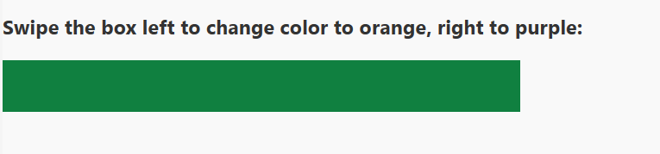

1. Triggering swipe left event:

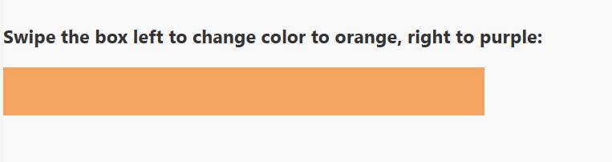

1. Triggering swipe right event:

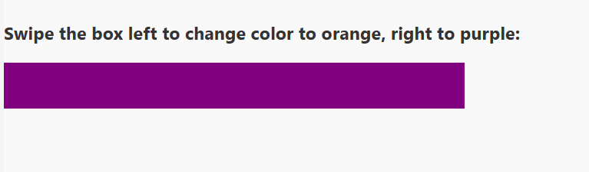

1. Tap functionality: Before triggering

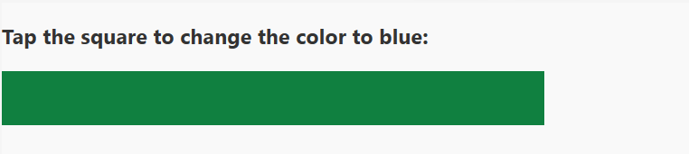

Post trigger:

