

Indian Institute of Technology, Indore

CS 257 DBIS Project

Digital Video Library Management System

Submitted by- Niranjan Joshi (160001026) and Kanishkar J (160001028)

AIM OF THE PROJECT:
The aim of the project is to provide online digital management system where multiple users can upload, access videos, create channels, playlists and like or comment upon the videos. The project can be used for educational or entertainment purpose.

ER DIAGRAM:

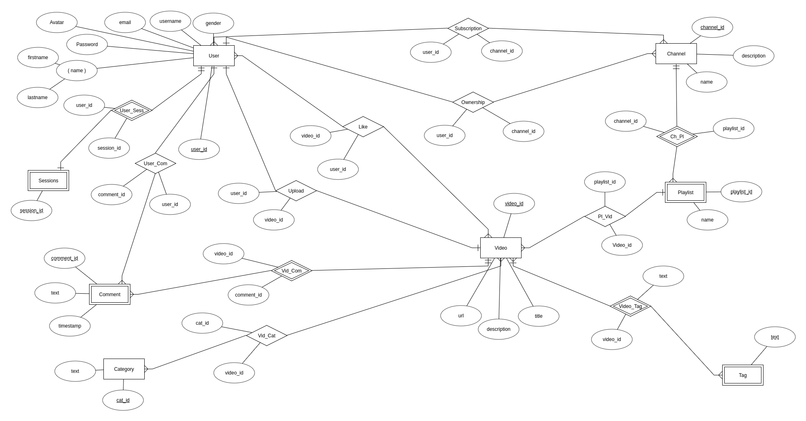
ENTITY SET:
- Video
- Channel
- Category
- User
- Tag: Weak entity set Existentially Dependent on Video
- Comments: Weak entity set existentially Dependent on Video
- Playlist: Weak entity set Existentially Dependent on Channel

ENTITY RELATIONSHIPS:
- Subscription (User-Channel)
- Ownership (User-Channel)
- Upload (User_Video)
- Like (User_ Video)
- Video_Comment
- Belongs (Video_Channel)
- Video_Category
- Video_Tag
- Playlist_Video
- Playlist_Channel

FUNCTIONAL DEPENDENCY CONSTRAINTS:

User:
( user_id ) → ( name, email, password )

Channel:
( channel_id ) → ( name, description, User.user_id, User.name, User.email, User.password )
( channel_id ) → ( name, description)

Video:
( video_id ) → ( title, url, description )
( url ) → ( title, description )

Category:
( cat_id ) → ( name )

Tag:
( video_id, text ) → ( text )

Comment:
( video_id, Comment_id ) → ( text, timestamp )

Playlist:
( channel_id, playlist_id ) → ( name )
( video_id , playlist_id ) → ( name )

TABLES FROM ER DIAGRAM AND FUNCTIONAL DEPENDENCIES:

User( user_id, username, email, password)

Profle(user_id, frstname, lastname, gender, avatar)
foreign key : user_id references User.user_id

Channel( channel_id, name, description, user_id)
foreign key : user_id references User.user_id

Video( video_id, url, title, description, user_id)
foreign key : user_id references User.user_id

Tag( text , video_id)
foreign key : video_id references Video.video_id

Category( cat_id, text)

Playlist( playlist_id, name, channel_id)
foreign key : channel_id references Channel.channel_id

Comment( comment_id, text, timestamp, video_id, user_id)
foreign key : user_id references User.user_id
video_id references Video.video_id

Subscription ( user_id, channel_id )
foreign key : user_id references User.user_id
channel_id references Channel.channel_id

Like(video_id, user_id)
foreign key : user_id references User.user_id
video_id references Video. video_id

Pl_Vid(video_id, playlist_id)
foreign key : video_id references Video. video_id
playlist_id references Playlist.playlist_id

Vid_Cat(cat_id, video_id)
foreign key : video_id references Video.video_id
cat_id references Category.cat_id

Sessions(user_id, session_id)
foreign key : user_id references User.user_id

SOFTWARE AND HARDWARE REQUIREMENTS:

Hardware requirements for hosting website:
- At least 2 GB RAM
- 1.5 GHz Processor
- Internet connection

Software requirements:
- Linux system
- python3
- pip
- mysql client
- apache server
- Software for database administration (Mysql workbench)

Instructions on linux:
- Install LAMP server on the system.
- Create a database with utf8_unicode_ci character encoding.
- Create user with username django and password django.
- If you want to configure the server and connection details open Revels/.env and edit the value for the variables.
- Open the terminal, then navigate into Revels directory in the terminal now run the following command to create the databases :
- python3 create.py
- Run the queries in triggers.sql to create the triggers.
- Run the queries in data.sql to create the sample database.
- Open the terminal, then navigate into Revels directory in the terminal now run the following command to install all dependencies :
- sudo pip install -r req.txt
- In the terminal now run the following command to initiate the server :
- python3 manage.py runserver 0.0.0.0:8000
- Open the browser and navigate to http://localhost:8000

FILE STRUCTURE OF THE PROJECT/ BLOCKS:
The project is implemented using django web framework of python.

- Overall structure of the project:
The project is named Revels. The main directory contains all the apps- Auth, Frontend and ORM along with git files for version control, the manage.py file which is used to run the project, req.txt containing requirements, create.py containing create table queries, triggers.sql for setting up triggers.
The subdirectory Revels consists of settings.py file
where database and admin are configured. The urls.py contains urlpatterns which django checks upon getting request from the user.
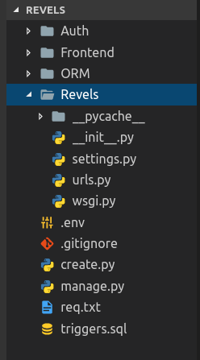

- Inside Auth:
The Auth is an app that handles user authentication. The main django urls.py searches for urls related to authentication in Auth/urls.py.
The views.py file consists of functions which handle the requests from users and render appropriate HTTP response. The apps.py file tells django that ‘Auth’ is an app.
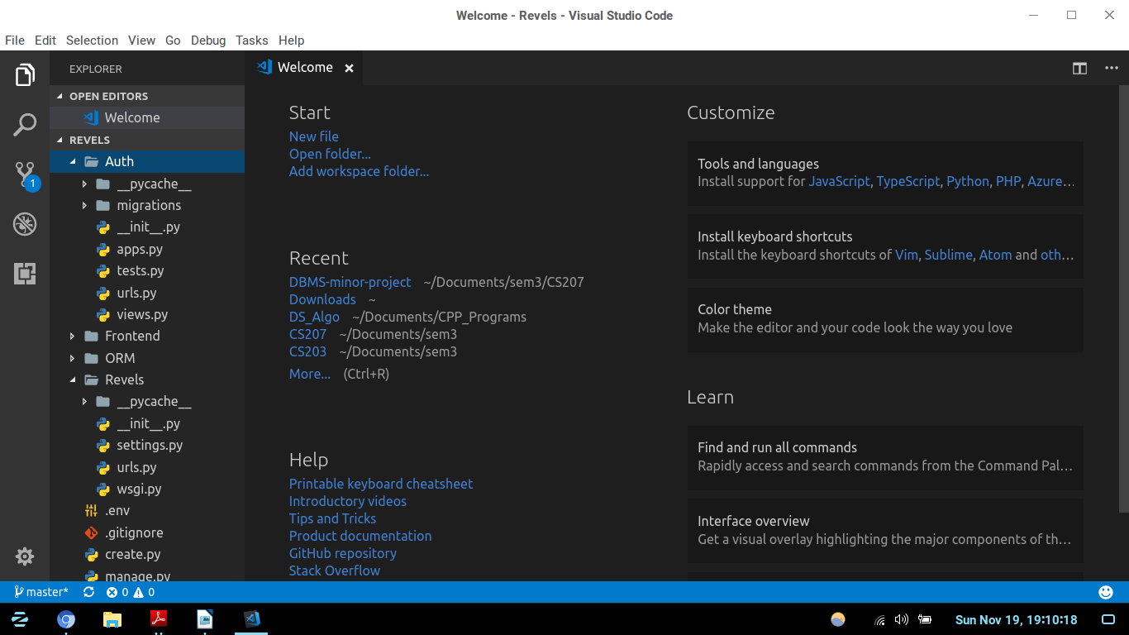

- Inside ORM:
ORM stands for Object Relational Mapping.
The ORM contains python files of all tables. These files contain create table and other sql queries for these table. The sql queries are wrapped inside python functions. The purpose of this is to increase readability of the code. These functions can be called as normal python functions from views.py. The important file here is dbconnect.py. In this file functions along with SQLException handling are present which can query or modify the database. The connection is opened and the cursor is used to execute queries. The relations.py file contains queries related to all relation sets.
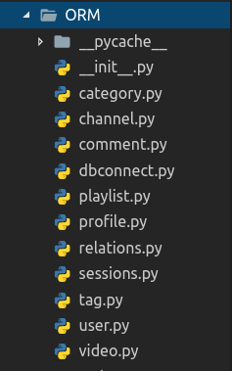

- Inside Frontend:
The Frontend app handles all GUI of the website except authentication part. The urls.py in the Frontend is checked when django receives request for url related to Frontend. The views.py file contain functions to render templates. The templates are html files with output the response from server. The templates contain dynamic parts like for loops, if-else conditions. Each page is rendered from views.py, content of the template is provided through python dictionary.
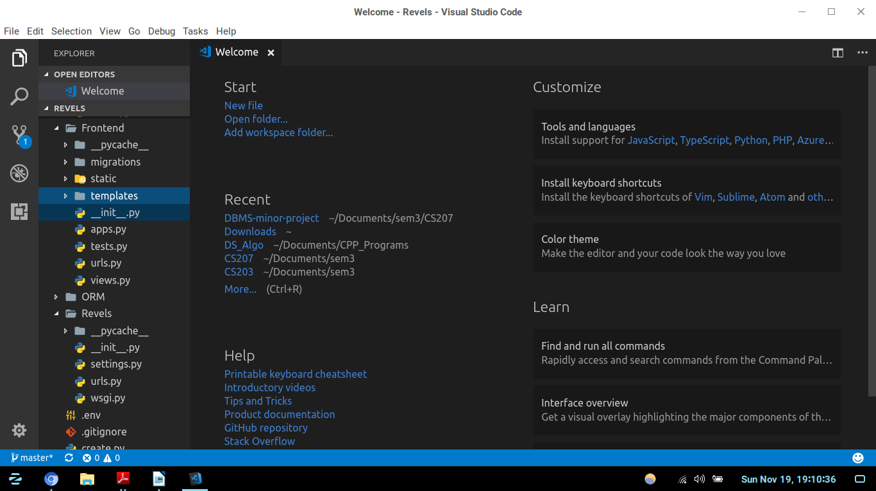
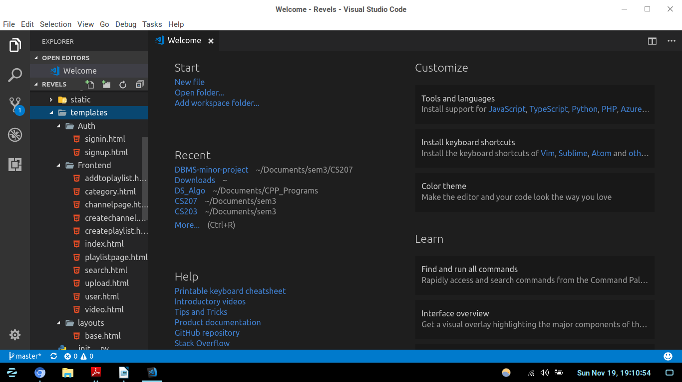

FEATURES OF DIGITAL VIDEO LIBRARY MANAGEMENT SYSTEM (REVELS PORTAL):
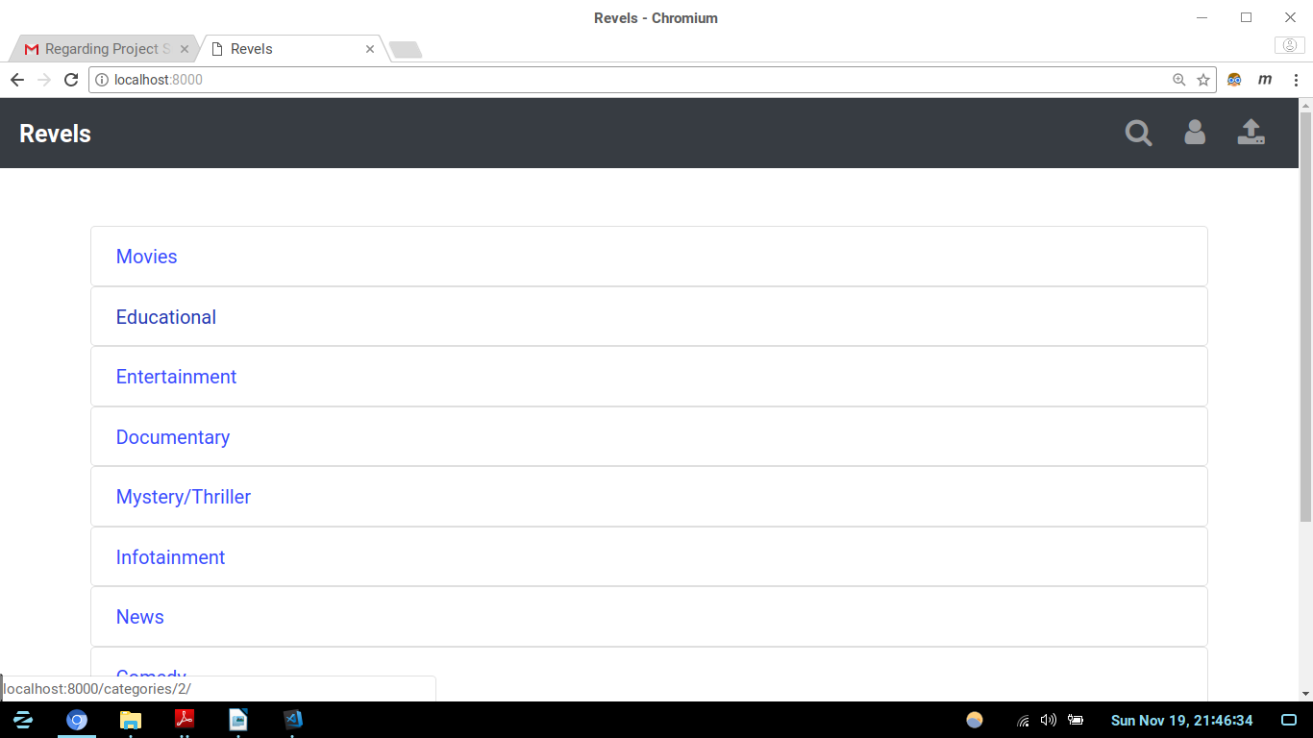
- Index ( / ):
The index page is the home page of the website at url ‘localhost:8000/’. It displays all the categories, user signin / profile page and upload video button. The template for index is
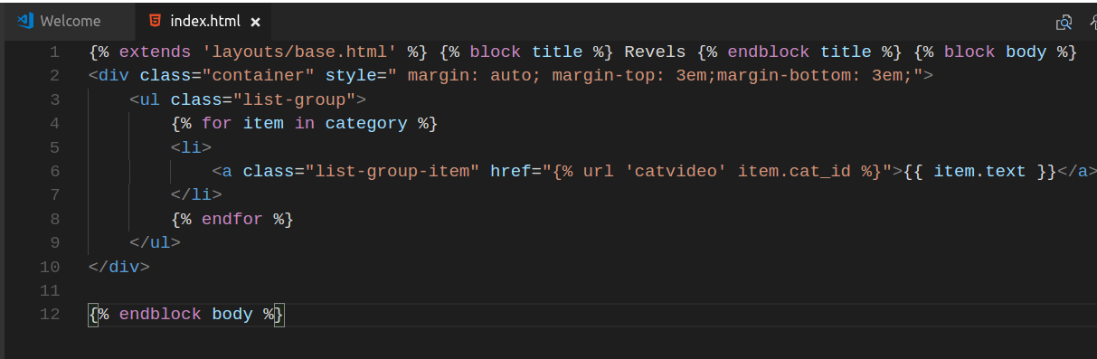
The view function index renders this template.

- Displaying Playlist ( /playlist/(no.)/ ):
The playlist is viewed differently for different users. If a user owns the channel and hence the playlist then he gets the option for deletion of playlist and deletion of videos from playlist.
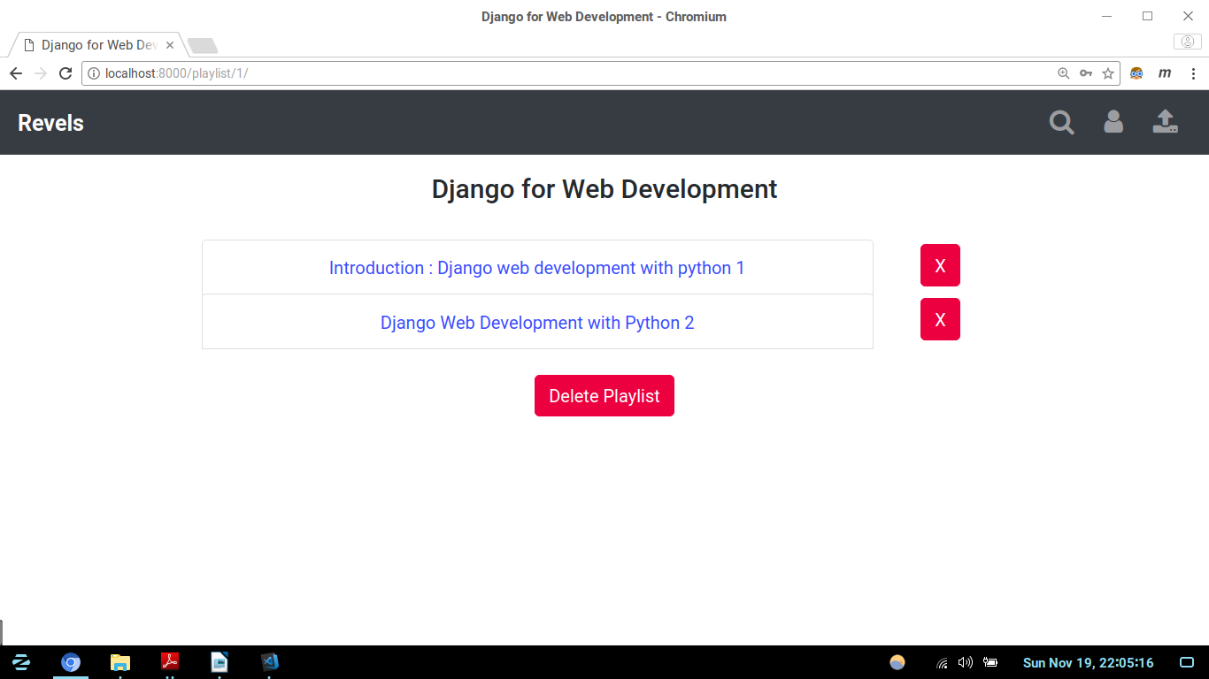
If the user is not signed in or if he's not the owner of the playlist then he cannot deletion the video. Addition of the video to the playlist is done from video page itself.
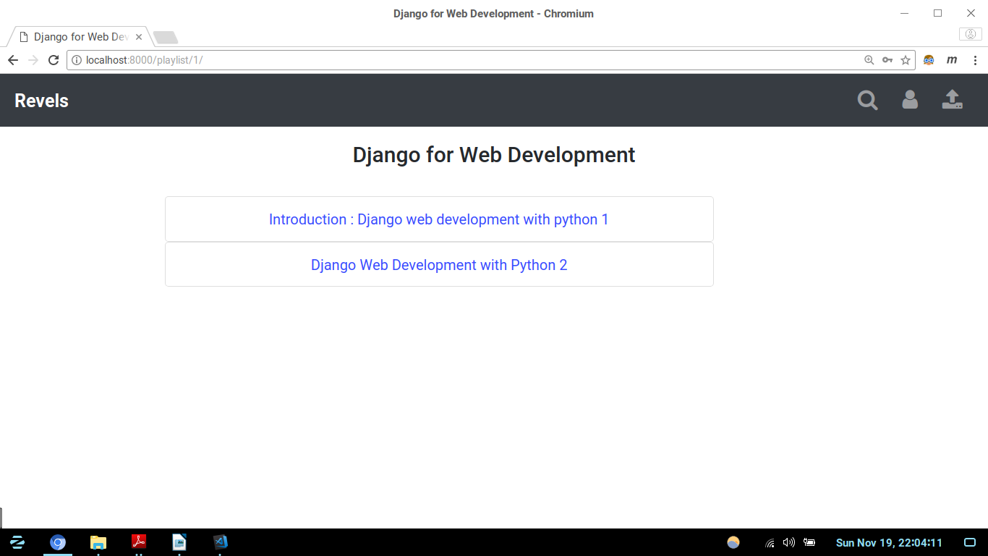
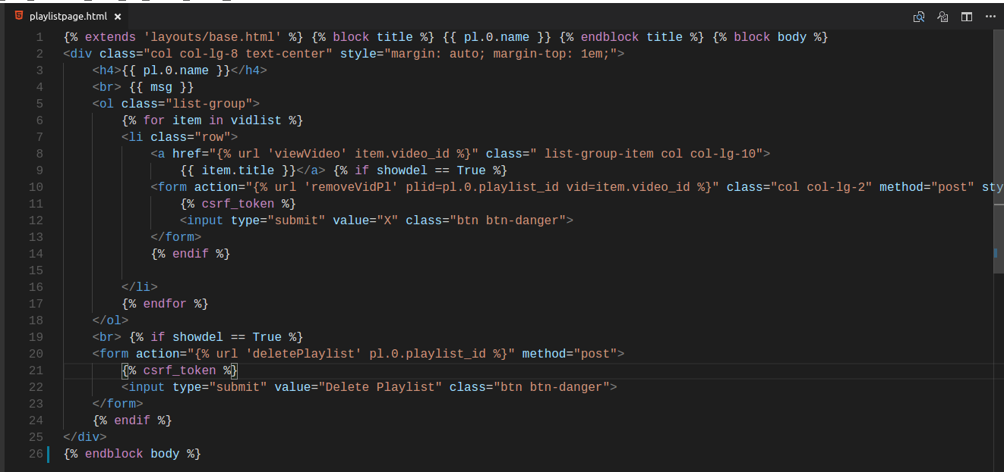
- Search page ( /search/ ):
The search page helps to search a particular video, channel, playlist, other users, etc. The video is searched based on title, description, tags,etc. The results are displayed on the same page. Clicking on the video redirects to the video page of that video.
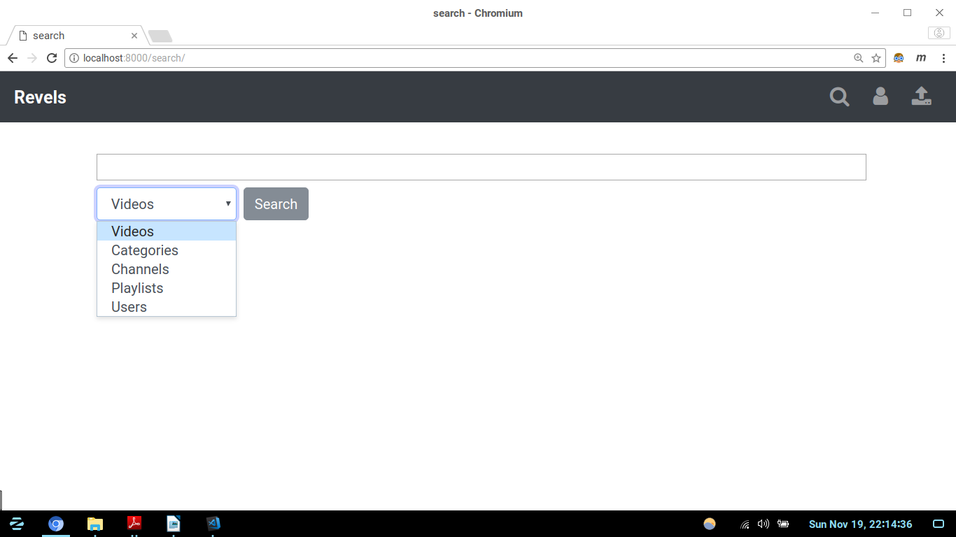
After the search...
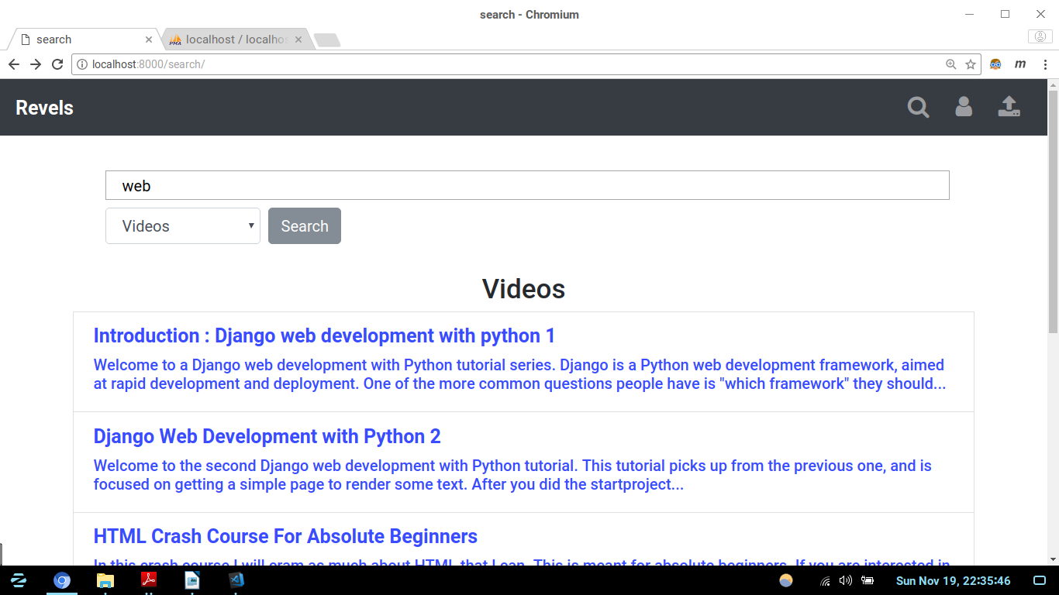
SQL queries for the search....
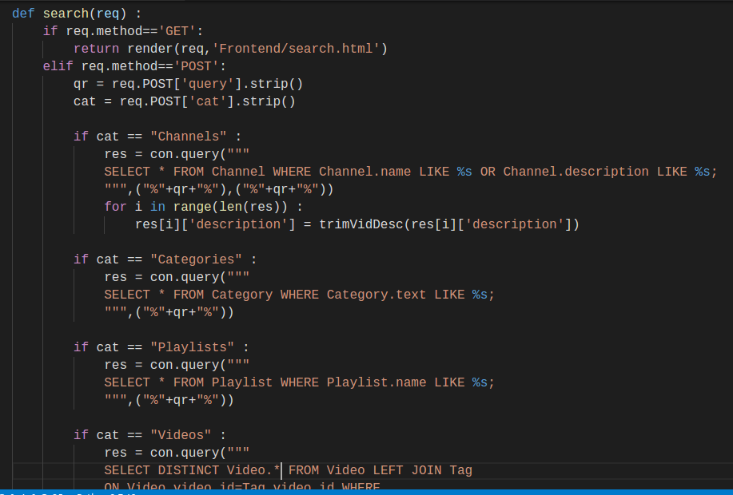

- Upload video ( /upload/ ):
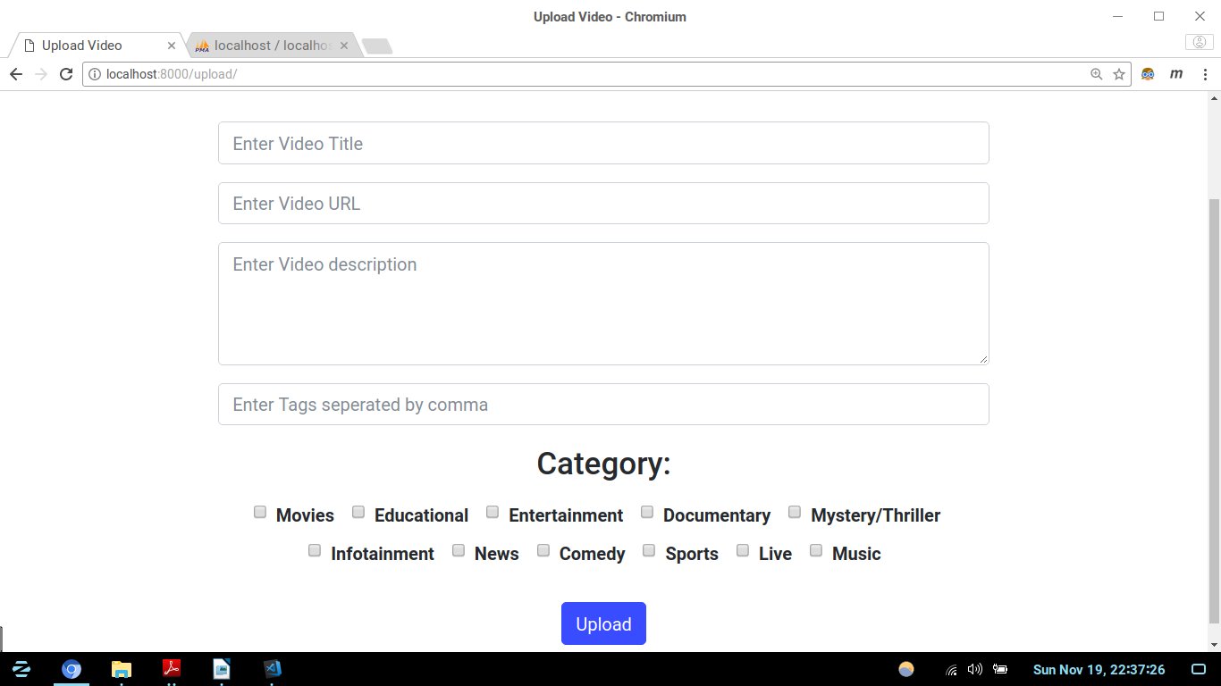
The video can only be uploaded if user is signed in else the page redirects to the signin page.
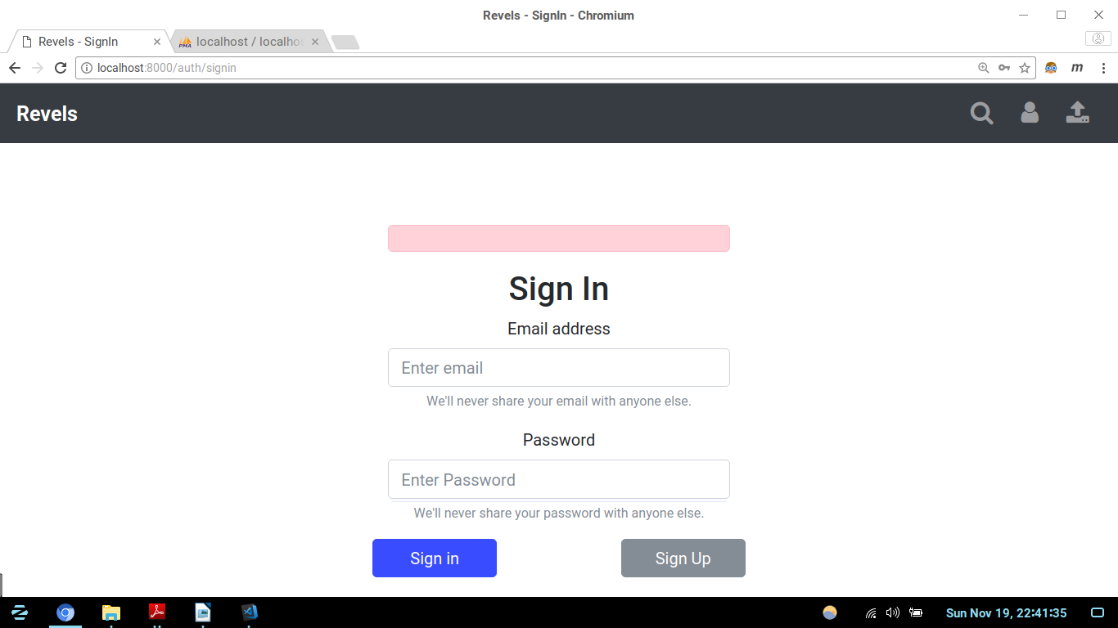
- User Profile ( /users/(no.)/ ):
The user page displays all the information about the user which includes username, name, channels, uploaded videos, subscribed channels, etc.

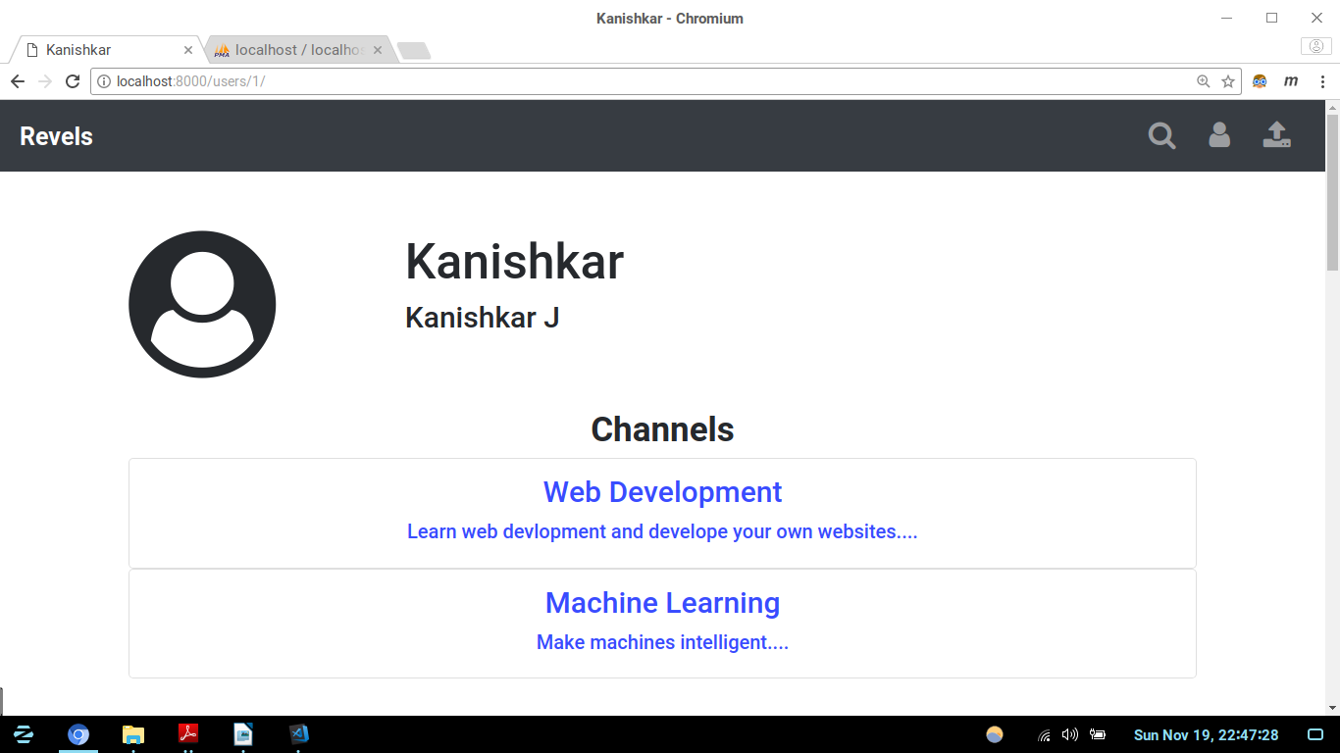
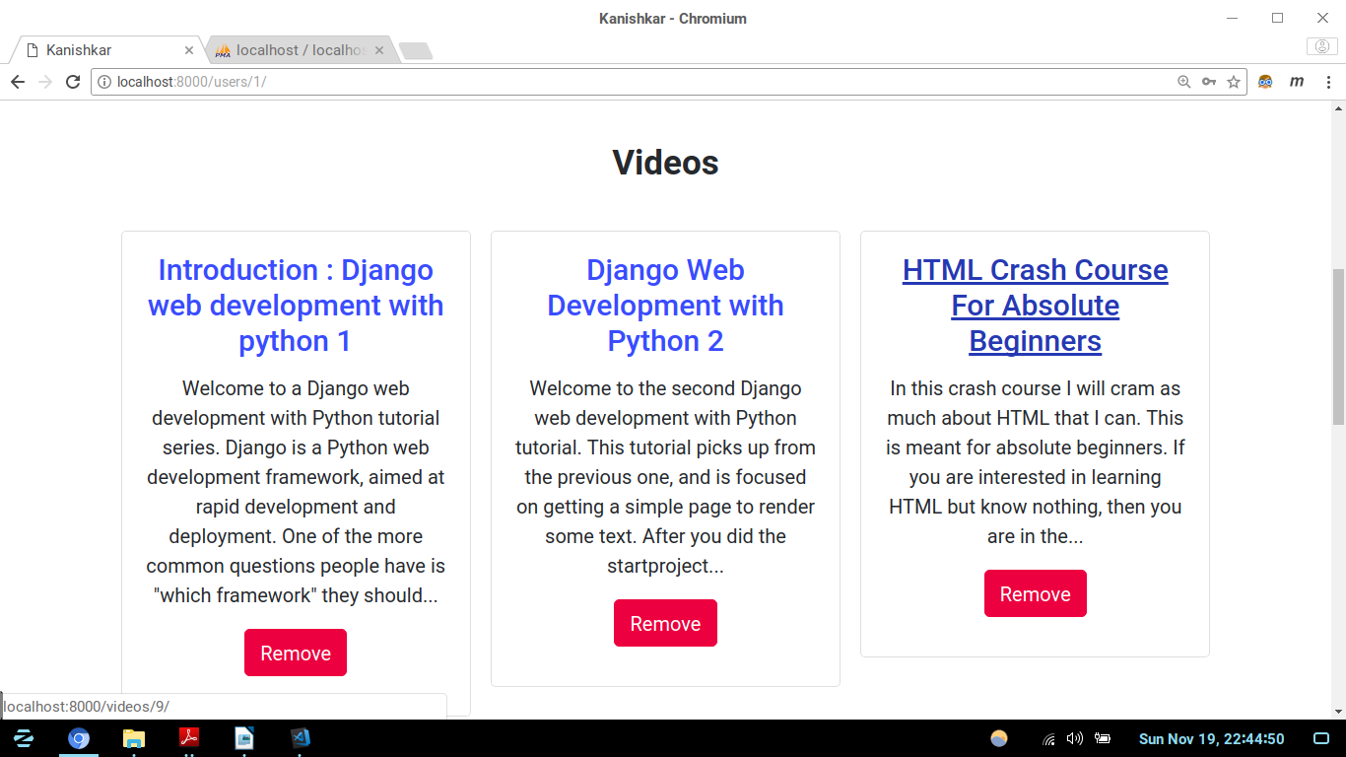
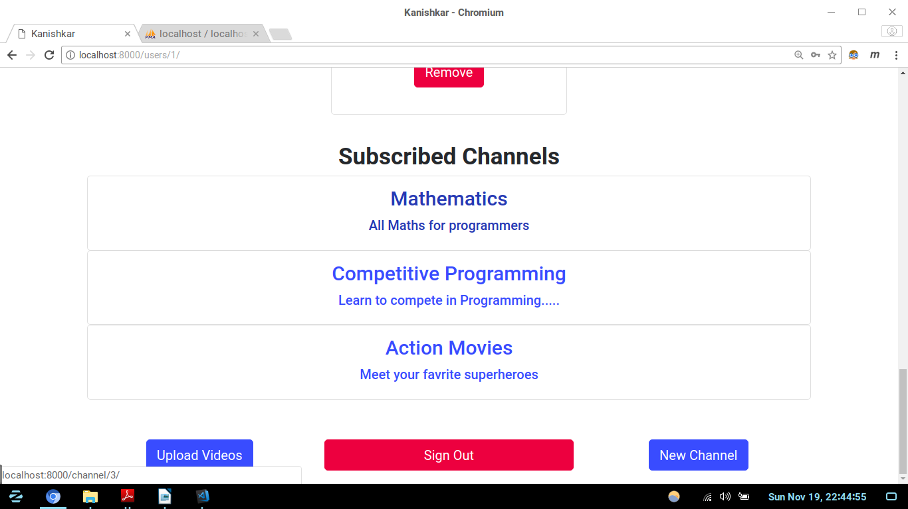
If the user goes to his own user page the he can get features for adding new channel, uploading videos, remove his uploaded videos, etc.

- Video page ( /videos/(no.) ):
The video page is the main video display page. Anyone can like, comment, add video to their playlist, navigate through tags by clicking on them, etc.


