SUPPLY CHAIN PERFORMANCE REPORT
End-to-End Delivery Operations Analysis
Analysis period: January 2015 – January 2018

Table of Contents

1. Executive Summary
2. Business Context & Objectives
3. Key Performance Indicators (KPIs)
4. Profitability and Delay Analysis
5. Bottleneck Detection
6. Root Cause Analysis
7. Time-Based Delay Patterns
8. Machine Learning Model Results
9. Strategic Recommendations
10. Conclusion

1. Executive Summary
This report presents a comprehensive analysis of the delivery operations of a global e-commerce company managing end-to-end order fulfilment across multiple regions. The analysis covers 172,765 orders spanning January 2015 through January 2018, focusing on identifying root causes of chronic late deliveries, quantifying their financial impact, and establishing a data-driven framework for improvement.
The headline finding is starting: 54.71% of all orders are delivered late, costing the business $2.1M in eroded profitability on delayed orders alone. While total profit across fulfilled orders reached $7.5M, the persistent late-delivery problem represents both a significant financial drain and a major customer experience risk. A Random Forest predictive model achieved 74% accuracy in identifying at-risk orders before they become late.

Key Finding | Metric
Overall Late Delivery Rate | 54.71%
On-Time Delivery Rate | 45.29%
Total Orders Analyzed | 172,765
Total Profit (profitable orders) | $7.5M
Profit at Risk (delayed orders) | $2.1M
Predictive Model Accuracy (RF) | 74%

2. Business Context & Objectives
The company operates a global e-commerce platform selling products across categories including sporting goods, fitness equipment, outdoor gear, footwear, and apparel across multiple international regions.

Core Business Problem
Actual shipping times frequently deviate from scheduled delivery windows, creating eroded customer trust, reduced order profitability, and an inability to make reliable commitments to buyers at point of purchase.

Analytical Objectives
- Understand the current state of delivery performance across all dimensions (region, mode, time, and customer segment).
- Quantify the financial impact of delays on order profitability.
- Identify the primary operational bottlenecks driving late deliveries.
- Build a predictive model to flag high-risk orders before they are shipped.
- Deliver actionable recommendations to improve on-time delivery and profitability.

3. Key Performance Indicators (KPIs)
The following KPIs were computed directly from the cleaned dataset to establish a performance baseline.
KPI | Value
Total Orders | 172,765
Late Deliveries | 94,523
Late Delivery % | 54.71%
On-Time Delivery % | 45.29%
Total Profit (profitable orders) | $7.5M
Profit at Risk (delayed orders) | $2.1M
90th Percentile Delay | 3 days
Average Order Profit | $22.03

Late Delivery Rate at 54.71% | More than half of all orders arrive late. This is not an edge-case problem — it is the default experience for most customers.

$2.1M Profit at Risk | Orders that experienced delays collectively generated $2.1M in profit that is under constant pressure from further operational deterioration.

90th Percentile Delay = 3 Days | Even the most extreme cases are contained within 3 days of lateness, suggesting the problem is systemic and process-driven rather than catastrophic.

4. Profitability and Delay Analysis

4.1 Profitability Distribution
Order-level profitability was classified into three tiers based on Order Profit Per Order. While 80.7% of orders are profitable, the 18.7% loss-making share represents a meaningful drag that is disproportionately concentrated among delayed shipments.

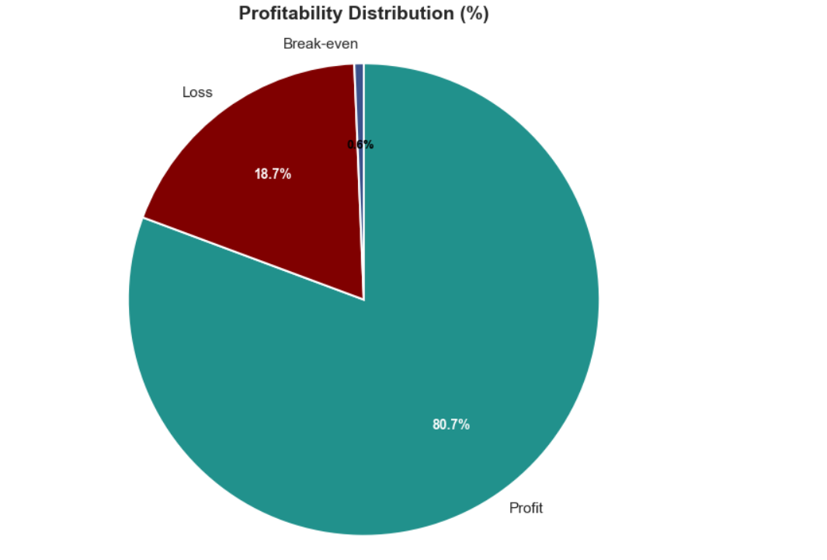
Figure: Distribution of orders by profitability status

Key Insights
Profit dominates the distribution (80.7%). Most orders are classified as profitable, indicating that the business generates positive margin on most transactions.
Loss-making orders represent 18.7%. Nearly one in five orders is loss-making, creating a meaningful opportunity to review discounting, shipping costs, product margins, and order-level profitability.
Break-even orders account for only 0.6%. The break-even segment is very small, but it is still worth monitoring because small changes in price, discounts, or fulfilment costs could move these orders into profit or loss.

4.2 Delay Distribution & Profit vs. Delay Days
The delay distribution shows that 31.0% of all orders arrive exactly 1 day late, the single largest cohort. Combined, orders delayed by 1–4 days account for 54.7% of all order volume, directly mapping to the overall late delivery rate.

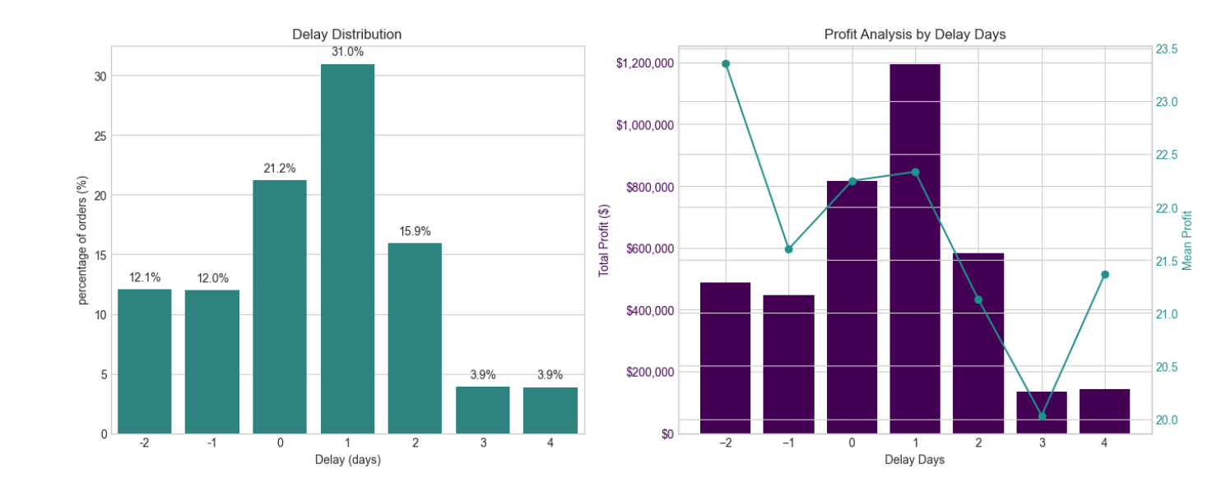

A critical observation from the original analysis is that mean profit per order remains stable at approximately $21–$23 across delay levels. The profitability problem is therefore driven by the volume of delayed orders, not by individual order economics, making systemic throughput improvement the highest-leverage intervention.

5. Bottleneck Detection
Delay percentage was computed across six key operational dimensions. The visible results indicate that the fulfilment process breaks down across the system rather than in one isolated region or customer segment.

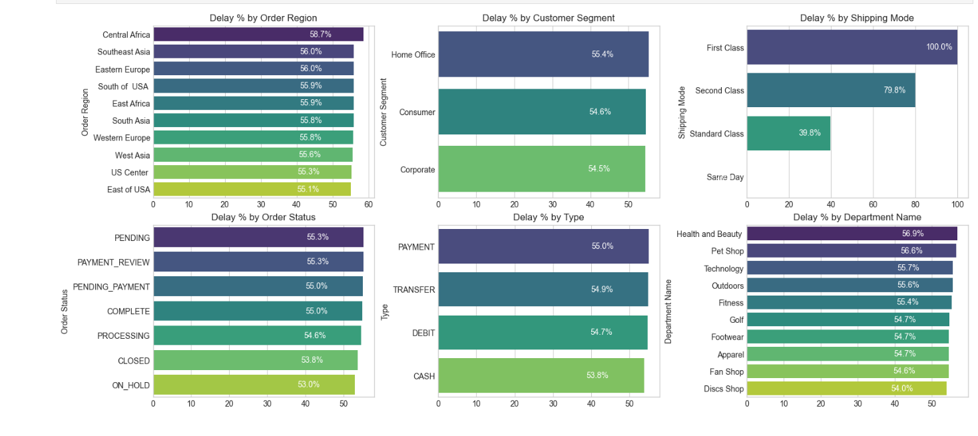

Selected visible category-level findings:
Dimension | Observed result | Interpretation
Order Region | Central Africa: 58.7%; most listed regions: 55.1–56.0% | Narrow regional spread points to a company-wide systemic issue.
Customer Segment | Home Office: 55.4%; Consumer: 54.6%; Corporate: 54.5% | Customer segments experience nearly identical delay rates.
Shipping Mode | First Class: 100.0%; Second Class: 79.8%; Standard Class: 39.8%; Same Day: 0.0% | Shipping-mode assignment is the strongest visible lever.
Department | Health & Beauty: 56.9%; Pet Shop: 56.6% | These departments marginally lead in delay rate and merit an inventory/carrier audit.

Shipping Mode is the #1 Lever | First Class has a 100% delay rate and Second Class 79.8%, while Standard Class is 39.8% and Same Day is 0.0%. The mode assignment logic is the most impactful single variable to fix.

Regional Spread is Narrow (55–59%) | Central Africa leads at 58.7%, but most regions cluster between 55% and 59%. This rules out a purely localised logistics failure and supports a systemic diagnosis.

Customer Segments Nearly Identical (54.5–55.4%) | Consumer, Corporate, and Home Office customers experience a similar delivery problem.

Health & Beauty (56.9%) and Pet Shop (56.6%) Lead by Department | These departments warrant targeted inventory and carrier audits.

6. Root Cause Analysis
Central Africa was selected for a deep-dive root cause analysis as the highest-delay region (58.7%). The visible chart ranks leading driver factors by delay percentage within this region.
Driver factor in Central Africa | Delay rate
Customer Segment: Consumer | 60.2%
Department: Golf | 60.8%
Department: Outdoors | 61.3%
Order Status: PENDING_PAYMENT | 62.6%
Type: TRANSFER | 63.3%
Type: PAYMENT | 63.6%
Order Status: PENDING | 69.1%
Order Status: PAYMENT_REVIEW | 80.0%

The visible results point to payment processing and order-state progression as important areas to investigate. PAYMENT_REVIEW and PENDING_PAYMENT states have elevated delay rates, suggesting that orders may be waiting for review or payment resolution before fulfilment can progress.

7. Time-Based Delay Patterns
Three temporal dimensions were analysed: month of year, day of week, and hour of day. While delay rates are relatively stable across the dimensions (approximately 53–57%), specific peaks highlight opportunities for targeted capacity planning.
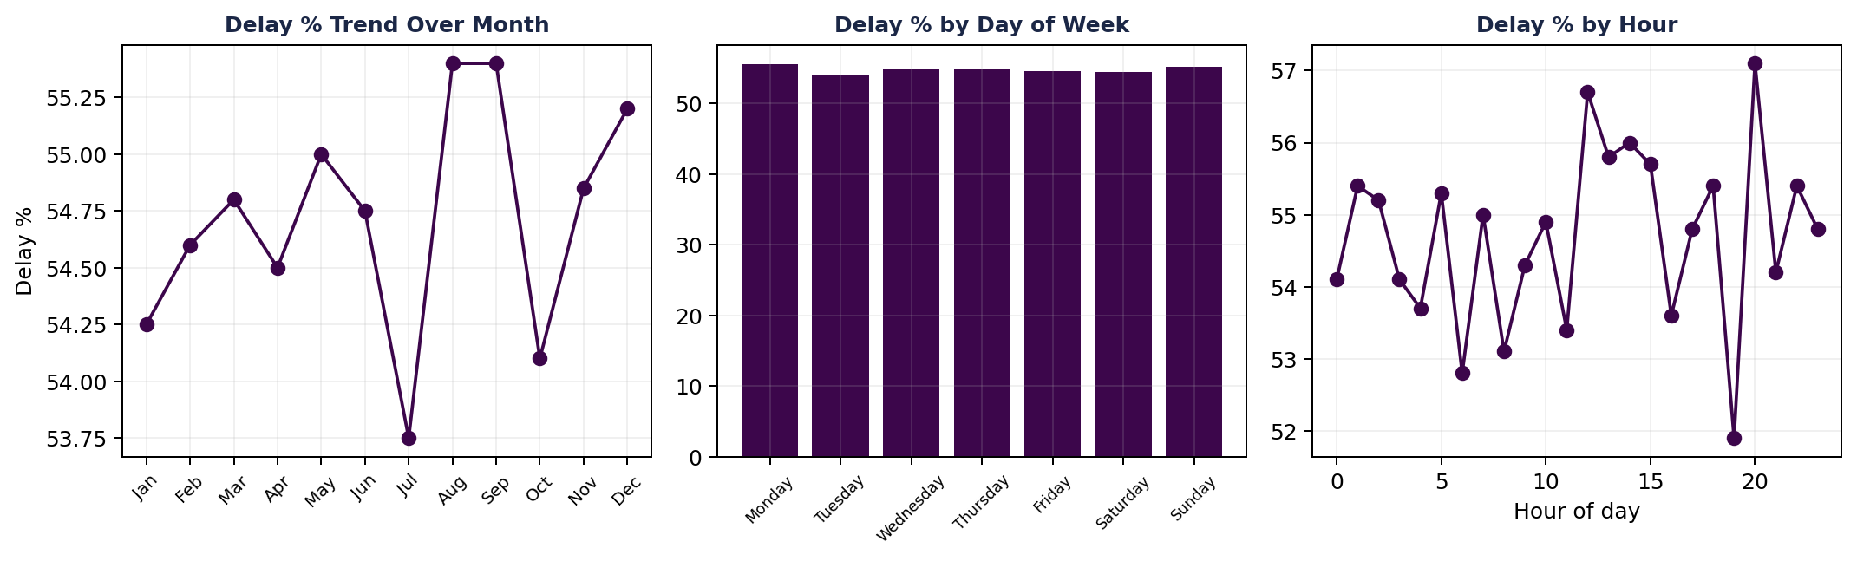
Peak Delay Months: August & September (55.4%) and December (55.2%) | August and September are the highest months at 55.4%, with December close behind. July is a notable low point at approximately 53.75%, indicating seasonal variation that may be planned for.

Day-of-Week Variance is Minimal | Monday (55.5%) and Sunday (55.2%) are the peak days, but the spread across the week is less than one percentage point. Day-of-week is not a meaningful standalone lever.

Intra-Day Peaks: Hour 21 (57.1%), Hour 12 (56.7%), Hour 14 (56.0%) | Late-evening orders have the highest visible delay rate, potentially reflecting processing cut-off windows. Midday peaks suggest possible bottlenecks during high-volume hours.

8. Machine Learning Model Results
A supervised classification model was built to predict whether an individual order will be delivered late (Late_delivery_risk = 1). The pipeline included frequency encoding of categorical variables, a stratified train/test split, SMOTE oversampling to address class imbalance, and Random Forest classification.

Class Imbalance Handling (SMOTE)
Split | Class 0 (On-time) | Class 1 (Late)
Before SMOTE (train) | 59,030 | 79,182
After SMOTE (train) | 79,182 | 79,182

Random Forest Classifier – Test Set Performance (34,553 records)
Metric | Class 0 (On-time) | Class 1 (Late) | Overall (Weighted)
Precision | 0.68 | 0.78 | 0.74
Recall | 0.72 | 0.75 | 0.74
F1-Score | 0.70 | 0.77 | 0.74
Accuracy | — | — | 0.74
Support | 14,758 | 19,795 | 34,553

74% Overall Accuracy | The model correctly classifies nearly 3 in 4 orders — a useful foundation for a pilot order-level late-delivery alert system.

Higher Precision on Late Orders (0.78) | When the model predicts an order will be late, it is correct 78% of the time, supporting targeted interventions without excessive false alarms.

Recall for Late Orders at 0.75 | The model captures 75% of actual late orders. The remaining 25% miss rate creates a clear improvement opportunity.

Class 0 Harder to Predict (Precision 0.68) | On-time deliveries share characteristics with late ones given the systemic nature of delays, making them harder to distinguish.

9. Strategic Recommendations
Based on the findings across all analytical dimensions, the following prioritized actions are recommended:

CRITICAL | 1. Immediately Audit First Class & Second Class Shipping Capacity  First Class shipping has a 100% delay rate and Second Class 79.8%. Conduct an immediate carrier SLA audit. Until resolved, consider suspending First Class or repricing it to reflect actual performance.

HIGH | 2. Deploy the Predictive Alert System  The Random Forest model (74% accuracy, 78% precision on late orders) is ready for production piloting. Integrate it into order management to flag high-risk orders at confirmation and trigger proactive customer communication and priority handling.

HIGH | 3. Resolve Payment Processing Bottlenecks  PAYMENT_REVIEW has a 55.3% overall delay rate and 80.0% in Central Africa; PENDING_PAYMENT is also elevated. Introduce automated escalation for stalled payment reviews exceeding two hours.

MEDIUM | 4. Develop Seasonal Surge Capacity Plans  August, September (55.4%), and December (55.2%) are peak delay periods in the visible analysis. Build pre-season capacity plans, including temporary logistics partnerships, inventory pre-positioning, and adjusted delivery promise windows.

MEDIUM | 5. Default to Standard Class for Eligible Orders  Standard Class achieves a 39.8% delay rate, better than First and Second Class. Re-evaluate shipping-mode assignment logic to default eligible orders to Standard Class where service commitments permit.

MEDIUM | 6. Investigate High-Delay Departments in Africa  Outdoors (61.3%) and Golf (60.8%) in Central Africa show elevated delay rates. Audit stock availability, pick-and-pack times, and carrier assignment for these product categories.

LOW | 7. Reduce Loss-Making Order Share (18.7%)  Review pricing and discounting for loss-making orders. Combine profitability analysis with delay analysis to determine whether discounted orders are disproportionately delayed.

LOW | 8. Continuously Retrain the Predictive Model  Retrain the model quarterly and evaluate carrier-level data, weather events, and warehouse utilisation features. Target recall above 80% for late orders within six months.

10. Conclusion
This analysis has surfaced a clear and urgent picture: a global e-commerce operation where the majority of orders (54.71%) fail to meet their promised delivery windows, putting $2.1M in profit at risk and undermining customer trust at scale.
The root causes are identifiable and addressable. Shipping mode misconfiguration (First Class at 100% late and Second Class at 79.8%) is the dominant operational failure. Payment processing friction creates a secondary bottleneck. Seasonal volume spikes are not adequately planned for, while geographic disparities, although present, are secondary to the systemic company-wide pattern.

A Random Forest predictive model trained on readily available order features achieves 74% accuracy in identifying at-risk orders. This provides a practical starting point for a controlled pilot, with further validation and monitoring before full production deployment.
Priority Area | Current State | Target State
Late Delivery Rate | 54.71% | < 30% within 12 months
First Class On-Time Rate | 0% | > 80%
Second Class On-Time Rate | 20.2% | > 60%
Predictive Model Accuracy | 74% | > 82% (enhanced model)
Loss-Making Orders | 18.7% | < 12%
Profit at Risk | $2.1M | Reduce by 40%

With focused execution on the eight recommendations in this report, starting with the critical shipping-mode audit and predictive alert-system pilot—the business can systematically improve delivery performance, reduce profit at risk, and build the operational reliability required for sustained e-commerce growth.

