261-[NF]-Lab - Public and Private IP addresses

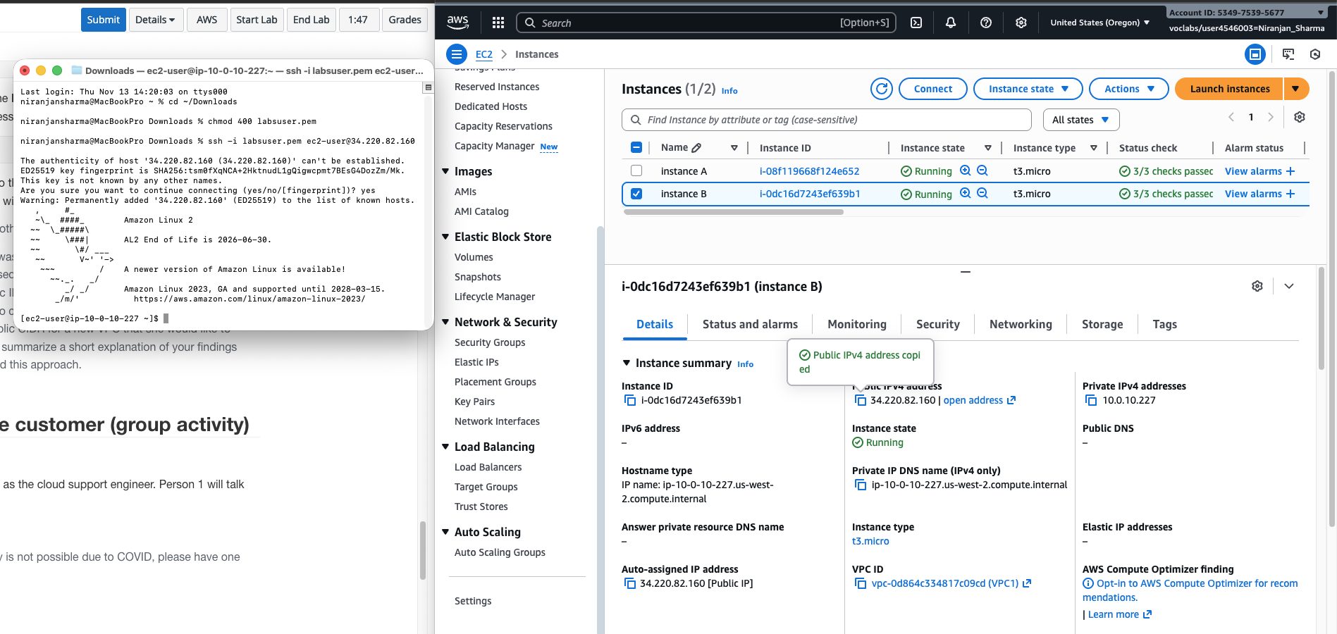

262-[NF]-Lab - Static and Dynamic and IP addresses

The client needs to associate a static public IP address (Elastic IP) with their EC2 instance so that the IP address remains constant when the instance is stopped and restarted.
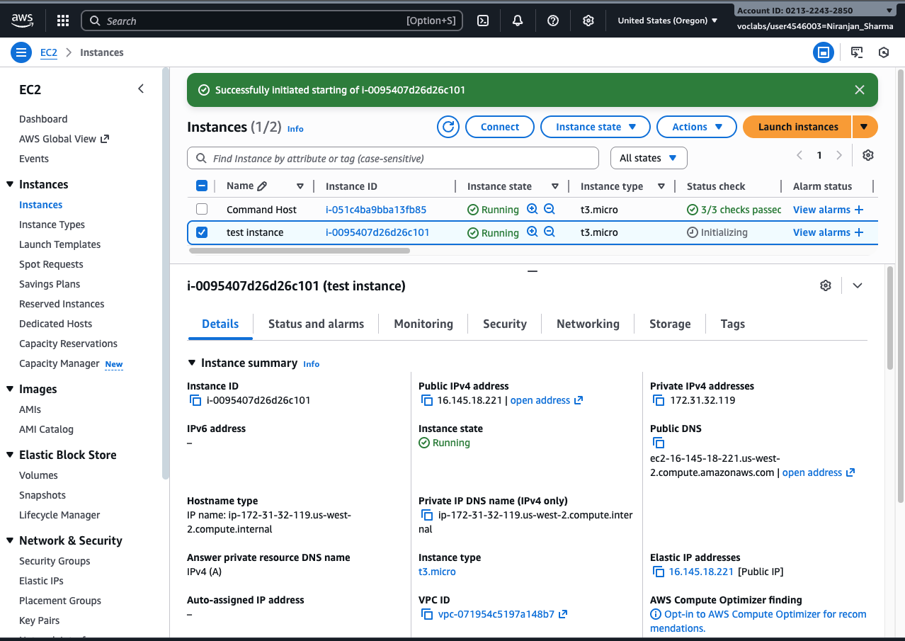

263-[NF]-Lab - Create Subnets in a VPC

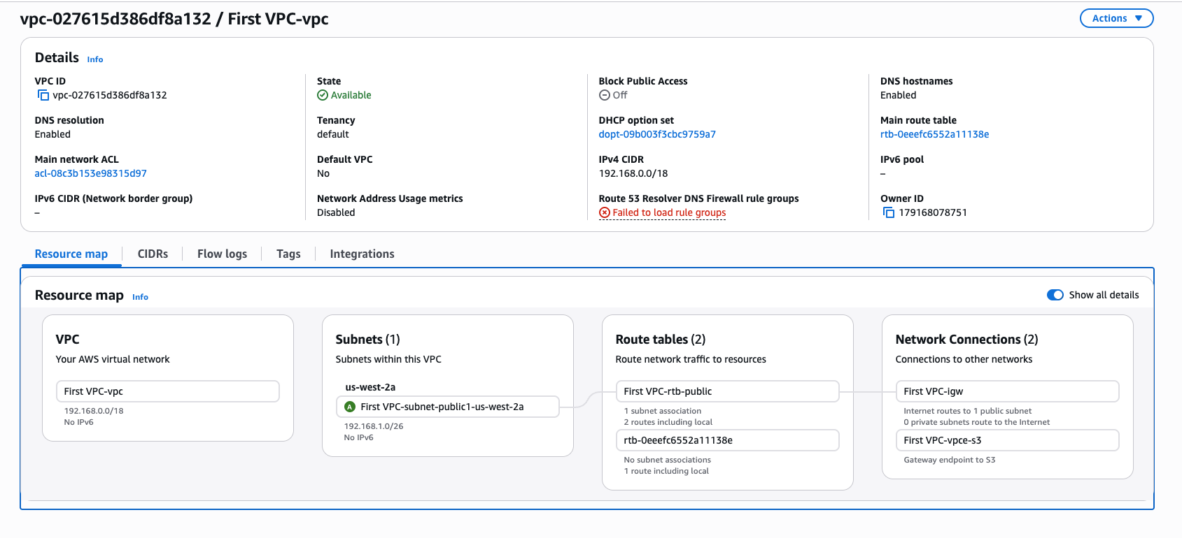

264-[NF]-Lab - Networking resources for a VPC

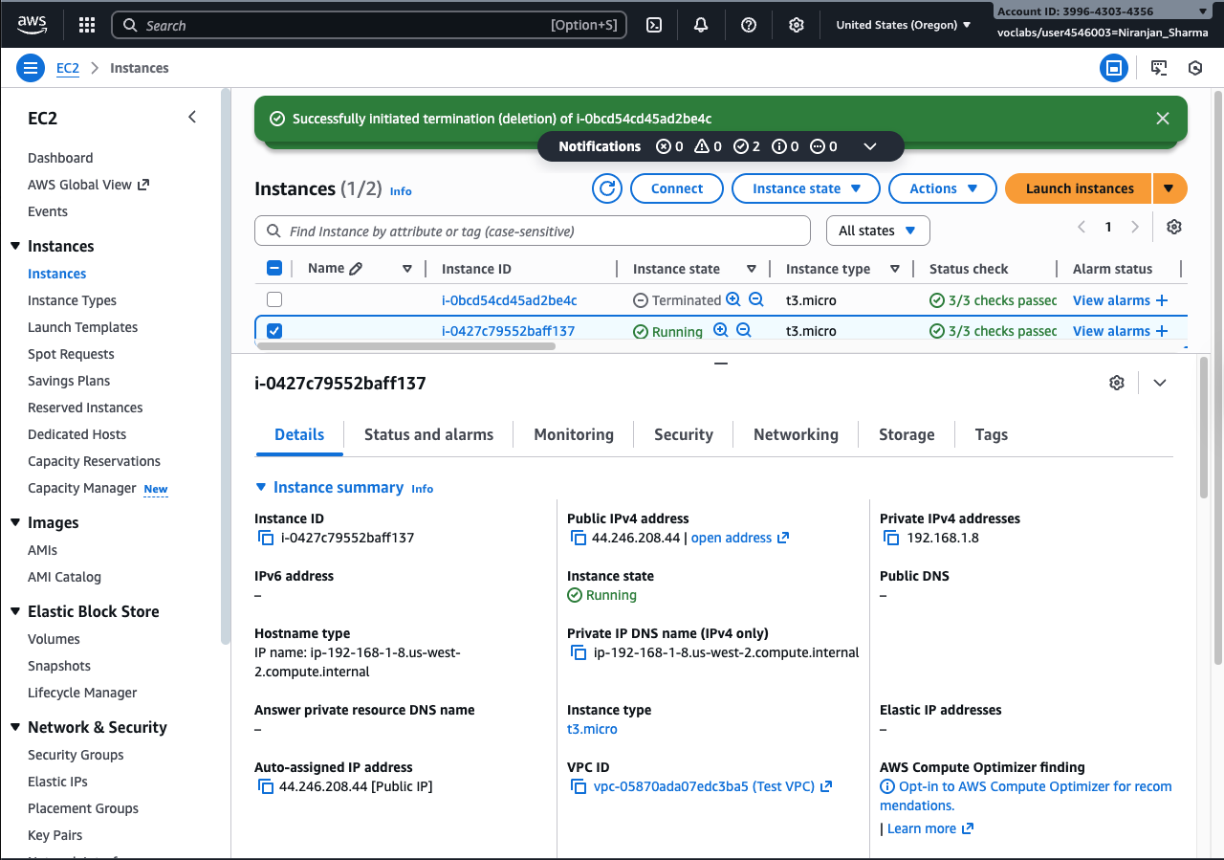
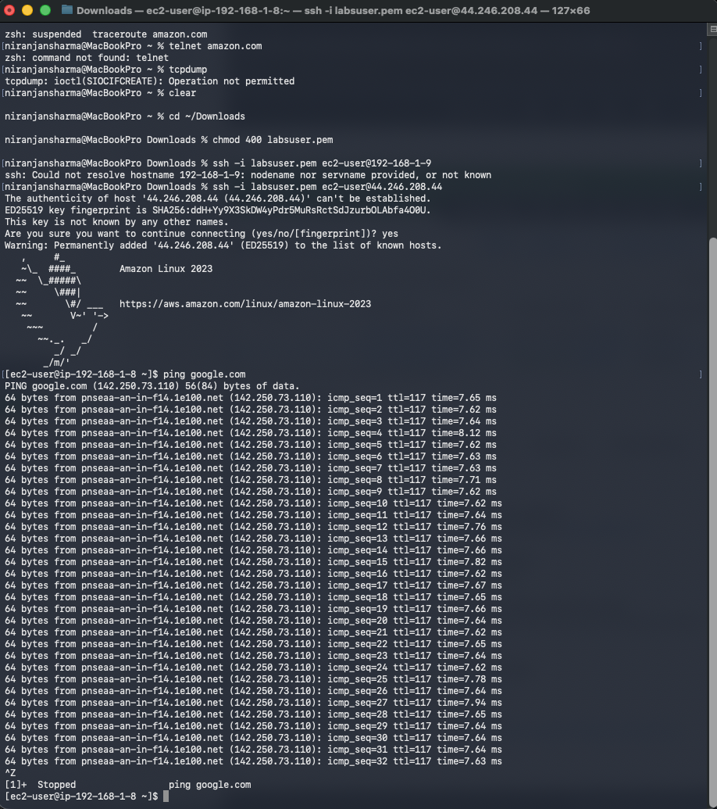
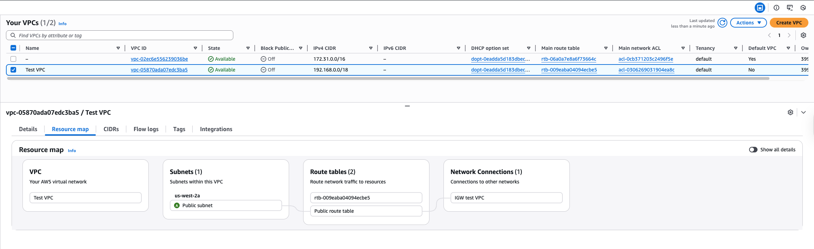

265

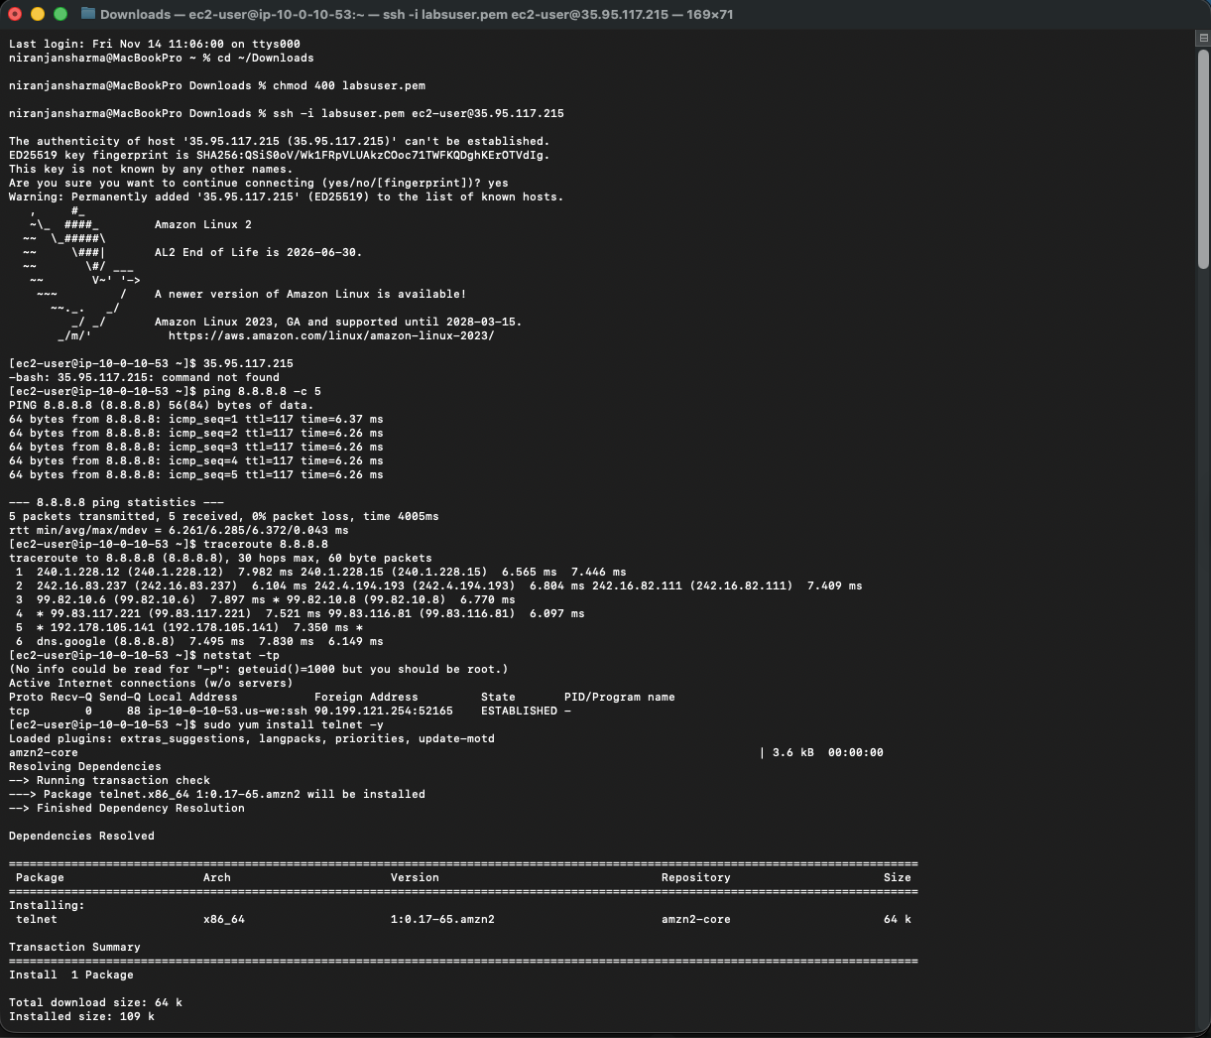
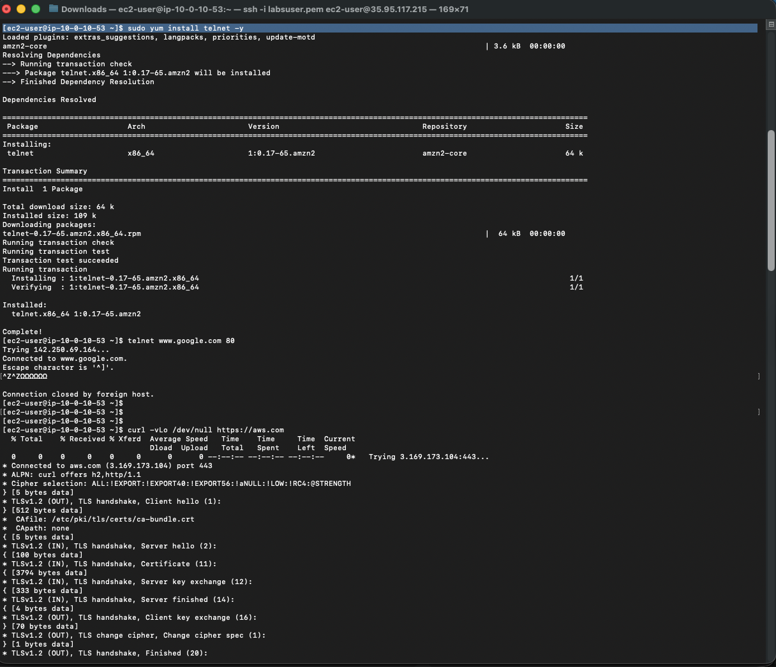
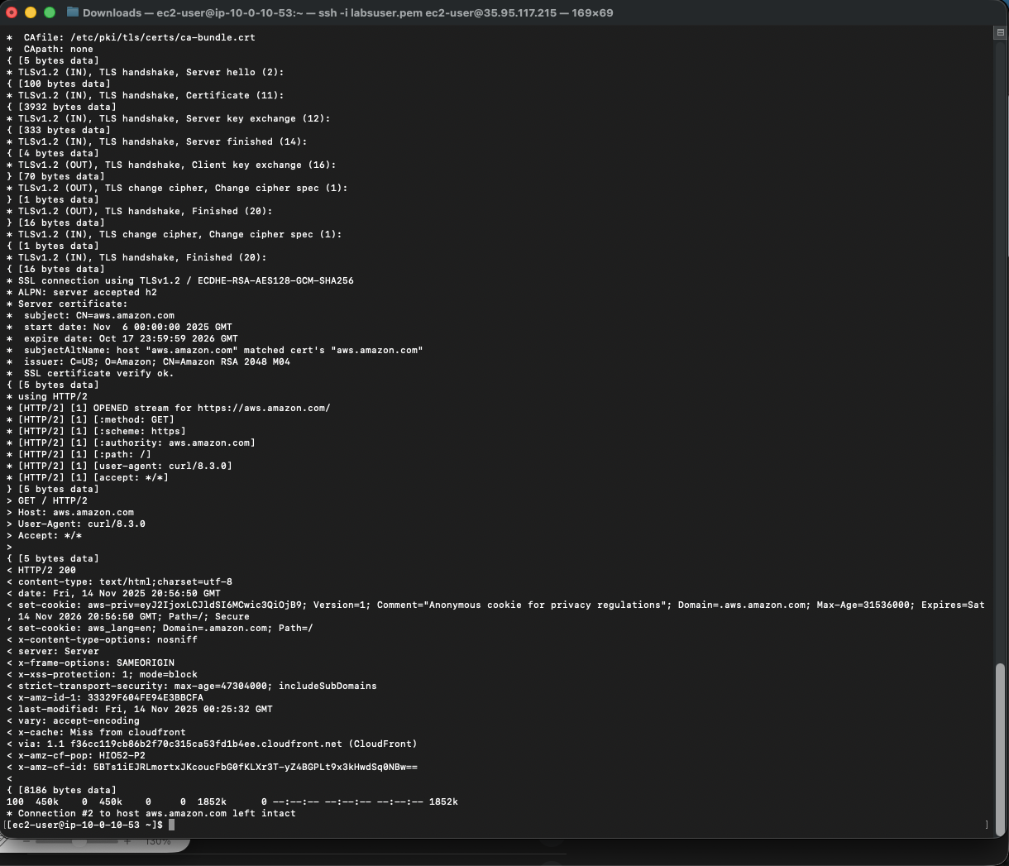

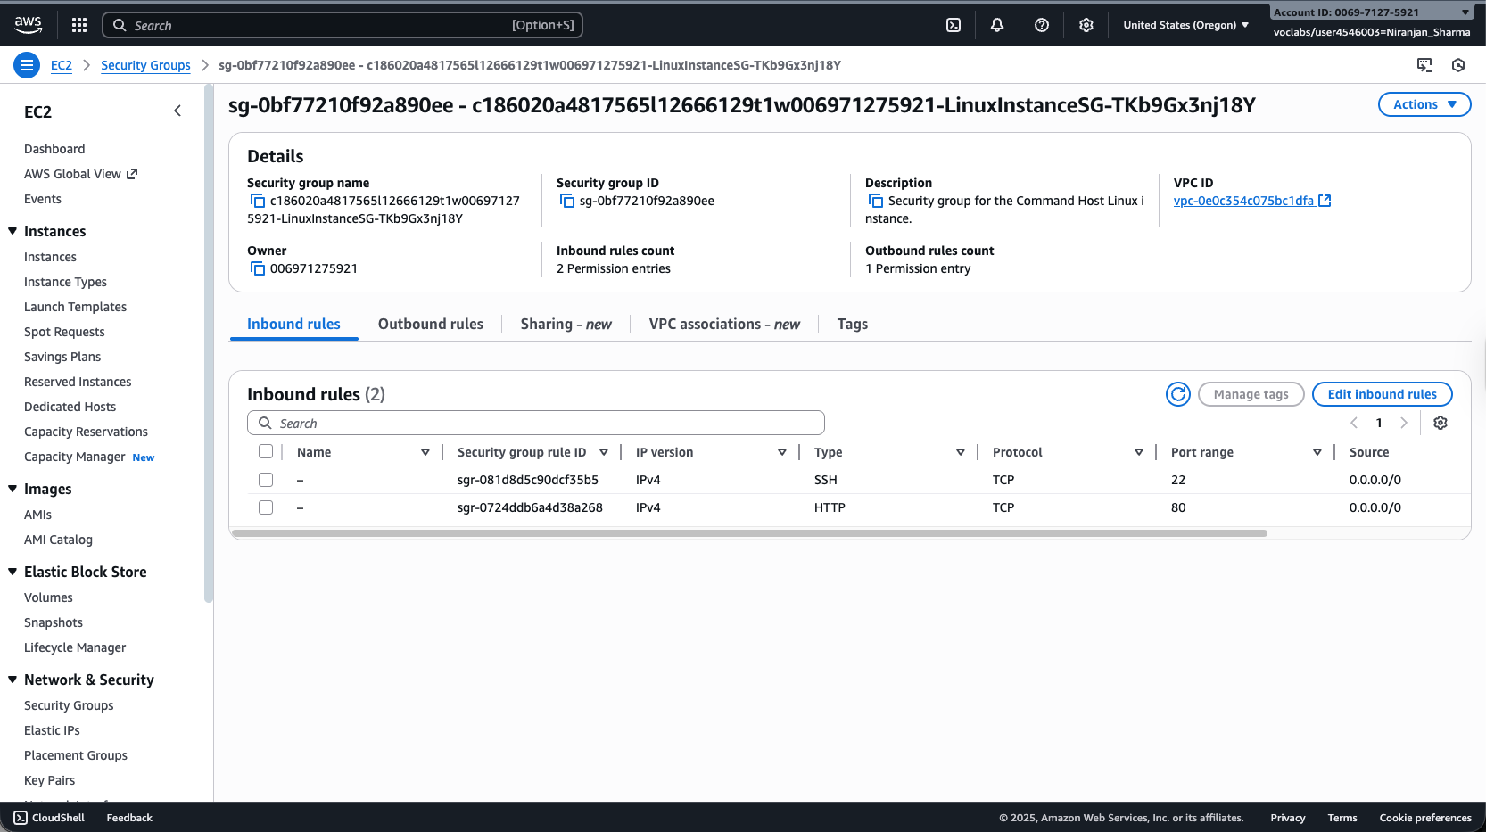
EC2 security group did not have inbound HTTP security enabled. So, to make the test page reachable I included inbound HTTP to the security group.
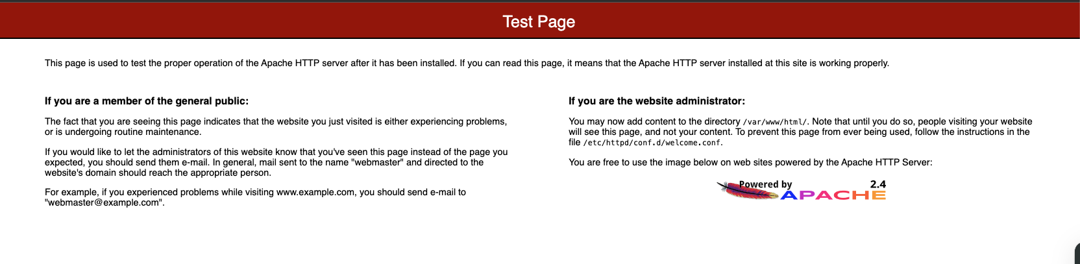
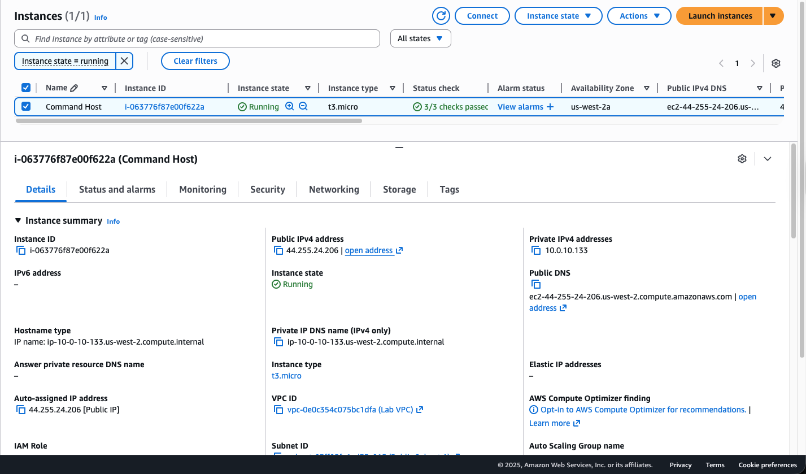
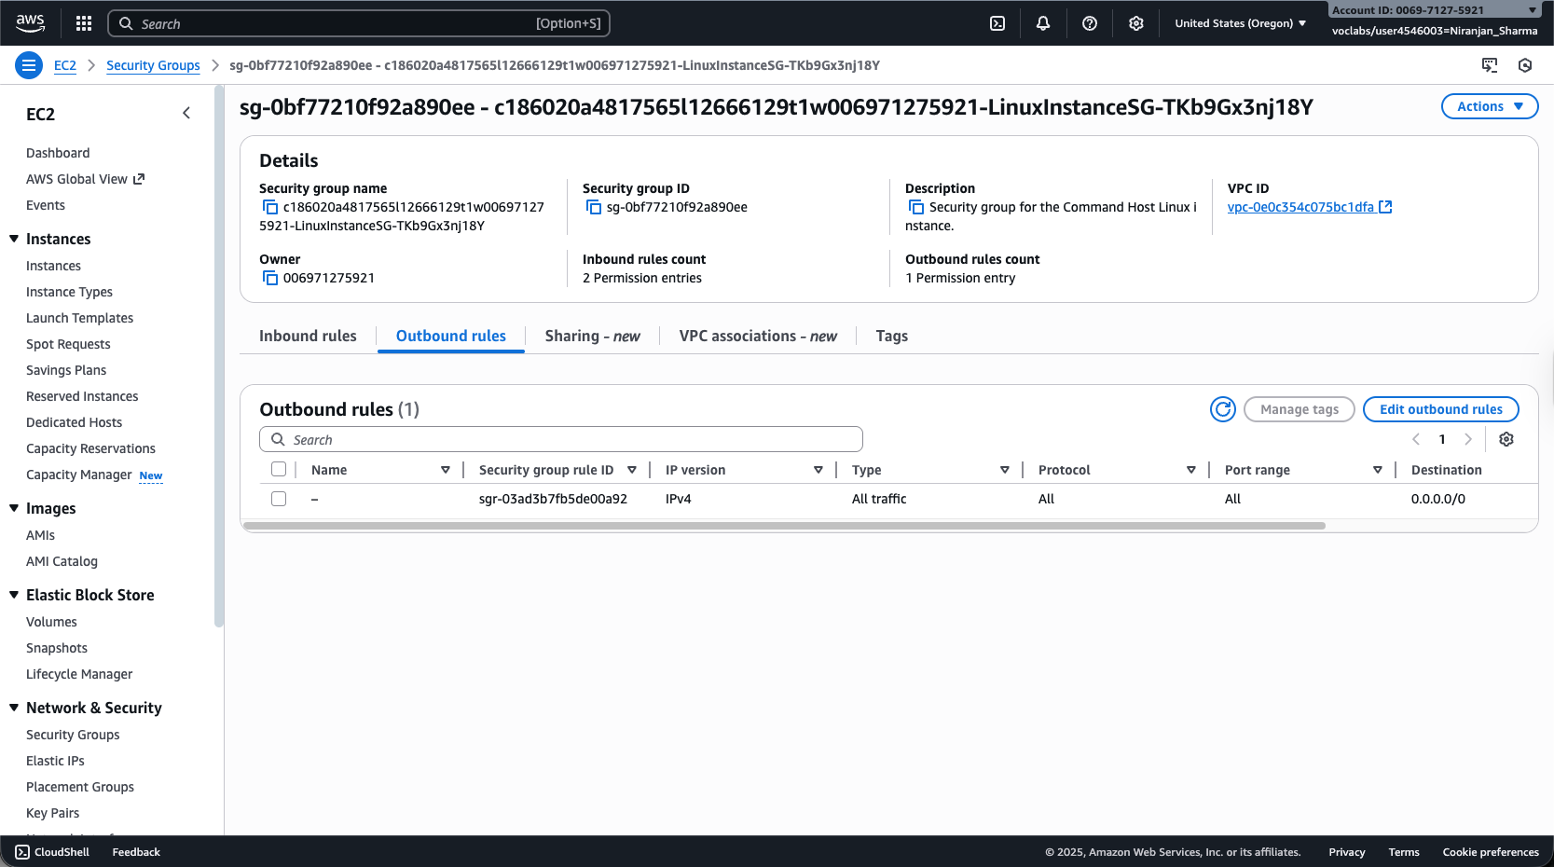

267-[NF]-Lab - Build your VPC and Launch a Web Server

