Creating a Hello, World Program
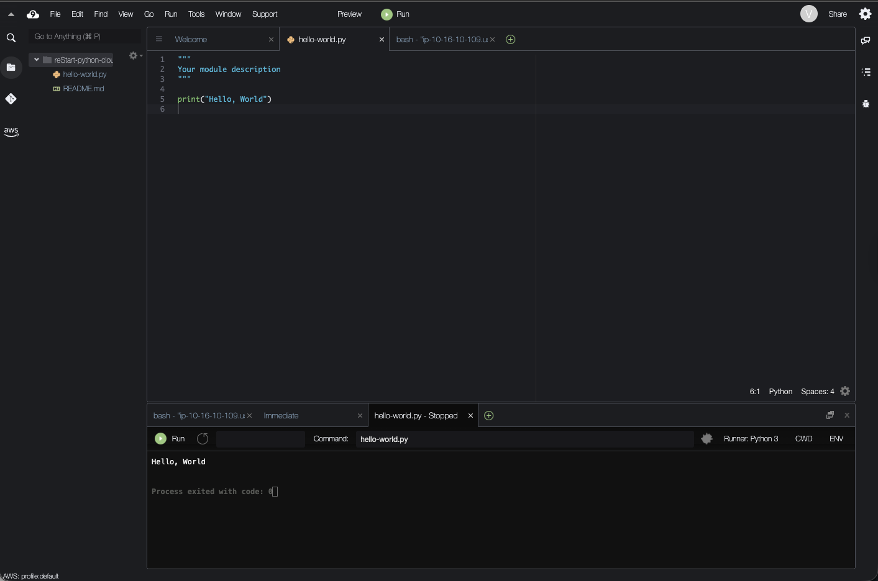
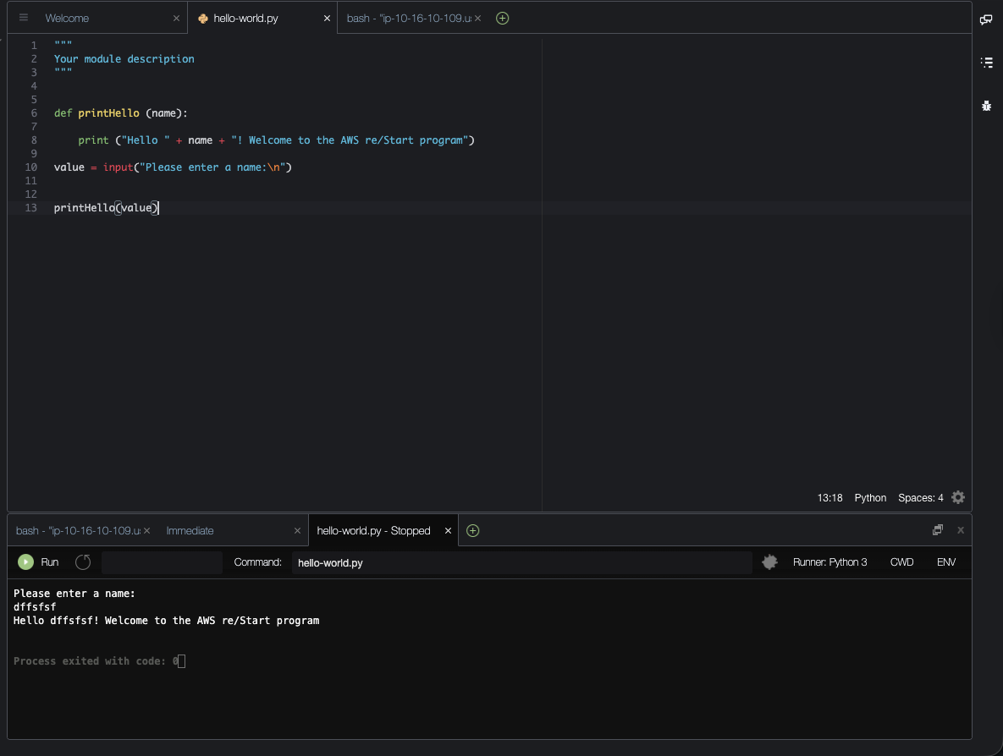

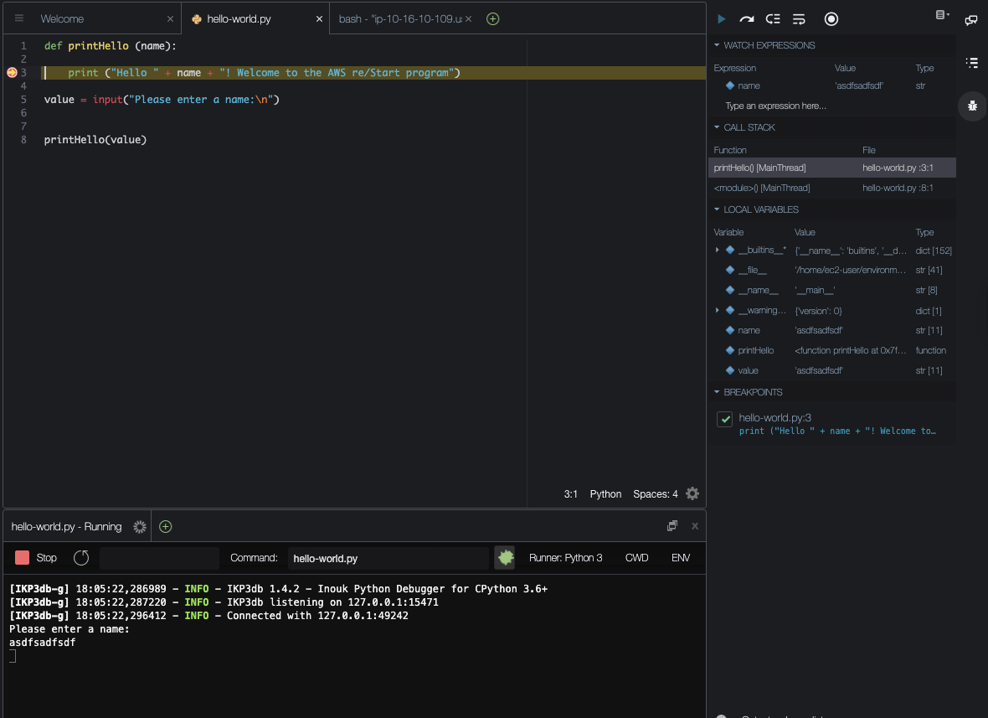

Working with Numeric Data Types

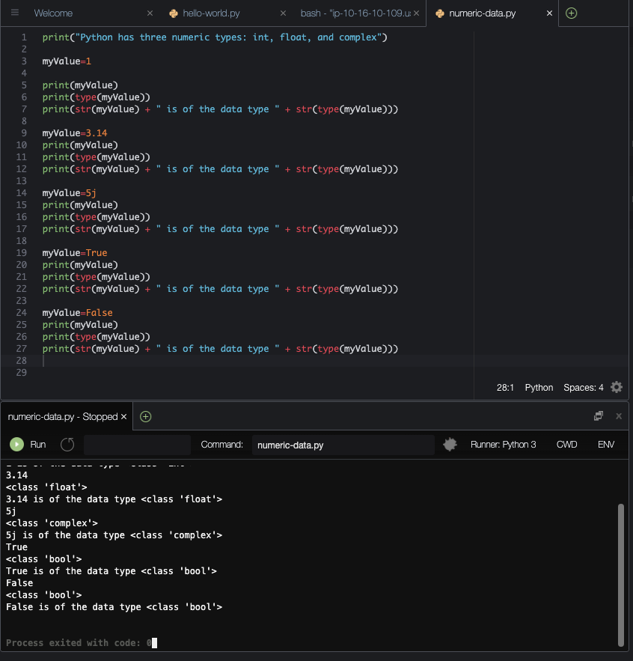

Working with the String Data Type

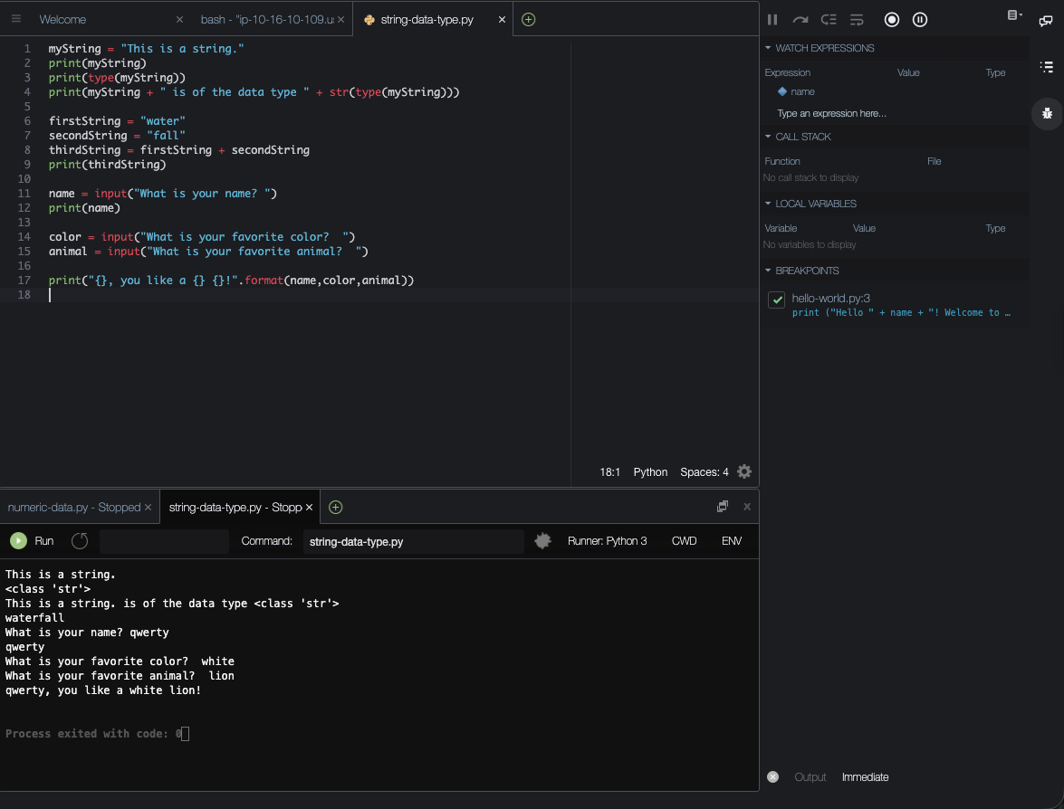

Working with Lists, Tuples, and Dictionaries

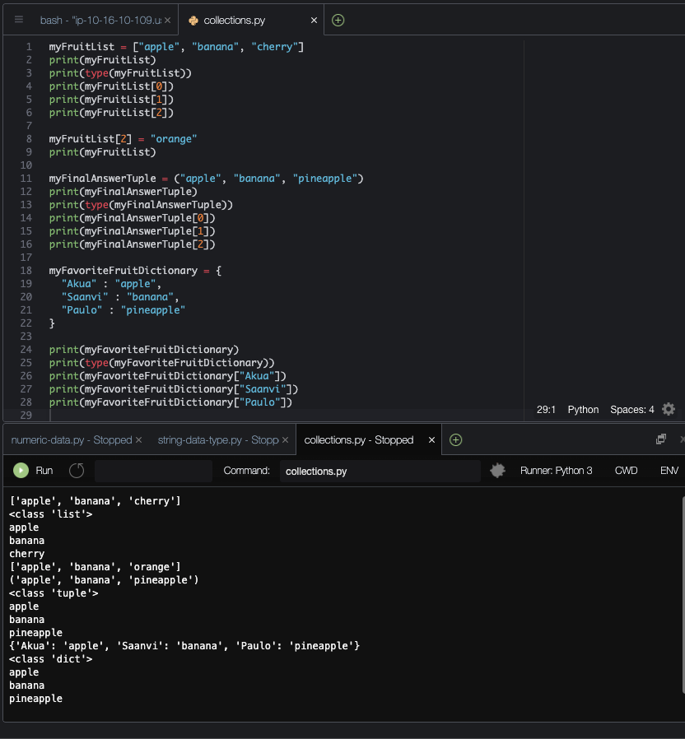

Categorizing Values
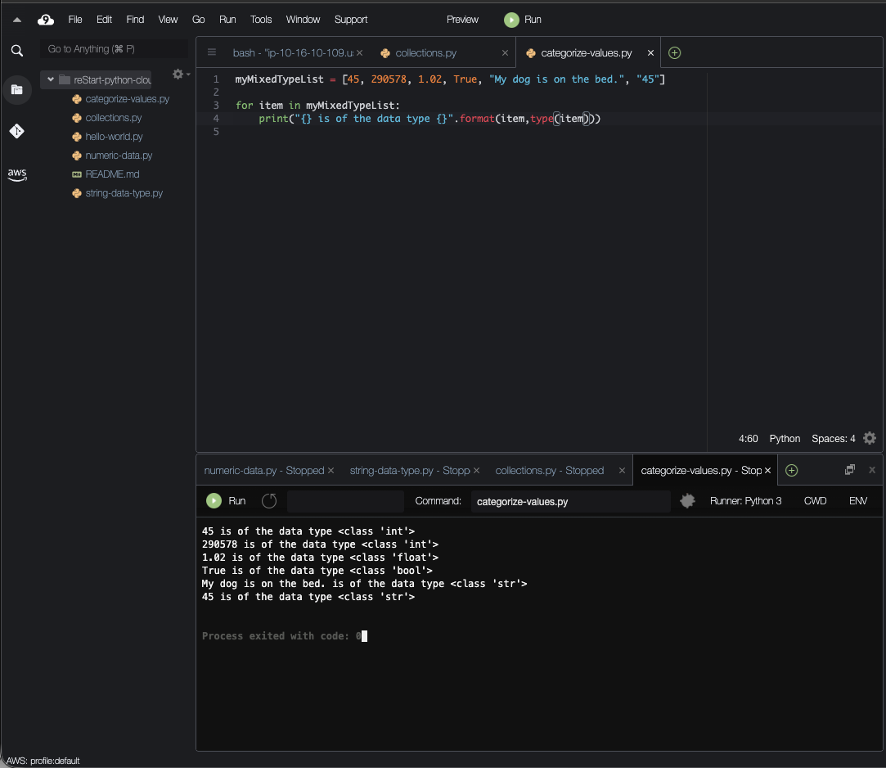

Working with Composite Data Types
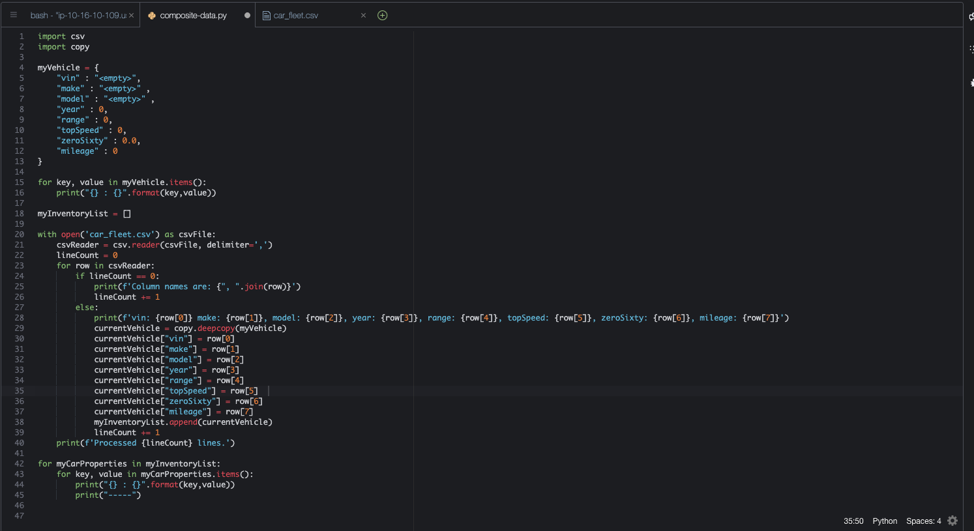

Working with Conditionals

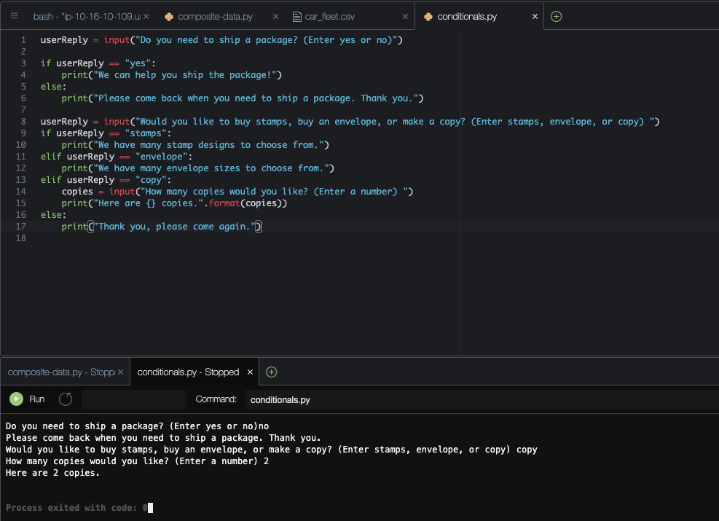

Working with Loops
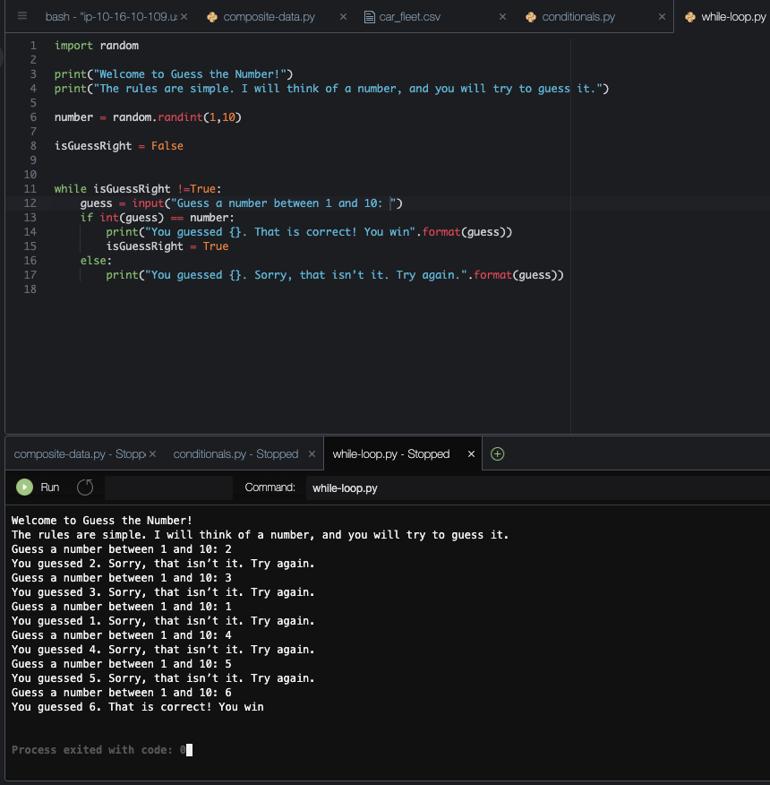
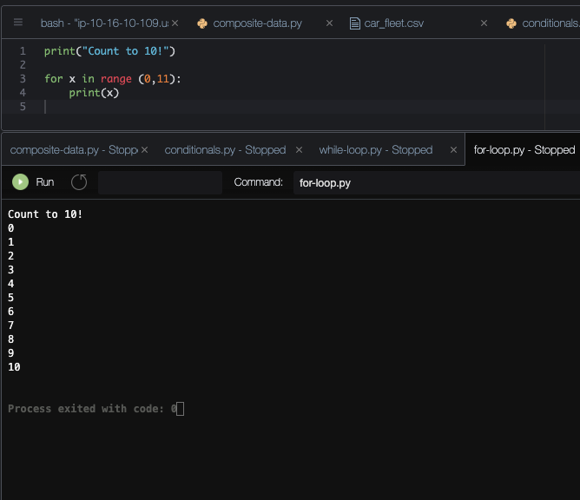

Creating a Git Repository
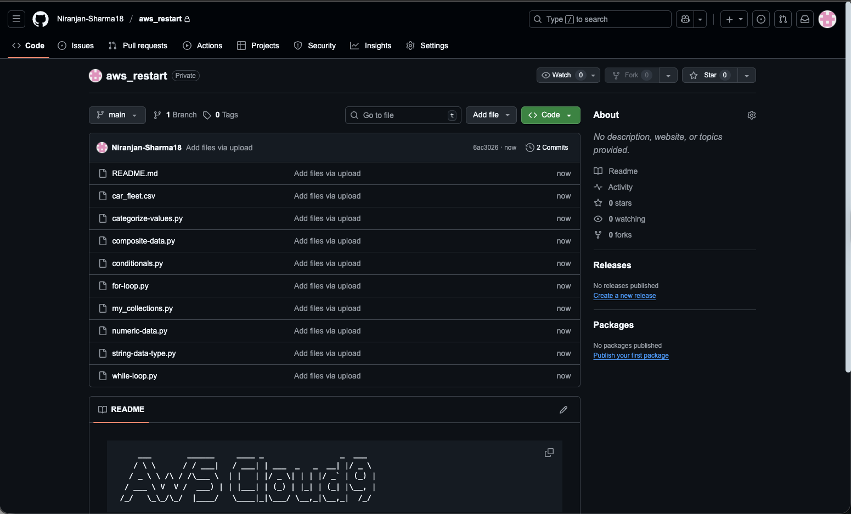

Preparing to Analyze Insulin with Python
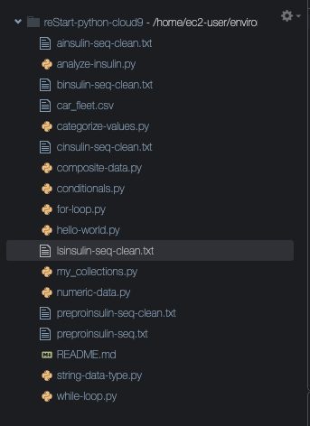

Working with the String Sequence and Numeric Weight of Insulin in Python
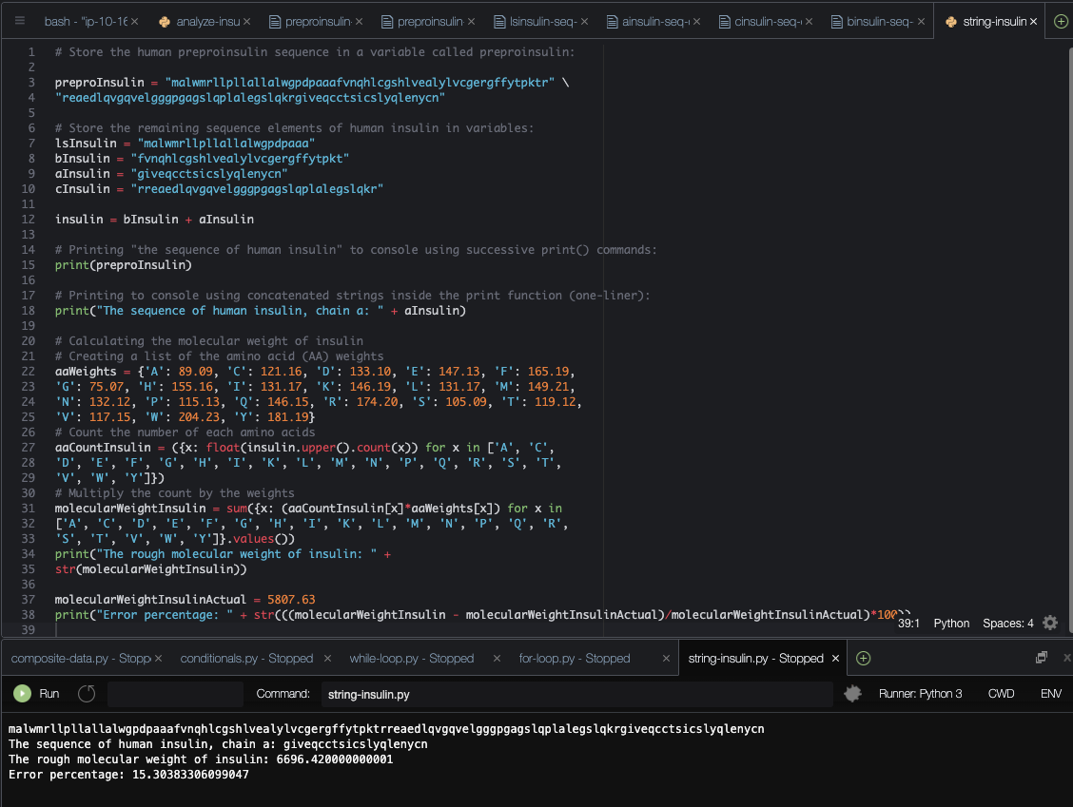

Calculating the Net Charge of Insulin by Using Python Lists and Loops

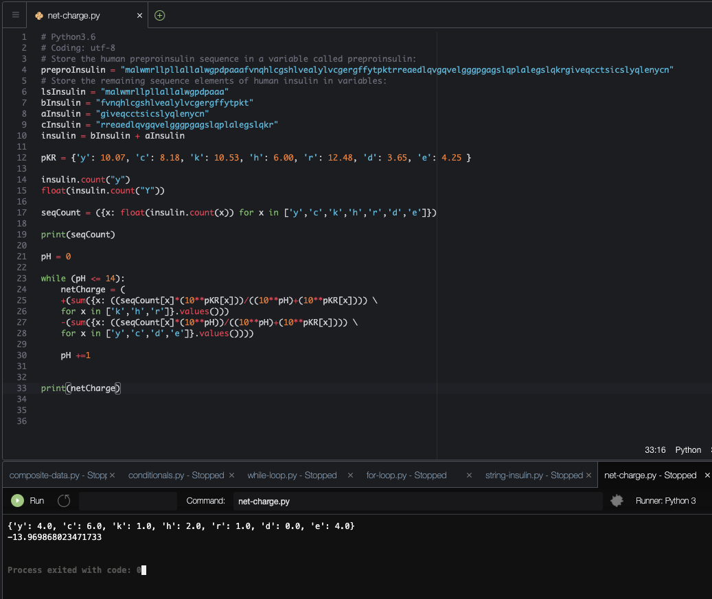

Using Functions to Implement a Caesar Cipher

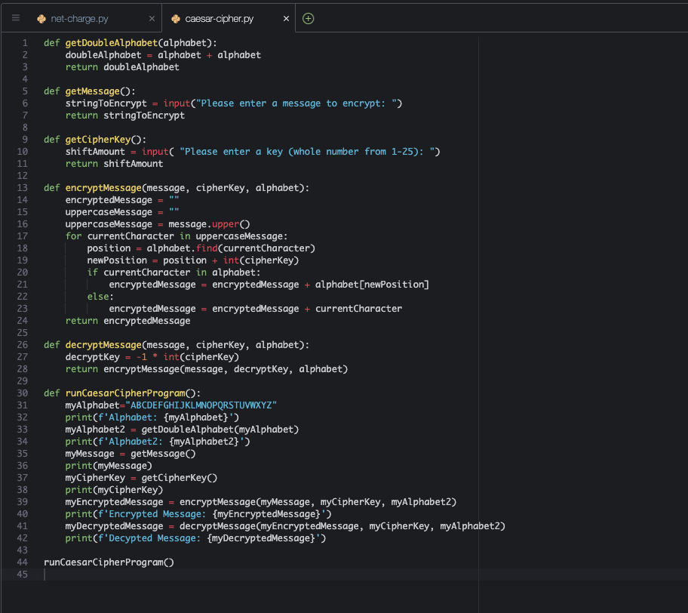

Creating File Handlers and Modules for Retrieving Information about Insulin

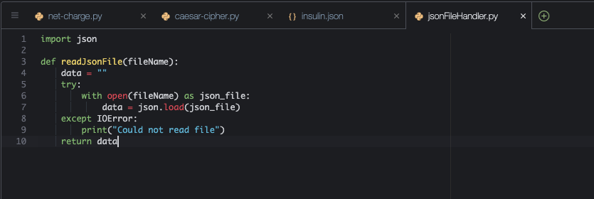

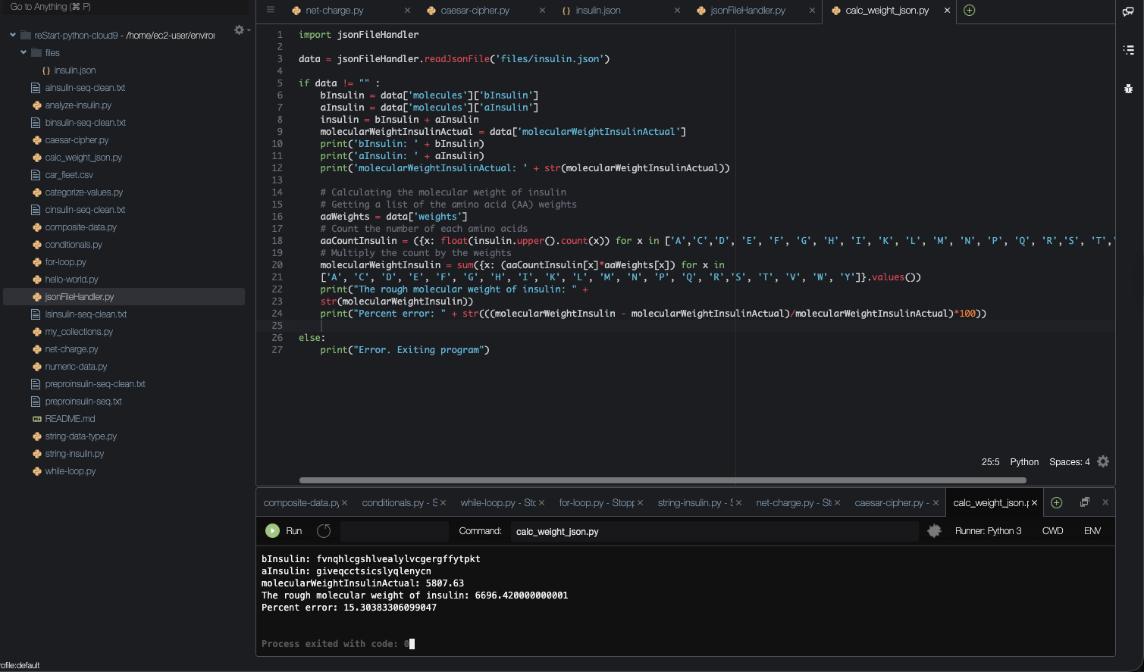

Introducing System Administration with Python

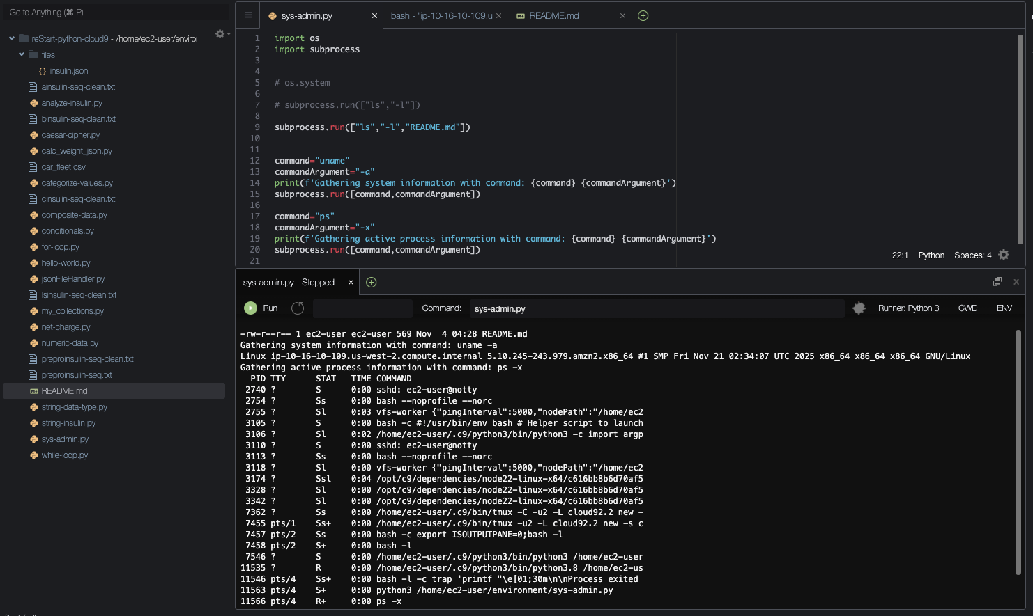

Using the Debugger

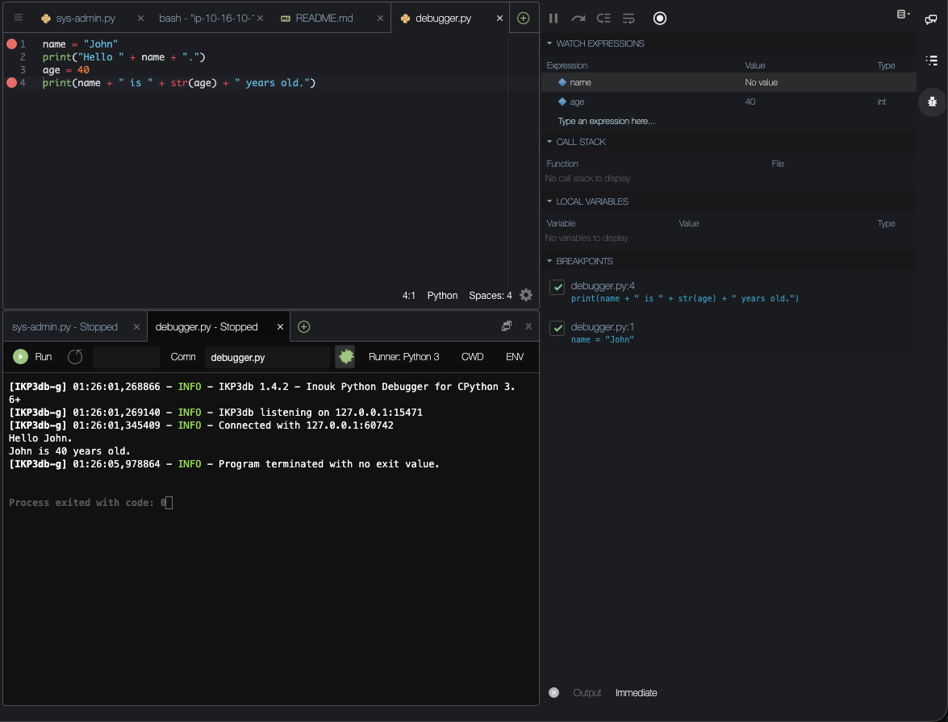

Debugging the Caesar Cipher Program

Exercise: 1

Line 28 was trying to add a string cipherKey input

Typecasted the input to int to fix the error:
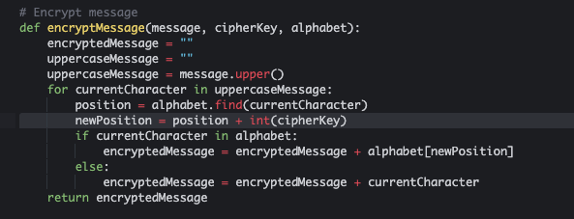

Exercise: 2

Input message needed to be converted to a capital letter:

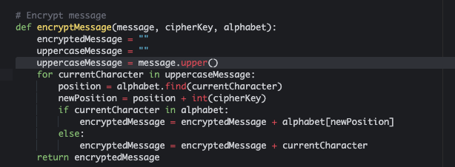

Exercise: 3

Change the return line to use decryptKey:

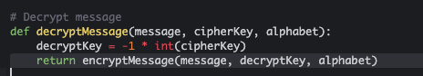

Exercise: 4

Change the following line:

print(f'Decrypted Message: {myEncryptedMessage}')

to:

print(f'Decrypted Message: {myDecryptedMessage}')

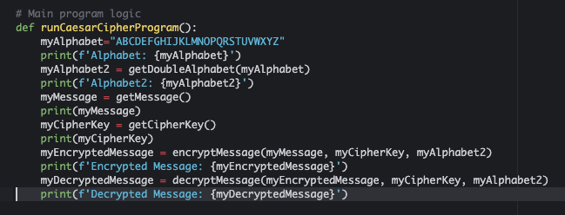

Evaluate a DevOps Tool

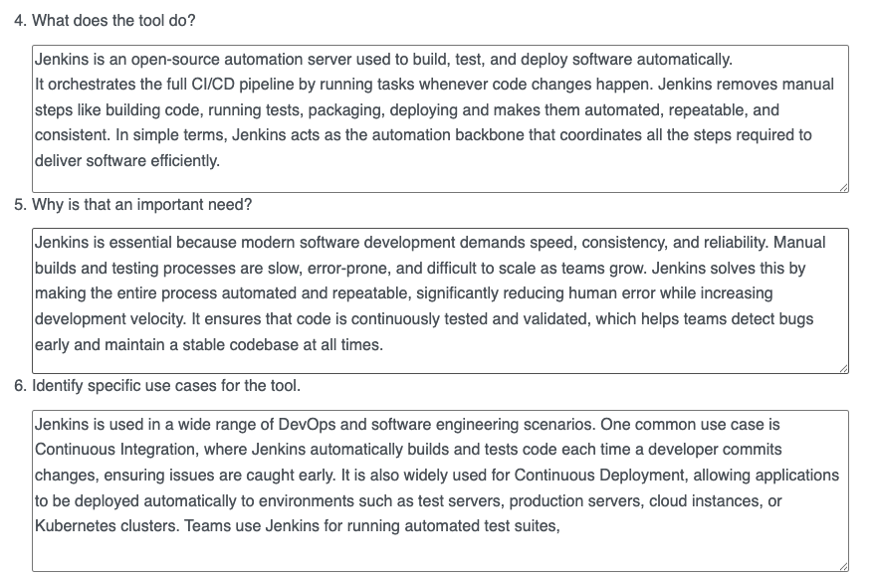

Compare and Contrast Automation and Orchestration

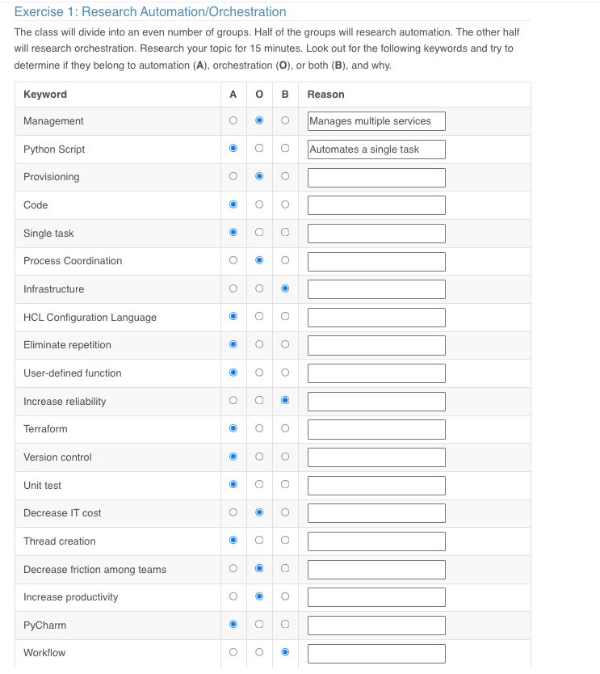

Challenge Lab: Python Scripting Exercise

