Analysis of Cancer Growth and Decay Cells using
First Order Neutrosophic Differential Equation

Suganya Baby N ¹ , Dhavamani M ², Usha S ³

¹Assistant Professor, ² Assistant Professor (Sr.G), ³Associate Professor
^{1,2}Department of Mathematics, ³ Department of Electrical and Electronics Engineering,
^{1,2,3}Kongu Engineering College,Perundurai-638 060, Tamilnadu, India

Corresponding Author: N.Suganya Baby , Email: shrisuganya7@gmail.com, 9894923773

ABSTRACT

In this article, an attempt is made for solving first order Neutrosophic Differential Equation by using Trapezoidal Neutrosophic Number. Furthermore, a problem involved with tumor growth is illustrated to show the results of the Differential Equation with the base value as Trapezoidal neutrosophic number. The solution of the proposed method is developed using MATLAB tool and the results are interpreted in the graphical form.

Keywords: 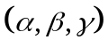- cut sets; Neutrosophic set; Neutrosophic differential equation ;Single-valued Neutrosophic set ; Trapezoidal Neutrosophic number .

1. INTRODUCTION

The immediate and direct understanding of the real world is too complex. Models of reality which are simplified aspects of the world are created. These mathematical models are challenging and exact solutions could not be easily found. In modeling the problems in various fields, the uncertainty prevalent in the data makes it impossible to utilized classical methods. The reason is that uncertainities exists in the natural environmental. The classical theory that depends on the crisp does not appear to be much suitable for dealing with such uncertainty.
K. Atanassov[1] in 1986 proposed the generalization of Fuzzy Sets , called Intuitionistic Fuzzy Sets (IFS). The above mentioned sets have some disadvantages. To get the better results, a new theory called Neutrosophic logic and sets is introduced in the present study. Smarandache [4] has propounded the Neutrosophic set concept that involves the extensions of classical set, fuzzy set , Intuitionistic fuzzy set, and so on.
Neutrosophic set is characterized by the membership function which constitutes truth degree, falsehood and indeterminacy membership function. Here indeterminacy leads more information when compared to fuzzy sets and Intuitionistic fuzzy sets. Thus, the application of neutrosophy will give better results than fuzzy and IFS.
Differential equations are much significant in the field of Engineering and Science. Modeling the problems in this field include some parameters that are uncertain or imprecise. This paves a way for the emergence of imprecise differential equations like Fuzzy Differential Equation [2] and Intuitionistic Fuzzy Differential Equation which comprises certainity and uncertainity functions, whereas indeterminacy do not exist. To resolve this, Neutrosophic Differential Equation is evolved.
In this present article, ODE of first order using trapezoidal neutrosophic number has been solved. This equation is applied for tumor growth problems and its effectiveness is determined.
2. PRELIMINARIES
Definition : 2.1 [7]
Let be the Universe of discourse. A Single valued Neutrosophic set on is defined as where represents the membership degree , indeterministic degree and non-membership degree respectively of the element such that .
Definition : 2.2 [5]
- cut Neutrosophic set is denoted by so that 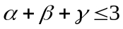 is given by

Definition : 2.3 [5]
A Neutrosophic set B on the set of real numbers is said to be Neutrosophic number if it has the following properties.
(i) B is normal if there exists 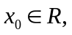such that .
(ii) B is convex set for the truth function ( (ie)
)) (iii) B is concave set for the indeterministic function ) and falsehood function , ( ie)
))
))

Definition : 2.4 [3]
Trapezoidal Neutrosophic number B is a subset of neutrosophic number in R having truth, indeterministic and falsehood function given by
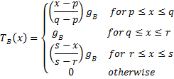
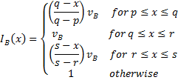
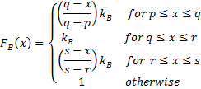
where and Trapezoidal Neutrosophic Number is expressed by
Note :
shoots up constantly for and diminishes for but reduces constantly for and escalates for .

Definition :2. 5 [6]
- cut of a Trapezoidal Neutrosophic Number is
(, where [
[
[

Definition : 2.6 [6]
If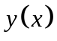 be the solution for the Neutrosophic Differential Equation and its -cut be .
The solution is strong if it has the following condition,
(i) 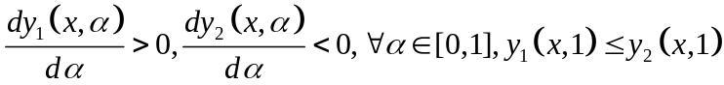.
(ii) 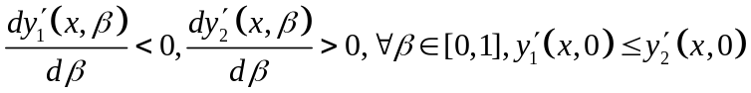.
(iii) 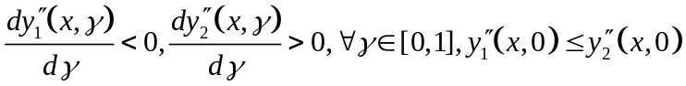.
Or else the solution is feeble.

3. Solving First Order Neutrosophic Differential Equation using TNN :
Consider the Neutrosophic differential equation of first order of the form
with the basic condition ) ------(I)
CASE: (I)
If
For equation (I), taking - cut , we have
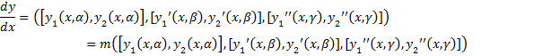
whose initial condition is
where and
with the initial condition

Then the result for the above equation is

CASE: (II)
If
For equation (I), taking - cut , we have
whose initial condition is
where and
with

whose initial condition

Then the result for the above equation is given by

Application : 3.1
Cancer cells without any treatment in a human body increases at a constant rate . The initial population of the cells is given as a trapezoidal neutrosophic number (2, 4, 6, 8 ; 0.8, 0.2, 0.3). Interpret the population of cancer cells after two months.

Solution :

The differential equation is given by
where

The solution is
;
;
;

Here
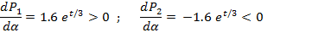
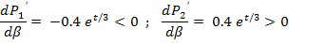
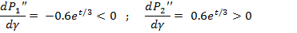

In the below table, the solution is given for distinct values of ( when t = 2.

 | P₁(t,α) | P₂(t,α) | P₁(t,β) | P₂(t, β) | P₁(t,γ) | P₂(t, γ)
0 | 3.1164 | 12.4655 | 1.5582 | 2.3373 | 2.3373 | 3.5059
0.1 | 3.4280 | 12.1539 | 1.4803 | 2.4152 | 2.2204 | 3.6228
0.2 | 3.7396 | 11.8422 | 1.4024 | 2.4931 | 2.1036 | 3.7396
0.3 | 4.0513 | 11.5306 | 1.3245 | 2.5710 | 1.9867 | 3.8565
0.4 | 4.3629 | 11.2189 | 1.2465 | 2.6489 | 1.8698 | 3.9734
0.5 | 4.6746 | 10.9073 | 1.1686 | 2.7268 | 1.7530 | 4.0902
0.6 | 4.9862 | 10.5957 | 1.0907 | 2.8047 | 1.6361 | 4.2071
0.7 | 5.2978 | 10.2840 | 1.0128 | 2.8826 | 1.5192 | 4.3240
0.8 | 5.6095 | 9.9724 | 0.9349 | 2.9606 | 1.4024 | 4.4408
0.9 | 5.9211 | 9.6608 | 0.8570 | 3.0385 | 1.2855 | 4.5577
1.0 | 6.2327 | 9.3491 | 0.7791 | 3.1164 | 1.1686 | 4.6746
Table 1: Population of Cancer Cells after two months
.

The graphical representation of the above table is shown below.

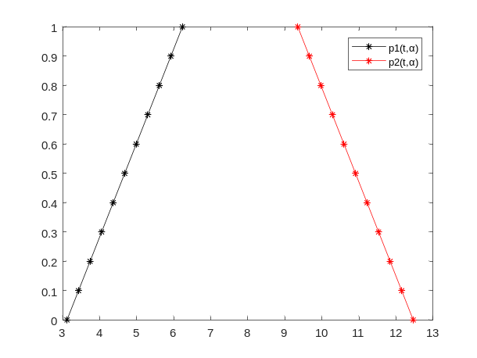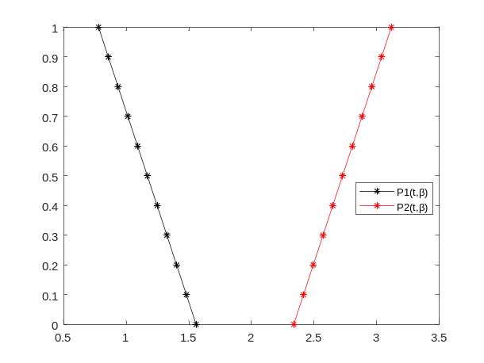
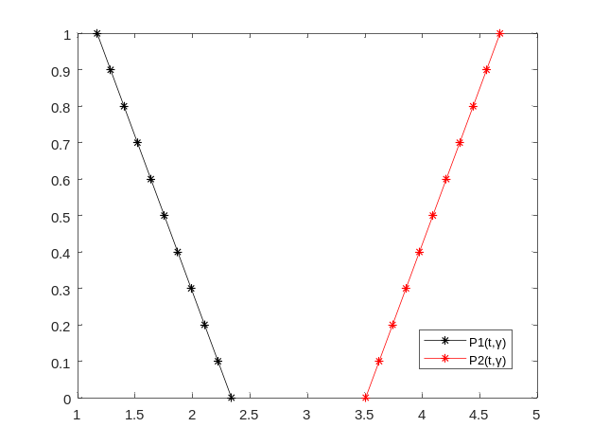
Figure 1: Population of cancer cell growth after two months

In the above example, the solution obtained is strong.

Application : 3.2
Cancer cells after undergoing chemotherapy decreases at a rate of 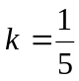. The initial population of the cells is given as a Trapezoidal Neutrosophic Number (2, 4, 6, 8 ; 0.8, 0.2, 0.3). Interpret the population of cancer cells after two months.

Solution:
The differential equation is given by
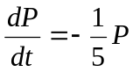 where
The solution is
;
;
;
Here
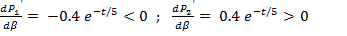
 | P₁(t,α) | P₂(t,α) | P₁(t,β) | P₂(t, β) | P₁(t,γ) | P₂(t, γ)
0 | 1.0725 | 4.2900 | 0.5363 | 0.8044 | 0.8044 | 1.2066
0.1 | 1.1798 | 4.1828 | 0.5094 | 0.8312 | 0.7642 | 1.2468
0.2 | 1.2870 | 4.0755 | 0.4826 | 0.8580 | 0.7239 | 1.2870
0.3 | 1.3943 | 3.9683 | 0.4558 | 0.8848 | 0.6837 | 1.3272
0.4 | 1.5015 | 3.8610 | 0.4290 | 0.9116 | 0.6435 | 1.3675
0.5 | 1.6088 | 3.7538 | 0.4022 | 0.9384 | 0.6033 | 1.4077
0.6 | 1.7160 | 3.6465 | 0.3754 | 0.9653 | 0.5631 | 1.4479
0.7 | 1.8233 | 3.5393 | 0.3486 | 0.9921 | 0.5228 | 1.4881
0.8 | 1.9305 | 3.4320 | 0.3218 | 1.0189 | 0.4826 | 1.5283
0.9 | 2.0378 | 3.3248 | 0.2949 | 1.0457 | 0.4424 | 1.5685
1.0 | 2.1450 | 3.2175 | 0.2681 | 1.0725 | 0.4022 | 1.6088

Table 2: Population of Cancer Cells after two months

The graphical representation of the above table is shown below.

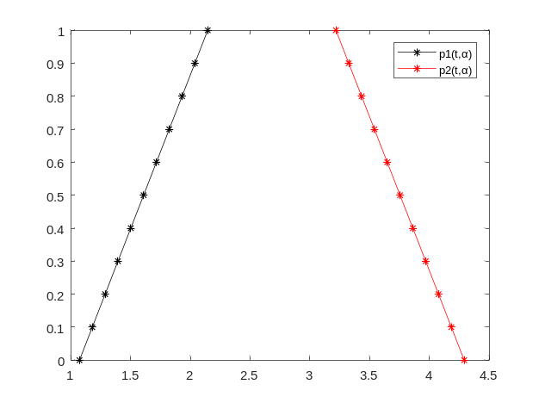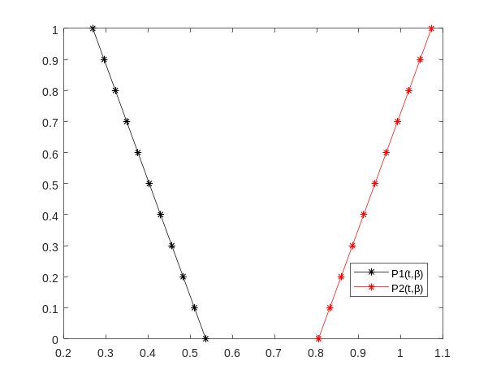
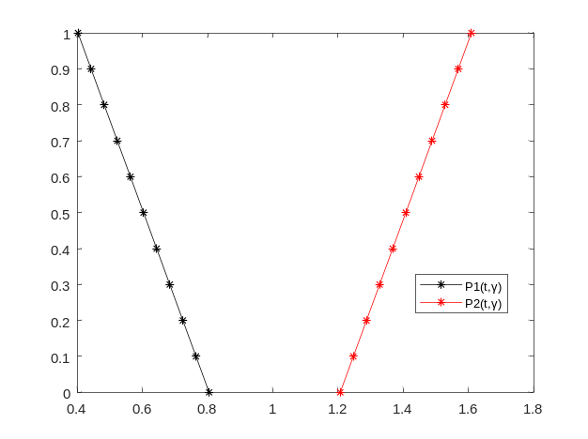

Figure 2: Population of cancer cell growth after two months.

The solution obtained here is strong.

4. CONCLUSION
In this present article, Neutrosophic differential equation of First Order through the use of Trapezoidal Neutrosophic Numbers has been solved using () - cut method. The proposed method is applied in medical field for analysing the growth and decay of tumor cells. By using MATLAB , the results were obtained for the indeterminacy function, truth function and falsehood function. Here the proposed method is found to be effective.
5. FUTURE SCOPE
Future research may be done in the Neutrosophic fractional calculus. In this era, Solving Neutrosophic Differential Equation by using various numerical techniques is an emerging field. In real world applications ,Neutrosophic differential equations of higher order and Partial Differential equations using Neutrosophic numbers can be interpreted to solve the problems for further study.
Conflict of Interest: I wish to state that Author and Co-authors does not have any COI.
REFERENCES
[1] Atanassov.K , Intuitionistic fuzzy sets, Fuzzy Sets and Systems 20 (1986) 87-96.
[2] Chalco-Cano.Y, Roman-Flores.H, “On new solutions of fuzzy differential equations”,
Chaos, Solitons and Fractals, (38) (2008), 112-119.

[3] Irfan Deli, Yusuf Subas, “A ranking method of single valued Neutrosophic numbers and
its applications to multi-attribute decision making problems”, Int. J. Mach. Learn. and
Cyber,(2016).

[4] Smarandache.F, Neutrosophic set, a generalisation of the Intuitionistic fuzzy sets”, Int. J.
Pure Appl. Math. (24), (2005),287-297.

[5] Sumathi I.R, Mohana Priya V (2018) A new perspective on neutrosophic differential
equation,Int J Eng Technol 7 (4.10):422-425.

[6] Sumathi I.R, Antony Crispin Sweety.C, New approach on differential equation via
trapezoidal neutrosophic number ,Complex & Intelligent Systems (2019)5:417-424.

[7] Wang, H.F.Y Smarandache, Q Zhang and Sunder raman.R “Single valued neutrosophic
sets”, Multispace and Multistructure,(4) (2010),410-413.

