ZEROCRUMB: A Web-Based Platform for Rescuing Surplus Food and Connecting Donors, NGOs and Communities

Madhanesh M and Niranjan S
Department of Computer Science and Design,
Rajalakshmi Engineering College, Chennai, Tamil Nadu, India
Under the guidance of Dr. P. Revathy
madhanesh.chyr@gmail.com | niranjansb457@gmail.com

Abstract— Food waste and food insecurity can coexist within the same community. Hostels, restaurants, caterers and event organizers may discard edible surplus because they lack a quick and trusted way to identify recipients, while orphanages and community organizations may struggle to plan reliable meals. This paper presents ZEROCRUMB, a proposed web-based coordination platform intended to connect food providers, NGOs, volunteers and recipient organizations. The project follows a human-centred design-thinking process and proposes a four-stage workflow: listing, matching, claiming and delivering. Its planned capabilities include surplus-food listings, location-aware discovery, real-time notifications, verified organizational coordination, food-safety prompts, delivery-status tracking and an impact dashboard. A shared database, backend services, location services, notification services and cloud hosting form the conceptual system architecture. Phase I produced stakeholder and pain-point analysis, the problem definition, the proposed workflow, requirements and dashboard prototype concepts. No quantitative performance or social-impact measurements have yet been recorded; therefore, the benefits discussed are expected outcomes requiring Phase II implementation and field evaluation. ZEROCRUMB is a coordination aid and does not replace food-safety inspection or responsible human handling.

Keywords— food redistribution, surplus food, food waste, food donation, NGO coordination, location-aware matching, web platform,design thinking, SDG 2

I. INTRODUCTION
Food waste and food insecurity can exist side by side in the same locality. Hostels, restaurants, caterers and event organizers may have edible surplus, while orphanages and community organizations may need dependable access to meals. Redistribution is difficult when availability, collection and delivery information is fragmented across calls and messaging groups. ZEROCRUMB investigates a shared web platform through which providers publish surplus food, nearby NGOs discover and claim suitable listings, and volunteers coordinate collection and delivery.
Problem Statement
Edible surplus may be discarded while nearby communities need food. Without a shared system, donors and recipients rely on informal contacts, making it difficult to identify demand, arrange collection before food spoils and track delivery. The design problem is to make the donation journey visible, simple and time-aware while keeping food-safety checks explicit.
Objectives
Reduce avoidable food waste; connect donors with orphanages and communities; improve pickup and delivery coordination; encourage responsible donation practices; and provide visibility into meals and deliveries.

II. RELATED WORK
Relevant work spans food-waste assessment, food-security reporting, human-centred design, NGO-led redistribution and food-safety guidance. UNEP’s Food Waste Index provides a framework for understanding food waste [1], while FAO reporting contextualizes food insecurity [2]. Design thinking emphasizes understanding stakeholder needs before selecting a solution [3], [4]. Existing local practices include calls, messaging groups, NGO collection drives and digital surplus-food listings.

Research Gap
The gap addressed is not the absence of food-donation platforms. ZEROCRUMB investigates a local workflow combining simple listing, location-aware discovery, time-

sensitive alerts, safety prompts, delivery tracking and impact visibility for orphanages and community organizations.

III. SYSTEM ARCHITECTURE
The conceptual architecture contains provider and NGO interfaces, application/backend services, a shared database and supporting location, notification, safety, impact and cloud-operation services. Providers create listings; backend services validate and store them; nearby discovery uses location and time information; NGOs claim suitable listings; and pickup and delivery progress are recorded.
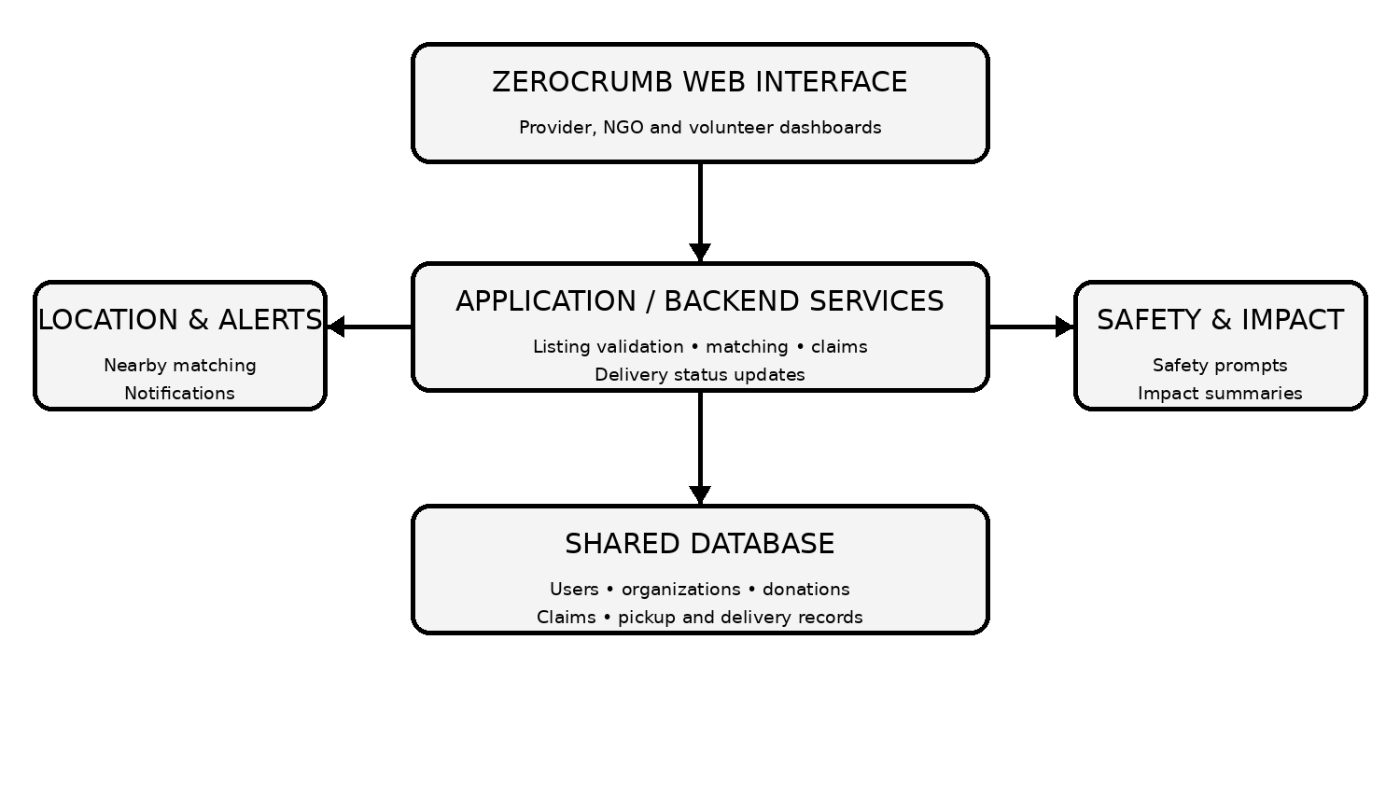
Fig. 1. ZEROCRUMB conceptual system architecture.
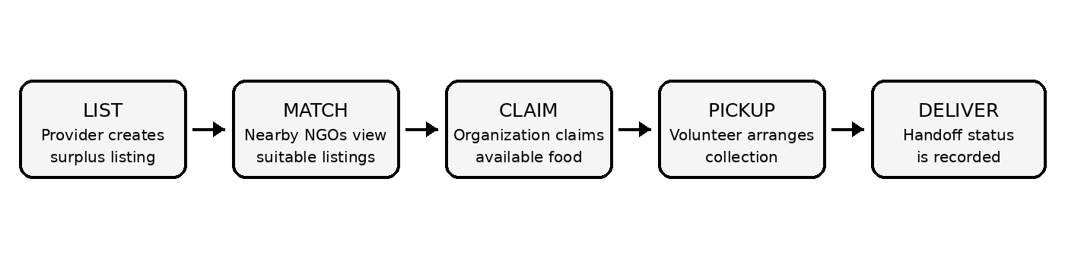
Fig. 2. ZEROCRUMB donation workflow: listing, matching, claiming, pickup and delivery.

Workflow
LIST—provider enters food type, quantity, pickup location and best-before time. MATCH—nearby NGOs discover available listings. CLAIM—an eligible organization claims a listing. DELIVER—volunteers coordinate collection and record handoff. The claiming organization remains responsible for deciding whether it can safely collect and use the food.

IV. DESIGN AND REQUIREMENTS
The project follows design-thinking activities: empathize, define, ideate and prototype. The ideation workshop identifies real-time surplus listings, GPS-based matching, alerts, NGO/volunteer coordination, verified profiles, safety checklists and impact dashboards. The design challenge is to minimize food waste while helping orphanages receive nutritious surplus food efficiently.

TABLE I. COMPARISON OF CURRENT APPROACHES
Approach | Strength | Limitation / relevance
Calls and personal contacts | Quick among known participants | No shared visibility or status tracking
Messaging groups | Wide reach; low setup effort | Unstructured claims and pickup status
NGO collection drives | Established local volunteer networks | Manual coordination and capacity constraints
Surplus-food applications | Structured listings and matching | Coverage and adoption vary by locality
Proposed ZEROCRUMB | Listings, matching, alerts and tracking | Requires adoption and human safety checks

TABLE II. DONATION LISTING FIELDS
Field | Description | Workflow relevance
Donor / Provider | Hostel, restaurant, caterer or event organizer | Provider creates the surplus-food listing
Food details | Food type and available quantity | NGO coordinator views available surplus listings
Pickup location | Location supplied for collection and nearby discovery | Eligible organization submits a claim
Time information | Listing time and best-before / pickup deadline | Relevant coordinators receive time-sensitive notifications
Claim status | Available, claimed, pickup in progress or delivered | Pickup and delivery status are updated

TABLE III. FUNCTIONAL VERIFICATION
Function | Phase I status
Create surplus-food listing | Specified in proposed workflow
Discover nearby listings | Location-aware feature proposed
Claim a suitable listing | Specified in proposed workflow
Coordinate pickup and delivery | Workflow and status tracking proposed
View impact summary | Dashboard prototype concept documented

V. MODULES AND API DESIGN
The Provider and Listing Module manages surplus listings and donation history. The Matching and Claim Module supports nearby discovery, alerts and claims. The Tracking and Dashboard Module records pickup and delivery progress and displays impact summaries. The backend is responsible for validation, role-based rules, status updates and notifications. Table II summarizes the principal information associated with a donation listing. Table III identifies the main functions and their Phase I status.

TABLE IV. QUANTITATIVE EVALUATION PARAMETERS
Parameter | Evaluation status
Listing completion time | To be measured
Relevant nearby matches | To be evaluated
Claim completion rate | To be measured
Notification delivery time | To be measured
Delivery-status completion | To be evaluated
User satisfaction / usability | To be evaluated

VI. IMPLEMENTATION STATUS AND DISCUSSION
The documented Phase I outputs are the problem statement, stakeholder and pain-point analysis, design challenge, proposed list–match–claim–deliver workflow, conceptual architecture, requirements, feasibility considerations and dashboard screen concepts. The project report describes the platform as proposed and the dashboards as prototype concepts. It does not establish a production deployment or completed field trial. Accordingly, the parameters in Table IV are evaluation items for Phase II; no measured performance or social-impact results are claimed.
Expected benefits include shared visibility, easier discovery of nearby opportunities and clearer claim and handoff status. Limitations include donor and NGO adoption, listing accuracy, volunteer and transport availability, location accuracy, food hygiene during transit and local regulatory requirements.

VII. FUTURE WORK AND CONCLUSION
Future work includes stakeholder validation, implementation of the listing and claim workflow, integration of location and notification services, privacy and security review, usability testing and a controlled pilot. ZEROCRUMB presents a proposed web-based coordination approach for surplus-food redistribution. Its design artefacts establish a basis for implementation, but operational and social-impact claims must be supported by measured Phase II results.

ACKNOWLEDGMENT
The authors thank Dr. P. Revathy for guidance and the Department of Computer Science and Design, Rajalakshmi Engineering College, for academic support.
REFERENCES
[1] United Nations Environment Programme, Food Waste Index Report 2021, Nairobi, Kenya, 2021.
[2] FAO et al., The State of Food Security and Nutrition in the World, annual report series, Rome, Italy.
[3] T. Brown, “Design Thinking,” Harvard Business Review, vol. 86, no. 6, pp. 84–92, 2008.
[4] Hasso Plattner Institute of Design at Stanford, An Introduction to Design Thinking: Process Guide, Stanford University, 2010.
[5] United Nations, “Transforming Our World: The 2030 Agenda for Sustainable Development,” 2015.
[6] Food Safety and Standards Authority of India, official website and food-safety guidance, https://www.fssai.gov.in/.

