RAJALAKSHMI ENGINEERING COLLEGE
Department of Computer Science and Design
GE23627 Design Thinking and Innovation
Ideate Phase – Ideation Workshop Sheet

Team Information
Team Name: | Student 1(Roll No and Name) | Student 2(Roll No and Name) | Student 3(Roll No and Name)
ZEROCRUMB | 241701026  Madhanesh M | 241701040  Niranjan S | --

Problem Statement:
Large quantities of edible, perfectly safe surplus food are wasted every day by hostels, catering services, restaurants, and event organizers, while orphanages nearby continue to face food shortages and struggle to provide nutritious, consistent meals.
This happens mainly because of poor coordination between food donors and orphanages — donors have no easy way to identify who needs the food and by when, and orphanages have no reliable channel to request it. The result is unnecessary food waste, added environmental burden, and hunger that persists despite nearby surplus.

Target Users:

Primary: Orphanages & orphanage children, hostel management & kitchens, catering service providers, restaurants & hotels, and event organizers (halls, functions, festivals). Secondary: NGOs working on food donation, volunteers & delivery personnel, local communities, food safety authorities, and waste management organizations. Decision Makers: Hostel wardens & administrators, catering company owners/managers, restaurant & hotel owners, orphanage administrators, and NGO coordinators & local government.

Brainstorming Rules
- Focus on generating many ideas.
- Do not criticize any idea during brainstorming.
- Encourage creative and unusual ideas.
- Build on ideas proposed by teammates.
- Write or sketch ideas

Idea Generation (Brainstorming)
Idea No | Student 1 Idea | Student 2 Idea | Student 3 Idea
1 | Real-time surplus food listing app for hostels, caterers & restaurants | SMS/WhatsApp-based donation alerts to orphanages, requiring no app install | --
2 | GPS-based matching that connects each donation to the nearest orphanage | A centralized NGO/volunteer network to coordinate pickup & delivery | --
3 | Verified donor & orphanage profiles with a simple safety/hygiene checklist | Fixed community drop-point food banks near hostels and orphanages | --
4 | Impact dashboard tracking meals saved, deliveries made & waste reduced | Donor recognition / rewards program for hostels & restaurants that donate regularly | --
5 | Push/real-time alerts the moment surplus food is listed | Volunteer scheduling & route optimization tool for pickup & drop-off | --

Idea Voting (Dot Voting)
Idea | Student 1 Vote | Student 2 Vote | Student 3 Vote | Total Votes
Idea 1 — Real-time surplus food listing + GPS matching platform (Zerocrumb) | 2 | 2 | - | 4
Idea 2 — SMS/WhatsApp donation alerts | 1 | 0 | - | 1
Idea 3 — Centralized NGO/volunteer coordination network | 1 | 1 | - | 2
Idea 4 — Community drop-point food banks | 0 | 1 | - | 1
Idea 5 — Donor rewards / recognition program | 0 | 0 | - | 0

Top Idea Selected
Selected Idea:
Zerocrumb — a web platform where hostels, caterers, restaurants & event organizers list surplus food in seconds; GPS/Maps matching connects it to the nearest orphanage; and a verified NGO/volunteer network coordinates safe, real-time pickup and delivery.

Concept Development

Feature | Description
Project Title | Zerocrumb — Rescuing Surplus Food. Feeding Hope.
Key Features | • Donor Listings — hostels, caterers & restaurants post surplus food in seconds  • Location Matching — GPS/Maps integration connects donors to the nearest orphanage  • Real-Time Alerts — push, SMS & email notify orphanages the moment food is listed  • Verified NGO Network — NGOs and volunteers coordinate pickup & delivery reliably  • Safety Checklist — simple hygiene & freshness checks before every donation is listed  • Impact Dashboard — tracks meals saved, deliveries made, and food waste reduced
Technology Required | • Web application for donors & orphanages, with cloud hosting/server for deployment  • Database (MySQL / MongoDB) for user & donation data  • GPS / Google Maps integration for location tracking  • Notification service (SMS, Email, Push)  • Transportation support for collection & delivery
Expected Benefits | • Reduction in edible food waste  • Increased availability of nutritious food for orphanages  • Faster, more efficient food distribution  • Better utilization of surplus food

Solution Architecture Diagram
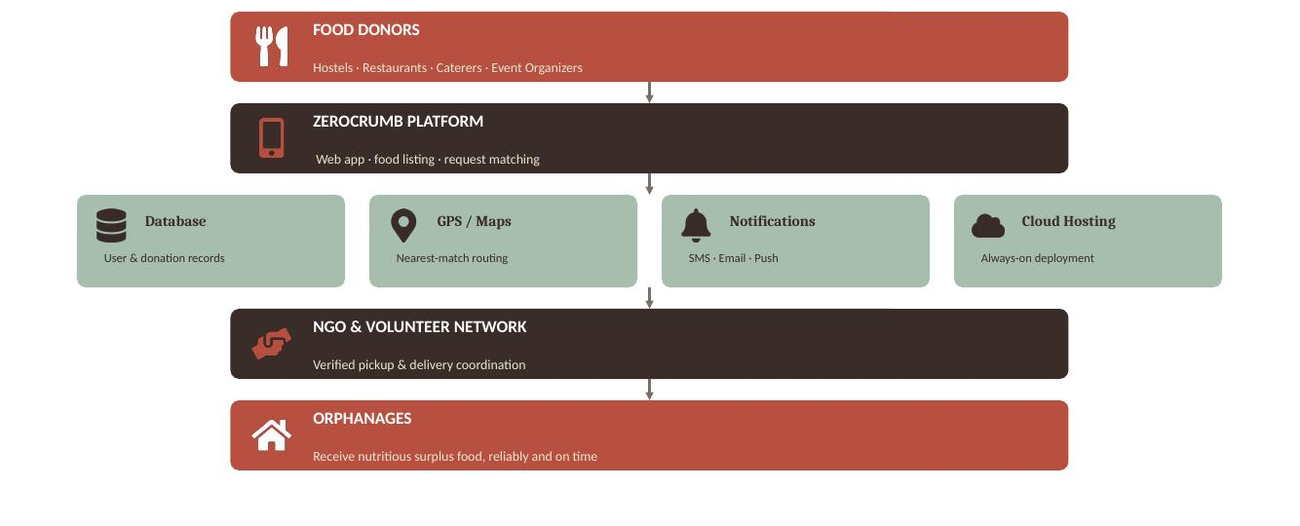

Flow: Food Donors (hostels, restaurants, caterers, event organizers) -> Zerocrumb Platform (web app, food listing & request matching, backed by database, GPS/Maps, notifications & cloud hosting) -> NGO & Volunteer Network (verified pickup & delivery) -> Orphanages (receive nutritious surplus food reliably and on time).

Short Idea Pitch
Problem Addressed:
Large quantities of edible surplus food from hostels, caterers, restaurants and event organizers go to waste daily, while nearby orphanages continue to face food shortages — largely due to a lack of coordination between donors and those in need.

Proposed Solution:
Zerocrumb is a web platform where food donors list surplus food in seconds; GPS-based matching connects it to the nearest orphanage; verified NGOs and volunteers coordinate pickup and delivery; and a safety checklist plus real-time alerts keep the process quick, safe and reliable.

Key Benefit to Users:
Orphanages receive nutritious surplus food reliably and on time, donors get a simple, guilt-free way to put surplus food to good use, and NGOs/volunteers get one coordinated system instead of scattered manual effort.

Signature of the Coordinator

