**CHATBOT USING IBM WATSON.**

**TEAM MEMBER**

**311521205034 :NIRANJAN KUMAR A**

**Phase 2 Submission Document**

**Project:** Virtual guide using ibm cloud watson assistant.

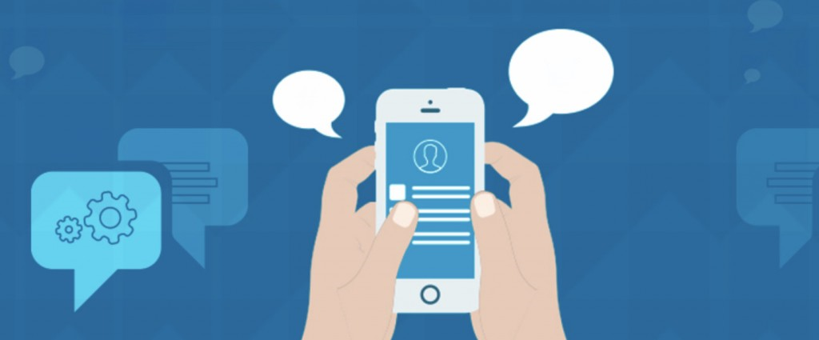

**INTRODUCTION:-**

Many people use chat applications more than social networks or other apps. The largest services like Whatsapp, Telegram or Facebook Messenger, have hundreds of millions of active users [1]. Because of this trend it is a great place for potential growth for companies. For example, the dealing with an enormous amount of customer questions via mail could be dealt with by a chatbot. Thanks to artificial intelligence and chat applications opening app stores for bots it becomes a lot easier to build chatbots and integrate it into existing chat applications. A lot of companies already made chatbots to serve their customers by automating their customer service with keeping a human touch and without them having to download an extra application on their phone. Facebook Messenger already has more than 34.000 bots on their platform [2]. A company that uses a chatbot is KLM, the Royal dutch airlines, which developed a Facebook Messenger bot which a user can chat with to get information about his flight, information about delays, if a gate has changed and when boarding starts. In this paper we will study the domain of chatbots: what chatbots are, what capabilities they have and how to make a chatbot using the IBM Watson services.

**CONTENT FOR PROJECT PHASE 2:-**

Considerimplementing advanced features such as natural language understanding (NLU) for more accurate user intent recognition.

**Chatbot:-**

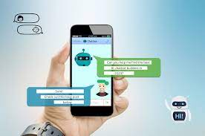

Chatbots are applications you can interact with using natural language within a chat interface and are often used as automated online assistants where you can interact with speech or via text. Artificial intelligence in chatbots is often used to understand natural language and to give a human like response to try to mimic a human conversation.

**Problems with chatbots:-**

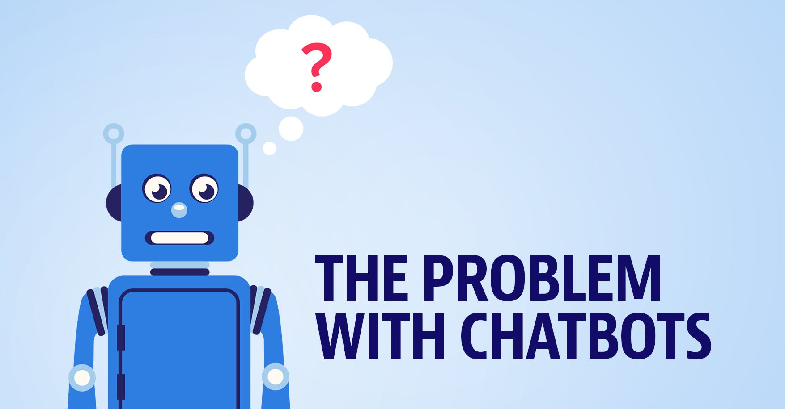

Although chatbots are used a lot, they are not perfect. Most chatbots lack the understanding of context and have problems understanding a basic question when a user talks to a chatbot in a way he would talk to a person, which could be very frustrating, because they try to act as a person but lack the basic understanding of language or context and therefore fail to create a good user experience. One of the problems here is that most chatbots are not good at natural language processing. Questions posed in natural language can be posed in a lot of different ways, for example: give me the weather forecast, is it raining? Do I need an umbrella. Bots often do not understand the relation between rain and using an umbrella like a person can. This gives the feeling that you can not have a simple conversation. Another problem is the lack of understanding follow-up questions. when asking a such a question bots often do not remember the question the users posed before or the answer it self gave. This problem generates another problem, which is that chatbots cannot answer everything. They are focused on a specific topic which means that for every question topic you need another chatbot. Since that chatbots still offer a cold and poor user experience and its lack of functionality, the user should not assume that the chatbots can solve all of their problems or answer all of their questions correctly, although companies or developers often present those bots that way.

**AI engines for chatbots:-**

To make a chatbot, multiple services or engines are developed to power an artificial intelligent chatbot with, like Octane ai, Motion.ai, IBM Watson, Dexter, BeepBoopHQ and more. In the next section we will discuss the capabilities of IBM Watson as an AI engine for chatbots. We have chosen for IBM Watson because of the enormous amount of availabilities to experiment with it and Watson has proven in the game Jeopardy that it is good in answering difficult open questions [5]. With IBM Watson you are able to use machine learning without having programming skills, it is easy to train via a web interface and easy to implement in your own system(s).

**IBM Watson:-**

Watson, named after IBM’s founder, Thomas J. Watson, is a computer system making use of Artificial Intelligence and cognitive computing technology to become a self-learning “questioning answering (QA) machine“ using natural-language processing and had the capability of answering difficult questions within seconds [6]. According to Kelly and Hamm [7] Watson is the first step of the era of cognitive computing and this means that computers can learn from interaction with humans or by analyzing lots of (big) data by simulating the functions like the thought processes of the human brain. This allows Watson to learn from structured- and unstructured data it gathered and has the ability to learn the context of this data and to reason in order to give a precise answer or to make a decision by using machine learning and deep learning algorithms [8]. Furthermore, Watson makes use of the following kinds of technologies, like big data, web intelligence and cloud computing.

**Big data, Web intelligence and cloud computing:-**

Big data is a term that refers to an enormous amount of data sets that could be structured or unstructured. With big data there are a lot of big challenges to deal with, e.g. curation, storage infrastructure, security, visualisation and many more. Because of the size and complexity of big data, normal computers are not able to face these challenges [9]. IBM Watson has the ability to tackle these challenges with his supercomputer power and intelligent cognitive learning system. As Bob Picciano explained, Watson is able to go trough data in record speeds. 100 gigabytes per seconds, which allows businesses to integrate their own datasets with external datasets and use them to analyse complex data structures [10]. IBM Watson is an example of web intelligence that uses its A.I. and information technology to solve big questions in a short amount of time. Web intelligence is a combination of artificial intelligence (AI) and advanced Information technology (IT). Both are part of the rapid growing internet and World Wide Web [11]. Web intelligence is applied in different sectors, like the government, in business and for personal use. IBM Watson is accessible via different applications and web interfaces, like via mobile, desktop or other devices that are connected to the web [12]. This is called cloud computing. Cloud computing is a term that was called ‘The web’. In simple terms, it has a front-end and a back-end. The front end provides the user on-demand access in many applications that are hosted on the web [13]. Examples are mail clients (Google mail, Microsoft Outlook), environments to work together via the browser of a desktop, mobile or tablet (Google Drive, Invision, Adobe cloud). The servers where all those applications run and have their storage can be seen as the back-end.

**Watson Conversation:-**

In IBM’s Bluemix cloud platform there are multiple services you could use to integrate into your bot. There are services available for natural language processing, to analyze emotions or tone of voice, image recognition and many more. In this part, we will explain how to make a chatbot in the very simple steps among many different tutorials and experiments we conducted. To make a chatbot you could use the Watson Conversation service to create virtual agents (bots). Watson Conversation has the key functions to make a simple chatbot. With this service Watson makes it easy to build a chatbot that understands messages posed in text and integrate them in existing messaging applications. It is not necessarily to have coding experience, because it has a visual dialog builder, which helps you to create these conversations easily. This service already includes natural language processing where you can create a structured conversation and it provides an API you could call from any website or app.

**Watson Tone Analyzer:-**

Watson tone analyzer makes it possible to analyze tones, emotions and writing style in written text . With this service you can easily analyze the emotions: happy, angry, disgust, fear, sadness and joy. Social tendencies like: openness, Conscientiousness, extraversion, agreeableness and emotional range and the language styles: confident, analytical and tentative (see figure 4). in order to make a chatbot more human-like or help the user better when they are frustrated with your service Watson makes it possible to respond differently when it analyzes a certain emotion. For example, when someone is waiting for a long time on his food to be delivered and becomes angry the bot can adjust the tone of his responses to calm down the angry customer or a human customer service employee can overtake the bot and chat with the customer to calm it down. In the Watson Conversation service you can use the output of the tone analyzer where you can add different responses on different types of emotions, tones or writing styles.

**Watson Retrieve & Rank:-**

In order to make the chatbot smarter, it is better to let the bot search in database for answers. IBM offers a service called Retrieve and Rank which is a search engine with machine learning capabilities.The service consists of two parts: - Retrieve: SolR based search component that can retrieve a list of possible matches from your documents giving a query - Rank: A Machine learning component that learns to rank those matches to sort them. So that the best possible match gets a higher ranking. Because it is a machine learning based solution it means that you have to train it. It will learn from the training how to handle your data and improves the relevance of the search results by time and training

**Watson Tradeoff Analytics:-**

When Watson has to make decisions and there are a lot of options to choose from, it can be really difficult to choose the best one. Especially when the user gives conflicting criteria. For example, when the user asks “I want to buy the best but cheapest phone. Normally, the best phone is not the cheapest which is a conflicting criteria. With this service you also could personalize the decision making process by using the user’s individual preferences. When the user sets up its preferences, Watson Tradeoff Analytics will analyze these and will give you the best-balanced option by balancing the conflicting criteria.

**Watson Virtual Agent:-**

Watson Virtual Agent is a pre-trained chatbot you could use for customer service. Because the bot is already trained to work in a lot of domains you only have to add data like company information, documents, etc. It automates certain services to your customers. It also provides some insights and analytics about your customer’s engagement, which help you to understanding your customer’s needs.

**Watson Knowledge Studio:-**

Watson Knowledge Studio is a cloud-based application that discovers deep insights and knowledge in random text without any coding. When you teach it to find certain data within the unstructured text , it identifies the relationships of the texts in the given data and easily deploys them. It will accelerate the training process by saving time. You could buy this product with a monthly subscription.

**APIs:-**

In Watson Developer Cloud, several versions of API’s are available. For the products like Watson Discovery and Watson Conversation, you could easily get the API’s in there. Other products like Watson Knowledge Studio and Watson Virtual Agent do not have open API’s. Other than that, there are also API’s available for the functions like natural language understand and visual recognition with color tagging.

**Conclusion:-**

In this technical report, we have discussed the way to make a chatbot using IBM Watson. Although there are limitations on the methodology and APIs of IBM Watson, we proposed to make a chatbot with the certain API’s and the services from IBM that we illustrated above. By using Watson it could be easy and more efficient to make an intelligent chatbot, but the conversations with the customer still are scripted. Furthermore, some important initial steps like training the data have been done manually. It is not possible to make a completely automated chatbot yet, but with using the services of Watson, IBM makes it possible to make a chatbot that learns from earlier interactions or data and respond in other ways in different kind of situations. If you want to make a smart chatbot, some coding skills are required. The several services do have a web interfaces to train the bot with to make it smarter, but it is still not that easy to make a chatbot that can do a lot of different things.