AN AICTE ACTIVITY POINT PROGRAMME REPORT SUBMITTED TO

THE NATIONAL INSTITUTE OF ENGINEERING, MYSURU
(An Autonomous Institute under VTU, Belagavi)


In partial fulfillment of the requirements for the award of degree of

Bachelor of Engineering
in
Computer Science and Engineering
Submitted by

Niranjan Bhat (4NI21CS064)
Pravallika T (4NI21CS077)
Pushpak L (4NI21CS081)
Sachin Shetty (4NI21CS087)
Sarvas Deepak Mundargi (4NI21CS097)
Sharanya G S (4NI21CS099)
Shivakumar D M (4NI21CS102)
Srinidhi V (4NI21CS110)
Swaroop G P (4NI21CS114)
Vighnesh Bhat (4NI21CS120)
Vinay K V (4NI21CS121)

Under the mentorship of
Dr. Rekha KS Professor

DEPARTMENT OF COMPUTER SCIENCE AND ENGINEERING
THE NATIONAL INSTITUTE OF ENGINEERING
Mysore-570 008
2024-2025

DEPARTMENT OF COMPUTER SCIENCE AND ENGINEERING
THE NATIONAL INSTITUTE OF ENGINEERING
(An Autonomous Institute under VTU, Belagavi)



CERTIFICATE

This is to certify that the work carried out by the following students as part of the AICTE Activity Point Programme: Niranjan Bhat (4NI21CS064), Pushpak L (4NI21CS081), Sarvas Deepak Mundargi (4NI21CS097), Sharanya G S (4NI21CS099), Shivakumar D M (4NI21CS102), Srinidhi V (4NI21CS110), Vighnesh Bhat (4NI21CS120), Vinay K V (4NI21CS121), Swaroop G P (4NI21CS114), Pravallika T (4NI21CS077), and Sachin Shetty (4NI21CS087), in partial fulfillment of the AICTE Activity Point Programme in the (Specify Semester - IV/VI) semester, Department of Computer Science and Engineering, as per the academic regulations of The National Institute of Engineering, Mysuru, during the academic year 2024-25.

Signature of Mentor Professor & Head

______________ _______________
Dr.Rekha KS (Dr. Anitha.R)
Sl.No | Contents | Page no.
1. | Information about the activities | 1
2. | Activity 1 | 2
3. | Activity 2 | 6
4. | Activity 3 | 11
5. | Activity 4 | 15
6. | Activity 5 | 19
7. | Conclusion | 23
8. | Photos | 24
TABLE OF CONTENT
Introduction

The AICTE Activity Point Programme is an innovative initiative designed to nurture holistic development among students. Beyond technical expertise, the program emphasizes the cultivation of soft skills, leadership qualities, and societal commitment. By encouraging students to engage in community-focused activities, the initiative fosters teamwork, entrepreneurial thinking, and a sense of responsibility toward society.
As part of this program, several impactful activities were conducted to align with its objectives. These included teaching mathematics to students in government schools, where innovative methods were used to simplify complex concepts and make learning enjoyable. Park cleaning initiatives were undertaken to promote environmental awareness and community cleanliness. Digital awareness campaigns targeted local shopkeepers, equipping them with essential technological knowledge to enhance their operations. Public awareness programs focused on reducing plastic usage and promoting sustainable practices. Additionally, sessions were organized to educate households with cattle on the benefits and implementation of biogas systems, emphasizing its economic and environmental advantages.
These activities provided students with a platform to apply their knowledge practically while developing essential life skills. The AICTE Activity Point Programme thus not only bridges the gap between academia and real-world applications but also instills a sense of purpose and civic responsibility in the participants.

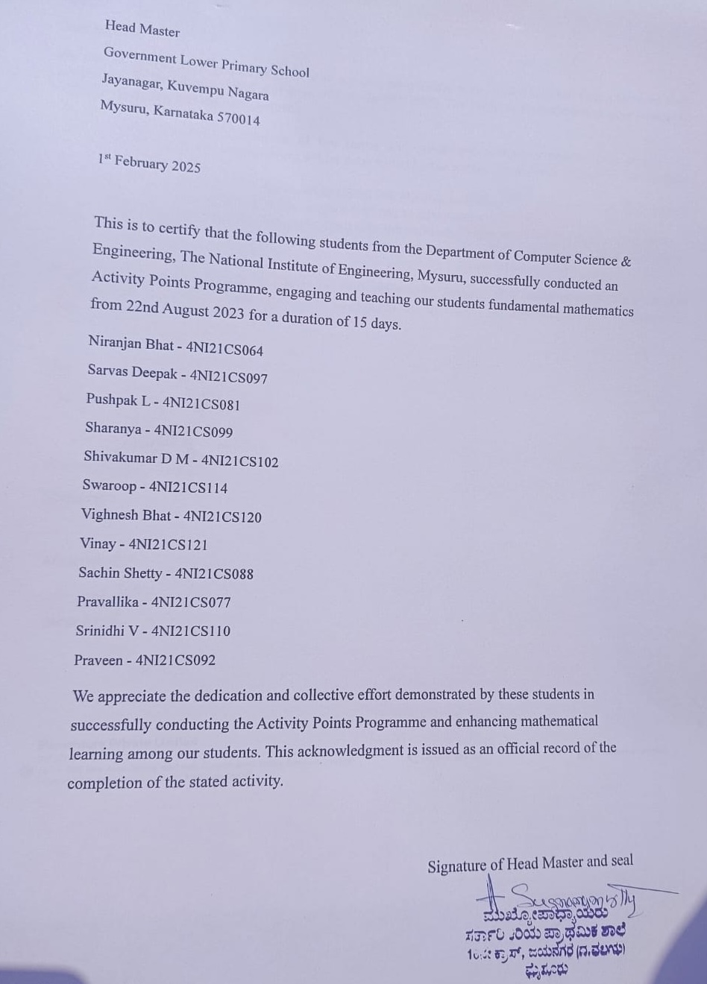

Activity 1

Engaging Young Minds: Interactive Learning at Government School

Mathematics is a fundamental discipline that requires strong conceptual understanding and problem-solving skills. Visual learning enhances mathematical comprehension by incorporating diagrams, graphs, animations, and interactive tools, making abstract concepts more tangible. This approach aids in bridging the gap between theoretical knowledge and practical application, fostering deeper engagement among learners.
As part of the AICTE Activity Point Programme, a workshop on "Mathematics with Visual Learning" was conducted to introduce students to innovative learning methodologies. The session focused on integrating visual aids such as geometric representations, coordinate plane plotting, and dynamic simulations to simplify complex mathematical theories. Participants explored tools like GeoGebra, MATLAB, and Desmos, which provided interactive visualizations for better comprehension of algebraic and calculus concepts.
The workshop emphasized the significance of visual representation in problem-solving, reinforcing how mathematical models can be interpreted more effectively through structured visuals. Students actively engaged in hands-on exercises, enabling them to grasp intricate topics such as differential equations, probability distributions, and vector algebra with clarity.
The initiative successfully demonstrated that visual learning not only enhances mathematical intuition but also fosters analytical thinking. By integrating technology-driven visualization techniques, students can develop a more profound and lasting understanding of mathematical principles, ultimately improving their academic performance and problem-solving abilities
Topics Covered in the School Activity
Basic Number Systems
The concept of basic number systems was introduced to students to help them understand numerical representations. Through engaging activities such as identifying numbers on charts and writing them on boards, students learned to recognize, write, and sequence numbers. Hands-on techniques, including counting with beads, further reinforced their understanding.
Counting
Students were taught basic counting techniques using real-world examples and visual aids. Techniques such as counting objects, using fingers, and beads made the process interactive and enjoyable. This approach helped students grasp the fundamentals of addition and subtraction and develop their numerical fluency.
Basic English
To improve language skills, students were introduced to simple English words and phrases. Teaching focused on common vocabulary, including greetings and everyday objects. Image recognition was used as a tool to help students associate pictures with their English names, enhancing their vocabulary and comprehension.
Image Recognition and Naming in English
This topic combined visual learning with language development. Students were shown images of objects, animals, and fruits, and they were encouraged to name them in English. This approach reinforced their vocabulary while also improving their confidence in identifying and naming items correctly.
Basic Problems
Students were guided through solving simple problems related to addition, subtraction, and patterns. By using beads and visual aids, the problem-solving sessions were designed to make abstract mathematical concepts tangible. This hands-on approach helped students understand the application of basic mathematics in everyday life.
Learning in a Friendlier Way: A Joyful Experience for All
The interactive sessions conducted in government schools offered a unique and enjoyable learning experience, both for the young students and the engineering students of the CSE Department, NIE Mysuru. Unlike traditional teacher-student dynamics, the friendly approach adopted by the engineering students created a relaxed and engaging environment. The young learners felt more comfortable asking questions, sharing their thoughts, and actively participating in activities. This bond, built on mutual trust and camaraderie, made the learning process not only effective but also fun and memorable.The engineering students employed creative teaching methods such as storytelling, games, and hands-on activities using beads and visuals. Their enthusiasm and approachable nature broke the barriers of formal education, allowing students to view learning as a joyful experience.

This innovative approach also rekindled fond memories for the college students. They were transported back to their own school days, recalling the joy of discovering new concepts and the excitement of solving basic problems for the first time.
For the engineering students, the activity was more than just a teaching exercise—it was an opportunity to give back to the community while reliving their childhood. The experience was a blend of nostalgia, fulfillment, and the sheer delight of making learning enjoyable for young minds.
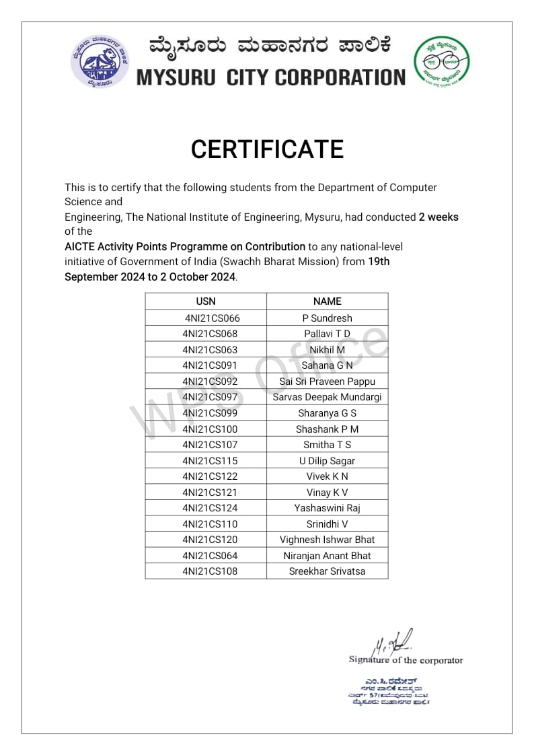


Activity 2

Cleaning Drive
Cleaning Drive
Place: Chamundi Hills and Vidyaranyapuram Park - Mysuru
Date of Activity: Chamundi Hills - November, 2024; Vidyaranyapuram Park – September 2024
In an effort to promote environmental consciousness and contribute towards a cleaner and greener Mysuru, our group of student volunteers organized a large-scale cleaning drive at two significant locations in the city—Chamundi Hills and Vidyaranyapuram Park. This initiative was not just about picking up litter; it was about instilling a sense of responsibility among people regarding waste management and sustainable practices.
Cleaning Drive at Chamundi Hills
Chamundi Hills, a popular spiritual and trekking destination, often sees heavy footfall, leading to a significant amount of waste accumulation along the steps and surrounding areas. On the morning of June 2, 2024, our team, consisting of six to seven enthusiastic students, gathered at the base of the hill. Equipped with gloves, garbage bags, and masks, we divided ourselves into smaller teams and strategically spread out along the staircase leading to the temple.
Our first task was to collect plastic and other non-biodegradable waste that had been discarded by visitors. We carefully picked up plastic bottles, wrappers, and polythene bags that were littered along the 1,000-plus steps. Some of our team members also focused on cleaning up food waste that had attracted stray animals, contributing to unsanitary conditions. As we progressed upwards, we placed signboards at certain points, urging visitors to refrain from littering and to make use of designated dustbins.
Apart from waste collection, we also took a step towards ecological conservation. Carrying small seed saplings with us, we identified barren patches of soil along the steps and planted them in locations where they had the best chance of growing. Our group had learned through online research that planting trees along footpaths and hill steps can help prevent soil erosion and promote biodiversity. We made sure to pour water around the saplings and hoped that the upcoming monsoon showers would aid their growth.
The cleaning drive was not without its challenges. Some areas along the steps were difficult to access due to steep terrain, making it hard to remove deeply embedded trash. Additionally, a few visitors were reluctant to use dustbins even after noticing our efforts. However, by engaging in conversations with passersby and explaining the importance of keeping the hill clean, we managed to raise awareness and even encouraged a few tourists to join us in our activity.
Cleaning Drive at Vidyaranyapuram Park
The second part of our cleaning drive took place at Vidyaranyapuram Park on February 1, 2025. Unlike Chamundi Hills, where the challenge was mainly plastic waste, here, we focused on collecting dry leaves and helping the municipal workers maintain the park’s cleanliness. This activity was particularly significant because Mysuru has long been recognized for its green spaces, and maintaining them requires collective community participation.
We started early in the morning by gathering at the park entrance. Dividing ourselves into teams, some of us raked and collected fallen leaves, while others picked up plastic waste discarded along pathways and near benches. We noticed that the biggest littering issue in the park came from food vendors, as many visitors left behind disposable plates, cups, and straws. To address this, we spoke to a few vendors, requesting them to keep small waste bins next to their stalls and to encourage customers to dispose of trash responsibly.
Another significant challenge we encountered was the presence of mosquitoes and insects in areas where stagnant water had collected. Using brooms, we cleared blocked drains and suggested to the local workers that regular drainage checks could help prevent mosquito breeding. We also interacted with the park maintenance staff and understood that they often struggle with a lack of manpower. This inspired us to pledge future voluntary visits to assist them whenever possible.
To make our cleaning drive more impactful, we planned a small awareness session for morning walkers and visitors. We set up a temporary board displaying information about waste segregation, composting, and the benefits of keeping public spaces clean. Some passersby showed genuine interest and even appreciated our efforts, motivating us further.

Impact and Takeaways
The cleaning drive at Chamundi Hills and Vidyaranyapuram Park was more than just a one-day initiative—it was an experience that left a lasting impression on both our team and the people around us. We realized how much effort goes into maintaining public places and how small actions, like throwing waste in a bin or planting a sapling, can make a significant difference.
One of the biggest takeaways was understanding the role of community engagement. Cleaning drives alone are not enough; the key is to bring about behavioral change in people so that they voluntarily contribute to maintaining cleanliness. We also learned that persistence is essential—despite challenges, such as reluctance from some visitors or difficulties in reaching certain areas, the satisfaction of seeing a cleaner space at the end of the day made all our efforts worthwhile.
Moving forward, we aim to organize similar initiatives and encourage more students to participate. With continuous efforts, we hope to contribute towards making Mysuru not just India’s cleanest city, but also the most environmentally responsible one. This cleaning drive was just the beginning, and we look forward to creating an even bigger impact in the future.

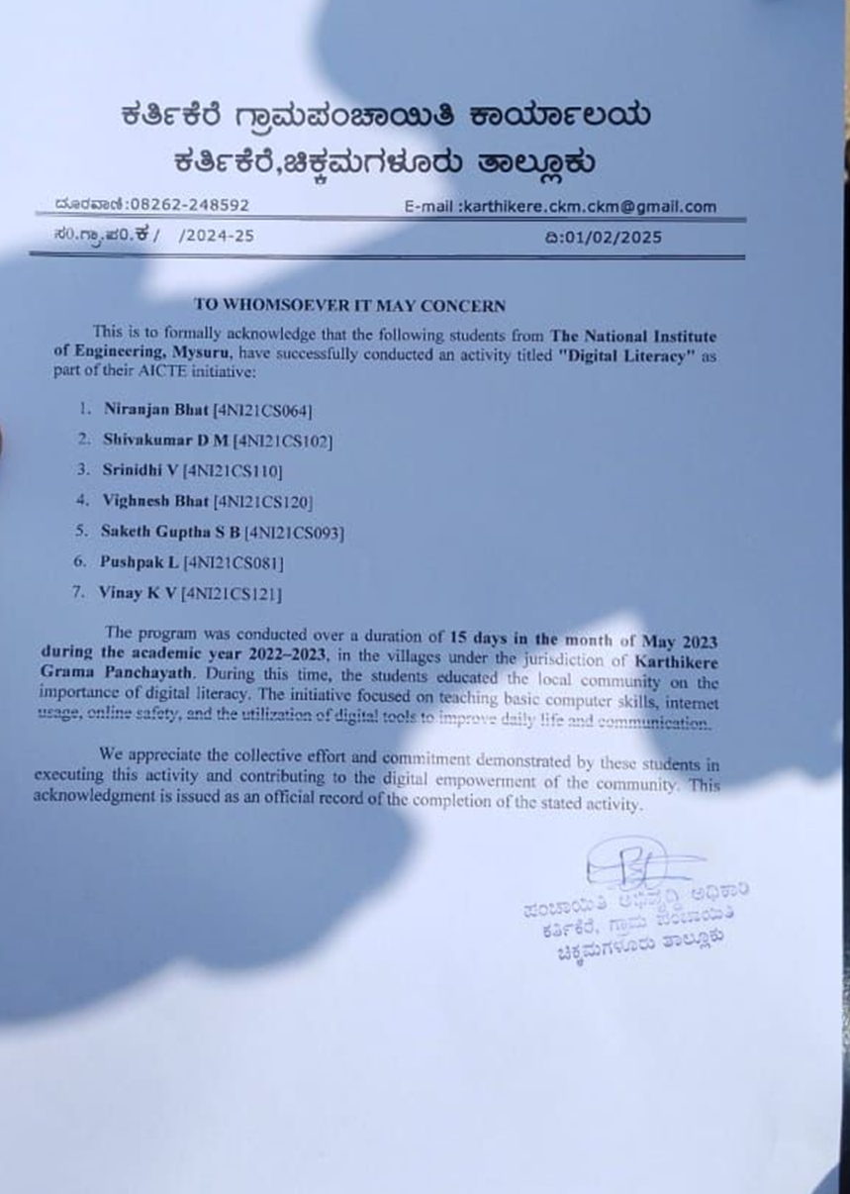

Activity 3

Digital Literacy

Introduction
In today's digital era, financial transactions have rapidly shifted towards cashless methods, making it essential for businesses—both large and small—to adapt to this transformation. Street vendors, who form a significant part of the unorganized sector, often lack awareness and access to digital payment systems. This creates barriers to their financial growth and security. To address this gap, an initiative was undertaken as part of the AICTE Activity Point Programme to educate and equip street vendors with digital literacy skills.
Objective
The primary objective of this initiative was to familiarize street vendors with various digital payment systems and financial tools, enabling them to conduct secure, seamless, and efficient transactions. Additionally, the campaign aimed to build confidence in using digital platforms, enhancing their overall financial inclusion and business sustainability. The initiative sought to bridge the technological divide that often leaves small-scale vendors at a disadvantage in an increasingly cashless society.
Description of the Activity
The digital literacy drive was conducted in Nettekerehalli and Kuruvangi, Chikkamagaluru, in May 2023. The campaign focused on educating street vendors on the benefits of digital transactions, including security, convenience, and efficiency. During the sessions, vendors were introduced to various digital payment applications such as Google Pay, PhonePe, Paytm, and UPI-based transactions.
Students provided hands-on demonstrations, guiding vendors step by step on setting up digital payment accounts, linking their bank accounts, and securely performing transactions. Special emphasis was placed on fraud awareness, ensuring that vendors could recognize and avoid common scams associated with online payments. QR codes were also distributed to help vendors easily integrate digital payment options into their businesses.
The campaign was met with an overwhelmingly positive response, as many vendors expressed interest in adopting digital payments to attract more customers and streamline their transactions. Some vendors, who were previously skeptical of cashless payments, gained confidence through practical demonstrations and real-life success stories shared by their peers. Vendors were also given printed guides in their local language to reinforce learning and serve as a reference for future use.
Moreover, the campaign included interactive Q&A sessions where vendors could raise their concerns about digital transactions. This engagement helped in addressing myths and misconceptions regarding digital payments, allowing vendors to embrace the change with confidence. The initiative also encouraged vendors to spread awareness among their peers, fostering a ripple effect that could extend financial literacy to a broader audience.
Impact and Learnings
Increased Awareness: Many vendors who had never used digital transactions before gained a fundamental understanding of their benefits. This newfound awareness played a crucial role in shifting their perspective towards modern financial tools.
Practical Implementation: Vendors actively set up digital payment systems with the assistance of student volunteers. Hands-on experience helped vendors overcome hesitation and technical difficulties.
Financial Inclusion: By embracing digital payments, vendors improved their business efficiency, reducing dependency on cash and minimizing risks associated with theft and counterfeit currency. This integration not only made their businesses more secure but also expanded their customer base, as more customers prefer cashless transactions.
Security and Fraud Prevention: Vendors learned best practices to protect themselves from online scams and financial fraud. They were educated on identifying phishing scams, fake calls, and fraudulent messages that could compromise their financial security.
Economic Growth and Adaptability: By integrating digital payment systems, vendors became more competitive in a changing economic landscape. They could now participate in government initiatives promoting digital transactions and benefit from financial schemes available to small businesses using digital platforms
.
Conclusion
This initiative not only empowered street vendors with essential digital literacy skills but also provided students with an opportunity to engage with the community in a meaningful way. The program successfully bridged the gap between technology and accessibility, reinforcing the significance of digital financial inclusion in today’s economy. By equipping small-scale businesses with the necessary tools to thrive in a digital world, this campaign contributed to their economic sustainability and long-term growth.
Additionally, the experience enriched the participating students, fostering a sense of social responsibility and leadership skills essential for their holistic development. The success of this initiative highlights the importance of continued efforts in promoting digital literacy and financial inclusion. Future campaigns can build on this foundation by introducing more advanced financial tools, expanding outreach to a wider vendor community, and collaborating with financial institutions to offer customized digital solutions for small businesses.
Through consistent efforts, such initiatives can lead to a digitally empowered society where financial technology is accessible to everyone, regardless of their socio-economic background. As digital transactions become the norm, ensuring that no one is left behind in this transformation remains a crucial step toward inclusive economic development
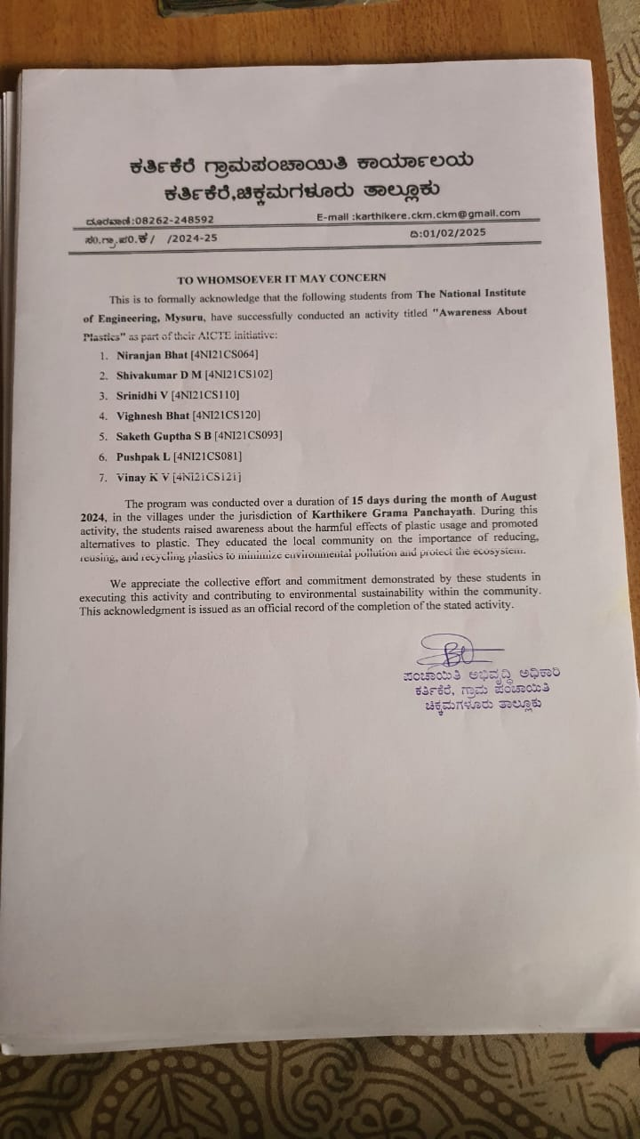

Activity 4

Plastic Awareness
Introduction
Plastic pollution has become one of the most pressing environmental issues, particularly in rural and semi-urban areas where waste management infrastructure is limited. Single-use plastic bags, which are widely used by street vendors, contribute significantly to this problem, leading to environmental degradation and health hazards. To address this challenge, a plastic awareness drive was organized in Bandihalli and Chikkanahalli, Chikkamagaluru, in August 2024 as part of the AICTE Activity Point Programme. This initiative aimed to educate street vendors about the harmful effects of plastic waste and encourage them to adopt sustainable alternatives such as cloth and paper bags.
Objective
The primary objective of this awareness drive was to promote eco-friendly practices among street vendors by reducing their dependence on single-use plastics. The campaign aimed to:
- Educate vendors about the environmental impact of plastic pollution.
- Provide viable and affordable alternatives to plastic bags.
- Encourage behavioral change by demonstrating the benefits of sustainable practices.
- Address common challenges vendors face in switching to alternative materials.
Description of the Activity
The awareness campaign took place over two days, where volunteers visited various vendor stalls in Bandihalli and Chikkanahalli to engage directly with the local sellers. The activity included the following key components:
1. Interactive Awareness Sessions:
- Volunteers conducted short sessions at vendor marketplaces, explaining how plastic waste affects the environment, soil quality, and local water bodies.
- Practical demonstrations were used to showcase how non-biodegradable plastic remains in the environment for hundreds of years, leading to pollution and harm to wildlife.
- Vendors were shown simple and cost-effective ways to transition to cloth or paper bags without impacting their daily business operations.
2. Distribution of Eco-Friendly Bags:
- To facilitate an easy shift away from plastic, volunteers distributed reusable cloth bags to vendors, emphasizing their durability and reusability.

- Local tailoring units were involved in supplying the cloth bags, thereby supporting local businesses while promoting sustainability.
- Vendors were encouraged to offer cloth bags to their customers and charge a nominal fee to cover the costs, making the switch economically feasible.
3. Addressing Practical Challenges:
- Many vendors raised concerns about the affordability and availability of alternatives to plastic bags.
- Volunteers provided information about government schemes that support small businesses in adopting sustainable practices.
- Vendors were informed about wholesale suppliers who provide bulk eco-friendly bags at lower prices, making it easier for them to transition.
4. Engagement with the Community:
- Customers visiting the vendor stalls were also educated about the importance of avoiding plastic bags and encouraged to carry their own reusable bags.
- Posters and flyers were distributed in local languages, reinforcing the key messages of the campaign.
Challenges Faced and Solutions Implemented
During the campaign, several challenges were encountered:
- Resistance to Change: Some vendors were initially reluctant to switch to cloth bags due to concerns about cost and customer acceptance. To address this, volunteers demonstrated the long-term cost savings of reusable bags compared to plastic bags, which need frequent replenishment.
- Limited Awareness: Many vendors were unaware of the harmful effects of plastic and had never considered alternatives. Educational videos and real-life case studies were shared to create awareness and inspire change.
- Economic Constraints: Small vendors often operate on thin profit margins, making it difficult for them to invest in eco-friendly alternatives. The initiative included information on affordable bulk purchases and partnerships with NGOs that provide subsidized cloth bags to small vendors.
Impact and Learnings
- Positive Response: Many vendors expressed willingness to reduce their use of plastic bags after understanding their environmental impact.
- Practical Implementation: Several vendors started using cloth bags immediately after the session and encouraged their customers to do the same.Community Involvement: The campaign inspired local shop owners and residents to take part in reducing plastic waste, leading to a broader impact beyond just the vendors.
- Long-Term Awareness: By distributing printed guides and posters, the campaign ensured that vendors could continue educating themselves and their customers about plastic pollution.
Conclusion
The plastic awareness drive was a significant step towards fostering sustainable practices among street vendors in Bandihalli and Chikkanahalli. Through interactive discussions, hands-on demonstrations, and practical solutions, vendors were empowered to make environmentally responsible choices.
This initiative not only contributed to environmental conservation but also created a sense of social responsibility among the students involved. It provided them with firsthand experience in community engagement, problem-solving, and leadership.
Future efforts can build upon this initiative by collaborating with local governing bodies to implement stricter regulations on plastic use and providing financial incentives for businesses that adopt eco-friendly alternatives. By continuing such awareness drives, we can collectively work towards a cleaner, healthier, and more sustainable environment.
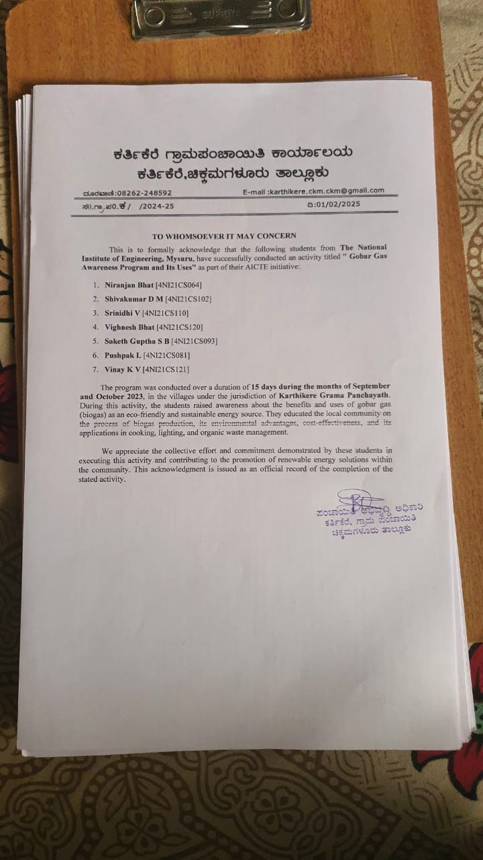

Activity 5

Gobar Gas Awareness
Introduction
Biogas, commonly known as Gobar gas, is a renewable and cost-effective alternative to traditional cooking fuels like firewood and LPG. Despite its potential, many livestock owners in rural areas are unaware of its benefits due to lack of information and misconceptions about its implementation. In an effort to bridge this knowledge gap, a Gobar gas awareness campaign was conducted in Bandihalli and Chikkanahalli, Chikkamagaluru, in September - October 2023. Unlike expert-led programs, this initiative was driven entirely by a group of six to seven students who, after gathering information from online sources like government websites, YouTube tutorials, and research articles, set out to educate livestock owners on the practicality of biogas usage.
Objective
The campaign aimed to:
- Educate livestock owners on how Gobar gas can serve as a sustainable energy source for cooking and heating.
- Provide cost comparisons between traditional fuels (firewood, LPG) and Gobar gas to highlight long-term savings.
- Raise awareness about the negative impact of firewood usage, such as deforestation and indoor air pollution.
- Inform farmers about government subsidies and financial support available for biogas plant installations.
Description of the Activity
Our student group planned a structured approach to effectively communicate the advantages of Gobar gas to livestock owners. The campaign involved the following activities:
- On-the-Field Demonstrations and Simplified Explanations:
- Since most farmers had never seen a biogas plant in operation, we used printed diagrams and phone-based video tutorials to visually explain the process.
- Using simple terms, we described how cow dung is converted into methane gas through anaerobic digestion, which can then be used for cooking, heating, and even electricity generation.
2. Cost Comparisons and Practical Feasibility:
- One of the key aspects of our discussions was the economic advantage of Gobar gas. Farmers were shown a breakdown of monthly fuel expenses for LPG and firewood versus the one-time cost of setting up a small biogas plant.
- By calculating an estimated payback period, we demonstrated how a Gobar gas system would start saving money in as little as two years.
- A few farmers expressed concern about maintenance, so we explained how once the system is set up, it requires minimal upkeep, mainly adding dung and occasional cleaning.
3. Environmental and Health Awareness:
- Many farmers rely on firewood for cooking, unaware of its harmful impact on their health and the environment. We explained how indoor air pollution from firewood smoke contributes to respiratory diseases, particularly among women who do most of the cooking.
- The dangers of deforestation were also highlighted, showing how excessive firewood usage contributes to climate change and soil degradation.
- To make the message more relatable, we cited real-life examples from other villages that successfully adopted Gobar gas and improved their living conditions.
4. Government Subsidy Information:
- Farmers were often unaware that government schemes offer subsidies for setting up biogas plants. We provided information on relevant programs and how they could apply for financial assistance.
- Contact details of local agencies and government bodies were shared to help interested livestock owners take the next step.
Challenges Faced and Learnings
While the campaign was well-received, we encountered several challenges:
- Skepticism from Farmers: Many were hesitant to believe that a system fueled by cow dung could provide reliable energy. Some thought it would produce an unpleasant smell, requiring additional clarifications from our side.
- Financial Concerns: Even with subsidies, some farmers found the initial setup cost daunting. To address this, we emphasized community-based biogas plants, where multiple households could share one system.
- Lack of Technical Knowledge: Some farmers showed interest but were unsure how to construct and maintain a biogas plant. While we couldn’t offer hands-on guidance, we directed them to government training programs that provide technical assistance.
Conclusion
Despite these challenges, the awareness campaign successfully sparked interest in Gobar gas as a sustainable energy solution among livestock owners in Bandihalli and Chikkanahalli. Through simplified explanations, cost-benefit analyses, and real-life success stories, we were able to convince many farmers of its long-term advantages.
This initiative also reinforced the importance of self-driven community education. As students, we may not have been experts, but our research, enthusiasm, and structured approach enabled us to create a meaningful impact. With continued awareness efforts and government support, rural households can gradually transition towards cleaner and more efficient energy sources, improving both economic stability and environmental sustainability
Conclusion

The AICTE Activity Point Programme has proven to be a transformative initiative that goes beyond the conventional focus on academic excellence, encouraging students to engage in activities that foster their overall development. By emphasizing the importance of soft skills, leadership, teamwork, and societal responsibility, the program has offered students a well-rounded approach to personal and professional growth. Through various impactful activities—such as teaching mathematics in government schools, environmental awareness campaigns, digital literacy programs, and promoting sustainable practices—students have had the chance to apply their academic knowledge in real-world scenarios while simultaneously making a positive impact on their communities.
The initiative has also helped bridge the gap between theoretical learning and practical application, preparing students to face the challenges of the professional world with confidence and a sense of purpose. Moreover, by engaging in these activities, students have cultivated essential life skills, including communication, problem-solving, and critical thinking, which will serve them well in their future endeavors. The AICTE Activity Point Programme has not only instilled a sense of civic duty in its participants but also equipped them with the tools to contribute meaningfully to societal development.
In conclusion, the program stands as a testament to the power of holistic education, fostering well-rounded individuals who are not only academically competent but also socially conscious and ready to take on leadership roles in both professional and community settings. It is a commendable step toward creating a generation of students who are empowered to make a lasting difference in the world around them.

Photos

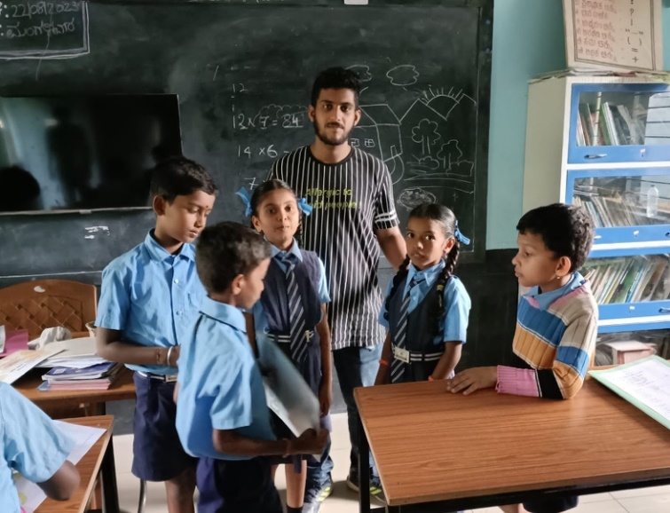
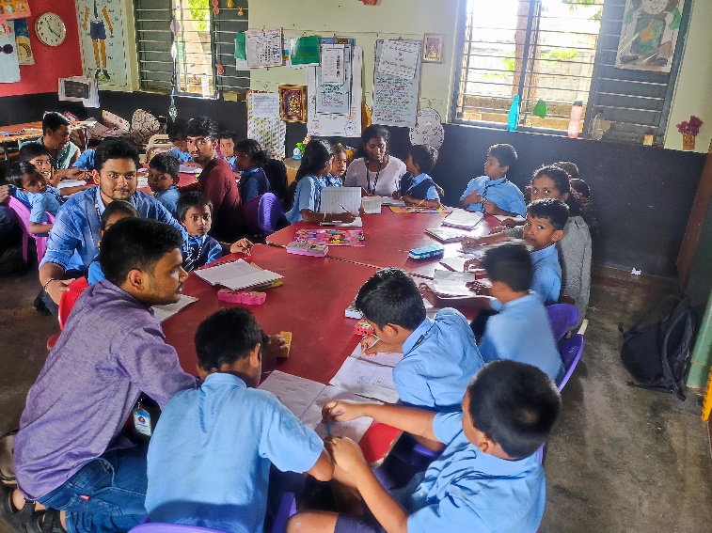
Activity 1
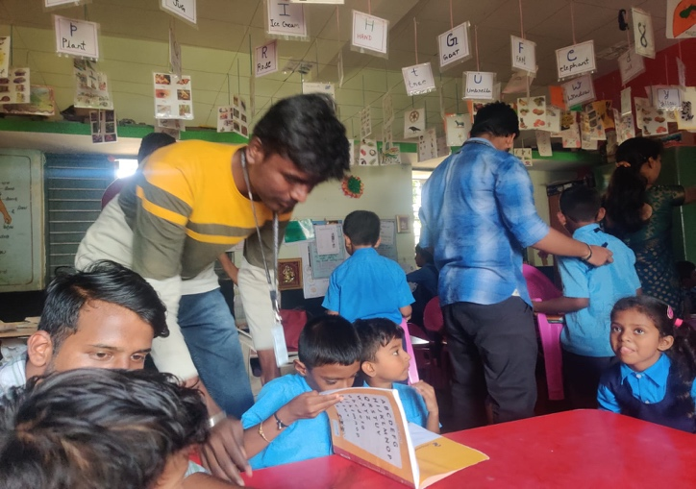
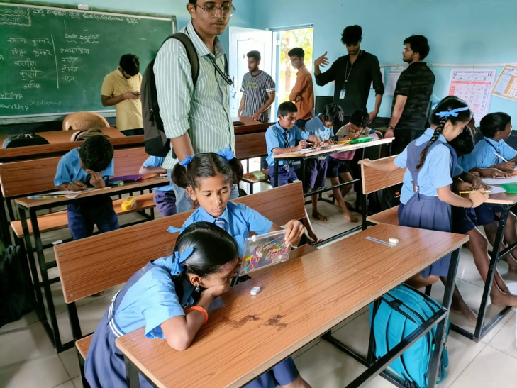
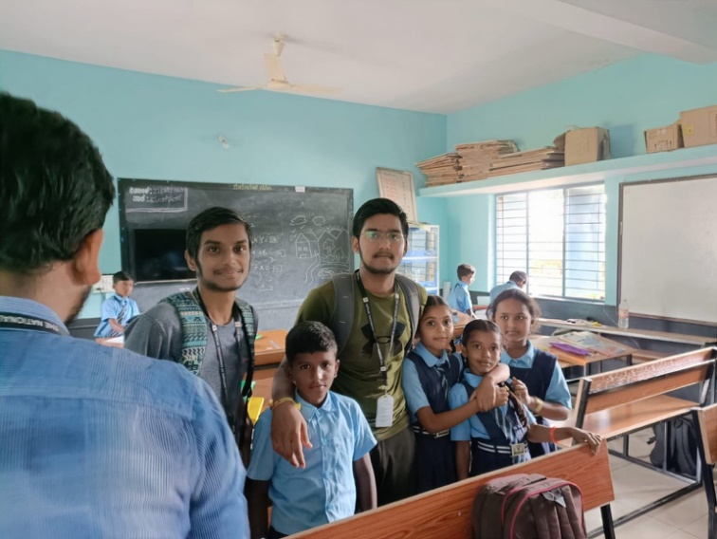
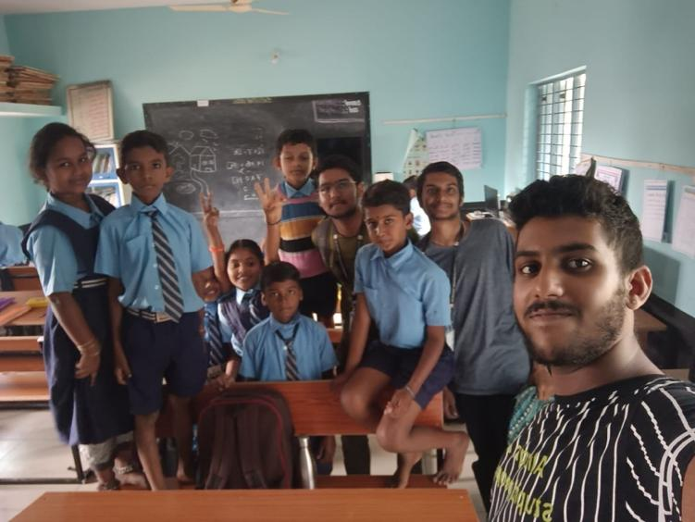

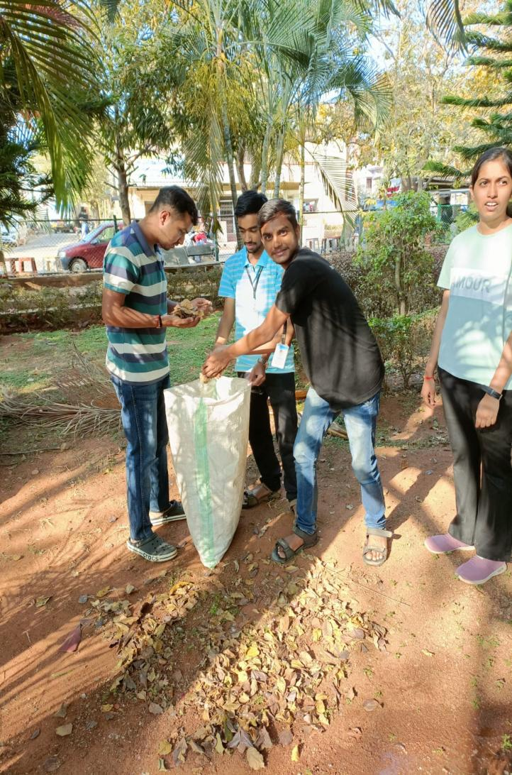
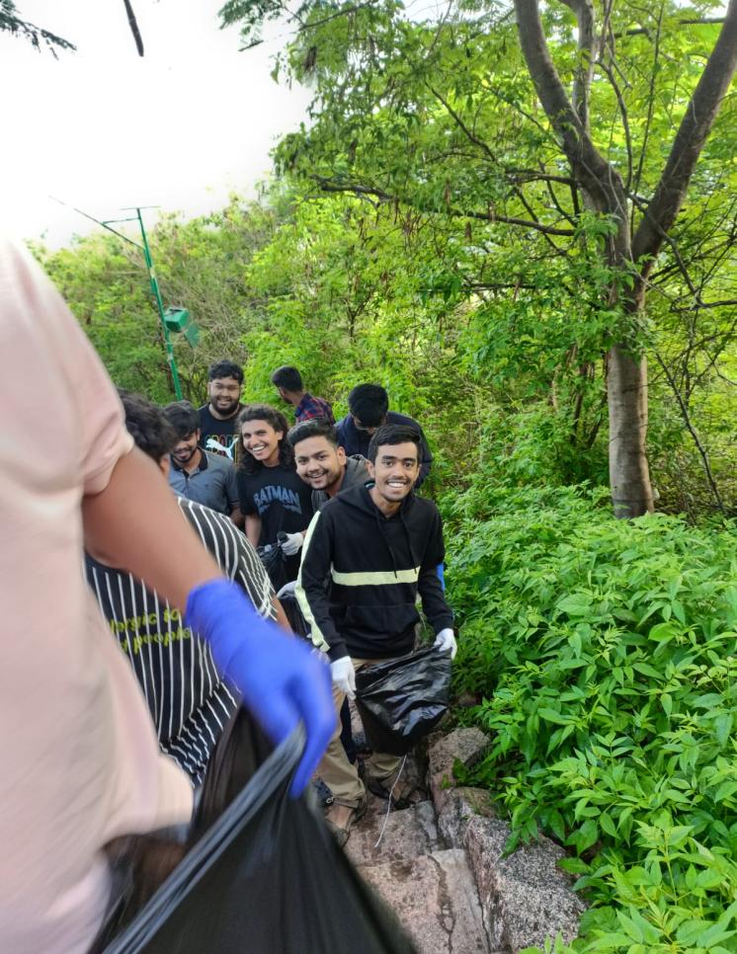
Activity 2
