Brief Details

Terraform VM > creates bastion-vm, jenkins-vm and app-vm
bastionvm > install ansible
proxy jump from Terraform-vm to jenkins-vm with bastion-vm as proxy
proxy jump from Terraform-vm to app-vm with bastion-vm as proxy

Task and Subtask Screenshot in SS folder
All task instruction in README.md for detailed instructions # read this file on github as formatted in Markdown

Architecture
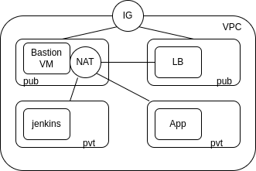

Jenkins console
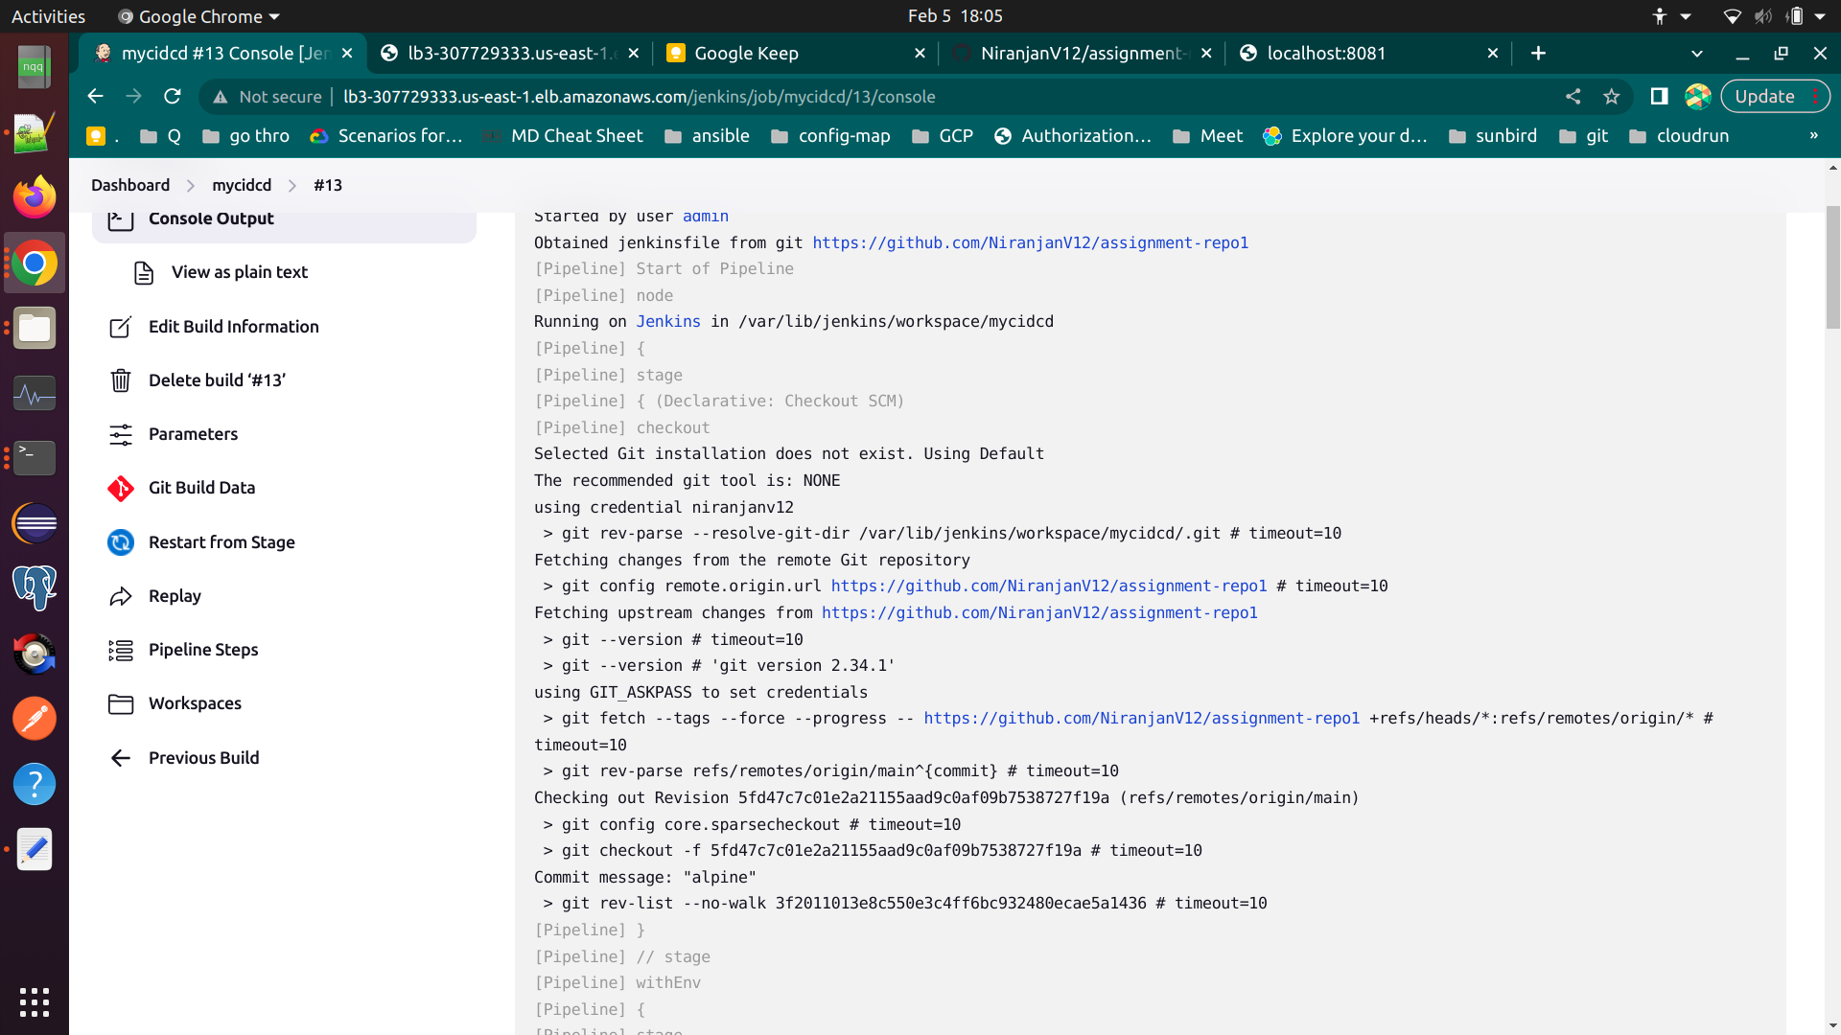

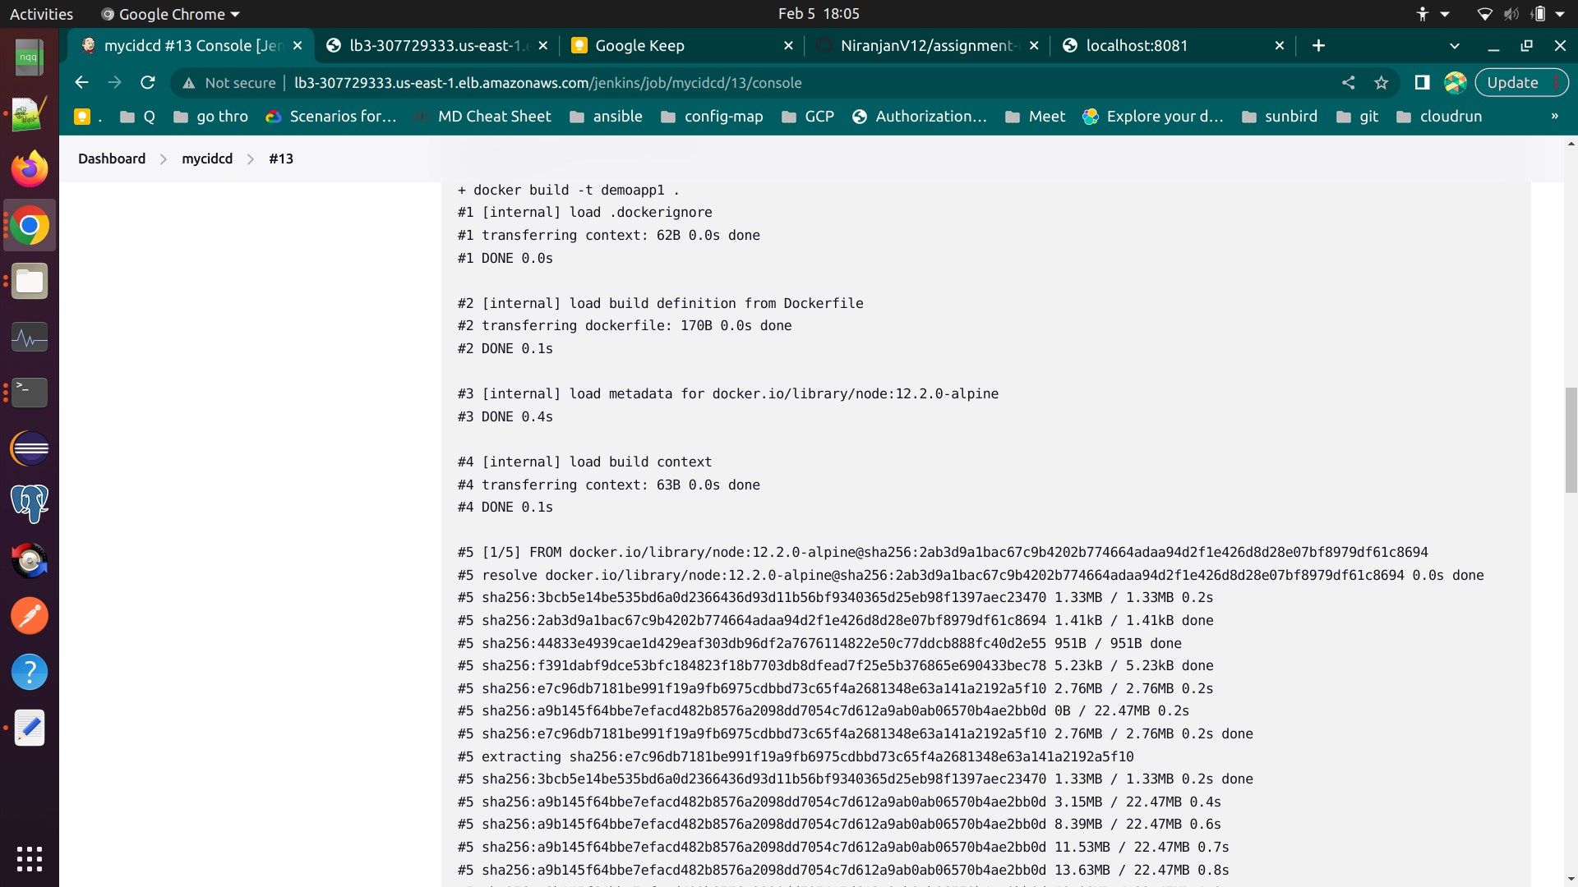
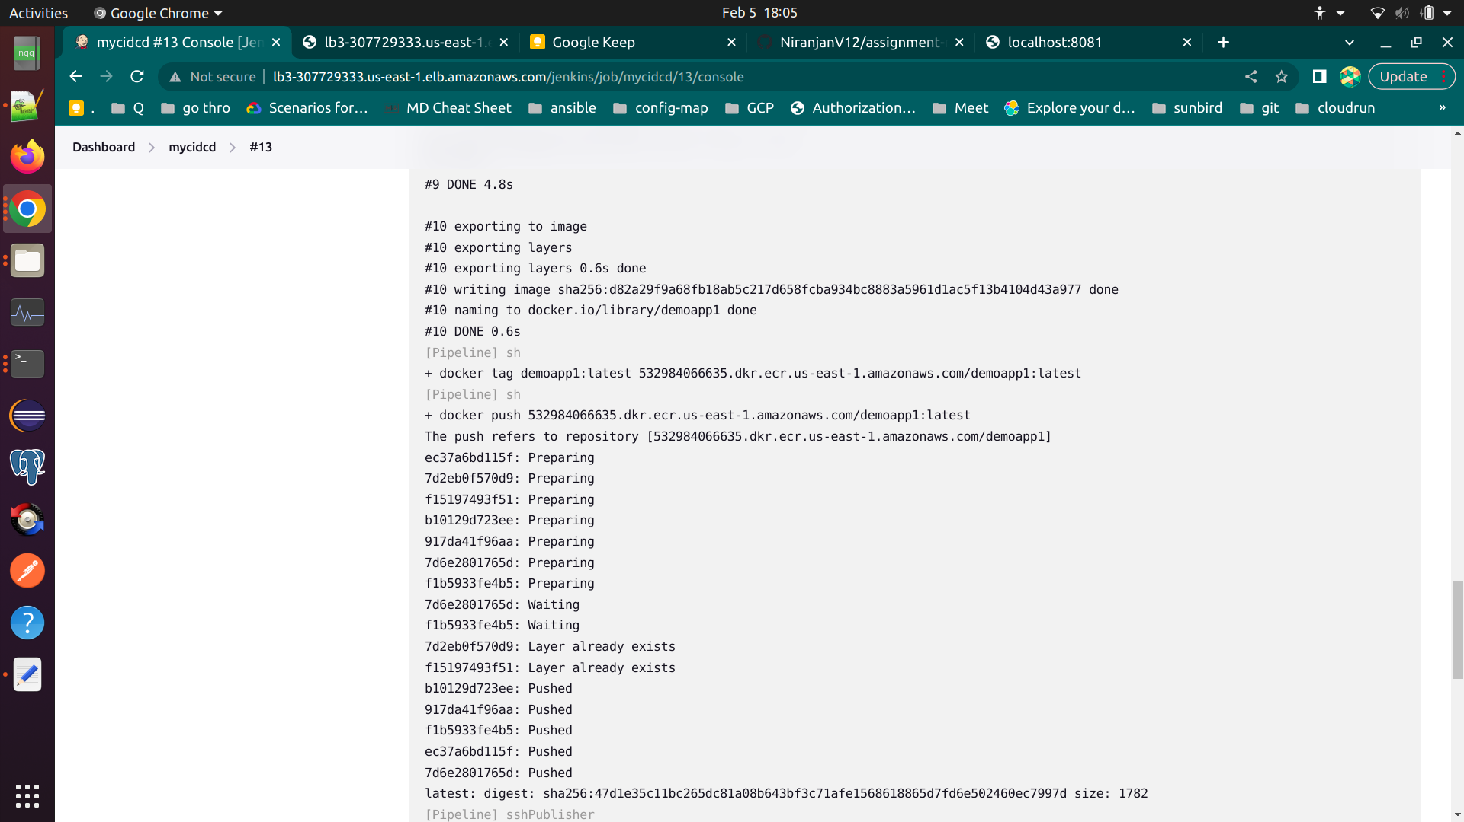

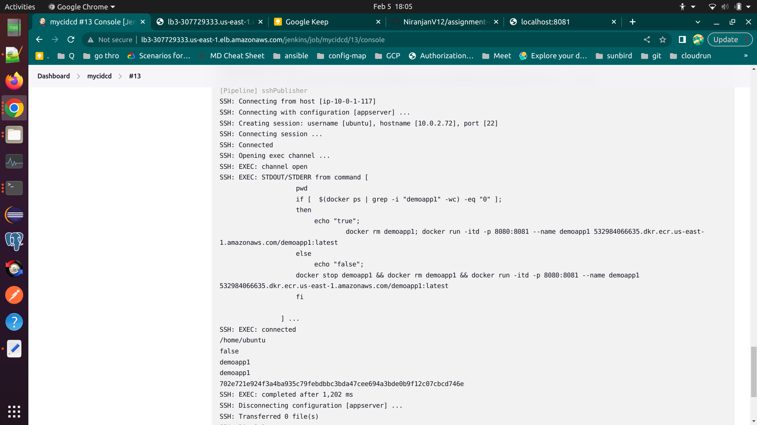

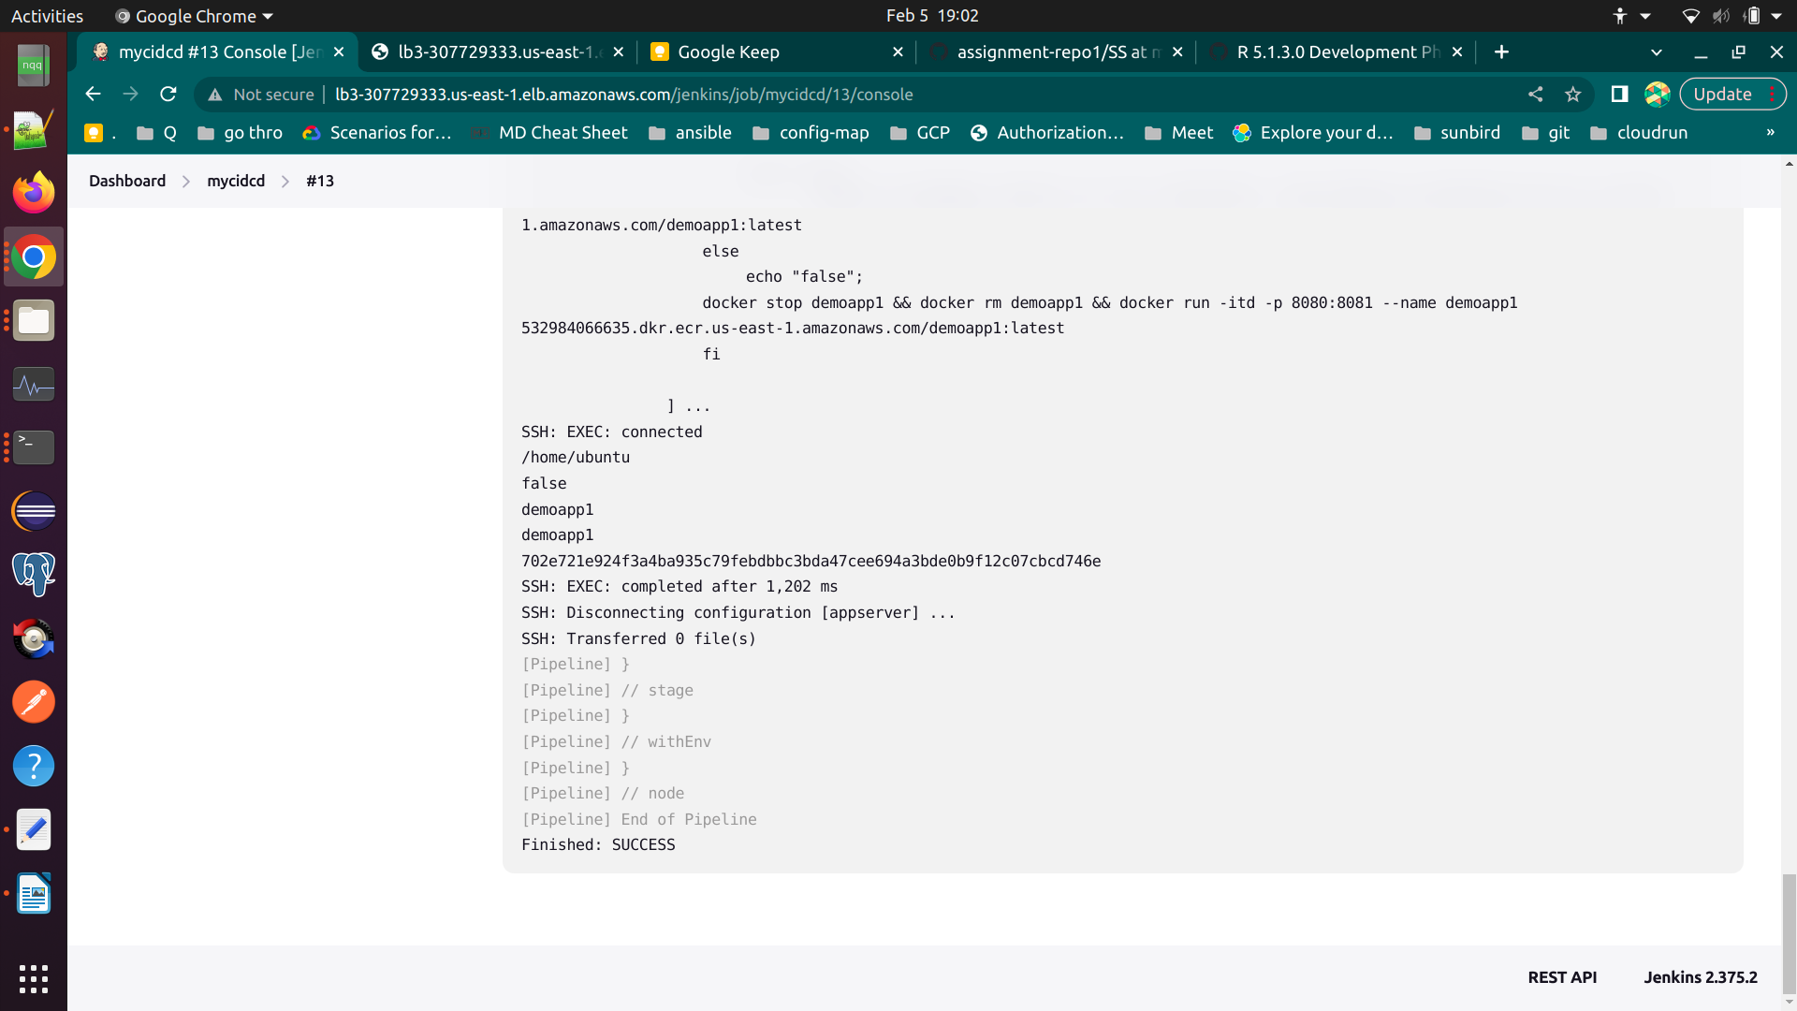

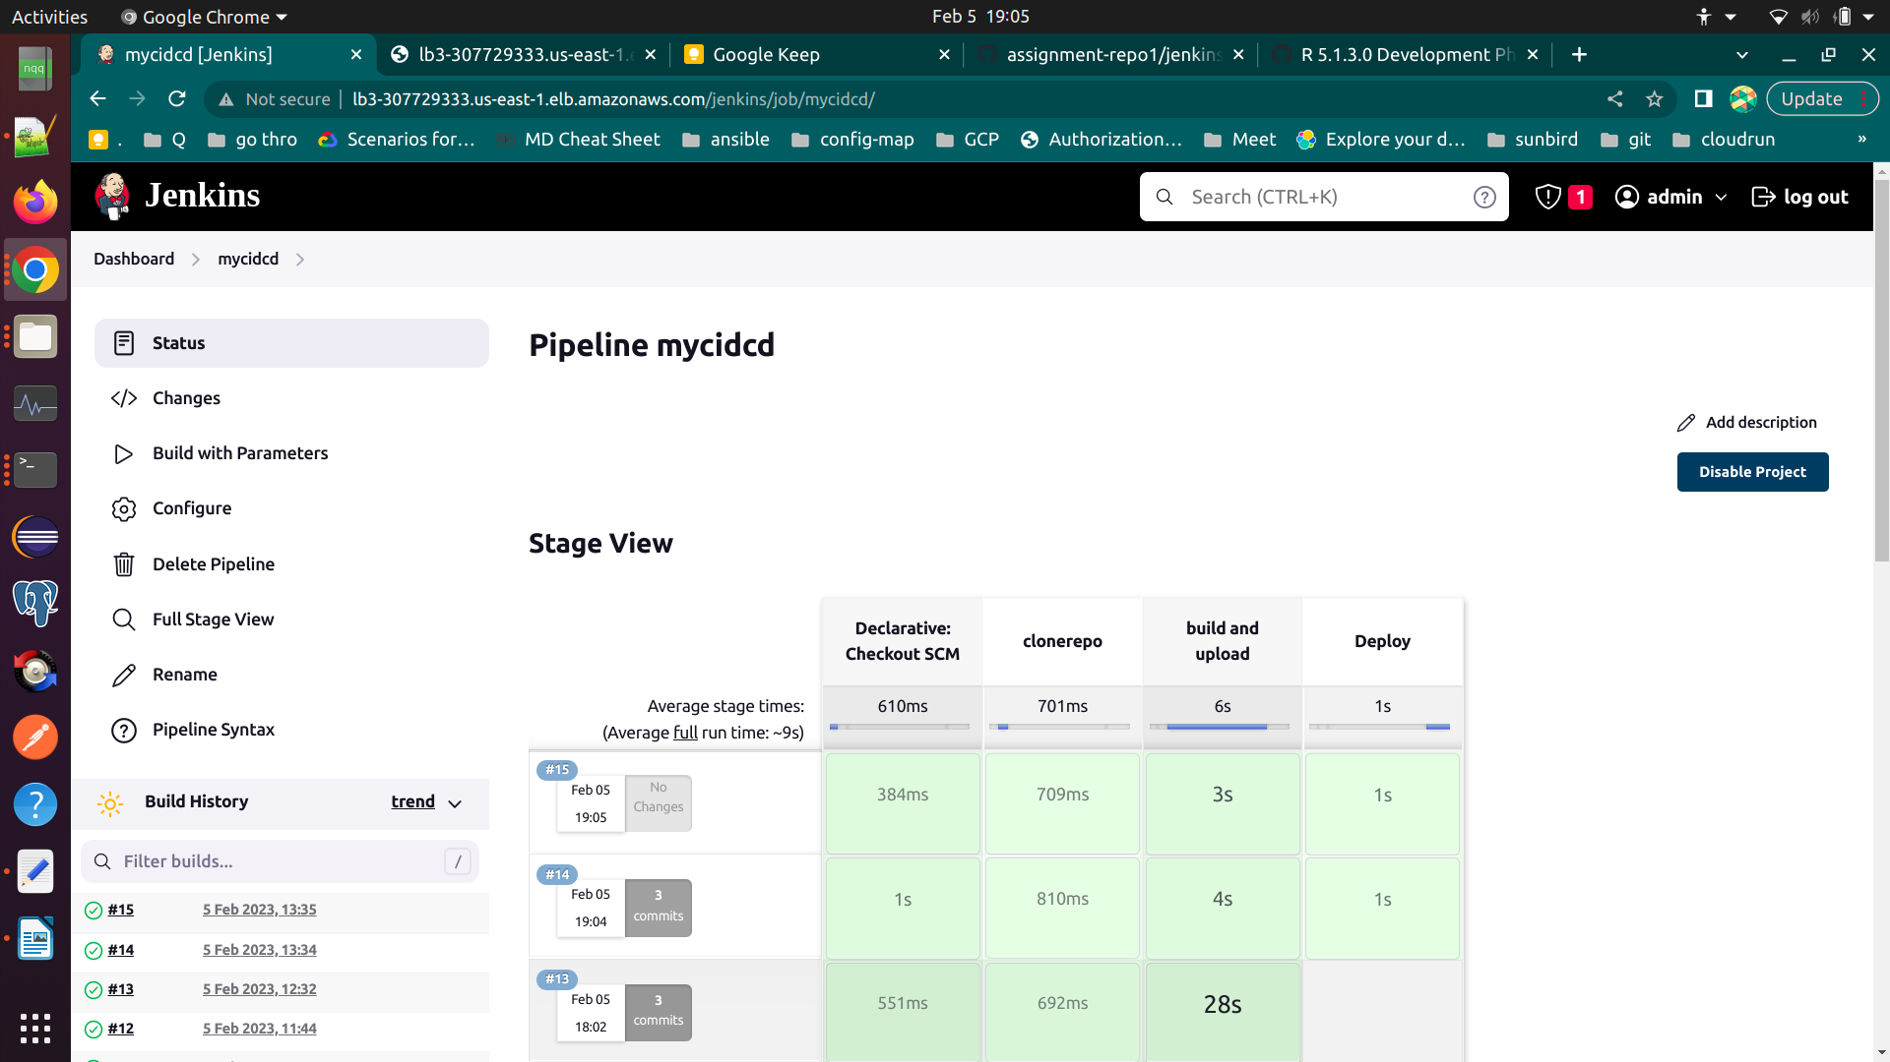

a
sa
s
a
sa

