**Name: Niranjan Vinod Patil.**

**Roll No: SCSB307.**

**Practical Assignment No: 5A.**

**Write a stored procedure which will read the amount and department name and updates the salary of each employee in that department by adding specified amount to his/her salary.**

**Solution:**

DECLARE

e_amount employees.salary % type;

d_name departments.department_name % type;

de_name departments.department_name % type;

e_fname employees.first_name % type;

e_salary employees.salary % type;

procedure update_sal(amount IN employees.salary % type, d_name IN departments.department_name % type)

is

cursor my_curs is select employees.first_name,departments.department_name,employees.salary from employees,departments where departments.department_name = d_name;

BEGIN

open my_curs;

LOOP

FETCH my_curs into e_fname,de_name,e_salary;

EXIT WHEN my_curs%notfound;

e_salary:=e_salary+amount;

dbms_output.put_line( ' ' ||e_fname || ' ' || ''|| de_name ||

' ' || e_salary);

END LOOP;

CLOSE my_curs;

END;

BEGIN

e_amount:=& e_amount;

d_name:=& d_name;

update_sal(e_amount,d_name);

dbms_output.put_line('EnDDDDDDDD');

END;

/

**Screenshot:**

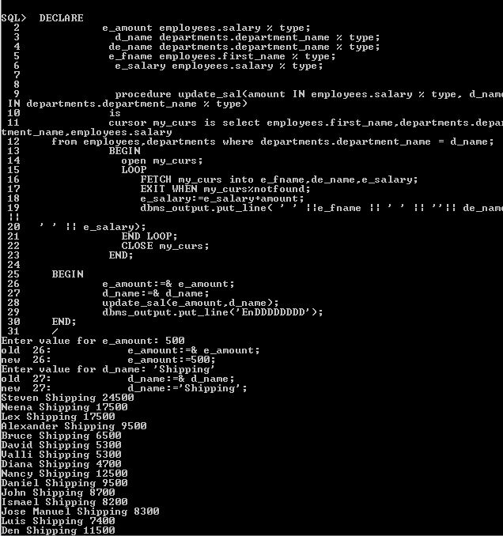

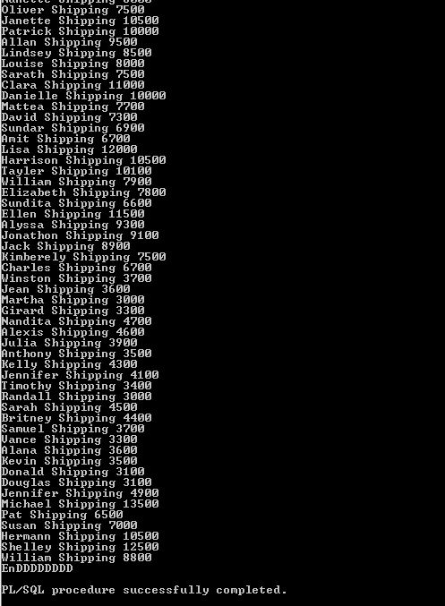

**OUTPUT:**

SQL> select employees.first_name,departments.department_name,employees.salary

2 from employees,departments where departments.department_name = 'Sales';

FIRST_NAME DEPARTMENT_NAME SALARY

-------------------- ------------------------------ ----------

Steven Sales 24000

Neena Sales 17000

Lex Sales 17000

Alexander Sales 9000

Bruce Sales 6000

David Sales 4800

Valli Sales 4800

Diana Sales 4200

Nancy Sales 12000

Daniel Sales 9000

John Sales 8200

FIRST_NAME DEPARTMENT_NAME SALARY

-------------------- ------------------------------ ----------

Ismael Sales 7700

Jose Manuel Sales 7800

Luis Sales 6900

Den Sales 11000

Alexander Sales 3100

Shelli Sales 2900

Sigal Sales 2800

Guy Sales 2600

Karen Sales 2500

Matthew Sales 8000

Adam Sales 8200

FIRST_NAME DEPARTMENT_NAME SALARY

-------------------- ------------------------------ ----------

Payam Sales 7900

Shanta Sales 6500

Kevin Sales 5800

Julia Sales 3200

Irene Sales 2700

James Sales 2400

Steven Sales 2200

Laura Sales 3300

Mozhe Sales 2800

James Sales 2500

TJ Sales 2100

FIRST_NAME DEPARTMENT_NAME SALARY

-------------------- ------------------------------ ----------

Jason Sales 3300

Michael Sales 2900

Ki Sales 2400

Hazel Sales 2200

Renske Sales 3600

Stephen Sales 3200

John Sales 2700

Joshua Sales 2500

Trenna Sales 3500

Curtis Sales 3100

Randall Sales 2600

FIRST_NAME DEPARTMENT_NAME SALARY

-------------------- ------------------------------ ----------

Peter Sales 2500

John Sales 14000

Karen Sales 13500

Alberto Sales 12000

Gerald Sales 11000

Eleni Sales 10500

Peter Sales 10000

David Sales 9500

Peter Sales 9000

Christopher Sales 8000

Nanette Sales 7500

FIRST_NAME DEPARTMENT_NAME SALARY

-------------------- ------------------------------ ----------

Oliver Sales 7000

Janette Sales 10000

Patrick Sales 9500

Allan Sales 9000

Lindsey Sales 8000

Louise Sales 7500

Sarath Sales 7000

Clara Sales 10500

Danielle Sales 9500

Mattea Sales 7200

David Sales 6800

FIRST_NAME DEPARTMENT_NAME SALARY

-------------------- ------------------------------ ----------

Sundar Sales 6400

Amit Sales 6200

Lisa Sales 11500

Harrison Sales 10000

Tayler Sales 9600

William Sales 7400

Elizabeth Sales 7300

Sundita Sales 6100

Ellen Sales 11000

Alyssa Sales 8800

Jonathon Sales 8600

FIRST_NAME DEPARTMENT_NAME SALARY

-------------------- ------------------------------ ----------

Jack Sales 8400

Kimberely Sales 7000

Charles Sales 6200

Winston Sales 3200

Jean Sales 3100

Martha Sales 2500

Girard Sales 2800

Nandita Sales 4200

Alexis Sales 4100

Julia Sales 3400

Anthony Sales 3000

FIRST_NAME DEPARTMENT_NAME SALARY

-------------------- ------------------------------ ----------

Kelly Sales 3800

Jennifer Sales 3600

Timothy Sales 2900

Randall Sales 2500

Sarah Sales 4000

Britney Sales 3900

Samuel Sales 3200

Vance Sales 2800

Alana Sales 3100

Kevin Sales 3000

Donald Sales 2600

FIRST_NAME DEPARTMENT_NAME SALARY

-------------------- ------------------------------ ----------

Douglas Sales 2600

Jennifer Sales 4400

Michael Sales 13000

Pat Sales 6000

Susan Sales 6500

Hermann Sales 10000

Shelley Sales 12000

William Sales 8300

107 rows selected.

SQL> DECLARE

2 e_amount employees.salary % type;

3 d_name departments.department_name % type;

4 de_name departments.department_name % type;

5 e_fname employees.first_name % type;

6 e_salary employees.salary % type;

7

8

9 procedure update_sal(amount IN employees.salary % type, d_name IN

departments.department_name % type)

10 is

11 cursor my_curs is select employees.first_name,departments.departme

nt_name,employees.salary

12 from employees,departments where departments.department_name = d_name;

13 BEGIN

14 open my_curs;

15 LOOP

16 FETCH my_curs into e_fname,de_name,e_salary;

17 EXIT WHEN my_curs%notfound;

18 e_salary:=e_salary+amount;

19 dbms_output.put_line( ' ' ||e_fname || ' ' || ''|| de_name ||

' ' || e_salary);

20 END LOOP;

21 CLOSE my_curs;

22 END;

23

24 BEGIN

25 e_amount:=& e_amount;

26 d_name:=& d_name;

27 update_sal(e_amount,d_name);

28 dbms_output.put_line('EnDDDDDDDD');

29 END;

30 /

Enter value for e_amount: 500

old 25: e_amount:=& e_amount;

new 25: e_amount:=500;

Enter value for d_name: 'Sales'

old 26: d_name:=& d_name;

new 26: d_name:='Sales';

Steven Sales 24500

Neena Sales 17500

Lex Sales 17500

Alexander Sales 9500

Bruce Sales 6500

David Sales 5300

Valli Sales 5300

Diana Sales 4700

Nancy Sales 12500

Daniel Sales 9500

John Sales 8700

Ismael Sales 8200

Jose Manuel Sales 8300

Luis Sales 7400

Den Sales 11500

Alexander Sales 3600

Shelli Sales 3400

Sigal Sales 3300

Guy Sales 3100

Karen Sales 3000

Matthew Sales 8500

Adam Sales 8700

Payam Sales 8400

Shanta Sales 7000

Kevin Sales 6300

Julia Sales 3700

Irene Sales 3200

James Sales 2900

Steven Sales 2700

Laura Sales 3800

Mozhe Sales 3300

James Sales 3000

TJ Sales 2600

Jason Sales 3800

Michael Sales 3400

Ki Sales 2900

Hazel Sales 2700

Renske Sales 4100

Stephen Sales 3700

John Sales 3200

Joshua Sales 3000

Trenna Sales 4000

Curtis Sales 3600

Randall Sales 3100

Peter Sales 3000

John Sales 14500

Karen Sales 14000

Alberto Sales 12500

Gerald Sales 11500

Eleni Sales 11000

Peter Sales 10500

David Sales 10000

Peter Sales 9500

Christopher Sales 8500

Nanette Sales 8000

Oliver Sales 7500

Janette Sales 10500

Patrick Sales 10000

Allan Sales 9500

Lindsey Sales 8500

Louise Sales 8000

Sarath Sales 7500

Clara Sales 11000

Danielle Sales 10000

Mattea Sales 7700

David Sales 7300

Sundar Sales 6900

Amit Sales 6700

Lisa Sales 12000

Harrison Sales 10500

Tayler Sales 10100

William Sales 7900

Elizabeth Sales 7800

Sundita Sales 6600

Ellen Sales 11500

Alyssa Sales 9300

Jonathon Sales 9100

Jack Sales 8900

Kimberely Sales 7500

Charles Sales 6700

Winston Sales 3700

Jean Sales 3600

Martha Sales 3000

Girard Sales 3300

Nandita Sales 4700

Alexis Sales 4600

Julia Sales 3900

Anthony Sales 3500

Kelly Sales 4300

Jennifer Sales 4100

Timothy Sales 3400

Randall Sales 3000

Sarah Sales 4500

Britney Sales 4400

Samuel Sales 3700

Vance Sales 3300

Alana Sales 3600

Kevin Sales 3500

Donald Sales 3100

Douglas Sales 3100

Jennifer Sales 4900

Michael Sales 13500

Pat Sales 6500

Susan Sales 7000

Hermann Sales 10500

Shelley Sales 12500

William Sales 8800

EnDDDDDDDD

PL/SQL procedure successfully completed.

SQL>