

INTERNSHIP REPORT



EncureIT Systems Pvt. Ltd

Submitted By

Niranjan Vinod Patil
S174083.
0120160134.

DEPARTMENT OF COMPUTER ENGINEERING
MIT ACADEMY OF ENGINEERING
ALANDI (D), PUNE

DEPARTMENT OF COMPUTER ENGINEERING

CERTIFICATE

This is to certify that the “Internship report” submitted by Mast. Niranjan Vinod Patil. PRN. No.: 0120160134 and Examination Seat No.: S174083 is work done by him/her and submitted during 2017 – 2018 academic year.

Mentor for Internship Department Internship Coordinator
(Mr. Rudragouda Patil) (Mrs. R. R. Badre)

Institute Internship Coordinator Head of the Department
(Mrs. R. R. Badre) (Dr. Shitalkumar A. Jain)

Internship certificate provided by the internship institution



Date: 14^{h} July 2018

TO WHOM IT MAY CONCERN

This is to certify that Mast. Niranjan Patil S/o Mr. Vinod Patil was is our organization as Intern from 4th June 2018 to 14th July 2018 for training of Software Development. He is student in MITAOE, Alandi, Pune. During this period, he was involved in training in software development.
We wish Mast. Niranjan a bright future.

For EncureIT Systems Private Limited
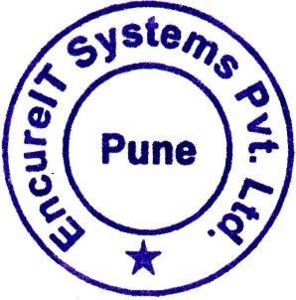
Gaurav Parakh
Organization Chief



ACKNOWLEDGEMENT

I, Mr. Niranjan Vinod Patil the student of Computer Engineering Department at MIT Academy of Engineering Pune (An Autonomous Institute), has been completed Summer Internship in “EncureIT Systems Pvt. Ltd.”.
I take this opportunity to record my profound gratitude and indebtedness to Mr. Ajit Pawar, Mr. Harshad Pawar and Mr. Aflak Arshi Employees, EncureIT Systems Pvt. Ltd, for their inspiring guidance, valuable advices, constant encouragement and untiring supervision throughout my internship.
I express my deep sense of gratitude to Mr. Gaurav Parakh sir Director, EncureIT Systems Pvt. Ltd and Mr. Ashish Jain Sir, for his continuous inspiration and encouragement.
Finally, I would like to acknowledge and express my special thanks to Mr. Jayvant Devare Assistant Professor, Computer Engineering Department, MIT Academy of Engineering Pune (An Autonomous Institute), my family and other employees for their patience, encouragement, support they have made during the period of this internship.

(Niranjan Vinod Patil)

Table of Contents

Topic |  |  | Page No.
1. | Introduction |  | 06.
 | 1.1 | About the organization. | 06.
 | 1.2 | Scope of the work. | 09.
2. | Internship Discussion |  | 13.
 | 2.1 | Learning Experience. | 13.
 | 2.2 | Most challenging task performed. | 18.
3. | Conclusion |  | 21.
4. | Bibliography |  | 23.

1) Introduction.

1.1 About the Organization.

Specialties:
Security, Testing Services, Product Engineering Services, Web Development Services, Professional Training Services.
Company Type: Privately Held.
Size: 11-50 employees.
Address: KPCT Mall, C Wing, Office No 309, Fatimanagar, Pune 411040, India.
Website: http://www.encureit.com/

EncureIT System is primarily an Information Security Specialist Company that believes in delivering comprehensive professional security services to its clients. This company is Startup Company in Sept 2012 with a team of highly professional skilled people team having huge experience in IT industry with excellent knowledge in Product Development, Testing Services and providing Professional Services across various domain and industries.
The company primarily provides professional services in the niche skills areas of Security. The various security services offerings are in the areas of Application Vulnerability Scanning, Application Penetration Testing, Network Server Penetration Testing, Secure Architecture Design Review, Web Services Security Testing, Secure Code Review (Java/J2EE/ASP.NET/PHP), Mobile Application Security, Network & Data Centre Security, PCI DSS Compliance, Security Testing Trainings (OWASP & SANS) and IT Infrastructure Security Management. The other professional Testing Services are offered in the area of Product Development, Testing Services, Database Testing, Test Automation, Performance Testing and BI & DWH Testing.

Mission:
- To share our technical proficiency and expertise and create IT designs that conveys the client’s message to its audience in the best way possible.
- To earn the repute of an exceptional IT service provider by creating e-business solutions that outshine its competitors.
Services:
EncureIT System has an array of services onboard from which you are free to take your pick.
- Mobile App Development: Mobile Apps are loved for two things - Striking Layout and Responsive functionality. They provide the best of both with adaptability to any screen size.
- Web Development: They believe in creating the simple, creative and flexible Design websites right from scratch. Services of company are adept enough to meet the toughest challenges to achieve optimal client satisfaction.
- CMS & Ecommerce Development: Your store can now go online with hassle free content management. Name any development, functionality or personalization you have in mind. They have the solution for it.
- Digital Marketing services.
- Resource Augmentation.
- With 24X7 admin support.
Working:
EncureIT System teaches effective plan about working process. The plan is that “To bring your idea alive online, it is required to pass through a sequence of intricate processes. These processes ensure that your idea reaches their deserved platform in top form”.

Plan has different stages:
- Planning: A successful project is built upon the minutest details. Knowing them and their requirements provides the basis for a clear plan of action.
- Structure: Structure is the foundation of any product or process that’s online. Be it mobile apps, website development or digital marketing. You name it, we achieve it!
- Design: A good design possesses an attractive look that appeals to your target audience. While a visual design is something we excel at, we are just as good in designing strategies.
- Development: We are the bridge that transitions your idea into a successful project. To ensure your idea achieves perfection in its digital form, the latest technologies and designs are brought onboard to create your perfect project.
- Digital: Once everything needed is in place, it’s time to get your business online. That’s when our digital marketing wizards get at work with the assurance of securing the best results on search engines.
- Deployment: Your website is ready just like you envisioned it to be. Now, we upload it onto servers to get it live for the world to use.
The period of Internship: One and Half Month.
Starting Date: 04 June 2018.
Ending Date: 14 July 2018.
Time: 10:00 AM – 5:00 PM.

1.2 Scope of the work.
In Digital World, a Web Application Development is a client–server software application in which the client (or user interface) runs in a web browser. Common web application include email, online retail sales, online auctions, wikis, instant messaging services and many other functions.
Web Application Development is the creation of application programs that reside on remote servers and are delivered to the user's device over the Internet.
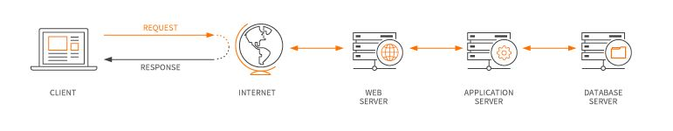
Fig 1.1 Web Application.
They work in a variety of organizations of any size, and some work as independent freelancers. The creation of a Web Application usually involves one or more Developers.
The complete web development is divided into two:
- Front-end development: Front-end developers work on the appearance of a website and make it interactive. For instance, a coloured button on a website and optimize website for various web browsers and devices. Front-end developers need to know HTML5, CSS3, JavaScript, and frameworks like Jquery, Foundation, Angular, Bootstrap etc.
- Back-end development: Back-end developers work on making websites more functional. Adding new features, making the website faster etc. are the major responsibilities of a back-end developer. A back-end developer needs to know a server-side programming language like PHP, JavaScript, Python, and Ruby on Rails etc. In addition to the languages, back-end developers are also required to frameworks corresponding to the language they know. For instance, if you know PHP you should know Laravel, CodeIgniter and other related PHP-based frameworks. Similarly, if you know JavaScript, you should know frameworks like Node.js Express.js etc.

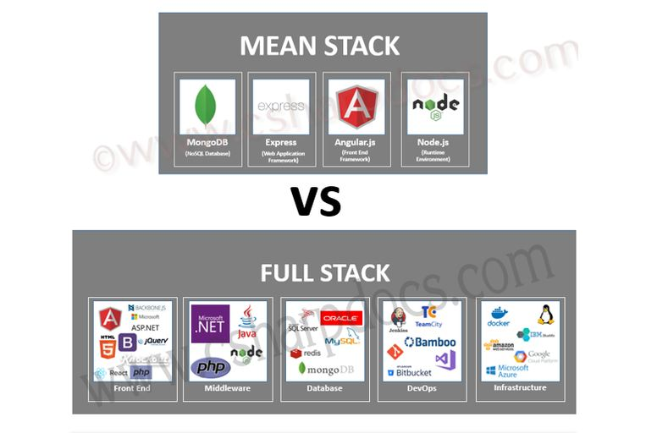
Fig 1.2 MEAN STACK VS FULL STACK.
Generally, developers like to work one of the above domains. However, there are some developers who work on both front-end as well as back-end. These are full-stack developers. Full stack is a high term and does not specify what technologies you should use.
Now do you see that there are multiple server-side programming languages that one can teach— PHP, JavaScript, Python etc. While the technologies for front-end remain the same, technology used for back-end development varies.
For example, PHP developers and Python developers both can use HTML 5, Jquery, and CSS 3 to work on front-end development, while a PHP developer would use PHP and Python developers would use Python for back-end.
Depending on the back-end technologies developers use, they are further called as LAMP developer, WAMP developer and MEAN stack developer.
LAMP developer: Use PHP for back-end development and Linux server. (JavaScript, HTML, CSS and more for front-end).
MEAN Stack developer: Use JavaScript for back-end development and front-end development. The term "stack" is basically a reference to the set of languages or technologies which the developer uses to build sites and/or applications. A MEAN stack developer uses the MEAN stack which is:
MEAN stack developers know the following technologies:
- M- Mongo DB: It is a No SQL DATABASE.
- E- Express js: Server side JS runtime Environment, Primarily for back-end development.
- A- Angular 2/4/6: Client side framework and for front-end development.
- N- Node Js: server Side JS runtime Environment, for back-end development and build websites/web apps that can handle large traffic easily.
The reason for popularity of MEAN stack is the scalability it offers to product. Products built with MEAN stack are capable of handling large traffic easily without hampering the performance of product. All JavaScript-based frameworks offer scalability better than others.
In fact, companies that were earlier using PHP and other older technologies are now moving to MEAN stack.
According to some survey and employee of EncureIT System for fresher’s Learning Flow of MEAN stack developer technologies:
Angular ->Express js -> nodejs -> Mongodb
Angular is a JavaScript MVC (Model View Controller) framework, which is developed by Google. It is used for creating well-structured client-side and maintainable front-end applications. It extends HTML It also implements two-way data binding, connecting your HTML (views) to your JavaScript objects (models) seamlessly.
EncureIT uses this to develop the web apps because it is more flexible regarding server communication. Finally, developers at EncureIT move the model and business logic to the front end and build back end to reach the accurate destination of the web apps. EncureIT is known for offering reliable Angular development and consulting services for clients worldwide. As a trusted Angular development company specializing in building high-quality browser based apps, our expert Angular developers are conversant with all the features of the framework.
EncureIT team is capable of creating engaging and readable applications with quick time to market. As team of EncureIT have several years of experience in the industry, they provide high-quality and cost-effective Angular development solutions.
Therefore,
In the internship, I have worked on “Angular” which is great platform to building web application

2) Internship Discussion.

2.1 Learning Experience.

- Knowledge acquired:
Week wise knowledge acquired in internship is as below:
Week 1:
- Understanding of what is FULL Stack Developer and MEAN Stack Developer.
- Understanding of what is angular, why we used, what is a prerequisite, what is difference between Angular JS and Angular Versions?
- Revised HTML 5 and CSS 3 Tags.

Practical Uses of Angular:

Create a Single Page Application (SPA) or a Website Menu in an Instant.
There are three major releases of Angular. The first version that was released is Angular1, which is also called Angular JS. Angular1 was followed by Angular2, which came in with a lot of changes when compared to Angular1.
The structure of Angular is based on the components/services architecture. Angular JS was based on the model view controller. Angular 4 released in March 2017 proves to be a major breakthrough and is the latest release from the Angular team after Angular2.Angular 4 is almost the same as Angular 2. It has a backward compatibility with Angular 2. Projects developed in Angular 2 will work without any issues with Angular 4.
Therefore, I choose Angular 4 version as working platform to building web application in internship.
Angular 4 is a JavaScript framework for building web applications and apps in JavaScript, html, and Type-Script, which is a superset of JavaScript. Angular provides built-in features for animation, http service, and materials which in turn have features such as auto-complete, navigation, toolbar, menus, etc. The code is written in Type-Script, which compiles to JavaScript and displays the same in the browser.

Prerequisites for Angular 4:
Basic understanding of HTML, CSS, JavaScript, Type-Script, and Document Object Model (DOM).
Week 2:
- According to prerequisites, start study of JavaScript, Type-Script, and Document Object Model (DOM).
- Installation setup procedure of Angular.
To install Angular 4, we require the following:
- Nodejs (Nodejs version has to be greater than 4.)
- Npm (Npm version has to be greater than 3.)
- Angular CLI: This is Command Line Interface for creating website using Angular.
- IDE for writing your code: You can use any IDE of your choice, i.e., Web Storm, Atom, Visual Studio Code, etc. I choose Visual Studio as IDE.
- Start study of Angular 4 Tutorial of tutorials point and Basic understanding of Angular folder structure and Angular CLI commands.
Week 3:
- Study of main building blocks of angular like Component, Modules, Data Binding, Event Binding, Template, Directives and Services.
- Component: A component controls one or more section on the screen called a view.
- Modules: Angular apps are modular and to maintain modularity, we have Angular modules or you can say NgModules. Every Angular app contains at least one Angular module, i.e. the root module. Generally, it is named as AppModule. The root module can be the only module in a small application. While most of the apps have multiple modules. You can say, a module is a cohesive block of code with a related set of capabilities which have a specific application domain or a workflow.
- Data Binding: If you are not using a framework, you have to push data values into the HTML controls and turn user responses into some actions and value updates. Writing such push/pull logic is tedious, error-prone, and a nightmare to read. Angular supports data binding, a mechanism for coordinating parts of a template with parts of a component. You should add binding markup to the template HTML to tell Angular how to connect both sides.
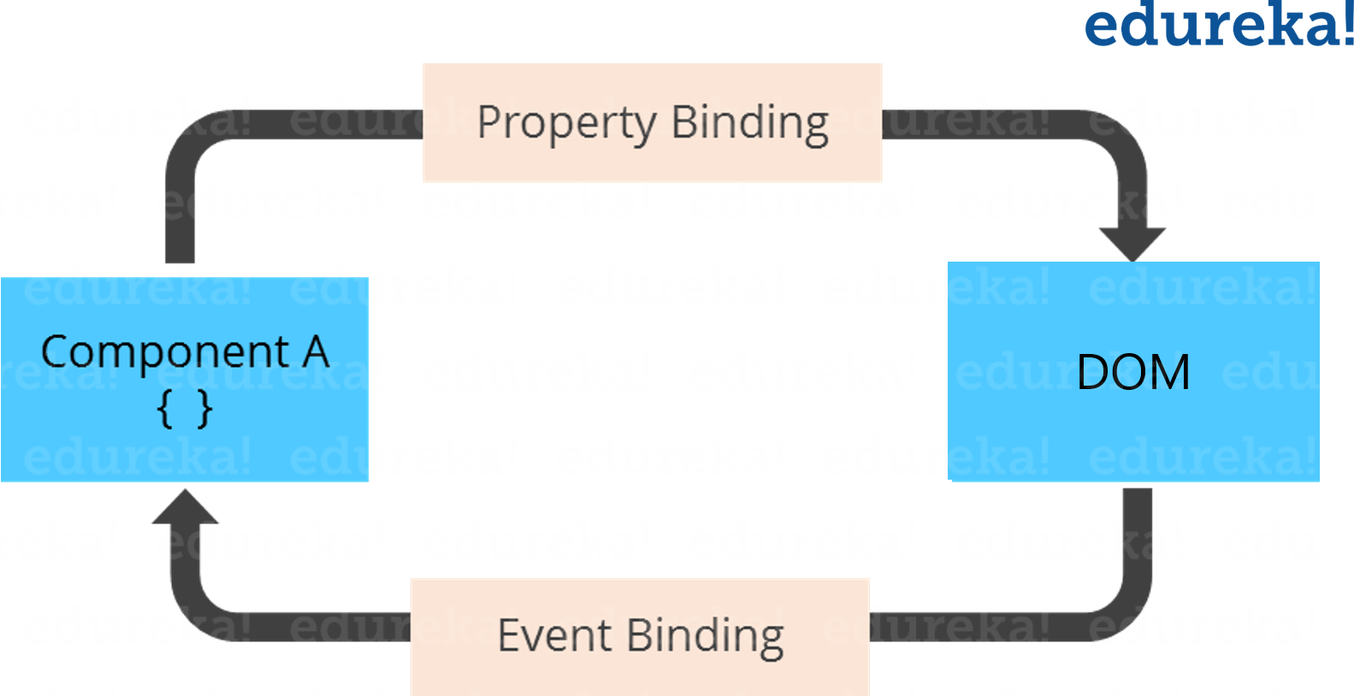
Fig 2.1 Data Binding.
- Template: A template is nothing but a form of HTML tags that tells Angular about how to render the component. A template looks like regular HTML, except for a few differences.
- Directives: Angular templates are dynamic. When Angular renders them, it transforms the DOM according to the instructions given by directives. A directive is a class with a @Directive decorator. A component is a directive-with-a-template; a @Component decorator is actually a @Directive decorator extended with template-oriented features. While a component is technically a directive, components are so distinctive and central to Angular applications that this architectural overview separates components from directives.
- Services: Service is a broad category encompassing any value, function, or feature that your application needs. A service is typically a class with a well-defined purpose. Anything can be a service. Examples include:
- logging service
- data service
- message bus
- tax calculator
- application configuration
Week 4:
- Study of Pipes, Routing, two way data binding and Form Validation concept.
- Two-way data binding:
This is an important part as it combines property and event binding in a single notation, using the ngModel directive. Here’s an example from the MovieDetailComponent template: <input [(ngmodel)] =”moviename”>
In two-way binding, a data property value flows to the input box from the component as with property binding. The user’s changes also flow back to the component, resetting the property to the latest value, as with event binding. Angular processes all data bindings once per JavaScript event cycle, from the root of the application component tree through all child components.
Data binding plays an important role in communication between a template and its component. Data binding is also important for communication between parent and child components.
- Routing:
Routing basically means navigating between pages. You have seen many sites with links that direct you to a new page. This can be achieved using routing. Here the pages that we are referring to will be in the form of components.

- Developed some small modules using reference of W3School website like navigation bar, Sign-Up and Sign-In form in Angular.
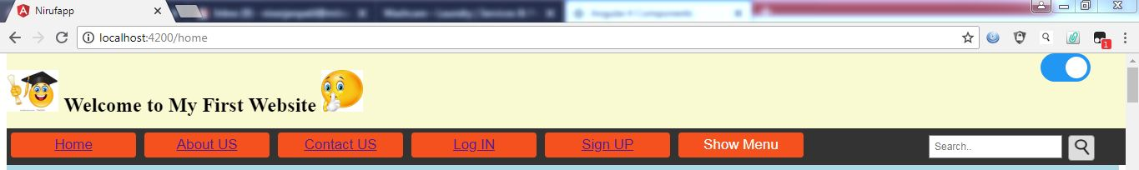
Fig 2.2 Navigation Bar.

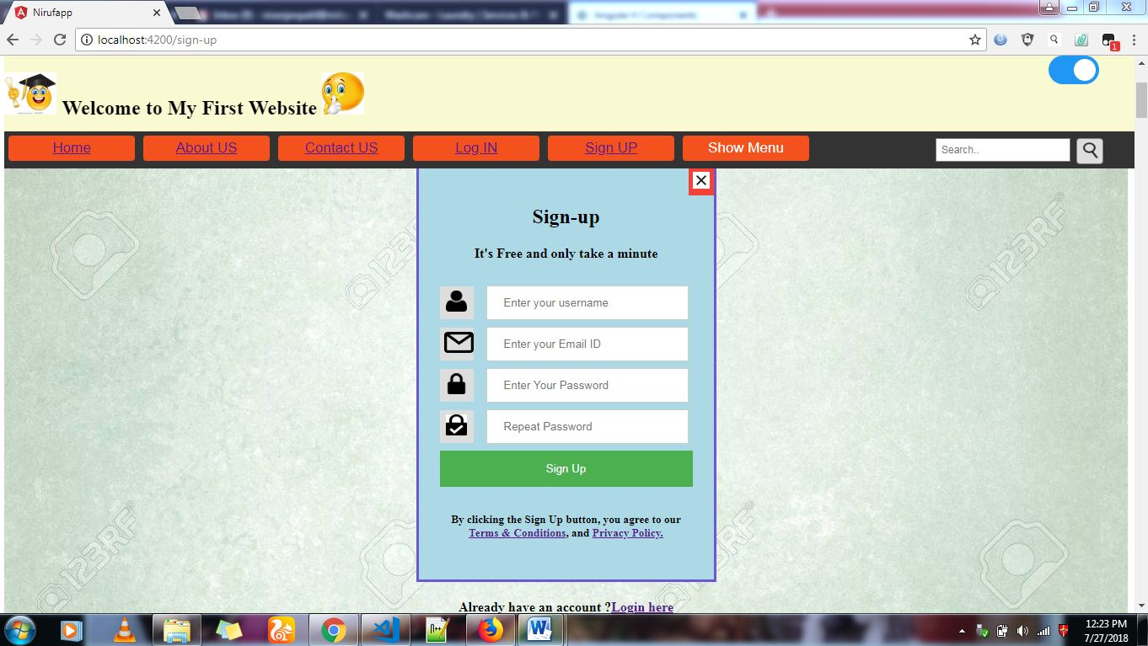
Fig 2.3 Sign-Up Form.

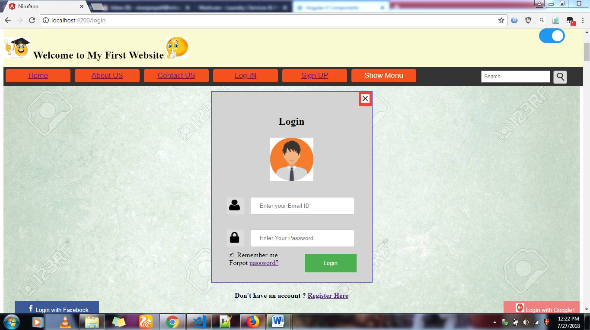

Fig 2.4 Log-In Form.
Week 5:
- Development of Wash Care Laundry website in Angular.
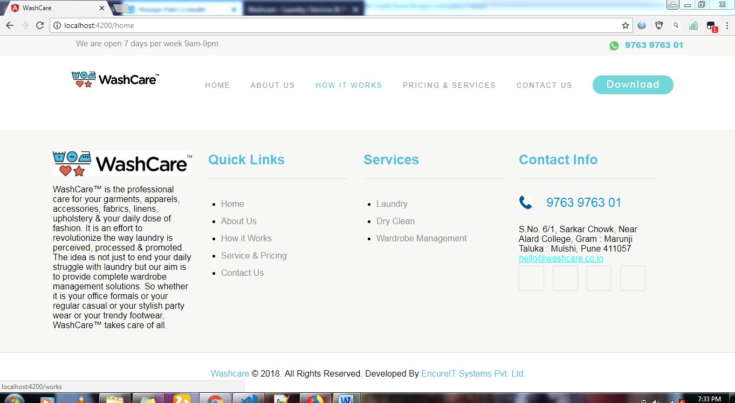

Fig 2.5 Header and Footer of Website.

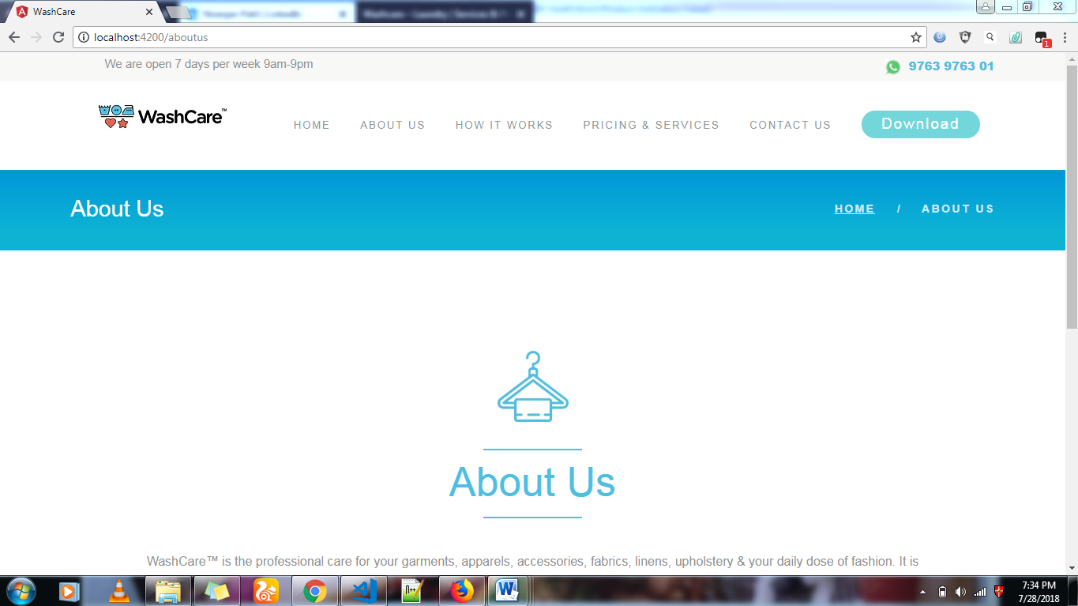

Fig 2.6 About Us Page of Website.
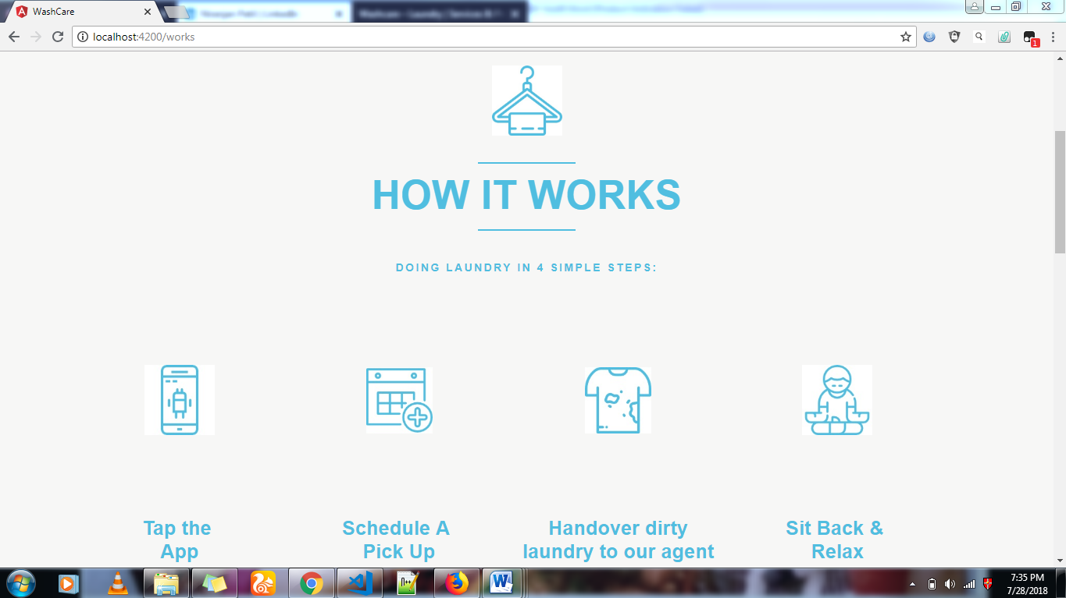

Fig 2.6 How It Works Page of Website

2.2 Most Challenging task performed
After learning of Angular 4. Discussion with Mr. Ashish Jain sir in EncureIT system and me is to be happened and I got tasks during the internship like Development of Wash Care Laundry website in Angular. This task is best and most challenging mission that was assigned to me during my internship.
I follow some fundamental concepts of System Engineering course in the task like system engineering management process and eight characteristics of system lifecycle function (Development, Making, Deployment, Operation, Support, Disposal, Training and verification). And also follow Working plan of EncureIT System. That’s why my task is so easy and well good performed.
First of all, I collect requirement and make a plan to develop a website then I start my work according to plan as well as I discuss with sir when I faces some problem or when I need a suggestion. And I tried to make responsive web pages in my website. Thank you so much sir for giving opportunity and trust on me.
For develop website in angular following component structure is used:
Main Component
AppComponent

Header Parent Components Footer

Child Components
Home
About Us
How It Works
Pricing & Services
Contact Us
Download

3) Conclusion.
Before when I go to the EncureIT System for internship, I study basic concept and scope of Organizational Behavior and human behavior in the workplace from an individual, group, and Organizational perspective from Psychology course in third semester. First of all, I have gone through EncureIT System website. In website I study History, mission, services and structure of organization.
EncureIT System opening time is 10:00 AM. So, we had been reached to EncureIT System office sharp at 9:50 AM then we meet Mr. Gaurav Parakh sir, Director of EncureIT System. They welcomed to our team and very interactive discussion is to be happened with sir. In that discussion we talk about rules and regulation of EncureIT system and share own experience of Two years in engineering. Then according to my interest and discussion with sir I have started worked on web development and sir had been introduced with Mr. Ajit Pawar, Mr. Harshad Pawar and Mr. Aflak Arshi are team member of Wash care Laundry project of EncureIT Systems Pvt. Ltd, for their guidance, advices, encouragement throughout my internship.
Mr. Ajit Pawar sir told me for good and innovative work we should always think positively and search about innovative ideas and sometimes does reverse engineering for solving problem and before you learning you should find out answer of some question like what is the meaning of topic? why we used? Hence, experience with Mr. Ajit Pawar sir is very good and memorable. Sir is doing very smart work and sir has more experience in IT industry. But On the exterior, EncureIT System team of professionals.
Look closely and I find out a group of people who’ve synced with each other and cracked the code of work-life balance. So, I think EncureIT System is the good platform where the best technological solutions are tailored to cater client requirements with successful results.
According to my observation environment in EncureIT System is very co-operative and organization take care of every employee. During internship I realize the employee life, organization environment and working of organization, some problem is come in internship but I face that problem and honestly i tried to find out best solution for that problem and experience of how to handle critical situation. So given Internships provide invaluable professional experience and allow me to test the theories and concepts I have been introduced in my college career but, Very good experience in EncureIT System.
Skill (Career specific abilities) learned during Internship:
- Professional communications: Internship teaches me discussions with bosses or coworkers are different from discussions with lecturers or fellow students.
- Making connections: In internship I learn How to build relationships with people around the office.
- Independence: Internship teaches me being able to work independently with little guidance is very important in the working world.
- Improve good decision making ability: Internship teaches me to make my own decisions and do things on your own
- Time management.

4) Bibliography.

- EncureIT System Website.
- “Angular from Theory to Practice” Book by Asim Hussain.
- “Tutorials Point” tutorial of Angular 4.

