Name: Niranjan Vinod Patil.
Batch: B-3.
Roll No: SCETTY305.

Subject: Computer Graphics & Gaming Lab

3D Transformation
DECELOPa PROGRAM TO DRAW 3D CUBE AND PERFORM FOLLOWING TRANSFORMATION ON IT USING OPENGL
A) SCALING B)TRANSLATION C) SCALING
#include<GL/glut.h>
#include<GL/gl.h>
#include<stdio.h>
#include<math.h>
typedef float Matrix4 [4][4];
Matrix4 theMatrix;
static GLfloat input[8][3]=
{
{40,40,-50},{90,40,-50},{90,90,-50},{40,90,-50},
{30,30,0},{80,30,0},{80,80,0},{30,80,0}
};
float output[8][3];
int tx,ty,tz;
int sx,sy,sz;
float angle;
int choice,choiceRot;
void setIdentityM(Matrix4 m)
{
for(int i=0;i<4;i++)
for(int j=0;j<4;j++)
m[i][j]=(i==j);
}
void translate(int tx,int ty,int tz)
{
for(int i=0;i<8;i++)
{

output[i][0]=input[i][0]+tx;
output[i][1]=input[i][1]+ty;
output[i][2]=input[i][2]+tz;
}
}
void scale(int sx,int sy,int sz)
{
theMatrix[0][0]=sx;
theMatrix[1][1]=sy;
theMatrix[2][2]=sz;
}
void RotateX(float angle) //Parallel to x
{
angle = angle*3.142/180;
theMatrix[1][1] = cos(angle);
theMatrix[1][2] = -sin(angle);
theMatrix[2][1] = sin(angle);
theMatrix[2][2] = cos(angle);
}
void RotateY(float angle) //parallel to y
{
angle = angle*3.14/180;
theMatrix[0][0] = cos(angle);
theMatrix[0][2] = -sin(angle);
theMatrix[2][0] = sin(angle);
theMatrix[2][2] = cos(angle);
}
void RotateZ(float angle) //parallel to z
{
angle = angle*3.14/180;
theMatrix[0][0] = cos(angle);
theMatrix[0][1] = sin(angle);
theMatrix[1][0] = -sin(angle);
theMatrix[1][1] = cos(angle);
}
void multiplyM()
{
//We Don't require 4th row and column in scaling and rotation
//[8][3]=[8][3]*[3][3] //4th not used
for(int i=0;i<8;i++)
{
for(int j=0;j<3;j++)
{
output[i][j]=0;
for(int k=0;k<3;k++)
{
output[i][j]=output[i][j]+input[i][k]*theMatrix[k][j];
}
}

}
}
void Axes(void)
{
glColor3f (0.0, 0.0, 0.0); // Set the color to BLACK
glBegin(GL_LINES); // Plotting X-Axis
glVertex2s(-1000 ,0);
glVertex2s( 1000 ,0);
glEnd();
glBegin(GL_LINES); // Plotting Y-Axis
glVertex2s(0 ,-1000);
glVertex2s(0 , 1000);
glEnd();
}
void draw(float a[8][3])
{
glBegin(GL_QUADS);
glColor3f(0.7,0.4,0.5); //behind
glVertex3fv(a[0]);
glVertex3fv(a[1]);
glVertex3fv(a[2]);
glVertex3fv(a[3]);
glColor3f(0.8,0.2,0.4); //bottom
glVertex3fv(a[0]);
glVertex3fv(a[1]);
glVertex3fv(a[5]);
glVertex3fv(a[4]);
glColor3f(0.3,0.6,0.7); //left
glVertex3fv(a[0]);
glVertex3fv(a[4]);
glVertex3fv(a[7]);
glVertex3fv(a[3]);
glColor3f(0.2,0.8,0.2); //right
glVertex3fv(a[1]);
glVertex3fv(a[2]);
glVertex3fv(a[6]);
glVertex3fv(a[5]);
glColor3f(0.7,0.7,0.2); //up
glVertex3fv(a[2]);
glVertex3fv(a[3]);
glVertex3fv(a[7]);
glVertex3fv(a[6]);
glColor3f(1.0,0.1,0.1);
glVertex3fv(a[4]);
glVertex3fv(a[5]);
glVertex3fv(a[6]);
glVertex3fv(a[7]);

glEnd();
}
void init()
{
glClearColor(1.0,1.0,1.0,1.0); //set backgrond color to white
glOrtho(-454.0,454.0,-250.0,250.0,-250.0,250.0);
// Set the no. of Co-ordinates along X & Y axes and their gappings
glEnable(GL_DEPTH_TEST);
// To Render the surfaces Properly according to their depths
}
void display()
{
glClear(GL_COLOR_BUFFER_BIT|GL_DEPTH_BUFFER_BIT);
Axes();
glColor3f(1.0,0.0,0.0);
draw(input);
setIdentityM(theMatrix);
switch(choice)
{
case 1: translate(tx,ty,tz);
break;
case 2: scale(sx,sy,sz);
multiplyM();
break;
case 3:
switch (choiceRot) {
case 1:
RotateX(angle);
break;
case 2: RotateY(angle);
break;
case 3:
RotateZ(angle);
break;
default:
break;
}
multiplyM();
break;
}
draw(output);
glFlush();
}
int main(int argc, char** argv)
{
glutInit(&argc,argv);
glutInitDisplayMode(GLUT_SINGLE|GLUT_RGB|GLUT_DEPTH);
glutInitWindowSize(1362,750);
glutInitWindowPosition(0,0);
glutCreateWindow("3D TRANSFORMATIONS");
init();

printf("Enter your choice number:\n1.Translation\n2.Scaling\n3.Rotation\n=");
scanf("%d",&choice);
switch (choice) {
case 1:
printf("\nEnter Tx,Ty &Tz: \n");
scanf("%d%d%d",&tx,&ty,&tz);
break;
case 2:
printf("\nEnter Sx,Sy &Sz: \n");
scanf("%d%d%d",&sx,&sy,&sz);
break;
case 3:
printf("Enter your choice for Rotation about axis:\n");
printf("1.parallel to X-axis.(y& z)\n2.parallel to Y-axis.(x& z)\n3.parallel to Z-axis.(x& y)\n=>");
scanf("%d",&choiceRot);
switch (choiceRot) {
case 1:
printf("\nENter Rotation angle: ");
scanf("%f",&angle);
break;
case 2:
printf("\nENter Rotation angle: ");
scanf("%f",&angle);
break;
case 3:
printf("\nENter Rotation angle: ");
scanf("%f",&angle);
break;
default:
break;
}
break;
default:
break;
}
glutDisplayFunc(display);
glutMainLoop();
return 0;
}

Output –

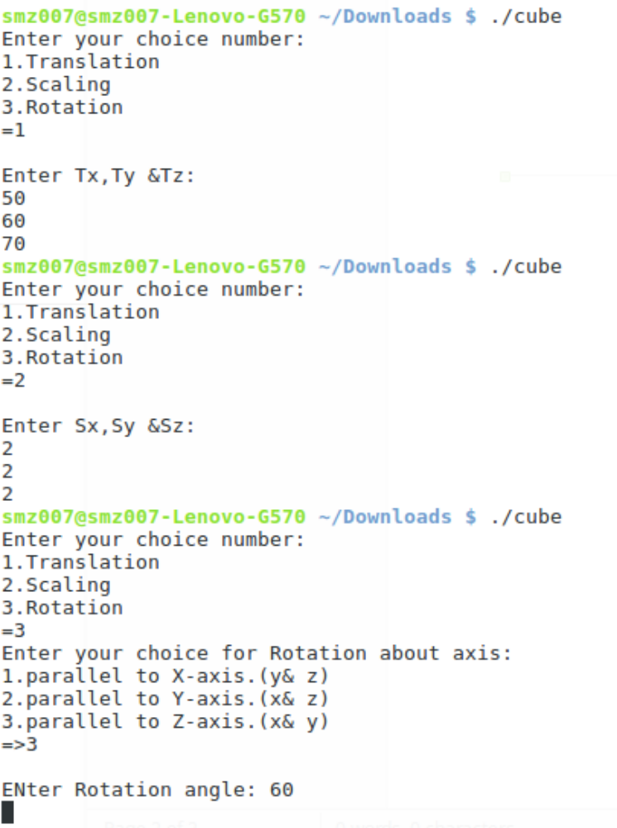

Translation –
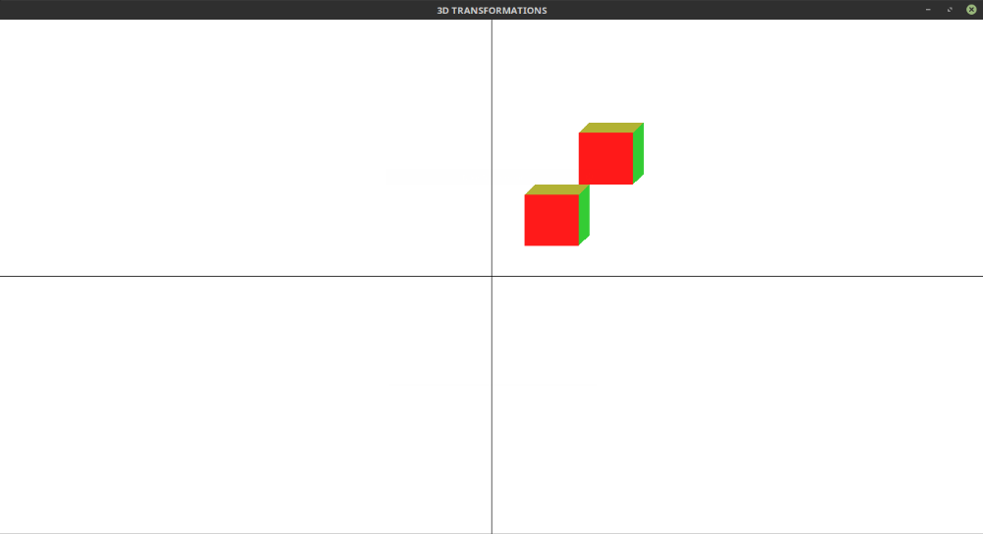
Scaling -

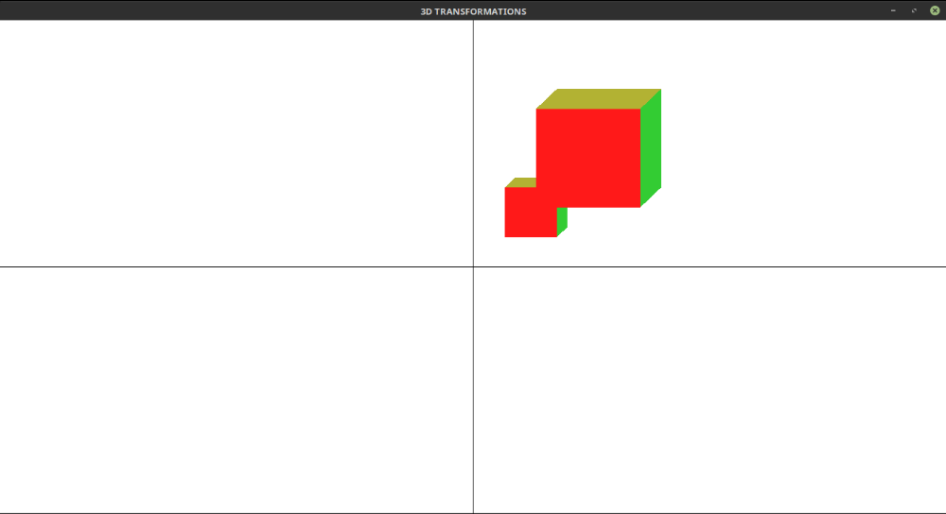

Rotation –

