Acknowledgement

I would like to express my sincere gratitude to the management of Sir M. Visvesvaraya Institute of Technology, Bengaluru for providing the opportunity and resources to complete this assignment. I extend my heartfelt thanks to Ms. N. Bhagya Laksmi, Assistant Professor, Dept. of CSE, for her guidance and support throughout the work.
I would also like to thank Dr. T. N. Anitha, Head of the Department, Dept. of CSE, for her encouragement and valuable suggestions.
I convey my sincere thanks to Dr. M. N. Thippeswamy, Principal, Sir MVIT, for providing the necessary academic environment and facilities.
I am grateful to the faculty and staff of the Department of Computer Science and Engineering for their cooperation. Finally, I thank my friends and family for their support during the completion of this assignment.

1. Introduction

This report presents the development of two interconnected web-based assignments aimed at strengthening foundational skills in both client-side and server-side web technologies.
Assignment 1 involves designing a structured personal portfolio website comprising Home, Resume, and Biodata pages. The design utilizes HTML for content organization, CSS for styling and layout refinement, and JavaScript to incorporate light interactivity. The focus of this assignment is on visual structure, responsive layout, and the creation of a clean and user-friendly interface.
Assignment 2 introduces backend functionality through the creation of an online registration form. The form captures essential user details and performs client-side validation using jQuery. Upon submission, the data is processed by a PHP script and presented back to the user in a formatted output page. This assignment highlights server-side processing, data handling through POST requests, and dynamic content generation.
Combined, these two assignments provide a cohesive learning experience that covers core web development principles from building static web interfaces to implementing interactive, data-driven features.

2. TECHNOLOGIES USED

This project uses a combination of frontend and backend technologies to develop both the personal portfolio website and the online registration form. The main tools used in each assignment are listed below.

2.1 Assignment 1: Portfolio Website
HTML5
Used to create the structure of the Home, Resume, and Biodata pages.
CSS3
Used for styling, layout design, colors, spacing, shadows, and responsive UI.
JavaScript
Used for a simple alert function on the Home page to add basic interactivity.
VS Code and Web Browser
VS Code was used for coding, and Chrome/Edge was used for testing the pages.

2.2 Assignment 2: Online Registration Form
HTML5
Used to design the registration form and input fields.
CSS3
Used to style the form container, labels, inputs, and buttons.
JavaScript / jQuery
Used for client-side validation, especially checking the phone number before submission.
PHP
Used as the backend to process form data and display the submitted information on a new page.
VS Code & Web Browser
VS Code was used for coding, and the browser was used to test the form and PHP output.

3. IMPLEMENTATION

This project consists of two components: a personal portfolio website and an online registration form. The implementation details of both assignments are summarized below in a concise manner.

3.1 Assignment 1: Portfolio Website
The portfolio website is implemented using three main HTML pages styled with a common CSS file.
Home Page
- Contains a welcome message and basic introduction.
- Includes navigation links to the Resume and Biodata pages.
- A JavaScript function is used to display a simple alert when the user clicks a button.
Resume Page
- Displays personal details, educational background, skills, and project information.
- Content is arranged using HTML lists for better readability.
Biodata Page
- Contains personal and family details in a structured table format.
- Designed using table rows and columns styled with CSS for clarity.
Styling
- All pages use a shared CSS file for consistent appearance.
- Features include card-style layouts, spacing, shadows, color themes, and a sticky footer.

3.2 Assignment 2: Online Registration Form
This part of the project implements a functional form that collects user data and processes it using PHP.
Form Design
- The form collects essential details such as name, email, phone number, gender, course selection, and address.
- Designed using HTML form elements like <input>, <select>, and <textarea>.
Validation
- jQuery is used to validate the phone number before submission.
- If the phone number is less than 10 digits, an alert is shown and submission is prevented.
Backend Processing (submit.php)
- The form sends data to submit.php via POST method.
- PHP retrieves the submitted values and displays them in a formatted output page.
- This demonstrates basic server-side processing.
Styling
- The form uses a separate CSS file to provide clear layout, padding, and alignment.
- The design maintains a clean and user-friendly interface.

4. SCREENSHOTS

4.1 Screenshots of Assignment 1: Portfolio Website
Home Page Resume Page
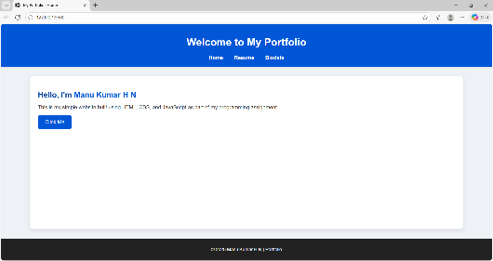
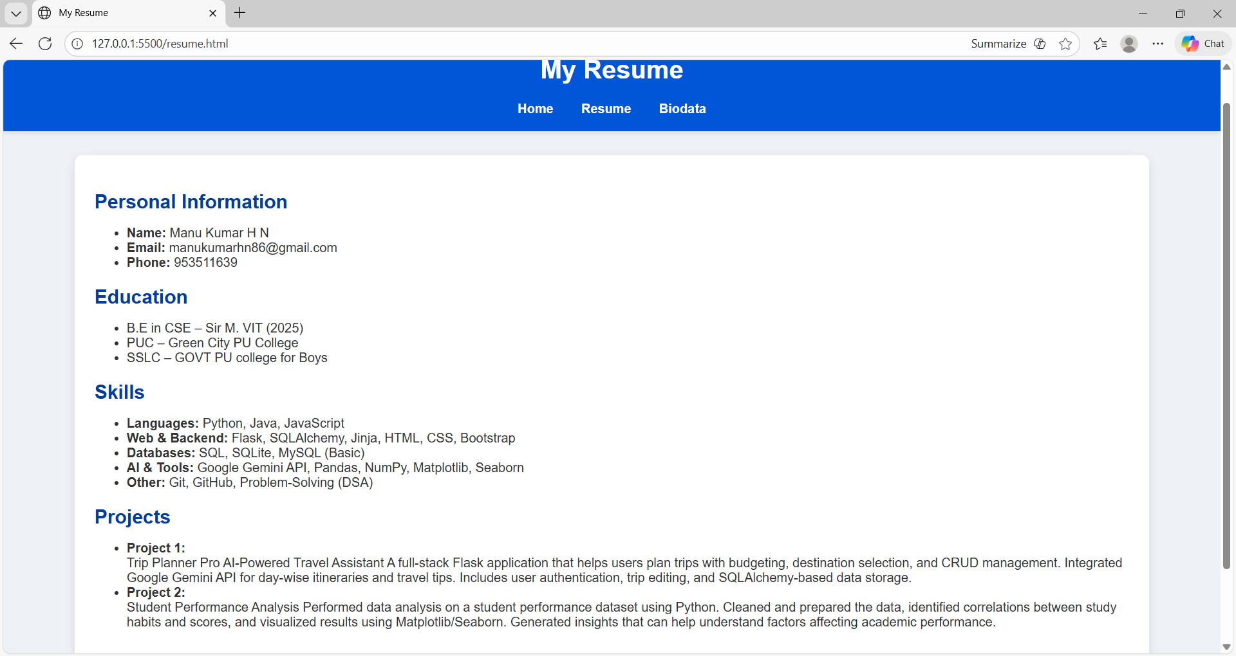

Biodata Page
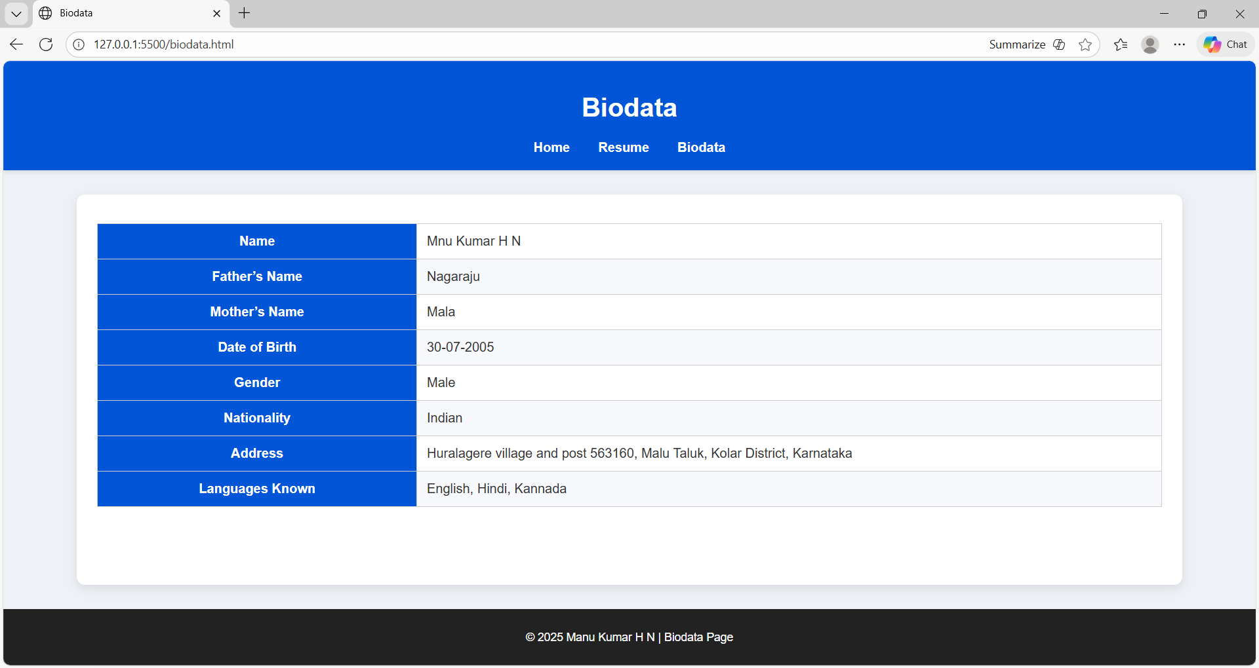

4.2 Screenshots of Assignment 2: Registration Form

Registration Form Page PHP Output Page (Submitted Details)
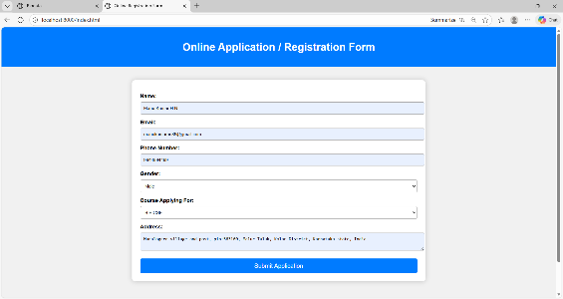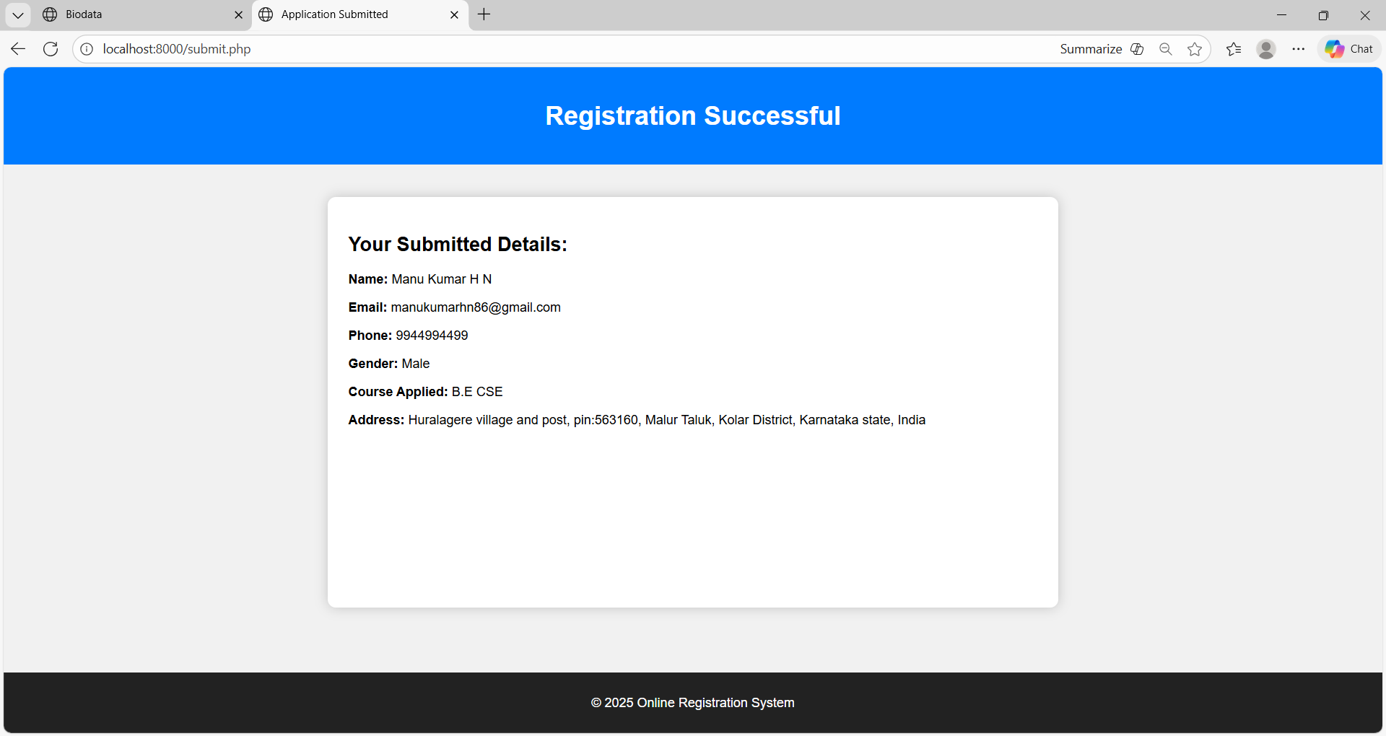

5. CONCLUSION

This project provided practical exposure to the fundamental concepts of web development by combining both frontend and backend techniques.
Assignment 1 enabled the creation of a personal portfolio website using HTML, CSS, and JavaScript. Through this assignment, the structure, styling, navigation, and basic interactivity of web pages were explored. The result was a clean, organized, and user-friendly website that presents personal, academic, and biodata information effectively.
Assignment 2 introduced backend functionality through the development of an online registration form. Here, form design and validation were implemented using HTML, CSS, and jQuery, while PHP handled the processing and display of submitted user information. This assignment helped in understanding how frontend forms interact with server-side scripts to generate dynamic content.
Overall, the project strengthened understanding of essential web technologies and demonstrated how different components work together to build functional web applications. Skills in layout design, styling, form handling, validation, and server-side data processing were successfully developed.

