**RA2111013010064**

**NIRANJANA V**

**BIOMEDICAL**

**FOOD ORDERING SYSTEM**

**SOURCE CODE :**

**#include <stdio.h>**

**int main()**

**{**

**int a,qty,rate,total;**

**printf("\nMENU CARD \nSelect your drink \n1.COFFEE \n2.TEA \n3.COLD COFFEE \n4.MILK SHAKE \n5.KULFI\n");**

**scanf("%d",&a);**

**switch(a)**

**{**

**case 1:**

**printf("\nYou have selected Coffee.\n Enter the quantity :");**

**scanf("%d",&qty);**

**rate=5;**

**total=qty*rate;**

**printf("\nTotal amount :%d",total);**

**break;**

**case 2:**

**printf("\nYou have selected Tea.\n Enter the quantity :");**

**scanf("%d",&qty);**

**rate=10;**

**total=qty*rate;**

**printf("\nTotal amount :%d",total);**

**break;**

**case 3:**

**printf("\nYou have selected Cold coffee.\n Enter the quantity :");**

**scanf("%d",&qty);**

**rate=15;**

**total=qty*rate;**

**printf("\nTotal amount :%d",total);**

**break;**

**case 4:**

**printf("\nYou have selected Milk shake.\n Enter the quantity :");**

**scanf("%d",&qty);**

**rate=20;**

**total=qty*rate;**

**printf("\nTotal amount :%d",total);**

**break;**

**case 5:**

**printf("\nYou have selected kulfi.\n Enter the quantity :");**

**scanf("%d",&qty);**

**rate=15;**

**total=qty*rate;**

**printf("\nTotal amount :%d",total);**

**break;**

**default:**

**printf("\nSorry Unavailable...%ds",a);**

**break;**

**}**

**return 0;**

**}**

**OUTPUT :**

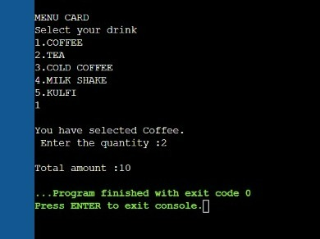

THANK YOU