Brain-Tasks-App
End-to-End DevOps Deployment
Docker • Amazon ECR • AWS EKS • AWS CodeBuild • AWS CodePipeline • CloudWatch

Prepared by: Niranjana Mohan
Repository: https://github.com/Niranjanamohan183/Brain-Tasks-App
Date: 23/07/2026

1. Project Overview
This document records the setup and deployment steps for containerizing, provisioning infrastructure for, and CI/CD-deploying the Brain-Tasks-App React application to AWS EKS. Each section below pairs the commands run with a placeholder for the corresponding screenshot. Replace each placeholder with your own screenshot as you complete that step.
- Application: Brain-Tasks-App (prebuilt React/Vite static app)
- Containerization: Docker + Nginx, served on port 3000
- Registry: Amazon ECR
- Orchestration: AWS EKS (Kubernetes)
- CI: AWS CodeBuild (build, push, deploy)
- CI/CD Orchestration: AWS CodePipeline, triggered by GitHub source stage
- Monitoring: Amazon CloudWatch Logs (build logs + Container Insights)

2. Docker

2.1 Build the Image
Steps:
- Write a Dockerfile using an Nginx base image to serve the prebuilt React/Vite static build
- Write nginx.conf to listen on port 3000 and fall back to index.html for client-side routing
- Add a .dockerignore file to exclude git, markdown, and manifest files from the build context
- Open a terminal in the project root directory containing the Dockerfile
Command: docker build -t brain-tasks-app:local .
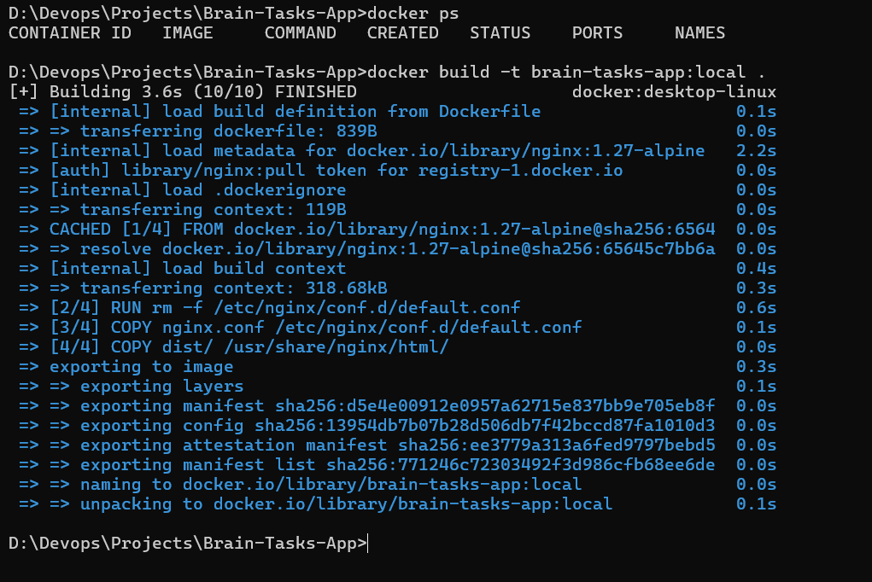
Screenshot 1 — Docker build output showing successful image creation.

2.2 Run & Verify the Container
Steps:
- Stop and remove any existing container using the same name, if present
- Run the container in detached mode, mapping host port 3000 to container port 3000
- Confirm the container is listed and shows a healthy/running status with docker ps
- Open a browser and verify the application loads at http://localhost:3000
Command: docker run -d -p 3000:3000 --name brain-tasks-app brain-tasks-app:local
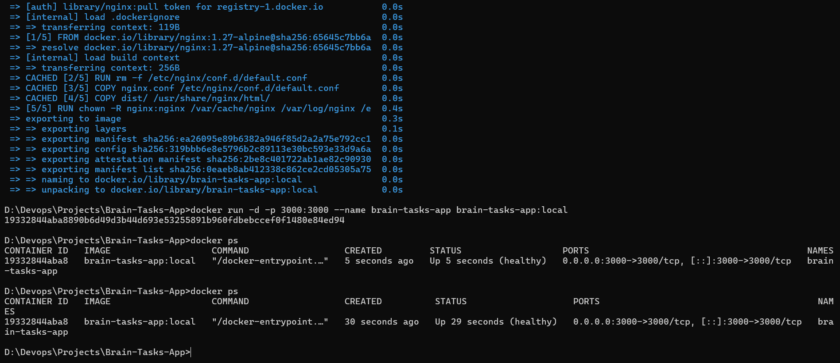
Screenshot 2 — docker ps output showing the container running and healthy.
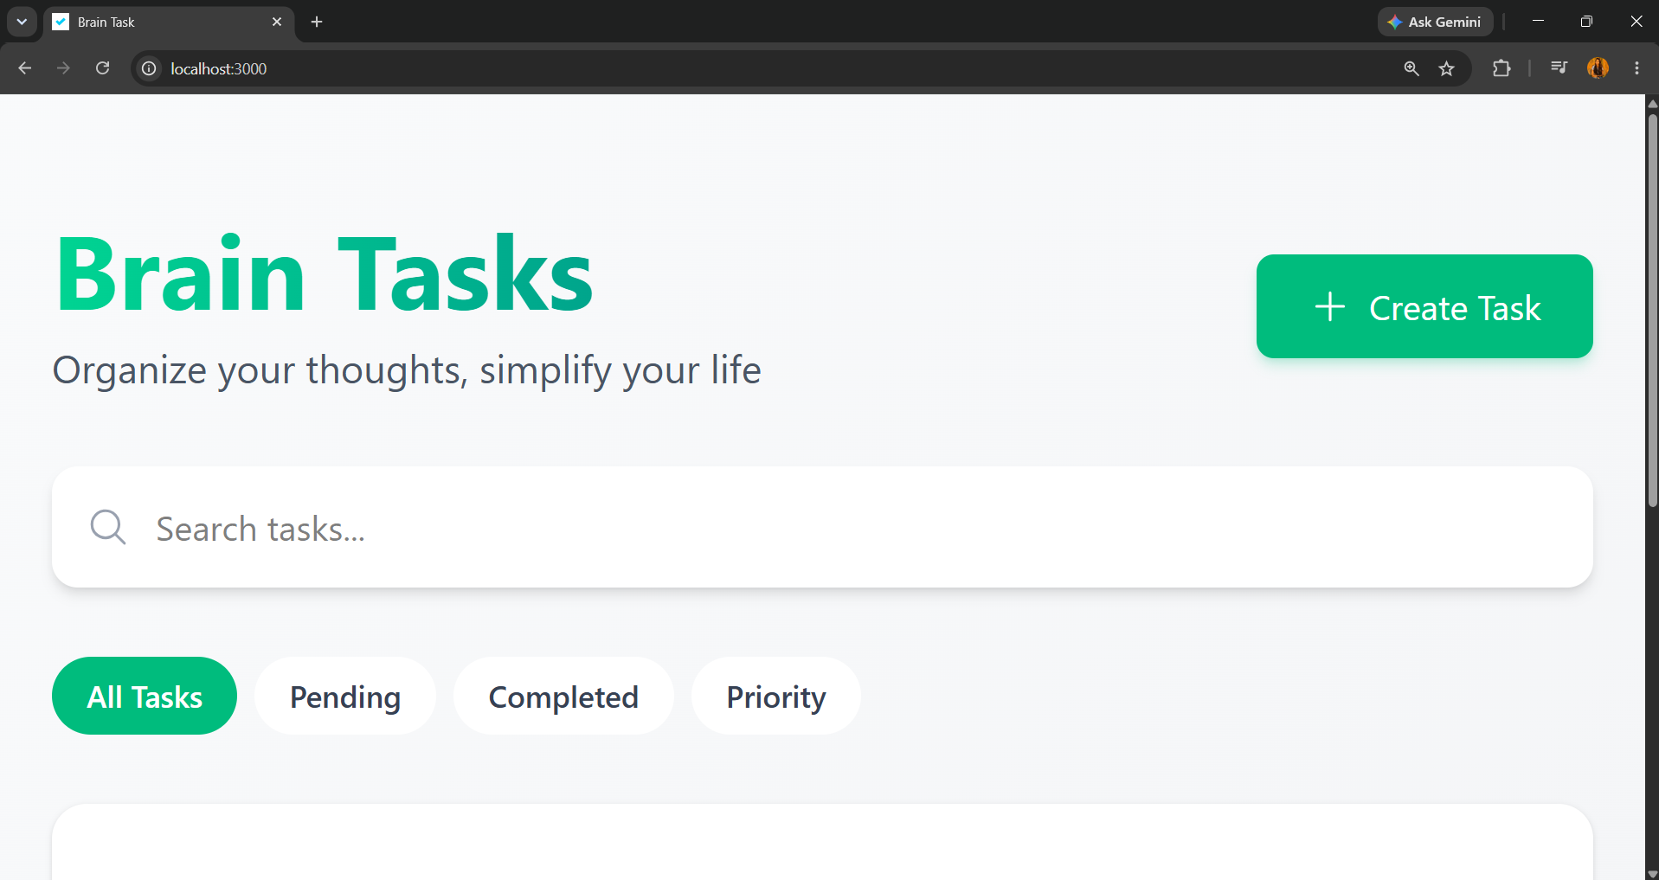
Screenshot 3 — Application loaded in the browser at http://localhost:3000.

3. Amazon ECR — Registry
Steps:
- Create a private repository on Amazon ECR named brain-tasks-app
- Authenticate the local Docker CLI to ECR using aws ecr get-login-password piped into docker login
- Tag the local image with the ECR repository URI
- Push the tagged image to the registry using the command below
- Refresh the ECR console repository page to confirm the new tag appears
Command: aws ecr create-repository –repository-name brain-tasks-app –region ap-south-1 –image-scanning-configuration scanOnPush=true
Command: aws ecr get-login-password –region ap-south-1 | docker login –username AWS –password-stdin <account-id>.dkr.ecr.ap-south-1.amazonaws.com
Command: docker tag brain-tasks-app:local <account-id>.dkr.ecr.ap-south-1.amazonaws.com/brain-tasks-app:latest
Command: docker push <account-id>.dkr.ecr.ap-south-1.amazonaws.com/brain-tasks-app:latest
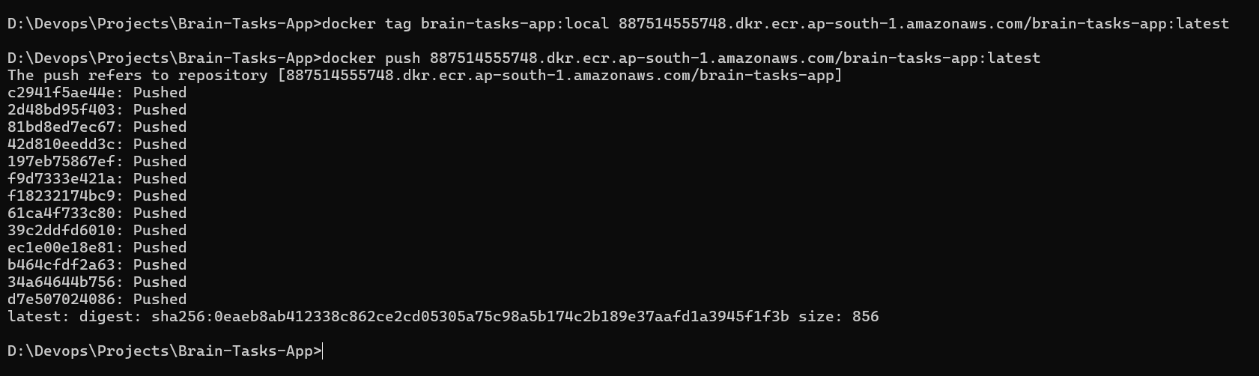
Screenshot 4 — ECR repository page showing the pushed image and tags.

4. Kubernetes — AWS EKS

4.1 Cluster Creation
Steps:
- Ensure the AWS CLI is configured with valid credentials (aws configure) and that eksctl and kubectl are installed
- Run the eksctl command below to create a managed EKS cluster with two t3.medium nodes in ap-south-1
- Wait for cluster and nodegroup creation to complete (typically 15-20 minutes)
- Update the local kubeconfig: aws eks update-kubeconfig --name brain-tasks-cluster --region ap-south-1
- Run kubectl get nodes to confirm the nodes are in Ready state
Command: eksctl create cluster --name brain-tasks-cluster --region ap-south-1 --
nodegroup-name brain-tasks-nodes --node-type t3.medium --nodes 2 –managed

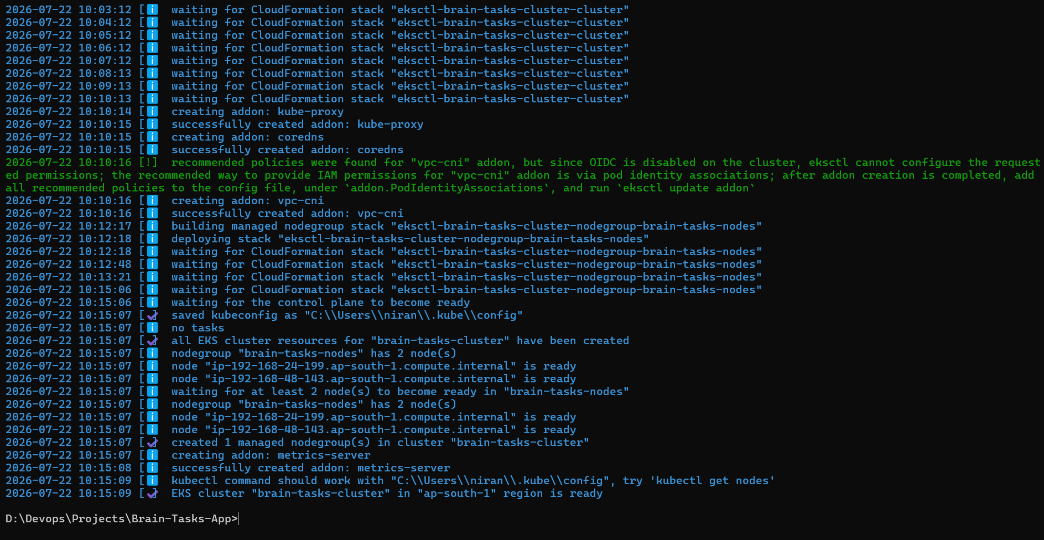
Screenshot 5 — eksctl cluster creation output.
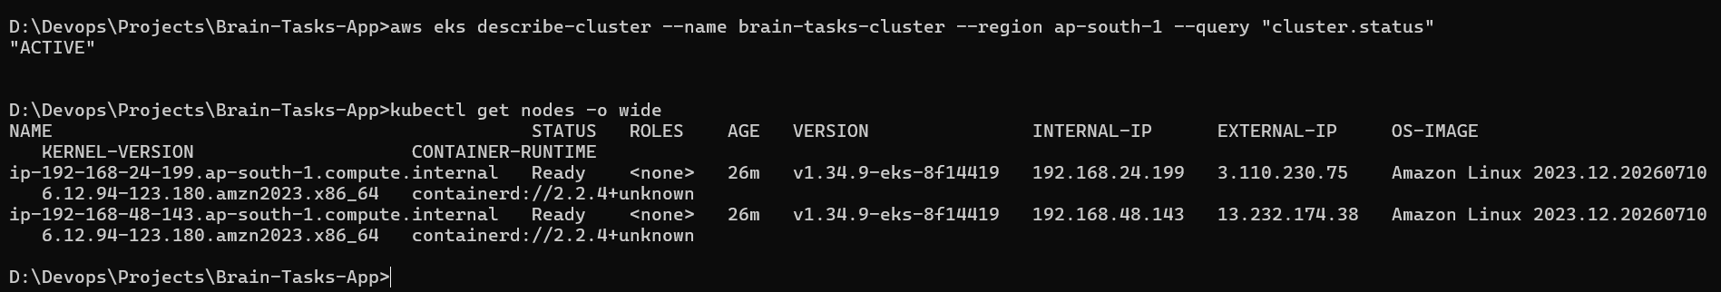
Screenshot 6 — kubectl get nodes showing nodes in Ready state (confirms cluster is running).

4.2 Deploy the Application
Steps:
- Write the Kubernetes manifests: k8s/deployment.yaml (pod spec, image reference, replica count, probes) and k8s/service.yaml (LoadBalancer service exposing port 3000)
- Apply the Deployment manifest: kubectl apply -f k8s/deployment.yaml
- Apply the Service manifest: kubectl apply -f k8s/service.yaml
- Run kubectl get pods to confirm the application pods are Running
- Run kubectl get svc brain-tasks-app-svc -o wide and wait for the LoadBalancer EXTERNAL-IP/hostname to be assigned
- Open the LoadBalancer's public URL in a browser to confirm the application is reachable
Commands: kubectl apply -f k8s/deployment.yaml | kubectl apply -f k8s/service.yaml

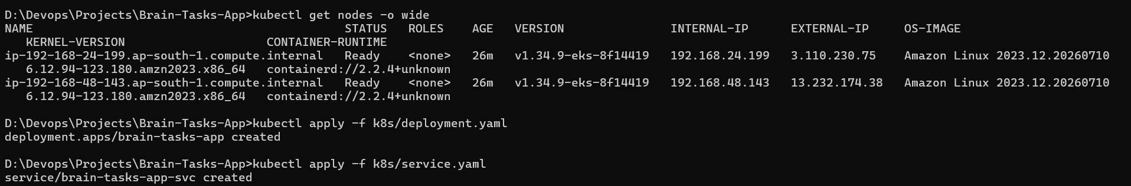
Screenshot 7 — Deployment and Service applied successfully (kubectl get pods).
Screenshot 8 — kubectl get svc brain-tasks-app-svc -o wide, showing the LoadBalancer hostname.
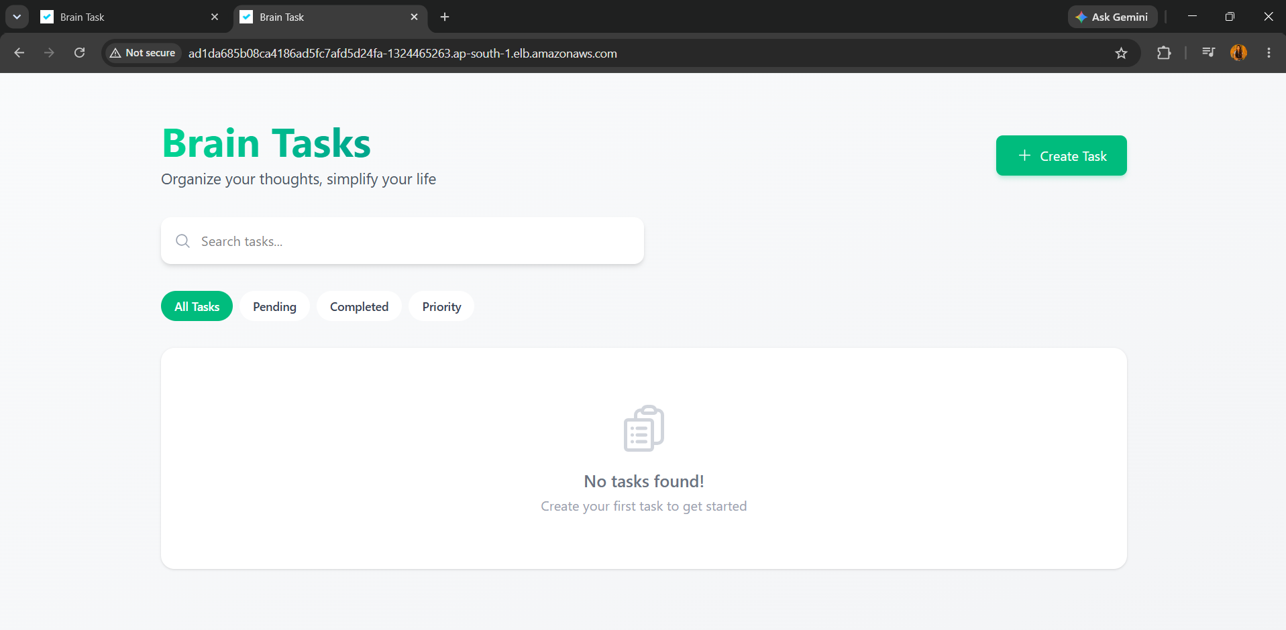
Screenshot 9 — Application loaded in the browser via the LoadBalancer's public URL.

4.3 LoadBalancer ARN
Steps:
- Open the AWS EC2 console and go to Load Balancers
- Select the LoadBalancer created for brain-tasks-app-svc and copy its ARN
- Record the ARN below for the submission summary
Command: aws elb describe-load-balancers --region ap-south-1 --query "LoadBalancerDescriptions[?DNSName=='ad1da685b08ca4186ad5fc7afd5d24fa-1324465263.ap-south-1.elb.amazonaws.com']"
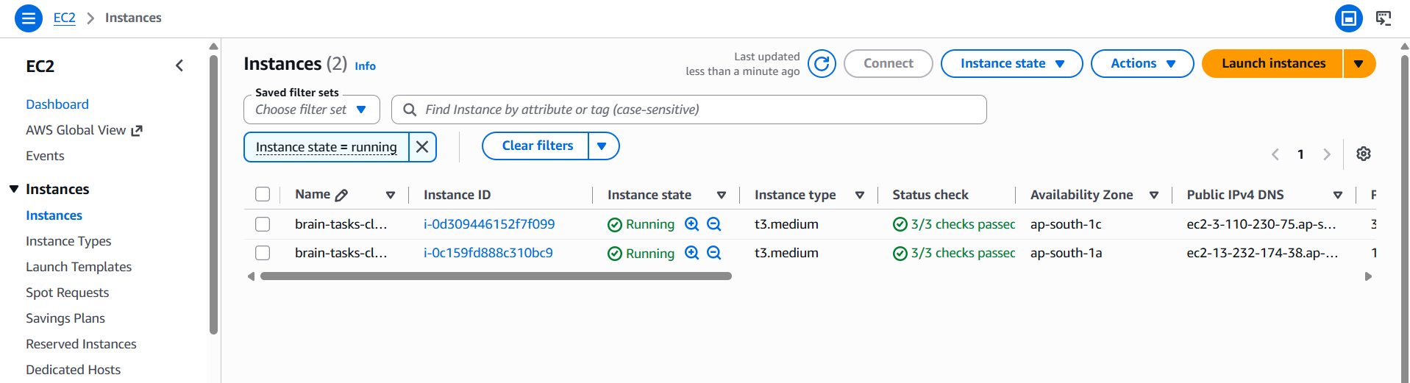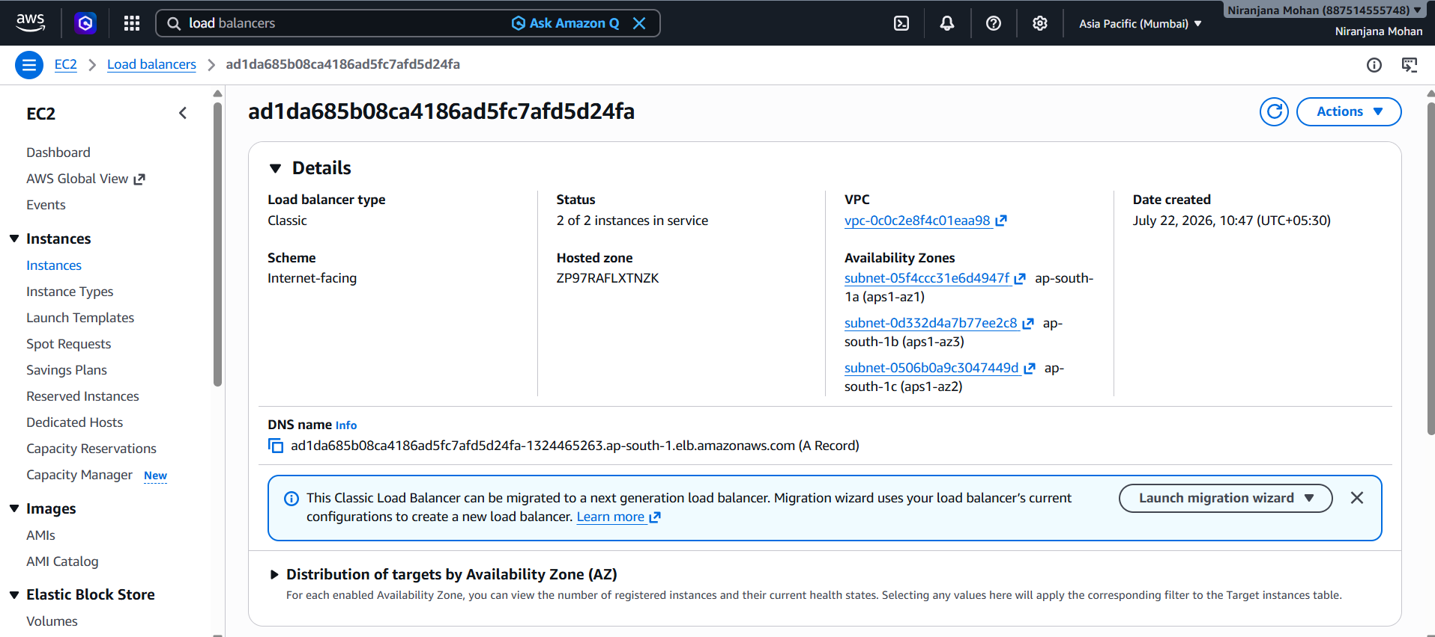

5. IAM — EKS Access for CodeBuild
Steps:
- Create (or reuse) the CodeBuild service role and note its IAM role ARN
- Map that role into the EKS cluster's RBAC so kubectl commands run from CodeBuild are authorized
- Confirm the mapping by checking the aws-auth ConfigMap in the cluster
Command: eksctl create iamidentitymapping --cluster brain-tasks-cluster --region ap-south-1 --arn arn:aws:iam::<account-id>:role/<codebuild-service-role> --group system:masters --username codebuild
[ Insert Screenshot 10 here ]
Screenshot 10 — aws-auth ConfigMap showing the CodeBuild role mapped into the cluster.

6. AWS CodeBuild

6.1 Project Setup
Steps:
- Create a CodeBuild project connected to this GitHub repository, branch main
- Choose a managed image (Amazon Linux 2, Standard runtime) and enable Privileged mode (required for Docker builds)
- Point the project at buildspec.yml in the repo root
- Add environment variables: AWS_ACCOUNT_ID, AWS_REGION, ECR_REPO_NAME, EKS_CLUSTER_NAME
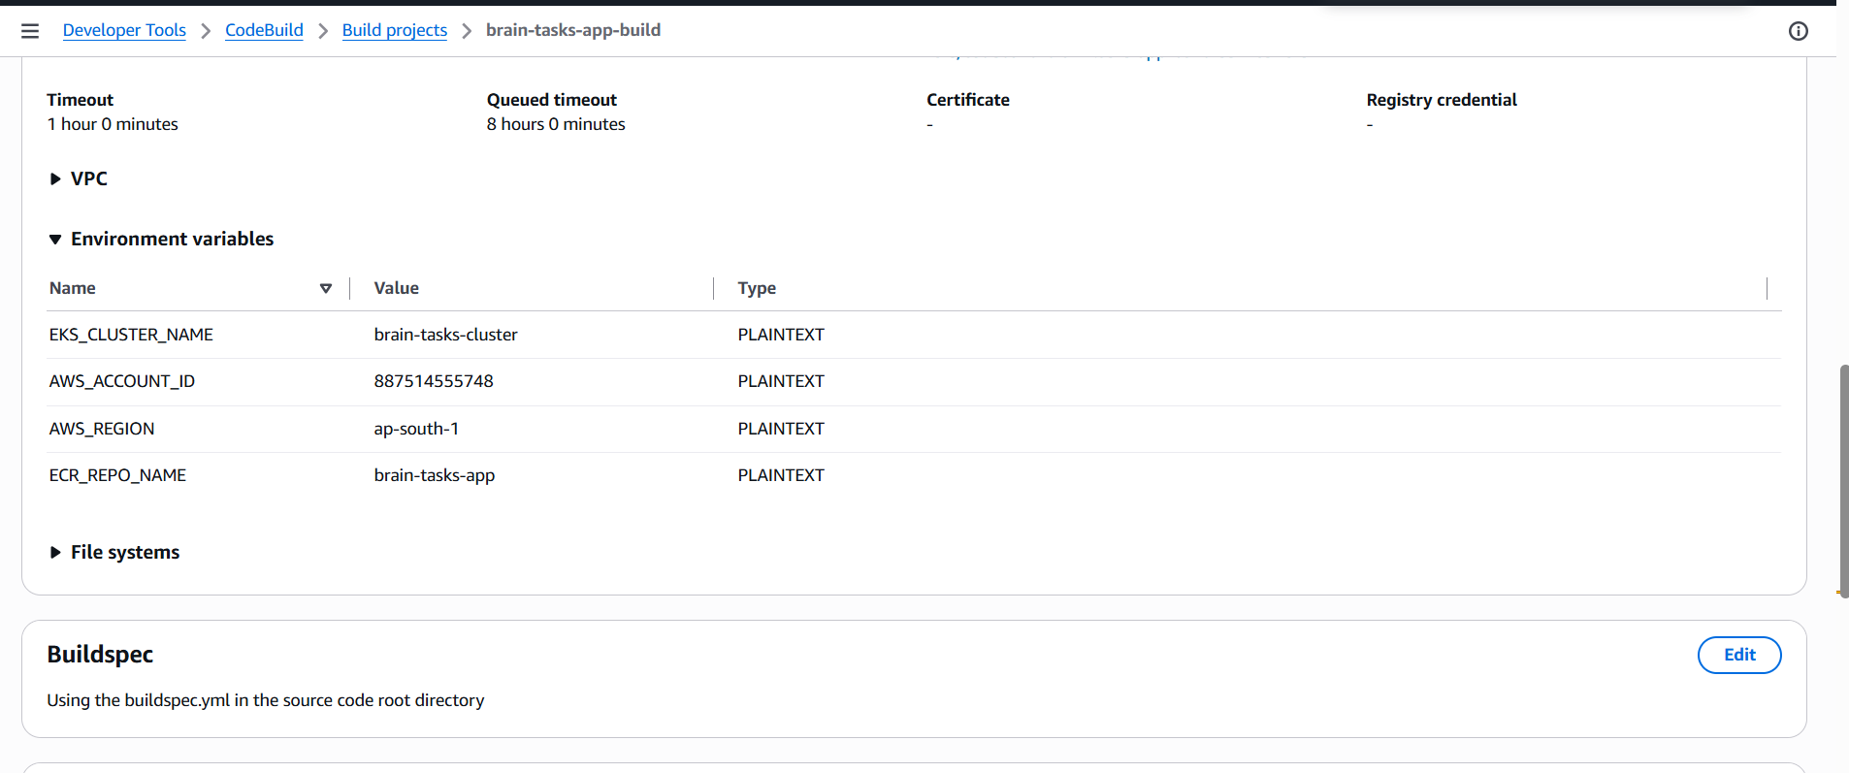
Screenshot 11 — CodeBuild project configuration (source, environment, buildspec).
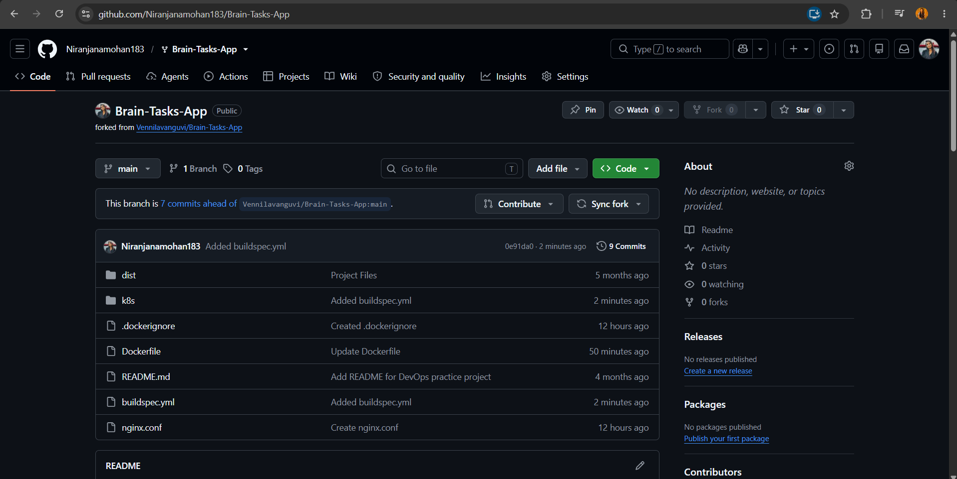
[ Insert Screenshot 12 here ]
Screenshot 12 — Successful CodeBuild run — all phases (INSTALL, PRE_BUILD, BUILD, POST_BUILD) green.

6.2 Build Explanation
buildspec.yml runs the following phases on every build:
- install — installs kubectl into the build container
- pre_build — logs in to ECR and computes the image tag from the git commit hash
- build — runs docker build, tagging the image with the commit hash and 'latest'
- post_build — pushes the image to ECR, updates kubeconfig, applies the k8s manifests, and waits for rollout to finish

7. AWS CodePipeline

7.1 Pipeline Setup
Steps:
- Create a CodePipeline with a Source stage connected to GitHub (via CodeStar connection), branch main
- Add a Build stage pointing to the brain-tasks-app-build CodeBuild project
- Save the pipeline and trigger a run to confirm both stages succeed
- Push a test commit to confirm the pipeline triggers automatically
Command: aws codepipeline start-pipeline-execution --name brain-tasks-app-pipeline --region ap-south-1
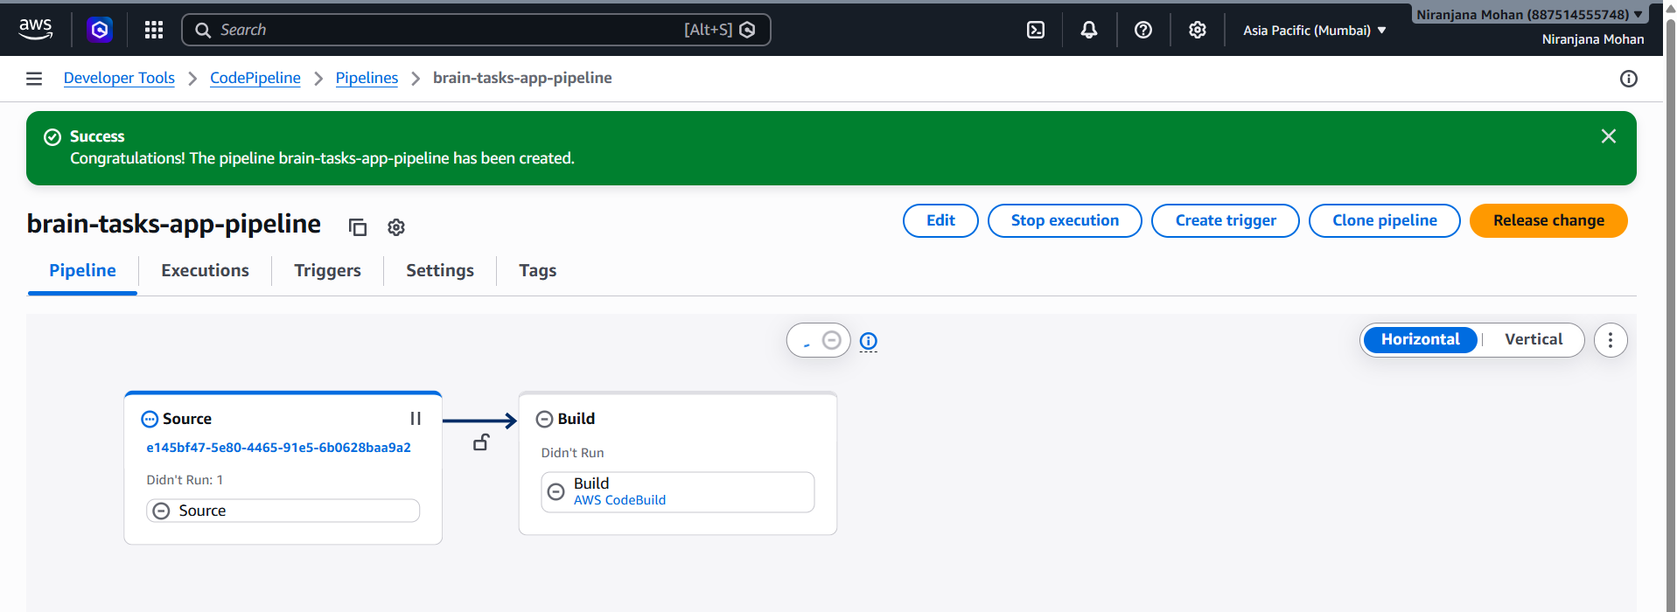
Screenshot 13 — CodePipeline configuration showing Source and Build stages.

7.2 Pipeline Explanation
The pipeline runs the following stages on every push to main:
- Source — pulls the latest code from GitHub
- Build — triggers CodeBuild, which builds the Docker image, pushes it to ECR, and deploys to EKS via buildspec.yml
- (Optional) Deploy — a separate EKS deploy stage, if your pipeline splits deploy out from the Build stage

8. Monitoring — CloudWatch
CodeBuild logs stream automatically to CloudWatch Logs. CloudWatch Container Insights was installed on the EKS cluster to also collect application (nginx) logs from the running pods.
Steps:
- Update local kubeconfig: aws eks update-kubeconfig –name brain-tasks-cluster –region ap-south-1
- Apply the CloudWatch Container Insights manifest (cwagent-fluent-bit-quickstart.yaml) to the cluster
- Confirm the CloudWatch agent and Fluent Bit pods are Running: kubectl get pods -n amazon-cloudwatch
- Open the CloudWatch console and confirm the CodeBuild log group (/aws/codebuild/brain-tasks-app-build)
- Open the CloudWatch console and confirm the application log group under Container Insights
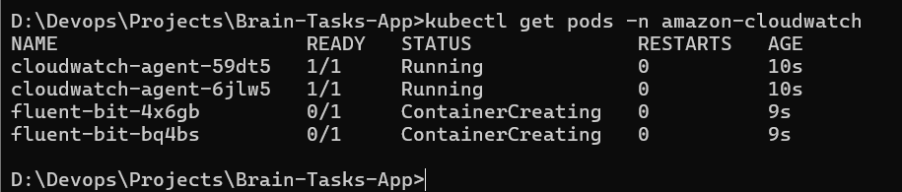
Screenshot 15 — CloudWatch Logs — CodeBuild build log group.
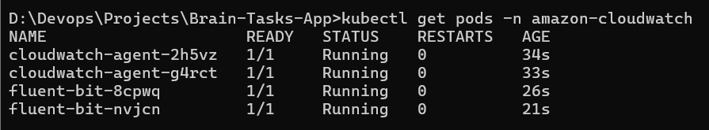
Screenshot 16 — CloudWatch Logs — application/Container Insights log group showing nginx request logs.

9. Version Control
The full codebase (Dockerfile, nginx.conf, .dockerignore, k8s/, buildspec.yml, README.md) was pushed to GitHub.
Steps:
- Create a new branch: git checkout -b devops-deployment
- Stage and commit all files: git add Dockerfile nginx.conf .dockerignore k8s/ buildspec.yml followed by git commit -m “Add Docker, K8s manifests, and CodeBuild pipeline”
- Push the branch: git push origin devops-deployment
- Open a Pull Request on GitHub and merge into main
- Confirm all files appear in the GitHub repository
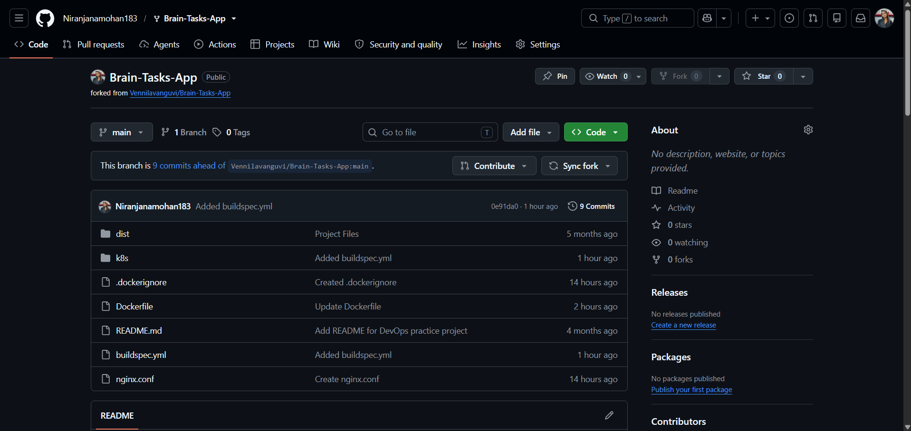
Screenshot 17 — GitHub repository showing the pushed codebase.

