Application Deployment — Submission Report
Brain-Tasks-App: Dockerized React App on AWS EKS with CI/CD via CodePipeline
Submitted by | Niranjana Mohan
Date | July 31, 2026
Application | Brain-Tasks-App (React / Vite)
GitHub Repository | https://github.com/Niranjanamohan183/brain-tasks-app
Container Registry | 887514555748.dkr.ecr.ap-south-1.amazonaws.com/brain-tasks-app
EKS Cluster Name | brain-tasks-eks (ap-south-1)
LoadBalancer ARN | arn:aws:elasticloadbalancing:ap-south-1:887514555748:loadbalancer/ae55cd8f39fc34ade9721759e69553ed

1. Objective
This document records the end-to-end deployment of the Brain-Tasks-App React application to a production-ready state on AWS, covering containerization, image registry, Kubernetes orchestration on EKS, and a fully automated CI/CD pipeline using AWS CodeBuild, CodePipeline, and CloudWatch monitoring.

2. Architecture Overview
- Source Code: GitHub repository (forked from original, code pushed via CLI)
- Containerization: Multi-stage Dockerfile (Node build stage + nginx serve stage)
- Registry: AWS ECR / DockerHub — stores versioned images
- Orchestration: AWS EKS cluster running Deployment + LoadBalancer Service
- CI: AWS CodeBuild — builds Docker image, pushes to registry
- CD: AWS CodePipeline — Source (GitHub) -> Build (CodeBuild) -> Deploy (CodeBuild + kubectl)
- Monitoring: AWS CloudWatch Logs + Container Insights

4. Version Control — GitHub
The application repository was cloned and re-pushed to a personal GitHub repository using CLI commands so that CodeBuild/CodePipeline could be configured against it.
Commands used:
Repository URL: https://github.com/Niranjanamohan183/brain-tasks-app
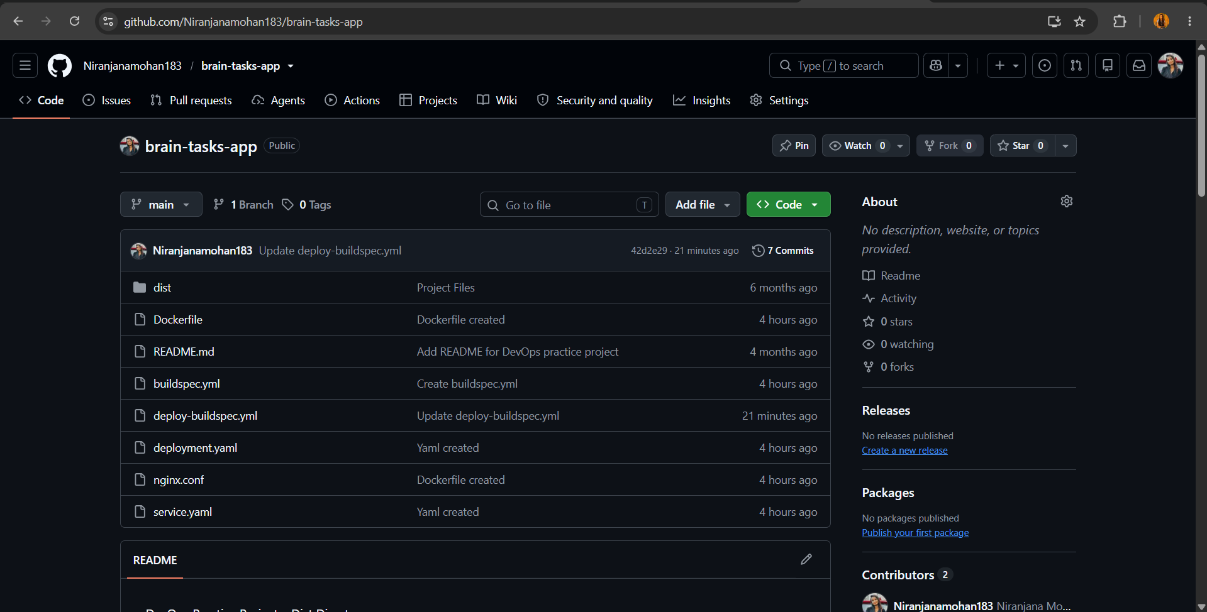

5. Dockerization

5.1 Dockerfile
A multi-stage Dockerfile was created: Stage 1 builds the React app using Node; Stage 2 serves the static build output using nginx on port 3000.

5.2 Build & Run Locally
docker build -t brain-tasks-app:latest . docker run -d -p 3000:3000 brain-tasks-app:latest
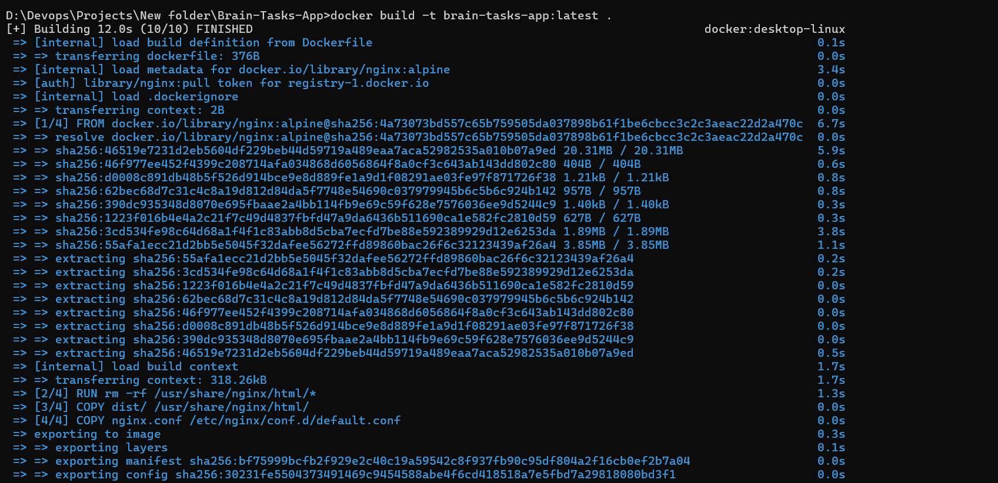
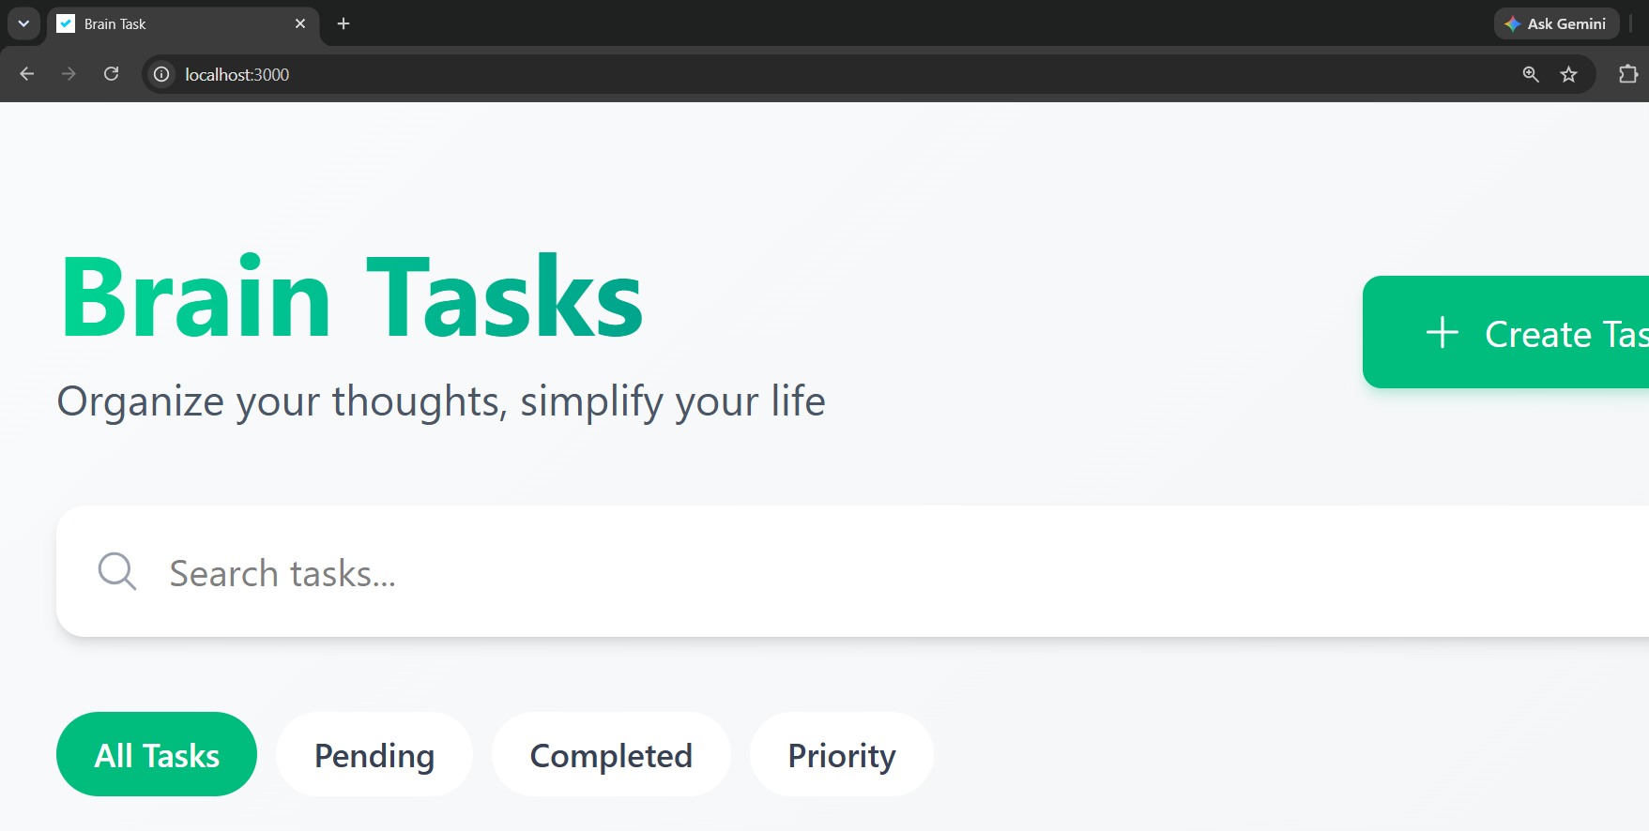

6. Container Registry (ECR / DockerHub)
A private repository was created to store versioned Docker images, and the locally built image was tagged and pushed.
Registry Type: AWS ECR / DockerHub
Repository URI: <account-id>.dkr.ecr.ap-south-1.amazonaws.com/brain-tasks-app
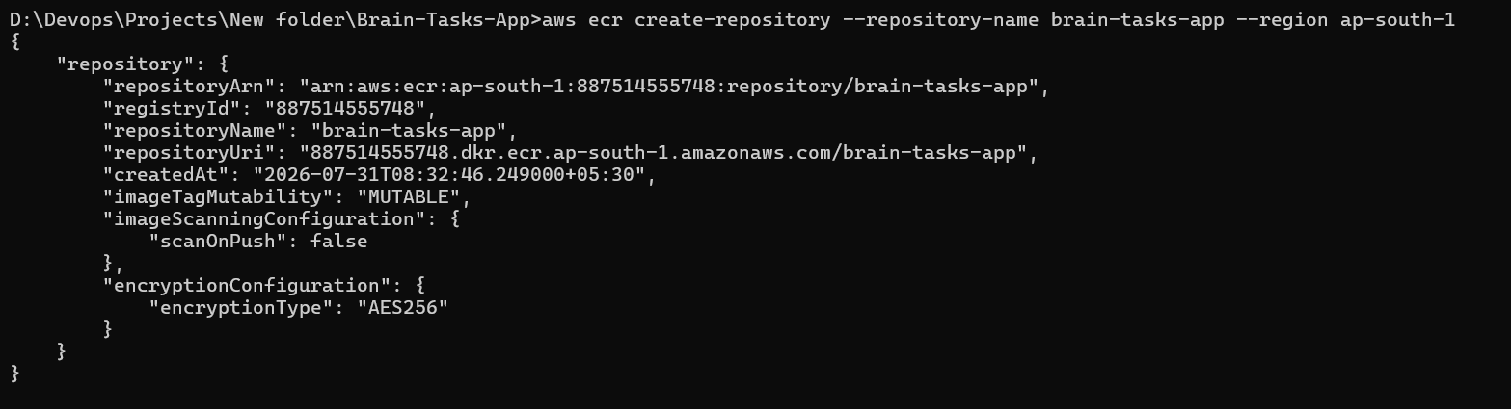
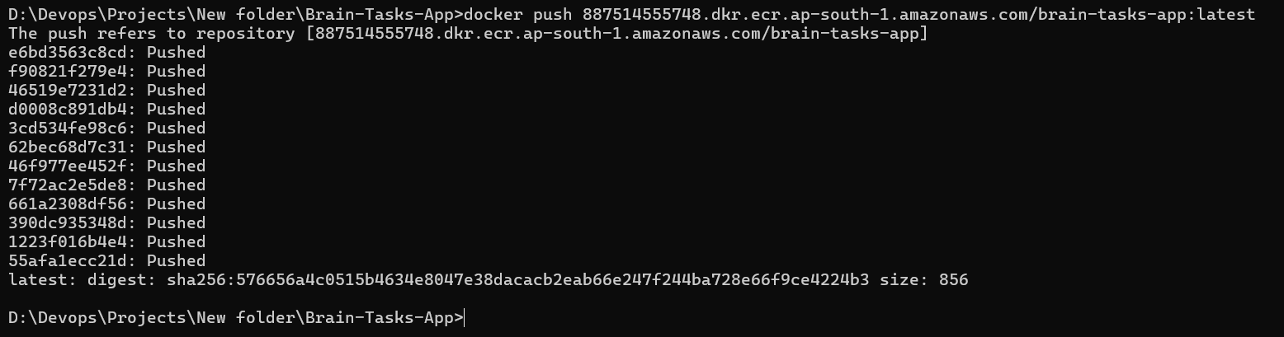

7. Kubernetes Setup — AWS EKS

7.1 Cluster Creation
An EKS cluster was provisioned using eksctl with a managed node group.
eksctl create cluster --name brain-tasks-eks --region ap-south-1 --nodegroup-name brain-tasks-nodes --node-type t3.medium --nodes 2 --managed
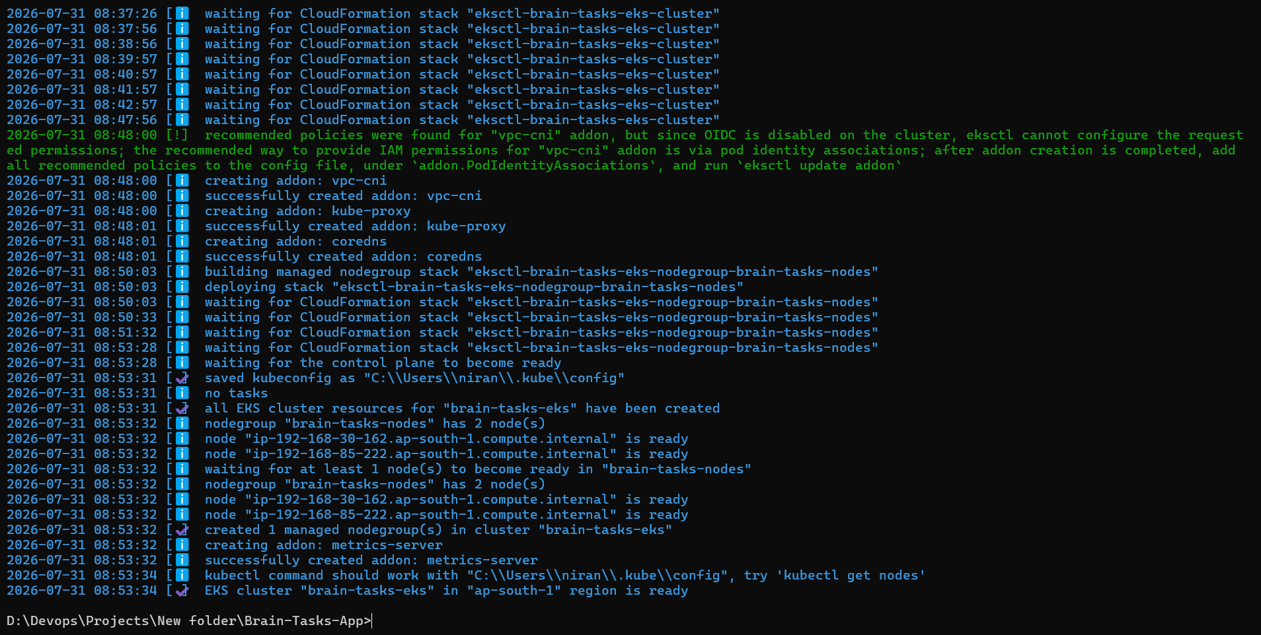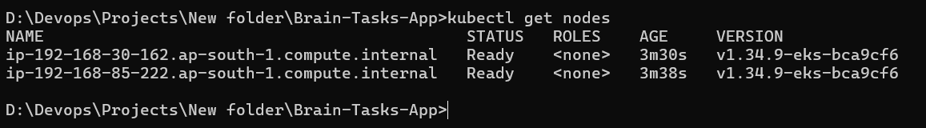

7.2 Deployment & Service YAML
deployment.yaml defines the pod spec, replica count, and container image reference. service.yaml exposes the app externally via type: LoadBalancer, mapping port 80 to container port 3000.
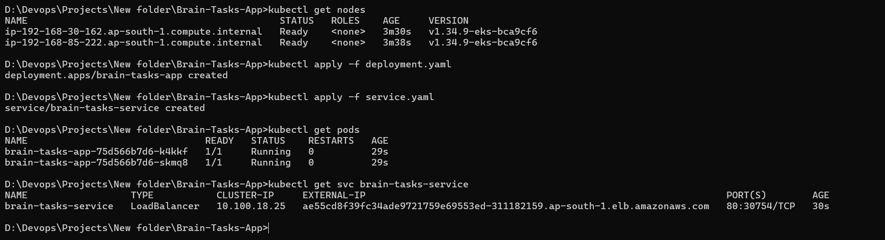

7.3 Application Verified
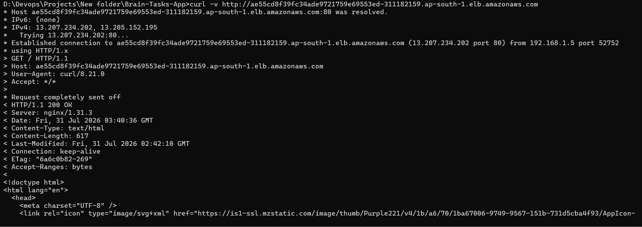

8. AWS CodeBuild
A CodeBuild project was configured with GitHub as source, a managed Amazon Linux/Ubuntu build image (privileged mode enabled for Docker), and buildspec.yml defining the build phases.

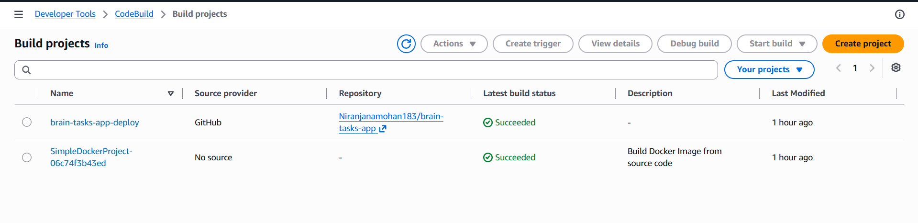
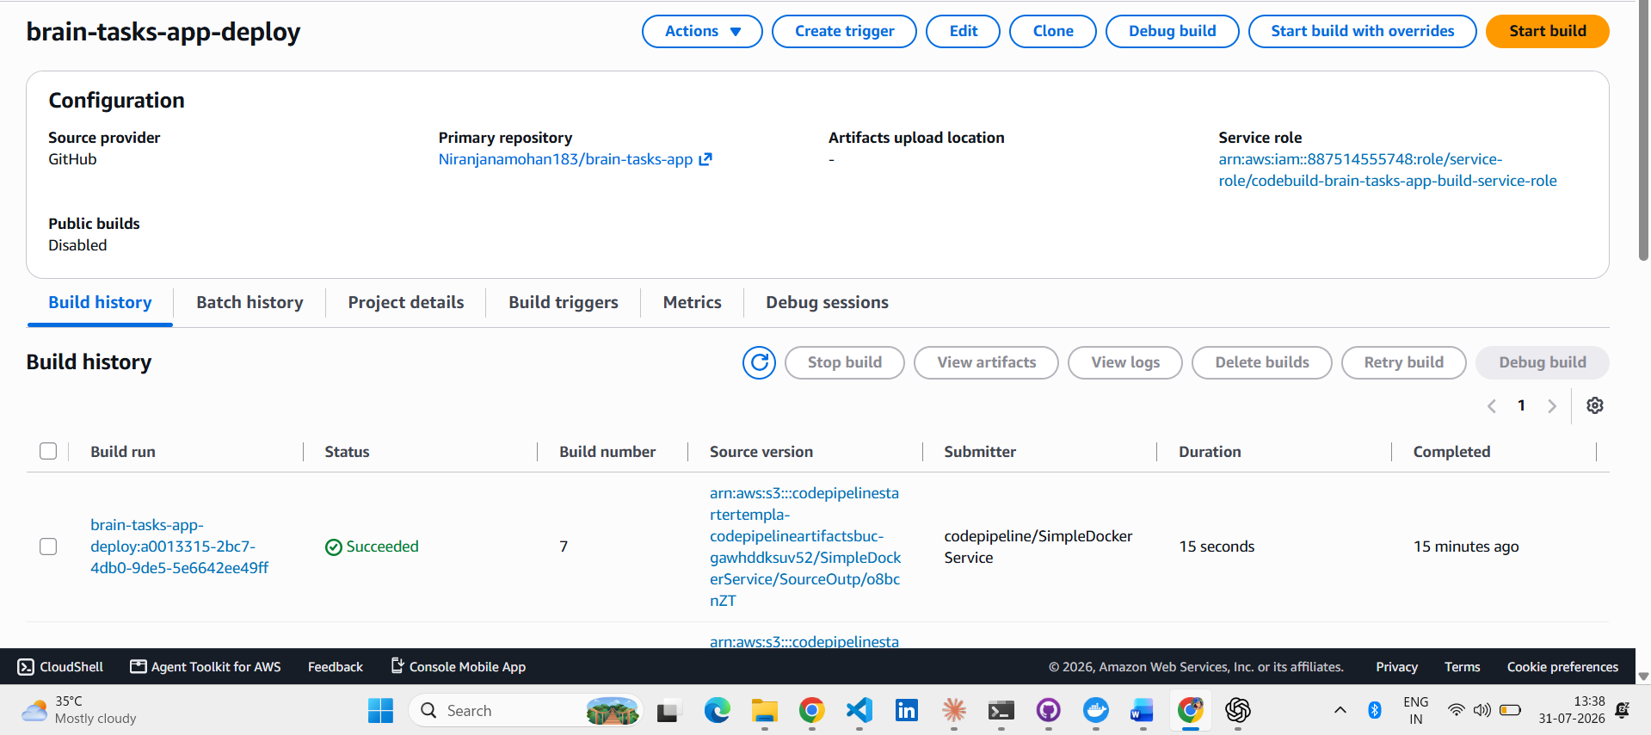

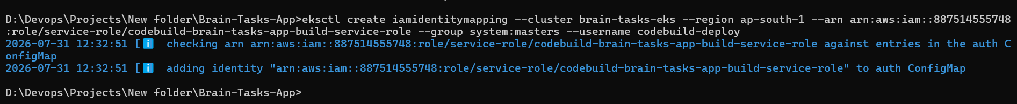

9. AWS CodePipeline
A three-stage pipeline was created: Source (GitHub, webhook-triggered), Build (CodeBuild project building and pushing the Docker image), and Deploy (a second CodeBuild project running kubectl apply against the EKS cluster).

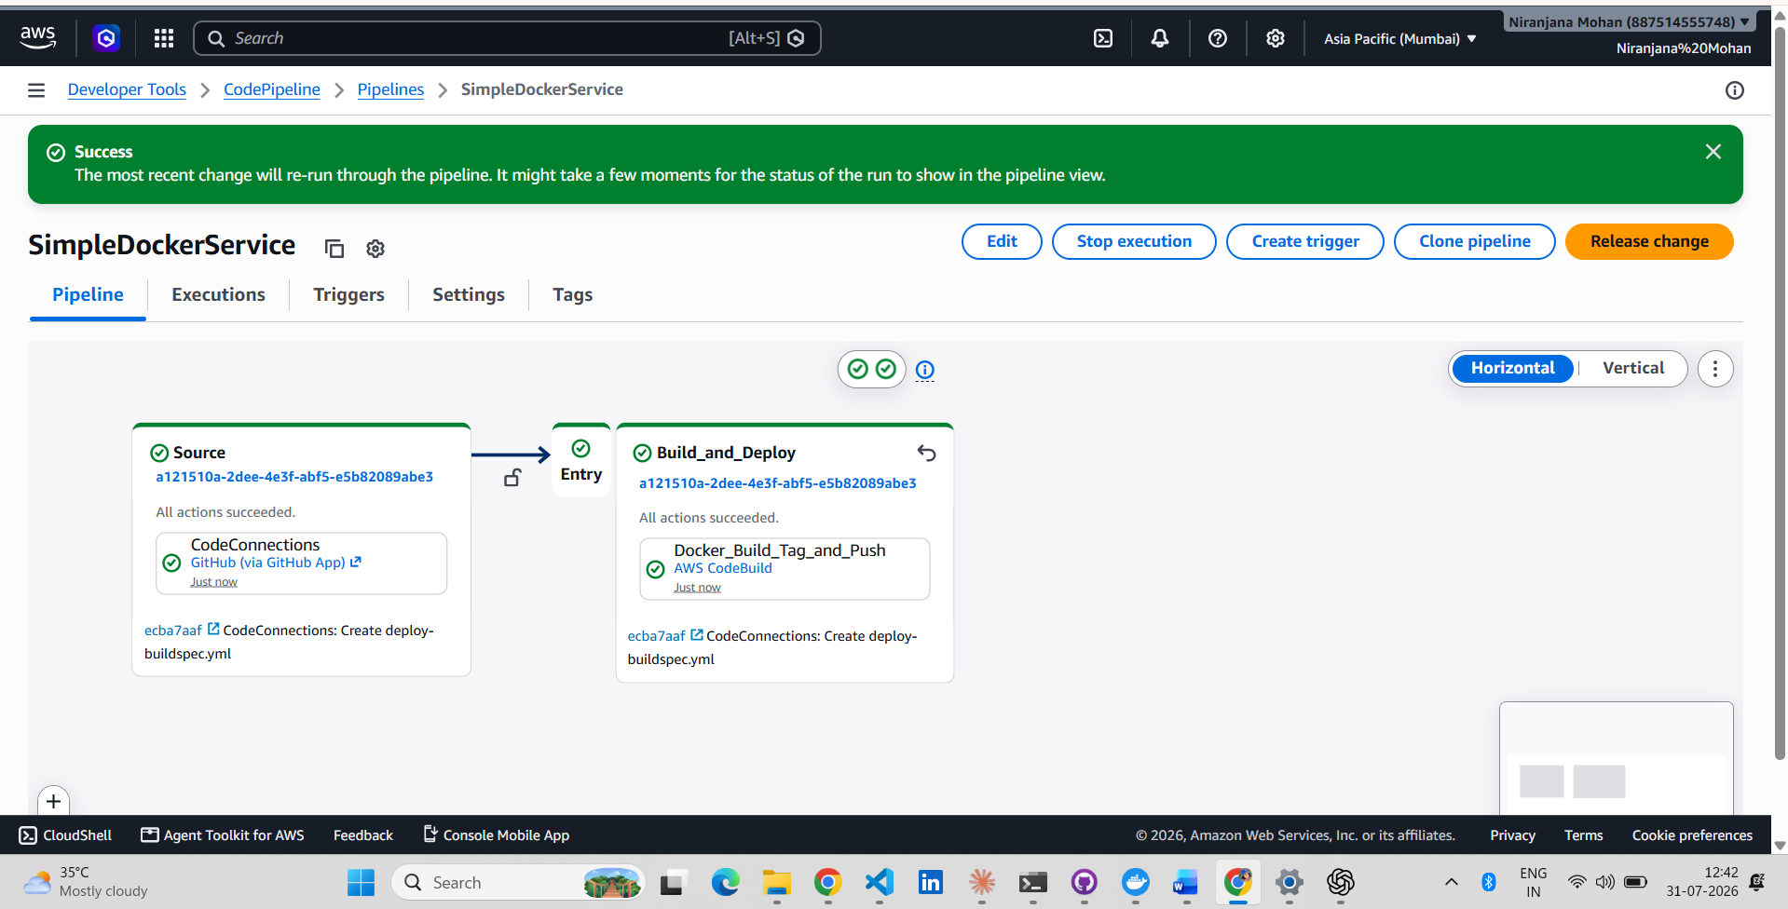

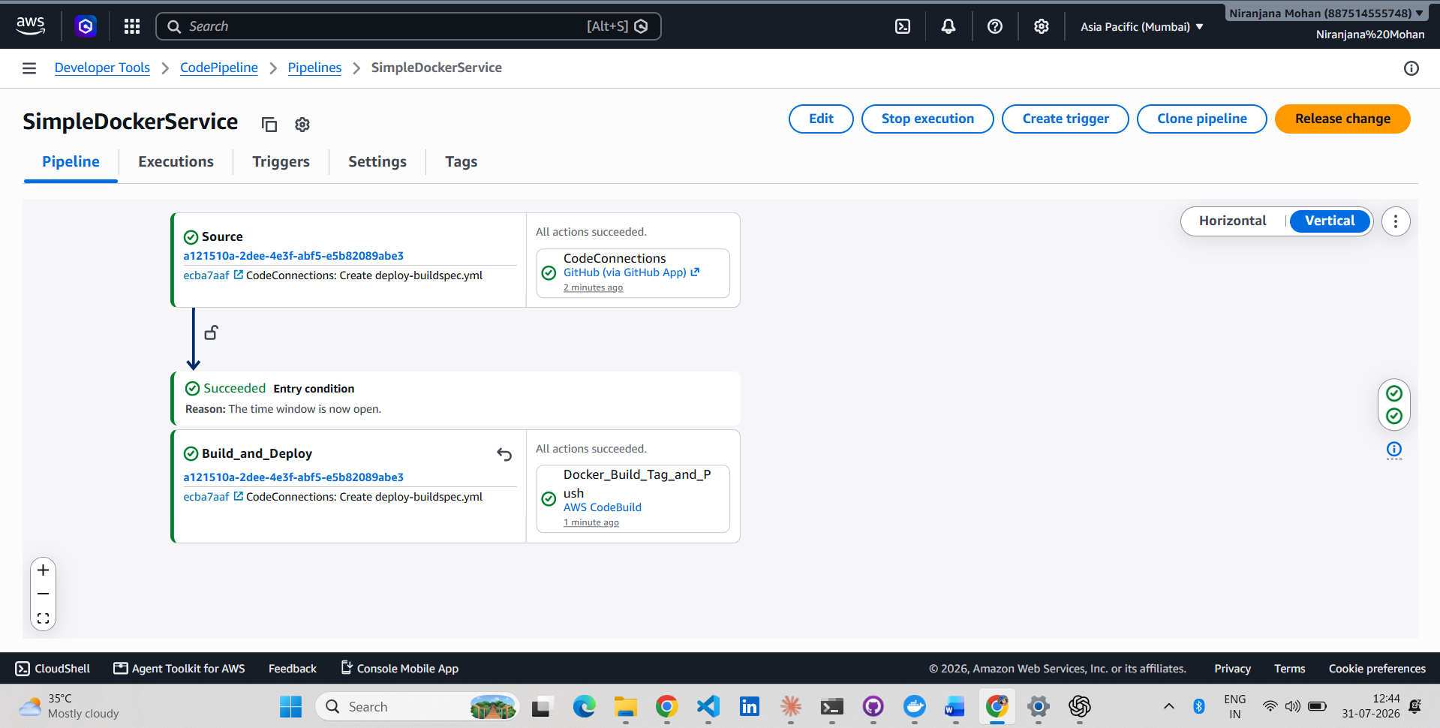
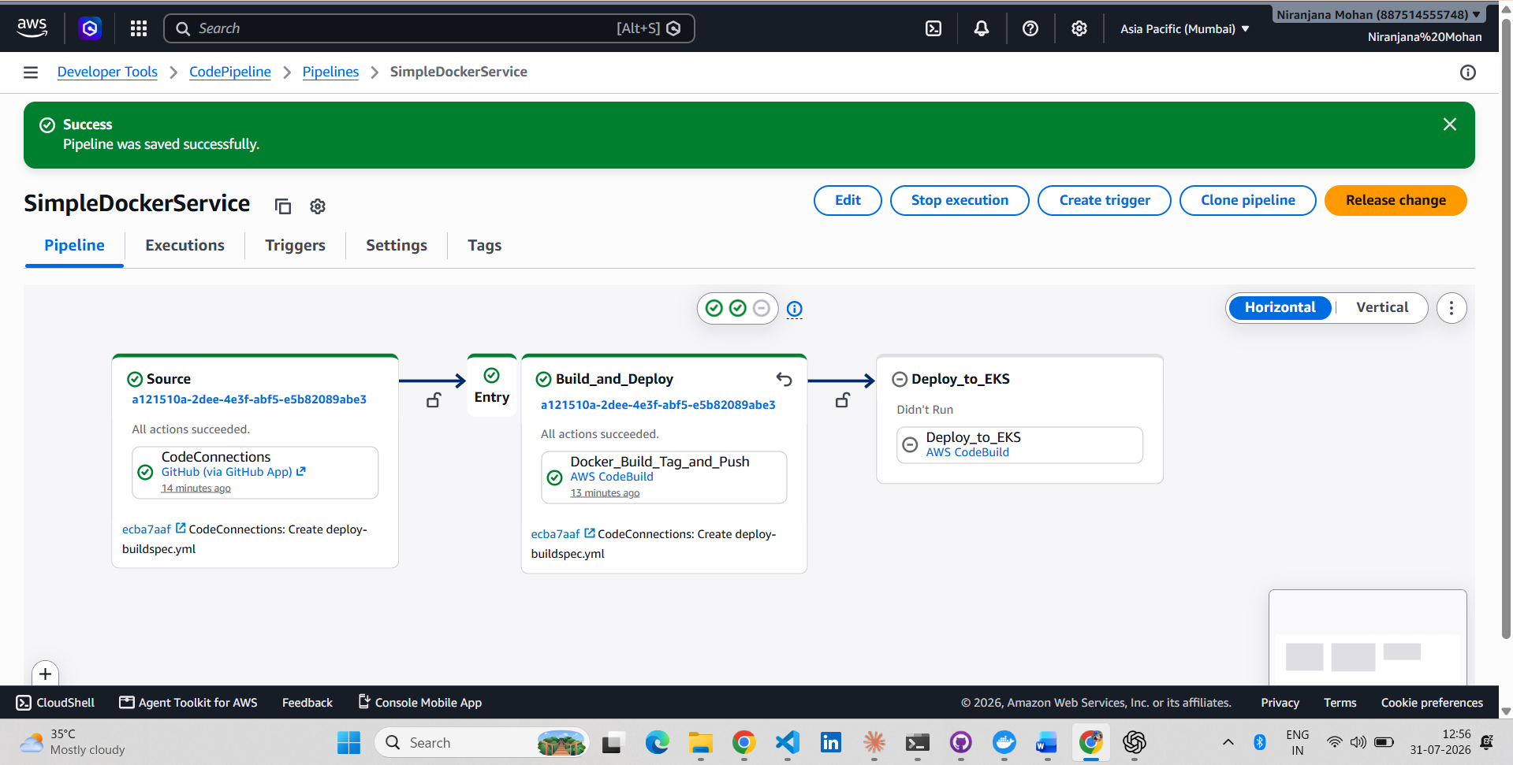

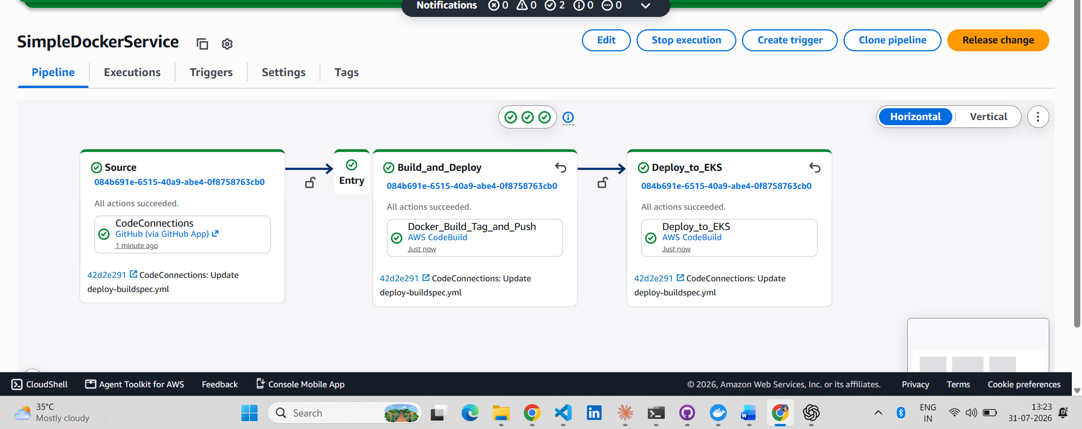

10. Monitoring — CloudWatch
Build and deploy logs are streamed automatically to CloudWatch Log Groups under /aws/codebuild/<project-name>. Application/runtime logs are monitored via CloudWatch Container Insights on the EKS cluster.

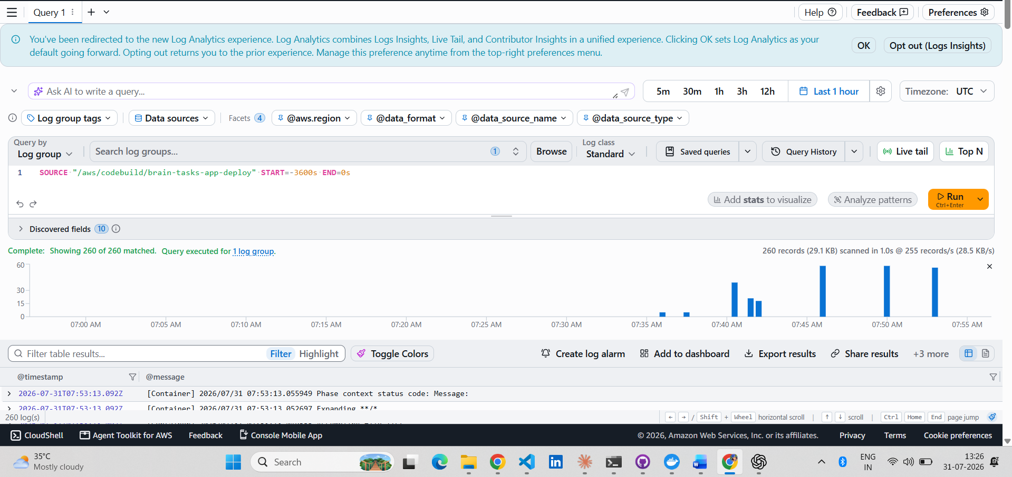

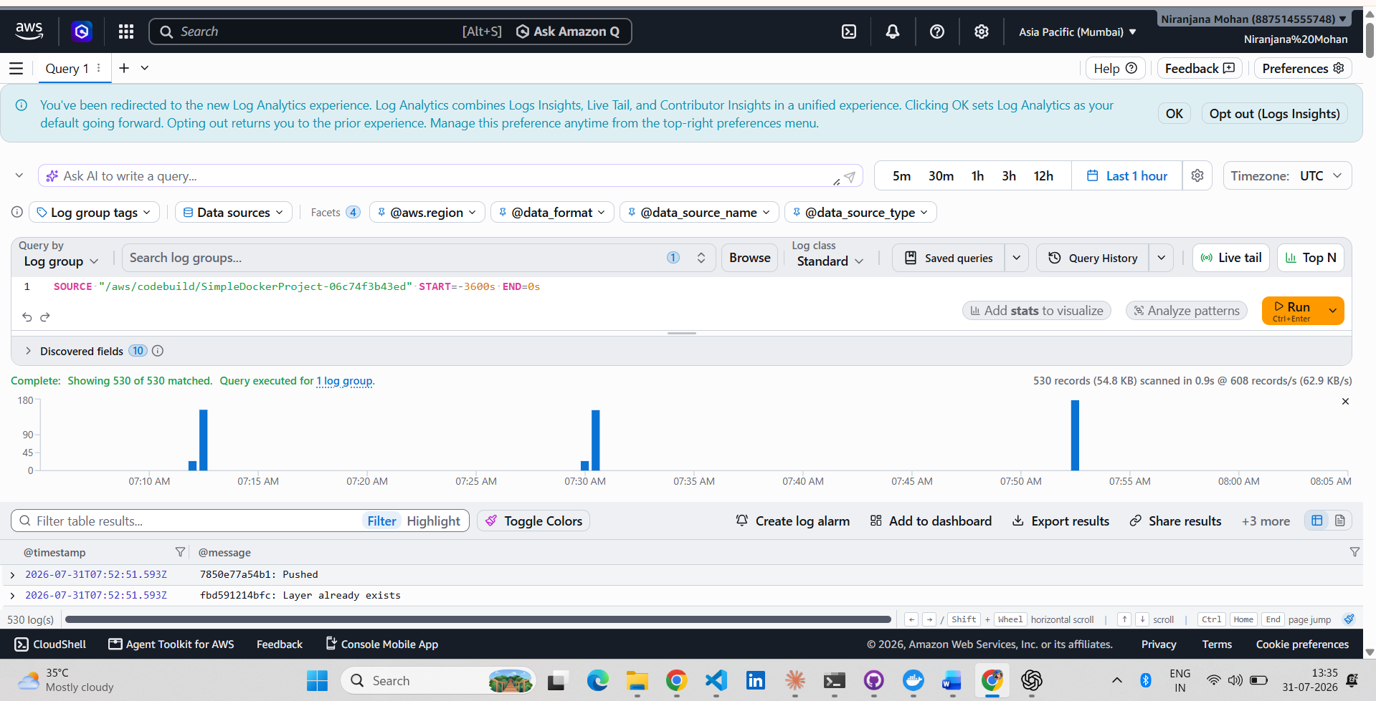

11. Final Deployment Details

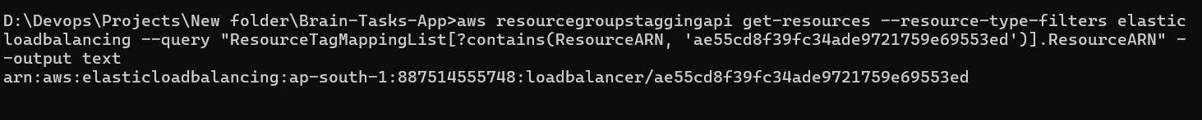

13. Conclusion
Field | Value
GitHub Repository | https://github.com/Niranjanamohan183/brain-tasks-app
AWS Account ID | 887514555748
Region | ap-south-1
ECR Repository URI | 887514555748.dkr.ecr.ap-south-1.amazonaws.com/brain-tasks-app
EKS Cluster | brain-tasks-eks
CodeBuild Project (Build) | SimpleDockerProject-06c74f3b43ed (Docker_Build_Tag_and_Push)
CodeBuild Project (Deploy) | brain-tasks-app-deploy
CodePipeline | SimpleDockerService
Application URL | http://ae55cd8f39fc34ade9721759e69553ed-311182159.ap-south-1.elb.amazonaws.com
LoadBalancer ARN | arn:aws:elasticloadbalancing:ap-south-1:887514555748:loadbalancer/ae55cd8f39fc34ade9721759e69553ed
Replica Count | 2

